Barriper Village Hall

Building Specification Document for Tendering Process

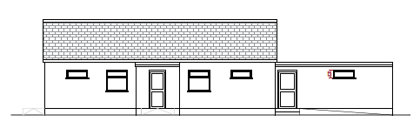

Barripper Village Hall, Botetoe Road, Barripper,
Camborne, Cornwall TR14 0RR

Contents
Material manufacturers clarification statement 4
Preamble 4
Non Domestic Developments 6
Risks 7
Construction Site 9
Site Set up & Demolition 9
Foundations 9
Ground Floor 9
Structural Calculations 9
External Walls & Internal Walls 9
Existing Hall Internal Wall Insulation 10
Lintels 10
Cladding 10
Roof Structure & Ceiling 11
Soffit, facias, and Rainwater Goods 11
Fire protection 11
Notches, Recesses and Holes Etc 11
Insulation 11
Windows & External Doors 11
Principal Entrance Doors 12
Doors To Accessible Entrances 12
Manually Operated Non-Powered Entrance Doors 12
Drainage 13
Manholes 13
Foul Water Drainage 13
Surface Water Drainage 13
Fire Alarm System 13
Water Supply & Sewage Connections 13
Joinery 14
Internal Doors 14
Architrave & Skirting 15
Mechanical & Electrical 16
Renewables 16
Utilities Connections 16
Electrical 16
Lighting 17
Plumbing 17
Hot Water & Heating System 18
Mechanical Ventilation 18
Rainwater Harvesting 18
Final Finishes 18
Flooring 18
Wall & Woodwork Finishes 18
Pathways & Landscaping 18

Barripper Village Hall Extension – Building Specification

Document Change Log
Version 1:
NONE

Material manufacturers clarification statement
Throughout all the documentation and building regulation drawings certain material manufacturers have been stated. These manufacturers are provided to show the relevant performance standards of a particular product. Other manufacturers can be selected but it is up to the contractor to supply the evidence that the materials are of equivalent or above the specified standards. i.e. Celetex, the insulation can be of any manufacturer as long as it has the correct performance standards.

Principle Designer: Envisage Planning & Design
Client Project Manager: Paul Bearham South West Community Builds

Preamble
The drawings have been prepared under the supervision and instructions of the above-named designer for the sole purpose of obtaining Local Authority Planning Permission and/or Building Regulation approval only and are not intended to be a complete working drawing.

The Contractor / Builder shall assume full & complete responsibility for all, and any works constructed as a result of obtaining these permissions / approvals whether the drawings are referred to or otherwise, all dimensions should be checked. The contractor/Builder should satisfy himself as to the suitability of all materials and details referred to and their intended use.

The builder/contractor shall be responsible for including for all works described or being apparent on the drawings or can be reasonably inferred as being necessary for the proper execution of the works.
All work is to comply with the Local Authorities requirements, Planning conditions, British Standards, the current Building Regulations & recognised good building practice.

All material and workmanship is to be carried out in accordance with current British Standards and Codes of Practice, and Agreement Certificate where applicable.

The contractor/builder shall be responsible for checking all dimensions and levels prior to commencement of work on site.

The contractor shall be responsible for ensuring that the approved drawing/specification are being followed. Any deviations shall be agreed with the client and the Local Authority prior to commencement of those works on site.

The position and depth of all services within the vicinity are to be checked prior to commencement of work on site and any relevant permission obtained before construction work commences. Any deviations from the approved specification and details may also affect the energy efficiency aspects of the construction. This may result in costly remedial works being necessary to achieve compliance with the Building Regulations. Any deviations shall be agreed with the SAP energy assessor and the Local Authority prior to commencement of those works on site.

Health & Safety Contractor is to comply with all relevant Health and Safety legislation, which governs the provision of his duties, including: The Construction (Design & Management) Regulations 2015 (CDM Regulations), The Control of Substances Hazardous to Health (COSHH) Regulations, The Work Place Regulations, the Personal Protective Equipment Regulations, the Manual Handling Regulations, the Electricity at Work Regulations, the Abrasive Wheels Regulations, The Control of Asbestos at Work Regulations, the Control of Lead at Work Regulations, Scaffold Regulations, and all other controlling legislation relating to the construction work, plant on site and the handling, use, storage and disposal of materials. The Workplace Health, Safety and Welfare Regulations: Any building or part of a building which will be used as a workplace must comply with the Workplace Health, Safety and Welfare Regulations. This includes requirements for heating, lighting and ventilation, the provision of drinking water, hot water, sanitary and changing facilities, layout of workspaces for inclusive access/use etc. It shall be the Client and/or the principal contractor to employ a fully qualified CDM co-ordinator, or alternatively notify HSE to ensure the requirements of the current legislation are covered by The Construction (Design and Management) Regulations 2015 and the Health and Safety at Work Act are complied with by all site staff/suppliers etc during the various stages of the design and construction works.

The contractor must obtain all installation drawings, instructions or the like issued by manufacturers, suppliers and specialists of all materials or components specified on the drawings to ensure correct use and installation of such specified items. The contractor is to ensure the stability of the works at all times with particular attention being paid to the temporary condition of the various structural elements of the works as well as any adjacent buildings/structures during construction and demolition.
This project comprises work for a commercial client and is notifiable to the HSE if the construction phase will exceed more than 30 working days or involves more than 500 man days. Summary of client’s role/ duties:
- Make suitable arrangements for managing a project, including making sure other duty holders are appointed as appropriate, and that sufficient time and resources are allocated to the project
- Provide pre-construction information as soon as is practicable to every designer & contractor appointed/considered for appointment
- Make sure that the principal designer and principal contractor carry out their duties
- Make sure that welfare facilities are provided on this project our role as designer is to secure building regulation approval and, accordingly, we have fulfilled our duties under the CDM 2015 regulations up to that point.

At this stage the role as principal designer will cease. All relevant health and safety information will be passed to the client for distribution to the principal contractor. For the construction stage of this project all designers will have designer duties under the CDM Regulations 2015. Designers include any person who as part of their business prepares or modifies a design arranges for, or instructs, any person under their control to do so, relating to a structure, or to a product or mechanical or electrical system.
Design hazard elimination & risk reduction - The scope of the works is clearly illustrated on the drawings. The following risks have been assessed and are judged to be no more stringent or unusual than a capable contractor would be expected to manage or to be aware of.

Non Domestic Developments
The waste collection authority should be consulted for guidance on resolving the requirements taking into consideration to the volumes of waste, storage containers, location of storage areas, collection points, vehicle access, fire hazards and protection etc.

Risks
Risk | Action
Structural collapse | The superstructure design should be carried out in accordance with the relevant temporary works design guidance to ensure stability is maintained during the construction phase. Contractor/client to seek engineers’ advice prior to the commencement of those works on site.
Fire precautions and flammable/explosive materials | The contractor should carry out a risk assessment in accordance with HSG 168 - Fire Safety in Construction and take actions based on the outcome of this. Where timber frame construction is to be used follow the Structural Timber Association guidance taking into account the 16 steps to fire safety.
Noise & disturbance to neighbours | The contractor should have due regard for the neighbours privacy and maintain noise to a minimum level, or time period to reduce the impact. The working hours during which noisy operations can be undertaken shall be restricted to 8am to 5pm Monday to Saturday.
Health & respiratory injuries | The client/contractor must undertake a site specific survey of hazardous materials including asbestos prior to the commencement of works on site. Any hazards must be remediated and/or removed by a specialist removal/remediating contractor prior to any demolition/alteration works being undertaken. All demolition works should include suitable damping down to minimise dust.
Site access & construction facilities | The site is directly accessed from the public highway. The contractor should layout the storage of materials and welfare facilities such that clear visibility is provided for vehicles accessing and leaving the site. The contractor should minimise the transfer of mud and dirt from the construction site onto the surrounding roads. Site signage to be provided and maintained.
Injury to trespassers | The contractor should provide suitable hoarding/fencing.
Falls from height | Contractor to provide suitable safe access. Check security of ladders, guard rails and scaffolding on a daily basis
Falling debris and objects | Contractor to provide suitable and adequate protection to operatives and occupants. Manual handling of materials Ensure all operatives have adequate training, provided with protective gear and warning signs.
Collapse of structure | Contractor to provide adequate temporary support as required. Liaise with the structural engineer regarding support of existing structure or potential collapse of excavated foundations/retaining wall/service trenches. Provide support of any unstable ground. Provide vehicle barriers to prevent overturning/surcharge of trenches and pedestrian barriers to prevent falls into excavation.
Buried services | A site specific survey has not been carried out of the buried services and this should be undertaken prior to works commencing on site by the main contractor. Services exposed during construction to be isolated/made safe by qualified person during which time the area shall be cordoned off until such time it is deemed to be made safe.
Mobile cranes, moving plant/ machinery | Provide suitable protective gear, safety barriers along with warning signs.
Flammable and explosive materials | Risk assessments must also be undertaken of the materials being used on site considering the risks of fire and explosions from the substances used, considering ignition sources and method of storage on site. Provisions will also be necessary for the existing and/or the new tank.
On-site welding | Provide suitable protective gear.
Fire | Hot works can only be undertaken following an appropriate risk assessment by the contractor. All access/egress routes should remain free of obstructions at all times.
Employees, trades & subcontractors | Ensure all work personnel have the necessary Health and safety training prior to starting work on site.

Construction Site

Site Set up & Demolition
The main construction site for the extension is an open space and this is available at the start of the contract. As part of the contract process, the main contractor will organise the site layout, allowing for minimum disruption for the existing users of the existing hall as well as continuing access to cricket pitch, and playground, keeping as main parking spaces for the member of the public as possible.

Foundations
Prior to preparing oversite, remove all topsoil, vegetable matter from the area of the proposed construction.
All excavations shall be adequately supported, protected, and kept free from water at all times. All excavated surfaces shall be cleaned of any loose and/or disturbed materials prior to and during pouring concrete.
Foundation design to be carried out by structural engineer. Traditional strip foundations will be used. No ground investigation has been undertaken.
Any depth of foundation indicated is indicative only.
Under external walls - Concrete foundations to be 600mm x 225mm C30 concrete strip to BS 5328 1997, ensuring a minimum of 150mm toe/bearing either side of substructure blockwork. All at a depth to local authority approval upon site inspection but a minimum 600mm to 50mm below finished ground level or alternatively they shall be taken down below the invert of any adjacent drains within 1.0m of the excavations.

Ground Floor
75mm concrete screed to be laid on top of 500g polythene vapor barrier over 750mm Celotex flooring insulation or similar. With 25mm Celotex insulation 'up standing' insulation around perimeter to prevent 'cold bridging'. All to be sat upon the existing 150mm reinforced concrete slab.

Structural Calculations
Any structural engineer’s details and calculations that may be required for the project to be read in conjunction with construction notes. Any deviations to calculations and/or details to be referred to engineer for their approval.

External Walls & Internal Walls
The external walls will be constructed using 100mm blockwork with 50mm of rigid PIR insulation, with a 50mm clear cavity and 100mm block external skin. To be rendered or dry lined, then finished with 5mm thick gypsum skim to receive decoration.
All openings to have 50mm x 50mm (covered in DPC) cavity closer's fitted. Cavity closer's to be fitted at the head of cavity.

Internal stud partitions: 90mm x 38mm CLS stud-work at 600mm centres with head and sole plates and half height noggins. 90mm Rock wool (with a minimum density of 10kg/M3) insulation to centre. Internal face to be finished with 12.5mm acoustic plasterboard (with a minimum density of 10kg/M3) and 5mm thick gypsum skim to receive decoration.

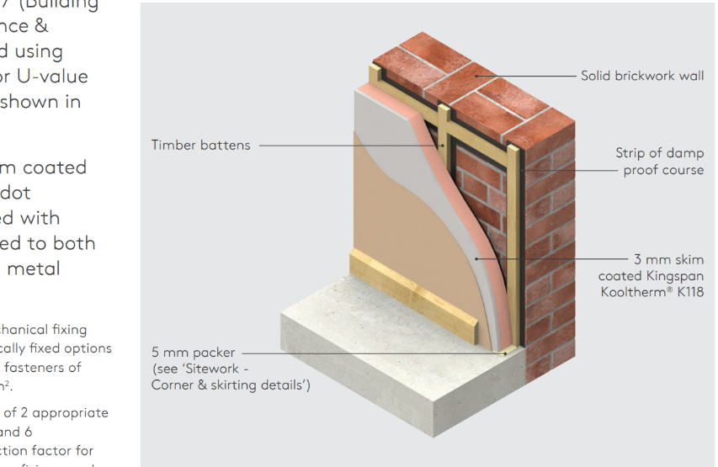
Existing Hall Internal Wall Insulation
The existing main hall internal walls will be internally insulated. This will be by fitting 72.5mm insulated plaster board using Kingspan Kooltherm K118 insulated plasterboard or equivalent. This will be mechanically fixed to a 25mm x 47mm treated softwood frame outlining all openings and services, including top and bottom with no more than a maximum of 600mm centres. This timber frame will have dpc fixed between the timber and the existing wall.
This will be finished by 5mm thick gypsum skim to receive decoration.

Lintels
All Lintels in blockwork to comply with structural engineers note or through the use of calculation tables supplied by the manufacturer of the lintels.

Cladding
The external cladding will be Cedral Click and will be installed as per the manufacturers’ system specification using timber counter battens.
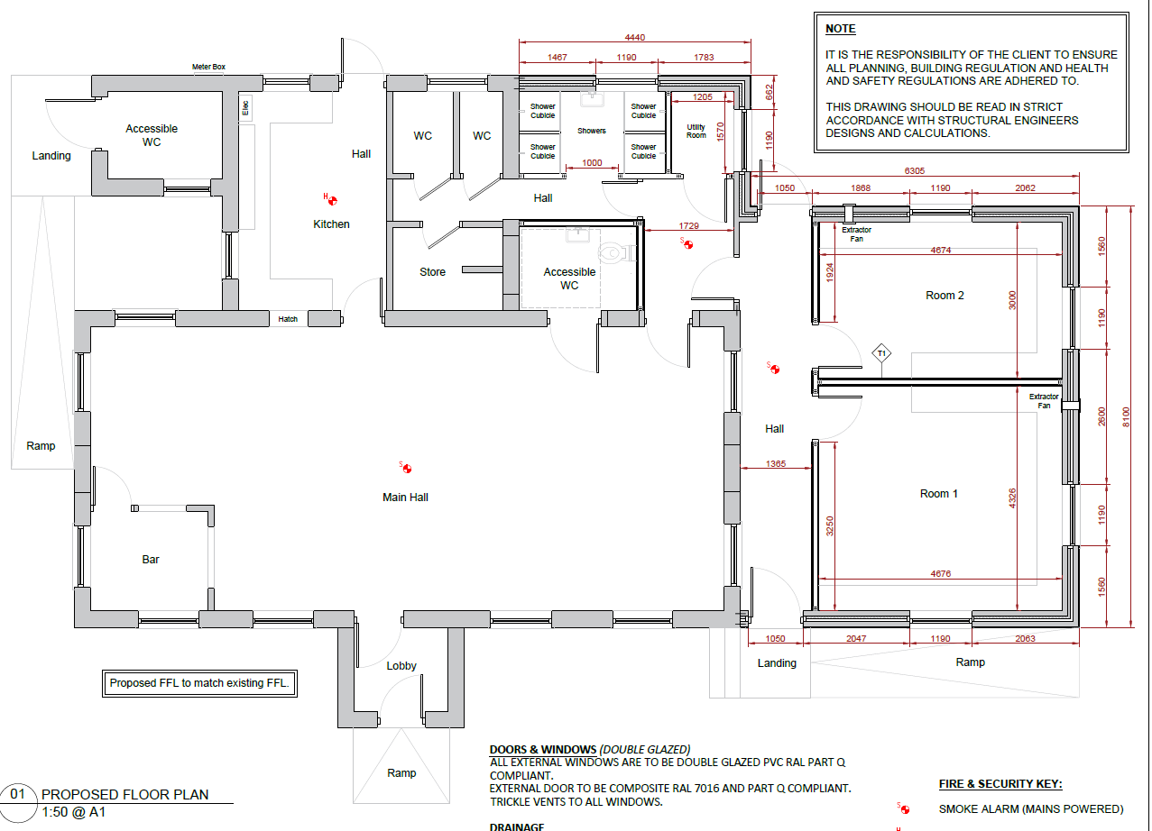
The building cladding colour will be Cedral Click Wood in C05 Platinum Grey.

The Cladding will be along the red lined edges of the building.

Roof Structure & Ceiling
Flat roof (warm roof): Flat roof to be of a 'warm roof construction' using 220mm Solid timber joists or Engineered I beam ceiling joists set @ 400mm centres. To this fix a VAPOR barrier and 9mm PLY with 120mm thick PIR Celotex or similar. To this fit 18mm thick wbp sheeting ply to top face, finished with GRP roofing supplied and fitted in accordance with manufacturers specification and instructions. GRP roof finish to AA, AB or AC class fire rating. Internal ceiling to finished with a 12.5mm plasterboard and 5 mm thick gypsum skim to receive decoration.

Roof U value to achieve 0.16 W/M2K

Soffit, facias, and Rainwater Goods
All soffits, facias and rainwater goods will be upvc and will be coloured white.

Fire protection
All steel beams are to be fire protected to a minimum 30mm fire resistance by cladding with 15mm Gypsum Glasroc F Firecase fireboard. To be installed as per manufacturers data sheet.

Notches, Recesses and Holes Etc
Vertical chases should not be deeper than 1/3rd of the wall thickness or, in the cavity walls, 1/3rd the thickness of one leaf. Horizontal chases should not be deeper than 1/6th the thickness of the wall leaf. Chases should not be positioned as to impair the stability of the wall.
Notches and holes in simply supported floor and ceiling joists should be within the following limits:
Notches should not be deeper than 0.125 times the depth of the joist and should not be cut closer to the support than 0.07 of the span, nor further than 0.25 times the span. Holes should have a diameter not greater than 0.25 the depth of a joist and should be drilled at the joist centreline. They should not be less than 3 diameters (centre to centre) apart and should be located between 0.25 and 0.4 times the span from the support. Notches or holes should not be cut in rafters, purlins or binders unless approved by an engineer. Rafters retained by ceiling ties at eaves level may be birds mouthed at supports to a depth not exceeding 1/3rd of the rafter depth

Insulation
The building fabric should be constructed so that there are no reasonable thermal bridges in the insulation layers caused by gaps within the various elements such as those around windows and door openings. Reasonable provision should also be made to reduce unwanted air leakage through all elements of the proposed works. Insulation material to be protected from moisture damage during construction.
Al insulation to be confirmed that it will achieve the required U value within the walling, roof and floor systems, before installation.

Windows & External Doors
uPVC windows with 28mm Low E Argon filled insulated and double-glazed sealed units with 20mm air gap. Trickle vents equivalent to 8,000 sq. mm. Glazing to windows with a sill height less than 800mm to be fitted with toughened safety glass to BS 6206.
Additional mechanical ventilation in the form of Heat recovery ventilation to rooms in the following areas: -
Kitchen – 60 litres / second
WC - 15 litres / second
Ensure a 10mm air gap to WC doors. Extractor fans to be installed in accordance to approved document F1 appendix E 'Good practice guide to the installation of extractor fans for'.
All new windows and doors to be rebated minimum 25mm behind external timber cladding. Ensure all new windows achieve 1.6W/M2K. Maximum sill height 1,100mm. Fixed mechanical ventilation and any associated controls must be commissioned and tested. Notice of test results are to be provided on completion.
Ensure all new external doors achieve a minimum U value of: -
3.0W/M2K for solid door up to 40% glassed
1.8W/M2K for doors with 40% - 60% glassing
1.6W/M2K of doors with more than 60% glassing

All doors to be fitted with toughened or laminated safety glass and any glazing within 300mm of a door to be toughened or laminated safety glass. All to BS 6206. All windows and doors to be designed to PAS 24 or equivalent security standard and installed in accordance with the manufacturer’s details.
External Door No. | Material
D1 & D2 | UPVC with half panels (top glass panel & bottom fixed panel)
External Door Materials & Glazing

Principal Entrance Doors
The access to the principal entrance doors of the building is considered level. The new doorway will have an overall minimum clear opening width of 800mm.

Doors To Accessible Entrances
Maximum 20N force required at the leading edge of the door Clear widths as Table 2 below. Ideally vision panels should be provided

Manually Operated Non-Powered Entrance Doors
300mm unobstructed space on pull door side of door. Contrasting door furniture that can be operated with a closed fist (i.e. Lever)

Drainage

Manholes
To be 300/450mm dia. pre-formed plastic manhole bases and chambers on concrete base. Where in vehicular area suitable heavy duty covers to be provided with sides surrounded in concrete in accordance with manufacturers details.
Any manhole or inspection chamber located within the building to have a double sealed airtight screw down cover and frame suitable to accept the desired floor finish treatment.

Foul Water Drainage
It is not anticipated that any additional drainage will be required. All below ground drainage in accordance with BS 8301 to existing system.

Surface Water Drainage
Provide ACO or similar profile channel against external wall wherever the ground to dpc clearance is less than 150mm.
All new rainwater goods to match fascia and soffits, with continuous downpipes discharging to roddable gullies to an underground 6,500l rainwater harvesting then to the existing soakaway.
If a new soakaway is required it will be a minimum 5m from buildings, roads or areas of unstable ground. Soakaway made with soakaway crates or equivalent above. The actual size of the soakaway should be determined by a percolation test. Below ground surface water pipes to have a minimum fall of 1 in 80 on 9mm granular bed with 150mm granular surround, with drains being provided with 100mm thick (1:2:4 mix) reinforced concrete cover where they have less than 450mm cover.

Fire Alarm System
The building should be provided with a suitable electronically operated automatic fire warning system, designed and installed in accordance with BS5839. A commissioning certificate must be provided to the Local Authority prior to the occupation of the building.

Water Supply & Sewage Connections
The existing water supply to be adapted and extended as necessary to serve the altered and extended works. All works are to be carried out by a certified plumber and in accordance with all current water authority regulations.
If the existing sewerage connection will be connected into, and all works are to be carried out in accordance with all current water authority regulations.

Joinery

Internal Doors
All door furniture to be of a commercial standard (TBC). All doors to be rated as per the door schedule and building regulation drawings.
The two Internal Doors for the meeting rooms to use Howdens Dordogne White Satin Smooth Pre-finished Moulded Middleweight Door. The existing external door adjacent to the utility room will be changed to an internal Howdens Dordogne White Satin Smooth Pre-finished Moulded Middleweight Door.
Internal Door No. | Manufacturer & Model | Glass Panel | Quantity
D3, D4, D5 | Howdens Dordogne White Satin Smooth Pre-finished Moulded Middleweight Door | None | 3
Doors Required
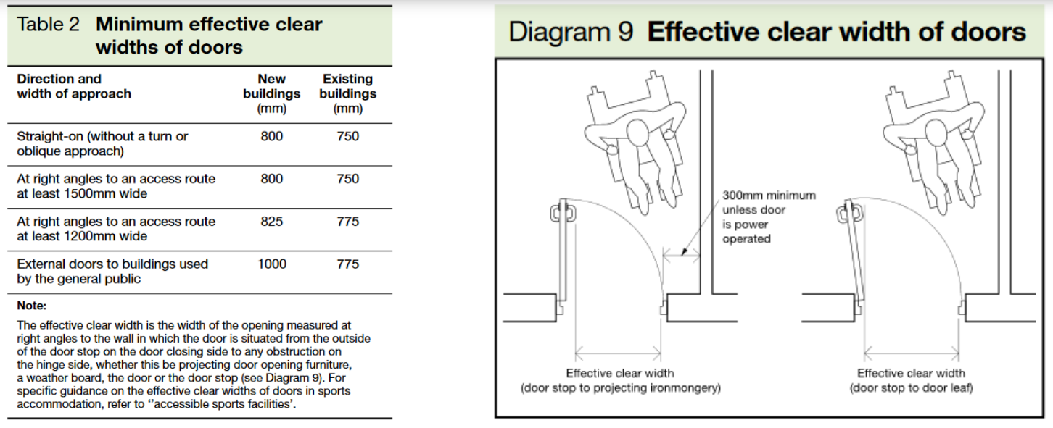
There is an unobstructed space of at least 300mm on the pull side of the door between the leading edge of the door and any return wall, unless the door has power controlled opening Where fitted with a latch, the door opening furniture can be operated with one hand using a closed fist (ie lever handle) All door opening furniture contrasts visually with the door The door frame contrasts visually with the surrounding wall The surface of the leading edge of the door that is not self closing, or is likely to be held open, contrast visually with the other door surfaces and its surroundings Where appropriate in door leaves or side panels wider than 40mm, vision panels towards the leading edge of the door have vertical dimensions which include at least the minimum zone, or zones of visibility between 500mm and 1500mm above floor level Glass doors should be clearly defined with manifestation on the glass at two levels, 850mm to 1000mm and 1400 to 1600mm contrasting visually with the background seen through the glass Where of glass or fully glazed, they are clearly differential from any adjacent glazed wall or partition by the provision of a high contrasting strip at the top and sides Fire doors in corridors held open by an electromagnetic device must self close when activated by smoke detectors or fire alarm system or power failure or activated by a hand switch

Architrave & Skirting

All Architrave and skirting to be mechanically fixed with glued mitres, and all holes and joints to be caulked. The architrave and skirting profile will be or similar to Howdens 4.2m Square White MDF Skirting 96mm & Architrave 70mm Board.

Mechanical & Electrical

Renewables
Installation of 6500 litre rainwater harvesting tank for outside tap for watering plant and washing machinery.

Utilities Connections
The site currently has single phase electric, water and foul water connected.
Services | Existing | New connection point
Electrical | In utility Rooms | Remain
Water | Connected to SWW | Remain
Foul | Connected to SWW manhole within site boundary. | Remain
Surface water | Surface run off into soakaway area. | To rainwater harvesting tank and in to soak away within the site boundary.
Telephone | Broadband connected | Remain

Electrical
- Switches/controls requiring precise hand movement 750 – 1200mm above floor level.
- Pull cords for emergency alarms to be red with 50mm diameter bangles at 100mm and 800 – 1100mm height above floor level.
- Sockets no closer than 350mm to corners of room.
- Sockets to be located between 400 – 1000mm above floor level.
- General public use switches to have large push pads aligning with door handle between 900 – 1100mm above floor level.
- Front plates to contrast with background.

Room | No. of Double Sockets | Additional requirements
Room 1 | X 3 (1 with USB A&C) | Connection for Extractor fan  Cat 6 ceiling network point for WIFI point
Room 2 | X 3 (1 with USB A&C) | Connection for Extractor fan
Hall | X 1 | None
Exterior | 2 waterproof double sockets | None
Electrical installation for each room.

Lighting
Emergency lighting and exit signage will be installed to the latest regulations. All lighting will be LED Downlighters designed to create consistent lighting across each area. These lights will include emergency M3 as part of the lighting layout. The lighting scheme will NOT use surface mount NM3 fittings for emergency lighting requirement, but they will be integral to the general luminaire.
Provide 100% energy efficient internal light fittings and lamps throughout to be capable of taking lamps having a luminous efficiency greater than 40 lumens per circuit-Watt. Energy efficient external security lighting to be a maximum wattage of 150w and fitted with movement detecting (PIR) and daylight cut-off devices. External lighting should be LED and to be switchable from inside the property.
External lighting will be downlighters (total of 5) mounted around building. All external lighting connected to the building to be controlled by a daylight sensor with the ability to easily switch off all exterior lighting, if required.
Room | Lux Level | Dimmable
Room 1 | 300 | Yes
Room 2 | 300 | Yes
Hall | 150 | No – PIR
Exterior | 5 Downlighters only, fitted each side of the window from and back windows and one along the South East Elevation. | Additional PIR on corner of building.
Required Lux levels for each room.

Plumbing
All plumbing to be to the latest regulations, including MV3 mixing valves on all hot water taps and shower units.

Hot Water & Heating System
The existing boiler will feed the radiators (3 off) in the new extension.
A thermostat controlling both rooms and the hallway will be installed in Room 1

Mechanical Ventilation
Each meeting room will be fitted with a heat recovery extractor fan. Meeting the required air flow rates for such spaces.

Rainwater Harvesting
The rainwater harvesting tank will be a 6,500 litre below ground system with a pressurised non return pump to directly feed an outdoor tap mounted on the South East Elevation. (See link below).

Carat 6500 Litre Garden System - Rainwater Harvesting

Final Finishes

Flooring
All flooring to be laid in accordance with the manufacturer’s recommendations.
Altro – Altas 40 Pewter Grey (X4039). To be installed as per manufacturer’s instructions.
Room | Flooring Type | Skirting Type
Room 1 | Altro | MDF
Room 2 | Altro | MDF
Hall | Altro | MDF
Flooring requirements for each room

Wall & Woodwork Finishes
All walls will be painted white with 2 layers of base coat and then a topcoat of a durable finish (e.g. Dulux Trade Diamond Matt). All woodwork to receive primer & undercoat with at least 2 coats of Satin Wood in White (TBC).

Pathways & Landscaping
There will be a pathway between for the new entrances and around the extension using brushed concrete Both doors will require a landing and a ramp with a concrete path joining them together, along the extension wall.

