
INVITATION TO TENDER (ITT)
To Supply and Install Windows at the Lescudjack Centre - 004
Gul Skills Community Hub
Primary Contact
Alison Elvey
Finance & Administration Director
Trelya
The Lescudjack Centre
Penmere Close
Penzance
TR18 3PE

07874879970
procurement@trelya.com

INSTRUCTIONS FOR SUBMITTING TENDERS
- Service Providers will be held to have fully informed and satisfied themselves by their own independent observations and enquiries, including the size and number of windows listed, where appropriate site visits, as to the nature, extent and practicability of the contract requirements and its location, the means of access to deliver the project and all other points which can in any way affect the prices inserted in the Invitation to Tender. No payments will be made in respect of additional costs incurred by the Contractor in dealing with any obstruction or access problems.
- Viewing by appointment only contact: Deb Parker: t. 07752446533 / procurement@trelya.com
- All contract documents, whether a tender is submitted or not, remain the property of Trelya and shall be treated as private and confidential.

- Tenders shall remain open for acceptance for a period of 90 days after the latest date for submission.

- Trelya will not be responsible for or pay any expenses or losses, which the Service Provider may incur in the preparation of their tender.

- Trelya is not obliged to accept any tender and reserves the right to withdraw the tender at any time.

- Tenders are to be returned by post to: Alison Elvey, Trelya, The Lescudjack Centre, Penmere Close, Penzance, TR18 3PE OR by email marked “To Supply and Install Windows at the Lescudjack Centre - 004” for the attention of Alison Elvey to procurement@trelya.com.

TENDERS ARE TO BE RECEIVED BY NO LATER THAN MIDNIGHT 16TH August 2024

PART A

SPECIFICATION

Project Brief

This ITT sets out Trelya’s requirements for a suitable Contractor to supply, deliver and install windows, including all necessary builders work in connection with the installation, temporary works and any necessary design.

The property is the Lescudjack Centre, located at Penmere Close, Penzance TR18 3PE. This is a coastal location so the window design should be suitable for this.

This ITT establishes some broad parameters that Trelya will consider when selecting the successful Contractor and offers guidance on the desired outcome of the project.

The purpose of this Brief is to obtain like for like competitive tenders and to form the basis of the Contractor appointment. Tenderers must demonstrate that they can provide a comprehensive, high-quality service for the benefit of the charity. However, Trelya reserves the right to add to, omit from, or amend the Brief in any way prior to execution of the contract. Changes that materially affect the provision of services described herein which shall cause a change in the price of providing such altered services must be agreed between Trelya and the appointed Contractor.

The works will need to comply with all relevant regulations including current building regulations and be awarded through a JCT minor works contract with contractor design.

In line with our funders requirements (Cornwall Council’s Social Value Policy - http://tinyurl.com/33xdz28v), Trelya’s Procurement Policy and Trelya’s Environmental Policy we aim to maximise economic, social and / or environmental benefits in how we buy goods, works or services. This includes maximizing the added benefits that can be achieved to the local economy through our suppliers.

Please note the Lescudjack Centre is a busy community centre which also hosts a dentist, NHS mental health services, a café and Trelya’s service delivery with young people. There are services running from 8am to 8pm most days Monday to Friday. This means that contractors will need to be mindful of the buildings users and will have to work around the room availability whilst installing windows.

Background to Trelya

Trelya is an award-winning medium-size independent charity based in West Cornwall working to enable positive change in West Cornwall’s most under resourced communities.

Behind the images of sun, sea and sand, Trelya is located in one of the most economically deprived communities in the UK; in a county where people experience high unemployment, high house prices, low pay, often seasonal work and rural isolation. Trelya aims to break the cycle of social exclusion including enabling adults and young people at risk of social exclusion, as a result of social and economic deprivation, to develop the skills, knowledge, awareness, aspirations and motivation to make positive choices about their lives and their behaviours.

We know from experience that the children, young people and families living in our communities are unique and skilled individuals with incredible potential. Trelya creates opportunities to fulfil that potential through provision of a nursery “Skylar” (rated ‘Outstanding’ by Ofsted), ‘Gallos’ an award-winning youth work and mentoring programme and ‘Gul,’ which is one of Cornwall’s most successful employment and training programmes for those furthest from the labour market.

Gul Skills Community Hub

Trelya has recently secured a Cornwall and Isles of Scilly Good Growth Shared Prosperity Fund Grant which is a mix of capital and revenue expenditure. This capital expenditure will help to reimagine our Community Centre, the Lescudjack Centre, at the heart of Treneere in Penzance.

As part of this capital expenditure, we are upgrading the external windows and several internal windows at the Lescudjack Centre.

Requirement

Replacement of external windows and replacement of some internal windows with fire rated glass. Where the window frames are currently Aluminium, we would like a quote for both an Aluminium replacement and UPVC. All windows should be triple glazed and comply with fire safety regulations.

Please note that the measurements in the table are approximate measurements therefore we require suppliers to visit the site and take exact measurements to ensure the quote is 100% accurate. We take no responsibility for the accuracy of the measurements below which should be used as a guide.

The specifications for each window is outlined in the table below:

26 x large windows (incl. extra-large)
11 x small windows
6 x small aluminium (high up)
2 x large aluminium window/wall panels (hallways)
4 x sets of rectangular panel windows (2 x 2 panes + 2 x 3 panes) high up at top of wall (higher gym)
4 x sets of rectangular panel windows high up at top of wall (lower gym) – Currently no windows here
1 x set of large high panel windows (gym)
2 x large floor to ceiling windows (Skylar)
2 x small floor to ceiling windows (Skylar)
1 x rectangular panel window (Skylar)
2 x windows panes (Lower Ground Floor – Fire Exit)
10 x Internal Windows requiring Fire rated glass panes only
1 x sliding window / or 2 x internal windows with openings

Specification

Our funders require us to obtain like for like quotes so please ensure all the windows listed are included. All windows should be triple glazed and comply with the relevant British standard and commercial buildings regulations (including but not exclusively Fire Safety, Ventilation, Energy efficiency, sound insulation). Where sills, reveals or heads are damaged they should be made good or repaired like for like.

Map of Lescudjack Centre layout

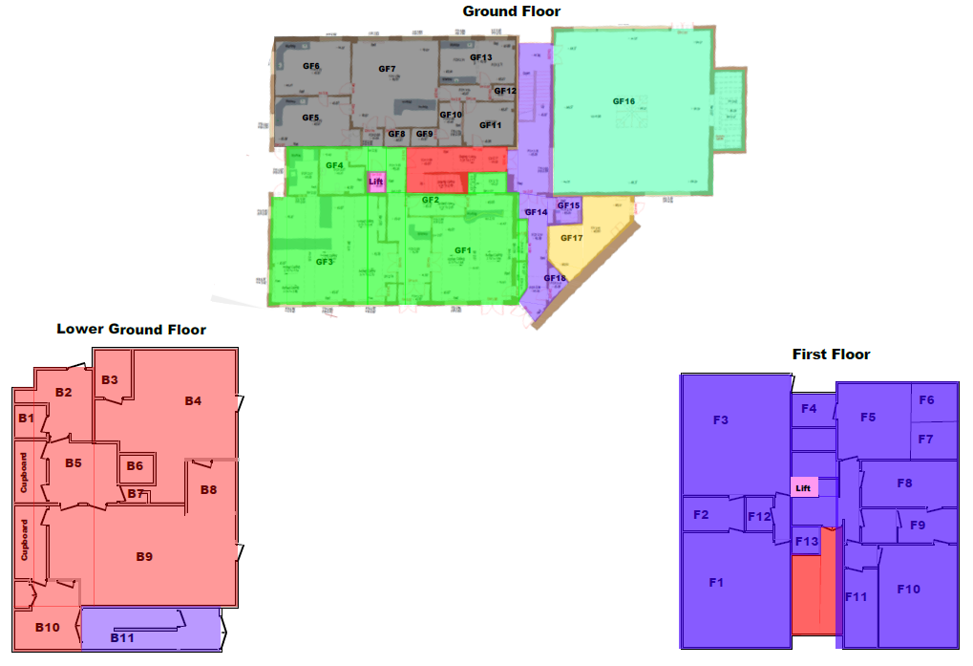

Room/Zone | Specification |  | Total No of Windows
ALL MEASUREMENTS ARE APPROXIMATE – CONTRACTORS MUST VISIT THE SITE TO CONFIRM SIZES
GROUND FLOOR – EXTERNAL WINDOWS
Gul youth and arts café (GF1) | 1 x large window  1727mm by 1727mm  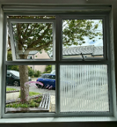 |  | 1 x 1727mm x 1727mm  TOTAL - 1 LARGE WINDOW
Gul Community Café (GF3) | 3 x large windows  1727mm by 1727mm  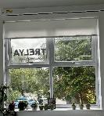 | 1 x Extra Large Window  2387mm by 1727mm  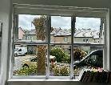 | 3 X 1727mm X 1727mm  1 x 2387mm x 1727mm  TOTAL - 4 LARGE WINDOWS
Kitchen Area (GF3) | 1 x small window - 838mm by 1727mm  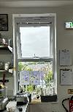 | 1 x small kitchen window with glass top panel and lower vent panel - 1714mm by 825mm  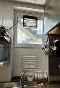 | 1 x 838mm x 1727mm  1 x 1714mm x 825mm  TOTAL - 2 SMALL WINDOWS

Dentist Waiting Room (GF7)  Dentist Clinics (GF5, GF6, GF13) | 5 x large windows (Clinics) - 1727mm by 1727mm  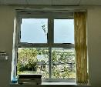 | 2 x Extra Large (Waiting Room) - 2083mm by 1740mm  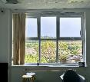 | 5 x 1727mm x 1727mm  2 x 2083mm x 1740mm  TOTAL - 7 LARGE WINDOWS
Stairs to Skylar | Large aluminium window/wall panels  Currently Aluminium  3200mm by 2400mm | 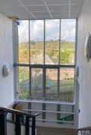 | 1 x 3200mm x 2400mm  TOTAL - 1 LARGE ALUMINIUM WINDOW
Gym (GF16) | 4 x sets of rectangular panel windows  2 x 2200mm x 1100mm (2 x panes each end)  2 x 3300mm x 1100mm (Middle 2 x 3 panes)   | 1 x large high panel windows  Frosted Glass - 4400mm x 1100mm (4 x panes)   | 2 x 2200mm x 1100mm  2 x 3300mm x 1100mm  1 x 4400mm x 1100mm  TOTAL - 5 WINDOWS (4 x rectangular panel windows  1 x sets of large high panel windows)

Lower Gym -  New Installation of windows (not a replacement) (GF16) | 4 x sets of rectangular panel windows  2 x 2200mm by 1100mm (2 x panes each)  2 x 3300mm by 1100mm (3 x panes each)  To match upper windows in gym |  | 2 x 2200mm x 1100mm  2 x 3300mm x 1100mm  TOTAL – 4 WINDOWS

LOWER GROUND FLOOR – EXTERNAL WINDOWS
Lower Ground Floor (B11) | Replacement of Side window panes only:  Top Pane 1092mm by 508mm  Bottom Pane 812mm by 508mm  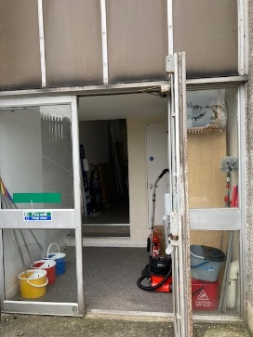 | 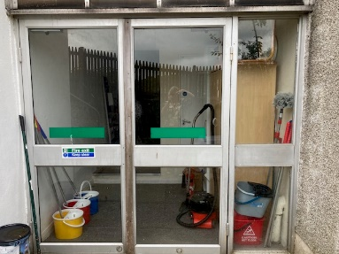 | 1 x 1092mm x 508mm  1 x 812mm x 508mm  TOTAL 2 x panes of glass
Skylar (B3, B4, B8) | 3 x Small window - 812mm by 812mm    1 x rectangular panel window -  863mm by 2032mm  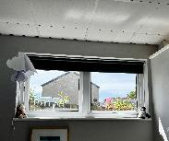 | 2 x large floor to ceiling windows - 1727mm by 2032mm  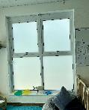  2 x small floor to ceiling windows - 838mm by 2032mm  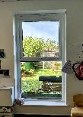 | 3 x 812mm x 812mm  2 x 1727mm x 2032mm  1 x 863mm x 2032mm  2 x 838mm x 2032mm  TOTAL – 5 SMALL WINDOWS  2 X LARGE FLOOR TO CEILING WINDOWS  2 X SMALL FLOOR TO CEILING WINDOWS  1 X RECTANGULAR PANEL WINDOW
Main stairs (F13) | 1 x Large Aluminium window/wall panels  Currently Aluminium  3000mm by 2580mm | 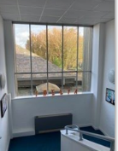 | 1 x 300mm x 2580mm  TOTAL – 1 LARGE ALUMINUM WINDOW

FIRST FLOOR – EXTERNAL WINDOWS ONLY
Gul office (F10) | 2 x large windows  1755mm by 1455mm | 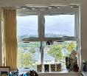 | 2 x 1755mm x 1455mm  TOTAL - 2 LARGE WINDOWS
Executives’ office (F9) | 1 x large window  1755mm by 1455mm | 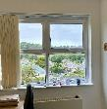 | 1 X 1755mm x 1455mm  TOTAL - 1 LARGE WINDOW
Health & Wellbeing Office (F11) | 1 x small window  838mm by 838mm | 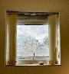 | 1 x 838mm x 838mm  TOTAL - 1 SMALL WINDOW
Youth team office (F8) | 1 x large window  2336mm by 1455mm | 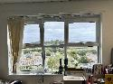 | 1 x 2336mm x 1455mm  TOTAL - 1 LARGE WINDOW
Dentist Staff Room/Office/Kitchen (F5, F6, F7) | 3 x large windows  1727mm by 1422mm | 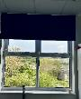 | 3 x 1727mm x 1422mm  TOTAL - 3 LARGE WINDOWS
Multispace kitchen (F4) | 1 x small window  838mm by 1422mm |  | 1 x 838mm x 1422mm  TOTAL - 1 SMALL WINDOW
Multispace (F3) | 1 x small window  812mm by 1422mm  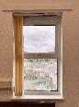  3 x large windows  1727mm by 1422mm  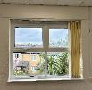 | 1 x Extra Large Window  2337mm by 1422mm  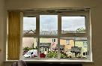  2 x small aluminium windows (See below) | 1 x 812mm x 1422mm  1 x 2337mm x 1422mm  3 x 1727mm x 1422mm  TOTAL – 1 SMALL WINDOW  4 LARGE WINDOWS. 7 WINDOWS IN TOTAL
Conference room – small consulting room (F2) | 1 x large window  1422mm by 1422mm | 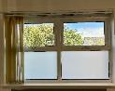 | 1 x 1422mm x 1422  TOTAL - 1 LARGE WINDOW

Conference room (F1) | 2 x large windows  1727mm by 1422mm  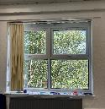 | 1 x small window  838mm x 1422mm   | 2 x 1727mm x 1422mm  1 x 838mm x 1422mm  TOTAL – 2 LARGE WINDOWS AND 1 SMALL WINDOW – 3 IN TOTAL
Dentist Staff Room and Corridor (High Windows) | 2 x small Aluminium windows:  including frame 1500mm by 900mm and infill section 1450 by 850mm  Internal View:  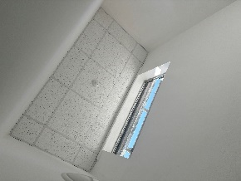 | External View  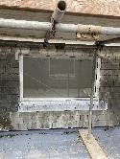 | 2 x 1500mm x 900mm and infill section 1450 x 850mm  TOTAL - 2 SMALL ALUMINIUM WINDOWS
Conference Room and Multispace (High Windows) | 4 x small Aluminium windows:  including frame 1200mm by 900mm / infill section 1150mm by 850mm  Internal View:  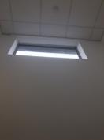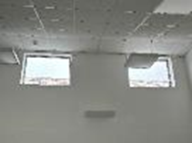 | External View:  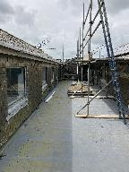 | 4 x 1200mm x 900mm and infill section 1150mm x 850mm  TOTAL - 4 SMALL ALUMINIUM WINDOWS

GROUND FLOOR – INTERNAL WINDOWS – GLASS ONLY – All Sound Proof and Fire Proof.
Reception Office (GF2) Internal Windows  Measurements incl. frames but only replacing glass with sound and fire proof rated glass | 2 x Internal windows:  381mm by 1104mm  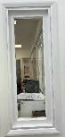 | 3 x Internal Windows:  736mm by 1104mm  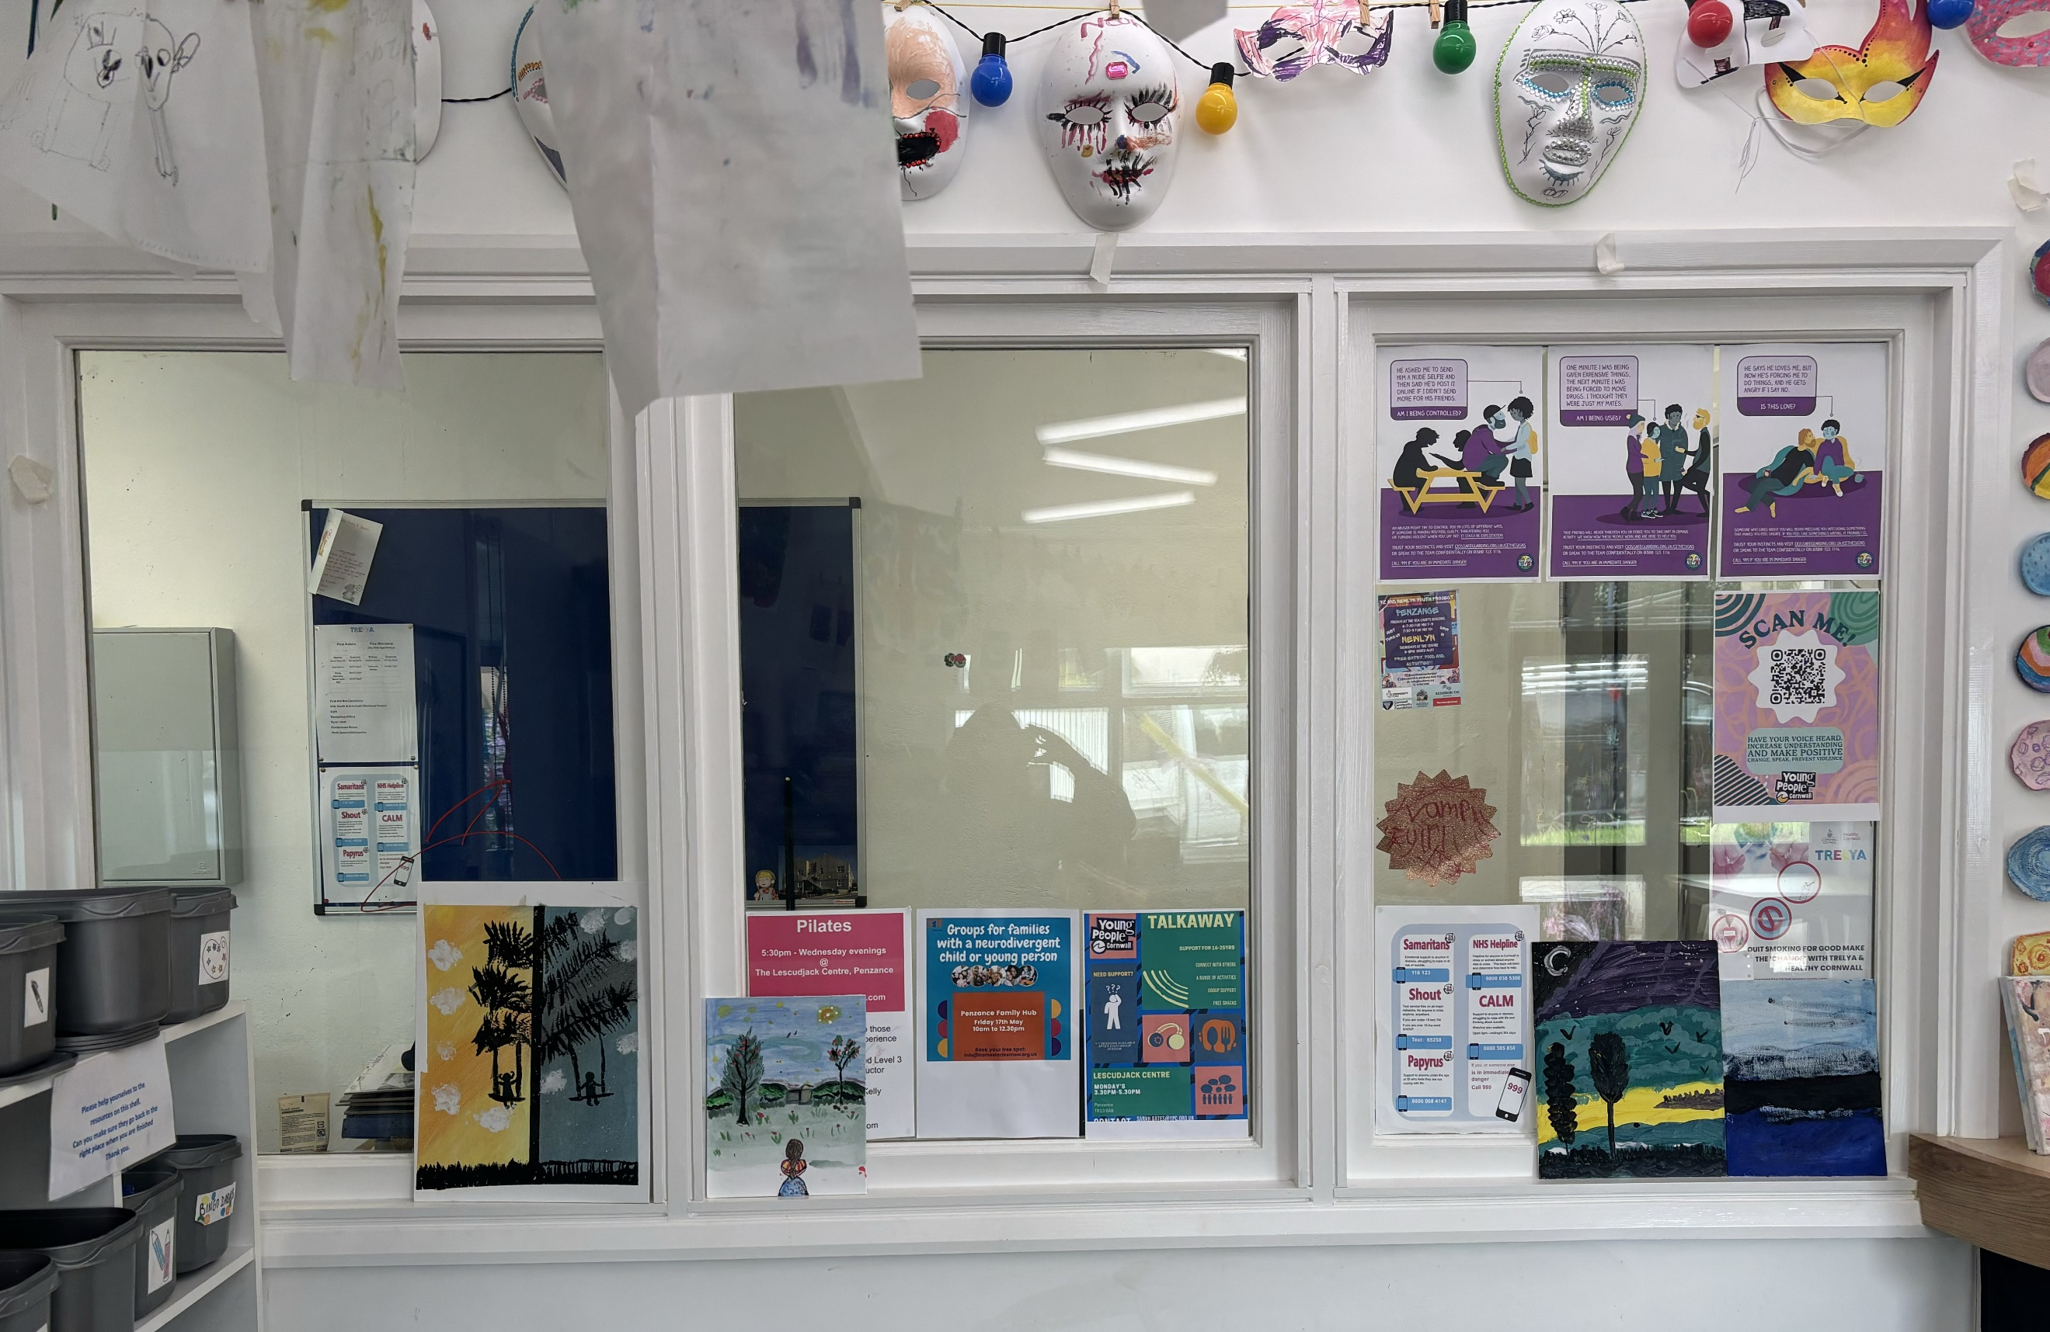 | 2 x 381mm x 1104mm  3 x 736mm x 1104mm  TOTAL – 5 WINDOWS
Glass panels / windows by the side of café door (GF3)  Measurements incl. frames but only replacing glass with sound and fire proof rated glass | 2 x Internal Windows each side of café door  647mm by 1130mm   |  | 2 x 647mm x 1130mm  TOTAL – 2 WINDOWS
Glass panels / windows by the side of rainbow room door (GF1)  Measurements incl. frames but only replacing glass with sound and fire proof rated glass | 2 x internal windows each side of door to rainbow room  647mm by 1130mm  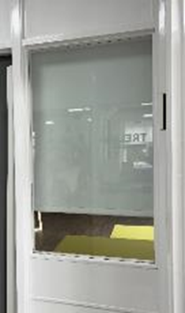 |  | 2 x 647mm x 1130mm  TOTAL – 2 WINDOWS

Internal window between office and rainbow room door (GF1)  Measurements incl. frames but only replacing glass with sound and fire proof rated glass | 1 x internal window next to office behind reception  736mm by 1105mm  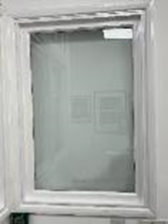 | 1 x 736mm x 1105mm  TOTAL 1 X WINDOW
GROUND FLOOR – INTERNAL WINDOWS – DOUBLE INTERNAL WINDOW CONVERTED INTO ONE SLIDING WINDOW (OPTION 1) or 2 INTERNAL WINDOWS WITH OPENERS (OPTION 2) – All Sound Proof and Fire Proof.
Option 1 - Internal window to made into sliding (GF2) | 2 x Internal Windows made into one sliding window (each window  736mm by 1104mm) or total size estimate with frame 158cm by 114cm.  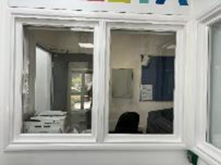  The sliding window will be opened from inside the office and be sound proofed, fire proof (so can be sealed) and lockable. | 2 x 736mm x 1104mm windows made into one large sliding window.  Tenderer to provide a specification for the sliding window within their return
Option 2 -  Internal window with top openings (GF2)  Measurements incl. frames but only replacing glass with sound and fire proof rated glass | 2 x Internal Windows with top opening/s (each window  736mm by 1104mm)  **Will decide on Option 1 or 2 when quotation received** | 2 x 736mm x 1104mm windows
TOTAL
26 x large windows (incl. extra-large)
11 x small windows
6 x small aluminium (high)
2 x large aluminium window/wall panels (hallways)
4 x sets of rectangular panel windows (2 x 2 panes + 2 x 3 panes) high up at top of wall (gym)
4 x sets of rectangular panel windows high up at top of wall (lower gym) – Currently no windows here
1 x set of large high panel windows (gym)
2 x large floor to ceiling windows (Skylar)
2 x small floor to ceiling windows (Skylar)
1 x rectangular panel window (Skylar)
2 x windows panes (Lower Ground Floor – Fire Exit)
10 x Internal Windows requiring Fire Rated glass panes only
1 x sliding windows / or 2 x internal windows with openings

The following must be considered / included within the price:

- The site is an active community building visited by the general public with a dentist, NHS Mental Health Hub, café and children’s nursery. There are services running from 8am to 8pm most days Monday to Friday. This means that contractors will need to be mindful of the buildings users and will have to work around the room availability whilst installing windows, to ensure no disruption or impact on the users, which could include out of office hours.
- The contractor must employ all necessary protective measures to ensure that no damage whatsoever occurs whilst building operations are in progress. If sills, reveals or heads are damaged they should be made good / repaired to a like for like standard as found.
- The surrounding area is a residential area and there is restricted parking with peak times as parents pick up children. The contractor will be limited to one vehicle in the carpark. Other vehicles will have to park elsewhere which may not be adjacent to the site.
- The contractor is to execute his works and arrange for deliveries to and removals from the site so as to comply with the requirements and cause the minimum of inconvenience to neighbours and general public.
- All deliveries and unloading of all the materials shall be undertaken in consideration of the users of the building.
- Trelya, immediate neighbours and residents of the area should be notified in advance of any intense days of traffic movements, in liaison with Trelya staff.
- Any damage to the road-side verges, footways, and highways must be avoided and if any occurs shall be reinstated promptly.
- At no time shall mud, other materials and excess water be spread on the road.
- The contractor will be required to undertake site visits to establish the location of existing mains and services, necessary to complete the works. It is the contractor’s responsibility to ascertain the precise location of and safeguard from damage during the works any existing services, etc., which exist within the work area and pay all costs to the appropriate body in respect of any damage caused.
- The Contractor will be responsible for the design of all temporary works, temporary terminations, permanent terminations, re-routing of services and re-connections in all phases where necessary.
- SITE VISIT: We would expect the contractor to visit the site prior to quoting to ensure that all measurements of windows are correct.
- Before tendering, ascertain the nature of the site, the type and extent of the works, access thereto and all local conditions and restrictions likely to affect the execution of the Works.
- The Contractor shall be deemed to have visited the site before tendering and to have satisfied himself as to the means of communication, access to the site, the extent and nature of the work and the site, the conditions under which work will be carried out, conditions affecting the supply of labour and materials, and any matters which may affect his tender as no claims on the grounds of lack of knowledge in this respect will be entertained.
- Appointments for visiting the site are to be made with Deb Parker on 07752 446533/ procurement@trelya.com.

Welfare facilities
Welfare facilities are provided by Trelya on site within the Lescudjack Centre such as access to toilets and washing facilities.

Waste Disposal
It is the responsibility of contractor to dispose of all waste materials. Therefore, all waste, rubbish or litter arising from the installation shall be removed as it accumulates and disposed of by the Contractor.

The Service and Works
The service and works required are outlined in the specification above. The tenderer must provide details of how the works will be delivered with the level of quality standards applied.
The tenderer is requested to submit a tender for providing all the services, together with an individual breakdown for each of the elements, providing a detailed “Schedule of Costs”.
Once appointed, the Contractor will be responsible for ordering the correct equipment and materials based on the agreed design and “Schedule of Costs”.
The Contractor shall not sub-contract the works or any part thereof without the written consent of Trelya, which shall not be unreasonable withheld. The Contractor shall at all reasonable times keep a competent person in charge and any instructions given by officers of Trelya shall be deemed as having been issued to the Contractor.
Performance Monitoring
The service will be provided in accordance with the specification for the contract, supplied separately and also in accordance with the relevant terms and conditions.
Any inconsistency in or between the contract specification shall be corrected.
Key Responsibilities of Contractor:
- Oversee the project: including installation, monitoring, control and delivery. This will include some of the works being undertaken outside of office hours;
- Compile a plan identifying the timeline: from contract commencement to completion of installation and sign off;
- Identify impact on services when undertaking the work identify the impact on users of the building.
- Protection of work areas: allow for protection of all work areas.
- Access: allow for access of any equipment needed to complete the works, including scaffolding towers and cherry pickers.
- Risk Assessments: Prepare documentation including risk assessments, health and safety and evidence of relevant insurances prior to commencing the works.
- Safeguarding: Due to the people who use the centre, safeguarding is a key consideration in the delivery of this work. Please provide details, if any, of your contractors’ levels of DBS check (including the number, whether you are registered with the DBS update service, full name of those that are and DoB).
- Damage to Property: Any repairs or cost of repairs, including making good sills, reveals, heads and decoration, caused by damage to the property during the works shall be made good to the satisfaction of Trelya at the Contractor’s expense.
- Ordering equipment: Once appointed, the Contractor will be responsible for ordering the correct equipment and materials based on the agreed design and price.
- Sub-contracting: The Contractor shall not sub-contract the works or any part thereof without the written consent of Trelya, which shall not be unreasonable withheld.

Timetable for Tender Process / Project Delivery
Tenders should be returned by 16th August 2024. We are looking for this work to be completed as soon as possible. Please provide details of how long the work will take to complete.
 | Date
Issue ITT | 19th July 2024
Deadline for viewing by appointment only contact Deb Parker: t. 07752446533 / procurement@trelya.com | 12 noon Friday 2nd August 2024
Deadline for questions regarding the tender which should be received by email to Alison Elvey, (procurement@trelya.com) | Friday 9th August 2024
Tender Submission Deadline | Midnight Friday 16th August 2024
ITT validity period | 90 days from closing date
Estimated Award of Contract | late August 2024
Anticipated Contract Commencement Date | September 2024
Anticipated Completion of works | 30th November 2024
Payment Terms | Payment to the Contractor will be within 30 days of receipt of invoice subject to agreement of the account by Trelya’s Finance and Administration Director. Please identify in your tender if you require a deposit which would be subject to agreement. Trelya will hold a 1.5% retention for 6 months.

Part B

STANDARD TENDER SUBMISSION DOCUMENTS

To Supply and Install Windows at the Lescudjack Centre - 004

Issue Date: 19th July 2024
Deadline for receipt of tenders: Midnight 16th August 2024

(TO BE RETURNED)
Insert name of Tenderer:

Overview of the ITT Evaluation Process

The ITT sets out the procedural requirements with which the Tenderers must comply when making a Tender Submission.

The process has been structured in the way that it has in order to:
- Assist Trelya in identifying the Tenderers which will be most advantageous having regard to Trelya’s stated requirements and objectives;
- Make clear the requirements with which Tenderers must comply and the basis on which the Tenderers will be evaluated;
- Ensure compliance with the Project Funders requirements; and
- Maintain competition throughout.

If a Tenderer does not comply with any of the requirements contained in this ITT and this section Standard Tender Submission Documents, Trelya may (in its sole discretion) disqualify the Tenderer. It is the responsibility of each Tenderer to ensure that they have all the information they need to prepare their quotation.

Trelya will be publishing the ITT on contracts finder and Trelya.com to seek at least three written tenders for the items listed above and will choose the supplier based on the evaluation model below.

Evaluation Model

The evaluation model below shall be used for this ITT, which will be determined to two decimal places.

Pass/Fail Criteria
Failure of any one of the pass/fail questions listed below will mean automatic disqualification from this quotation process.
Compliance to Scope of Works | Pass / fail
ITT response received on time  ITT response in the correct format  Section 2 - Acceptable financial profile  Section 4 - Technical and Professional Ability & Examples of contracts undertaken in past 3 years  Section 5.1 - Insurance levels acceptable  Section 5.3 - Acceptable Health and Safety Compliance  Section 5.4 – Social Value Policy  Section 5.5 - Real Living Wage  Section 5.6 - Environmental Sustainability Policy & Waste Management Policy  Section 5.7 – Equal Opportunities Policy  Part 4: Pricing Schedule  Part 5: Anti-Collusion  Part 6: Confidentiality Undertaking  Part 7: Freedom of Information Act | Pass / fail  Pass / fail  Pass / fail  Pass / fail  Pass / fail  Pass / fail  Pass / fail  Pass / fail  Pass / fail  Pass / fail  Pass / fail  Pass / fail  Pass / fail  Pass / fail

Scoring Criteria (out of 100% rounded to two decimal places)
Pricing | 65%
Quality of Equipment proposed | 10%
Social Value Policy | 5%
Delivery /Project management / Timing of Supply | 5%
After sales service/fault rectification (inc. Warranties & Guarantees) | 10%
Health & Safety on site | 5%
Total | 100%

Evaluation Criteria
Non-Price elements will be judged on a score from 0 to 10, which shall be subjected to a multiplier so criteria worth 20% will have a 0-10 score and a multiplier of 2. The 0-10 score shall be based on:

0-1 The Question is not answered, or the response is completely unacceptable. It does not meet the minimum requirement, or they have completely missed the point of the question
2-3 Very poor response and not acceptable – fails to meet the minimum requirement/standard. Requires major revision to the proposal to make it acceptable. Only partially answers the requirement, with major deficiencies and little relevant detail proposed.
4-5 Poor response only partially satisfying requirement/standard with deficiencies apparent. Some useful evidence provided but response falls well short of minimum requirements. Low probability of success, sufficient obstacles but correctable.
6-7 Response is acceptable and meets minimum requirement but remains basic and could have been expanded upon. Response is sufficient but does not inspire. Good probability of success, weaknesses can be readily corrected.
8-9 Response meets our expected requirement/standard and exceeds minimum expectations including as level of detail, which adds value to the bid. Great probability of success, no significant weaknesses noted.
10 – Excellent response – comprehensive and useful, which exceeds the specified performance or capability in a beneficial way. High probability of success, no weaknesses noted. The response is innovative and includes a full description of techniques and measurements to be employed.

Standard Selection Questionnaire
When completed, this form is to be sent back to the contact point given in the procurement documents along with the selection information requested in the procurement documentation.

If the relevant documentary evidence referred to in the Selection Questionnaire is not provided upon request and without delay, we reserve the right to amend the contract award decision and award to the next compliant bidder.

Consequences of misrepresentation
If you seriously misrepresent any factual information in filling in the Selection Questionnaire, and so induce Trelya to enter into a contract, there may be significant consequences. You may be excluded from the procurement procedure, and from bidding for other contracts for three years. If a contract has been entered into you may be sued for damages and the contract may be rescinded. If fraud, or fraudulent intent, can be proved, you or your responsible officers may be prosecuted and convicted of the offence of fraud by false representation, and you must be excluded from further procurements for five years.

Contents
Part 1: Potential supplier information 19
Part 2: Selection Questions 22
Part 3: Method Statements 25
Part 4: Pricing Schedule 28
Part 5: Anti-Collusion Certificate 29
Part 6: Confidentiality Undertaking 30
Part 7: Freedom of Information Act 2000 (FOI) Exemption Form 32
Part 8: Form of Tender 34
Part 9: Checklist 36

Part 1: Potential supplier information

Please answer the following questions in full.
Section 1 | Applicant Information
Question number | Question | Response
1.1(a) | Full name of potential supplier submitting the information
1.1(b) | Registered office address (if applicable)
1.1(c) | Registered website address (if applicable)
1.1(d) | Trading status  - Public Limited Company  - Limited Company  - Limited Liability Partnership  - Other Partnership  - Sole Trader  - Third Sector  Please specify your trading status
1.1(e) | Date of Registration
1.1(f) | Company registration number (if applicable)
1.1(g) | Charity registration number (if applicable)
1.1(h) | Head Office DUNS number
1.1(i) | Registered VAT number
1.1(j) | If applicable, is your organisation registered with the appropriate professional or trade organisation. If yes, please provide relevant details, including any registration number.  For example: Certass, Trustmark Registered Business, FENSA Approved Windows Installer
1.1(k) | Trading name that will be used if the tender is successful.
1.1(l) | Details of Persons of Significant Control (PSC), where appropriate:  - Name  - Date of Birth  - Nationality  - Which conditions are met for being a PSC in relation to the company;  - Over 25% up to (and including) 50%,  - More than 50% and less than 75%  - 75% or more.  (Please enter N/A if not applicable)
1.1(m) | Details of immediate parent company  - Full name of intermediate parent company  - Registered office address (if applicable)  - Registration number (if applicable)  - Head office DUNS number (if applicable)  - Head office VAT number (if applicable)  (Please enter N/A if not applicable)

Please provide the following information about your approach to this procurement
Section 1 | Bidding model
Question number | Question | Response
1.2(a) | Are you bidding as the lead contact for a group of economic operators
1.2(b) | Name of group of economic operators (if applicable)
1.2(c) | Proposed legal structure if the group of economic operators intends to form a named single entity prior to signing a contract, if awarded. If you do not propose to form a single legal entity, please explain the legal structure.
1.2(d) | Are you proposing to use sub-Contractors
If you answered yes to 1.2(d), please provide additional details for each sub-Contractor
Name
Registered address
Trading status
Company Registration number
Head Office DUNS number (if applicable)
Registered VAT number
Type of Organisation
The role each sub-Contractor will take in providing the works and/or supplies e.g. key deliverables
The approximate % of contractual obligations assigned to each sub-Contractor

Contact details and declaration
I declare that to the best of my knowledge the answers submitted, and information contained in this document are correct and accurate.
I declare that, upon request and without delay I will provide the certificates or documentary evidence referred to in this document.
I understand that the information will be used in the selection process to assess my organisation’s suitability to be invited to participate further in this procurement.
I understand that Trelya may reject this submission in its entirety if there is a failure to answer all the relevant questions fully, or if false/misleading information or content is provided in any section.
I am aware of the consequences of serious misrepresentation.
Section 1 | Contact details and declaration
Question number | Question | Response
1.3(a) | Contact name
1.3(b) | Name of organisation
1.3(c) | Role in organisation
1.3(d) | Phone number
1.3(e) | E-mail address
1.3(f) | Postal address
1.3(g) | Signature (electronic is acceptable)
1.3(h) | Date

Part 2: Selection Questions
Accounts and Financial Statements
Section 2 | Economic and Financial Standing
Question number | Question | Response
2.1 | Please provide a copy of your accounts for the last 3 years? If you can’t please provide one of the following?
2.1 | (a) A statement of turnover, Profit and Loss Account/Income Statement, Balance Sheet/Statement of Financial Position and Statement of Cashflow for the most recent year of trading for this organisation
2.1 | (b) A statement of the cashflow forecast for the current year and a bank letter outlining the current cash and credit position.
2.1 | (c) Alternative means of demonstrating financial status if any of the above is not available (e.g. forecast of turnover for the current year and a statement of funding provided by the owners and/or the bank, charity accruals accounts or an alternative means of demonstrating financial status).

Section 3 | If you are part of a wider group, please provide further details below
Name of organisation
Relationship to the supplier completing these questions
 | Are you able to provide parent company accounts if requested at a later stage? |  | Y / N
 | If yes, would the parent company be willing to provide a guarantee if necessary? |  | Y / N
 | If no, would you be able to obtain a guarantee elsewhere (e.g. from a bank)? |  | Y / N

Section 4 | Technical and Professional Ability
4.1 | Relevant experience and contract examples  Please provide details of 3 contracts, in any combination from either the public or private sector, voluntary, charity or social enterprise that are relevant. Contracts for supplies or services should have been performed during the past 3 years.  The named contract provided should be able to provide written evidence to confirm the accuracy of the information provided below.  Consortia bids should provide relevant examples of where the consortium has delivered similar requirements. If this is not possible, then 3 separate examples should be provided between the principal members of the proposed consortium.

 |  | Contract 1 | Contract 2 | Contract 3
- Name of Organisation
- Name of point of contact in customer organisation
- Position of above in customer organisation
- E mail address
- Start date
- Completion date
- Contract value
4.2 | Where you intend to sub-contract a proportion of the contract, please demonstrate below how you previously maintained a healthy supply chain with your sub-Contractor(s).
 | Supply Chain Management:

Additional Questions
Suppliers who self-certify that they meet the requirements to these additional questions will be required to provide evidence of this if they are successful at the contract award stage.
Section 5 | Additional Questions
5.1 | Insurance
Please confirm whether you already have, or can commit to obtain, prior to the commencement of the contract, the levels of insurance cover indicated below:

- Employers Liability Insurance £10m | Y / N
- Public Liability Insurance £5m | Y / N
- Products Liability £5m | Y / N
- Professional Indemnity £2m | Y / N

5.2 | Accreditation
 | Please list any relevant accredited memberships related to the project (add in relevant accreditations for project) that you already have, or can commit to having, prior to commencement of the project.
5.3 | Health & Safety
Please certify that your organisation has a Health & Safety Policy that complies with current legislative requirements.
Has your organisation or any of its Directors or Executive Officers been in receipt of enforcement/remedial orders in relation to the Health & Safety Executive in the last 3 years?
Please include your Health & Safety plan for the onsite works.
5.4 | Social Value
 | In line with our funders requirements (Cornwall Council’s Social Value Policy - http://tinyurl.com/33xdz28v), Trelya’s Procurement Policy and Trelya’s Environmental Policy we aim to maximise economic, social and / or environmental benefits in how we buy goods, works or services. This includes maximizing the added benefits that can be achieved to the local economy through our suppliers. Please demonstrate how you will fulfil this requirement.
5.5 | Real Living Wage
 | The funders of this project, and Trelya, are committed to paying the UK Real Living Wage as determined and amended from time to time by the Living Wage Foundation. Please provide a copy of your Real Living Wage Policy.
5.6 | Environmental Sustainability Policy / Waste Management Policy
 | The funders of this project, and Trelya, promote responsibility for the environment. Please provide a copy of your Environmental Sustainability Policy and Action Plan (how your policy will be implemented). Please also supply a copy of your Waste Management Policy.
5.7 | Equal Opportunities Policy
 | Trelya will not tolerate unlawful discrimination, harassment and victimisation that is prohibited by the Equality Act 2010 from its contractors. Please provide a copy of your Equal Opportunities Policy.
5.8 | Parent Company Guarantee and Undertaking
 | If applicable, Tenderers are required to indicate for the purpose of their Tender, their willingness to provide a Parent Company Guarantee in the form set out in Part 8.
5.9 | Project specific requirements: Experience of delivering similar requirements
With reference to the contracts detailed in section 4 (Technical and Professional Ability), please describe how these contracts demonstrate your prior experience of delivering similar requirements to those of Trelya.

If you are not able to provide a response, please clarify and describe below how you believe your organisation can meet the requirements of the specification.

(Word limit 500)

Part 3: Method Statements
Tenderers are required to submit a complete set of the Method Statements.
Tenderers are reminded that the Successful Tenderer’s Method Statements will be incorporated into the Contract and will become contractually binding on both parties. The Method Statements should therefore be written in a manner that allows them to be incorporated into the Contract and should not contain information which is not intended to be or is not contractual.
Tenderers should note that:
- Each Method Statement should be clearly labelled indicating the title and number of each Method Statement at the top of each page;
- The Method Statements should not include non-contractual text;
- Responses should be accurate and as succinct as possible, whilst covering all the specified topics.
- Where questions contain a word limit it must be adhered to.
- You may include appendices to your Method Statements provided that you follow the following guidelines:
  - Appendices must be kept to a minimum and must be relevant and proportionate to the Method Statement in question.
  - Appendices must be limited to diagrams, flow charts, illustrations and relevant policy documents only.
Therefore, Tenderers should ensure that all relevant information is included in the Method Statement itself.
- If you wish to cross reference from one Method Statement to the other, you may do so provided that you follow the following guidelines:
  - Keep cross referencing to a minimum and only include if the material would be duplicated otherwise. If you have sufficient word count, please repeat the information.
  - If cross referencing, you must include an explicit cross reference by way of: paragraph number, page number AND method statement number and title.
Evaluators will only evaluate the sections being cross referenced. Please note that if the cross reference is not explicit and the evaluators are unable to identify the section being cross referred to then they will not evaluate it.
The Method Statements required are as follows:
Criteria | Sub-Criteria | Question | Weighting
- Quality of equipment that you are proposing. |  |  | 10%
The number of windows and estimated sizes have been specified in detail above. All windows should meet the current relevant standard listed here, https://www.bsigroup.com/en-IL/Our-services/Product-certification/Industry-sector-schemes/Construction/Windows-and-doors-testing-certification-and-installation-services/Standards-for-windows-and-doors-/ and comply with current commercial buildings regulations (including but not exclusively Fire Safety, Ventilation, Energy efficiency, sound insulation)
Your response should include but not be limited to the following (Product specifications will not be included in the word count):
- The specification of windows to be provided
- The terms of the warranties for all the windows (also see below)
- The relevant standard for the windows listed
(Maximum 1000 Words)
Response:

Criteria | Sub-Criteria | Question | Weighting
- Social Value Policy. |  |  | 5%
This includes maximizing the added benefits that can be achieved to the local economy through our suppliers. Please demonstrate how you will fulfil this requirement. (Cornwall Council’s Social Value Policy - http://tinyurl.com/33xdz28v)

Given the location please identify how you support the local supply chain.

(Maximum 1000 Words)
Response:

Criteria | Sub-Criteria | Question | Weighting
- Delivery /Project management / Timing of Supply |  |  | 5%
Please explain how you will deliver the equipment and the installation programme including timescales.

Please specify if you are able to work weekends or after hours in case this is necessary to complete the project.

Provide details of your team and key personnel. Include CVs as necessary (e.g. Project Manager)

A project plan must be provided, detailing activities and resourcing.

(Maximum 1000 Words) Excluding Project Plan
Response:

Criteria | Sub-Criteria | Question | Weighting
- After sales service/fault rectification (inc. Warranties & Guarantees) |  |  | 10%
A key part of our value criteria is to obtain a sustainable (installation) both economically and environmentally in order to fulfil “whole life” criteria where aftercare processes support a long-term relationship with Trelya.

Given the location of the project please explain how you will fulfil aftercare service and provide examples (including contact details) where you have provided this.

Please explain how you will ensure clear communication with Trelya officers throughout the programme of work.

Please provide detail of warranties & Guarantees of the equipment proposed and detail what these offer including length of time etc what includes labour / parts and details of your after sales service/fault rectification.

It is expected that warranties will be for at least 12 years.

(Maximum 1000 Words)
Response:

Criteria | Sub-Criteria | Question | Weighting
- Health & Safety on site |  |  | 5%
Please explain how you will ensure site safety at all times and list your relevant certificate for the work.

(Maximum 1000 Words)
Response:

Part 4: Pricing Schedule
Tenderers are obliged to submit their pricing here including the total price and an itemised breakdown for the goods/services/works as detailed below.
Your Tender may be rejected if:
- you fail to fully complete the Pricing Schedule; and/or
- you submit an alternative Pricing Schedule.
- If you intend to offer an element of the goods, services or works free of charge then you must enter the number ‘0’ in the relevant cell of the pricing table.

Description | Price (excl VAT)
26 x large windows (incl. extra-large)  11 x small windows  6 x small aluminium (high)  2 x large aluminium window/wall panels (hallways)  4 x sets of rectangular panel windows (2 x 2 panes + 2 x 3 panes) high up at top of wall (gym)  4 x sets of rectangular panel windows high up at top of wall (lower gym) – Currently no windows here  1 x set of large high panel windows (gym)  2 x large floor to ceiling windows (Skylar)  2 x small floor to ceiling windows (Skylar)  1 x rectangular panel window (Skylar)  2 x windows panes (Lower Ground Floor – Fire Exit)  12 x Internal Windows requiring Fire Rated glass panes only  1 x sliding windows / or 2 x internal windows with openings | £
Total Contract cost

(exclusive of VAT)
VAT
For information purposes only, please provide costs for an annual inspections and maintenance

A fully itemised schedule of project costs is required showing clearly the individual elements of each item.
The prices quoted in the Tenderer’s Bid shall remain fixed throughout the term of the Contract except as may be varied in accordance with the terms of the Contract.
I offer to supply the goods and/or services listed in the pricing schedule in compliance with the specification and all other documents forming the contract and at the fixed price above.
*Signed: Date:
Name: (in block capitals):
In the capacity of:
(State official position, i.e. Director, Manager, Secretary etc.)
on behalf of:

Part 5: Anti-Collusion Certificate

To: Trelya
Anti-Collusion Certificate
The essence of the public procurement process is that Trelya shall receive bona fide competitive Tenders from all Tenderers. In recognition of this principle, we hereby certify that this is a bona fide Tender, intended to be competitive, and that we have not fixed or adjusted the amount of the Tender or the rates or prices quoted by or under or in accordance with any agreement or arrangement with any other Tenderer. We have not (as defined in the Invitation to Tender):
1. Entered into any agreement with any other person with the aim of preventing Tender being made or as to the fixing or adjusting of the amount of any Tender or the conditions on which any Tender are made; or
2. Informed any other person, other than the person calling for these Tender, of the amount or the approximate amount of the Tender, except where the disclosure, in confidence, of the amount of the Tender was necessary to obtain quotations necessary for the preparation of the Tender for insurance, for contract guarantee bonds or for professional advice required for the preparation of the Tender; or
3. Caused or induced any person to enter into such an agreement as is mentioned in paragraph 1 and 2 above or to inform us of the amount or the approximate amount of any rival Tender for the Contract; or
4. Committed any offence under the Bribery Act 2010 nor under Section 117 of the Local Government Act 1972; or
5. Offered or agreed to pay or give any sum of money, inducement or valuable consideration directly or indirectly to any person for doing or having done or causing or having caused to be done in relation to any other Tender or proposed Tender for the Services any act or omission; or
6. Canvassed any other persons referred to in paragraph 1 above in connection with the Contract; or
7. Contacted any officer of Trelya about any aspect of the Contract other than permitted as part of the procurement exercise for the purposes of, including (but without limitation), discussing the possible transfer to the employment of the Tenderer of such officer or for soliciting information in connection with the Contract.
We also undertake that we shall not procure the doing of any of the acts mentioned in paragraphs 1 to 7 above before the hour and date specified for the return of the Tender nor (in the event of our Final Tender being accepted) shall we do so while the resulting Contract continues in force between us (or our successors in title) and Trelya.
In this certificate the word "person" includes any person, body or association, corporate or incorporate and "agreement" includes any arrangement whether formal or informal and whether legally binding or not.
Signed: | Signed:
For and on behalf of: | For and on behalf of:
Dated: | Dated:

Part 6: Confidentiality Undertaking

To: Trelya
From: (“Tenderer”)
(“the Project”) To Supply and Install Windows at the Lescudjack Centre - 004
WHEREAS:
A. Trelya is conducting a major tendering process for the procurement of the Project.
B. Trelya intend to circulate certain documents and information relating to the Project (“the Tender Documents”) to the Tenderer.
C. The Tender Documents contain certain confidential information to which the Tenderer may have access, (“the Confidential Information”), which is more particularly described in the Schedule hereto and includes all other documents made available now and in the future to the Tenderer and identified as confidential.
D. Trelya gives to the Tenderer the Confidential Information in order for the Tenderer to submit a Tender subject to this undertaking.
1. We, the Tenderer, undertake to Trelya in consideration of the sum of one pound sterling (£1) (the receipt of which is hereby acknowledged) that:
a) We will hold the Confidential Information in the strictest confidence;
b) We will use the Confidential Information only for the purpose of preparing Tender and Final Tender (if applicable);
c) We will not disclose the Confidential Information to any third party (including without limitation to any agent, professional adviser or associated company) or to any employee other than third parties or employees who need to have access to prepare the Tender and Final Tender (if applicable);
d) In relation to those third parties or employees who are given access to this Confidential Information, we will ensure that they keep the Confidential Information confidential and are bound by personal undertaking to Trelya in the same terms;
e) We will not copy or reproduce the Confidential Information in any way; and
f) We will not directly or indirectly use the Confidential Information for any reason or divulge it without Trelya’s prior written consent to any person, firm, company or other organisation save where we can show that the Confidential Information, (or the relevant part thereof), has already come into the public domain or we are required to disclose the Confidential Information, (or relevant part thereof), by law.
2. We agree that any breach of this undertaking by us or any third party or employee to whom We release Confidential Information may result in legal proceedings being commenced against us, including a claim for the recovery of any losses or damages incurred by Trelya as a result of that breach. We shall in this respect be liable for and shall fully indemnify and keep indemnified Trelya against all liabilities, damages, costs, losses, claims, demands and proceedings arising from or in connection with any breach of this undertaking, however arising, by us or any third party or employee to whom we release Confidential Information.
3. We agree that this undertaking shall be subject to English Law and we hereby agree to submit to the exclusive jurisdiction of the English Courts.

Dated:

LIMITED COMPANY
Signature
Printed Name
Signing Capacity
Name of Company
Registered Office Address

PARTNERSHIP
Signature of Partners in firm
Printed Names
Name of Firm
Address

SCHEDULE TO THE CONFIDENTIALITY UNDERTAKING
Confidential Information shall include but not be limited to:-
1. The documents for the Contract including without limitation the ITT and appendices, the Contract and its Schedules, the Specification, any amendments or revisions to the tender documents, the Workforce Information, and all other documentation issued by Trelya relating to the bid process ("the Tender Documents").
2. Details of any discussions with Trelya, its officers or advisers in connection with the Tender Documents and any information that may be obtained by us through observation at meetings, conferences, presentations and demonstrations or as Trelya, its officers or advisers may provide to us whether orally or in writing, electronically, physical or visual form regarding the bid process or the clarifications or proposals for the Contract.

Part 7: Freedom of Information Act 2000 (FOI) Exemption Form

Guidance
Trelya encourages its Tenderers to take their own legal advice about the FoI Act. Trelya shall not be held liable for any actions claims or costs howsoever arising.
Trelya considers that the following information is likely to be captured by the “confidential” (s.41 absolute exemption) and/or “commercial interest” (s43 qualified exemption) and therefore maybe subject to the Public Interest test:
- Trade secrets; or
- Financial, commercial, scientific, technical or other information whose disclosure could reasonably be expected to result in a material financial loss or gain to the person to whom the information relates; or
- Where disclosure could prejudice the competitive position of that person in the conduct of his/her profession or business or otherwise in his/her occupation; or
- Where disclosure could prejudice the conduct or outcome of contractual or other negotiations of the person to whom the information relates.
NB: Tenderers should note that claiming blanket confidentiality of quotation documentation, breaches current Government guidelines provided to Trelya and will not be accepted, therefore rendering the entire quotation documentation disclosable under the FoI Act.
Procedure
1. Please specify below the relevant clauses or documentation containing the information you claim is exempt.
We consider that pricing schedules and technical specifications are most likely to be covered by one or other of the above exemptions and would therefore not, normally, be disclosed.
Each document claimed under the exemptions should be clearly marked as “confidential” or “commercially sensitive”.
Please confirm below the documents considered confidential:
Confidential Information:
Pricing Schedule

Commercially Sensitive Information:
Pricing Schedule

2. Trelya is obliged to consider whether something, which its Tenderer claims is confidential, is truly confidential. In those instances where Trelya does not agree with the exemption claimed, it will always consult with the Tenderer before disclosing the information.
Where Trelya decides to release such information, it will only do so in the following circumstances:
- Where the Tenderer consents; or
- Where the information or information of a similar type is generally available to the public (e.g. where a Minister would give such information in answer to a Parliamentary Question);or
- Where the Tenderer has been advised, at the time that the information is received, that the information will be released; or
- Where Trelya believes that the public interest would be better served by disclosing rather than by refusing to disclose the information. In this instance, the views of the Tenderer will be sought in advance of a decision being made. Where the Tenderer refuses to agree to disclosure of the information, the Tenderer is able to refer the matter to the Information Commissioner at the Tenderer’s expense.

Signed | Position
Print Name | Date

Part 8: Form of Tender

Please note, in line with our grant funding requirements, this form must be provided on supplier letterhead detailing supplier name, address and contact details.

TENDER FOR: To Supply and Install Windows at the Lescudjack Centre - 004.
TENDER RETURN DATE 12 Midnight 16th August 2024
TO: Trelya, The Lescudjack Centre, Penmere Close, Penzance, TR18 3PE

Sirs
We do hereby undertake to supply the Goods, Services and Works required to be done in accordance with the information provided in the Invitation to Tender the fixed price sum of: (in words)
Pounds
(£.00) excluding VAT
This offer will remain open for acceptance for 90 calendar days from the date of this Quotation.
We confirm that we can start work within x calendar days of acceptance of the Tender.
We are willing to enter into a Contract as set out in the standard Terms and Conditions attached to this Invitation to tender to Goods, Services and Works within the time stated which will include all matters noted in the information provided.
In submitting this Tender, we understand that Trelya does not bind itself to accept the lowest or any Tender nor to remunerate any expenses in providing the Tender.
Tenders will only be accepted on this Form of Tender and must be returned to Trelya no later than the time and date specified above.
Tenders with all relevant paperwork should be submitted in a sealed envelope for the attention of the Alison Elvey, Finance & Administration Director, labelled ‘To Supply and Install Windows at the Lescudjack Centre - 004’ and addressed to Trelya, The Lescudjack Centre, Penmere Close, Penzance , TR18 3PE OR emailed labelled ‘To Supply and Install Windows at the Lescudjack Centre - 004’ to procurement@trelya.com.
Yours faithfully

Signature of Supplier:
Date:
Print Name:
Official Position:
Organisation Name:
Address:

Telephone No./Email:

(It must be clearly shown whether the Supplier is a limited company, statutory corporation, partnership or single individual, trading under his own or another name, and also if the signatory is not the actual Supplier, the capacity in which he/she signs or is employed).

Part 9: Checklist

Bid Submission Reference  PART | Tender Submission Requirement | Included
 | ITT Response Questionnaire – Potential Supplier Information
 | ITT Response Questionnaire – Selection Questions
 | ITT Response Questionnaire – Method Statements
 | Completed Pricing Schedule
 | Anti-Collusion Certificate
 | Confidentiality Undertaking signed
 | Freedom of Information Act 2000 (FOI) Exemption Form completed and signed
 | Form of Tender
 | Checklist

Following Submission of Your Application

1. Once you have submitted your application to Trelya you must not make any further communication to any Officer or member of Trelya concerning the same until you receive a letter, phone call or email from Trelya stating whether your tender has been accepted or otherwise by Trelya.
2. If your tender is accepted by Trelya this will be a binding contract between the parties.
3. Trelya is not bound to accept the lowest nor any tender submitted to it, and Trelya reserves the right to accept part only of any tender.

Appendix A: Conflicts of Interest Declaration Form
Supply and Installation of Windows
Introduction
This Declaration Form is intended to capture conflicts of interest relating to individuals involved in the aforementioned procurement in order to avoid any distortion of competition and to ensure equal treatment of all companies seeking to do business with Trelya.
Involvement, in the context of conflicts of interest, may relate to any stage in the commercial lifecycle including preparation and planning, publication, selection and award and contract implementation.
Individuals must avoid placing themselves in a position where there is a conflict between their personal and/or outside interest and their official duties in a procurement and must comply with internal policy relating to gifts, hospitality and conflicts of interest at all times.
Examples of conflicts of interest may include, but are not restricted to:
- if you are a current or previous employee of a company, or have a member of your family, your partner (married, civil partnership or not), your siblings, your children, or any close personal or professional relationships that are an employee of a company, that is seeking to do business with the Contracting Authority;
- if you, or a member of your family/friends (as set out above), has a financial interest in a company that is seeking to do business with the Contracting Authority;
- if you, or a member of your family/friends (as set out above), has a financial relationship of any kind with a company seeking to do business with a Contracting Authority.
This is a non-exhaustive list of examples and it is your responsibility to ensure that any and all actual, potential or perceived conflicts are disclosed prior to you being involved in the procurement.
If you are unsure whether your current or previous relationship or involvement with a company that is seeking to do business with Trelya constitutes a conflict of interest, you should seek advice from an Authorised Individual stated below.
This Form also includes a requirement for individuals involved in the procurement to treat information (including but not restricted to bid documents, supplier evaluations etc.) with the appropriate level of confidentiality, and not make any unauthorised disclosures of this information.
All individuals with access to procurement information must sign this Form.
Authorised Individuals
Authorised Individuals are responsible for managing the disclosure of procurement information and conflicts of interest. The Authorised Individuals for the procurement are:

Alison Elvey, Finance & Administration Director, Trelya (accounting officer);
Sharon Rich Executive Director, Trelya;
Deb Parker, Senior Administrator, Trelya.

If conflicts of interest arise at any time during the commercial lifecycle, an Authorised Individual must be notified. Any disclosure of procurement information must also be approved by an Authorised Individual prior to disclosure.
Statements
- I acknowledge that my official duties cause me to have access to documents or data pertaining to the above procurement. I am aware that unauthorised disclosure of information could damage the integrity of the procurement and that transmission or revelation of such information to unauthorised persons will subject me to disciplinary action.
- I will not divulge, publish or reveal by word, conduct, or any other means such information or knowledge, except as necessary to do so in the performance of my official duties related to this procurement and in accordance with the laws of the United Kingdom, unless specially authorised in writing in each and every case by an Authorised Individual of the Contracting Authority.
- I acknowledge that the information I receive will be given only to persons specifically granted access to the procurement, and it may not be further divulged without specific prior written approval from an Authorised Individual.
- If at any time during the procurement my participation might result in an actual, potential or perceived conflict of interest, I will immediately report the circumstances to the appropriate Authorised Individual.
Declaration Guidance
Declaration A should be signed if there are no actual, potential or perceived conflicts of interest.
Declaration B should be signed if there are actual, potential or perceived conflicts of interest. The conflicts of interest and mitigation must be stated in Appendix 1 below, as must the role that the individual will be carrying out (where appropriate) within the procurement. An Authorised Individual must also sign Declaration B to confirm that they accept that appropriate mitigations have been put in place.
Declaration A (if no conflicts of interest)
By signing this Form, I declare that I have read and accept the Statements above, and that there are no conflicts of interest of any nature which would prevent me from participating in the aforementioned procurement.
If any actual, potential or perceived conflicts of interest arise in the future, I will inform an Authorised Individual immediately.
Name:
Job Title: Organisation / Department:
Signature: Date:
Declaration B (if actual, potential of perceived conflicts of interest)
By signing this Form, I confirm that the conflicts of interest in Appendix 1 have been mitigated appropriately to allow me to participate in a suitable role within the procurement.
If any other actual, potential or perceived conflicts of interest arise in the future, I will inform an Authorised Individual immediately.
Name:
Job Title: Organisation / Department:
Signature: Date:

Appendix 1
My conflict(s) of interest, including mitigations, is/are:
Conflict of interest [insert text]
Mitigation [insert text]
[Delete as appropriate]
Therefore my role in the procurement will be [briefly describe role]
OR
Therefore I will not have a role in the procurement.

Authorised Individual
By signing this Form, I confirm that the conflicts of interest in Appendix 1 have been mitigated appropriately, and therefore the individual’s role in the procurement, also stated in Appendix 1, is appropriate.
Name:
Job Title: Organisation / Department:
Signature: Date:

