Schedule 6 – Tender Assessment Criteria

1. **Evaluation overview**

Tenders will be evaluated against a combination of quality and pricing. Scores for each of these will be added together after applying the following weightings:

Pricing/commercial 30%

Quality 70%

1. **Pricing Evaluation Process**

The lowest tendered price will be awarded the maximum available score of 10, and each subsequent bid will be score as follows:

Lowest Price Tendered x Maximum Score Available (10)  
 Tender price

For example, a Tender which is 20% more expensive on price than the lowest tendered price will be allocated a score of 8.33.

The pricing score will be weighted against quality as described in section 1 of this schedule before being added to the weighted quality score.

1. **Quality Evaluation Assessment**

For each tender, the information listed in Schedule 4 (quality evidence supporting tender) and any additional information provided by the tenderer will be assessed against each of the quality factors listed below. A score will be awarded for each of these quality factors in accordance with the scoring matrix set out below

Each score achieved will be multiplied by the corresponding quality factor weighting as tabulated below to provide an overall score for each criteria.

When the weighted score for each criteria has been determined they will be added together to provide an overall quality score for each tender.

If a tender, including any clarifications, is incompatible with RAIB’s needs, it will be rejected and excluded from the tender assessment process.

# *Scoring Matrix*

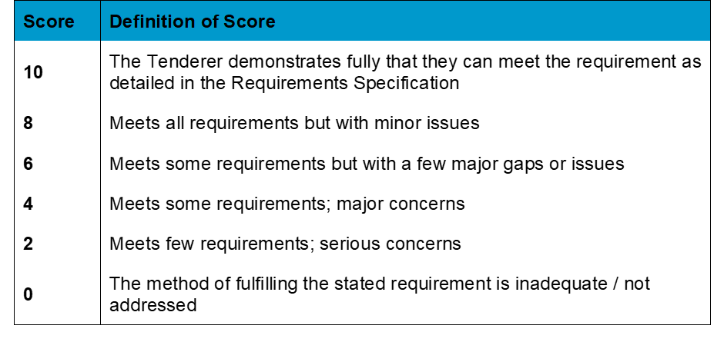

# *Quality Factors*

|  |  |
| --- | --- |
| ***Quality Factor*** | ***Quality Factor weighting*** |
| Company’s greening/recycling policy | 35% |
| Contract Management | 35% |
| Staff Training Programme | 20% |
| Customer Testimonials | 10% |

The Consensus Marking Procedure will be used. This is a two-step process, comprising:

* Independent evaluation; and
* Group consensus marking.

During the independent evaluation process, each evaluator will separately (i.e. without conferring with other evaluators) scrutinise the quality of answers given by Tenderers in their Tender. Each evaluator will then allocate a mark for the answer in accordance with the Marking Scheme applicable to that question

During the meeting, the evaluators will discuss the independent marks until they reach a consensus regarding the marks that should be attributed to each Tenderer's answer to the questions.

**Example**

|  |  |  |  |
| --- | --- | --- | --- |
| **Pricing assessment – example,** | | | |
| Potential supplier | Potential Supplier A | Potential Supplier B | Potential Supplier C |
| Price submitted | £10,000 | £12,000 | £14.000 |
| Pricing score | (£10,000 / £10,000) x 10 | (£10,000 / £12,000) x 10 | (£10,000 / £14,000) x 10 |
| Pricing score awarded | 10 | 8.33 | 7.14 |
| **Weighted pricing score  (35% weighting in this example)** | **3.50** | **2.91** | **2.50** |

|  |  |  |  |  |  |  |  |
| --- | --- | --- | --- | --- | --- | --- | --- |
| **Quality assessment – example,** | | | | | | | |
|  |  | Potential Supplier A | | Potential Supplier B | | Potential Supplier C | |
| Quality factor | Factor weighting | matrix score | criteria score | matrix score | criteria score | matrix score | criteria score |
| Company’s greening/recycling policy | 35% | 4 | 1.4 | 5 | 1.75 | 3 | 1.05 |
| Contract Management | 35% | 5 | 1.75 | 8 | 2.8 | 8 | 2.8 |
| Staff Training Programme | 20% | 5 | 1 | 6 | 1.2 | 6 | 1.2 |
| Customer Testimonials | 10% | 8 | 0.8 | 8 | 0.8 | 8 | 0.8 |
| Overall quality score awarded |  |  | 4.95 |  | 6.55 |  | 5.85 |
| **Weighted overall quality score (65% weighting in this example)** | |  | **3.21** |  | **4.25** |  | **3.80** |

|  |  |  |  |
| --- | --- | --- | --- |
| **Combined assessment – example,** | | | |
|  | Potential Supplier A | Potential Supplier B | Potential Supplier C |
| Weighted pricing score | **3.50** | **2.91** | **2.50** |
| Weighted overall quality score | **3.21** | **4.25** | **3.80** |
| **Total** | **6.71** | **7.16** | **6.3** |
| **Outcome** |  | **winner** |  |