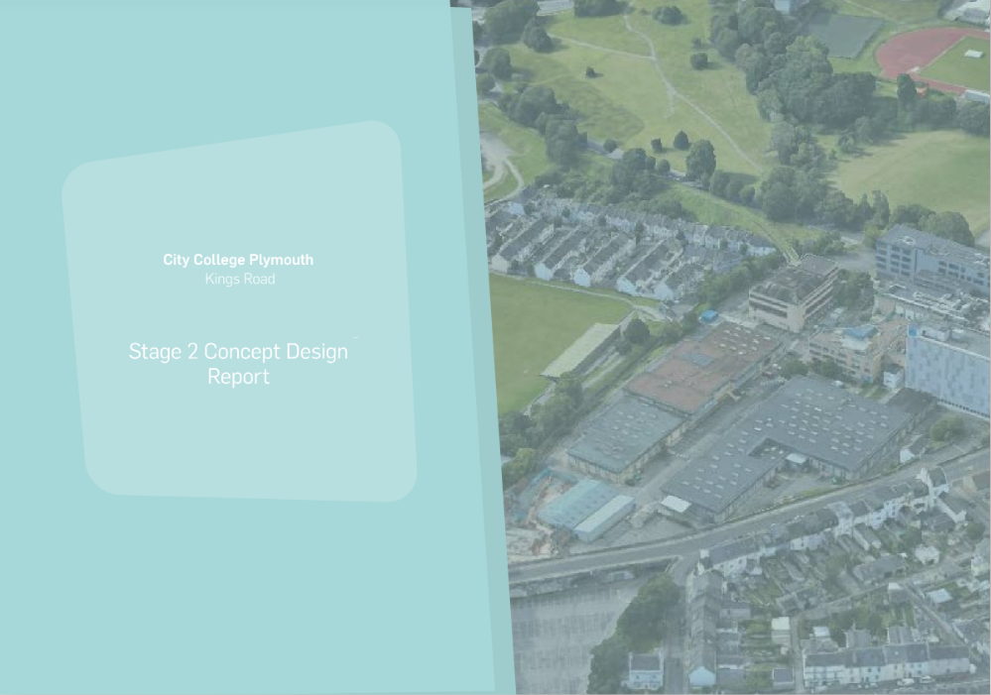**Introduction**

The purpose of this report is to develop the approach and design of a redevelopment to the Health & Early years facility in support of the local city need, on the Kings Road Site of City College Plymouth.

This project follows on from the existing estates report, which considered the whole estate, and also an emerging Masterplan for the Kings Road Campus which will be refocussed towards STEM subject provision. The key decision taken by City College Plymouth is to move non-STEM subject areas into a new facility in the City Centre; better aligning the student cohort to the community.

This has opened up possibilities for the Kings Road site to be re-developed to serve the specific curriculum needs of STEM, which could have not have previously been achieved due to the heavily built-up nature of the existing site.

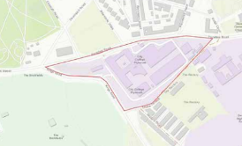

**Estate Development Objectives**

The underlying principles of the redevelopment options for the Kings Road site are as follows:

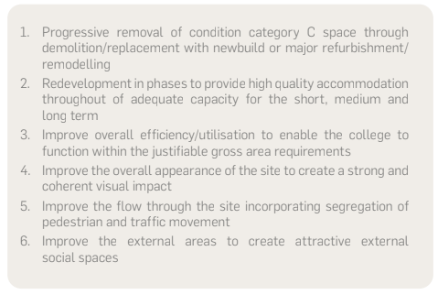

The Kings Road site building conditions are displayed in the image, showing over 50% of the site is in category C condition.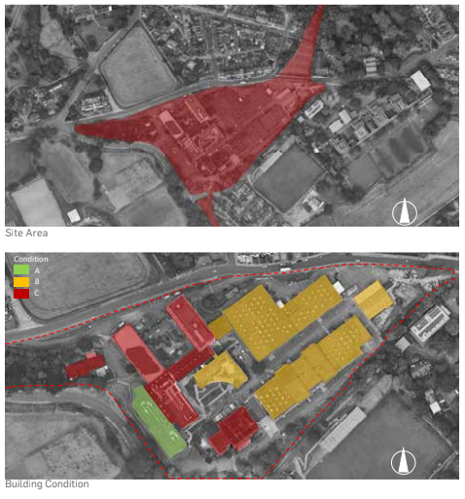

**Planning and Constraints on Further Development**

The college secured planning consent for the construction of the STEM centre, which was completed in 2017. There were no unusual/onerous conditions attached to the permission and we are not aware of any significant planning constraints limiting future additional development on the site. Transport and travel will continue to be issues that need to be

addressed as part of any further development and will most likely require reviews and updates to the Travel Plan.

The college will need the buy-in of Plymouth City Council to the proposed master plan to ensure their support for its delivery. This may require the development of a planning strategy/development brief in consultation with the Council. It may be necessary to also appoint a planning consultant to assist in developing the planning strategy for the site. PCC has been instrumental in past developments and their continued support is envisaged to deliver future developments and improvements. The Council is landlord on two sites occupied by the college and the college enjoys a good working relationship with the Council.

**Local Planning Department SPD Extract**

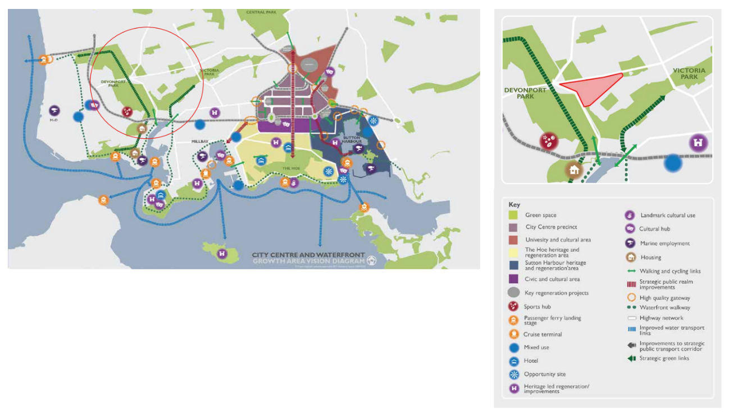

**Vision for Learning Environments**

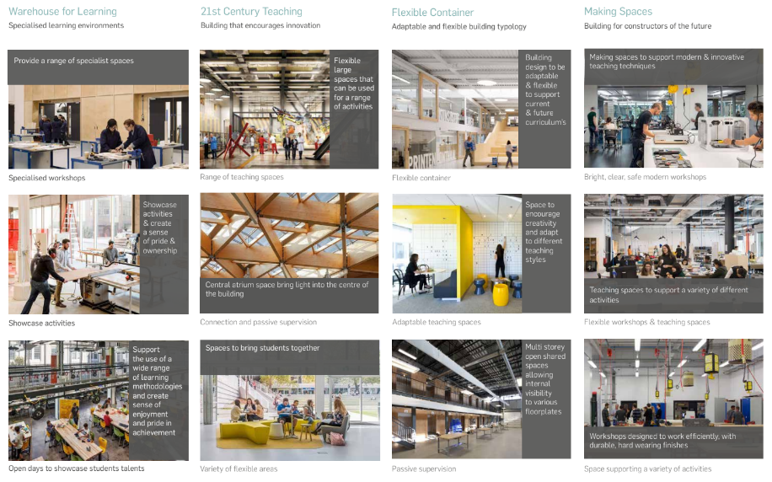

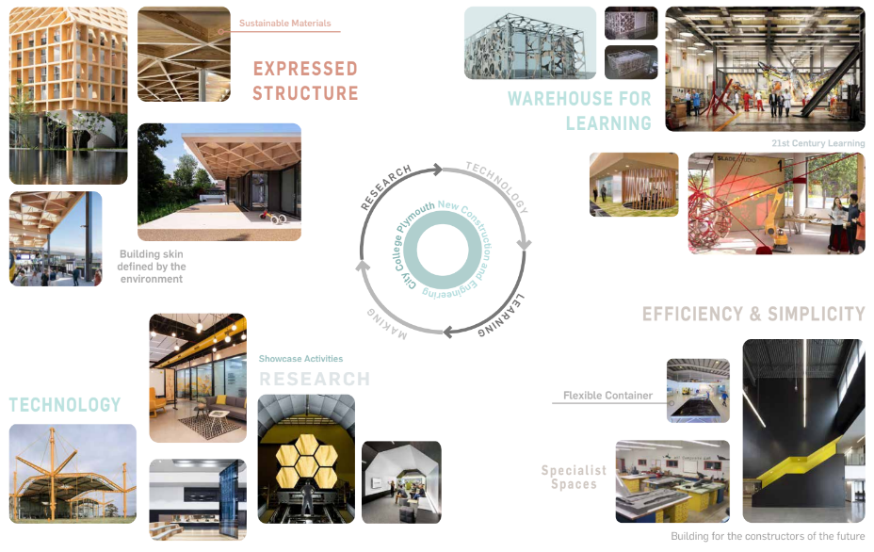

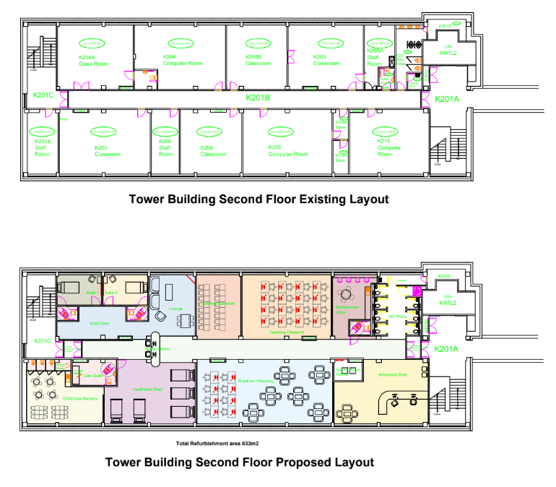**Existing and Proposed Floor Plans**

**Sustainability Strategy**

**Requirements**

The scheme has been developed mindful of the DfE’s aspiration for Net Zero Carbon estates by 2050, following the design requirements, set out in the DfE’s Employer's Requirements Part B: Further Education Output Specification Technical Annex 2H: Energy. We recognise the essential need to build these principles into the DNA of the developing design from inception to ensure that not only is the refurbishment building sustainable on paper but also through delivery and into operation, upkeep and eventually decommissioning phases. The design team has drawn on the knowledge of the range of design disciplines under the Atkins banner to ensure the proposed scheme embodies the most ambitious sustainability goals in a cohesive and coordinated whole.

**User-Centred College Design**

The most sustainable building is one which services the user's needs now and into the future. The scheme has been designed around the new Kings Campus Masterplan which seeks to redirect the campus offer toward skills and practices. As such it has a strong core superstructure into which the building program is a loose-fit assembly of flexible workshop spaces. These have defined uses for the immediate future curriculum, but over time are designed to allow easy adaptation as the construction and engineering departments evolve without requiring significant structural changes. This means wayfinding is clear and dissimilar activities can be accoladed within the various spaces without conflicting needs causing problems. The independent spaces then have straightforward servicing strategies, using passive principals where possible, to provide adaptable, resilient and inspiring environments for learning as required.

**Operational Carbon Strategy**

The design team is committed to designing the new link building to achieve Net Zero Carbon in Operation, as defined by the Framework Definition UK Green Building Council (using the methodology under EN15978). Moreover, through the campus masterplan the City College is committed to achieving the same performance across its entire campus and the new building has been designed to help kickstart this process.

**Ventilation**

The various ventilation requirements are broadly grouped in a similar way to the required operating temperatures, meaning that a similar dual strategy has been adopted.

• No nearby external pollution or noise sources have yet been identified (though further site survey work may be required) which could be a barrier to opening windows and vents therefore a passive natural ventilation strategy has been adopted as a preference.

**Water Use and Water Heating**

An education building will likely have a relatively high-water usage rate due to the need for practical work and washup and showering. Therefore it will be even more important to follow the best practice from annex 2J to minimise usage, for example by using water-saving fittings and rainwater harvesting where possible. The strategy will be developed in more detail in stage 3.

• The design team are aware of the ongoing monitoring and reporting required using the iSERVE methodology and K2n and systems will be designed and sub-metered accordingly.

• The potential for gathering, storage and use of rainwater from the various building roofs will be investigated for use in both toilet flushing, practical construction demonstrations and car washing.

• Hot water use will likely be mainly concentrated in the changing and showing facilities planned for the refurbed area. The feasibility to decarbonise this supply will be investigated at stage 3, thereby removing this DHW supply from the centralised campus hot water network (currently gas fired).

• The potential for integration of wastewater heat recovery will also be investigated.

**Operational Carbon Offsetting**

Due to some of the high-load manufacturing processes required on the site, providing a full operation Net Zero operation at all times is likely to be a challenge, however, it is expected that annual Net Zero performance is potentially realistic using onsite generation. Where the import of electrical energy is required the city college is committed to a transition to a non-fossil fuel site and Net Zero Electrification across the campus over the next couple of decades following the campus masterplan. As quickly as possible they intent to move to Net Zero utility suppliers and buy certified carbon offsets if necessary to cover short-term shortfalls in targets

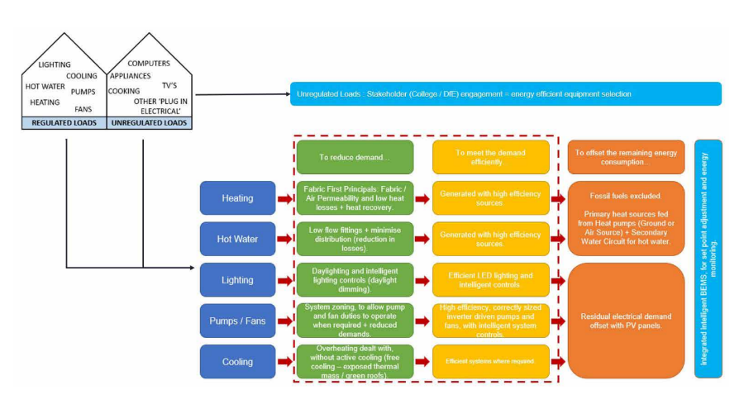

**Project Delivery**