ProContract – How Suppliers Can Register

How to Register

On the portal home page there is a link to Register (for free) on the right hand side of the screen, as shown below.

Click this link to begin the step-by-step registration wizard, where you will be required to enter your company details.

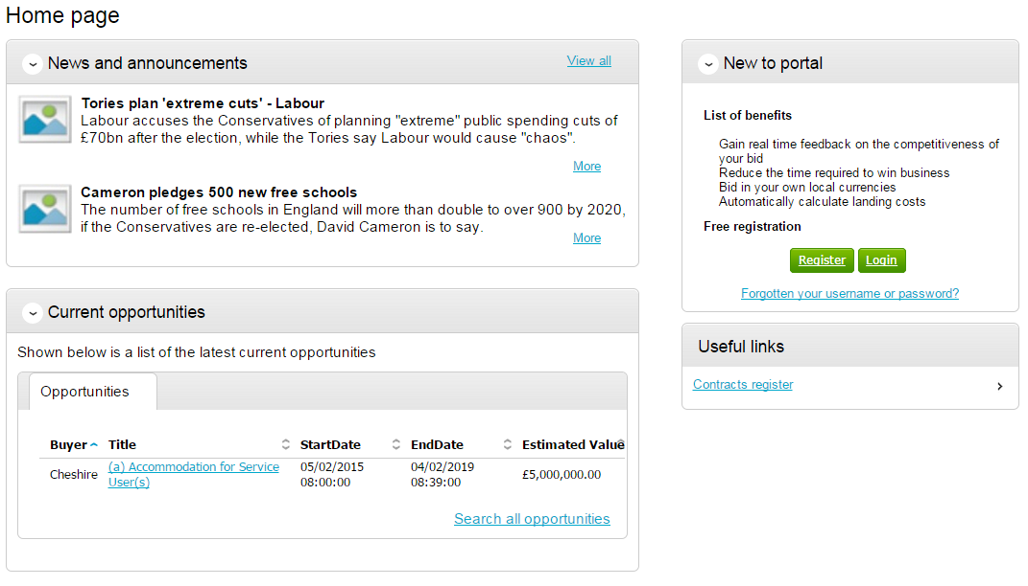

Requirements

This page is an introduction to the process that you will be taken through in order to complete your registration on the portal. Please read this text carefully before proceeding through this process.

Minimum and recommended system requirements can also be viewed here. If you wish to proceed, click Continue from the options at the bottom of the page, or if you want to abort the registration process click Cancel.

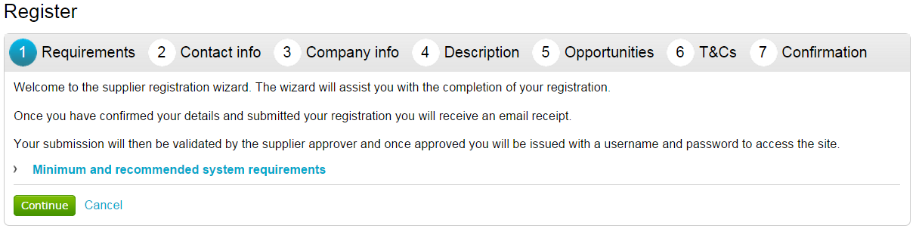

Contact Information

At this stage of the registration process you need to enter your own contact details, a username, a password, and a memorable word/hint. These details will be used when logging into the system. You will be the primary account holder for this company (although details can be changed post registration) so this account will be able to modify the details for the company and add more accounts (which is detailed in another guide).

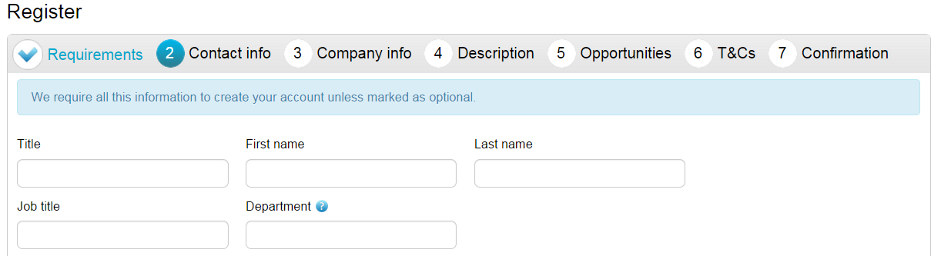

Contact Information

In this section your contact information is entered along with your job details. Complete all mandatory fields as required.
Note: Further help regarding the fields can be found in the by hovering over the icon.

Department - This will form your work group. All future members of this work group will be able to access events you are involved in.

E-mail - This is the e-mail address that messages will be sent to confirming registration details, and all other system communication that may take place during the tender process (including notifications of new tender opportunities). It is recommended in most instances that a GENERIC EMAIL ADDRESS is used, so that communication will not be lost if that person is away or leaves their position (i.e.to a sales@... or tenders@... address possible.) Also this must be of standard email format e.g. name@company.com

Security Information

The second part of this stage is dedicated to setting up your security information. This is where you are asked to specify a password, a memorable word and a hint to help you in case you forget it. This must be something that is secure and also that is memorable to you.

When the details have been completed then please click on the Continue button to proceed, the Back button to go back to the previous stage, or the Cancel button to cancel the registration.

Company Information

In this section you will need to populate details regarding the company you work for/are registering on behalf of, as shown below.

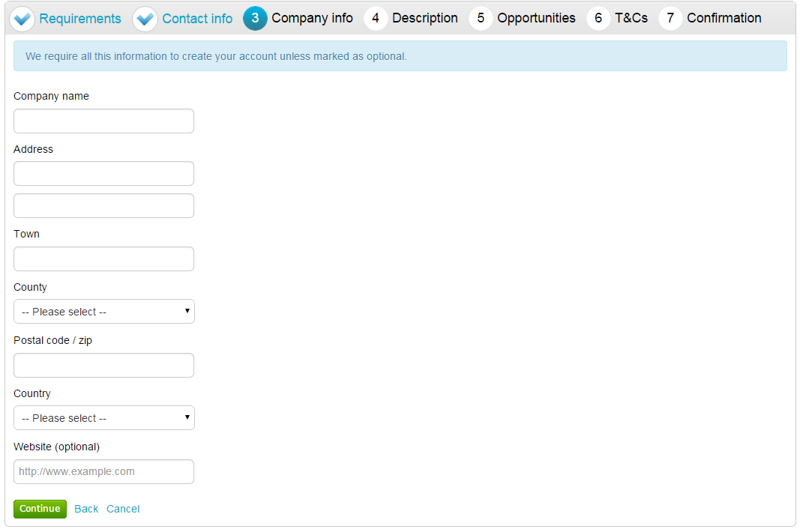

You are required to enter the name of the company you work for and location details.

If any of the fields do not apply but are mandatory, such as “Postcode/ZIP” for companies based outside of the United Kingdom, by entering “N/A” here you can still proceed.

Note: Some of the fields (County and Country) are chosen by using a dropdown menu. To select a County/State click the arrow to the right of the box to reveal a drop down menu containing all the possibilities that can be chosen

From the list select the required option by clicking on its name and this will populate the field as required.

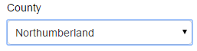

If United Kingdom is selected, then fields will appear requiring Registration number and VAT number.

When the details are complete then please click on the Continue button to proceed, the Back button to go back to the previous stage, or the Cancel button to cancel the registration.

Description

The first part of this stage requires a Company description and up to 6 keywords. Here more information on the company is entered to help the contracting organisation understand what it is your company does. The description helps promote your company to potential buyers, while the keywords can improve the ‘searchability’ of your company.

Note: A description and at least one keyword are required in this section. This is free text and as much information as required can be entered here.

It is important that you complete this information as the procuring organisations can search for a company based on the description or keywords specified.

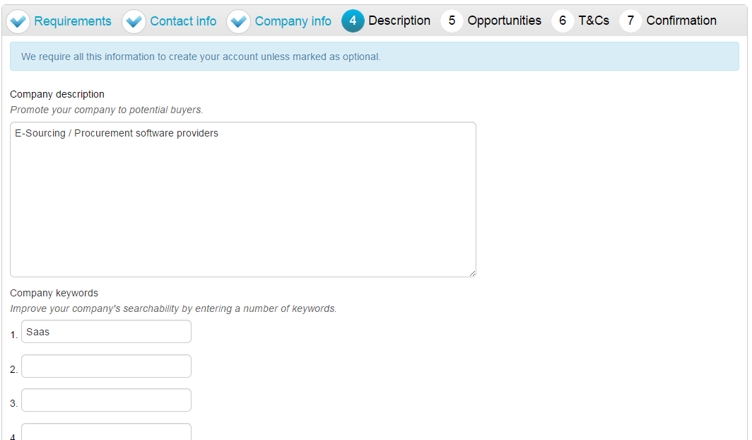

Number of Employees/Classifications

Enter your best estimate as to the number of employees in your organisation within the Number of employees field.

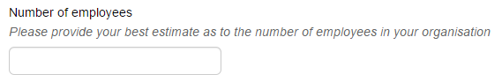
The final section is the Classifications section. This is where the supplier can highlight the classifications that the company belongs to (which is used for reporting purposes only). To select a classification hover over the relevant box and left click on the mouse to mark the box to the left with a tick. You can highlight as many that apply to your organisation.

Note: The first batch of classifications are mandatory and at least one must be selected from the list.

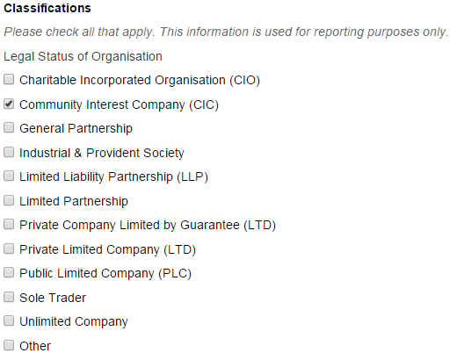

Note: The second batch of classifications are optional, and are selected in the same way as described above.

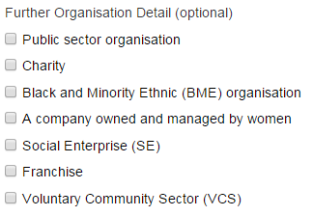
When the details are complete then please click on the Continue button to proceed, the Back button to go back to the previous stage, or the Cancel button to cancel the registration.

Opportunities - Category/Region Selection

This is the category and region selection stage of the supplier registration, which will look as shown below.

To select your chosen categories click the Select Categories button.

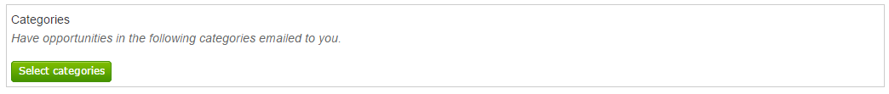

Categories List

This section is where you can register your company to receive automatic e-mail notifications of new opportunities that have been published that may be of interest to your company. This will greatly assist you when using the portal and means that relevant opportunities are not missed. At least one category must be selected.

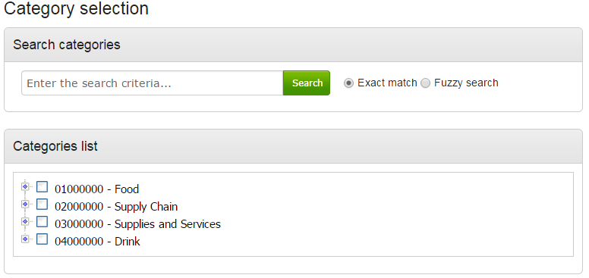

Category: The top level categories that you can register to receive updates under are all listed.

To select a top level category, mark the box to the left of the category by clicking it. You can select multiple categories if required. Ensure that you click on Select Categories to add this to the list.

If you are not sure, or if you want to put your company against lower level classifications, you may use the search facility at the top of the page to search for specific words to help you narrow down the categories to add to your account.

This can also be done by clicking on the blue diamond to the left of the category which will take you down to the next level. This can then be repeated to go down further levels in some categories.

Note: When selecting categories, only categories relevant to the goods or services you can offer as a supplier should be selected. Category selection can be revisited at anytime to carry out required amendments, and searches of advertised opportunities for all categories can also be carried out at anytime.

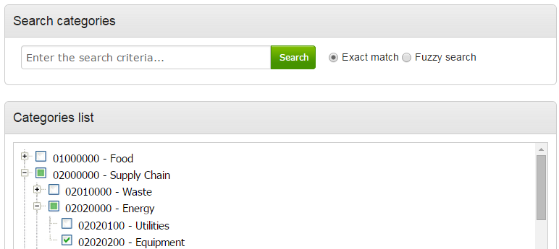

When all required categories have been chosen, click Select Categories from the options at the bottom of the page.

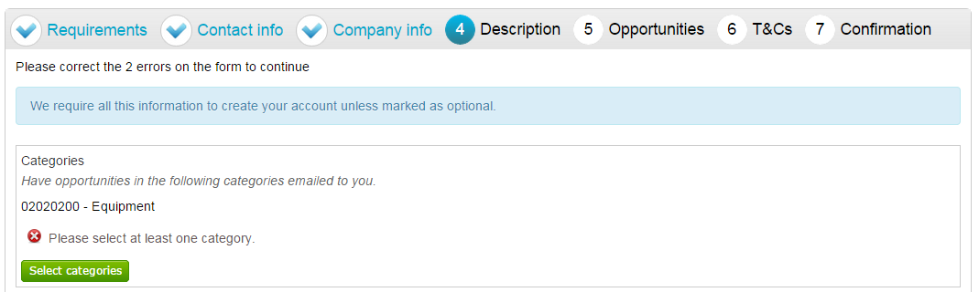

Selected categories are now shown as above.
Note: If a category has been added in error this can be removed by clicking the button.

Regions

At least one Region must now be selected. These will limit the opportunities that you are emailed to only regions that you supply to. Regions are selected in the same way as categories.

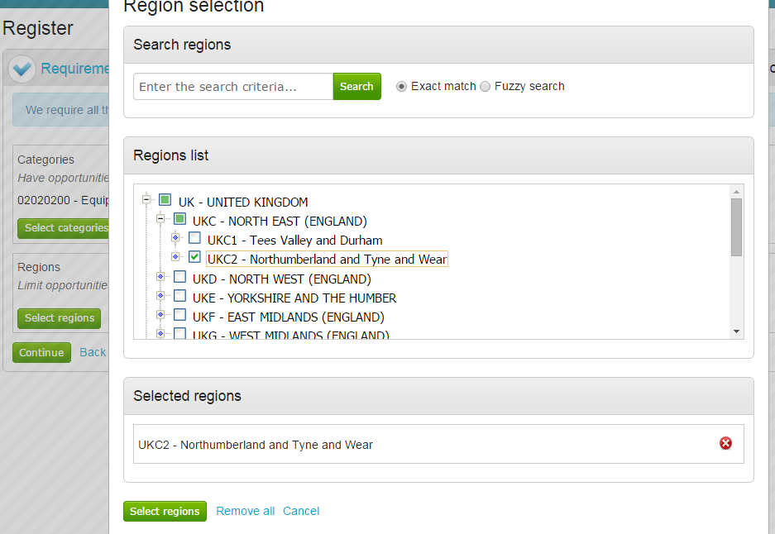

Additional Classifications/Categories

Also further lists/categories may now also be found (if the procuring organisation/portal have used these) This allows you to register against further supplier lists, as set up by the procuring organisation(s) to allow you to be further categorised and found more easily by procurers.

Note: This is totally independent of the Contract Category Interest that is chosen and this will NOT generate any email notifications.

Each list will show up with the title, followed by a classification structure, which you can register your company against. Tick the options that are applicable from this list, this may be done for several lists.

When the details are complete then please click on the Continue button to proceed, the Back button to go back to the previous stage, or the Cancel button to cancel the registration.

T&C’s and Privacy Policy

This is the step where you will be asked to agree to the Terms and Conditions of using the system, and also the privacy policy as laid out by Due North.

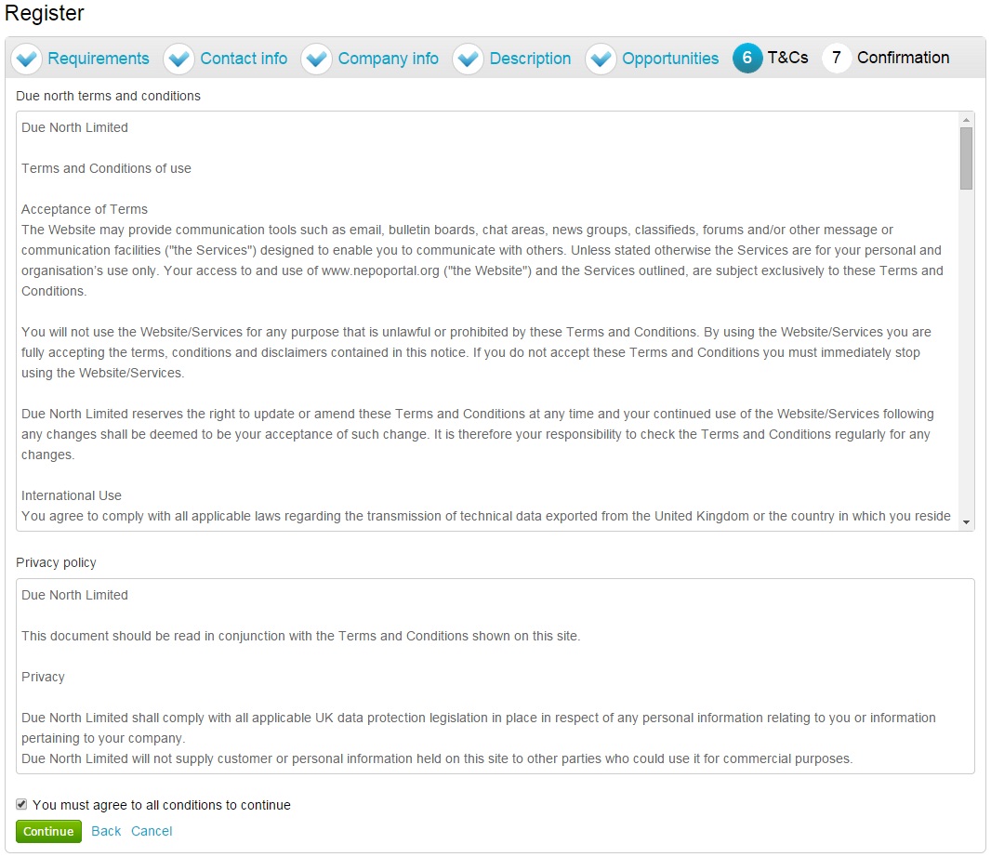

To agree with Due North Ltd’s Terms and Conditions and Privacy Policy tick the box placed at the bottom of the page.

When the box is ticked click on the Continue button to proceed, the Back button to go back to the previous stage, or the Cancel button to cancel the registration.

Confirmation Page

The final screen will be a summary of the details that have already been entered into the system, that need to be checked before completion of registration.

If you are unhappy or would like to change any of the information in the sections then this can be done by clicking on the relevant stage title along the top of the page.

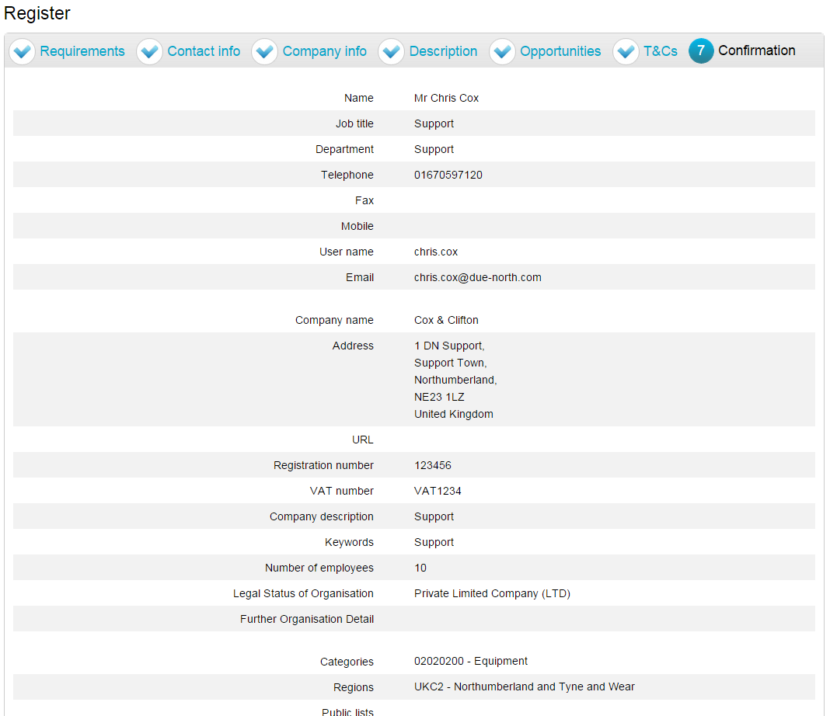

Submitting your Registration

Once you are happy that all details are complete and correct the Registration needs to be submitted.

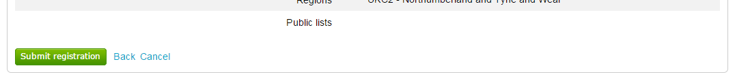

When you are happy that all the information is complete and correct, click Submit Registration at the bottom of the screen. Click the Back button to go back to the previous stage, or the Cancel button to cancel the registration.

This will show the Supplier Registration Confirmation page as shown below.

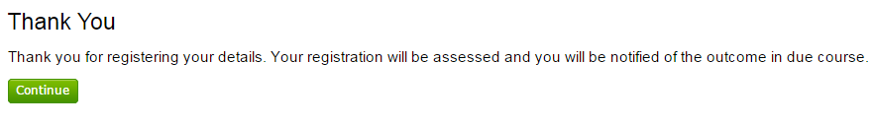
The system will then send a confirmation e-mail to say the application is being considered. The email will also contain an application reference number for your own records.

Click Continue to return to the supplier portal.

When the registration is accepted then you will receive an email containing a reminder of your username and the link to access the opportunity portal.

