Question requested 8 December Response 11 December

1 The Ts and Cs have been updated. Would you be able to point me in the right direction please?

**Answer** Pleasesee LC Conditions E-Professional Services - HRMS subcontractor – see document yellow highlight

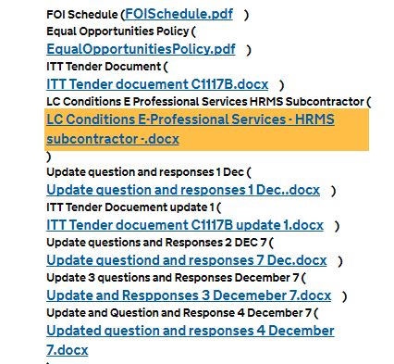

2 Backward compatibility to IE8.Would you be able to advise the nature of the support necessary for this? - will it simply be for respondents inputing responses? - or will it also be for accessing reports? - or also administrative editing of ad hoc surveys?

**Answer -** this is no longer a requirement and the site has been update to indicate this, some of the boroughs were using IE8 but this is now IE11 and Chrome the specification has been update

3 Is London Councils looking for a survey platform similar to the ones used in “customer surveys”, where you have a series of web forms that display questions/data fields and end-users fill in the survey field by field? The reason we ask is because you mentioned *“One of the largest surveys has 3140 entries per borough”* and I assume no person will fill in a survey with 3,000+ questions, field by field. Would that be correct? (*This question follows on from a previously asked question see Updated question and response 4)*

It would also be great to see a screenshot/mock-up/example of one of those surveys, to really take away all our doubts.

**Answer** Please see specification Appendix B – Detailed technical specification Data Inputting item 35 which states - *Survey respondents at the 33 London boroughs can input/edit data directly into a secure web form or by upload of customized Excel/CSV forms (in a specific, pre-determined format specified by London Councils) on the providers’ website. (See List of Surveys for more detail.)*

We are not prepared to provided screen shots, mock up or examples of the existing surveys, as we are looking for suppliers’ response to these requirements.