Data from two gallery monitors & reference external monitor- Nov 2016 – Oct 2017
(Tests with gallery fan coil chiller/heaters started from mid July 2017)

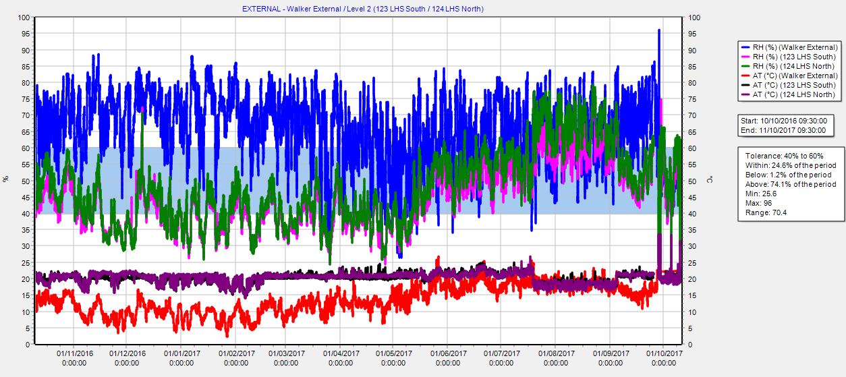

Data from two gallery monitors & reference external monitor- May – Nov 2015
(Period of Mayas exhibition where only fan coil chiller/heaters used)

