INVITATION TO TENDER (ITT)

FOR

Extension and Modifications to Willowbed Hall, Putton Lane, Chickerell, DT34AJ

On behalf of Chickerell Town Council

ITT Return Date: Friday 17th October at 10.00hrs

Index

- Project Overview

- Timescales

- List of Documents Forming ITT

- Contracting Requirements

- General Tender Conditions

- Confidentiality and Information Governance

- Tender Validity

- Instructions for Tender Submission Response

- Clarification Requests

- Evaluation Criteria

- PROJECT OVERVIEW

The existing use of the site is a Local Community Hall and Chickerell Town Council Office. The proposed works include the reconfiguration of the internal layout of the existing Town Council offices to provide a registrar room and meeting room and erect a single storey extension adjoined to the west of the existing building to provide new Town Council office accommodation, storage areas and reduced sized commercial kitchen. In addition, new ramped access will be provided to all principal entrances alongside new landscaping, re-sited vehicular access and cycle store.

The estimated project construction budget is £705,000.00

Site Location
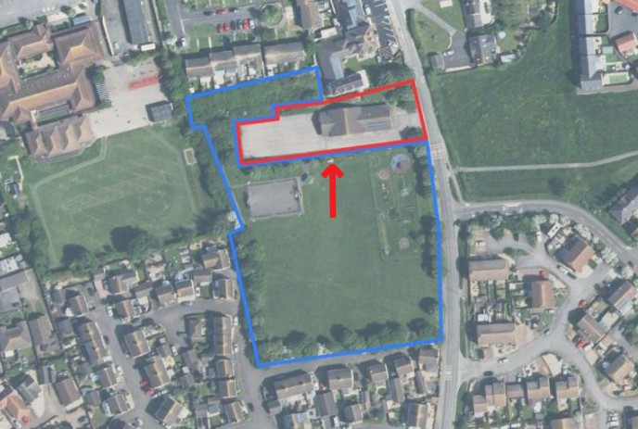

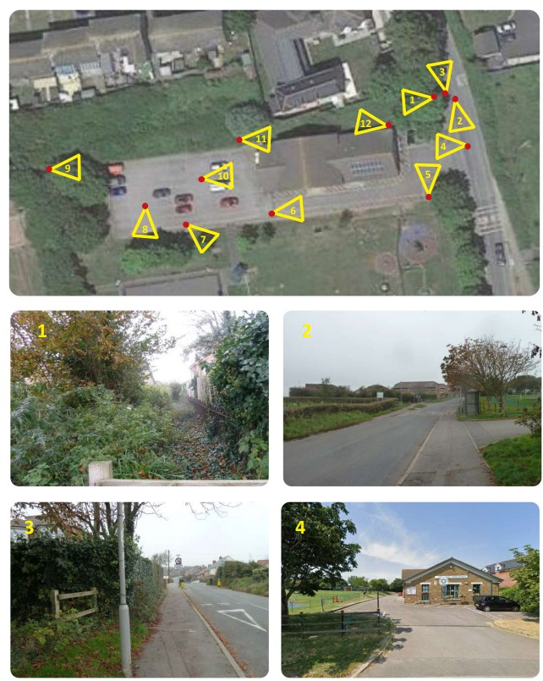
Photographic Survey Location Plan

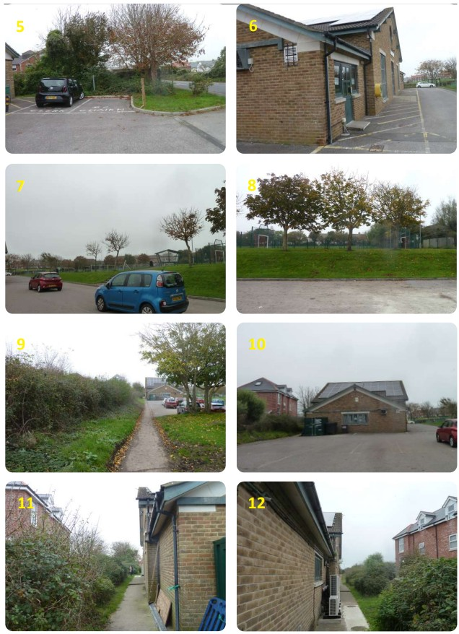

- TIMESCALES

Subject to any changes notified to potential Contractors by the Customer Organisation in accordance with the Tender Conditions, the following timescales shall apply to this Procurement Process

Activity | Date
ITT Issued | Friday 5th September 2025
Site Visits | By Appointment Only – Please contact:  Tara Williams (Facilities Manager)  Chickerell Town Council  01305 767458 Ext 304  Tara.williams@chickerell-tc-gov-uk
Deadline for Contractor Clarifications | Tuesday 30th September 2025  Clarifications to be sent to m.witt@westerndesign.co.uk
Deadline for Submission of ITT Responses  To include completed:-  - Form of Tender  - Pre-Qualification Questionnaire  - Priced Schedule of Works | Friday 17th October by 10.00am  ITT to be sent to m.witt@westerndesign.co.uk
Notification of Award Intention | Friday 31st October 2025
Contract Commencement | Monday 10th November
Completion of Construction | To be advised by Contractors ITT programme response

- LIST OF DOCUMENTS FORMING ITT

- Contractor Response
- Pre-Qualification Questionnaire
- Pricing Schedule
- Form of Tender

- Planning Approval reference P/FUL/2025/01397

- Western Design Architects drawings:-
  - 100 - Construction Notes
  - 101 - Detailed Ground Floor Plan
  - 102 – Elevations
  - 103 - Section 1
  - 104 - Section 2
  - 105 - Details A B and C
  - 106 - M and E Layout
  - 107 – Fire Escape Strategy
  - CDM01 – Designers Risk Assessment

  - Godsell Arnold partnership Ltd Structural Engineer’s drawings:-
    - 25039-GAP-XX-00-DR-S-0010 P02
    - 25039-GAP-XX-01-DR-S-0100 P02
    - 25039-GAP-XX-XX-DR-S-0101 P02

- Godsell Arnold partnership Ltd civils and drainage drawings:-
- 25039-GAP-ZZ-ZZ-RP-C-9000-A – SW drainage strategy report
- 25039-GAP-XX-XX-DR-C-9000-P03
- 25039-GAP-XX-XX-DR-C-9010-P01
- 25039-GAP-XX-XX-DR-C-9011-P01
- 25039-GAP-XX-XX-DR-C-9100-P01
- 25039-GAP-XX-XX-DR-C-9101-P01
- 25039-GAP-XX-XX-DR-C-9150-P01
- 25039-GAP-XX-XX-DR-C-9200-P01
- 25039-GAP-XX-XX-DR-C-9220-P01
- 25039-GAP-XX-XX-DR-C-9221-P01
- 25039-GAP-XX-XX-DR-C-9250-P01
- 25039-GAP-XX-XX-DR-C-9251-P01
- 25039-GAP-XX-XX-DR-C-9300-P01
- 25039-GAP-XX-XX-DR-C-9301-P01
- 25039-GAP-XX-XX-DR-C-9302-P01
- 25039-GAP-XX-XX-DR-C-9400-P01
- 25039-GAP-XX-XX-DR-C-9700-P01
- 25039-GAP-XX-XX-DR-C-9750-P01

- Cherry Tree Ecology Ltd Ecological Impact Assessment and Biodiversity Net Gain:-
- Willowbed Hall EcIA 06.03.25
- Willowbed Hall BNG 03.03.25

- Graham Cox Arboricultural Method Statement:-
- 250304 AS-39-25 AMS
- 250614 TPP rev iv
- 241101 Survey schedule

- CONTRACTING REQUIREMENTS

This section of the ITT sets out the Customer Organisation’s contracting requirements, general policy requirements, and the general tender conditions relating to this procurement process (“Procurement Process”).

Proposed Form of Contract
The Successful Contractor will be expected to enter into a JCT Intermediate Building Contract (IC 2024)

Public Liability Insurance
The Successful Contractor will be required to have Public Liability Insurance of £10 million.

General Policy Requirements
By submitting a tender response in connection with this Procurement Process, potential suppliers confirm that they will, and that they shall ensure that subcontractors will, comply with all applicable laws, codes of practice, statutory guidance and applicable Customer Organisation policies relevant to the goods/services and or works being supplied.

- GENERAL TENDER CONDITIONS (“Tender Conditions”)

Application of these Tender Conditions. In participating in this Procurement Process and/or by submitting a tender response it will be implied that you accept and will be bound by all the provisions of this ITT and its Annexes. Accordingly, tender responses should be on the basis of and strictly in accordance with the requirements of this ITT

Third party verifications – Your tender response is submitted on the basis that you consent to the Customer Organisation carrying out all necessary actions to verify the information that you have provided, and the analysis of your tender response being undertaken by one or more third parties commissioned by the Customer Organisation for such purposes.

Information provided to potential Contractors – Information that is supplied to potential Contractors as part of this Procurement Process is supplied in good faith. The information contained in the ITT and the supporting documents and in any related written or oral communication is believed to be correct at the time of issue but the Customer Organisation will not accept any liability for its accuracy, adequacy or completeness and no warranty is given as such. This exclusion does not extend to any fraudulent misrepresentation made by or on behalf of the Customer Organisation.

Potential Contractors to make their own enquires – You are responsible for analysing and reviewing all information provided to you as part of this Procurement Process and for forming your own opinions and seeking advice as you consider appropriate. You should notify the Customer Organisation promptly of any perceived ambiguity, inconsistency or omission in this ITT and/or any in of its associated documents and/or in any information provided to you as part of this Procurement Process.

Amendments to the ITT – At any time prior to the Tender Response Deadline, the Customer Organisation may amend the ITT. Any such amendment shall be issued to all potential Contractors, and if appropriate to ensure potential Contractors have reasonable time in which to take such amendment into account, the Tender Response Deadline shall, at the discretion of the Customer Organisation, be extended. Your tender response must comply with any amendment made by the Customer Organisation in accordance with this paragraph or it may be rejected.

Compliance of tender response submission – Any goods/services and or works offered should be on the basis of and strictly in accordance with the ITT (including, without limitation, any specification of the Customer Organisation’s requirements, these Tender Conditions and the Contract) and all other documents and any clarifications or updates issued by the Customer Organisation as part of this Procurement Process.

Format of tender response submission – Tender responses must comprise the relevant documents specified by the Customer Organisation completed in the format as detailed by the Customer Organisation in the (Contractor Response). Any documents requested by the Customer Organisation must be completed in full. It is, therefore, important that you read the ITT carefully before completing and submitting your tender response.

Rejection of tender responses or other documents – A tender response or any other document requested by the Customer Organisation may be rejected which:

- contains gaps, omissions, misrepresentations, errors, uncompleted sections, or changes to the format of the tender documentation provided;
- contains hand written amendments which have not been initialled by the authorised signatory;
- does not reflect and confirm full and unconditional compliance with all of the documents issued by the Customer Organisation forming part of the ITT;
- contains any caveats or any other statements or assumptions qualifying the tender response that are not capable of evaluation in accordance with the evaluation model or requiring changes to any documents issued by the Customer Organisation in any way;
- is not submitted in a manner consistent with the provisions set out in this ITT;
- is received after the Tender Response Deadline.

Disqualification – If you breach these Tender Conditions, if there are any errors, omissions or material adverse changes relating to any information supplied by you at any stage in this Procurement Process, if any other circumstances set out in this ITT, and/or in any supporting documents, entitling the Customer Organisation to reject a tender response apply and/or if you or your appointed advisers attempt:

  - to inappropriately influence this Procurement Process;
  - to fix or set the price for goods/services and/or works;
  - to enter into an arrangement with any other party that such party shall refrain from submitting a tender response;
  - to collude in any other way;
  - to engage in direct or indirect bribery or canvassing by you or your appointed advisers in relation to this Procurement Process; or
  - to obtain information from any of the employees, agents or advisors of the Customer Organisation concerning this Procurement Process (other than as set out in these Tender Conditions) or from another potential Contractor or another tender response.

The Customer Organisation shall be entitled to reject your tender response in full and to disqualify you from this Procurement Process. Subject to the “Liability” Tender Condition below, by participating in this Procurement Process you accept that the Customer Organisation shall have no liability to a disqualified potential Contractor in these circumstances.

Tender costs – You are responsible for obtaining all information necessary for preparation of your tender response and for all costs and expenses incurred in preparation of the tender response. Subject to the “Liability” Tender Condition below, you accept by your participation in this procurement, including without limitation the submission of a tender response, that you will not be entitled to claim from the Customer Organisation any costs, expenses or liabilities that you may incur in tendering for this procurement irrespective of whether or not your tender response is successful

Rights to cancel or vary this Procurement Process - By issuing this ITT, entering into clarification communications with potential Contractors or by having any other form of communication with potential Contractors, the Customer Organisation is not bound in any way to enter into any contractual or other arrangement with you or any other potential Contractors. It is intended that the remainder of this Procurement Process will take place in accordance with the provisions of this ITT but the Customer Organisation reserves the right to terminate, suspend, amend or vary (to include, without limitation, in relation to any timescales or deadlines) this Procurement Process by notice to all potential Contractors in writing. Subject to the “Liability” Tender Condition below, the Customer Organisation will have no liability for any losses, costs or expenses caused to you as a result of such termination, suspension, amendment or variation.

Liability – Nothing in these Tender Conditions is intended to exclude or limit the liability of the Customer Organisation in relation to fraud or in other circumstances where the Customer Organisation’s liability may not be limited under any applicable law

- CONFIDENTIALITY AND INFORMATION GOVERNANCE

This ITT and its accompanying documents shall remain the property of the Customer Organisation

The Customer Organisation reserves the right to disclose all documents relating to this Procurement Process, including without limitation your tender response, to any employee, third party agent, adviser or other third party involved in the procurement in support of, and/or in collaboration with, the Customer Organisation.

The Customer Organisation further reserves the right to publish the Contract once awarded in accordance with any public sector transparency policies. By participating in this Procurement Process, you agree to such disclosure and/or publication by the Customer Organisation in accordance with such rights reserved by it under this paragraph.

The Freedom of Information Act 2000 (“FOIA”) and public sector transparency policies, including the placing of contract award notices on the Contracts Finder database, apply to the Customer Organisation (together the “Disclosure Obligations”).

You should be aware of the Customer Organisation’s obligations and responsibilities under the Disclosure Obligations to disclose information held by the Customer Organisation. Information provided by you in connection with this Procurement Process, or with any contract that may be awarded as a result of this exercise, may therefore have to be disclosed by the Customer Organisation under the Disclosure Obligations, unless the Customer Organisation decides that one of the statutory exemptions under the FOIA applies.

If you wish to designate information supplied as part of your tender response or otherwise in connection with this tender exercise as “confidential”, you must provide clear and specific detail as to:
- the precise elements which are considered confidential and/or commercially sensitive;
- why you consider an exemption under the FOIA would apply; and
- the estimated length of time during which the exemption will apply.

In addition, marking any material as “confidential” or “commercially sensitive” or equivalent should not be taken to mean that the Customer Organisation accepts any duty of confidentiality by virtue of such marking. You accept that the decision as to which information will be disclosed is reserved to the Customer Organisation, notwithstanding any consultation with you or any designation of information as confidential or commercially sensitive or equivalent you may have made.

You agree, by participating further in this Procurement Process and/or submitting your tender response, that all information is provided to the Customer Organisation on the basis that it may be disclosed under the Disclosure Obligations if the Customer Organisation considers that it is required to do so and/or may be used by the Customer Organisation in accordance with the provisions provision of this ITT

Tender responses are also submitted on the condition that the appointed Contractor will only process personal data (as may be defined under any relevant data protection laws) that it gains access to in performance of this Contract in accordance with the Customer Organisation ’s instructions and will not use such personal data for any other purpose. The contracted Contractor will undertake to process any personal data on the Customer Organisation’s behalf in accordance with the relevant provisions of any relevant data protection laws and to ensure all consents required under such laws are obtained.
- TENDER VALIDITY

Your tender response must remain open for acceptance by the Customer Organisation for a period of ninety days from the Tender Response Deadline. A tender response not valid for this period may be rejected by the Customer Organisation.

- INSTRUCTIONS FOR TENDER SUBMISSION RESPONSE

Submissions will only be accepted if they are returned via the Customer Organisation’s electronic tendering software package ‘Gov.Uk Contracts Finder’

The following requirements should be complied with when summiting your response to this ITT:

- Please ensure that you send your submission in good time to prevent issues with technology – late tender responses may be rejected by the Customer Organisation.
- Please ensure that information provided as part of its response is of sufficient quality and detail that an informed assessment of it can be made by the Customer Organisation.
- Do not submit any additional supporting documentation with your response except where specifically requested to do so as part of this ITT. PDF, JPG, PPT, Word and Excel formats can be used for any additional supporting documentation (other formats should not be used without the prior written approval of the Customer Organisation).
- All attachments/supporting documentation should be provided separately to your main response and clearly labelled to make it clear as to which part of your tender response it relates.
- If you submit a generic policy / document you must indicate the page and paragraph reference that is relevant to a particular part of your tender response.
- Unless otherwise stated, all tender responses should be in the format of the relevant Customer Organisation requirement with your response to that requirement inserted underneath.
- Where supporting evidence is requested as ‘or equivalent’ – you must demonstrate such equivalence as part of your tender response.
- Any deliberate alteration of a Customer Organisation requirement as part of your response will invalidate your tender response to that requirement and for evaluation purposes you shall be deemed not to have responded to that particular requirement.
- Responses should concise, unambiguous, and should directly address the requirement stated.
- Your tender responses to the tender requirements and pricing will be incorporated into the Contract, as appropriate.
- Your response, all submitted additional documents and all correspondence relating to this Procurement Process must be written in English.

- CLARIFICATION REQUESTS

All clarification requests should be submitted to via the ‘Contracts Finder’ portal by the Clarification Deadline, as set out in the Timescales section of this document. The Customer Organisation is under no obligation to respond to clarification requests received after the Clarification Deadline.

Any clarification requests should clearly reference the appropriate reference heading in the documentation and, to the extent possible, should be aggregated rather than sent individually.

The Customer Organisation reserves the right to issue any clarification request made by you, and the response, to all potential suppliers unless you expressly require it to be kept confidential at the time the request is made. If the Customer Organisation considers the contents of the request not to be confidential, it will inform you and you will have the opportunity to withdraw the clarification query prior to the Customer Organisation responding to all potential Contractors.

The Customer Organisation may at any time request further information from potential Contractors to verify or clarify any aspects of their response or other information they may have provided. Should you not provide supplementary information or clarifications to the Customer Organisation by any deadline notified to you, your tender response may be rejected in full and you may be disqualified from this Procurement Process.

- EVALUATION CRITERIA

Responses from potential Contractors will be assessed to determine the most advantageous tender using the a scoring matrix and will be assessed entirely on the responses submitted.

The process and criteria for selection and award of the contract are outlined below:-

Criteria |  | Weighting
Price  (Completed Pricing Schedule) |  | 60%
Quality |  | 40%
(Quality Sub weighting)
 | Project Understanding | (10)
 | Relevant Experience | (10)
 | Local Knowledge | (10)
 | Project Personnel | (10)
 | Supply Chain | (10)
 | Programme | (15)
 | Workload / Capacity | (5)
 | Management Structure | (5)
 | Dispute History | (5)
 | Financial Stability | (5)
 | References | (5)
 | Health and Safety | (5)
 | Quality Assurance | (5)

Tender responses will be scored by an evaluation panel appointed by the Customer Organisation for all criteria other than Pricing using the following scoring model:

Score Key Assessment | Score | Interpretation
Excellent | 4 | Response is completely relevant and excellent overall. The response is comprehensive, unambiguous and demonstrates a thorough understanding of the requirement and provides details of how the requirement will be met in full.
Good | 3 | Response is relevant and good. The response is sufficiently detailed to demonstrate a good understanding and provides details on how the requirements will be fulfilled.
Minor Reservations | 2 | Response is relevant and acceptable. The response addresses a broad understanding of the requirement but may lack details on how the requirement will be fulfilled in certain areas.
Serious Reservations /  Non Compliant | 1 | Response is partially relevant but generally poor. The response addresses some elements of the requirement but contains insufficient/limited detail or explanation to demonstrate how the requirement will be fulfilled.
Unacceptable / Non Compliant | 0 | Does not meet the requirement. Does not comply and/or insufficient information provided to demonstrate that the Tenderer has the understanding or suitable methodology, with little or no evidence to support the response.

Commercial Evaluation - Prices must not be subject to any pricing assumptions, qualifications or indexation not provided for explicitly by the Customer Organisation as part of the pricing approach. In the event that any prices are expressed as being subject to any pricing assumptions, qualifications or indexation not provided for by the Customer Organisation as part of the pricing approach, the Customer Organisation may reject the full tender response at this point.

The Customer Organisation may also reject any tender response where the Overall Price for the goods/services and/or works is considered by the Customer Organisation to be abnormally low and the contractor explanation does not satisfactorily account for the low cost.

The pricing score will be as a proportion of the lowest weighted tender sum.

Moderation and application of weightings – The evaluation panel appointed for this procurement will meet to agree and moderate scores for each award criteria. Final scores in terms of a percentage of the overall tender score will be obtained by applying the relevant weighting factors set out as part of the award criteria table above. The percentage scores for each award criteria will be amalgamated to give a percentage score out of 100.

The winning tender response – The winning tender response shall be the tender response scoring the highest percentage score out of 100 when applying the above evaluation methodology.

