Bar End Heat Network, Winchester
Winchester City Council (‘the Council’) is looking to commission pre-feasibility work to assess the potential for a (renewable, low carbon, a mix, or phased approach to zero carbon) Heat Network for a cluster of mostly public sector buildings in development around the area known as Bar End in Winchester based on a Heat Mapping exercise for Winchester Town.

The pre-feasibility work will require the production of a Heat Map for the Town and Energy Masterplanning for area of Bar End to help identify the best business solution to carry forward into any subsequent future feasibility work in future.

Background
The Council has identified an opportunity to provide a District Heat Network (DHN). Several development opportunities are currently being explored on land east of Winchester at Bar End, and the Council wishes to investigate the possibility of developing a DHN for new public sector buildings with an energy centre on Council land anchored on the provision of a new Council leisure center in the area.

The project supports the Council’s carbon reduction programme and consideration of low carbon options in the replacement of the leisure centre, through the productions of a pre-feasibility assessment to identify suitable DHN options that could be the subject of more detailed feasibility work. At this stage we are therefore looking to employ a consultancy to produce a Heat Map and Energy Master Plan for the area of Bar End as detailed in the requirements below.

The work is funded by a grant awarded by the Department of Energy & Climate Change Heat Networks Delivery Unit (HNDU) and the City Council may apply for further funding if the pre-feasibility work indicates potential for a heat network to be established in Winchester.

Project Aims
Undertake an energy mapping and modelling study of the proposed area to identify the following for the purposes of decentralised energy scheme development so that they may meet the strategic aims of Winchester City Council:
- potentially useful heating, cooling and power demand loads;
- heat supply opportunities;
- clearly defined low and zero carbon energy supply for the study area;
- clearly defined cost savings/revenue streams.

Use the outputs of energy mapping to inform the development of an energy master plan for the proposed area encompassing short and long term scheme plans, which identifies, evaluates and prioritises any potential decentralised energy scheme opportunities.

To identify an initial core scheme and full potential scheme over the long term together with potential phasing, timeline, key dependencies and constraints.

Scope
The Council would like a quote which includes all of the following pieces of work and meets the relevant objectives within the CIBSE/ADE CP1 Heat Networks: Code of Practice for the UK (CIBSE CoP) relevant to this stage of work.

- A Heat Map for Winchester Town
This should identify opportunities within the project area (shown on the attached map 1) and provide advice on the provision of a Heat Network anchored on a new leisure centre and include:
- Asset Mapping: Current building use; development proposals and Local Plan allocations; and land ownership details.
- Demand Load Mapping: Identify, categorise and map on GIS existing heating, cooling and power demand loads including monthly and annual load profiles per building with seasonal and weekday variations (kWh/m²). The projected loads should include new developments proposed within the area as listed below, including the proposed new leisure centre which could provide the anchor load.
- Heat Density Mapping: showing the concentrations of demand represented with GIS mapping.
- Demand Energy Modelling: Undertake heating, cooling and power demand energy modelling of identified development using appropriate industry benchmarks as identified in Section 2 of the CIBSE CoP and in line with the nature and scale of envisaged development. The modelling should also take account of building regulations standards likely to be applicable for the various phases of development. Where the consultant deems it prudent any modelling outcomes can be adjusted to form a more realistic baseline position regarding energy demands. Categorise and GIS map projected energy demand and supply loads.
- Heat Supply Mapping: Assess potential heat options, their technical and financial feasibility, scale of technology required, supply and access practicalities.

- An Energy Master Plan for the area of Bar End (See Map 2)
The master plan should cover the opportunities identified through the Heat Mapping exercise and include consideration of the phasing of proposed development and reflect where suitable and practical a desire to consider self generation of power and the maximising of available opportunities and cover:-
- Potential heat options including:
  - Private wire, heat pumps (ground, water and air-sourced), gas combined heat and power CHP, biomass/bio fuel/biogas CHP, biomass boilers, hydro, heat recovery from sewage and Anaerobic Digesters; and
  - An assessment of the range of potential measures that would be suitable for a new leisure centre to meet its own and wider needs to function as a key DHN anchor load.
- Identify constraints and opportunities: such as major existing water, sewerage, energy and transport infrastructure routes, archaeology, landscape, wildlife, contours, highways, public opinion and whether they pose any potential significant risks or provide opportunities or added benefits.
- Determine if the identified heating, cooling and power demands are suitable for DHN, and the combinations of buildings required. This should include both high temperature and low temperature heat network solutions.
- Determine the initial suitability of connection of existing buildings and their connection needs as well as the requirements of future development to enable connection to any potential district energy network.
- Determine potential energy centre locations and network routes.
- Undertake appropriate modelling to identify the key district heating, cooling, and private wire scheme opportunities over the short and long term. Make an initial assessment of these opportunities including:-
  - the technical suitability of connecting to potential heat sources
  - key requirements and
  - cost implications on viability
- Evaluate and prioritise identified options according to agreed criteria to include:-
  - technology suitability, financial performance (including in response to key sensitivities)
  - CO₂ reduction potential initial and full
  - Cost per tonne of CO₂ saved for initial and full potential scheme
  - Development risk
  - Supply risk
- Provide initial technology recommendations including a technology pathway and timeline to achieve zero carbon heat for identified potential projects.
- Identify thermal storage requirements and detail the impact on the operation of the recommended technology solution. In addition, identify and qualify the interaction between thermal storage and the wider energy system.
- Determine the high level potential for direct electricity supply to significant non-residential buildings via development of a ‘private-wire network’ in the case of potential CHP projects identified and opportunities for linked electricity generation for buildings or electric vehicles.
- Refine the overall district energy potential options in relation to the energy centre location, energy supply technologies, network routes, scale and phasing of schemes for initial core scheme opportunities through to the full potential long term scheme opportunities.
- Estimate high level project costs for initial and future phases including the level of accuracy. Provide a breakdown of the key capital cost items included in capex estimates including:-
  - Energy centre building
  - Major plant
  - Mechanical
  - Electrical
  - DH Network
  - DH Substations
  - Customer Connections
  - Project Management
  - Contingency
- Provide a breakdown of pipe network sizes and lengths together with assumed costs per metre installed.

- Energy Master Planning: Economic Assessment
- Undertake an initial economic assessment of the identified technical project opportunities through the development of a high level financial model and on the basis of whole life costs. Basic economic assumptions to be used in the economic assessment should include but not be limited to:
  - Benchmark energy tariffs used should be based on real data or where modelled, based on market realistic tariffs appropriate for the proposed customer types
  - The baseline will assume a cost neutral position regarding overall energy costs for customers
  - Estimated operating and maintenance (O & M) costs should be included but energy purchase costs should be presented separately
  - The technical and economic assessments should cover initial and phased schemes
  - Any assumed connections costs for new developments should be clearly justified.
  - Options for alternative uses of surplus heat including conversion to electricity to be used on site or for sale, including feed-in-tariffs if eligible.
  - Consideration of options for the sale of energy such as private wire, and impact on viability of the scheme.
  - Capital grant support scenarios of 10%, 20%, and 30% taking into consideration the Heat Networks Investment Project
- Identify Energy sales tariffs/% cost saving to customer through comparison of baseline energy bill data against network modelling.
- Social NPV , pre-interest range of internal rates of return (IRR) and net present value (NPV) over a 25 year and 40 year project life for the base line scenarios and in response to key sensitivities to be agreed with client and reflective of assumed cost estimate accuracies including:
      - Capex
      - Energy purchase prices
      - Heat demand

4. Refinement of Opportunities and Recommendations
- Make recommendations on options to take further: Use the outputs of the energy masterplanning study to make recommendations on which opportunities are potentially suitable to progress to a future detailed techno-economic feasibility study taking into consideration:-
  - Suitability of heat sources including supply and access practicalities and which options appear most feasible.
  - Nature, scale, costs, timeframe, phasing and location of potential schemes.
  - Key risks, constraints and issues.
  - Delivery, ownership and governance structures
  - potential benefits over the BAU development scenario
  - Linked electricity generation for buildings or electric vehicles.
- Recommend the next steps and implementation requirements for the recommended schemes. Include an estimate of costs for next steps.
- Set out a detailed, coherent plan for the next steps taking into consideration the timing of development at Bar End and planning requirements
- Potential for future expansion.

5. Outputs
- Submission of draft reports to the Council for comment.
- Consultant to present results and respond to stakeholder questions.
- Submission of final Heat Map and energy master plan.
- All key project outputs will also be made available to BEIS as part of the HNDU funding requirements Consultants should carefully note the following requirements and ensure they are fully addressed in tender responses:
- Draft and Final Mapping and Masterplanning Study including:
  - Detailed outcomes and key recommendations as to which short and long term district heating, cooling and power network opportunities to progress to future feasibility study and why
  - Key technical, cost, environmental, and other relevant details of recommended district energy schemes including benefits, opportunities, risks and constraints
  - GIS mapping of recommended scheme, including network route(s), energy centre locations, buildings connected, scheme phasing to full build out
  - Risks and Issues Register using HNDU monthly highlight report template.
  - Executive Summary for non-technical audience which outlines the scale of opportunity and how this is best delivered encompassing
  - Overarching summary of the study – i.e. the subject matter of the report
  - Key background summary – rationale for study , terms of reference, key aims, timeframe and current status
  - Summary method of analysis
  - Key Outputs – for each work package area
  - Discussion – key opportunities/risks/limitations
  - Conclusion/recommendations reflecting future funding opportunities through the HNDU.
  - Next steps
- Heat Network Project Metric Template for each project opportunity identified (provided by the local authority, and submitted back to the local authority and HNDU for each heat network scheme opportunity identified for the study area).
- Additional Requirements:
- GIS ‘Shape’ files to be made available unlocked and for the local authority’s subsequent unlicensed use and submission to DECC
- Outputs must be compatible with existing software used by the Client
- A full list of the inputs and assumptions used for any technical and financial modelling should be provided
- Maps should include copies of PDF and GIS files
- An energy demand and supply listing for all network buildings should be provided in Excel with unlocked tables

6. Potential new developments to be included in Energy Mastermapping exercise (shown on attached map):-
- New leisure centre (approximately 8,000 m²) likely to be located at Bar End (2 alternative locations shown) to include 50m pool option, or similar water area, up to 12 court main hall, fitness facilities, 4 dance studios, and 4 squash courts
- Creative Enterprise Centre at Barfield Close for creative industries, replacement depot for Drainage and Street Care Team
- Replacement storage premises (3 units including museum storage) at Matley’s Yard
- Mixed use development on Bar End Depot site
- Replacement for sports pavilions at King George V Playing Fields:
- Social housing development in Milland Road
- Hampshire County Council: redevelopment of Chilcomb House for offices, temperature-controlled storage of documents and special collections of archaeology, arts, natural sciences and history

There is also a number of existing public sector buildings that should be included in the assessment, but not limited to the following:-
- Hampshire County Council land holdings to the south of Bar End Road
- Winchester City Council Depot site on Barfield Close
- University of Winchester Sports Pavilion

7. Reference and Background Documents
The Contractor should use the following documents as reference in the production of the Heat Map and Energy Masterplan.
- Blueprint for delivery of the District’s carbon reduction objectives A Low Carbon Route Map for Winchester District - CAG Consultants, May 2014 (Decentralised Energy: section 2.7 and 2.8: Biomass/Woodfuel)
- The potential for renewable energy in the Winchester District, Ecoup Ltd, 2012
- Local Plan Policies:- Winchester District Local Plan Part 1 2013 (see policies CP11 and 12). NB. Policy CP11 will be applied in compliance with the maximum standards set out in Government advice
- Background on new Leisure Centre proposals:- Winchester Leisure Centre Outline Facility Brief & Options Appraisal Sept 2014 (see sections 2.6 and 2.7)
- Background on Creative Enterprise Centre proposals:- Update On Creative Enterprise Centre, Street Care Depot And Storage Premises, Winchester WCC CAB2750 7 December 2015

8. Timetable (The local authority’s aim is for the study to cover a 3-4 month period)
Client issues brief | Monday 9 January 2017
Deadline for quotes | 5pm on Monday 23 January 2017
Appointment of consultant | Thursday 26 January 2017
Deadline for draft report | Thursday 23 March 2017
Deadline for final report | Thursday 13 April 2017
9. Project Management Requirements
9.1 The minimum requirements for client-related meetings are as follows:
- Project inception meeting
- Client update meetings in person with the consultant’s key project team, on a monthly basis as a minimum
- Fortnightly updates by telephone or email
- Draft final report review meeting

9.2 Additional requirements are as follows, however consultants may wish to suggest additional meetings as part of their proposed programme of work:
- Site visits – 2 days
- Interim options review work shop – ½ day
- Final energy masterplanning presentation to the Client Project Board - ½ day

9.3 The consultant’s project management approach should be consistent with Prince 2 or other recognised project management methodology and be clearly detailed and presented together with all key roles, responsibilities and hours allocated

9.4 A project highlight report, together with Risks and Issues Registers using the HNDU template must be provided to the local authority at least monthly, a copy of which will also be provided to BEIS. Footnote – LA review and add as necessary prior to being submitted to HNDU. [project guide 1]

9.5 The consultant’s approach to performance monitoring of the delivery of this scheme must be clearly presented within tender responses with a clearly defined approach to dealing with significant client dissatisfaction issues including:
  - A named Project Director who will be the key contact for the receipt of client concerns/issues
  - An escalation procedure
  - Maximum Response time commitment

9.6 The local authority will be the first point of contact for key potential private and public sector customers of the scheme. Any planned communication with potential customers should, in the first instance, to be discussed and agreed with the local authority’s internal project manager.

10. Proposal Specifications
Your proposal will need to set out the following:
- Company name, lead consultant and supporting staff qualifications, experience and time to be spent on project by different team members, and contact details
- Proposed project plan and methodology to be followed
- Confirmation that you can deliver to the set deadlines
- Total cost of work including an estimate of any expenses
- Contact details for a reference where your company has worked on a similar project

The Council reserves the right not to award the contract to any bidder.

If it does award the contract it will be to the lowest priced proposal which understands the brief, allocates suitably experienced staff and a sufficiently resourced project team, and which can meet the Council’s deadlines.

Proposals should be submitted electronically to the email address provided below by 5pm on Monday 23 January 2017.

Zoë James
Project Manager
Winchester City Council

Tel: 01962 848 508
Email: zjames@winchester.gov.uk

Please note that any queries regarding the scope of this work should be directed to:

Richard Smith
Associate Director Leisure
MACE
Email: winchesterleisure@macegroup.com

11. Conditions

The Council reserves the right to not appoint any bidder as an outcome of this quotation process.

The Council reserves the right to withdraw from using the services of the consultant at any time during the project if it is not satisfied with the standard or quality of the work.

Payment of fees will be on completion (to the Council’s satisfaction) of the project, in accordance with this Brief.

Any work outside the Brief, or as subsequently agreed in writing between the Council and the appointed consultant will be considered as additional work. The parties must first agree the content and cost of any such work before it is undertaken.

No part of the work should be sub-contracted to third parties without the Council’s prior consent.

The appointed consultant shall at all times be fully covered by professional indemnity insurance.

The Council will own the copyright of the final report and will have the right to copy, publish and distribute it as required (subject to the work being accredited to the consultant).

11. Contents of a Bid and Tender Evaluation

Bids will be evaluated with the following weighting:
- Price 25%
Price will be scored relative to the other bids received and the maximum value of the contract £25,000.
- Quality 75% with a series of gateways as set out in the table below. The contents of a bid should therefore include:-
- A clear description not exceeding 4 A4 pages your methodology for how you propose to deliver the commission, describing the expertise available for delivery and any added value aspects;
- Costs broken down to show how the money will be deployed on the various elements;
- 3 examples and referees for recent work (within the last 3 years) of a comparable nature, and relevant to the proposed project. For each project please provide evidence on delivery to timescale and customer requirements.
- Full description of the organisation(s) including governance arrangements and CVs of lead staff;
- A basic risk register for the project;
- A copy of the most recent annual accounts or other appropriate evidence where not available (where a bid is from a combination of consultants, the documentation should be supplied for the lead consultant);
- Confirmation of the level of Public Liability, Employer's Liability and Professional indemnity Insurance.
- A basic project plan (e.g. simple Gantt chart) showing key milestones for the project); and

Quality Criteria and Sub-Weightings:

Question | Score Weighting | 100 %  Fully Meets The Requirement | Points: 75  Comprehensively meets the requirements | Points: 50  Acceptably Meets the Requirements | Points: 0  Does Not Meet the Requirements
Approach
- Has a credible and robust methodology been provided which demonstrates:  - how the project scope will be addressed and the outcomes delivered  - a clear understanding of the local authority's aims, objectives, and scope of study and in relation to local circumstances? | 25% | Bidder provides good detail of their proposed potential working methodology to deliver the commission and demonstrates and understanding of the Council's specific local circumstances and background. | Bidder provides good detail of their proposed potential working methodology to deliver the commission, with limited demonstration of understanding of the Council's specific local circumstances and background. | Bidder provides acceptable detail of their proposed potential working methodology to deliver the commission, and/or does not demonstrate understanding of the Council's specific local circumstances and background. | No answer provided/very poor answer provided.
- Provides a robust, credible information demonstrating recent and relevant experience delivering at least 3 similar projects over the last 3 years to timescale, budget and client requirements? | 25% | Bidder provides 3 relevant recent examples of successful projects, providing evidence for all of the elements specified. | Bidder provides 2 relevant recent examples of successful projects, providing evidence for all of the elements specified. | Bidder provides 1 relevant recent examples of successful projects, providing evidence for all of the elements specified. | Bidder provides no examples of relevant projects.
Staff & Resources
- Bidder provides details (name, position, CVs, specific project roles, key assigned tasks, hours, cost rates, costs and specific relevant experience) of the team they propose allocating to the project which demonstrates that the project is fully resourced for the work proposed in the bid with staff with appropriate experience? | 25% | Demonstrates that the project is fully resourced for the work proposed in the bid with all staff with appropriate experience. | Demonstrates that the project is fully resourced for the work proposed in the bid with key staff with appropriate experience | - | No answer provided/ does not demonstrate the project is fully resourced.
- Winchester City Council requires that bidding companies are financially solvent. Please confirm that the lead consultancy is financially solvent and provide a copy of the most recent annual accounts or other appropriate evidence where not available. Confirmation provided? | Pass/Fail Gateway | Only a "yes" answer will be acceptable - any other will be a "fail" and the bid will not be considered further. | - | - | A "no" answer provided and/or no evidence
- Winchester City Council requires that bidding companies have sufficient liability insurance. Please confirm the lead consultancy's level of Public Liability, Employer's Liability and Professional indemnity Insurance provided. Confirmation provided? | Pass/Fail Gateway | Only a "yes" answer will be acceptable - any other will be a "fail" and the bid will not be considered further. | - | - | A "no" answer provided and/or no evidence
Project & Programme Management
- Capacity to deliver the commission within the stated timescales. Provision of a project programme and associated Gantt Chart to demonstrate that the bidder can deliver the required work within the stated timescales? | Pass/Fail Gateway | Only a "yes" answer will be acceptable - any other will be a "fail" and the bid will not be considered further. | - | - | A "no" answer provided and/or no evidence
- Supplies details of potential risks specific to the project and suggest how your organisation would monitor and overcome or manage these risks? | Pass/Fail Gateway | Only a "yes" answer will be acceptable - any other will be a "fail" and the bid will not be considered further. | - | - | A "no" answer provided and/or no evidence

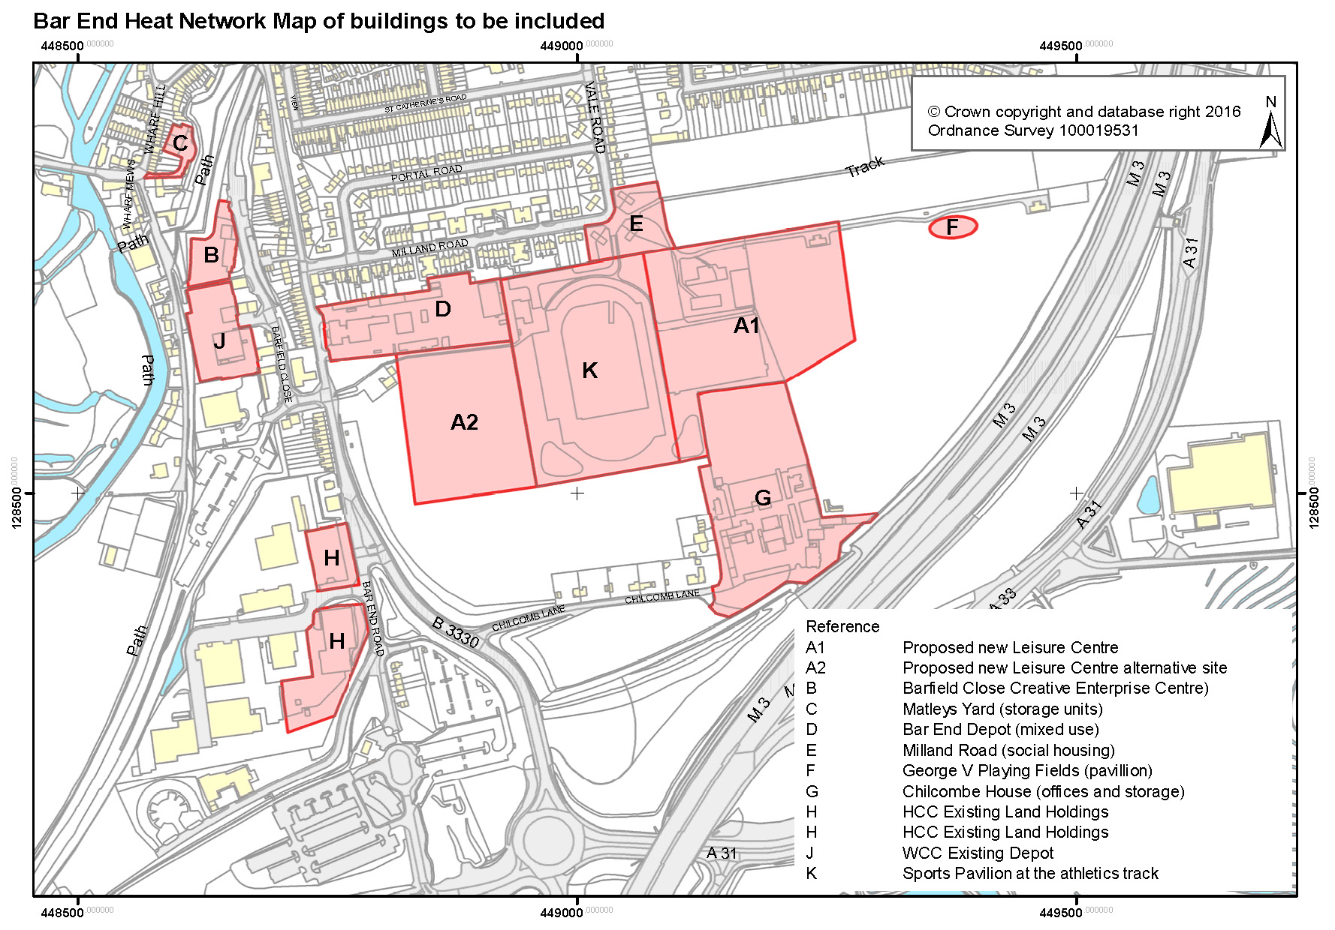
Map 2

