|  |  |
| --- | --- |
| **Whole Site Risk Assessment Record – Chippenham Fen National Nature Reserve** |  |

|  |  |  |  |  |  |  |
| --- | --- | --- | --- | --- | --- | --- |
| NNRs covered | **Chippenham Fen** | | | | | |
| Assessment of: | Whole site risk assessment | | | | | |
| Training Required? | N/A | | | NE High Risk Category |  | |
| Date completed | 25/8/2023 | | | Review Date | 25/8/2024 | |
| Signed off by (SRM name) | Chris Hainsworth | | | | | |
| What are the Hazards? | | Who might be harmed and how? | What precautions are you already taking? | | | Further Action |
| **Travelling to & from the site**  Small narrow country roads and blind corner on approach. | | Staff, Volunteers & Visitors  Travelling in poor weather/low light conditions – potential for driving accident  Access at Park farm blind corner – potential for traffic accident. | Provide all visitors with ‘How to find Us’ map which advises not to turn off on blind corner but approach from Snailwell direction  Reinforce need to drive slowly to avoid creating dust issue which upsets neighbours. | | |  |
| **Visiting Fen**  Trips, slips and falls due to soft, uneven ground and mud. | | Staff, Volunteers & Visitors  Falls, Sprains and breaks | Highlight issue to all site users.  Provide all site users with a Site Hazard map.  Encourage all site users to keep to designated paths.  Issue staff with good footwear.  Encourage all visitors to wear boots/ suitable foot wear.  Mow rides and tracks to make access easy.  Keep outside of work base clear of mud in winter. | | |  |
| **Visiting Fen**  Dykes and ponds obscured by vegetation  Old peat workings and Springs obscured by vegetation | | Staff, Volunteers & Visitors  Falling into water bodies/old peat workings / becoming stuck /lost /drowning. | Issue Site Hazard map to all visitors.  Warn people not to venture of the path and if do then proceed with caution.  Always stress dangers to visitors  Work base has shower, emergency blanket and spare clothes to prevent people getting hypothermia if immersed. | | |  |
| **Visiting Fen**  Walking adjacent to water:  where depth, temperature, current, visibility, obstruction and pollutants are unknown factors | | Staff, Volunteers & Visitors  Accidental immersion  Staff/volunteers lack of risk assessment awareness and training in relation to working on/adjacent to water | Procedures available for such activities which include: • risk assessment of the task;  -appropriate manning levels;  -definition of the criteria permitting entry into the watercourse;  -specifying factors precluding entry;  provision of approved lifejacket;  -conditions/times when wearing lifejacket is mandatory;  -provision of rescue equipment;  -On-site risk assessment by operator | | |  |
| **Visiting Fen**  Reedbeds/ tall fen  Disorientation | | Staff, Volunteers & Visitors  Falling into water bodies/old peat workings / becoming stuck /lost /drowning | Mobile phones are issued to all staff away from offices carrying out field trips.  Lone working discouraged. | | |  |
| **Visiting Fen**  Reedbeds/ tall fen  Reeds – sharp edges | | Staff, Volunteers & Visitors  Saw Sedge has row of tiny teeth on leaf vein which can cause cuts/lacerations | Staff reminded to wear appropriate protective clothing and to cover legs and arms. (Gloves, robust waders,eye protection)  Field staff are emergency first aid trained and are issued with a first aid kit. | | |  |
| **Visiting Fen**  Reedbeds/ tall fen  Trips, slips and falls due to soft ground, Wet holes /dykes obscured by vegetation | | Staff, Volunteers & Visitors  Sprains, drowning | Guidance provided to relevant staff highlight the need to keep to obvious crossing points, consult relevant map before entering reed bed block. | | |  |
| **Visiting Fen**  Biting Insects | | Staff, Volunteers & Visitors  Adverse skin reactions | Encourage keeping bare skin minimal,  Insect repellent is recommend and provided for staff and contractors. | | |  |
| **Visiting Fen**  Ticks & Lyme’s disease.  Weils disease  Tetanus | | Staff, Volunteers & Visitors  Could contract a disease following exposure to pathogen on site | Discuss issues with all groups that visit the site. In particular discuss the high number of deer on site and what to look out for with Tick bites.  Awareness of rat problem and consider control if droppings and urine are found in shed.  Request all staff keep tetanus program upto date.  Encourage handwashing before food.  In field provide handwash gel.  All tick bites to be recorded as accidents on NE form. | | |  |
| **Visiting fen**  Site infrastructure – Fences, gates, Styles. | | Staff, Volunteers & Visitors Electric fences can give shocks causing heart issues in some.  Barbed Wire fences can cause cuts and entanglement.  Styles can be a trip hazard | All infrastructure to be checked quarterly.  Warn people of electric fences – consider turning off for events.  Always use gates to enter/exit fields. If not using gates encourage folks to roll under fences rather that climb over.  Maintain record of infrastructure check | | |  |
| **Visiting fen**  Tree Safety | | Staff, Volunteers & Visitors  Trees or branches falling and injuring/killing. | Undertake tree safety audit annually and bi annually seek professional advice.  Cancel work/events in high wind.  Act upon findings of Tree safety audit in timely manner.  Maintain constant vigilance and deal with any concerns immediately. | | |  |
| **Buffalo**  Unpredictable livestock, large horns, sharp hooves.  Inquisitive nature | | Staff, Volunteers & Visitors Can butt & kick, cause falls trips, piercing injuries and bruising | Untrained visitors or groups should not enter field with buffalo present.  All staff handling/checking buffalo are mentored by an experienced colleague. Continuous on the job assessment of the task to ensure we are doing it the best way. | | |  |
| **Buffalo**  Exposure to Zoonoses | | Staff, Volunteers & Visitors May pick up scab, E. Coli infections etc | Ensure hand wash/ anti bacterial gel is available for use after handling sheep/ before refreshments.  Brief staff on risks.  Monitor incidence of illness following handling events.  Request staff get up to date ‘tetanus’ and record date of injection. | | |  |
| **Anti social behaviour** | | Staff, Volunteers & Visitors  Physical / verbal abuse / Assault | Interactions with individuals or groups who are misusing the site should be handled carefully especially if lone working or at evenings/ early mornings. Retreating and calling the police is first response.  All staff to comply with NE lone working protocol | | |  |

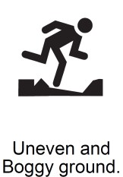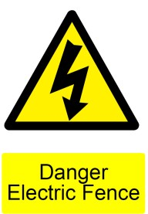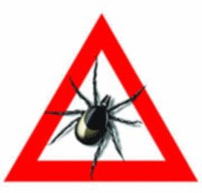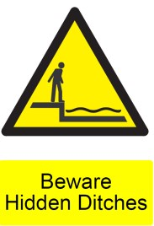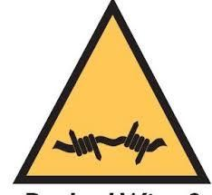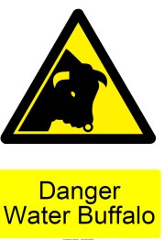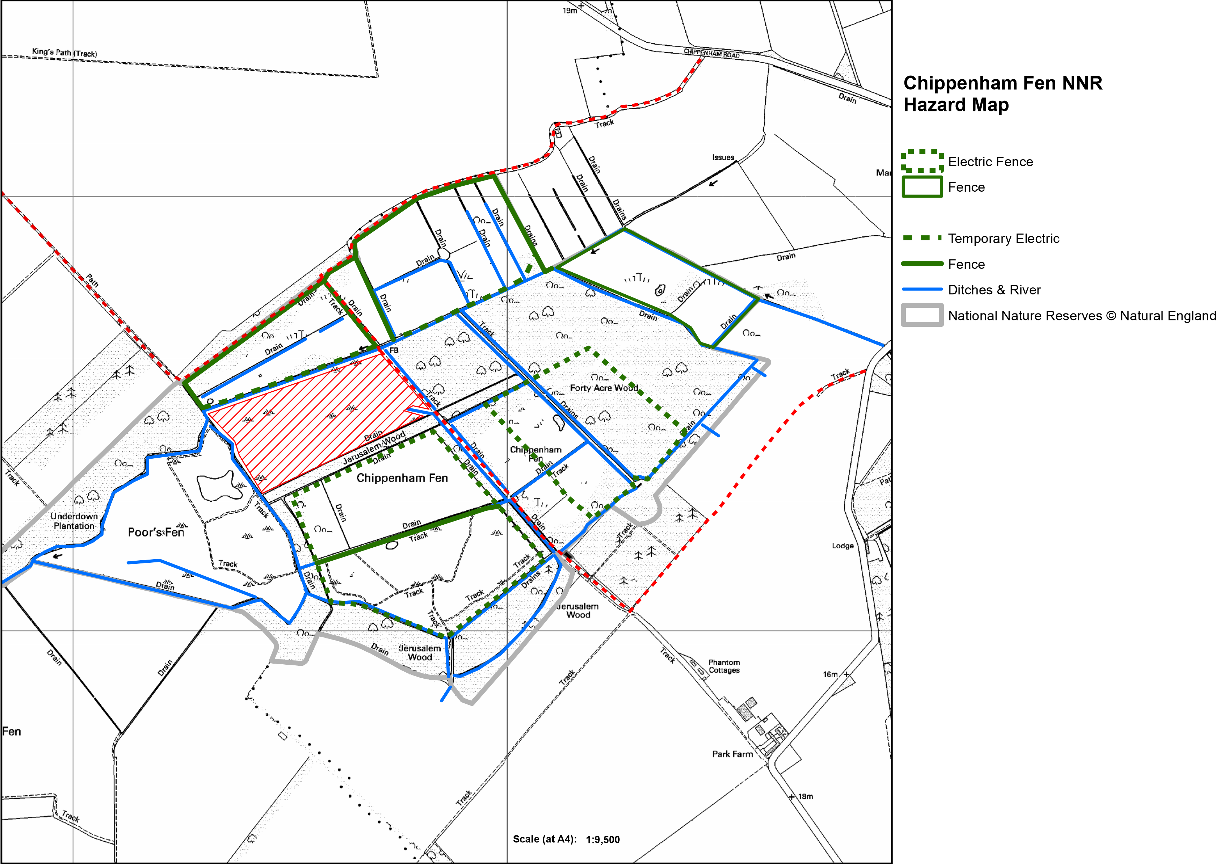

Hazards

* Water Buffalo & Cattle
* Deep Ditches with cold water
* Uneven, wet and muddy ground
* Trees- Be aware in High Winds.
* Ticks & Biting or stinging insects. Cover body appropriately and check for ticks when home;

THINK LYME DISEASE

* Weils disease

**In Case of Emergency**

Office: 01638 721329

Grid Ref: TL653691

Postcode for base: CB7 5QB

What3 Words for Office: **basics.stands.scoots**

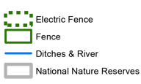

 Footpath

DO NOT ACCESS

HIDDEN WET PITS