

www.gov.uk/naturalengland

Request for Quotation

UNDERSTANDING THE IMPACTS OF CLIMATE CHANGE ON LANDSCAPE CHARACTER

28 September 2023

Request for Quotation
UNDERSTANDING THE IMPACTS OF CLIMATE CHANGE ON LANDSCAPE CHARACTER

You are invited to submit a quotation for the requirement described in the specification, Section 2.
Please confirm by email, receipt of these documents and whether you intend to submit a quote or not.
Your response should be returned to the following email address by:
Email: Catherine.fallon@naturalengland.org.uk
Date: 27 October 2023
Time: 17:00 GMT
Ensure you include the name of the quotation and ‘Final Submission’ in the subject field to make it clear that it is your response.
Contact Details and Timetable
Catherine Fallon will be your contact for any questions linked to the content of the quote or the process. Please submit any clarification questions via email and note that, unless commercially sensitive, both the question and the response will be circulated to all tenderers.

Action | Date
Date of issue of RFQ | 28 September 2023 at 17:00 GMT
Deadline for clarifications questions | 19 October 2023 at 17:00 GMT
Deadline for receipt of Quotation | 27 October 2023 at 17:00 GMT
Intended date of Contract Award | 2 November 2023
Intended Contract Start Date | 6 November 2023
Intended Delivery Date / Contract Duration | 31 March 2024

Section 1: General Information
Glossary
Unless the context otherwise requires, the following words and expressions used within this Request for Quotation shall have the following meanings (to be interpreted in the singular or plural as the context requires):
“Authority” | means Natural England who is the Contracting Authority.
“Contract” | means the contract to be entered into by the Authority and the successful supplier.
“Response” | means the information submitted by a supplier in response to the RFQ.
“RFQ” | means this Request for Quotation and all related documents published by the Authority and made available to suppliers.

Conditions applying to the RFQ
You should examine your Response and related documents ensuring it is complete and in accordance with the stated instructions prior to submission.
Your Response must contain sufficient information to enable the Authority to evaluate it fairly and effectively. You should ensure that you have prepared your Response fully and accurately and that prices quoted are arithmetically correct for the units stated.
By submitting a Response, you, the supplier, are deemed to accept the terms and conditions provided in the RFQ. Confirmation of this is required in Annex 2.
Failure to comply with the instructions set out in the RFQ may result in the supplier’s exclusion from this quotation process.

Acceptance of Quotations
By issuing this RFQ the Authority does not bind itself to accept any quotation and reserves the right not to award a contract to any supplier who submits a quotation.
Costs
The Authority will not reimburse you for any costs and expenses which you incur preparing and submitting your quotation, even if the Authority amends or terminates the procurement process.
Self-Declaration and Mandatory Requirements
The RFQ includes a self-declaration response (Annex 1) which covers basic information about the supplier, as well as any grounds for exclusion. If you do not comply with them, your quotation will not be evaluated.
Any mandatory requirements will be set out in Section 2, Specification of Requirements and, if you do not comply with them, your quotation will not be evaluated.
Clarifications
Any request for clarification regarding the RFQ and supporting documentation must be submitted via email no later than the deadline for clarifications set out in the Timetable. The Authority shall be under no obligation to respond to queries raised after the clarification deadline.
The Authority will respond to all reasonable clarifications as soon as possible but cannot guarantee a minimum response time. The Authority will publish all clarifications and its responses to all suppliers via email unless deemed commercially sensitive.
If a supplier believes that a request for clarification is commercially sensitive, it should clearly state this when submitting the clarification request. However, if the Authority considers either that:
- the clarification and response are not commercially sensitive; and
- all suppliers may benefit from its disclosure,
then the Authority will notify the supplier (via email), and the supplier will have an opportunity to withdraw the request for clarification by sending a further message requesting the withdrawal of the clarification request. If not withdrawn by the supplier within 2 working days of the Authority’s notification, the Authority may publish the clarification request and its response to all suppliers and the Authority shall not be liable to the supplier for any consequences of such publication.
The Authority reserves the right to seek clarification of any aspect of a quotation and/or provide additional information during the evaluation phase to carry out a fair evaluation. Where the Authority seeks clarification on any aspect of the quotation, the supplier must respond within the timeframe requested by the Authority.
Amendments
The Authority may amend the RFQ at any time prior to the deadline for receipt. If it amends the RFQ the Authority will notify you via email.
Suppliers may modify their quotation prior to the deadline for Responses. No Responses may be modified after the deadline for Responses.
Suppliers may withdraw their quotations at any time by submitting a notice via the email to the named contact.
Conditions of Contract
The Authority’s Standard Condensed Terms and Conditions provided as part of the RFQ will be included in any contract awarded as a result of this quotation process. The Authority will not accept any changes to these terms and conditions proposed by a supplier.
Suppliers should note that the quotation provided by the successful bidder will form part of the Contract.
Prices
Prices must be submitted in £ sterling, inclusive of VAT.
We are seeking to deliver the specification within a financial budget range of £40,000 to £60,000 (inclusive of VAT).
IMPORTANT: Please note the estimated budget range is between £32,000 - £48,000 excluding VAT, the estimated contract value including VAT is £40,000 - £60,000. Tenders should be submitted including VAT.
Disclosure
All Central Government Departments, their Executive Agencies and Non Departmental Public Bodies are subject to control and reporting within Government. In particular, they report to the Cabinet Office and HM Treasury for all expenditure. Further the Cabinet Office has a cross-Government role delivering overall Government policy on public procurement, including ensuring value for money and related aspects of good procurement practice. For these purposes, the Authority may disclose within Government any details contained in your quotation. The information will not be disclosed outside Government during the procurement.
In addition, the Authority is subject to the Freedom of Information Act 2000 and the Environmental Information Regulations 2004, which provide a public right of access to information held by public bodies. In accordance with these two statutes, the Authority may be required to disclose information contained in your quotation to any person who submits a request for information pursuant to those statutes.
Further to the Government’s transparency agenda, all UK Government organisations must advertise on Contract Finder in accordance with the following publication thresholds:
Central Contracting Authority’s: £12,000
Sub Central Contracting Authority’s and NHS Trusts: £30,000

For the purpose of this RFQ the Authority is classified as a Central Contracting Authority with a publication threshold of £12,000 inclusive of VAT.
If this opportunity is advertised via Contracts Finder, we are obliged to publish details of the awarded contract including who has won the contract, the contract value, and indicate whether the winning supplier is a small and medium-sized enterprise (“SMEs”) or voluntary organisation or charity. A copy of the contract must also be published with confidential information redacted.
By submitting a Response, you consent to these terms as part of the procurement.
Disclaimers
Whilst the information in this RFQ and any supporting information referred to herein or provided to you by the Authority have been prepared in good faith the Authority does not warrant that this information is comprehensive or that it has been independently verified.
The Authority does not:
- make any representation or warranty (express or implied) as to the accuracy, reasonableness or completeness of the RFQ;
- accept any liability for the information contained in the RFQ or for the fairness, accuracy or completeness of that information; or
- accept any liability for any loss or damage (other than in respect of fraudulent misrepresentation or any other liability which cannot lawfully be excluded) arising as a result of reliance on such information or any subsequent communication.
Any supplier considering entering into contractual relationships with the Authority following receipt of the RFQ should make its own investigations and independent assessment of the Authority and its requirements for the goods and/or services and should seek its own professional financial and legal advice.

Protection of Personal Data
In order to comply with the General Data Protection Regulations 2018 the supplier must agree to the following:
- You must only process any personal data in strict accordance with instructions from the Authority.
- You must ensure that all the personal data that we disclose to you or you collect on our behalf under this agreement are kept confidential.
- You must take reasonable steps to ensure the reliability of employees who have access to personal data.
- Only employees who may be required to assist in meeting the obligations under this agreement may have access to the personal data.
- Any disclosure of personal data must be made in confidence and extend only so far as that which is specifically necessary for the purposes of this agreement.
- You must ensure that there are appropriate security measures in place to safeguard against any unauthorised access or unlawful processing or accidental loss, destruction or damage or disclosure of the personal data.
- On termination of this agreement, for whatever reason, the personal data must be returned to us promptly and safely, together with all copies in your possession or control.
General Data Protection Regulations 2018
For the purposes of the Regulations the Authority is the data processor.
The personal information that we have asked you provide on individuals (data subjects) that will be working for you on this contract will be used in compiling the tender list and in assessing your offer. If you are unsuccessful the information will be held and destroyed within two years of the award of contracts. If you are awarded a contract it will be retained for the duration of the contract and destroyed within seven years of the contract’s expiry.
We may monitor the performance of the individuals during the execution of the contract, and the results of our monitoring, together with the information that you have provided, will be used in determining what work is allocated under the contract, and in any renewal of the contract or in the award of future contracts of a similar nature. The information will not be disclosed to anyone outside the Authority without the consent of the data subject, unless the Authority is required by law to make such disclosures.
Equality, Diversity & Inclusion (EDI)
The Client is striving to create a diverse and inclusive working environment where every individual has equality of opportunity to progress and to apply their unique insights to making the UK a great place for living. The Service Provider is expected to respect this commitment in all dealings with Natural England staff and service users.
Suppliers are expected to;
- Support Defra group to achieve its Public Sector Equality Duty as defined by the Equality Act 2010, and to support delivery of Defra group’s Equality & Diversity Strategy.
- Meet the standards set out in the Government’s Supplier Code of Conduct
- Work with Defra group to ensure equality, diversity and inclusion impacts are addressed (positive and negative) in the goods, service and works we procure, barriers are removed and opportunities realised.
Sustainable Procurement
Addressing global sustainability impacts and realising additional community benefits within commercial activity is core to Defra group’s approach, working with its supply chain is key to achieving sustainable outcomes. In addition to supporting Defra group to meet its outcomes we look to understand and reduce negative sustainability impacts associated with our commercial activity and realise benefits.
The Client encourages its suppliers to share these values, work to address negative impacts and realise opportunities, measure performance and success.
Suppliers are expected to have an understanding of the Sustainable Development Goals, the interconnections between them and the relevance to the Goods, Services and works procured on the Client’s behalf
Conflicts of Interest
The concept of a conflict of interest includes but is not limited to any situation where an Involved Person or Relevant Body has directly or indirectly, a financial, economic or other personal interest which might be perceived to compromise their impartiality and independence in the context of the procurement procedure and/or affect the integrity of the contract award.
We expect suppliers to mitigate appropriately against any real or perceived conflict of interest through their work with government. A supplier with a position of influence gained through a contract should not use that position to unfairly disadvantage any other supplier or reduce the potential for future competition
Where the supplier is aware of any circumstances giving rise to a conflict of interest or has any indication that a conflict of interest exists or may arise you should inform the Authority of this as soon as possible (whether before or after they have submitted a quotation). Tenderers should remain alert to the possibility of conflicts of interest arising at all stages of the procurement and should update the Authority if any new circumstances or information arises, or there are any changes to information already provided to the Authority. Failure to do so, and/or to properly manage any conflicts of interest may result in a quotation being rejected.
Provided that it has been carried out in an open, fair and transparent manner, routine pre-market engagement carried out by the Authority should not represent a conflict of interest for the supplier.

Section 2: The Invitation
Specification of Requirements
UNDERSTANDING THE IMPACTS OF CLIMATE CHANGE ON LANDSCAPE CHARACTER

Background to Natural England

Natural England are the government’s adviser for the natural environment in England. We help to protect and restore our natural world. Natural England is an executive non-departmental public body, sponsored by the Department for Environment, Food & Rural Affairs.

Our vision is ‘Thriving Nature for people and planet.’ We aim to achieve this through our mission ‘Building partnerships for Nature’s recovery.’ Our priorities for 2020 to 2025 support our mission and the ambitions of the government’s 25 Year Environment Plan. We aim for:

- A well-managed Nature Recovery Network across land, water, and sea, which creates and protects resilient ecosystems rich in wildlife and natural beauty, enjoyed by people and widely benefiting society.

- People connected to the natural environment for their own and society’s wellbeing, enjoyment, and prosperity.

- Nature-based solutions contributing fully to tackling the climate change challenge and wider environmental hazards and threats.

- Improvements in the natural capital that drives sustainable economic growth, healthy food systems and prospering communities.

- Evidence and expertise being used by a broad range of partnerships, organisations, and communities to achieve Nature recovery and enable effective regulation and accreditation.

- Being a values-led organisation that delivers excellent service standards to all partners, organisations and communities engaged in achieving Nature’s recovery.

For more information about our procurement policies please see Procurement at Natural England - Natural England - GOV.UK (www.gov.uk).

We lead on setting standards, and in the delivery of Natural England’s statutory role as the Government’s landscape adviser providing advice across government and responsible authorities to maximise the role and contribution of our landscapes and seascapes.

We also have a role in improving the delivery of outcomes from the protected landscapes. We disseminate landscape, historic environment, cultural
heritage and geodiversity evidence and advice and are reviewing our priorities for evidence including our National Character Area (NCA) profiles.

https://www.gov.uk/government/publications/national-character-area-profiles-data-for-local-decision-making/national-character-area-profiles
We have provided standards for the implementation of various work areas including the Tree Action Plan, Nature Recovery Network, and species reintroduction programmes.
We require up-to-date evidence about our landscapes and we monitor landscape character change over time. This information is used to inform future policies and strategies around climate change and the impact on landscape character.

Background relevant to the Understanding the Impacts of Climate Change on Landscape Character project

The Climate Change Act of 2008, requires the government to complete a Climate Change Risk Assessment (CCRA) every 5 years, followed by a National Adaptation Programme (NAP). The government is currently in its third statutory cycle of national risk assessment and adaptation planning.

The latest CCRA published in January 2022 identified 61 climate change risks including a risk identifying that climate change will have an impact on landscape character (Risk N18). It also identified that there is lack of evidence regarding the extent and impact of this risk.

The latest National Adaptation Programme, NAP3 published in July 2023 includes a specific action to commission research to help understand the impacts of climate change on landscape character. This commission follows on as a direct response to the action identified in NAP3.
The Third National Adaptation Programme (NAP 3)
https://assets.publishing.service.gov.uk/government/uploads/system/uploads/attachment_data/file/1172931/The_Third_National_Adaptation_Programme.pdf
NAP3 Annex 1: Climate risks and opportunities (publishing.service.gov.uk)

Project requirements

This project will include the following tasks and outputs.

Task 1 - Literature Review
This task is to undertake a literature review of the available evidence and information on climate change, as relevant to understanding the impacts of climate change on landscape character. This literature review will help inform the findings of this report. An initial list of relevant Natural England literature is included at Annex 3, to form a starting point for the successful contractor.

The purpose of this literature review is to gain an overview of the research already conducted on the impacts of climate change on the environment, and specifically to highlight any evidence that could help inform an understanding of its impacts on landscape character. It will include a review of existing research, scientific papers, policies and plans in relation to climate change and the natural environment.

In addition to a literature review, this initial task should provide an initial (rather than in-depth) exploration of other resources such as satellite images and other earth observation data and arial photography (for example WW2 reconnaissance photographs) in order to demonstrate how such resources can help develop a better understanding of the impacts of climate change on landscape character. Tenderers are invited to propose how these resources could be considered as part of this review (and potentially incorporated in the profiles developed at Task 3).

Task 2 - Groupings of National Character Areas
This task is to explore appropriate ‘groupings’ or ‘typologies’ of England’s 159 National Character Areas where the impacts and land management responses to climate change are likely to be similar. This is for the purpose of presenting the evidence gained from the literature review (Task 1) at a strategic level which could be signposted from the relevant NCA profiles (a new interactive web platform for the NCA profiles is currently in development).

Contractors should explore whether the following typologies are fit for purpose for this task:
- Agricultural Landscape Types (ALTs),
- Broad Landscape Types
- ALTs plus the sub-ALTs including coastal types (being developed by LUC (Land Use Consultants) for a current Natural England project to compile a Landscape Change Atlas); and
- the Archetypes being developed by the Climate Change Commission.
Further information on the above typologies is provided in Annex 4.

Following this exploration, an appropriate typology for this research should be recommended and presented for agreement with Natural England. Each type (within the recommended typology) should be described using bullet-pointed key landscape characteristics, to carry through into the profiles developed under Task 3. GIS outputs from this task, such as the digitised mapping of the recommended typology and presentation of findings also associated with task 3 will form a project output.

The chosen landscape types should correlate with how that landscape is likely to respond to the impacts of climate change, showing both the direct impacts of climate change itself, and the likely changes to the landscape as a result of adaptation or mitigation measures.

Task 3 - Illustrated Profiles
Contractors are required to design (in agreement with Natural England) illustrated profiles to present evidence on the climate change impacts on landscape character, using the recommended typology. We would welcome ideas on content from contractors, but it is likely to include:
- A map showing the location of the landscape types across England referencing component NCAs and protected landscapes (National Parks and Areas of Outstanding Natural Beauty)
- The key characteristics of the landscape type (as provided under Task 2)
- How the characteristics of the landscape are likely to be impacted by climate change; assuming no intervention (with reference to different timelines agreed with Natural England)
- How the characteristics of the landscape might change/respond to adaptation measures
- Recommendations for adaptation/mitigation measures appropriate to the landscape concerned – including how the public/local communities might be engaged in decisions about future change.
- The landscape typology and the illustrated profiles (used alongside NCA Profiles) should be capable of providing a national framework of spatial information, landscape principles and advice as context for local initiatives and decision making (see task 4)
This information should be presented in accordance with mandatory accessibility standards as far as possible, whilst being suited to a broad professional audience (but not necessarily the landscape profession). They should also include photographs and sketches/diagrams for illustration and be around 6 pages in length. Aspects to consider in terms of presenting information on landscape character impacts should include the following:
- Impacts on natural habitats / flora and fauna
- Cultural and social changes
- Impacts on perceptual and aesthetic qualities
The ‘Landscape Wheel’ (Diagram 1) serves as a useful guide to help identify the key features and elements that form landscape character. This helps guide an understanding of landscape character, factoring in the different aspects that interact to produce distinctive landscape character.

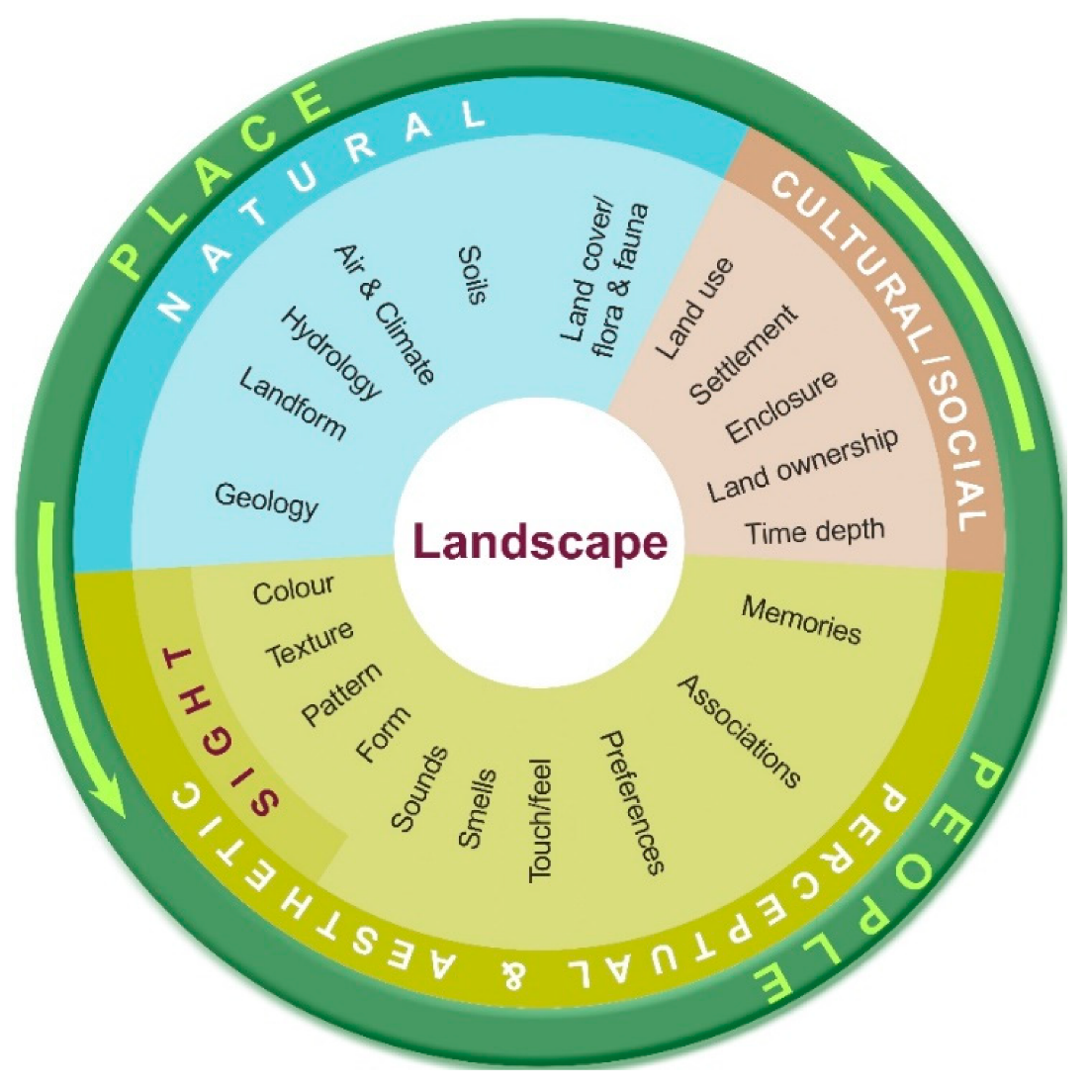

Diagram 1 – The Landscape Wheel

An illustrated profile should be written for all the typologies that have been agreed with Natural England. The total number and types of typology selected forms part of Task 2 above.

Prior to the roll out of the full set of profiles, a pilot profile study will be presented to the project steering group by 1 January 2023. This pilot study profile will include lowland heathlands and their landscape context as a focus and the profile will also be used to complete task 4 (see below).

Task 4 - Collaborative work with Natural England’s Thames Solent Team
The overall aim of this task is to investigate how the ‘national’ outputs from this commission (such as the climate change profiles) and local initiatives can best inform one another.

It will involve working collaboratively with the Natural England project manager for this commission and Natural England’s Thames Solent, Senior Landscape Advisor, in developing a better understanding of the work being undertaken in relation to a climate change research project in one of Natural England’s Priority Places, the Heathlands Priority Place.

This project is using some of the guidelines in Natural England’s Climate Change Adaptation Manual ( NE751 ) published in 2020 to develop a methodology for assessing habitat at local level and how to integrate climate change integration into pilot projects that are being delivered as part of Natural England’s nature recovery objective.

This task is being included into this project in order to demonstrate how climate change guidelines are being implemented at local scale and to explore how they can incorporate assessment of landscape impacts (as well as habitats) and how well they correlate with principles/actions at a national scale identified in task 3.

There is an ambition to assess the potential climate change implications for groupings of Sites of Special Scientific Interest (SSSI) in order to provide a strategic view of potential solutions. In addition, there is an ambition to develop a link between the NCA typologies and SSSI typologies. The Heathland Priority Place project is a good site to explore this thinking further, with a pilot project which incorporates several SSSIs in the large areas of heathland centred on the Basingstoke, Farnham, Fleet area.

This pilot project working collaboratively with a team at a local scale will enable us to address the link to different habitats in different landscape typologies and how these are impacted by climate change. Future projects could potentially give some consideration to how protected landscapes and the different SSSIs in protected landscape are impacted by climate change.

This task is expected to include:
- Attendance at a site visit (organised by Natural England) to understand the Heathland’s Priority Place project and the landscape context
- One workshop with a small number of key stakeholders (organised collaboratively with Natural England) for which presentational content and reporting will be provided by the supplier
- A case study report with lessons learnt and recommendations

Task 5 - Report
Produce a project report which includes a summary of the information gathered from the literature review, ideally presented by landscape type (with reference to the full profiles produced under this contract). The report will also make an assessment of the likely climate change impacts on landscape character for each of the landscape types that have been identified.

Contractors should also provide a 2-page Executive Summary (content to be agreed with Natural England).

Task 6 - Webinar
In addition to the Report and Executive Summary, we require a presentation of the study findings to Natural England staff at a webinar. The material used for this presentation (e.g., PowerPoint slides) should be provided to Natural England, as a further contract output.

Project Meetings
In addition to the meetings outlined in the Tasks above, other meetings and key contact points should be built into the tender process and should include:

- An initial inception meeting with Natural England’s Steering Group to confirm the scope of the work and the steps the contractor intends to take to meet the project requirements.
- Fortnightly updates with the Project Manager via MS Teams calls, emails and/or telephone calls.
- Virtual meetings with the project manager and other Natural England staff at key points in the project.
- Allowance of one in person meeting as part of a potential smaller stakeholder group.
- A final virtual meeting with the internal Steering Group to present the draft report.
Payment

The Authority will raise purchase orders to cover the cost of the services which will be issued to the awarded supplier following contract award.
The Authority’s preference is for all invoices to be sent electronically, quoting a valid Purchase Order number. Supplier to submit invoices in two instalments, with the first invoice to be submitted mid-January and the final invoice to be submitted after completion of all the work outputs and no later than mid-March 2024. Invoices will be paid following a review by the project manager that the required outputs have been satisfactorily completed.
It is anticipated that this contract will be awarded for a period of five months, to end no later than March 2024. Prices will remain fixed for the duration of the contract award period. We may at our sole discretion extend this contract to include related or further work. Any extension shall be agreed in writing in advance of any work commencing and may be subject to further competition.
Supporting Documents
Contractors submitting a tender for this project will be asked to provide Natural England with:
● details of research methodologies to be used
● CVs of the staff and subcontractors contributing to the project
● examples of past work
● Timetable (Gantt Chart or similar)
● Risk assessment and contingencies for ensuring successful completion of the contract.
● Quality assurance measures

Evaluation Methodology
We will award this contract in line with the most economically advantageous tender (MEAT) as set out in the following award criteria:
Technical – 60%
Commercial – 40%
Evaluation criteria
Evaluation weightings are 60% technical and 40% commercial, the winning tenderer will be the highest scoring combined score.
Award Criteria | Weighting (%) | Evaluation Topic & Weighting | Sub-Criteria | Weighted Question
Technical | 60% | Service / Product Proposal | Methodology | 6 Questions  Q1.1 Literature Review  10% of technical score  Q1.2 Typologies Task  10% of technical score  Q1.3 Profiles Task  10% of technical score  Q1.4 Thames Solent Task  10% of technical score  Q1.5 Report Task  10% of technical score  Q1.6 Presentation Task 10% of technical score
Technical | 60% | Service / Product Proposal | Key personnel | Q2 – Staff CVs  10% of technical score
Technical | 60% | Service / Product Proposal | Quality Assurance measures | Q3.1 - Materials  10% of technical score  Q3.2 - Previous Projects  10% of technical score
Technical | 60% | Service / Product Proposal | Risks & Constraints | Q4 – Risk Assessment  10% of technical score
Commercial | 40% | Whole life cost of the proposed Contract | Commercial Model | 100% of commercial score

Technical 60%
Technical evaluations will be based on responses to specific questions covering key criteria which are outlined below. Scores for questions will be based on the following:
Description | Score | Definition
Very good | 100 | Addresses all the Authority’s requirements with all the relevant supporting information set out in the RFQ. There are no weaknesses and therefore the tender response gives the Authority complete confidence that all the requirements will be met to a high standard.
Good | 70 | Addresses all the Authority’s requirements with all the relevant supporting information set out in the RFQ. The response contains minor weaknesses and therefore the tender response gives the Authority confidence that all the requirements will be met to a good standard.
Moderate | 50 | Addresses most of the requirements with most of the relevant supporting information set out in the RFQ. The response contains moderate weaknesses and therefore the tender response gives the Authority confidence that most of the requirements will be met to a suitable standard.
Weak | 20 | Substantially addresses the requirements but not all and provides supporting information that is of limited or no relevance or a methodology containing significant weaknesses and therefore raises concerns for the Authority that the requirements may not all be met.
Unacceptable | 0 | No response or provides a response that gives the Authority no confidence that the requirement will be met.

Technical evaluation is assessed using the evaluation topics and sub-criteria stated in the Evaluation Criteria section above.
Separate submissions for each technical question should be provided and will be evaluated in isolation. Tenderers should provide answers that meet the criteria of each technical question.

Criteria | Detailed Evaluation Criteria
Q1.1  Provide details of your understanding of the key aims of the Literature Review and how you will approach this task. | Your response should:  1) Demonstrate a clear understanding of the nature of the requirements.  2) Be a clear, practical, achievable, and cost-effective methodology to deliver these requirements.  3) Have information in sufficient detail to allow a full appraisal of the suitability of the approach to deliver for the project.
Q1.2  Provide details of your understanding of the key aims of the Typologies Task and how you will approach this task. | Your response should:  1) Demonstrate a clear understanding of the nature of the requirements.  2) Be a clear, practical, achievable, and cost-effective methodology to deliver these requirements.  3) Have information in sufficient detail to allow a full appraisal of the suitability of the approach to deliver for the project.
Q1.3  Provide details of your understanding of the key aims of the Profiles Task and how you will approach this task. | Your response should:  1) Demonstrate a clear understanding of the nature of the requirements.  2) Be a clear, practical, achievable, and cost-effective methodology to deliver these requirements.  3) Have information in sufficient detail to allow a full appraisal of the suitability of the approach to deliver for the project.
Q1.4  Provide details of your understanding of the key aims of the Thames Solent Task and how you will approach this task. | Your response should:  1) Demonstrate a clear understanding of the nature of the requirements.  2) Be a clear, practical, achievable, and cost-effective methodology to deliver these requirements.  3) Have information in sufficient detail to allow a full appraisal of the suitability of the approach to deliver for the project.
Q1.5  Provide details of your understanding of the key aims of the Report Task and how you will approach this task. | Your response should:  1) Demonstrate a clear understanding of the nature of the requirements.  2) Be a clear, practical, achievable, and cost-effective methodology to deliver these requirements.  3) Have information in sufficient detail to allow a full appraisal of the suitability of the approach to deliver for the project.
Q1.6  Provide details of your understanding of the key aims of the Presentation Task and how you will approach this task. | Your response should:  1) Demonstrate a clear understanding of the nature of the requirements.  2) Be a clear, practical, achievable, and cost-effective methodology to deliver these requirements.  3) Have information in sufficient detail to allow a full appraisal of the suitability of the approach to deliver for the project.

Personnel | Detailed Evaluation Criteria
Q2  Provide evidence of experienced and qualified staff to deliver the project to the required specification, timelines and project budget. | CVs of key staff involved.

Quality Assurance | Detailed Evaluation Criteria
Q3.1  Provide details of your ability to provide materials in the specified format, using the required time periods and timeline formats? | Demonstrate GIS mapping and other IT skills, graphic design skills and illustration and drawing skills.
Q3.2  Provide evidence of previous relevant projects. | Provide copies of other projects of similar scope and complexity completed in the past 5 years.

Risk Assessment | Detailed Evaluation Criteria
Q4  Provide details of your understanding of the risk and constraints of this project. | Provide a risk assessment for this project and contingency measures to ensure successful completion of the contract.

Commercial (40%)
The Contract is to be awarded as a fixed price which will be paid according to the completion of the deliverables stated in the Specification of Requirements.
Suppliers are required to submit a total cost to provide the deliverables stated in the Specification of Requirements. In addition to this the Commercial Response template must be completed to provide a breakdown of the whole life costs against each deliverable used in the delivery of this requirement.
Calculation Method
The method for calculating the weighted scores is as follows:
Commercial
Score = (Lowest Quotation Price / Supplier’s Quotation Price) x 40% (Maximum available marks)
Technical
Score = (Bidder’s Total Technical Score / Highest Technical Score) x 60% (Maximum available marks)
The total score (weighted) (TWS) is then calculated by adding the total weighted commercial score (WC) to the total weighted technical score (WT): WC + WT = TWS.
Information to be returned
Please note, the following information requested must be provided. Incomplete tender submissions may be discounted.
- Completed Commercial Response template
- Separate response submission for each technical question (in accordance with the response instructions)
- Completed Mandatory Requirements (Annex 1)
- Completed Acceptance of Terms and Conditions (Annex 2)
- Project programme (Gannt chart or similar)

Award
Once the evaluation of the Response(s) is complete all suppliers will be notified of the outcome via email.
The successful supplier will be issued the contract, incorporating their Response, for signature. The Authority will then counter sign.

Annex 1 Mandatory Requirements
Part 1 Potential Supplier Information
Please answer the following self-declaration questions in full and include this Annex in your quotation response.
Part 1.1 Potential Supplier Information:
Question no. | Question | Response
1.1(a) | Full name of the potential supplier submitting the information
1.1(b) | Registered office address (if applicable)
1.1(c) | Company registration number (if applicable)
1.1(d) | Charity registration number (if applicable)
1.1(e) | Head office DUNS number (if applicable)
1.1(f) | Registered VAT number
1.1(g) | Are you a Small, Medium or Micro Enterprise (SME)? | (Yes / No)
Note: See EU definition of SME https://ec.europa.eu/growth/smes/business-friendly-environment/sme-definition_en
Part 1.2 Contact details and declaration
By submitting a quotation to this RFQ I declare that to the best of my knowledge the answers submitted and information contained in this document are correct and accurate.
I declare that, upon request and without delay you will provide the certificates or documentary evidence referred to in this document.
I understand that the information will be used in the selection process to assess my organisation’s suitability to be invited to participate further in this procurement.
I understand that the authority may reject this submission in its entirety if there is a failure to answer all the relevant questions fully, or if false/misleading information or content is provided in any section.
I am aware of the consequences of serious misrepresentation.

Question no. | Question | Response
1.2(a) | Contact name
1.2(b) | Name of organisation
1.2(c) | Role in organisation
1.2(d) | Phone number
1.2(e) | E-mail address
1.2(f) | Postal address
1.2(g) | Signature (electronic is acceptable)
1.2(h) | Date

Part 2 Exclusion Grounds
Part 2.1 Grounds for mandatory exclusion
Question no. | Question | Response
2.1(a) | Please indicate if, within the past five years you, your organisation or any other person who has powers of representation, decision or control in the organisation been convicted anywhere in the world of any of the offences within the summary below.
 | Participation in a criminal organisation. | (Yes / No)  If yes please provide details at 2.1 (b)
 | Corruption. | ((Yes / No)  If yes please provide details at 2.1 (b)
 | Fraud. | (Yes / No)  If yes please provide details at 2.1 (b)
 | Terrorist offences or offences linked to terrorist activities | (Yes / No)  If yes please provide details at 2.1 (b)
 | Money laundering or terrorist financing | (Yes / No)  If yes please provide details at 2.1 (b)
 | Child labour and other forms of trafficking in human beings | (Yes / No)  If yes please provide details at 2.1 (b)
2.1(b) | If you have answered yes to question 2.1(a), please provide further details.  Date of conviction, specify which of the grounds listed the conviction was for, and the reasons for conviction.  Identity of who has been convicted  If the relevant documentation is available electronically please provide the web address, issuing authority, precise reference of the documents.
2.1 (c) | If you have answered Yes to any of the points above have measures been taken to demonstrate the reliability of the organisation despite the existence of a relevant ground for exclusion? (i.e. Self-Cleaning) | (Yes / No)
2.1(d) | Has it been established, for your organisation by a judicial or administrative decision having final and binding effect in accordance with the legal provisions of any part of the United Kingdom or the legal provisions of the country in which the organisation is established (if outside the UK), that the organisation is in breach of obligations related to the payment of tax or social security contributions? | (Yes / No)
2.1(e) | If you have answered yes to question 2.3(a), please provide further details. Please also confirm you have paid or have entered into a binding arrangement with a view to paying, the outstanding sum including where applicable any accrued interest and/or fines.

Part 2.2 Grounds for discretionary exclusion
Question no. | Question | Response
2.2(a) | The detailed grounds for discretionary exclusion of an organisation are set out on this webpage, which should be referred to before completing these questions.  Please indicate if, within the past three years, anywhere in the world any of the following situations have applied to you, your organisation or any other person who has powers of representation, decision or control in the organisation
2.2(b) | Breach of environmental obligations? | (Yes / No)  If yes please provide details at 2.2 (f)
2.2(c) | Breach of social obligations? | (Yes / No)  If yes please provide details at 2.2 (f)
2.2(d) | Breach of labour law obligations? | (Yes / No)  If yes please provide details at 2.2 (f)
2.2(e) | Shown significant or persistent deficiencies in the performance of a substantive requirement under a prior public contract, a prior contract with a contracting entity, or a prior concession contract, which led to early termination of that prior contract, damages or other comparable sanctions? | (Yes / No)  If yes please provide details at 2.2 (f)
2.2 (f) | If you have answered Yes to any of the above, explain what measures been taken to demonstrate the reliability of the organisation despite the existence of a relevant ground for exclusion? (Self Cleaning)

Annex 2 Acceptance of Terms and Conditions
I/We accept in full the terms and conditions appended to this Request for Quote document.
Note that completion of the terms and conditions themselves are not necessary at this stage. A copy is included with this RFQ for reference only.
Company ____________________________________________________
Signature ____________________________________________________
Print Name ____________________________________________________
Position ____________________________________________________
Date ____________________________________________________

ANNEX 3 - Relevant Natural England publications
Natural England’s Climate Change Strategic Plan published in March 2023, which sets out 6 objectives for climate change adaptation, including specific actions. And includes some pilot case studies.
NE's Climate Change Strategic Plan.pdf
National Character Area (NCA) profiles, these are guidance documents which inform decision making about places in England. They contain information which supports planning and conservation initiatives at a landscape scale and helps to inform how land is managed and how landscape changes. There are 159 NCAs in total which cover the whole of England.
National Character Areas
The Character Area Climate Change Project - in 2007 a study of 4 NCAs was undertaken to assess the potential impacts of climate change on the natural environment in the NCAs studied. This was followed by further research on a further 5 NCAs which was published in 2009. This Character Area Climate Change project consisted of a set of pilot studies that trialled a methodology that used bioclimatic data and information gathered from national experts and workshops held with external stakeholders. The NCAs studied were as follows:
Cumbria High Fells
https://publications.naturalengland.org.uk/publication/55001?category=5978088475197440
Shropshire Hills
https://publications.naturalengland.org.uk/publication/51002?category=5978088475197440
Dorset Downs and Cranborne Chase
https://publications.naturalengland.org.uk/publication/52003?category=5978088475197440
The Broads
https://publications.naturalengland.org.uk/publication/51004?category=5978088475197440
Sherwood
https://publications.naturalengland.org.uk/publication/4980532123271168?category=5978088475197440
South East Northumberland
https://publications.naturalengland.org.uk/publication/5594748953821184?category=5978088475197440
Humberhead Levels
https://publications.naturalengland.org.uk/publication/4760457999024128?category=59780884751974
North Kent
https://publications.naturalengland.org.uk/publication/4980659898548224?category=5978088475197440
South Downs
Natural England Access to Evidence - National Character Area climate change vulnerability assessments

ANNEX 4 – Suggested Mapping Resources
Summary of National Character Areas landscape typologies/classifications
Note - This summary information has been derived from an existing commission by Natural England to Land Use Consultants relating to the Environmental Improvement Plan G1 Outcomes Indicator ‘Change in landscape and waterscape character.
Agricultural Landscape Types (ALTs)
ALTs are the highest tier of landscape classification used for monitoring work within Natural England/Defra and were originally devised to assist with Agri-environment Scheme landscape monitoring. Each of the six ALTs (outlined at the end of this Appendix) are comprised of groupings of National Character Areas which have broadly similar character and landscape pressures/opportunities, with a focus on the farmed countryside. The ALTS have provided a consistent and robust classification for monitoring, and they are relatively well known and accepted across Natural England and externally. Although the detail of the methodology behind the creation of ALTs is not fully documented, they are considered to provide a sound spatial framework. It is noted that 3 NCAs are unclassified into ALTs (112: Inner London, 158: Isles of Scilly and 159: Lundy).
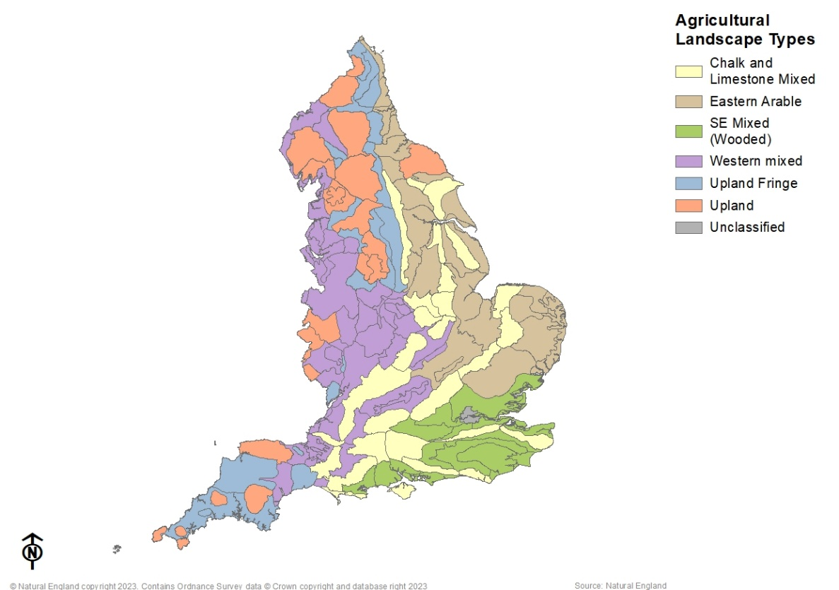
Broad Landscape Types (BLT)
BLTs were initially developed through work for the Countryside Agency by Julie Martin and Professor Carys Swanwick of the University of Sheffield in 2004. They were generated in support of the introduction of the Farm Environmental Plan (FEP) in 2004/5. There was recognition of the need to ‘ensure that decisions on which options to enter into are made within the context of both the character of the area within which the holding sits, and the character of the holding itself. This contextual information will aid decisions about both the choice and the siting of the range of potential options under the scheme.’
As there was no existing national landscape typology at this broad scale that could be used as a framework, the landscape types were chosen by identifying – based on professional judgement – broad groupings of landscapes with similar geology and/or landform and/or landcover. The names of the NCAs often provided clear pointers to the landscape type, through their use of terms such as claylands, vales or forest.
In most cases the choice of landscape type was relatively straightforward. The main area of difficulty related to landscapes on the coast. These were deemed coastal landscapes if they had a lengthy coastline and/or if the sea was the overriding influence on their character; otherwise they were allocated to other landscape types. Key characteristics and common features of each type are held in a series of matrices using an agreed lexicon.

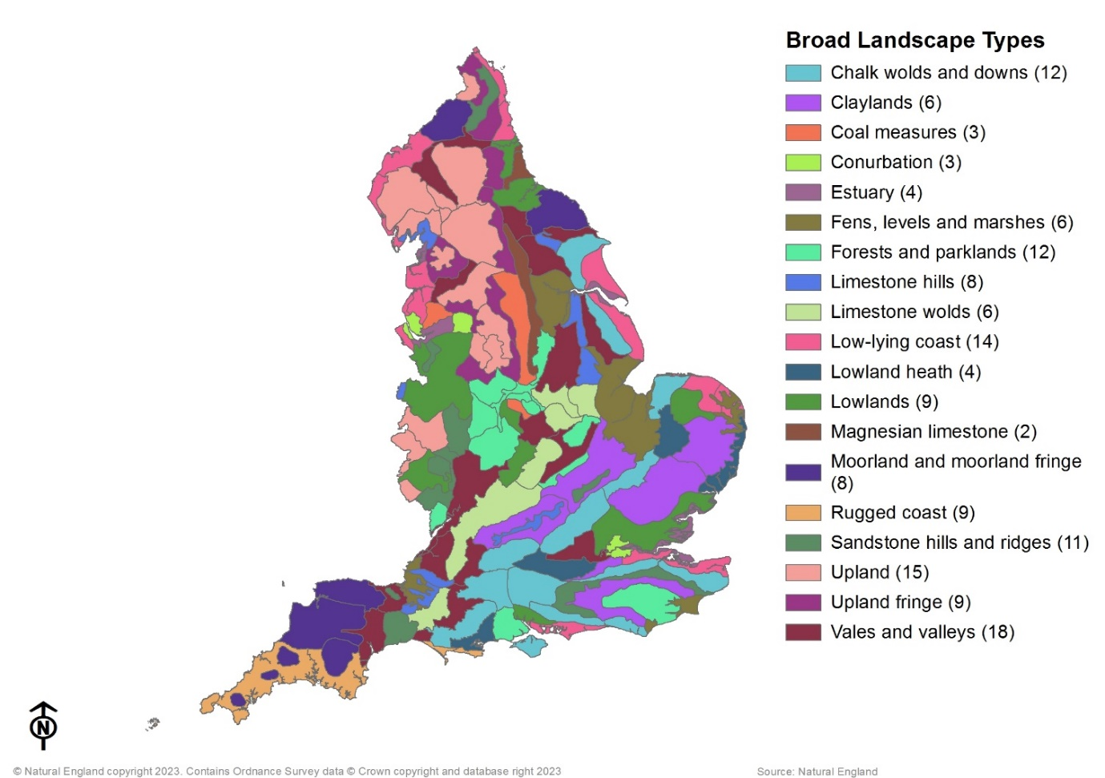
Sub-Agricultural Landscape Types (name under review)
A proposed bespoke spatial framework has been recently developed for future G1 Indicator landscape change monitoring and is based on Agricultural Landscape Types. It is considered necessary to use a spatial framework which accommodates the full spectrum of landscape characteristics and use, including varied management strategies, pressures and drivers of change. This classification is currently draft and unpublished at September 2023.
The current ALT classification being aimed at Agri-Environment Scheme monitoring does not sufficiently accommodate for coastal or urban characteristics or their pressures, as evidenced by three NCAs left unclassified (Inner London, Lundy and Isles of Scilly). It was proposed to create a sub-classification system which sits below the higher-tier ALTs, referred to as sub-ALTs, and which is more encompassing.
Coastal and urban have been incorporated into the ALT classification, as sub-categories. Each of the ALTs and their groupings of NCAs have been evaluated
using desk-based study and professional judgement, for characteristics which are potentially more aligned with urban or coastal sub-categories.
This classification has 18 sub-categories, some of which include both coastal and urban/urban fringe where appropriate. For example, the NCAs which fall into the Eastern Arable ALT have been divided into “Eastern Arable”, “Eastern Arable/Coastal” or “Eastern Arable/Urban/Urban Fringe/Coastal”. No NCAs have been moved from their “parent” ALT category. This excludes the addition of an “Urban” sub-category which encompasses NCA 112: Inner London. Inner London is over 97% covered by the “Major Towns and Cities” layer and is very different in character from all other NCAs, including the Manchester and Merseyside conurbations.
NCAs 156: West Penwith and 157: The Lizard, although not typically upland landscapes being of much lower elevation than ‘true uplands’ lower-lying and coastal, do exhibit habitat management similar to upland landscapes, and therefore have been grouped together as “Upland/Coastal” for the purposes of this landscape change monitoring work. In the original ALT classification, NCAs 158: Isles of Scilly and 159: Lundy remained unclassified. These have been moved into the “Upland Fringe/Coastal” sub-ALT, as they exhibit some similar management requirements to upland fringe landscapes.

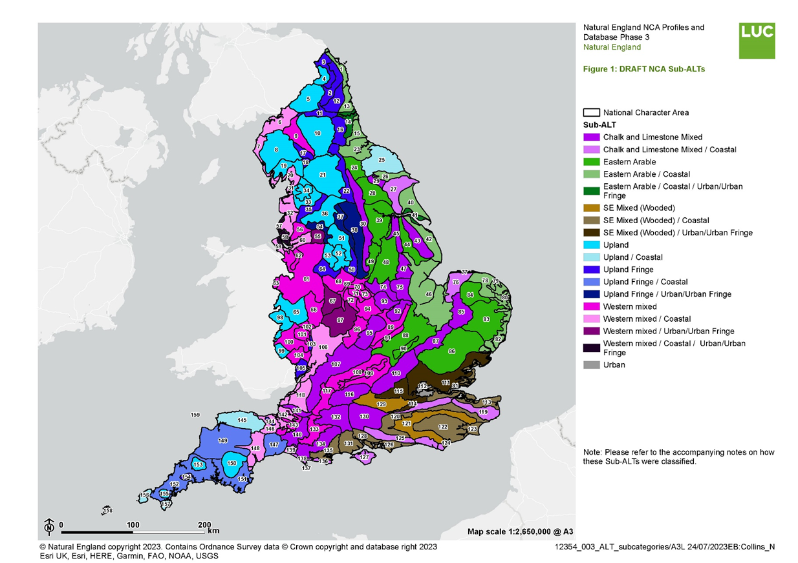
Sub Agricultural Landscape Typologies Map – link to map
12354_Sub-ALT_Working_WebApp (arcgis.com)

DESCRIPTIONS
ALT 1: Chalk and Limestone Mixed
This type of landscape covers the chalklands and Oolitic and Jurassic limestones of England, which characteristically form dominant ridgelines across the South East, Dorset and Gloucestershire and spread north-eastward into Lincolnshire and Yorkshire. The ridgelines typically have a steep scarp slope largely under permanent grass or woodland cover and a gentler dip slope under arable production, as in the North Downs, South Downs, Chilterns and Cotswolds. In some areas the ridgelines give way to rolling chalk plateaux and hills, as in the Hampshire Downs, Salisbury Plain and Lincolnshire Wolds, again largely under arable production – primarily wheat and oilseed rape, although these areas were traditionally also associated with the production of malting barley. Salisbury Plain stands apart, providing one of the largest areas of calcareous grassland in lowland England retained on the military training grounds managed by the MOD. Where the underlying chalk and limestones are capped by deep clay soils, woodland cover may be extensive, often of ancient origin. Land ownership is characterised by large estates with smaller mixed farms characteristic of the valley landscapes. Much of this type has been designated as National Park or Area of Outstanding Natural Beauty (AONBs), such as the South Downs, Lincolnshire Wolds, Kent Downs, North Wessex Downs, Cotswolds and Chilterns. Habitats of particular importance within these landscapes are ancient woodland, semi-natural calcareous grassland, the floodplain water meadows and marshes that may also include significant reed beds as in the Pang and Test Valleys, and calcareous rivers of the main river valleys that cut through the underlying bedrock.
ALT 2: Eastern Arable
This landscape type is concentrated in the East of England, East Midlands, Yorkshire and Humber and along the North East coastal plain. It is bisected by the Chalk and Limestone Mixed agricultural landscape type where this is dictated by the underlying geology. This landscape type occurs at a low altitude (and includes the Fens and Humberhead Levels) although there are also some gently rolling areas and incised valleys. In these lower lying areas and in other areas of floodplain pump drainage schemes drain the land. General cropping (arable farming) is the dominant enterprise in all areas except the Fens and Breckland where large scale horticultural production predominates. This is very largely an enclosure landscape where the majority of field boundaries were established during the 18th and 19th century parliamentary enclosures and create a rectilinear pattern, with the majority of lower lying areas bounded by rectilinear patterns of ditches and dykes. Field sizes are often large, though not as large as those in the Chalk and Limestone Mixed landscapes. Some earlier enclosures survive around villages. Woodland is relatively sparse but on the heaviest clay soils there are sometimes extensive areas of ancient woodland and/or conifer plantations. Pasture is a minor component of land use and is limited to small fields in the valley floors. There are long stretches of coastline; and coastal marshes, peaty fenland and carrs survive in some areas, notably in the protected landscape of the Broads. The type includes part or all of the Suffolk Coast and Heaths, Norfolk Coast and Northumberland Coast Areas of Outstanding Natural Beauty (AONBs).
ALT 3: South East Mixed (Wooded)
The South East Mixed (Wooded) landscapes spread across the High and Low Weald of Kent, Sussex and Surrey and parts of the Hampshire coast, also taking in parts of Berkshire, Dorset and Hertfordshire and Essex. This is a diverse collection of areas but all are characterised by having poor agricultural soils, mainly sands (Greensand) and clays; hence these areas lie at the margins of modern intensive agriculture. They are generally heavily wooded with up to 20% woodland cover (compared to 8% average for England), much of it ancient, with iconic woodlands including Epping and Hainault Forests and Burnham Beeches, This type also includes the largest concentration of lowland heathland in England, much of it common land, including the Thames Basin Heaths, the Surrey and Dorset Heaths, the New Forest and Ashdown Forest. ES has done much to bring these heathlands under conservation management, although areas of smaller heathland commons may be birch dominated and largely unmanaged. Since the turn of the last century large tracts were converted to extensive conifer plantations. Much of the farmed landscape is derived from the medieval period, with small irregularly-shaped fields originating from clearance of the wildwood by individual farmers. Farms are typically small and pastoral in character, traditionally a mix of beef and sheep with small dairy herds. But as all these areas lie close to centres of population, farming has given way in many areas to hobby farming, horse keeping and other amenity uses. Key habitats of this landscape type are lowland heathland and acidic and neutral grassland. The type includes the New Forest National Park, and all or part of the Chichester Harbour, High Weald and Surrey Hills AONBs.
ALT 4: Western Mixed
The western mixed agricultural landscape type lies in the central western part of England mostly over rich and well-drained clay and silt soils in river valleys and rolling hills. It occupies a large swathe of the West Midlands, extending north to Cheshire and the Lancashire coast and south through the Severn Vale and Somerset Levels to the Devon Redlands. As the name implies, dairy farming is a common and often predominant land use, but beef and sheep farming and mixed arable cropping, including root crops such as potatoes and stubble turnips, are also common along with the increasing growth of fodder maize. Woodland cover is lower than in most of the other landscape types although shelterbelts and small farm woodlands tend to be frequent. Impeded drainage often gives rise to meres and mosses, which may be distinctive landscape features, for example on the Staffordshire Plain, and there is a legacy of wetland reclamation in areas such as Morecambe Bay and the Somerset Levels. Some areas in the Midlands and North West have a coalfield industrial heritage and strong urban fringe influences. Building materials and types vary but are often very distinctive, for example half-timber in the Midlands. Relatively little of the area is protected under SSSI designation and individual sites tend to be small. Few Areas of Outstanding Natural Beauty occur in this landscape type (the relatively small Solway Coast, Arnside and Silverdale and Cannock Chase AONBs being exceptions).
ALT 5: Upland Fringe
This agricultural landscape type is located in the foothills of the Pennine spine in northern England, from the Scottish border to the fringes of the Peak District, and also in Devon and Cornwall. Most of this type is classified as Disadvantaged Area under the EU Less Favoured Area Directive. All of these areas (except the Blackdowns and Quantock Hills in the South West) border the upland agricultural landscape type, sometimes with a gradual change of character and sometimes with a much sharper demarcation. Dairy farming is the main farm enterprise on the more free-draining and flatter land, with stock-rearing (suckler beef and sheep production) on the less productive land. A high proportion of the land use is improved permanent pasture, with most of the remainder being grass leys (i.e. long-term grassland which is periodically ploughed and reseeded). Arable cropping is less common although forage crops such as stubble turnips are grown in place. Improved grassland gives way to unimproved acid grassland, valley mires and heathland on poorer soils. Woodland (dominated by oak, ash and hazel) occurs on steeper ground and the poorest soils. Field sizes are generally small with a strong network of large hedgerows which are ancient in origin and stone walls and hedgebanks on higher ground. Relatively little of the area is covered by protected landscape designations with the exception of the Blackdown Hills, the Quantocks and the coasts of Devon and Cornwall.
ALT 6: Upland
This agricultural landscape type occurs in the higher regions of England (above 400m in the north but at a lower altitude in the South West). The largest area runs along the Pennine spine from the Scottish borders to the Peak District and includes the Cumbrian Fells, the Bowland Fells and the outlier of the North York Moors. The Cambrian massif crosses the border from Wales in western Shropshire and Herefordshire. In the South West, this landscape type occurs on Dartmoor, Exmoor, Bodmin Moor and Carnmenellis. In almost all areas, this landscape type gives way at lower altitudes to the upland fringe dairying and stock-rearing agricultural landscape type. High rainfall, thin and steep soils and low annual average temperatures mean that agricultural productivity is relatively low and is reliant on grazing livestock. Whereas low lying land is parcelled into fields (mostly permanent grassland and often bordered by stone walls) the highest and least productive land is unenclosed moorland and usually registered common land. All of the landscape type lies within the Less Favoured Area, most of it being classified as ‘Severely Disadvantaged’. A significant proportion of this landscape type is designated as SSSI (particularly the heather moorlands) and the large majority lies within National Parks and Areas of Outstanding Natural Beauty (AONBs). This is the landscape type that has benefited from very high levels of targeting under ES.
UK Rural Land Use Archetypes
The Climate Change Committee (CCC) commissioned the Centre for Ecology and Hydrology to identify and characterise a set of baseline archetypes that are representative of current rural land-use and land-management in England and each of the devolved administrations. This work represents the first part of the CCC’s wider project on Archetypes for transforming rural UK land-use to high-carbon, climate resilient, nature rich and economically productive systems.
- A total of 12 archetypes representative of current rural land-use and land-management in England and the devolved administrations were shortlisted for this project. The archetypes are intended to represent key differences across a range of parameters, including geography, farming system (land use and land management) and spatial-scale.
- Archetypes were selected on the basis of having a distinct land use and management combination, cover a substantial area of the UK, with options for changing land use and management in the future for the benefit of climate mitigation and resilience and the delivery of other benefits (e.g. biodiversity). For this reason, archetypes dominated by existing woodland were excluded from the short list due to limited scope for change under the UK forestry standard.
- The 12 archetypes cover around 46% of the land area of the UK. Agricultural and land use, land use change and forestry (LULUCF) emissions have been estimated for each archetype. Archetypes containing organic soils were found to have the highest per hectare land use emissions, while archetypes with grazing livestock had the highest agricultural emissions on a per hectare basis.
https://www.theccc.org.uk/publication/archetypes-representative-of-current-uk-rural-land-use-and-land-management-ukceh/
Multi-tier archetypes to characterise British landscapes, farmland and farming practices. NERC EDS Environmental Information Data Centre.
https://doi.org/10.5285/3b44375a-cbe6-468c-9395-41471054d0f3

