Atamis Supplier User Guide

For assistance with responding to this tender in the health Family (Atamis) System please refer to the Health Family User Guide which can be found via this link

Supplier Portal User Guide - Health Commercial System - Supplier Portal User Guide (refined.site)

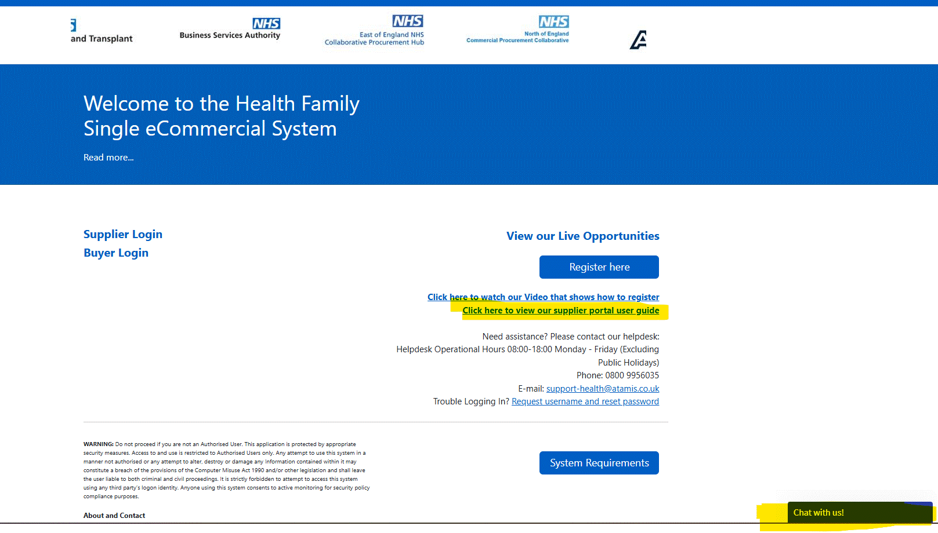

Please see below how the page should look like when they open the user guide link.

