A review of the London mental health transformation programmes
Request for Quotation

Dear Bidders,

Request for Quotation: A review of the London mental health transformation programmes

NHS England on behalf of Healthy London Partnership (HLP) invites expressions of interest and request for quote responses, for the formal review of HLP’s London mental health transformation programmes, with the intention of instituting change in order to improve impact where necessary.
We currently have a requirement for the services as expressed in this Request for Quotation (RFQ) document. We need our chosen supplier to commence the work on 23 July 2018 and finish the work on or before December 2018.
Please note the attached NHS Terms and Conditions for the provision of Services (Appendix 3) will apply to any contract awarded as a result of this procurement exercise.
If you are interested in quoting for this requirement, please submit an ‘Expression of Interest’ form by noon on 21 June 2018. The closing date for submitting clarification questions is 22 June 2018. Please ensure a completed ‘Response Form’ is submitted to the following email box hlp.mhtransformationlondon@nhs.net by 29 June 2018:
Summary
HLP was formed in May 2015 is a collaboration between London’s 32 CCGs and NHS England (London Region) in response to the NHS Five Year Forward View (2014) and the London Health Commission's Better Health for London (BHfL) (2014). HLP also supports the delivery of the Sustainability and Transformation Plans with local Sustainability and Transformation Partnerships (STPs). HLP programmes are subject to the principle of subsidiarity, i.e. transformation is only delivered at a London level when it can’t be delivered more locally.
The review objectives are:
- Produce an evaluation of the impact of the current HLP Mental Health transformation programmes at a system, service and patient level, including their priorities, change model and methods, leadership and governance.
- Use the evaluation and the available evidence base to produce a review of the HLP Mental Health programmes that recommends any changes to the programmes, in the context of London’s evolving health and care system, including future priorities, change model and methods, leadership and governance that will maximise impact.
In conducting this work it is expected that the reviewer will evaluate three HLP Mental Health programme work streams:
- The Child and Adolescent Mental Health (CAMH) programme
- Adult Mental Health programme
- Crisis Mental Health (Urgent and Emergency) programme
The outputs will include a final evaluation report (part A above) to be completed by the end of September 2018 and a final review report (part B above) by the end of October 2018. The available budget for this review is £60,000 (including VAT and all expenses).
The deadline for submitting proposals is 29 June 2018. The successful organisation will be informed by 20 July 2018.
Key Actions | Dates
Issue of Request for Quotation (RFQ) | 14 June 2018
Requested date for submitting Expressions of Interest | 21 June 2018
Closing date for clarification questions | 22 June 2018
Proposal submission deadline | 29 June 2018
Evaluation of proposals | w/c 2 and 9 July 2018
Interview of shortlisted bidders | 16 July 2018
Contract award | 20 July 2018
Contract work commencement date | 23 July 2018
Project initiation meeting | 31 July 2018 TBC

For information please contact the Mental Health Transformation Programme on hlp.mhtransformationlondon@nhs.net.
About Healthy London Partnership
HLP was formed in May 2015 is a collaboration between London’s 32 CCGs and NHS England (London Region) in response to the NHS Five Year Forward View and the London Health Commission's Better Health for London (BHfL). HLP also supports the delivery of the Sustainability and Transformation Plans (STPs). HLP programmes are subject to the principle of subsidiarity, i.e. transformation is only delivered at a London level when it can’t be delivered more locally.
HLP works with a wide range of partners that includes: Strategic Transformation Partnerships (STPs), Clinical Commissioning Groups (CCGs), NHS England and Improvement (London), NHS provider Trusts, Public Health England, London Councils, Health Education England, the community and voluntary sectors, the Metropolitan Police, the Greater London Authority and the Mayor of London.
London’s Mental Health Transformation programmes
An overview of the Mental Health Transformation programme governance is provided in Appendix 1.
The London Mental Health Transformation Board has strategic oversight of the HLP mental health programmes that sit beneath it across all ages and across the continuum from prevention to treatment. However, HLP working in partnership with NHS England (London) delivers through a matrix of mental health programmes that also report to other HLP boards e.g. the Child and Adolescent Mental Health programme reports to the Children and Young People’s Board. A summary of programme leads and related work streams can be found in Appendix 2.
The Five Year Forward View for Mental Health (FYFVMH) (2016) set out national priorities and actions required to transform mental health care in England by 2020/21. The London mental health programme priorities align closely to those of the FYFVMH and BHfL recommendations.
The work of the Child and Adolescent Mental Health Programme is informed by Future in Mind (2015). The report focused specifically on CAMHS services which preceded the Five Year Forward View for Mental Health.
More than a million Londoners will experience mental ill health this year. London has the highest demand for child and adult mental health services in the country, the highest rate of compulsory psychiatric admissions in England and the highest rates of schizophrenia. Mental illness remains underdiagnosed and under-treated, with a 25% of people with mental illness receiving treatment compared to 92% of people with diabetes and over 75% of people with heart disease. Compounding these issues, the physical health of people with mental illness is often poor. People with serious mental illness (SMI) die 17 years earlier than the rest of the adult population.
We want to fundamentally shift from focusing on treatment of mental health issues to prevention and helping Londoners stay emotionally, mentally and physically well at all ages. When care is required we want people to be able to easily access services and be treated promptly. We want mental and physical health needs to both be met and to ensure individuals experience high quality integrated and seamless care across all settings. Through this we aspire to eliminate the inequality in life expectancy of those with serious mental illness.
Despite there being examples of excellent and innovative practice, services are often poor and fragmented, with limited communication between the agencies involved in an individual’s care. This includes the linkages between schools and mental health services, the contribution of the voluntary sector and the transition between services for young people and adults. If London is to achieve parity of esteem between mental and physical health, transformation is required at all stages of the pathway – from prevention, self-management and self-care to crisis services and treatment. There needs to be support for people with the most severe mental illness, at all levels of the health and care system, from very local to London-wide.
More information can be found here.
Formal review of the HLP Mental Health Programmes
The formal review will evaluate what we do and how we do it with regard to the difference it makes ultimately to Londoner’s who experience mental ill health. It will also recommend what we need to do in future and how we need to do it differently to have more impact in the context of an evolving health and care system.
The objectives are:
- Produce an evaluation of the impact of the current HLP Mental Health transformation programmes at a system, service and patient level, including their priorities, change model and methods, leadership and governance.
- Use the evaluation and evidence base to produce a review of the HLP Mental Health programmes that recommends any changes to the programmes, in the context of London’s evolving health and care system, including future priorities, change model and methods, leadership and governance that will maximise impact.
A. EVALUATION
This is a review of the HLP mental health programmes. It is to be informed by an evaluation of three programmes:
- The Child and Adolescent Mental Health (CAMH) programme
- Adult Mental Health programme
- Crisis Mental Health (Urgent and Emergency) programme
This evaluation will:
- Evaluate whether the priorities of Mental Health programmes align with the overall ambitions of BHfL and FYFVMH. This should include the extent to which these are agreed and shared across organisations and at different levels of the London system. I.e. Do the Mental Health Programmes have the right strategy to deliver?
- Understand the transformation model(s) adopted by the mental health programmes, the key principles that underpin them, the leadership and governance frameworks, how the different elements ensure co-ordination across programmes and their approaches. Key principles of the transformation model(s) should include ensuring that people and communities are at the heart of decision making and delivery; supporting local systems through building capacity and capability; fostering innovation, place based working and integration. Exploring:
  - How the programmes fit together as a systemic offer and in a way that is understood by Londoners?
  - How do programmes understand the difference they are making for Londoners, whether their impact is even, are we using what we have to the best effect, and programme links to the equalities agenda?
- Evaluate the extent to which the priorities of the Mental Health programmes’ change model(s) and methods are appropriate to delivering the strategic priorities. This is to be done within the context of London’s evolving health and care system, specifically the move to more accountable (and integrated) health and care organisations focused on meeting population health needs.
- Evaluate the impact of the Mental Health programmes’ change model(s) and methods, leadership, and governance in delivering the identified priorities, specifically at a system, service delivery and patient level. This will include how impact and outcomes are defined; measurement frameworks are used, and identifying the factors of successful implementation.
- Explore with stakeholders what changes would enhance the impact of the mental health programmes, particularly with regard to future priorities and to improve adoption and implementation.
- Produce an evidence review of successful complex health and care transformation programmes to help inform what key elements are required to improve impact and how transformation programmes can adapt and innovate over time.
It is important to note that some projects within these programmes plan separate evaluations (for example Health Based Place of Safety (HBPoS) and Primary care mental health) these will not be repeated as part of this evaluation but the findings and methodology used can help to inform the review (part B). Thrive LDN and London Digital Mental Wellbeing programmes are also not in the scope of the evaluations (part A) but are in the scope of the review (part B).
B. REVIEW
The review is expected to use the insights from the evaluation of programmes and available evidence base of successful health and care transformation programmes to make recommendations with the intention of instituting change in order to improve impact. It is expected that the recommendations will consider what enables a system of delivery that innovates over time, is sustainable and has the capacity and capability to achieve the change needed by Londoners. Recommendations about the future of the programme should include a consideration of the role of evaluation in the programme and the best methods of embedding evaluation across its activities in a timely way to inform delivery over time.
The successful bidder will be expected to use a range of qualitative data collection methods, such as:
- A review of key documents, publications and processes
- In depth interviews with Mental Health Transformation Board members
- In depth interviews with Mental Health programme teams
- In depth interviews with key stakeholders such as STPs, CCGs, NHS England and NHS Improvement (London Region), NHS Mental Health Trusts, Local Authorities, Health Education England, Public Health England, Greater London Authority, voluntary sector organisations, senior clinicians, ‘frontline’ service delivery staff, patients, the emergency services (including the Metropolitan Police and the ambulance services) and the Care Quality Commission.
- Design, delivery and analysis of online surveys (with open and closed questions)
- Run workshop(s)/series of interactive sessions to gather feedback, and share and test findings
The successful bidder will:
- Provide update reports as required to the project steering group, overseeing the day to day project management and delivery of the project.
- Present findings to the Cavendish Square Group (Mental Health Trusts CEO Group)
- Present findings to the Mental Health Transformation Board
The mental health programme team will support access to stakeholders and provide documentation as far as possible.
Deliverables
- A draft evaluation plan/protocol by 26th July 2018 for discussion and refinement with the Project steering group on 31st July 2018
- An evaluation report (part A) to be completed by the end of September 2018, to be presented to the Mental Health Transformation Board on 28 September 2018 highlighting key findings.
- A final review report (part B) to be completed by the end of October 2018.
- Presentations of both the evaluation and review reports (parts A & B) including key findings and recommendations to the Cavendish Square Chief Executive Officer group on 9 November 2018 and the Mental Health Transformation Board on 30 November 2018. A final (peer reviewed) evaluation report by end November 2018
The Proposal
Proposals should include the following (more detail is provided within the Response Form):
- Evidence of proven experience and capability in the field
- Proposed approach or methodology for undertaking the evaluation and review as set out within this RFQ
- Project delivery plan
- Reporting and project management arrangements
- Proposed evaluation team
- Detailed costing
The outputs will include a final evaluation report (part A) to be completed by the end of September 2018, and a final review report (part B) by the end of October 2018. The available budget for this review is £60,000 (including VAT and all expenses).
The deadline for proposals is 29 June 2018. The successful organisation will be informed by 20th July 2018.
For information please contact the Mental Health Transformation Programme on hlp.mhtransformationlondon@nhs.net.
Our requirements and governance
It is important to note that we are looking for a review team who can work collaboratively with Healthy London Partnership and NHS England (London).
A project steering group will meet monthly with the successful bidder and will work alongside the bidder to ensure that the project is on track. It will highlight any issues and challenges that need to be resolved and will provide advice on approaches or activities, to ensure the objectives of this commissioned work are met to the highest standards possible. The Programme Manager will liaise regularly with the successful bidder to monitor and manage progress against the stated deliverables.
The successful bidder will be responsible for delivering all aspects of the project, including obtaining relevant authorisations and approvals where applicable, organising access to data and key documents, designing and carrying out interviews, surveys, workshops and the analysis and reporting of findings. The mental health programme team will however support in accessing stakeholders it already has relationships with and in accessing documents that it holds.
The successful bidder will have:
- Extensive experience in conducting robust qualitative and quantitative research
- The ability to develop and disseminate knowledge and evidence in a clear and compelling way
- Knowledge of mental health policy and policy implementation
- Understanding of different health and care transformation programmes and change models.
- Knowledge of the structure of health and social services in London
- Extensive experience in developing effective working relationships with a wide range of stakeholders in health and social care, including the public, patients, frontline staff in health and social care and those at senior levels.
The successful bidder must ensure that they have both capacity and adequate resources in place in order to deliver a robust, high quality and timely evaluation. We expect that the successful team will include senior evaluators who are able to conduct in-depth interviews, able to probe questions sensitively, and build on feedback from other interviewees accordingly.
EVALUATION PROCESS
Following bid submission, an initial compliance check will be performed by the procurement team which will cover the following:
- Check compliance to word limits/redacting excess words.
- Check confirmation of acceptance of Terms and Conditions.
- Check Conflicts of Interest

STAGE 1 – WRITTEN RESPONSE
Following this compliance check, the bids will be sent to The Panel for evaluation. The Panel will score the bids in accordance with the following Evaluation Criteria.
The technical evaluation of the proposal will be scored in accordance with Table 1 and 2 below. It should be noted that evaluation will be based solely on the view of The Authority in relation to the requirements and expectations detailed in this document. Each question (as detailed in Table 1 and in the response form) will be evaluated using the scoring criteria set out in Table 2
Table 1 Weighted questions (see response form for further detail)
Number | Question | Weighted %
Q 1 | Evidence of proven experience and capability in the field | 20%
Q 2 | Proposed approach or methodology for undertaking the evaluation and review as set out within the RFQ | 20%
Q3 | Project delivery plan | 15%
Q4 | Reporting and project management arrangements | 10%
Q5 | Proposed evaluation team | 15%
Q6 | Costing (Any quotations exceeding the financial envelope will be disqualified) | 20%
 | TOTAL: Proposed Approach & Costing | 100%

Table 2 – Weighted questions scoring criteria
Assessment | Description | Score
Deficient | Response to the question(s) (or an implicit requirement) significantly deficient or no response received. | 0%
Major Concerns | Inadequate detail provided and some of the questions not answered and/or some of the answers to questions are not directly relevant to the question(s). | 20%
Concerns | Limited information provided, and/or a response that is inadequate or only partially addresses the question(s). | 40%
Acceptable | The evaluator is confident that the Bidder provides sufficient evidence of required capability and capacity to deliver the required services | 60%
Good | A comprehensive response submitted in terms of detail and relevance to the question with comprehensive evidence. | 80%
Excellent | The evaluator is confident that the Bidder has demonstrated, within their response to the question, considerable assurance and evidence of capacity and capability that meet the proposed contract requirements | 100%

Example of scoring
If the Bidder scores “Acceptable” for a Question weighted at 20% they would achieve the following percentage score:
Question weighting = 20%. Bidder scores “Acceptable” (60%) in line with the evaluation criteria.
Therefore the score is 20% X 60% (score for an “Acceptable” answer) = Question achieved a total score for that question of 12% out of a possible 20%
Financial Scoring
Financial scoring will be based on the value of the price submitted by the Bidder in Financial submission section (Question 6) of the RFQ because the Authority has fixed all other elements of the price, for the proposed contract.
The Bidder with the lowest proposed price within the budget range set out below will score the maximum 20%.
Step 1: Bidder’s Fee (Y) minus Lowest Bidder Fee (X)
Step 2: Divided by 5,000
Step 3: Multiplied by 1%
Step 4: Deduct resultant percentage calculated in Step 3 from maximum of 20%.
Step 5: The resultant score is the figure in Column 6 in the table below.
Example: For illustrative purposes only the financial figures DO NOT represent this project they are purely for illustration purposes
Lowest bid = X | £50,000 | Bidder | Financial submission (Y) | Y% = Y-X | 20%- Y%
 |  | Bidder A | £60,000 | 2.00% | 18.00%
 |  | Bidder B | £59,500 | 1.90% | 18.10%
 |  | Bidder C | £50,000 | 0.00% | 20.00%
5000 |  | Bidder D | £54,500 | 0.90% | 19.10%
 |  | Bidder E | £57,500 | 1.50% | 18.50%
1% |  | Bidder F | £56,000 | 1.20% | 18.80%
20% |  | Lowest ££ | £50,000

Interviews
Following evaluation of all submissions the commissioner will invite the three highest scoring bidders to a formal interview process. The format of the interviews will be published to the 3 highest scoring bidders in the event of a tie for position three then all those that achieve the third highest score will be invited to attend.

Appendix 1 - Matrix of Mental Health Programmes governance arrangements 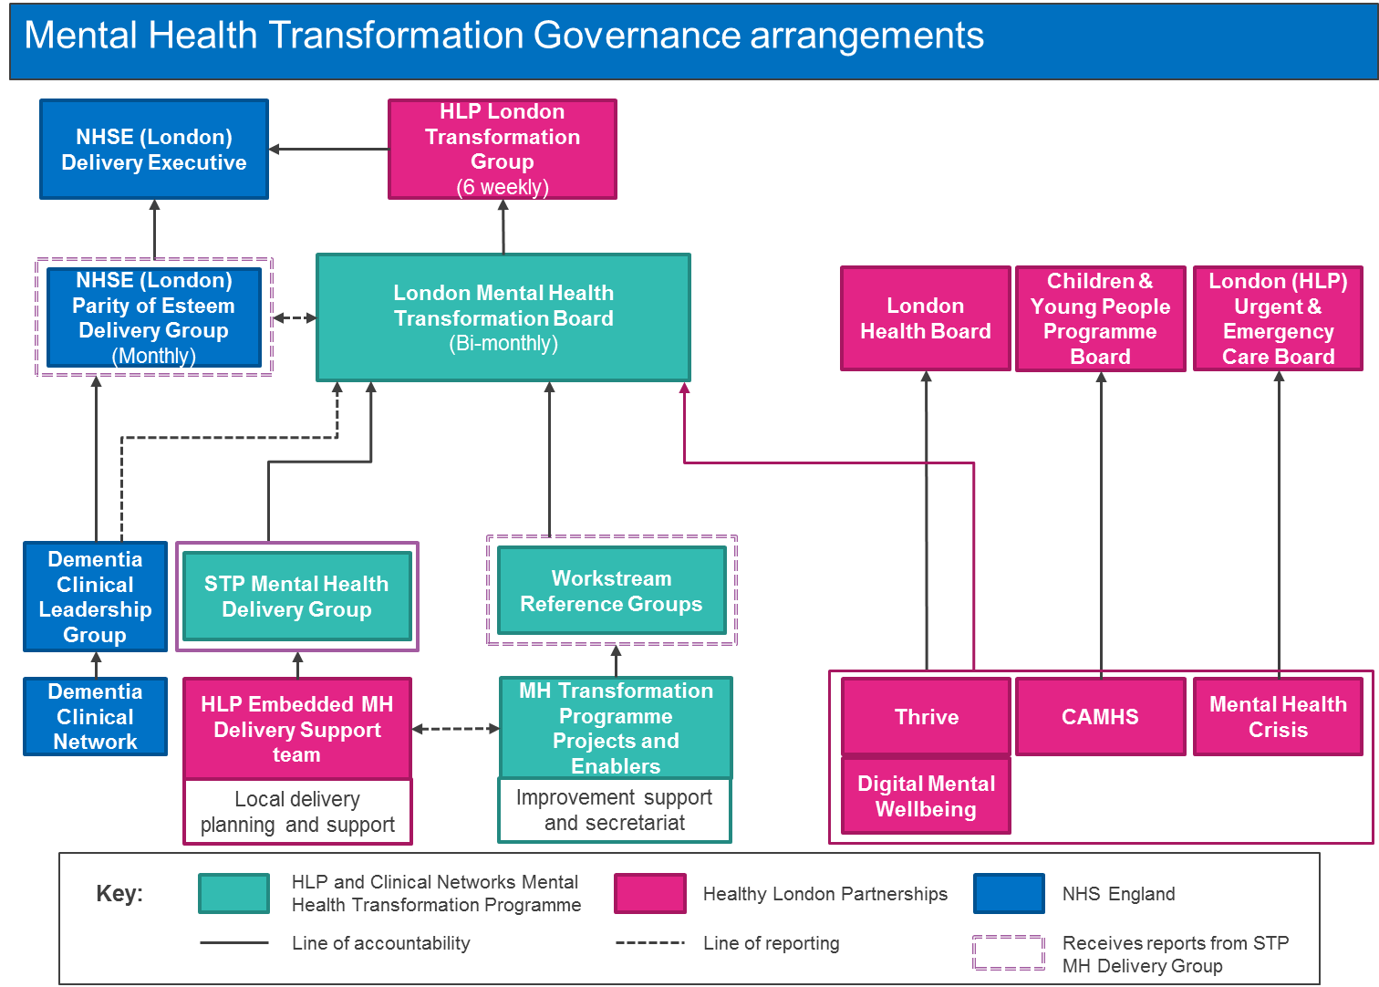
Appendix 2 – Overview of London Mental Health Programmes and work streams
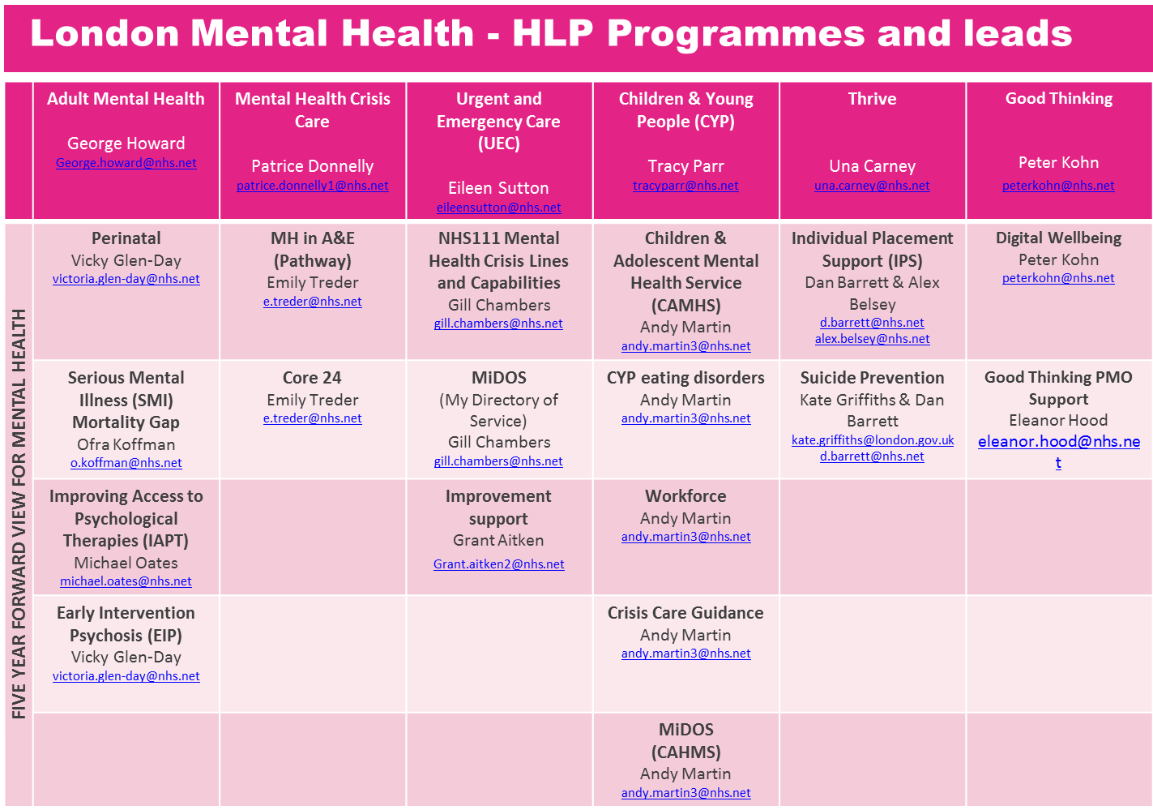
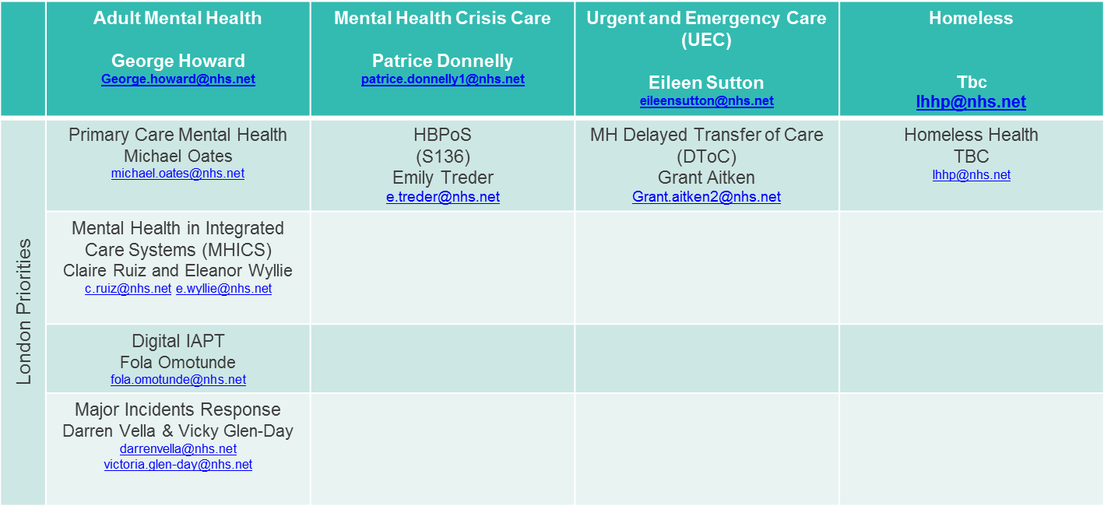

Appendix 3: NHS Terms and Conditions of Contract
NHS Terms and Conditions for the provision of Services

