

**Multi-disciplinary Panel Tender Brief**

**September 2016**

**Former Lord Mayor Treloar Hospital Site, Alton, Hampshire**

**Provision of technical services to assist OJEU developer procurement**

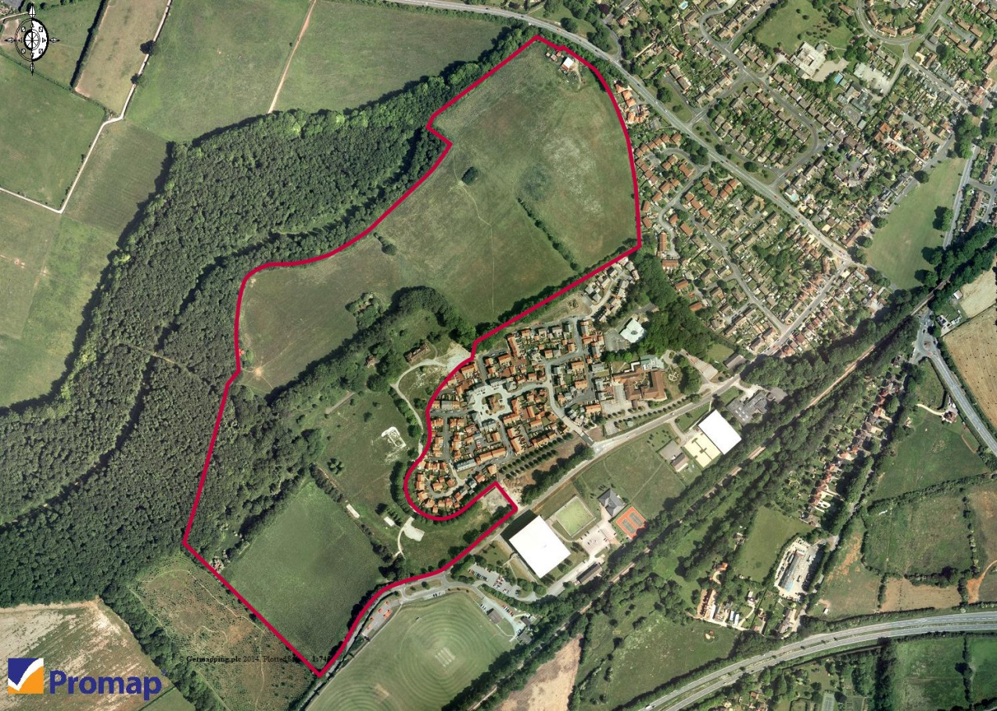

|  |
| --- |
| **Response to invitation to participate in a mini competition** |
| **Panel Name**:- Multi-disciplinary |
| **Project Name**:- Provision of Technical Services to assist marketing of residential land (Multi-disciplinary Panel Appointment) – Lord Mayor Treloar, Alton  **Date:- 20th September 2016** |
| **Proposal Brief**  ***INTRODUCTION***  The Homes and Communities Agency (HCA) is seeking interest from multi-disciplinary consultants who offer expertise in providing a range of technical services including infrastructure provision, to work on its site at the former Lord Mayor Treloar site (LMT) at Alton, Hampshire (Plans at Appendix A). Interested consultants must have experience in the delivery of infrastructure to residential sites of a similar scale to the LMT site.  The project will deliver the following outputs for HCA:   * 280 new homes on HCA owned land (20% affordable) * Public Open Space (including a country park of 10 ha) * Significant highway improvements, including bridge widening   This project forms part of a collaboration with Harvington Properties who own the adjacent Selborne Road site which will deliver 249 new homes. Objectives of the Panel Appointment To assist the effective marketing of Lord Mayor Treloar site by providing:   * An updated utilities assessment * A resource to assist the Competitive Dialogue process in addressing bidder questions regarding all technical aspects of the LMT site. This will involve some questions on existing technical studies, any updated studies and the proposed new South Alton bridge which the HCA has designed * Technical advice to support the evaluation of options for the transfer of the Country Park to a third party * A source of advice on any technical matters that may arise during the tender, pre contract, conditional contract or unconditional contract stages of the project   ***BACKGROUND***  The Lord Mayor Treloar site in Alton comprises 26 ha of former hospital land, acquired by the HCA as part of the Hospital Sites Programme in 2005 (see Appendix A for location). The site lies at the south western edge of Alton, situated within East Hampshire at the head of the northern River Wey valley. The HCA has secured outline planning consent with a neighboring developer, Harvington Properties, to deliver 529 new homes. The HCA will be delivering circa 280 units on its Lord Mayor Treloar site and is now proposing to market the site with the benefit of the planning consent. It should be noted that it is a requirement of the local planning authority to deliver key highways infrastructure and bridge works which the HCA and Harvington have scoped and designed.  Previous technical advice  In order to obtain planning consent and complete the necessary legal agreements with Harvington Properties, the HCA commissioned Aecom to design the bridge and undertake various technical studies. This commission has now reached its full scope and the HCA is tendering for new services under a separate commission in order to meet best practice in procurement and comply with OJEU.  ***THE SERVICES***  The scope of the commission will be as follows. The HCA reserves the right to draw down services as required.  **Task 1** – Update the existing Utilities Assessment (Aecom, 2014 – see Appendix E) through correspondence with all relevant utility providers to establish local capacity/reinforcement requirements and up-to-date costs of provision. The fee quotation for this task must allow for charges levied by utility companies.  **Task 2** – To assist the OJEU Competitive Dialogue process and advise on the bridge design, highways and technical reports, to include:   * Attendance at two dialogue sessions in London; * Provide written answers to all relevant bidder written queries on technical matters; and * Providing any required input into the HCA procurement report   **Task 3** – To provide advice on any technical matters relating to options for the transfer of the Country Park to a third party e.g establishing annual maintenance costs  **Task 4** – Any other tasks to ensure the successful completion of the Agency’s objective’s as identified in the tender response which may include further updates on existing technical studies.  ***INDICATIVE PROGRAMME (please note the dates relating to the OJEU procurement are subject to review).***   |  |  | | --- | --- | | HCA issues brief | 20th September 2016 | | Mini competition return | 5th October 2016 | | HCA appoints consultant | 7th October 2016 | | Consultant to commence instruction | 10th October 2016 | | Utilities Assessment (UA) updated | End of November 2016 | | ITPD issued including updated UA | December 2016 | | Tenders returned after dialogue (allowing for 3 dialogue meetings) | Mid March 2017 | | Evaluation completed | Mid April 2017 | | HCA approvals in place | End of May 2017 | | Issue tender letters and allowance for standstill period | Mid June 2017 | | Conditional contracts exchanged allowing for 8 week period | August 2017 |   ***THE CLIENT***  The HCA is the client for this commission. Payments for services provided by this commission will be made by HCA. Invoices quoting relevant purchase order and Instruction to Proceed (ITP) numbers to be submitted to HCA Creditors and (Redacted).  ***Contact:***  (Redacted), Area Manager, Homes and Communities Agency, 2 Rivergate, Temple Quay, Bristol, BS1 6EH.  Office: (Redacted)  Mobile: (Redacted)  Email: (Redacted)  Please contact (Redacted) if you have any queries in connection to this brief.  If necessary, you are free to walk around the site unaccompanied, but you must advise HCA at least 2 days in advance.  ***FEES***  Please quote a fixed, lump sum fee for each of the tasks listed above (except task 4), excluding VAT. Increases will only be accepted where this is an additional commission of tasks and not due to an underestimate of work hours by bidders. The scope of task 4 is unknown and will not be evaluated as part of this contract. Services commissioned under Task 4 will need to be ancillary to those outlined in the scope of this document. Bidders should provide an hourly rate for individuals that may provide services under Task 4 which must not exceed agreed framework panel rates.  A breakdown of hours needs to be provided against agreed framework rates to indicate how the quotation has been determined. As part of their submission, tenderers should provide a schedule of their proposed work hours for each task (broken down as under Appendix C) and the level of staff providing these.  The fee quote must allow for the provision of a collateral warranty, in accordance with the current panel framework appointment, to the selected developer for the services undertaken. This must allow for minimum Professional Indemnity Insurance cover of £10m and 12 year expiry date. Confirmation is also required that no further fees will be charged for the release of technical information procured under this instruction to other parties.  If any of the anticipated work is ultimately not required, the HCA reserves the right to amend or terminate the contract.  Travel costs and other expenses should also be included within your fixed fee proposal and will not be chargeable separately.  The consultant’s fees will be paid at staged intervals throughout the commission.  ***SKILLS, EXPERIENCE AND KNOWLEDGE REQUIRED***  In order to undertake this commission, the panel member must demonstrate that it has the skills, knowledge and experience in the following areas. This will be assessed as part of the submission return to be completed using template in Appendix B. Please answer the prompt questions in Appendix B but in particular highlight:   * A track record of infrastructure delivery for residential developments of a similar scale and complexity to the LMT site, including bridge design and highways * The ability to understand the complexities of this site through demonstrable experience on similar projects * Knowledge and experience of working with utility providers in the local area * Experience of working on similar scale projects using the OJEU procurement process, taking part in Competitive Dialogue sessions, and any other experience relevant to the commission   ***SUBMISSION REQUIREMENTS***  The Consultant will be appointed under the HCA Multi-disciplinary Panel. The Framework Terms and Conditions will apply.  *An electronic copy of your submission should be emailed by no later than 10.00 a.m. on Wednesday 5th October 2016 to* (Redacted)  Using the HCA’s template tender response (Appendix B) and Resource Schedule (Appendix C), the submission should include the following: -   * Two clear examples of relevant experience of your organisation in delivering similar commissions, up to a maximum of 1 A4 side each. This should include the nature of the work, your organisation’s role and value of work. * Confirmation of named consultant team and description of experience and skills. This should be relevant to the examples given above. It should be noted that the HCA expect to have a lead consultant and first point of contact at the Director level (or equivalent) for this project. CVs will be accepted in addition, up to a maximum of one A4 side each; * Proposed timescale for updating the utilities assessment * A statement on how your organisation would get up to speed with all current site and planning/legal issues, including an estimate time for achieving this. * Resource Plan, breaking down the project by daily fee rates for the PM and any support staff attributable to the tasks outlined above under The Services. This must be inclusive of all expenses and travel costs. The HCA requires a fixed cost and further extensions by way of daily rates is only acceptable where additional tasks are commissioned in writing by the HCA’s Area Manager.   **SUPPORTING DOCUMENTS**  Appendix A Plans and photographs  Appendix B Tender response template  Appendix C Resource schedule  Appendix D Evaluation form  Appendix E Utilities Assessment, Aecom, 2014 |
| **Evaluation Criteria & Submission**  Submissions for this appointment will be evaluated against 70% quality and 30% price.  The proposal should not exceed 5 sides of A4 paper when printed. This excludes CVs (which can be a maximum of 1 A4 side per person). Any additional pages or appendices may be ignored or result in a deduction of scoring.  The ‘quality’ elements of the tender submissions in relation to the work up to the completion of commission will be marked against the following criteria:   * Experience (35%) * Proposed team (20%) * Management and Communication and Timescales (15%)   An example copy of the Submission Evaluation Matrix that will be used to assess the submissions against these criteria can be found in Appendix D. |