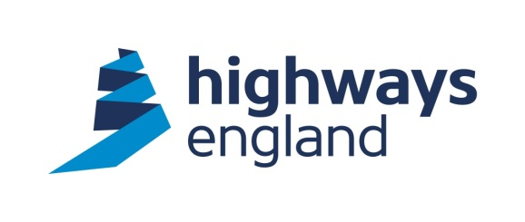  Our ref: PSM 11  Your ref: Redacted  Amco  Yew Trees  Main Street North  Aberford  West Yorkshire  LS25 3AA  For the attention of: Redacted | Highways England  Procurement  The Cube  199 Wharfside Street  Birmingham  B1 1RN  Direct Line: Redacted  10th May 2018  http://highwaysengland.co.uk
Dear Sir

CLOSED BRANCH LINES MINOR WORKS – PSM 11 – ROYAL OAK BRIDGE – BRICKWORK REPAIRS

Further to your quotation for the above works I am pleased to advise you that your price of £22,618.37 has been accepted. The works should not commence until the Jacobs Ecologists have undertaken their survey of the structure and either confirmed that they are content for the repairs to proceed or advised of any constraints, licenses required.

You should note that we will not pay for any works unless it has been specifically authorised in writing within the terms of the agreement.

Please note the works are to be undertaken under the Works Framework Contract 2016-2020 and the conditions of contract for these works are the NEC3 Engineering and Construction Short Contract.

Invoices should be sent to Financial Services Payments at Highways England, The Cube, 199 Wharfside Street, Birmingham B1 1RN, quoting the Blanket Purchase Agreement number, Release number and Receipt number. These details will be provided to you by the Historical Railways Estate team as works are certified.

I trust the above is acceptable. The agreed start date is subject to the results of the Jacobs Ecological surveys, the Completion Date is 29/03/19, or as dictated by the Ecological surveys. Should you wish to discuss the matter further please contact Redacted the Project Manager Historical Railways Estate on Redacted.

Please acknowledge receipt and acceptance of this letter by return.

Yours faithfully

Redacted

Redacted
Redacted
Email: Redacted @highwaysengland.co.uk

