APPENDIX B:

BACKGROUND INFORMATION ON THE NHS NATIONAL BOWEL CANCER SCREENING – Managed Service Provision (MSP)

The NHS Bowel Cancer Screening Programme aims to reduce the incidence of, and mortality from, bowel cancer by delivering a systematic, quality assured population-based screening programme. The NHS Long Term Plan outlines a commitment to detecting more people at risk of developing cancer and facilitating their treatment to prevent cancer.

The initial screening service is offered via invitation from five regionally commissioned hubs. Faecal Immunochemical Test (FIT) kits are sent to eligible patients; completed tests are mailed back to the hubs and are then analysed. This analysis results in one of two outcomes depending on whether a specific threshold is met:

- Patient receives a communication of no need for further tests currently or
- The results are handed over to Bowel Cancer Screening services for further investigation.

The supply of FIT kits is currently managed via a managed service provider (MSP) with contract management moving between the lead hub on an annual basis.

Population covered and scope:

- Currently ages 54-74, bi-annual providing home screening using Faecal Immunochemical Test (FIT).
- Age extension in 2024/25 to include testing 52 and 50 year olds taking the age range to 50-74 year olds by end 2024/25.
- Includes the Lynch patient cohort.
- Age 75 and over, bi-annual screening using FIT available upon request.
- The service covers England only.

There are 5 English Bowel Cancer Screening Hubs and for illustrative purposes only, the likely activity is indicated below for each Hub:

Hub | Kits sent 24/25 Estimate (m) | Kits returned 24/25 Estimated
Midlands and North West | 1.95 | 1.27
Southern | 2.64 | 1.87
Eastern | 1.68 | 1.16
North East | 1.38 | 0.97
London | 1.25 | 0.71

These quantities are based on current usage and estimates up to March 2025 (inclusive of 50-74 year old cohorts, 75 years old on request and Lynch patients. Estimated annual growth is currently between 4% and 7%.

MSP Operating Model

The Managed Service Provider works with the bowel cancer screening hubs in England to provide all eligible people a single FIT test kit and return it for analysis in a pre-paid package. The MSP provides:

- Management of Kit Return.
- Supply of all necessary hardware, consumables and reagents for analysis of FIT kits.
- Middleware/Communication Links with the NHS England Bowel Cancer Screening System and Hubs.

FIT Service Requirements

The MSP will have the following remit:

- Utilise FIT and be part of the Bowel Cancer Screening Programme’s pathway.
- Provision of analysers and their lifetime maintenance to Bowel Cancer Screening Hubs that use FIT to a level required by NHS England.
- Managing the inventory/stock of all reagents/materials required to conduct FIT Tests.
- Invite in scope subjects to the screening programme by sending them a FIT kit.
- Manage the logistics of sending out and returning FIT kits to people in scope.
- Ensure test results have been securely transferred and received within the Bowel Cancer Screening System (BCSS)
- Provision of training of Hub staff in using analysers.
- Provide a helpline for day to day issues.
- NHS England reserves the right to include innovations in the final specification which may support improvements to the bowel cancer screening pathway in relation to provision of FIT kits to eligible participants.
- NHS England Bowel Cancer Screening programme will include in the final specification future innovations to address any perceived patient inequalities. This could include improvements to support engagement of those who are not registered with a GP and those with capacity issues including sight impairment and manual dexterity issues.

The MSP will not be expected to provide the following:
- Pre-invitation letters
- Reminders; and
- Any results of the screening process that may or may not be sent to the in-scope people.

MSP Screening pathway*

For illustrative purpose, the below diagram describes the proposed screening pathway for the BCSP:

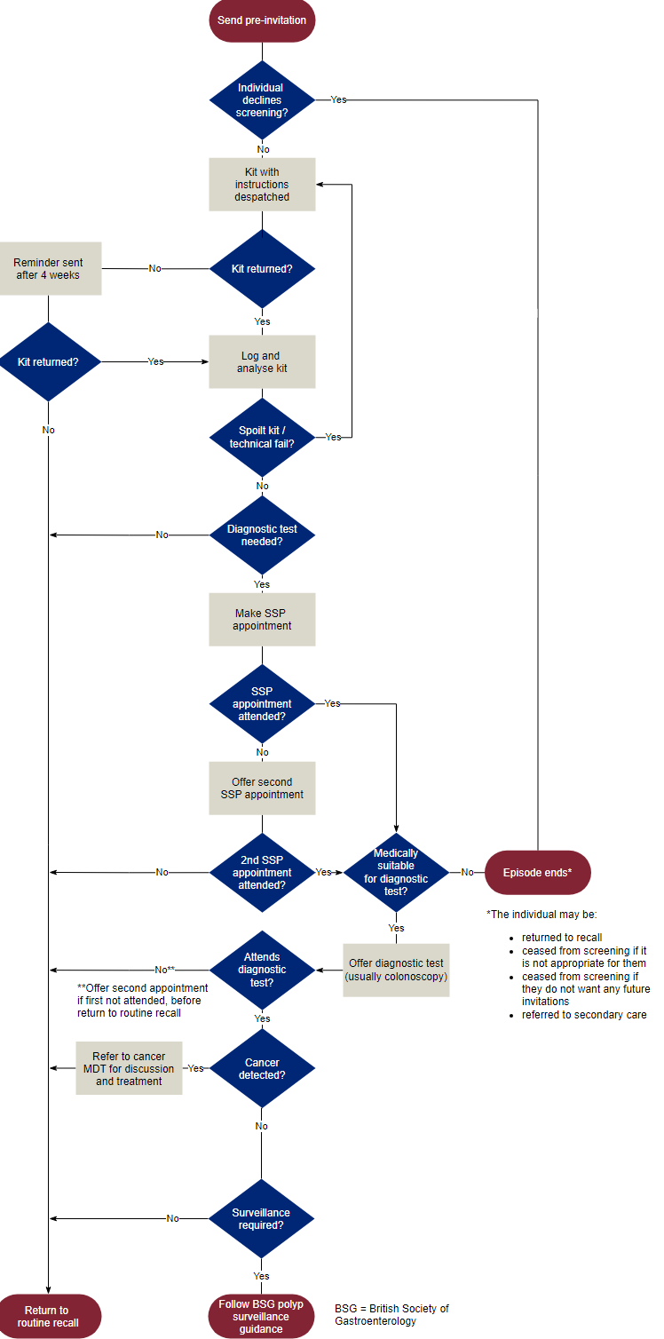
*The bowel screening pathway may be subject to future review and amendment as NHS screening policy and innovation changes.

