LEE VALLEY REGIONAL PARK AUTHORITY

FACILITIES INFORMATION

_____________________________________________________

Request for Quotation

Appointment of Consultants

to

New Leisure Services Procurement 2020
_____________________________________________________

Lee Valley Regional Park Authority
Myddelton House
Bulls Cross
Enfield
Middlesex
EN2 9HG
Tel: 01992 717711
Fax: 01992 719937
www.leevalleypark.org.uk

INDEX

1. Background 3
2. Facilities Information 4
1 LV Hockey and Tennis Centre 6
2 LV Ice Centre 6
3 LV Riding Centre 7
4 LV Athletics Centre 7
5 LV Campsite 9
6 LV Park Farm 9
7 LV Camping and Caravan Park 10
8 LV Golf Course 10
9 LV Water Works 11
10 LV Caravan Park 11
11 LV Marina - Stanstead 12
12 LV Marina - Springfield 12
13 LV White Water Centre 13
14 LV Velo Park 13

Background

The Authority
The Lee Valley Regional Park Authority was established by Act of Parliament in 1966. It has a statutory remit to develop, improve, preserve and manage for the purposes of recreation, sport, entertaining and the enjoyment of leisure in an area adjoining the river Lea. The 1966 Act requires the Authority to protect and enhance the environment and biodiversity, to create public open space for leisure and recreation and to deliver sports facilities of regional significance.

The Regional Park
The Regional Park compromises four thousand hectares of which one thousand six hundred are in ownership of the Authority. The Regional Park stretches approximately twenty-six miles from Ware in Hertfordshire through north and east London to the River Thames just across from the Millennium Dome in Greenwich.

Leisure Facilities
The Park includes a wide range of leisure facilities including:-
- Regionally significant sports facilities for cycling, canoeing, tennis, hockey, athletics, golf, ice skating and riding;
- A range of water based activities within extensive waterways including fisheries and opportunities for boating;
- Numerous sites of nature conservation; and
- Camping and hostelling.

Corporate Vision
The central kernel of the Authority’s current vision covering the priod to 2020 is:
‘’By 2020 the Lee Valley Regional Park will be a world class destination combining the best of open space, conservation and sporting excellence’’
This Vision, created in 2010 envisaged achievement through seven key aims:-
- Playing a central role for the London 2012 Olympics and its legacy;
- Becoming a Destination for Sporting Excellence; and
- A champion for the environment and biodiversity;
- Focused on Delivery and Value for Money;
- An Accessible Resource for all;
- A Major Partner in Regeneration; and committment to a
- Sustainable Environment
The growth of the Park is covered by the Park Development Framework and the Policy context covers five main areas:
- Lee Valley Regional Park Act 1966;
- National policy and guidance;
- Regional policy and guidance;
- Local planning policy;
- European and national law and regulation.

Procurement of Consultants
To achieve its corporate vision the Authority entered into a contract for the management of 14 of its key facilities with the Leisure Services Trust (trading as Vibrant Partnerships). This contract comes to an end in 2020 and the Authority has begun a procurement exercise covering management of its facilities from 2020 to 2030-2035.
This document has been prepared to assist the Authority in securing the services of a Consultancy which will in turn assist it with the procurement of a new management contract covering a number of its facilities for the post 2020 period.
This document draws on information contained in its 2015 management contract and is provided purely for information as part of its current exercise in procuring a Consultancy. Up to date information on all its facilities will form a key part of the wider procurement itself.

Facilities Information

The Facility/site locations are marked with a red dot on the map of the Park below.
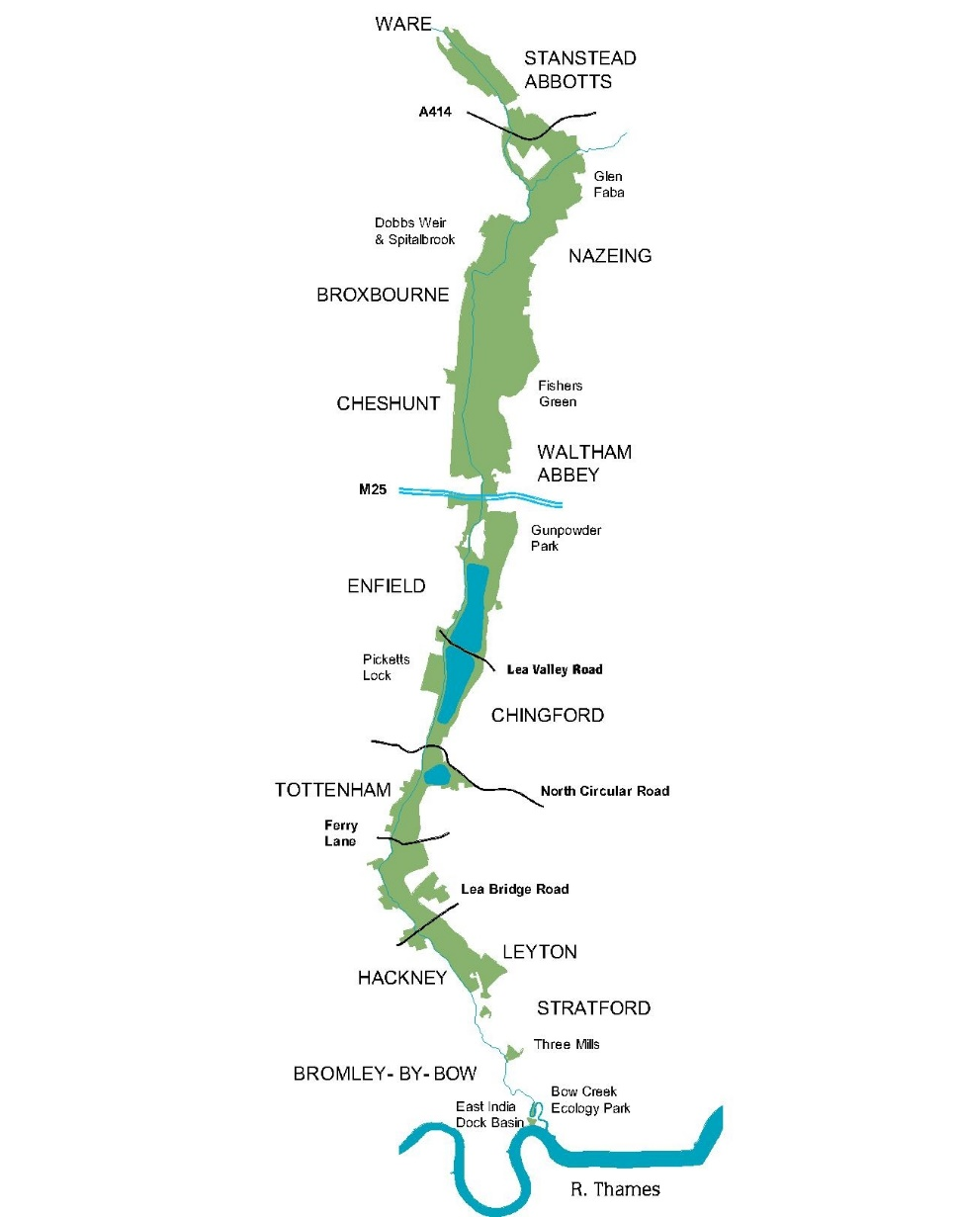

The 14 facilities which formed part of the 2015 Leisure Services Contract are:
- Lee Valley Hockey and Tennis Centre
- Lee Valley Ice Centre
- Lee Valley Riding Centre
- Lee Valley Athletics Centre
- Lee Valley Campsite
- Lee Valley Park Farm
- Lee Valley Camping and Caravan Park
- Lee Valley Golf Course
- Lee Valley Water Works
- Lee Valley Caravan Park
- Lee Valley Marina – Stanstead
- Lee Valley Marina – Springfield
- Lee Valley White Water Centre
- Lee Valley VeloPark
Note:
      - The information on each facility that follows is very brief and drawn from the 2015 contract and was up to date as at March 2015. The new Leisure Services Procurement may or may not include all these 14 facilities as part of the new contract.
      - Further and more up to date information, including details of current services and events on each of the above facilities can be found on the following website:
https://www.visitleevalley.org.uk

Lee Valley Hockey and Tennis Centre

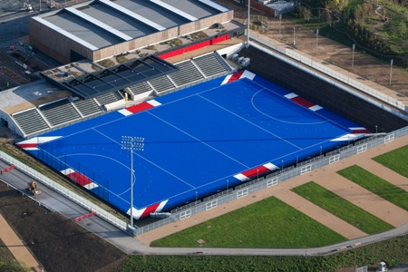
https://www.visitleevalley.org.uk/go/hockey-tennis

Purpose of the Facility
1.1 Lee Valley Hockey and Tennis Centre (LVHTC) on Queen Elizabeth Olympic Park offers first rate tennis facilities with six outdoor courts and four indoor courts for all year round use. The centre was the only purpose built London 2012 Paralympic Facility and building on the success of the Wheelchair Tennis event the Facility will be a regional hub for wheelchair tennis.
1.2 LVHTC is home to some of the best hockey facilities in the country. Working with England Hockey, local clubs, schools and community organisations the centre is running a range of hockey programmes following England Hockey's national frameworks and initiatives to support club development, catering for their training and league requirements. The centre is also creating a hockey programme for disabled players.

Operations
2.1 Opening Hours and Admission:
The Lee Valley Hockey and Tennis Centre (LVHTC) is open to the public 52 weeks of the year with reduced hours over bank holidays, during exclusive events and when planned maintenance is required. The current opening hours for the Lee Valley Hockey and Tennis Centre are 08.00 to 22.00(Mon-Fri) and 08:00 to 20.00 (Sat/Sun)
2.2 Sale of sporting equipment and merchandise and foodstuffs:
Sporting equipment and merchandise and foodstuff is sold on the premises by the operator.

Lee Valley Ice Centre
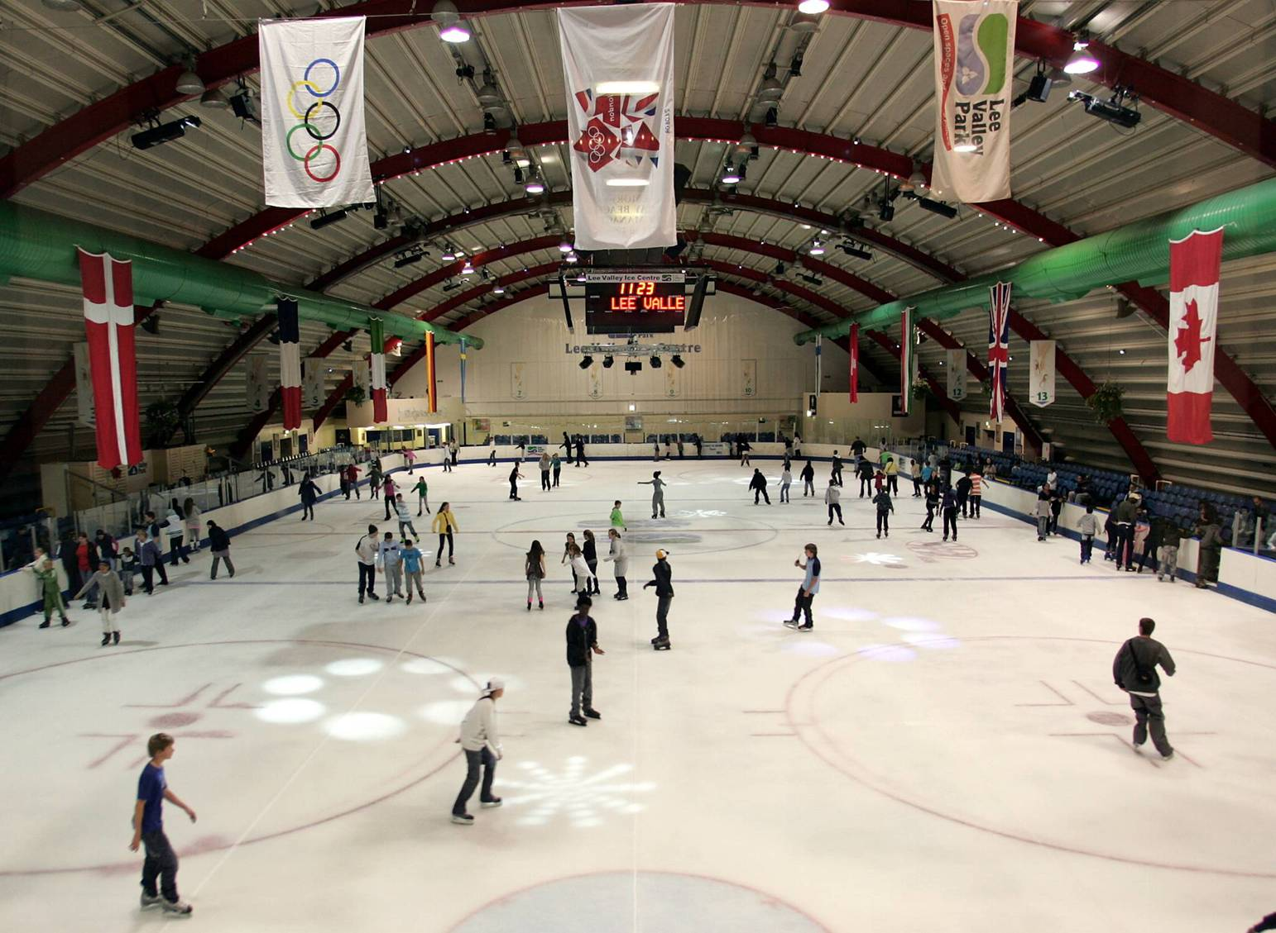

https://www.visitleevalley.org.uk/go/iceskating/

1 Purpose of the Facility
1.1 The Lee Valley Ice Centre (LVIC) is a regional centre of excellence for Ice Skating and offers an international sized (56m x 26m) ice pad for up to 760 skaters, with seating for up to 720 spectators. The Centre is regularly used by television for various programmes and filming and as a training Facility and home rink for some of England’s best skaters in all fields of skating (Single, Pairs Dance and Synchronised).
1.2 LVIC is the premier base for ice skating lessons in London. The centre offers a complete range of learn to skate courses, Patch ice (training sessions) , Elite training times, club hire and public skating sessions that suit all ages and abilities from toddlers to adults. Private ice skating lessons are also available from the team of national approved qualified coaches.
1.3 LVIC is also home to the Lee Valley Lions Ice Hockey teams (Junior & ED2, a total of 9 sections), South England Ladies team, 4 regional Recreational teams, as well as the London Raiders Ice Hockey semi-professional team, the southern IJS club and the Lee Valley London Skating Club.
1.4 LVIC is used to host international, national, regional and local competitions at all levels, and for NGB, as well as regional clubs and associations.
1.5 LVIC hosts International Skating Union events as and when required and is used by the NGB for screening of athletes and also hosts local and regional test for the NGB.

2. Operations
2.1 Opening Hours and Admission:
The Lee Valley Ice Centre is open to the public 52 weeks of the year with reduced hours over bank holidays, during exclusive events and when planned maintenance is required.
2.2 Sale of sporting equipment and merchandise and foodstuffs:
Sporting equipment and merchandise and foodstuff is sold on the premises by the operator.
Note: The Ice Centre is currently undergoing refurbishment and may be separately procured prior to 2020.
Lee Valley Riding Centre
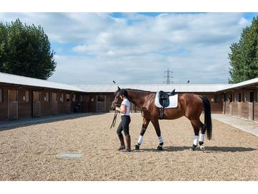

https://www.visitleevalley.org.uk/en/content/cms/outdoors/lee-valley-riding-centre/

1 Purpose of the Facility
  - The Lee Valley Riding Centre offers horse riding tuition, livery service and equestrian career training. Its unique location in central London makes it accessible to inner city schools, commuters and local residents. The Centre’s inclusive programme and range of horses provides riding to children, adults, people with physical impairments, beginners, elite competition riders, and career students.

  - The Centre is accredited as “Highly Commended” by the British Horse Society (BHS) as a riding school, livery yard and examination and training centre. The Centre is affiliated to The Pony Club and the Riding for the Disabled Association, and hosts British Universities and Colleges Sport training and competitions. Career students are taken on as apprentices and study for NVQs and British Horse Society riding instructor qualifications while they work.

  - The Centre has invested in excellent facilities, with 60 horses and ponies for riders of all abilities, all-weather floodlit riding arenas, equipment for numerous equestrian disciplines, and 30 livery stables for privately owned horses attracting a variety of horse owners including local parents and national competition riders.

2. Operations
2.1 Opening Hours and Admission:
The Lee Valley Riding Centre is open to the public 48 weeks of the year with reduced hours over bank holidays, during exclusive events and when planned maintenance is required.
2.2 Sale of sporting equipment and merchandise:
Sporting equipment and merchandise is sold on the premises by the operator.

Lee Valley Athletics Centre

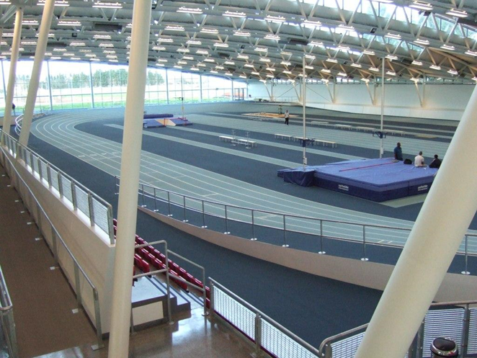

https://www.visitleevalley.org.uk/go/lee-valley-athletics-centre/

1 Purpose of the Facility
  - The LVAC is a modern athletics training and competition Facility and one of the best of its type in the world. Since opening in 2007 the centre has established a popular programme of activities catering for beginners in the sport through to Olympic champions. The centre is a regional facility attracting usage from across London and the South East all year round.
  - In recent years the LVAC has worked with other sports such as fencing and wheelchair rugby to ensure other sports can access the 1st class facilities. Furthermore some non-sporting events have been held at the Facility. These events have provided welcome income without compromising the overall sports programme.
  - The primary purpose of the LVAC is as an athletics training and competition Facility. The contractor is however encouraged to develop new products and income streams as long as the primary purpose isn’t undermined.

2 Operations
2.1 Opening Hours and Admission:
The Lee Valley Athletics Centre (LVAC) is open to the public 52 weeks of the year with reduced hours over bank holidays, during exclusive events and when planned maintenance is required. The current opening hours are: 08.00 (Mon- Sun) to 22.00 (Mon-Fri) and 17.00 (Sat/Sun)
2.2 Sale of sporting equipment and merchandise:
Sporting equipment and merchandise is sold on the premises by the operator.

Lee Valley Campsite
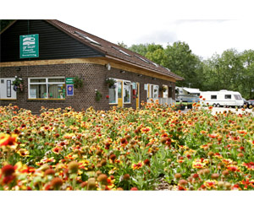https://www.visitleevalley.org.uk/en/content/cms/where-to-stay-and-short-breaks/sewardstone-campsite/

1 Purpose of the Facility
  - The Lee Valley Campsite is a freshly updated and improved campsite Facility and one of the best of its type in the area and is also a brilliant base for exploring the countryside and handy for central London too. The 1,000 acre River Lee Country Park is on the doorstep, with its traffic-free cycling and walking trails, boating, rare wildlife and even white water rafting, and Epping Forest with its mountain bike tracks is also close by. If customers are looking to discover the sights and sounds of the big city, from LVC they can be right at the heart of London in less than 40 minutes via bus and underground.
To make things easier, one day London travel cards are for sale in the campsite shop. Alternatively customers can explore the local historic market town of Waltham Abbey situated 3 miles from site. The site’s a perfect spot for tents, caravans and motorhomes, or you can choose to stay in a cosy cocoon or family cabin.
  - Situated within the site are a range of cocoons and cabins. Offering accommodation for up to four people they’re perfect for those who want to go back to nature but want more shelter than a tent. The cocoons (for two people) include two camp beds, heating, lighting, small table, electric sockets and a kettle. The cabins are perfect for families (sleep four, two adults and two children) include a set of bunk beds, double bed settee, coffee table, heating, lighting, electric sockets and a kettle.
  - Luxury static holiday homes - The site has 46 privately owned holiday homes. The long holiday season (1 March to 31 January) and the fully serviced pitches make this an ideal location to have a perfect holiday retreat.

2 Operations
2.1 Opening Hours and Admission:
The Lee Valley Campsite (LVC) is open to the public 48 weeks of the year in accordance with the licence provision with reduced hours over bank holidays, during exclusive events and when planned maintenance is required. 08.00 to 22.00 (Mon-Sun)
2.2 Sale of foodstuffs and merchandise:
Foodstuffs and merchandise is sold on the premises by the operator.

Lee Valley Park Farm

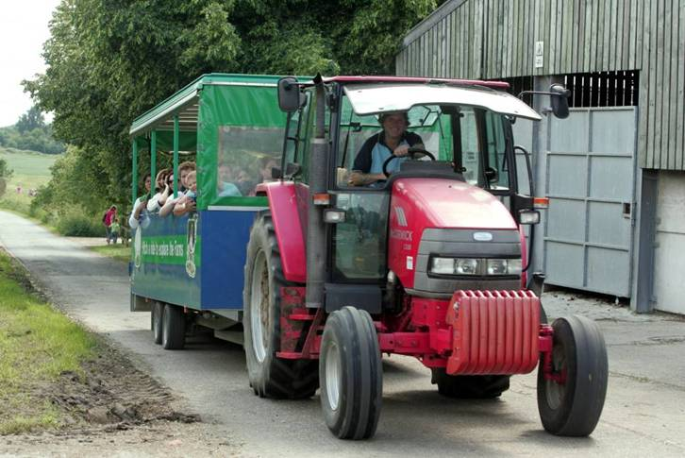

https://www.lvfarms.co.uk/

1 Purpose of the Facility
  - The Lee Valley Park Farm is a themed visitor attraction with a range of facilities designed to enhance the experience of the visitor, especially children. Aligned with the working farm (Holyfield Hall Farm), LVPF allows children access to a range of farm animals in a controlled and safe fashion and is a one of the Authority’s educational facilities. There are a range of retail opportunities including cafeteria, gift shop, gift vouchers and children’s parties.
  - Seasonal events. A range of seasonal events are held at the farm including, Easter, Christmas, Halloween, Peppa Pig, Mother’s/Father’s Days and Love British Farming.
  - LVPF is used by a range of educational establishments along with the Authority’s Youth and Schools Service to meet key aspects of the current national curriculum.

2 Operations
2.1 Opening Hours and Admission:
The Lee Valley Park Farm (LVPF) is open to the public 37 weeks of the year with no reduced hours over bank holidays, except when emergency maintenance is required. The current opening hours for the Lee Valley Park Farm are from 10.00 to 17.00 (Mon - Sun)
2.2 Sale of foodstuffs and merchandise:
Foodstuffs and merchandise is sold on the premises by the operator.

Lee Valley Camping and Caravan Park

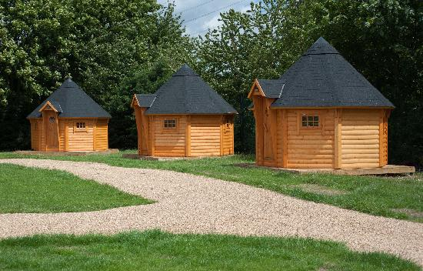

https://www.visitleevalley.org.uk/en/content/cms/where-to-stay-and-short-breaks/camping-caravan/

1 Purpose of the Facility
  - The Lee Valley Camping and Caravan Park is a peaceful camping and caravanning site within easy reach of both central London and the many attractions of Lee Valley Regional Park. Oxford Street, Buckingham Palace, the London Eye - from Lee Valley Camping and Caravan Park one can be taking in all the iconic sights of London in less than an hour. On the other hand, one can be deep into the 1,000 acre River Lee Country Park or Epping Forest in a matter of minutes. There are also horse riding and ice centres nearby. The overall complex includes an 18-hole golf course, Odeon cinema and the Lee Valley Athletics Centre. The site has 160 available pitches (100 with electric hook up facility) excellent facilities include heated shower / toilet blocks, a general shop where customers can also buy daily travel cards for access into London on all modes of public transport and a fun adventure playground.
  - Cabins & cocoons - situated within the site are 12 wooden Cabins and Cocoons. Offering accommodation for up to four people they’re perfect for customers who want to go back to nature but want more shelter than a tent. The cocoons (for two people) include two camp beds, heating, lighting, small table, electric sockets and a kettle. The cabins are perfect for families (sleep four, two adults and two children) include a set of bunk beds, double bed settee, coffee table, heating, lighting, electric sockets and a kettle.
  - The Facility provides an ideal base for campers, caravanners, motor-home owners and customers renting Cabins and Cocoons for easy access into central London with good bus and rail links direct from the site.

2 Operations
2.1 Opening Hours and Admission:
The Lee Valley Camping and Caravan Park (LVCCP) is open to the public 52 weeks of the year (in accordance with licencing provisions) with reduced hours over bank holidays, during exclusive events and when planned maintenance is required. The current opening hours are: 08.00 to 21.00. Facility staff live on site to maintain a 24 hour presence and to react to any ‘out of hours’ emergency situations.
2.2 Sale of foodstuffs and merchandise:
Foodstuffs and merchandise is sold on the premises by the operator.

Lee Valley Golf Course

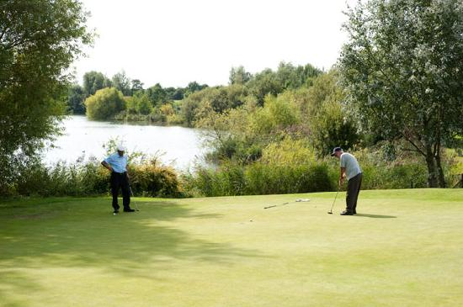

https://www.leevalleygcc.ie/

1 Purpose of the Facility
  - The Lee Valley Golf Course is a real urban oasis in north London, a consistently well-kept parkland course that takes full advantage of the River Lee and large lake water features in its layout. The 18 hole course is home to Leaside Golf Club, where members enjoy a combination of great value fees, all year round playability and some of the best fast running greens in London. The course also welcomes non-members.
  - Experienced players find the narrow fairways and water hazards pretty challenging, whilst the short yardage is helpful for beginners and younger players.

2 Operations
2.1 Opening Hours and Admission:
The Lee Valley Golf Course (LVGC) is open to the public 52 weeks of the year
2.2 Sale of sporting equipment and merchandise:
Sporting equipment and merchandise is sold on the premises by the operator.

Lee Valley WaterWorks

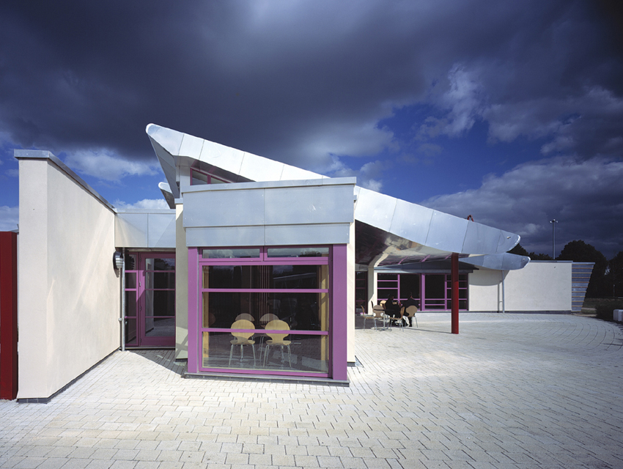

https://www.visitleevalley.org.uk/en/content/cms/nature/nature-reserve/waterworks-nature-reserve-midd/

1 Purpose of the Facility
  - The Waterworks provides a Facility for hire as, part or whole for organisations and or the public use for activities such as, meetings, weddings, parties, or club use.
  - The Waterworks also provides a café for public use during opening hours

2 Operations
2.1 Opening Hours and Admission:
The Lee Valley WaterWorks (LVWW) is open to the public 52 weeks of the year with reduced hours over bank holidays and when planned maintenance is required. The current opening hours are 10:00 to 16:00 Thursday to Sunday in Summer and 10:00 to 16:00 Friday to Sunday in Winter.
2.2 Sale of foodstuffs and merchandise:
Foodstuffs and merchandise is sold on the premises by the operator.

Lee Valley Caravan Park

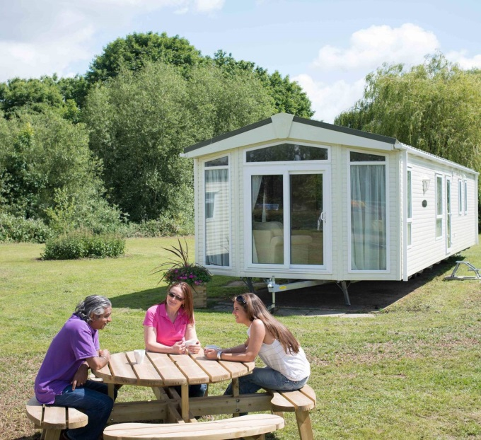
https://www.visitleevalley.org.uk/en/content/cms/where-to-stay-and-short-breaks/dobbs-weir-caravan-park/

1 Purpose of the Facility
  - Lee Valley Caravan Park, Dobbs Weir is just 30 minutes from London by train and is surrounded by the picturesque countryside of Hertfordshire and Essex - perfect for camping and caravanning. There are miles of cycling and walking routes, excellent fishing spots on and off site, and plenty of other things to do nearby. Wind down and relax by the River Lee or get active at one of the many attractions in the surrounding area including the Olympic Facility of Lee Valley White Water Centre. The site has excellent facilities including a licensed shop and children’s play area, plus, located nearby, is a riverside pub and café if customers don’t fancy cooking. Great for London and Cambridge, LVCP is a great base for day trips to these two cities. Broxbourne train station is just a ten minute drive from the site (with free parking nearby for customers) with trains running straight into central London in thirty minutes and reach historic Cambridge in less than an hour. Alternatively customers can explore the local historic market towns of Hertfordshire and Essex including: Hertford, Hoddesdon, Ware and Waltham Abbey, all with local markets and their own historic sites.
  - Lee Valley Caravan Park welcomes tents, motorhomes, trailer tents and touring caravans for stays. Luxury static holiday homes are also available to buy.
  - Pre-pitched tents. The site has a collection of good quality pre-pitched tents available for hire. The “Classics” are fitted out with cooker, table, chairs and camp-beds. The “Deluxe” has everything and all that is needed is bedding and foods.
  - Bike hire is on offer at the site. The hire costs include helmets, pumps and locks, plus an emergency phone number if any assistance is required.
  - Caravan storage. LVCP understand the importance of keeping customers caravans etc. safe and in a secure area. Caravan storage facilities include: Caravan, motorhome, trailer tent and campervan storage in two centrally located, secure compounds on hard standing with access between 08:00hours and 20:00hours, seven days a week with a check in/out card system and a controlled main entrance barrier into the site.

2 Operations
2.1 Opening Hours and Admission:
The Lee Valley Caravan Park (LVCP) is open to the public 48 weeks of the year (the site is closed for the month of February) in accordance with licence provisions with no reduced hours over bank holidays, during exclusive events and when planned maintenance is required. The current opening hours are 08:00 to 21:00 seven days a week.
2.2 Sale of foodstuffs and merchandise:
Foodstuffs and merchandise is sold on the premises by the operator.

Lee Valley Marina - Stanstead

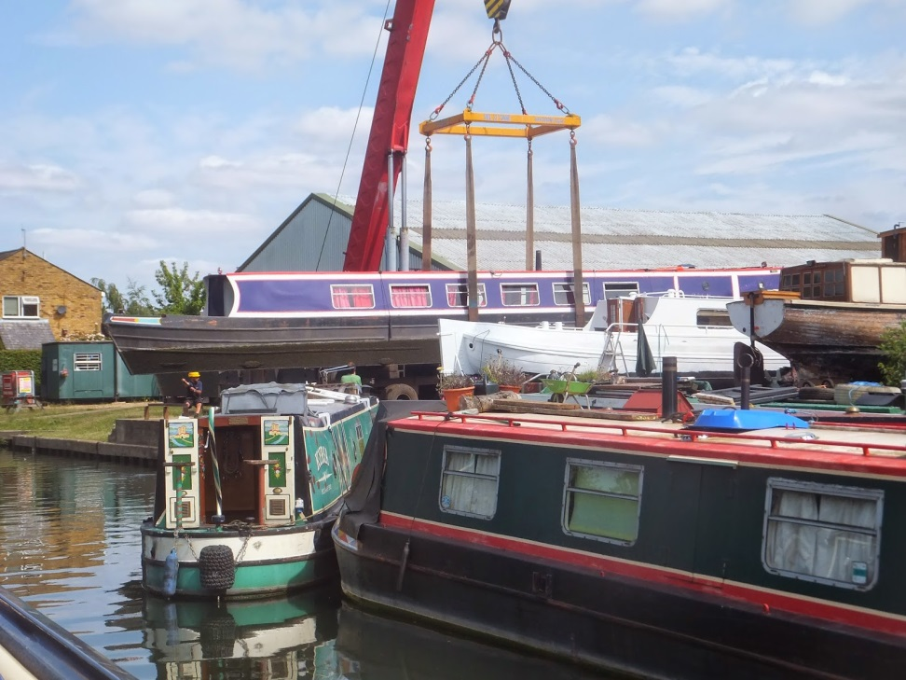

https://www.visitleevalley.org.uk/en/content/cms/outdoors/marinas/stanstead-marina/

1 Purpose of the Facility
  - Lee Valley Marina – Stanstead in Hertfordshire provides moorings, boat yard services and boats for sale. The marina is situated on the outskirts of the village of Stanstead Abbotts to the north of London and south of the market town of Ware. The River Lee flows south from Luton and becomes navigable at the market town of Hertford and then flows through the Hertfordshire countryside and Lee Valley Regional Park in to East London before joining the River Thames. The marina is just north of the confluence of the Rivers Stort and Lee and is connected to the rest of the national inland waterway system by the Hertford Union Canal and the River Thames giving over 2,500 miles of cruising waterways. The marina is well situated to visit the many attractions of the park and the local nature reserves including Rye Meads Nature Reserve & Stanstead Innings and Amwell Nature Reserve.
  - General services available – chandlery, diesel, water, boat pump out, Calor gas, solid fuel.
  - Engine Services available - new engines supplied, engine repairs and servicing, breakdown callouts for the Lee and Stort.
  - Boat services available - boat repairs, welding, fitting out, alterations, plumbing, painting and blacking.
  - Moorings available – overnight, long term for 200 boats, storage on land, berths on land for D.I.Y fitting out and repairs.

2 Operations
2.1 Opening Hours and Admission:
The Lee Valley Marina - Stanstead (LVMSt) is open to the public 52 weeks of the year with reduced hours over bank holidays and when planned maintenance is required.
2.2 Sale of foodstuffs and merchandise:
Foodstuffs and merchandise is sold on the premises by the operator.
Lee Valley Marina - Springfield

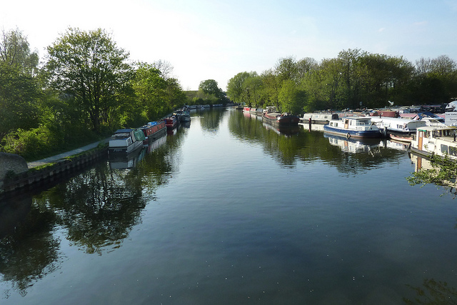
https://www.visitleevalley.org.uk/en/content/cms/outdoors/marinas/springfield-marina/

1 Purpose of the Facility
  - The Lee Valley Marina – Springfield has been owned, operated and developed as a revenue marina/boatyard by the Authority since the late 1960s, when it was purchased by the Authority from the Radley family. In the Authority's records it is noted that the Radley family had owned the site since the early 1890s, however, it's unlikely to have been operated as a boatyard initially. The transition to a yard with moorings is locally reported as being around the 1930’s. Sited on the lower reaches of the River Lee adjacent to Walthamstow Marshes, a Site of Special Scientific Interest (SSSI) and a Nature Reserve, the Marina has some 200 berths and is close to the City of London and the West End. It is ideally placed for cruising the canal systems and the River Thames and River Lee and Stort. The marina is more than adequately served by public transport. Lee Valley Marina, Springfield offers exceptional service and has an established reputation for quality repairs.
  - General services available – diesel, water, refuse disposal, sanitary disposal and boat pump out, Calor gas, toilets, showers, solid fuel, electric charging and hook ups.
  - Boat services available - Boat repairs, welding, painting, fitting out, surveys, BBS certificates arranged, refurbishment, repairs and blacking.
  - Engine services available - New engines sourced, engine repairs and servicing, breakdown callouts.
  - Moorings – overnight, long-term, winter storage (hard standing).
  - Other facilities and services - Slipway (maximum length 10.98 Metres), workboat, boat lift, club room. Towage, repair and maintenance service is available for all types of craft. C&RT Licences (short and long term).

2 Operations
2.1 Opening Hours and Admission:
The Lee Valley Marina - Springfield (LVMSp) is open to the public 52 weeks of the year with reduced hours if emergency maintenance is required.
2.2 Sale of foodstuffs and merchandise:
Foodstuffs and merchandise is sold on the premises by the operator.
Lee Valley White Water Centre

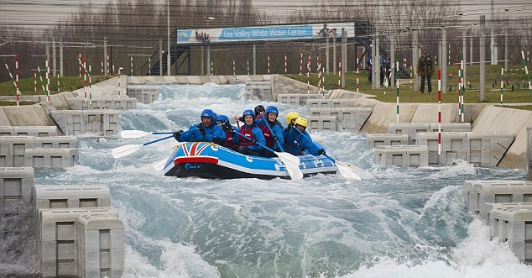
https://www.visitleevalley.org.uk/en/content/cms/outdoors/watersports/

1 Purpose of the Facility
  - Lee Valley White Water Centre (LVWWC) offers a range of white water activities from canoeing and kayaking to white water rafting. Development and expansion work has recently been completed and there are now improved facilities including more changing rooms, an expanded café with a bigger outdoor terrace area and the new Pavilion in the park which includes the Finish Line Café.
  - LVWWC is the high performance centre for British Canoeing’s Slalom team, with offices, physiotherapy facilities, high performance gym and performance analysis on site.
  - LVWWC will make water available to maximise British Canoeing’s performance at World Championships and Olympic Games (in line with the water use agreement).
  - LVWWC will give access to the worlds paddling community to train at the Facility in readiness for international competitions.
  - LVWWC will deliver tuition in paddlesport activities and host a paddlesport club delivering the complete range of paddlesport activities.
  - LVWWC will deliver adrenalin activities (i.e. but not limited to white water rafting, hydro speeding, hotdog, water wipe out) associated to white water and placid water environments.
  - LVWWC will host meetings and corporate activities, deliver team building activities and price activities to deliver a sustainable Facility.
  - LVWWC will host and deliver events associated to paddlesports and other sports where the Facility's facilities can facilitate those sports [i.e. but not limited to aquathon’s, open water swimming] and will develop additional attractions and activities to sustain the interest in the Facility to maintain sustainability.

2 Operations
2.1 Opening Hours and Admission:
The Lee Valley White Water Centre (LVWWC) is open to the public meeting the needs of its users. It is accepted that demand for water activities is highest in the summer months with demand and use declining over the colder winter months.
2.2 Sale of sporting equipment and merchandise:
Sporting equipment, foodstuffs and merchandise is sold on the premises by the operator.
Lee Valley VeloPark

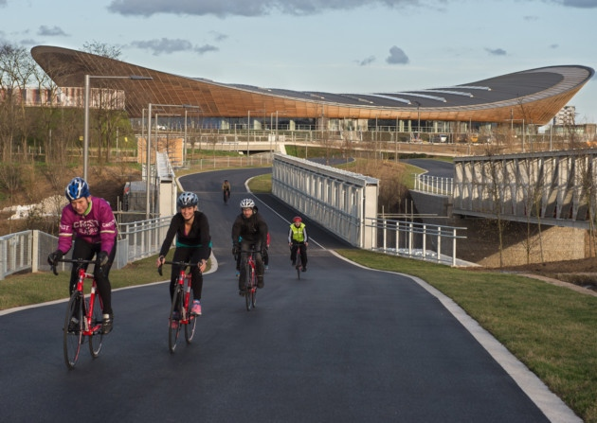
https://www.visitleevalley.org.uk/en/content/cms/london2012/velo-park/

1 Purpose of the Facility
  - Lee Valley VeloPark (LVVP) on Queen Elizabeth Olympic Park has a selection of cycling disciplines that provide cycling opportunities (e.g. lessons, training, taster sessions, events, corporate bookings, leagues, competitions, and coached sessions) for all cycling abilities from the beginner, casual user, club cyclist to the elite Olympic rider.
  - The Facility has spectator seating capacity of up to 6000. It is currently the only Facility in the world that has four disciplines of cycling in one Facility.
  - The four cycling disciplines cover:
- The 250m track in the iconic Velodrome,
- Racing on the one mile floodlit road circuit,
- Use of the mountain bike trails
- The berms of the 390m floodlit re-modelled Olympic BMX track.
  - LVVP has two treatments room, two meeting rooms and a five suite meeting area for holding conferences, meetings and other types of bookings. The track centre is used to host events, exhibitions, conference and programmed activities. It is around 3500 square metres in area.
  - LVVP is used to host international, national, regional and local competitions at all levels, and for British Cycling and Union Cycliste Internationale, as well as regional clubs and associations.
  - LVVP is regularly used by television for various programmes and filming and as a training Facility for regional and national led clubs, British Cycling riders, as and when required.

2 Operations
2.1 Opening Hours and Admission:
The Lee Valley VeloPark (LVVP) is open to the public 52 weeks of the year with reduced hours or closures over bank holidays, between Christmas and New Year and during exclusive events and when planned maintenance is required. The current opening hours are 09:00 to 22:00 (Monday to Friday) and 09:00 to 17:00 (Saturday and Sunday)
2.2 Sale of sporting equipment and merchandise:
Sporting equipment, foodstuffs and merchandise is sold on the premises by the operator.

