Wednesday, 23 January 2019
Thetford Town Council is seeking costs for an architect to work with the Council and Historic England to restore the Guildhall Twin Towers
TTC/19/002
Thetford Town Council have been invited to apply for a development grant from Historic England for the restoration of the cupolas on the Guildhall roof.

Historic England have advised that the Council to initially appoint their lead adviser and then put in the application for the development grant based on the figures provided by the selected architect/surveyor. The successful candidate will need to be conservation-accredited by one of the following bodies:

The AABC (Architects Accredited in Building Conservation)
The RIBA (accreditation category SCA or CA, depending on the listing grade of the building)
The RICS (Royal Institution of Chartered Surveyors)
The CIAT (Chartered Institution of Architectural Technologists)

The Partners are looking for a price to cover the two stages, beginning with what is known as project development, and then the following second stage which is the completion of the actual repairs.

The purpose of the project development stage is to identify as accurately as possible what the building defects are, the urgency and cost of dealing with them, and any constraints that might apply.

Most of the costs in the project development stage will be the fees for professional advisors. For simple projects, only one may be needed, such as an Architect or Surveyor, but others may also require a Structural Engineer, a Quantity Surveyor, or other specialists. Where more than one advisor is needed, the Architect or Surveyor will be the Lead Advisor, co-ordinating their work.

Providing a range of surveys such as a condition survey accompanied by investigation of the building (i.e., opening up and examining unseen or previously inaccessible areas).

Any further specialist surveys to confirm whether factors exist which could affect the way the repairs are carried out, or their timing, or which could pose problems during the repair stage such as danger to the workforce, delays, and additional costs. For example, the presence of bats, asbestos, or a defective electrical and heating system.

Identifying the repairs needed, drawing up a specification, and obtaining tenders for them either as one phase of work, or the first of several more to follow.

In some cases, there may be a need for some emergency work that cannot wait until the main repairs begin, such as propping a collapsing wall. This can be included in the project development phase.
Presenting the results of the tenders methodically in a Tender Report, accompanied by all the other reports resulting from the surveys.
Confirming all the costs of the intended repairs and the professional services associated with them.
A percentage fee for managing the completion of any works including ensuring all health and safety legislation is complied with throughout the project.

Quotation Requirements
Please can you complete the following table
FEE QUOTATION OR TENDER from
please complete each box with bold outlines
Date:
VAT charged
Yes*/No
* if yes, please
include
in figures below
Condition Survey
£
incl VAT
Drawings
if in-house
£
incl VAT
Drawings
by others?
Yes*/No
*if by others, no cost needed at present
Fee % for normal services on the whole
project
(development and repair)
Actual fee for normal services
in the development
assuming repair costs…
stage only
↓
Up to £50,000
%
£
incl VAT
Up to £100,000
%
£
incl VAT
Over £100,000
%
£
Incl VAT
Fee Apportionment
% (e.g: 60/40)
development/repair stage
/
Expenses
if additional to above:
£
fixed/up to?
incl VAT
Additional essential information for shortlisting
- Details of how your company and the staff you employ meet the requirements for Architects laid out by Historic England. Evidence to include CVs, and details of accreditations and membership of professional bodies.
- Minimum of 2 examples of projects completed on historic buildings particularly working with Historic England and details of two referees.
- A costed quotation for the works which gives a breakdown of costs for development and implementation phase (See table above).
- The council requires a copy of your public liability insurance, and a copy of health and safety policy, and samples of risk assessments.
- Costs of any additional surveys/works not included in the table above.

Failure to supply any of the information requested in the attached specification will result in the Tender being rejected.

Please note at this point no funds have been secured for this project and it will not start until a development grant has been received from Historic England

Contact name and number: Roz Barnett, Amenities Land and Property Officer or Tina Cunnell Town Clerk (01842) 754247.

Quotations to be received by noon, Friday 22th of February 2019.

Tender to be sent in sealed inner envelopes to be clearly marked
‘Tender – The Guildhall Two Towers Architect
For the Attention of the Town Clerk, Thetford Town Council

Postal Address The Carnegie, Thetford, Norfolk, IP24 2DS
Tel: (01842) 754247

Details of the winning contract will be published IAW Local Government Transparency Code 2014.

Should you require further information over and above the tender requirements then please do not hesitate to call.

Yours sincerely

Tina Cunnell BSc (Hons)
Town Clerk

THETFORD GUILDHALL

The Guildhall is a Grade II listed building, and, being in a Conservation Area, its repair is eligible for grant aid from Historic England.

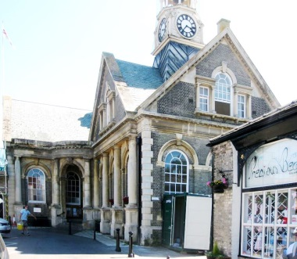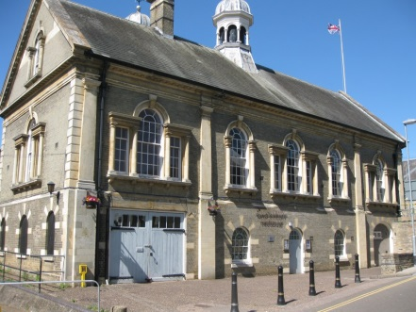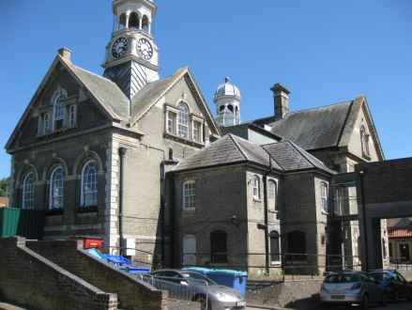

The Statutory List description reads:

TL8783 MARKET PLACE 617-1/6/101 (South West side) 10/03/71 Guildhall (Formerly Listed as: MARKET PLACE (South West side) Guildhall and Library)
GV II
Guildhall. 1901. By HJ Green.

Gault brick with stone dressings. Slate roofs. L-shaped plan. 2 storeys and dormer attic. South front of bar of L consists of 5 bays of Venetian windows at first floor divided into 1-3-1 bays by pilasters. Rusticated quoins. Gabled roof with central polygonal cupola to east of a ridge stack.

Stem of L faces Market Place and at entrant angle between the 2 wings is a convex projecting entrance porch with a round arch. One bay left and 3 bays right have round-headed sashes, the bays marked by engaged Tuscan columns. The stem has 3 big gables (one to each side) with Venetian windows and a central polygonal cupola mounted on a square plinth with a clock. Gabled roofs.

INTERIOR: entrance leads to hallway with staircase at end: closed string, turned balusters, ramped moulded handrail and square newels. Right and left are courtrooms. Large Court to south with 4-centred barrel-vaulted ceiling. East wall with niche under a swan-necked pediment containing a Coade stone statue of Justice. Small Court to north with panelled bench intact. Main upper room has a groin-vaulted roof and is lit by Venetian windows on 3 sides. King-post roof construction.

(The Buildings of England: Pevsner N: North-west and South Norfolk: Harmondsworth: 1962-: 341-347).
Listing NGR: TL8716782998

(“GV” signifies that the building is of group value with others nearby)

Built in 1901, the Guildhall was designed in an articulate version of the Baroque style that first emerged in Britain late in the 17th Century, and subsequently re-appeared at various times, including the present, when favoured by Architects and their clients. Its revival was especially prevalent towards the end of the 19th and at the beginning of the 20th Century, but remains with the present architectural repertoire; one of the best-known current exponents being Quinlan Terry.

Originally accommodating the local County Courts, The Guildhall is now a venue that can be hired for public or private events – appropriately so, as the design of the interior is very much in the style of 17th and 18th Century Assembly Rooms. Plans are underway to improve the present facilities, hopefully with the assistance of funding from the HLF.

The building is a focal point in the historic centre of Thetford, and this was no doubt the intention. Its external architectural features include two domed and colonnaded cupolas..

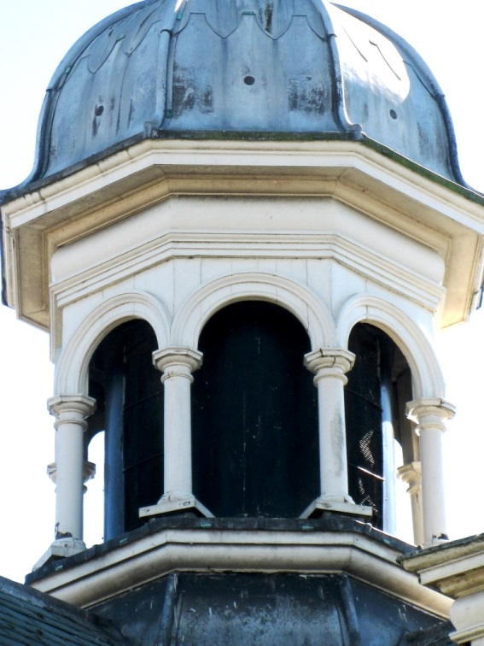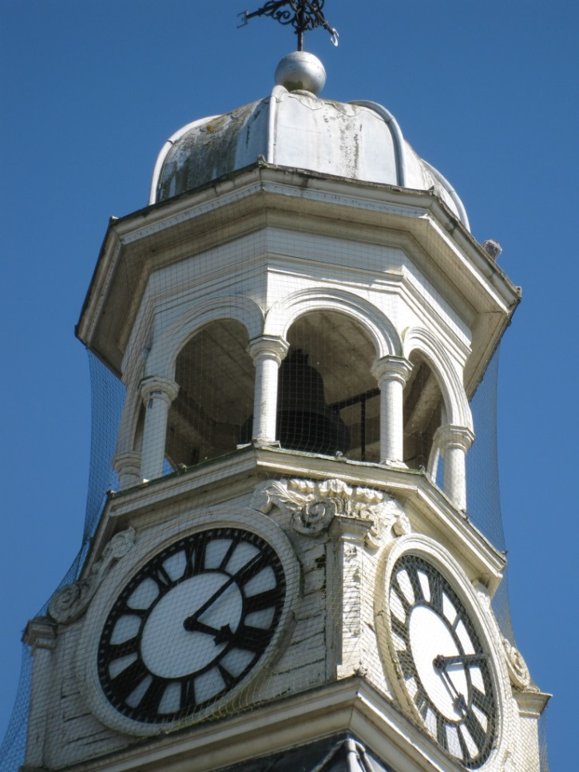

Difficulties of access to and maintenance of the cupolas has resulted in deterioration of the joinery. Repairs are likely to be costly, and the defects more extensive than currently visible.

Defining the scope and cost of the works require a full condition survey of the cupolas, a specification for repairs, and a competitive tendering exercise, all of which can form the basis of a grant application to Historic England. Costs for the repair stage would be in a subsequent and separate application.

It is suggested that for now, the survey can focus on the cupolas. When full access to them and opening up can take place, it will be possible to determine whether a more extensive survey of the roofs (or the buildings generally) is required. This could form a separately funded and subsequent exercise.

Subject to the availability of HE funds, and compliance with the requirements of the grant scheme, including procurement both of professional services and the repair contract.

