Church Walk Restoration

Project Breakdown
 | Details | Comments
1 | A lockable Steel Bollard is to be installed at the A50 end to stop unauthorised traffic along Church Walk. This will be removable for occasional and controlled access by landlords and business owners. | To be sourced by the Parish Council and the paving supplier will be expected to allow for its installation.
2 | Pave surface of Church Walk and continuation in front of Cheshire House (see plan) using Marshall’s Tegula block paving. Option to continue paving into side alley bin store by the Co-op to be included in the quotation. The supplier must allow for the removal of the existing concrete planter. Example shown below:  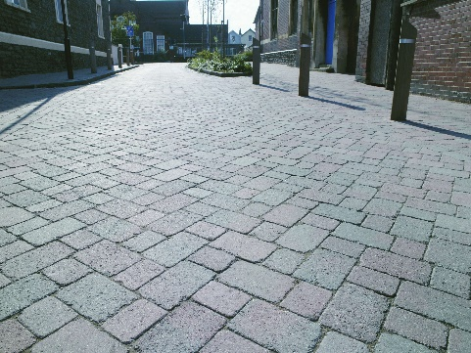 | Quote to be split between Church Walk and in front of Cheshire House and may be completed by separate projects. Supplier is expected to provide incentives to complete as one project.
3 | The entrance to the existing bin store may be sealed with timber gates. These will be sourced by the Parish Council. it is expected that they will be able to open safely to allow for the waste bins to be moved to refuse lorries. Example below. The supplier is expected to provide a separate quotation for paving this area  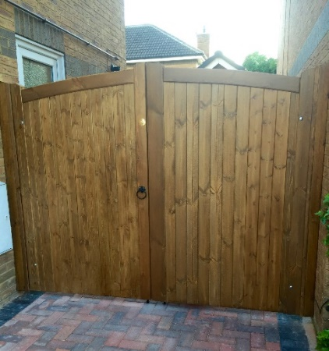

4 | It is the intention that the existing railings may be replaced with one of a suitable heritage design such as the example below. The supplier should allow for the installation of the railings when paving this area.  