**Schedule 2 (Specification)**



14 April 2023

Table of Contents

**1.** **GLOSSARY** 0

**2.** **INTRODUCTION** 3

**2.1** **What is split payment** 3

**2.2** **Why a proof of concept?** 4

**3.** **POC SPECIFICATION** 7

**3.1** **Objective** 7

**3.2** **Out-of-scope elements** 7

**3.3** **Core requirements** 7

**3.4** **Security and accessibility** 9

**4.** **POC PHASES** 11

**4.1** **Delivery timescale** 11

**4.2** **Basic capability development - Phase 1** 11

**4.3** **Targeted capability development - Phase 2** 13

**4.4** **Advanced capability development - Phase 3** 15

**5.** **REPORTING EXPECTATIONS** 19

**5.1** **In-Phase** 19

**5.2** **End-of-Phase** 19

**6.** **DEMONSTRATION`S EXPECTATIONS AND ACCEPTANCE CRITERIA** 22

**6.1** **Overview** 22

**6.2** **Performing the Demonstrations** 23

**6.3** **Demonstration witnessing** 24

**7.** **INTELLECTUAL PROPERTY EXPECTATIONS** 26

**8.** **ANNEX A** 28

**8.1** **Handling foreign exchange in the splitting mechanism: a fixed amount example** 28

**8.2** **Handling foreign exchange in the splitting mechanism: a percentage tax rate example** 29

**9.** **ANNEX B** 30

**9.1** **About the foundational datasets and user stories** 30

**9.2** **Use of data sets with user stories** 31

**9.3** **Percentage rates and fixed amounts** 31

**9.4** **Money transfers** 34

**10.** **ANNEX C** 36

**10.1** **Pay.UK** 36

# GLOSSARY

Some of the terms used throughout this document are capitalised to indicate they are being used with a particular meaning, context or purpose in mind. These capitalised terms are listed and defined in the following section:

|  |
| --- |
| **“Accuracy”** *or*  **“Accurately”** |
| That VAT is split out of payments only when it is truly owed to a tax authority such as HMRC, achieved through the evolution of the PoC, whereby extra Decisioning Factors are introduced to each Phase so that Split Decisioning becomes better informed by more data. | |
|  |  | |
| **“Decisioning Factors”** |
| Types of information that are distinct from one another, such as buyer location, seller location or product code, which are fed into a payment splitting mechanism to be evaluated for Split Decisioning purposes. | |
|  |  | |
| **“Relevant Transaction”** |
| This is a sale of goods or services to a UK buyer, by a seller thatis situated outside of the UK (is “overseas”). | |
|  |  | |
| **“Reliable”, “Reliably”**  *or*  **“Reliability”** |
| These refer to a mechanism’s ability to Repetitively (perfect fidelity) and Accurately:   * perform Split Decisioning including in Sifting; and * perform Split Actioning. | |
|  |  | |
|  |  | |
| **“Repetitively”** | This refers to a mechanism`s ability to perform Split Decisioning and Split Actioning with perfect fidelity. | |
|  |
| **“Resident”** |
| That a person (including one of no fixed abode) has an accepted postal address for banking purposes, which enables an association to be made between a person’s identity and a geographic location to which written communications could be sent to them. | |
|  |  | |
| **“Retail Payment”**  *or*  **“Retail Payment Transaction”** |
| For the purpose of the PoC this refers to a payment that is for the purchase of goods or services, irrespective of whether the buying consumer is a person or a business. | |
|  |  | |
| **“Sifting”** |
| The capability of a mechanism to reach Split Decisioning determinations at a volumetric scale (i.e., that it is able to look across an ongoing minute-by-minute churn of payments, to pick out Relevant Transactions). | |
|  |
| **“Simulated”** |
| This is the need within the demonstrations to avoid the use of data belonging to real persons or businesses, and instead use randomly generated, fictional payments data. | |
|  |  | |
|  |  | |
| **“Split Actioning”**  *or*  **“Actioning”** | A mechanism’s ability, after identifying a Relevant Transaction, to perform the needed calculations and split a payment into two, along with completing any required foreign exchange operations, so that each split part is packaged with Structured Data ready for transmission to its final intended recipient. | |
| **“Split Decisioning”** *or*  **“Decisioning”** |  |  |
| The ability of a mechanism to make a logic-based evaluation of multiple Decisioning Factors, to reach a determination that a VAT split should be applied to a payment because it is a Relevant Transaction. | |
|  |  | |
| **“Splitting Intervention”** |
| That a transaction has passed through Split Decisioning as defined above, and therefore is identified through Sifting as a Relevant Transaction to be treated for Split Actioning. | |
|  |  | |
|  |  | |
| **“Structured Data”** |
| Data that is accumulated on multiple payment splits (e.g., by scraping or harvesting it from evaluated Decisioning Factor sources), to provide a tax administration like HMRC with:   * context about the multiple origins of any aggregated sum of VAT due from multiple Relevant Transactions from a splitting mechanism; and * the ability to reconcile the multiple origins of the tax payments aforementioned with its records of tax liable persons and businesses. | |

# INTRODUCTION

## **What is split payment**

It is the idea that a payment might be split into elements which are then routed to different destinations. In a VAT context that is the notion that when qualifying goods or services are bought, the VAT within the purchaser’s payment could be routed to HMRC and the seller only receives the net amount.

*The splitting idea*

*VAT context*

The financial intermediary that processes the purchaser’s payment would be responsible for making the split and routing that VAT directly to HMRC.  This idea offers hope for better tackling VAT non-compliance, and in the longer-term fits into HMRC aspirations for transforming tax collection, as articulated in the 10-year [Tax Administration Strategy](https://www.gov.uk/government/publications/tax-administration-strategy).

## **Why a proof of concept?**

There are tax authorities that already collect VAT or General Sales Tax (GST) to varying degrees through legislatively mandated interventions on payments. Overlaying such technology on the UK VAT system would not be possible without first addressing a wide range of complex policy questions and understanding the full potential of any such technology.

*Around the world*

In order to test the potential of the technology our initial focus is on exploring the feasibility of splitting payments in a specific area of VAT for goods and services bought by UK consumers from non-compliant overseas sellers. This will test a range of capabilities including the technology’s ability to know when VAT is chargeable or not. Also, whether an intervention can be made without the consent of the seller or buyer, something that, as far as we are aware, known examples of split payment are unable to do.

*Testing the feasibility*

Such a mechanism would be driven by either payments system messages (e.g. the location of a seller or a buyer) or new data sources (e.g. product codes, e-invoices or equivalent). Currently, as far as we are aware, there are no marketed solutions available, and we are not aware of others asking the market to develop such solutions.

*Data*

A successful PoC would begin to inform whether or not a first potential use for Split Payment in the UK is viable. If successful, it could then also help shape future tax modernisation efforts, e.g., automated software which could link businesses, payments intermediaries and HMRC.

*Possible futures*

Notwithstanding the foregoing, HMRC’s current focus is only to discover whether technology is capable of real-time payment interventions to tackle overseas VAT non-compliance. This will inform policy development and dialogue.

*Objective*

# POC SPECIFICATION

## **Objective**

Supplier to develop a PoC to prove the technical feasibility of splitting digital Retail Payments to capture VAT from Relevant Transactions.

*What the PoC is for*

## **Out-of-scope elements**

The supplier is **not required** to show how**:**

* data associated with Splitting Interventions would – at intervals – be transmitted to, or ingested by a relevant tax authority (noting that core requirement 4 on preparatory packaging still applies);

*What the PoC is not for*

* monies captured from Splitting Interventions would be held or passed onto and ingested by a relevant tax authority (such as HMRC);
* a plan for the PoC to be turned into an operational implementation by HMRC after the PoC completes (however, as the reporting requirements state, at the end of Phase 3 only, a provider may give a projection of future uses); or
* a new tax policy could be drawn-up around the PoC by HMRC.

## **Core requirements**

Operating only at a technical level, the PoC must**:**

*Requirements across the Phases*

1. show how a Splitting Intervention would work, and be Reliably applied –
   * + - 1. for basic and targeted capability demonstrations (Phases 1 and 2), without the direct co-operation of the buying or selling counterparties; and
         2. for the advanced capabilities demonstration (Phase 3), with the indirect co-operation of the counterparties, through the use of new data sources about their transaction (in other words, data sources into which either party makes data inputs, e.g., e-invoicing systems);
2. show how relevant card and non-card payment transactions (depending on the Lot, as described below) could be correctly identified for Splitting Intervention (e.g., by disregarding non-Retail Payment Transactions) –
   * + - 1. card payments (**Lot 1.**) should be taken to mean payments through debit and credit cards, as well as linked uses of digital wallets, whereby a wallet acts as a processing portal through which a payment from a linked card is made; and

*Card payments & non-card payments*

* + - * 1. non-card payments (**Lot 2.**) should be taken to mean **both** Bacs and Faster Payments, and include linked uses of digital wallets, whereby a wallet is pre-loaded with funds transferred into it;

1. use Simulated payments transaction data, (including the randomly generated Foundation Data **(described in the** **Annex** **to this Specification**) that is supplied by HMRC (for the purposes of demonstrations under Phases 1 and 2)) and is developed by demonstration providers for the advanced capabilities they wish to show (under Phase 3);
2. show how Structured Data on successive Splitting Interventions (i.e., multiple payment splits) could be captured, recorded or otherwise held, and packaged in a consumable manner in preparation for transmission to a relevant tax authority (noting that actual onward transmission is out of scope of these requirements), alongside an auditable record of the basis upon which payments were declined for a Splitting Intervention; and
3. do all the above (requirements 1 to 4) –
   * + - 1. without materially degrading payment processing speeds;
         2. in a manner that the Supplier reasonably believes would be interoperable with existing and any foreseeable future payments networks or systems;
         3. in a manner that supports payment refunds, chargebacks and transaction reversals;
         4. *if possible*, using current payment messaging standards and card system rules, including any planned reforms to such standards and rules;
         5. *but if* ***d.*** *is not possible*, illustrating what new changes or reforms would have to be introduced (e.g., seeking the addition of further purpose codes to the existing agreed set under ISO20022);
         6. by exploiting other useful data sources, such as but not limited to Legal Entity Identifier ([LEI](https://www.gleif.org/en/about-lei/introducing-the-legal-entity-identifier-lei)), Level III card data, the GS1 standards (e.g. [EAN/UPC](https://www.gs1.org/standards/barcodes/ean-upc), [GTIN](https://www.gs1.org/standards/id-keys/gtin), [GLN](https://www.gs1.org/standards/id-keys/gln)), e-invoicing standards like Universal Business Language ([UBL](https://www.oasis-open.org/committees/tc_home.php?wg_abbrev=ubl#overview)), and other electronic data interchange (EDI) systems or equivalents; and
         7. using an overall design philosophy that is transparent, non-monopolistic, and could be replicated by other developers to reach the same functional outputs.

## **Security and accessibility**

At any stage throughout the PoC a successful demonstration must comply with the following security and accessibility criteria**:**

1. HMRC staff must have access to the test/development environment through browser user interfaces that are easy to use and are compliant with HTML 5 User Interface (UI) standards;
2. in order to access test/development environments, HMRC users must be provided with user accounts that are protected with a username and password;
3. the UI must be compatible with all standard HMRC browsers (Chrome/Edge/Firefox) and should not require the installation of plugins;
4. only Simulated data should be used for testing;
5. data must be encrypted at rest (when held in a data store) using unbroken algorithms: currently this will be to AES256 or equivalent;
6. data must be encrypted in transit using unbroken algorithms: currently this will be to at least TLS 1.2 for web traffic;
7. the solution must support a mechanism for mass export of data via an industry standard format (JSON, CSV, XML or equivalents etc.)
8. the service must have appropriate protections against external attacks (DDoS, SQL Injection, or equivalents etc.);
9. audit logs must be searchable, actionable and exportable to external systems;

and

1. only for card payments` demonstrations, any component developed must take into consideration future compliance with PCI-DSS (Payment Card Industry data security standards) [standards](https://www.pcisecuritystandards.org/standards/).

# POC PHASES

## **Delivery timescale**

The PoC will be carried out in 3 Phases:

* Basic Capability Development – Phase 1;
* Targeted Capability Development – Phase 2; and
* Advanced Capability Development – Phase 3,

together the “**Phases**”.

Phases 1 and 2 of the PoC must be completed no later than **31 May 2024**, and all Phases of the PoC must be completed and invoiced before **31 January 2025**. However, HMRC would prefer completion of all three (3) Phases by 31 July 2024 if possible.

Within these deadlines the timings of the Phases are for the Supplier to determine as part of their proposal, however bids which can achieve conclusion of all three (3) Phases by 31 July 2024 will score more highly in evaluation.

HMRC envisages that a majority of the PoC time is best spent on Phase 3 requirements.

## **Basic capability development - Phase 1**

The first capability that must be shown by a PoC is an ability to intuit or discern from current and/or planned future payment messaging and card payment data that, excluding the VAT compliance status of a seller, a payment has the characteristics of a Relevant Transaction, and to then apply a split for VAT. This links to the Reliability stipulation under Core Requirement 1.

*Context*

Therefore, this Phase 1 demo **is not** required to draw on anything other than current data available or data that is anticipated to become available within payments for its splitting decisions. **Core requirements 5e**. **and 5f**. **do not apply to this Phase**.

*Data*

Although core requirement **5a**. applies, **payment processing speed will not be tested in this Phase.**

This means that the capability to be demonstrated by the PoC should include identification of the**:**

*Basic requirements (first milestone of Phase 1)*

1. geographic sales origin of a transaction, by territory or jurisdiction (e.g., Switzerland, Hong Kong, Luxembourg or other);
2. territorial or jurisdictional residency or business location of a buyer (based on their address, e.g., United Kingdom or other); and
3. transaction’s presumed purpose (e.g., by means of an educated assumption, or by using the purpose codes that are already planned for introduction under ISO20022).

The basic requirements detailed above describe the factors in the decision process of whether to proceed with a payment split, hereafter referred to as Split Decisioning. Applying a split in consequence of this Decisioning is the **first milestone of Phase 1**.

*Decisioning Factors*

In addition, HMRC would like the PoC in the basic capability demonstration to**:**

*Additional requirements (second milestone of Phase 1)*

1. accommodate foreign exchange within transactions (see the Annex for examples of how HMRC foresee this could work); and
2. allow flexibility in the rate of tax to be split out (embracing percentages and flat amounts).

The additional requirements detailed above describe the actions to be taken once a splitting decision has been arrived at, hereafter referred to as “Split Actioning”. This is the **second milestone of Phase 1**.

The outcome of both milestones ought to illustrate how it might be possible to sift-out from overall payment volumes those that meet all characteristics of being a Relevant Transaction.

*Sifting for Split Actioning*

## **Targeted capability development - Phase 2**

The next capability that must be shown by a PoC is the ability to take the basic capability outputs and focus their application onto sellers that are VAT non-compliant.

*Context*

Accordingly, the PoC should show how a Splitting Intervention could be triggered by reference to each of the following types of intelligence that might come from a tax authority**:**

1. a list of compliant, or of non-compliant, sellers using open standards such as csv or xml or equivalent; or

*Targeting requirements (first milestone of Phase 2)*

1. a binary ‘do not split’ or ‘continue’ instruction from a tax authority’s systems, such as HMRC’s.

|  |
| --- |
| A PoC need only show how the mechanism for a Splitting Intervention can absorb and correctly react to such lists or instructions. It is **not required** to**:**   * take real lists from HMRC, or * build actual links to HMRC systems.   Also**:**   * although core requirement **5a**. applies, **payment processing speed will not be tested in this Phase;** and * although core requirement **5e**. and **5f**. applies, **the use of the following technologies will not be tested in this Phase –**    + any geolocating methods, such as [GLN](https://www.gs1.org/standards/id-keys/gln) or equivalents;   + any e-invoicing methods, such as [UBL](https://www.oasis-open.org/committees/tc_home.php?wg_abbrev=ubl#overview) or equivalents; and   + any other electronic data interchange (EDI) systems.   The targeting requirements detailed above describe the Split Decisioning factors for whether to proceed with a payment split. This is the **first milestone of Phase 2**. |

After the first milestone of Phase 2 has been shown, there is a refinement that HMRC would like to see. This refinement is the ability to**:**

*Additional requirement (second milestone of Phase 2)*

1. extract the tax from a payment, before that payment leaves the regulatory jurisdiction in which the buyer is Resident (e.g., perhaps by identifying this from the billing address on the buyer’s authorised source of funds).

* When reflecting on the foregoing paragraph, please note that whatever the solution might be, it is highly desirable if a mechanism was able to extract VAT owed to a tax authority even where a Resident buyer pays through a source of funds authorised and issued in another country.

In a UK context that means a mechanism that can make a Splitting Intervention for VAT before the monies are transmitted overseas to a sellers’ deposit account.

*UK context*

This requirement **13** describes an additional aspect of Split Actioning to be met once a splitting decision has been arrived at. This is the **second milestone of Phase 2.**

## **Advanced capability development - Phase 3**

The final capability to be shown is how the mechanism for a Splitting Intervention could have greater sophistication in how it:

*Context*

* draws on data to inform whether to perform a Split Actioning (this is about using data sources outside of payment messaging to enhance the mechanism`s functioning); and
* is used by tax authorities to aid compliance or improve tax administration.

There are two **milestones** in this phase. These are to discover**:**

* whether the targeted capability’s functioning can be further improved; and
* how a mechanism’s ‘targeted capability’ might be further developed for real-time collection of VAT/GST (by tax authorities around the world).

A key aspect of both milestones is how a tax authority ensures that it is only capturing the tax owed to it. It is a feature of VAT and GST regimes around the world that they are predicated on the consumption of goods or services within the respective tax authority’s territory or jurisdiction. A fully fledged splitting mechanism should be able to leverage diverse sources of data including, if necessary, newly created data points to distinguish where a buyer is intending or meaning to consume their purchase.

*Capturing VAT due*

For the **first milestone**, HMRC would like the supplier to show if the PoC could do all of the following requirements**:**

1. identify a seller’s territorial or jurisdictional location through the routing of a buyer’s payment to a seller’s final deposit account (if not already shown in Phase 1);

*Advanced requirements (first milestone of Phase 3)*

1. identify the territorial or jurisdictional location of a buyer when they make payment (in other words, where they are standing at that moment, e.g., United Kingdom, Spain, France or other);
2. discern or positively identify where it is intended that the purchased goods or services are to be delivered and/or consumed;
3. identify if the goods sold by a seller are already lodged within the territory or jurisdiction of the tax authority (e.g., in a fulfilment warehouse) where they are to be delivered and/or consumed;
4. record the information above within the Structured Data, per the core requirement, if a payment split is made; and
5. indicate to a seller that a split for tax (VAT/GST or other) has been made in respect of the payment portion that they receive.

**Note in respect of requirement 17** - If requirement 17 is shown, it should be demonstrated how this information can be used in the following three (3) different ways:

* + - 1. Goods are identified as lodged outside the tax authority’s territory, and this is used as one of the decision factors for making a payment split;
      2. Goods are identified as lodged inside the territory of a tax authority, and this is used as one of the decision factors for **not** splitting a payment; and

*Advanced Decisioning Factors*

* + - 1. Goods are identified as lodged inside the territory of a tax authority, and this is instead used as one of the decision factors for making a payment split.

The advanced requirements 14-17 detailed above describe the Split Decisioning Factors for whether to proceed with a payment split. Advanced requirements 18 and 19 describe Split Actioning steps. Requirements 14 to 19 make up the **first milestone of Phase 3.**

For the **second milestone**, and with due regard to the nuances of VAT and GST regimes around the world (and using UK VAT as the reference example), a supplier must show if a PoC could achieve all of the following requirements**:**

*Additional requirements (second milestone of Phase 3)*

1. Process buyer-deferred payment arrangements. This includes all kinds of “Buy-now, Pay-later” agreements, where the seller introduces a third-party provider of credit to the buyer;
2. Process buyer payments that in whole or in part comprise the redemption of the value in one or more pre-paid vouchers;
3. read and exploit geographic location data (e.g., [GLN](https://www.gs1.org/standards/id-keys/gln) or equivalent) in a way that in future could encompass related data arising from a physical or digital point-of-sale, and if appropriate a stock dispatch location, when a payment is made;
4. in principle, be further developed to interlink with or absorb data from other sources, such as that transmitted into tax authorities’ Customs systems (e.g., under the [WCO Data Model](https://mag.wcoomd.org/magazine/wco-news-97-issue-1-2022/making-digital-collaboration-possible-the-wco-data-model-latest-developments-and-implementation-guidance/) or equivalents);
5. use the Structured Data within electronic data interchange between businesses, and between financial institutions, to make an informed extraction of VAT (such as, but not limited to, electronic invoices, or various competing and proprietary types of trade finance technology for irrevocable payment commitments, like [BPO](https://www.swift.com/swift-resource/35051/download) and [PRM](https://marcopolonetwork.com/payment-risk-management/) or equivalents);
6. calculate a composite VAT or GST total across a mixed basket of goods and/or services, each of which might attract a [different rate of VAT](https://www.gov.uk/vat-rates); and
7. disregard a total sales basket value (exclusive of tax) at or below a particular amount, or only apply a split above a certain threshold.

The additional requirements 20-23 detailed above describe Split Decisioning Factors. Additional requirements 24 and 25 describe Split Actioning steps. Requirements 20 to 26 make up the **second milestone of Phase 3**.

Delivery of the requirements in the two milestones of Phase 3 must be provided in the order in which the requirements are set out above. This is because, in each milestone the requirements are listed in decreasing order of importance. In the view of HMRC, some of the most technically challenging requirements are listed at the top of the second milestone of phase 3.

*Milestone delivery*

It is probable that any eventual future implementation of split payments for tax purposes would be infeasible without these capabilities.

# REPORTING EXPECTATIONS

## **In-Phase**

Delivery of the PoC build must:

* use agile software development methodologies; and
* include the following interactions with HMRC:
  + Show and tells; and
  + Weekly check points with the PoC development team’s leadership.

*Interactions with HMRC*

‘Show and Tells’ are to occur at the end of a sprint or anytime that a developer needs to sense-check their work with HMRC, without it being received as a formal demonstration.

The purpose of the weekly check points is to provide steerage and assurance between the supplier and HMRC.

## **End-of-Phase**

At the end of **each** of the milestones in the three Phases, the Supplier shall provide the Buyer with a written report on the design philosophy used. Without disclosing any commercially sensitive information about the intellectual property owned by the developer, the report should describe the demonstrated splitting mechanism’s**:**

* sources of input data and their Reliability: this must cover the underlying origin of each type of source data in terms of who originally gives the information (e.g., whether it is a merchant), how it gets given including what system it is originally fed into, and the risk of false information being given, as well as any safeguards against this;

*Reporting elements*

* decision logic, in terms of how those inputs are functionally used as determinants;
* outputs, in terms of how the determinants collectively work to generate logic driven decisions to split a payment or not;
* architecture and design, using diagrams and process flows to show how the concept has been put together (using industry standard notation); and
* conformity with general software design principles, in terms of, for example, the chosen use of programming language, the chosen software design concept and its extensibility.

To help non-expert readers, the report should always give an overview explanation using non-technical language for the points above. It may then delve into a deeper level of detail using any necessary specialist technical language. Overall, it must be possible for a reader with no payments expertise to understand the core fundamentals of the described mechanism.

*Technical details*

Each report must conclude by explaining the advantages, potential weaknesses, and risks of the chosen development path. This encapsulates the breadth and quality of the data sources used to assist Split Decisioning. It also relates to the ability to integrate into payment processes.

*Concept integrity & industry coherence*

Reporting for each successive Phase should cover the same ground, but dwell on the enhancements that have been made for each of the reporting elements set above. It should illustrate how a mechanism is progressing toward greater Accuracy and Reliability in its Decisioning and Actioning, showcasing the logic processes behind this.

*Content development*

Specifically, at the end of Phase 3 only, demonstration providers **may** explain how all that has been shown and proven could be used in future. In particular, this can describe how payment splitting might in future harmonise individual taxpayers’ liabilities with the real-time collection of the tax that they owe when a triggering event occurs (such as a sale of land, a supply of insurance or of goods and services).

*Forward projection*

It is expected that the demonstrator, at the end of each Phase, will provide:

*Additional elements*

* a copy of the demonstration`s records used to support the final submission (whether the milestones are achieved or not); and
* any other information reasonably requested by HMRC to understand the PoC demonstration.

# DEMONSTRATION`S EXPECTATIONS AND ACCEPTANCE CRITERIA

## **Overview**

Within each of the three (3) Phases, the Supplier, whenever they reach a milestone, will be expected to validate the progress they have made with a written report as detailed at 5.2 of the Specification above.

There are **three acceptance criteria** that HMRC must see met in order to consider a milestone completed:

**all** the requirements set for the relevant milestone must be achieved;

*Acceptance criteria*

Split Decisioning and Actioning must operate **successfully**, as set for the relevant milestone; and

Split Decisioning and Actioning must operate **Reliably** across multiple attempts.

Additionally, HMRC expects any requirements set in previous milestones to the one being validated to remain a functioning part of the mechanism.

* + At completion of a Phase, the Supplier will provide a live Demonstration which will include:
    - an overview of how Demonstrations will be conducted in relation to the development plan;

*Live demonstrations*

* + - the process to be used to capture and record Demonstration results and the categorisation of Demonstration Issues;
    - the procedure to be followed to sign off each Demonstration;
    - the process for the production and maintenance of Demonstration Reports and a sample plan for the resolution of Demonstration Issues;
    - the names and contact details of the Buyer and the Supplier's Demonstration representatives;
    - a high level identification of the resources required for the Demonstrations including Buyer and/or third party involvement in the conduct of the Demonstrations;
    - the technical environments required to support the Demonstrations; and
    - the procedure for managing the configuration of the Demonstration environments.

## **Performing the Demonstrations**

* + Before submitting any Deliverables for Demonstration the Supplier shall subject the relevant Deliverables to its own internal quality control measures.
  + Demonstrations may be witnessed by the Demonstration Witnesses as outlined below
  + The Supplier shall notify the Buyer at least 10 Working Days in advance of the date, time and method of the relevant Demonstrations and the Buyer shall ensure that the Demonstration Witnesses attend the Demonstrations.
  + The Buyer may raise and close Demonstration Issues during the Demonstration witnessing process.
  + The Supplier shall provide to the Buyer in relation to each Demonstration:
    - a draft Demonstration Report not less than 2 Working Days prior to the date on which the Demonstration is planned; and
    - the final Demonstration Report within 5 Working Days of completion of the Demonstration.
  + Each Demonstration Report shall provide a full report on the Demonstration conducted in respect of the relevant Deliverables, including:
* an overview of the Demonstration conducted;
* identification of the relevant Demonstration Success Criteria that have or have not been satisfied together with the Supplier's explanation of why any criteria have not been met;
* the Demonstrations that were not completed together with the Supplier's explanation of why those Demonstrations were not completed;
* the Demonstration Success Criteria that were satisfied, not satisfied or which were not demonstrated; and
* the specification for any hardware and software used throughout Demonstration and any changes that were applied to that hardware and/or software during Demonstration.

## **Demonstration witnessing**

* + The Buyer may, in its sole discretion, require the attendance at any Demonstration of one or more Demonstration Witnesses selected by the Buyer, each of whom shall have appropriate skills to fulfil the role of a Demonstration Witness.
  + The Supplier shall give the Demonstration Witnesses access to any documentation and Demonstration environments reasonably necessary and requested by the Demonstration Witnesses to perform their role as a Demonstration Witness in respect of the relevant Demonstrations.
  + The Demonstration Witnesses:
    - shall actively review the Demonstration documentation;
    - will attend and engage in the performance of the Demonstrations on behalf of the Buyer so as to enable the Buyer to gain an informed view of whether a Demonstration Issue may be closed or whether the relevant element of the Demonstration should be re-Demonstrated;
    - shall not be involved in the execution of any Demonstration;
    - may produce and deliver their own, independent reports on Demonstration/s, which may be used by the Buyer to assess whether the Demonstration/s have been Achieved;
    - may raise Demonstration Issues on the Demonstration Issue Management Log in respect of any Demonstration; and
    - may require the Supplier to demonstrate the modifications made to any defective Deliverable before a Demonstration Issue is closed.

The Supplier shall use reasonable endeavours to submit each Deliverable by or before the date set out in the development plan in respect of the relevant Deliverable.

HMRC will reserve the right, at its complete discretion, to decide whether to terminate its contract with a supplier if the supplier fails to successfully show they have met the acceptance criteria for a milestone or phase. This right is in addition to, and notwithstanding, any other rights HMRC has within the contract to terminate its relationship with a supplier.

# INTELLECTUAL PROPERTY EXPECTATIONS

In testing and/or demonstrations throughout the PoC, HMRC`s preference is toward a demonstration that would not rely on any Supplier Existing Intellectual Property Rights (IPR) owned by a supplier.

*Demonstration preference*

For this reason, the Authority would favour a demonstration that could be deployed on any system, achieving the same core functions.

Should the Supplier’s proposal necessitate the use of any Supplier Existing IPR, the Supplier will grant to HMRC licence in accordance with Section 1.3 of Schedule 36 (Intellectual Property Rights) of the contract to allow HMRC to achieve the purposes of this procurement.

Any use of pre-existing proprietary techniques must be explainable in a manner which allows other developers to achieve similar payments processing effects through their own proprietary techniques without risking infringement of those proprietary technologies. Our evaluation criteria will give greater weight to proposals that avoid the use of proprietary technologies. This is because it is an important characteristic of the PoC that it allows for potential further competition between developers within any possible future implementation path (though there is no guarantee that any will be pursued in the future).

Any new Intellectual Property that arises, or is developed in the course of, or in connection with, the PoC will be owned by HMRC (known as the Foreground Intellectual Property in the terms and conditions).

*Foreground Intellectual Property*

The aim is for HMRC to be able to test, demonstrate and interrogate any discoveries or learning outcomes from the PoC for policy development purposes. Such actions will occur both during the course of PoC development and after the conclusion of the PoC. As part of this, HMRC may choose to showcase and share any outputs from the PoC within HMRC, with other UK Government Departments and public bodies, international organisations and the payments industry.

*HMRC`s use of Intellectual Property*

# ANNEX A

Please note: the following examples serve only an illustrative purpose. They are represented here merely to exemplify how it is envisaged a splitting mechanism might work when dealing with different currencies.

The starting point “A Payment” is always considered to be inclusive of VAT.

## **Handling foreign exchange in the splitting mechanism: a fixed amount example**

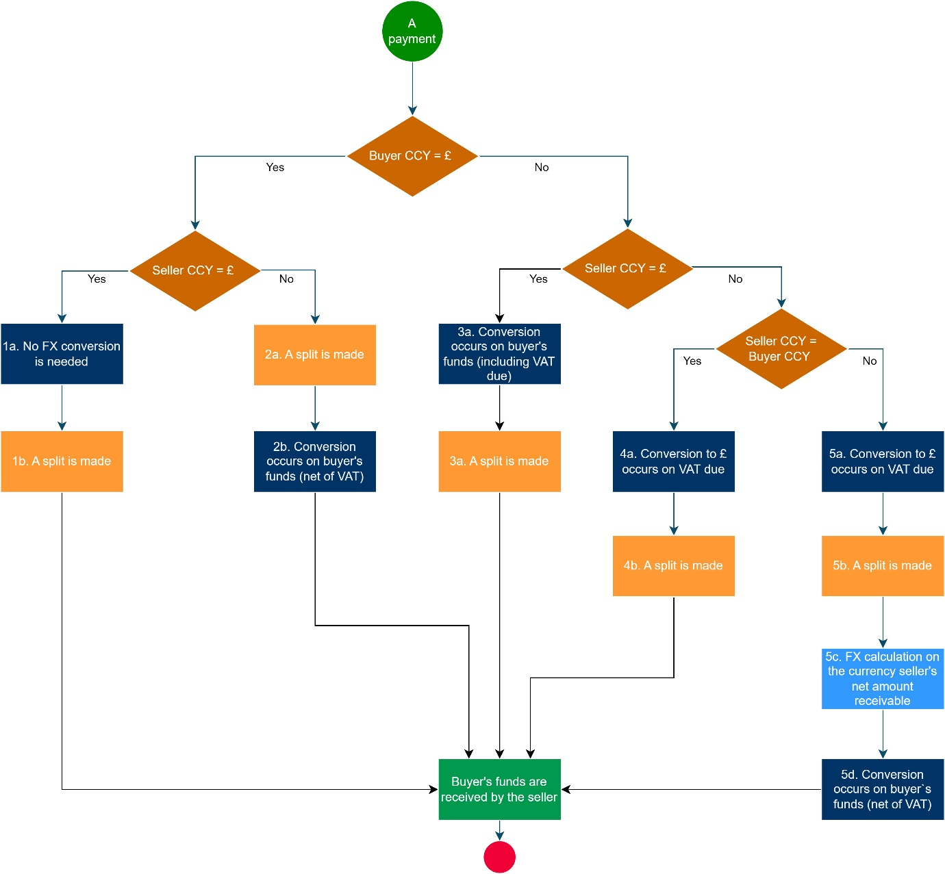

## **Handling foreign exchange in the splitting mechanism: a percentage tax rate example**

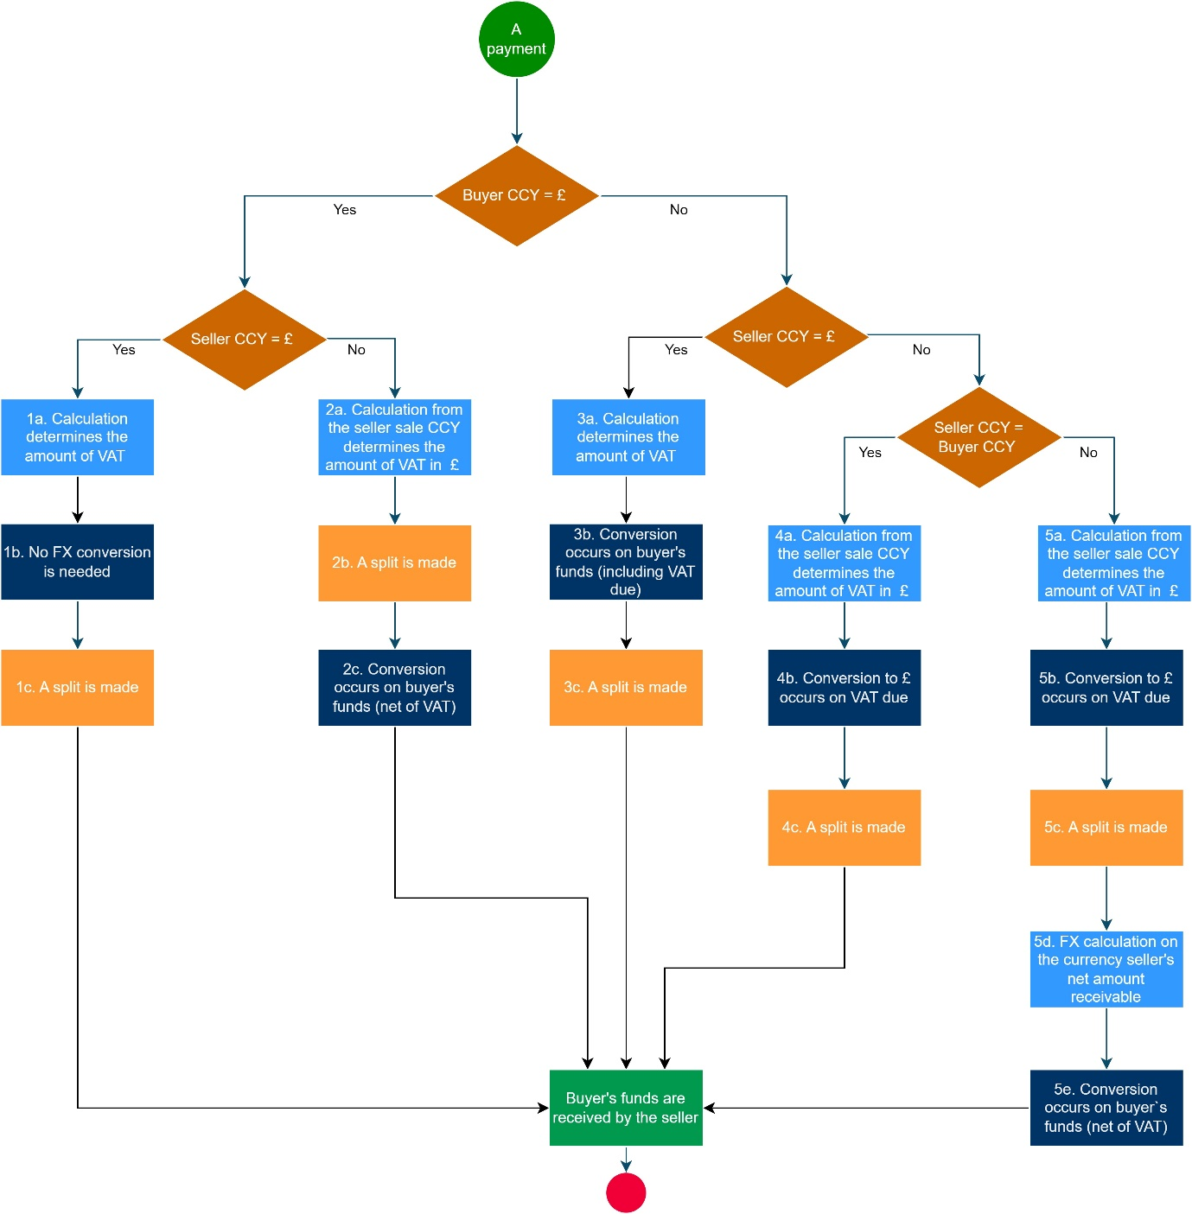

# ANNEX B

## **About the foundational datasets and user stories**

Synthetic data has been supplied to be used in demonstrating the scenarios from the user stories. No personally identifiable information has been used to create this data and it is available to use for the purpose of this proof-of-concept. These datasets are designed to be foundational data upon which to build transactions and embellish with further data as the PoC progresses.

*Overview*

There are three data sets reflected in three attached excel spreadsheets:

1) **Data set 1 Percentage rate** – VAT calculations use percentage VAT rates;

2) **Data set 2 Fixed amount** – VAT amount is fixed;

3) **Data set 3 Money transfer** – For money transfers exclusive of any VAT treatment.

The percentage rate and fixed amount data spreadsheets are almost identical; the difference being the VAT calculations applied. Differences are indicated in the **transaction_details** table below.

There may be some minor discrepancies between rounding in excel and other calculation methods (through code) which could mean pennies difference in calculations. This will be taken into consideration during demonstrations.

*Rounding*

HMRC has provided foundational datasets for use in the PoC. It is expected that additional data fields will be supplemented by the suppliers. We expect the suppliers to utilise test payment data for fields such as bank accounts, sort codes, credit and debit card numbers etc. in order to prove the concept requirements in the specification.

*Payment data*

## **Use of data sets with user stories**

As described above there are three datasets included from which user stories and scenarios will be tested (the user stories and scenarios are included in a separate spreadsheet):

**Data set 1 Percentage rate** - Used for user stories P1-01 to P1-09;

*Data sets*

**Data set 2 Fixed amount** – Used for user stories P1-10 to P1-14;

**Data set 3 Money transfer** – Used for user story P1-19.

There are exception case user stories for which the above datasets will also be used.

e.g. full refunds P1-15 / partial refunds P1-16 / Charge backs P1-17 / Erroneous Transaction P1-18.

The following tables describe the fields within the synthetic data sets.

## **Percentage rates and fixed amounts**

| **sellers** | |
| --- | --- |
| Field Name | Description |
| Seller ID | Unique ID for Seller. Identifies Seller in *transaction_headers* Table. Primary Key. |
| Name | Name of the seller (business or individual) |
| Seller Address  (10 fields) | Address Lines 1 -4, PO Box, Locality, Region, ZIP/Post code, Country, Country code (ISO 3166 Standard identifier). |
| Legal Entity Identifier (LEI) | Placeholder to test use of LEIs; for suppliers to populate as appropriate. |
| Bank Account | Placeholder to test use of bank accounts; for suppliers to populate as appropriate. |
| Sort Code | Placeholder to test use of sort codes; for suppliers to populate as appropriate. |
| IBAN (International Bank Account Number) | Placeholder to test use of IBANs; for suppliers to populate as appropriate. |
| BIC (Bank Identifier Code) | Placeholder to test use of BICs; for suppliers to populate as appropriate. |
| Merchant Category Code | ISO 18245 listed standard four digit number that classifies the type of goods or services a business offers. Identified for businesses in the synthetic data where appropriate. |

| **buyers** | |
| --- | --- |
| Field Name | Description |
| Buyer ID | Unique ID for Buyer. Identifies Buyer in *transaction_headers* Table. Primary Key. |
| Title | Title of Individual: Mr, Miss, Dr etc |
| First Name | First Name of the buyer |
| Last Name | Last Name of the buyer |
| Billing Address  (7 Fields) | Sample data fields of an e-commerce based Billing address consisting of: House Number, Street, Town or City, Province/State/County, Zip/Postcode, Country, ISO 3166 Standard identifier for the Country. |
| Delivery Address  (7 Fields) | Sample data fields of an e-commerce based Delivery address consisting of: House Number, Street, Town or City, Province/State/County, Zip/Postcode, Country, ISO 3166 Standard identifier for the Country. |

| **products** | |
| --- | --- |
| Field Name | Description |
| Name | Name of product. |
| Price gbp | Price of product in British pounds sterling |
| Vat code | VAT rate applied to product:  1: Standard rate 20%,  2: Zero Rate 0%,  3: Reduced rate 5% |
| Type | General Categorisation of Product:  Electronic, Grocery, Luxury, Medical, Mobility Scooter. |
| Seller ID | Indicates which Seller is supplying this product |
| Product ID | Unique ID for product. Identifies Product in *transaction_details* Table. Primary Key |

| **transaction_headers** | |
| --- | --- |
| Field Name | Description |
| transaction_id | Unique ID for transaction. Primary Key. |
| buyer ID | ID of buyer (as referenced in *buyers* table) |
| seller ID | ID of seller (as referenced in *sellers* table) |
| Currency | Transaction currency |
| Date and Time | Date and time of Transaction (used to determine exchange rate from *exchange_rates* table) |
| total_price_transaction_currency | Sum of total_price_transaction_currency for all detail records per transaction in t*ransaction_details* table |
| total_vat_gbp | Sum of total_vat_gbp for all detail records per transaction in *transaction_details* table |
| line_items_count | Number of detail records in a transaction in *transaction_details* table |
| buyer_billing_country | Billing Country of buyer |
| buyer_delivery_country | Delivery Country of buyer |
| seller_country | Seller Country |

| **transaction_details** | |
| --- | --- |
| Field Name | Description |
| transaction_id | Transaction ID links to Transaction ID in *transaction_headers* table. Primary key. |
| Line | Unique ID for detail record. Primary key. |
| unit_price_transaction_currency | Individual Product Price in seller’s currency. Uses the exchange rate from *exchange_rates* table to convert based on date of transaction. |
| Units | The quantity of products being purchased per detail record. |
| total_price_transaction_currency | Total price of all units per detail record. |
| gross_price_transaction_currency | Total_Price_transaction_currency Including VAT:  **Percentage Rate:** Gross price for the detail record calculated using the VAT percentage rate.  **Fixed Amount:** Gross price for the detail record calculated using the VAT Fixed Amount. |
| total_price_gbp | Total_price_transaction_currency converted back to GBP using the relevant exchange rate as per the transaction date. |
| total_vat_gbp | **Percentage Rate:** total VAT in GBP for the detail record calculated using the VAT percentage rate.  **Fixed Amount:**  fixed at £10 GBP |
| vat_code | **Percentage Rate:**  VAT rate applied to the product(s):  1: Standard rate 20%,  2: Zero Rate 0%,  3: Reduced rate 5%  **Fixed Amount:**  n/a – no rate applied as fixed amount |
| Product id | Unique ID for product. Identifies Product in products table. |

| **exchange_rates** | |
| --- | --- |
| Field Name | Description |
| Date | Date the exchange rate was relevant at (used to find exchange rate relevant at time of transaction date) |
| from_currency | The currency being converted from |
| to_currency | The currency being converted to |
| Rate | The rate that is used to calculate exchange |

## **Money transfers**

| **Payer & Payee (tables contain same fields)** | |
| --- | --- |
| Field Name | Description |
| Payer & Payee ID | A simple ID to link Payers and Payees to *Money Transfer* Table. Primary key. |
| First name / Last Name | First/Last name of Payer or Payee |
| Address Line 1 | House number |
| Address Line 2 | Street name |
| Address Line 3 | Locality: City, Town, Borough etc |
| Address Line 4 | Additional Address Line |
| PO BOX | PO Box |
| Region | county, state etc |
| Zip/Postcode | Zip/Postcode |
| country | Country where individual or Business registered |
| ISO Country Code | ISO 3166 Standard identifier for the Country |

| **Money Transfer** | |
| --- | --- |
| Field Name | Description |
| Transaction ID | A simple Transaction ID. Primary Key. |
| Payer | ID of the Payer in the transaction links to *Payer* Table |
| Payee | ID of the Payee in the transaction links to *Payee* Table |
| Payer Currency | Currency used by the Payer |
| Date and time | Date and time of transfer |
| Total value | Value of the transfer in Payer Currency |
| Payer Country | Country of Payer |
| Payee Country | Country of Payee |

# ANNEX C

## **Pay.UK**

Pay.UK is the recognised operator and standards body for the UK’s retail interbank payment systems.  They provide the digital payments networks used by the UK’s banks, building societies, other payment providers and all of their customers to make payments, ensuring they are secure, safe and simple to use.

Pay.UK will be providing HMRC with technical observations on work completed by suppliers during the development of the PoCs. HMRC will share with Pay.UK what it has seen during ad hoc meetings between HMRC and Pay.UK.

*Nature of PAY.UK`s involvement*

If observations provided by Pay.UK on a PoC are, in HMRC’s view, of common interest to more than one of the suppliers, the observations will be shared with all suppliers.

*Extent of PAY.UK`s involvement*

Pay.UK`s views will only be sought by HMRC for the purposes of gaining expert views on technical aspects of a PoC and its potential in the future. Any decision made by HMRC relating to the continuation of a contract during the development stage will be for HMRC alone in light of the circumstances and all the facts available to HMRC.