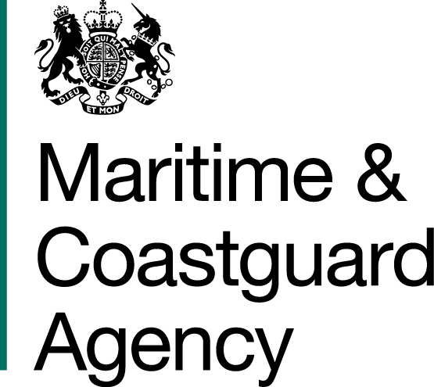 |  |  | Bay 3/21  Spring Place  105 Commercial Road  Southampton  SO15 1EG
 | To whom it may  Concern, |  | Tel:  E-mail: | +44 (0)20 381 72000  contracts@mcga.gov.uk
 |  |  | Your ref:  Our ref: |  | TCA 3/7/993
 |  |  | 23rd August 2016

INVITATION TO TENDER TO SUPPLY SMALL OIL RECOVERY

& CONTAINMENT SYSTEM

You are invited by the Secretary of State for Transport (from now on referred to as "the Authority") to submit a tender for the above contract.

One original and one copy (so marked) of your tender and proposals, including any covering letter, will be required. Your Tender Price should be entered onto the Price Schedule included within the documentation.

Tenders must be delivered by 11.00 hours on 7th October 2016.

Late tenders will not be accepted and it is your responsibility to ensure that your tender is received on time.

As part of your tender you should supply the following:-
- A detailed written description of your product. Warranty options should be clearly stated.
- Any element the manufacture of the product / sourcing of materials that has been carried out in a environmentally beneficial manner in line with MCA’s Sustainability Policy.
- Method and mode of delivery available for transporting the items.

SHOULD YOU BE SUCCESSFUL, THESE DOCUMENTS AND ANY SUBSEQUENT CORRESPONDENCE BETWEEN YOU AND THE DEPARTMENT WILL FORM A BINDING CONTRACT BETWEEN YOU AND THE AUTHORITY.

Please read all the documents listed in the Form of Tender. To ensure that all tenderers have access to the same information you can only obtain further information about contractual issues and Technical Information from me (The Contract Officer). All requests must be submitted in writing to me at the above e-mail address.

Yours sincerely,

Lee Cove
MCA Procurement Team

