

29th October 2014

Courier Service for the Planning Inspectorate

Reference: PINS 17/2/894

26th September 2019

Invitation to tender for the provision of a courier service for the Planning Inspectorate

The Planning Inspectorate invites you to submit a tender for the provision of a Courier Service.

The procurement process is being undertaken via the Crown Commercial Service’s Courier Service Framework, reference RM3798, Lot 1.

Your attention is drawn to the invitation to tender (ITT) notices and instructions overleaf. To ensure fairness, all tenderers are required to submit their tenders in accordance with the notices and instructions. Failure to do so could invalidate the tender.

Thank you for taking the time to consider working with the Planning Inspectorate, I look forward to hearing from you and encourage you to ask any questions should you require any clarification once you have reviewed all of the documentation.

Yours sincerely

D Symes

Daisy Symes

Senior Commercial Manager

Contents

|  |  |  |  |
| --- | --- | --- | --- |
|  | | | Page |
| 1. Introduction | | | 3 |
|  | Purpose of this document | | 3 |
|  | Introduction to the Planning Inspectorate | | 3 |
|  | Background to the requirement | | 4 |
| 2. The Requirement | | | 6 |
|  | Lot Structure | | 7 |
|  | Contract duration | | 7 |
| 3. Procurement processes and key dates | | | 8 |
| 4. Evaluation criteria | | | 10 |
| 5. Other matters | | | 11 |
|  | | Terms and conditions of contract | 11 |
|  | | Transparency | 11 |
|  | | Conduct | 11 |
|  | | Due diligence | 12 |
|  | | Costs and expenses | 12 |
| 6. Meeting the specification | | | 13 |
| 7. Contact at the Planning Inspectorate | | | 14 |
| Annex A – Specification | | |  |
| Annex B – Evaluation matrix | | |  |
| Annex C – Call Off order form Terms & Conditions | | |  |
| Annex D – Price schedule | | |  |
|  | | |  |
|  | | |  |

1. Introduction

**Purpose of this document**

This document is the note for tenderers for the procurement of a courier service for the Planning Inspectorate

**Introduction to the Planning Inspectorate**

1. The Planning Inspectorate is an Executive Government Agency in the Department for the Ministry of Housing, Communities and Local Government (MHCLG) and the Welsh Government. It is responsible for:

* national infrastructure planning, which includes large-scale projects such as harbours, power generating stations and electricity transmission lines;
* planning and enforcement appeals;
* examining local plans and community infrastructure levy charging schedules;
* listed building consent appeals;
* advertisement appeals;
* reporting on planning applications that are called in for MHCLG’s Secretary of State to decide;
* compulsory purchase orders;
* rights of way cases;
* cases arising from the Environmental Protection and Water Acts, the Transport and Works Act, other Highways Legislation; and,
* applications for awards of costs which may arise from any of the above.
* National Infrastructure Planning.

1. Our headquarters are in Bristol, where about 370 support staff and senior management are based. We also have a small office in Cathays Park, Cardiff which deals with casework arising in Wales. Support staff carry out a wide range of functions such as those relating to all aspects of casework (including dealing with the public); providing direct support for Inspectors; formal decision making for some types of casework; and ensuring essential organisational support through the provision of Corporate Services such as Finance, Commercial, HR and Digital.
2. Appeals are determined and recommendations are made by our home-based workforce which consists of some 350 Planning Inspectors, all of whom are professionally qualified (for example, as town planners, architects, lawyers or engineers). They come into the Bristol office infrequently, but they are provided with remote access to the Inspectorate’s ICT systems. In addition, we contract with 79 Non-Salaried Inspectors (NSIs) who are similarly geographically dispersed. Our staff also deal with National Infrastructure applications which can involve highly contentious planning requirements. More information about the Inspectorate is available [here](https://www.gov.uk/government/organisations/planning-inspectorate).
3. The Planning Inspectorate’s Strategic Plan for 2017-2020 has three clear Strategic Priorities:

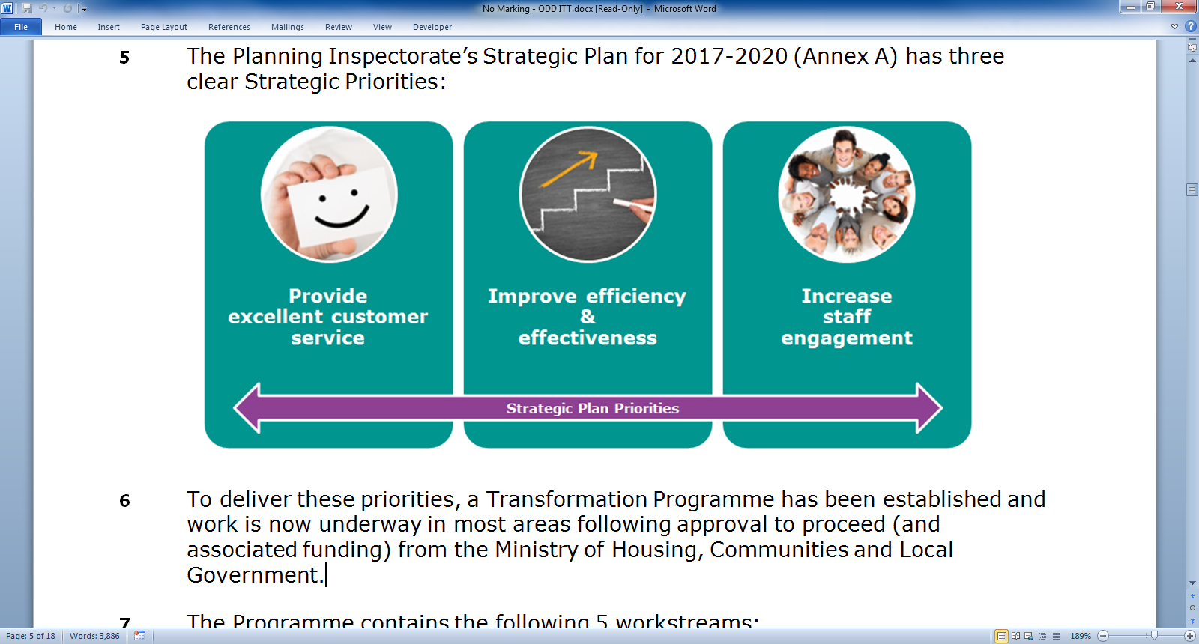

1. To deliver these priorities, a Transformation Programme has been established and work is now underway in most areas following approval to proceed (and associated funding) from the Ministry of Housing, Communities and Local Government. This is an exciting time for the Inspectorate as we strive to become an exemplar organisation, putting the customer at the heart of what we do.

**Background to the requirement**

1. Some planning appeal types and associated casework dealt with by the Planning Inspectorate are currently processed in hard copy format. When this is coupled with a large home-based workforce, the movement of casework and files between the Planning Inspectorate in Bristol/Cardiff and the workforce throughout England and Wales is considered a business-critical service.
2. The Inspectorate currently has a contract in place for its courier service which expires on 29 December 2019 so we need to run a new competition.
3. Contractually our home-based workforce offices are classed as their official place of work. For the purposes of this requirement deliveries to these locations is to be considered a standard requirement and therefore a surcharge is not expected to be applied.
4. Some Inspectors work in very remote locations and it is essential that they receive a fully effective service in line with the contract. The map in figure 1 provides an indicative visual representation of the location of Inspectors.
5. The table in figure 2 provides an indicative number of locations broken down by county.

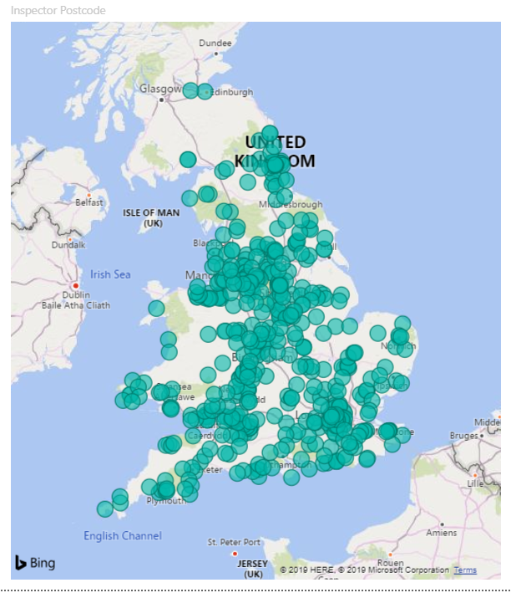

Figure 1 – indicative location of Inspectors

|  |  |  |  |
| --- | --- | --- | --- |
| **County** | **No. of home-based workers** | **County** | **No. of home-based workers** |
| Bedfordshire | 3 | Lincolnshire | 9 |
| Berkshire | 5 | London | 30 |
| Bristol | 5 | Merseyside | 6 |
| Buckinghamshire | 2 | Monmouthshire | 3 |
| Cambridgeshire | 10 | Norfolk | 6 |
| Carmarthen | 2 | North Yorkshire | 17 |
| Cheshire | 16 | Northamptonshire | 4 |
| Co. Durham | 8 | Northumberland | 8 |
| Cornwall | 6 | Nottinghamshire | 11 |
| Cumbria | 7 | Oxfordshire | 5 |
| Denbighshire | 1 | Pembrokeshire | 3 |
| Derbyshire | 16 | Rutland | 1 |
| Devon | 17 | Shropshire | 7 |
| Dorset | 8 | Somerset | 20 |
| East Sussex | 11 | South Yorkshire | 14 |
| East Yorkshire | 5 | Staffordshire | 8 |
| Essex | 9 | Suffolk | 5 |
| Flintshire | 2 | Surrey | 10 |
| Gloucestershire | 12 | Tyne & Wear | 21 |
| Greater Manchester | 20 | Vale of Glamorgan | 1 |
| Hampshire | 10 | Warwickshire | 2 |
| Herefordshire | 5 | West Midlands | 13 |
| Hertfordshire | 6 | West Sussex | 6 |
| Isle of Wight | 1 | West Yorkshire | 13 |
| Kent | 13 | Wiltshire | 9 |
| Lancashire | 10 | Worcestershire | 13 |
| Leicestershire | 9 | No Postcode on record | 32 |
|  |  |  |  |
|  |  | Total | 496 |

Figure 2 – indicative location of Inspectors

1. The table in figure 3 provides a breakdown of indicative usage statistics based on collections/deliveries made on the next day in the last 12 months. (figures are indicative only and no guarantee is given of usage).

**Next day delivery**

|  |  |  |  |
| --- | --- | --- | --- |
| **Delivery time** | **Number of consignments per annum** | **Number of items per annum** | **Total weight kg** |
| **Letter (cardboard wallet, up to A3 and 1kg)** | | | |
| Pre 9am | 11 | 11 | 10.8 |
| Pre 10am | 8 | 8 | 8 |
| Pre 12pm | 12 | 13 | 11.7 |
| Pre 5.30pm | 31 | 31 | 27 |
| 48hr | 2 | 3 | 2 |
| **Total** | **64** | **66** | **57.5** |
| **Bag (plastic bag, 440mmx570mm, up to 10kg)** | | | |
| Pre 9am | 10 | 22 | 38.7 |
| Pre 10am | 18 | 36 | 57.7 |
| Pre 12pm | 41 | 121 | 221.4 |
| Pre 5.30pm | 207 | 283 | 1,692.2 |
| 48hr | 70 | 132 | 607.2 |
| **Total** | **346** | **594** | **2,617.2** |
| **Box (own packaging used, up to 30kg)** | | | |
| Pre 9am | 5 | 24 | 198 |
| Pre 10am | 26 | 181 | 908 |
| Pre 12pm | 46 | 382 | 1,553.5 |
| Pre 5.30pm | 394 | 10,530 | 34,964.8 |
| 48hr | 191 | 546 | 5,417.2 |
| **Total** | **662** | **11,663** | **43,041.5** |

Figure 3 – indicative usage statistics

1. It should be noted that as we progress through our transformation programme and smarter working initiative, we do expect the volume of collections/deliveries to decrease over time. We have not yet quantified the impact on this contract, but we will advise the supplier once known.
2. The addresses for Temple Quay House and Cathays Park are as follows:

2. The Requirement

1. Annex A covers the Inspectorate’s specification for the provision of a courier service.

**Lot structure**

1. The Inspectorate is inviting tenders for the following lots on the RM3798 framework:

* Lot 1: Collection and Delivery of Documents and Parcels

1. If the Tenderer wishes to submit a Tender as part of a group or consortium of suppliers, the group or consortium must, within the Tender, provide an undertaking that the lead party (which shall have a legal personality or shall create a single entity) will take on full legal liability for the full duration of the Contract.

**Contract duration**

1. The contract duration will be 3 years from the agreed ‘go live’ date with an option to extend for 1 further year subject to business need and contractor performance.

3. Procurement Process & Key Dates

1. The table below sets out the procurement process and associated timescales. Please ensure that you read this carefully and note the key dates and action required.

|  |  |
| --- | --- |
| **Activity** | **Key Date\*** |
| **Invitation to tender issued** The tender will be published by the Inspectorate on the Crown Commercial Service e-procurement portal and [Contracts Finder](https://online.contractsfinder.businesslink.gov.uk/). | 26  September  2019 |
| **Final date for submission of questions** Please submit any questions you may have by 5pm on this date through the portal.  Questions and answers will be provided to other tenderers however any such information will be made anonymous before being passed on. The Inspectorate reserves the right not to respond to enquiries where this would be inappropriate. | 4  October  2019 |
| **Response to questions** to be issued by the Inspectorate, to all tenderers through the portal | 11  October  2019 |
| **Tender deadline** Tenders must be submitted as a Microsoft Word or PDF document through the Crown Commercial Service e-procurement portal no later than 12.00hrs. Tenders received after this deadline will not be accepted.  Should you encounter any problems please contact Daisy Symes | 12.00hrs  18 October  2019 |
| **Evaluation** The Inspectorate will evaluate all tenders in accordance with the evaluation criteria provided in Annex B  Should the Inspectorate have any clarification questions we will be in touch so please be prepared to provide a response as requested. | w/c 21 October 2019 |
| **Notification to successful bidder**  A formal acceptance letter will be issued to the successful bidder | w/c 28 October 2019 |
| **Kick off meeting** | w/c 4 November 2019 |
| **Anticipated contract start** | w/c 11 November 2019 |
| **Go Live date** | w/c 9 December 2019 |

*These are dates are indicative only and may be subject to change. The Inspectorate will endeavour to stay as close to this timetable as possible.

4. Evaluation Criteria

1. The Contract shall be awarded to the most economically advantageous tender scored in accordance with the matrix provided at Annex B.
2. Other criteria will be scored on a scale of 0-5 in accordance with the Inspectorate’s standard scoring guide as shown in figure 4 below.

Figure 4 – Evaluation Scoring

1. The scores will be calculated as per the details in Annex B, the Evaluation matrix.
2. The Inspectorate may request a presentation or interview by the Tenderer on its proposal and reserves the right to consider the presentation or interview as part of the evaluation process.
3. Marketing and sales brochures will not be evaluated unless specifically referred to by the Tenderer as particular evidence.

5. Other Matters

**Terms and conditions of contract**

1. The contract will be subject to the following framework terms and conditions included in Annex C:

Crown Commercial Service  
Courier Services Framework (RM3798)

Model order form and call off terms

**Transparency**

1. Tenderers should be aware that in accordance with the Government’s transparency agenda, the Inspectorate will publish the following information on contracts finder:
   * This ITT and all related documentation on the date it is issued to suppliers on the framework. For the avoidance of doubt, this doesn’t mean that suppliers outside of the framework can tender.
   * The resultant contract (except any information which is exempt from disclosure in accordance with the provisions of the Freedom of Information Act).
2. In addition to the above the MHCLG, which we form a part of, are obliged to publish all spend in excess of£250. This spend is published on a monthly basis and can be viewed on [MHCLG’s website](http://www.communities.gov.uk/corporate/transparencyingovernment/spenddata/albdata/planninginspectoratespenddata/) and [data.gov.uk](http://data.gov.uk/).
3. Further information on the Government’s transparency agenda is available via the ‘Programme for Government’ website: http://programmeforgovernment.hmg.gov.uk

**Conduct**

1. The tenderer must not communicate to any person the tender price (even approximately) before the date of the contract award other than to obtain, in strict confidence, a quotation for insurance required to submit the tender.
2. The tenderer must not try to obtain any information about any other person’s tender or proposed tender before the date of contract award.
3. The tenderer must not make any arrangements with any other person about whether or not they should tender, or about their tender price. The only exception is where the tenderer is considering a group tender (see paragraph 16).
4. The tenderer must not offer any inducement to any member of the Inspectorate’s staff for doing or refraining from doing any act in relation to the tender.
5. If the tenderer engages in any of the activities set out in this paragraph or if the Inspectorate considers the tenderers behaviour is any way unethical the customer reserves the right to disqualify the tenderer from the procurement.

**Due diligence**

1. While reasonable care has been taken in preparing the information in this ITT and any supporting documents, the information within the documents does not purport to be exhaustive nor has it been independently verified.
2. Neither the Inspectorate nor its representatives, employees, agents or advisors:
   * 1. makes any representation or warranty (express or implied) as to the accuracy, reasonableness or completeness of the ITT and supporting documents; or
     2. accepts any responsibility for the adequacy, accuracy or completeness of the information contained in the ITT and supporting documents nor shall any of them be liable for any loss or damage (other than in respect of fraudulent misrepresentation) arising as a result of reliance on such information or any subsequent communication.
3. It is the tenderer’s sole responsibility to undertake such investigations and take such advice (including professional advice) as it considers appropriate in order to make decisions regarding the content of its tenders and in order to verify any information provided to it during the procurement process and to query any ambiguity, whether actual or potential.

**Costs and Expenses**

1. You will not be entitled to claim from the Inspectorate any costs or expenses which you may incur in preparing your tender whether or not your tender is successful.

6. Meeting the Specification - Responses

1. The Tenderer shall submit their proposal through the Crown Commercial Service e-procurement portal describing how they will meet each element of the requirements set out in the Specification at Annex A and a written response to the evaluation criteria at Annex B.

**Contents of your tender**

1. As a minimum your tender should include the following information:

* Unqualified acceptance of the call-off contract terms and conditions

* Details of your organisation including information showing how your organisation is well placed to provide the services required
* Contact name, telephone number and e-mail address
* Confirmation that the specification at Annex A will be met
* Completion of the pricing schedule provided in Annex D
* Written response to the evaluation criteria at Annex B
* Details of any proposed Partners and/or Sub-contractors and a description of how any Partnership/Sub-contracting arrangement between contractors will operate. For the avoidance of doubt the selected Tenderer will be the Prime Contractor responsible for service delivery under the Contract;

**Where to send your tender**

1. Tenders must be submitted through the Crown Commercial Service e-procurement portal no later than 12.00hrs on 11 October 2019. Tenders received after this deadline will not be accepted.
2. Should you encounter any problems please contact Daisy Symes (see below for details).

7. Contact at the Planning Inspectorate

Daisy Symes, Senior Commercial manager at the Inspectorate, is the manager of this procurement and she can be reached via the following contact details:

E-mail: [daisy.symes@planninginspectorate.gov.uk](mailto:daisy.symes@planninginspectorate.gov.uk)

Telephone: 0303 444 5003

Address: Kite Wing, Temple Quay House, 2 The Square, Temple Quay, Bristol, BS1 6PN