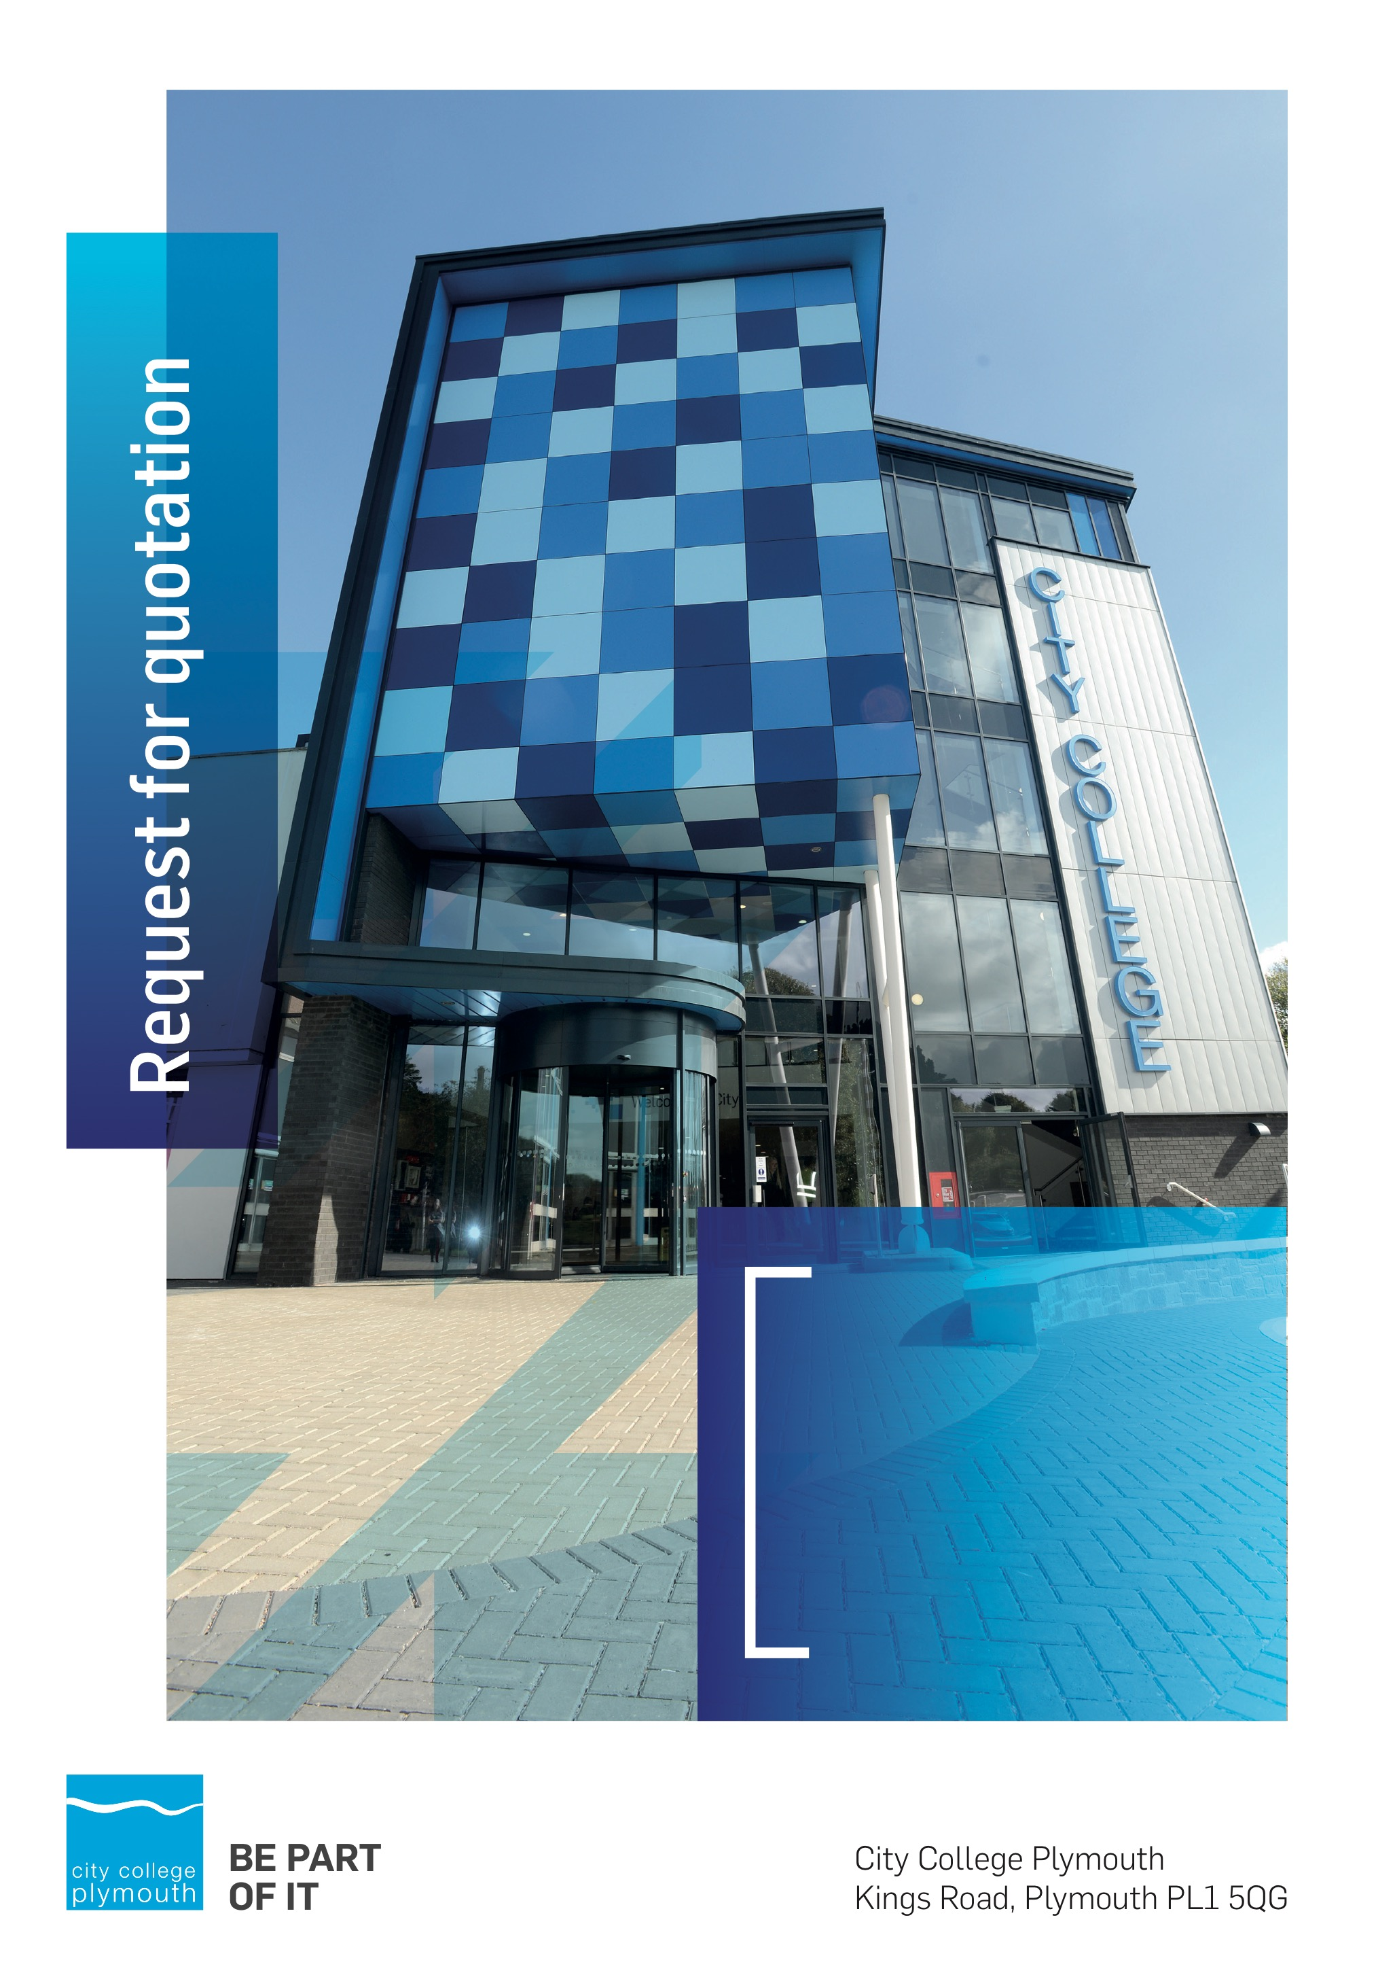

Request for Quotation
RFQ182
College Masterplan
Issued 2nd July 2021

Table of Contents
Table of Contents 2
Confidentiality Statement 3
Open Procedure 3
Submission Details 4
Submission Deadlines 4
Submission Questions and Clarifications 4
Electronic Submissions 4
Introduction and Executive Summary 5
Business Overview & Background 5
Our Guiding principle 6
Our Vision 6
Our Core values 6
Our Culture 6
The Way Forward - our Priorities 6
Detailed Requirement 7
PROCUREMENT Timescales 8
Written Submission 8
Pricing 9
Terms and Conditions 9
Validity 9
Selection Criteria 9
Award Price 10
Written submission 10
Assessment of Quotations 11
Freedom of Information Act 2000 11
General Data Protection Regulation (GDPR) 2018 11
Agreement Conditions Acceptance and Declaration 11
Supporting Documentation 11

Confidentiality Statement
This document, and any attachments thereto, regardless of form or medium, is intended only for use by the addressee(s) and may contain legally privileged and/or confidential, copyrighted, trademarked, patented or otherwise restricted information viewable by the intended recipient only. If you are not the intended recipient of this document (or the person responsible for delivering this document to the intended recipient), you are hereby notified that any dissemination, distribution, printing or copying of this document, and any attachment thereto, is strictly prohibited and violation of this condition may infringe upon copyright, trademark, patent, or other laws protecting proprietary and, or, intellectual property. In no event shall this document be delivered to anyone other than the intended recipient or original sender and violation may be considered a breach of law fully punishable by various domestic and international courts. If you have received this document in error, please respond to the originator of this message or email him/her at the address below and permanently delete and/or shred the original and any copies and any electronic form this document, and any attachments thereto and do not disseminate further.
Thank you for your consideration, City College Plymouth.
Where no notice is given, all information contained herein is Copyright 2021 City College Plymouth.

Open Procedure
The College fully adheres to the requirements of the Public Contracts Regulations 2015, including for opportunities which are under threshold amounts.
Any Contractor who directly or indirectly canvasses any Member or Officer of the Institution, or advisor concerning the award of the contract for the provision of the services, or who directly or indirectly obtains or attempts to obtain information from any such member or Officer concerning any Tender or proposed Tender for the service will be disqualified from having his/her Tender considered.

Submission Details

Submission Deadlines
All submissions for responding to this Request for Quote must be submitted via email as stated below, no later than:
Friday 30th July
12:00 Noon
Any submissions received after this date will not be considered.

Submission Questions and Clarifications
You may contact the following person if you have any questions or require clarification on any topics covered in this Request for Quotation by 23rd July 2021.
Adam Baker
Procurement Officer
Phone: 01752 30513
Email: tenders@cityplym.ac.uk
All correspondence during the Tender should be channeled via the Procurement Officer using the above details only. Bidders found to have gained an unfair advantage shall be disqualified from the current opportunity and future opportunities with the College for a minimum of four (4) years.

Electronic Submissions
Electronic submissions in response to this Request for Quotation are required and must meet the following criteria:
Sent via email to: tenders@cityplym.ac.uk
Document standards:
- Text must be in Microsoft Word format;
- Price tables must be in Microsoft Excel format (using pricing schedule in Appendix A);
- Supportive evidence may additionally be submitted in PDF format;
- Images, Designs, and other supporting evidence may be in either JPEG or PDF format
- Signed Agreement Acceptance and Declaration Appendix E.

Please note that the College is able to accept submissions sent in a compressed or “.zip” file format, so long as the files contained meet the standards described above.

WARRANTY:
By submitting your tender bid, you are warrantying to the College that you have not breached our canvassing or soliciting clause.

If any successful tenderer awarded a contract is found to have provided an inaccurate warranty, then the College reserves the right to terminate the awarded contract with immediate effect and re-tender the contract from which the successful tenderer will be excluded from re-bidding and shall be disqualified from any future opportunities for a period of four years.

Introduction and Executive Summary
City College Plymouth has recently had a complete building condition survey completed, which has fed into its Estates and Asset strategy. The College is now seeking to appoint a consultant to help formulate a 10 year masterplan for the future development of its Kings Road campus.
The anticipated value of the supply contract will exceed £25,000, therefore, as per the Public Contracts Regulations 2015 the opportunity will be advertised on the Government portal ‘Contracts Finder’.

Business Overview & Background
City College Plymouth has a learning environment and organisational culture that impacts positively on the health, wellbeing and sustainability of our community and enables all of our students and staff to achieve their full potential.
City College Plymouth is one of the largest providers of innovative, technical and professional, education in the South West with a national reputation for promoting enterprise, employability and science, technology, engineering and mathematics (STEM). The College plays a central role in the educational, cultural and economic life of the region and works with strategic partners to facilitate growth, raise aspirations and foster wealth creation.

The College was awarded the Teaching Excellence Framework (TEF) Gold award for its university-level provision and its most recent Ofsted inspection confirmed that the College continues to be ‘Good’ with many outstanding features. The College was rated first in the South West and second nationally for student satisfaction in the latest FE Choices student satisfaction survey.
City College Plymouth is also one of the first Institutes of technology in the UK Working in collaboration with education providers and employers across the South West to improve the training in science, technology, engineering and maths in order to address skills gaps within these industries and support regional growth.
City College supports the region’s employers with their award-winning Apprenticeship provision, as well as providing a range of courses and bespoke training programmes which enable employees to upskill or retrain to better support their business’ requirements.
The College operates on two main sites within the city, serving 12,500 students and employing over 650 staff. The College operates year round, with opening times from 0800-2100 on some days.

Our Guiding principle
City College Plymouth has a learning environment and organisational culture that impacts positively on the health, wellbeing and sustainability of our community and enables all of our students and staff to achieve their full potential.

Our Vision
To be the learning destination of choice

Our Core values
Respect, ownership, integrity for all

Our Culture
Nurturing a passion for teaching and learning
Enriching our community through knowledge, experience and skills
Enabling every student to be the best that they can be

The Way Forward - our Priorities
• Staff - our most important investment
• Students - our purpose
• Community - making a difference
• Achievement - reputation for success
• Wellbeing - infusing health into every day

Detailed Requirement

Followed a detailed condition survey and the updating of our property strategy City College Plymouth is seeking to appoint a consultant to work with the College on its 10 year masterplan for its Kings Road campus. The College anticipates the master planning process will include the following activities:
Stage 1 – familiarisation and analysis

- Identify key stakeholders and define master planning goals
- Detailed review of existing campus, estates strategy, condition surveys, utilisation study, maintenance records, site plans, current funding applications
- Advise City College of any information gaps and recommend if further input required
- Undertake a comprehensive site analysis for presentation to the College
- Agree deliverables and timescales, including a schedule of consultations, workshops, gateways and targets
- Review local policies and produce an overview of key town planning considerations
Stage 2 – option generation and appraisal
- Collaborative identification of short, medium and longer term options (minimum of three)
- Identification of opportunities and constraints
- Iterative review of option development
- Qualitative evaluation of options
- Affordability, capital cost, best value and deliverability
- Selection of preferred option
- Town planning context of preferred option
Stage 3 – outputs
- Prepare and present masterplan report to College senior management team
- Presentation to Corporation Board of Governors

A full detailed brief is available in Appendix B

PROCUREMENT Timescales

Action | Date
Tender Issued | 2nd July 2021
Tender return date | 30th July 2021
Interview short listed practices | w/c 9th August 2021
Appoint architectural team for option master planning | Mid to late August
Period for site familiarisation and review of information | September
Presentation of site analysis and agree deliverables | October
Option generation and appraisal | October to November
Selection of preferred option | Late November
Report and presentations to SMT and Corporation | December

Written Submission
You should submit a written document, which details your company offer with particular interest to the areas outlined below. This submitted document will be scored as per the table on page 9.
- Fees broken down into the 3 identified stages within Appendix A
- Case studies of similar work undertaken for Further Education Colleges
- Description and relevant experience of your proposed team
- Your understanding of the requirements of this project
- A detailed description of your approach and the scope of your work
- Please indicate how the award of any resulting contract to your organisation would support City College Plymouth students in their development and learning through the lifecycle of the project (social value)

Pricing
Bidders should provide pricing against each of the 3 stages within Appendix A.
Prices should be fixed and valid for the contract period and not subject to increase or escalation of any kind throughout the contract.

Terms and Conditions
The College’s normal business terms 30 days from the date of invoice. Payment will become due subject to the above upon the College’s full acceptance of the goods/services. This Request for Quotation and any resulting purchase order will be subject to the College’s General Terms and Conditions of Purchase of Goods/Services – see Appendix C.

Validity
Bidder’s offers should be open and valid for acceptance for a period of no less than four months [120] days from the date of submission.

Selection Criteria
The successful supplier will have provided the Most Economically Advantageous Tender (MEAT) to the college. It should be noted that the bidder with the lowest submitted prices will not necessarily be down-selected. All bidders will be notified via email of the results of the outcome no later than 90 days from the date of submission. The date of contract award will be provided within that email.
The marking criteria is as follows:
Category | Weight
Price | 50%
Previous experience of similar education sector projects | 15%
Proposed project team experience | 5%
Understanding of the project | 10%
Approach to and scope of the required work | 15%
Social Values | 5%
Please see table below for more details on the scoring method.

Award Price
Lowest quote price divided by quote price multiplied by 100.

Written submission

Assessment | Score | Interpretation
Excellent | 4 | Comprehensive response supported by examples  Description fully supported by details that demonstrate the applicant’s ability to provide the required services.
Good | 3 | Broad response supported by relevant examples.  Description well supported by details that demonstrate the applicant’s ability to provide the required services.
Satisfactory | 2 | Reasonable response supported by some evidence.  Description adequately supported by details that demonstrate the applicant’s ability to provide the required services.
Poor | 1 | Limited response not well supported by evidence.  Description inadequately supported by details that demonstrate the applicant’s ability to provide the required services.
Unacceptable | 0 | No response or insufficient information provided.

Assessment of Quotations
Bidders must ensure that their quotation fully addresses all information requested within this RFQ document. Bidders must ensure that any quotation fully meets the specification required. The College reserves the right to discount any quotation which does not fully meet the specification.
The College reserves the right to seek clarification with bidders upon receipt of quotations and may request one or more bidders to attend an interview.

Freedom of Information Act 2000
Under the Freedom of Information Act 2000 the College cannot guarantee that information provided by bidders during the course of this RFQ procedure or any resulting contract will be held a confidential. The College will not routinely release information to interested parties unless required to do so in order to meet our statutory obligations.

General Data Protection Regulation (GDPR) 2018
All bidders must comply with the General Data Protection Regulation (GDPR) 2018 in respect of using and processing personal information. Bidders must have in place technical and organisational safeguards to protect personal data from unauthorised use, disclosure or loss.
The College reserves the right to request a copy of your privacy statement if you are the successful bidder.

Agreement Conditions Acceptance and Declaration
Bidders are required to sign and return the attached Agreement Conditions Acceptance and Declaration, Appendix E.

Supporting Documentation
Appendix A: Pricing Schedule
Appendix B: College Masterplan Brief
Appendix C: City College Plymouth Standard Terms & Conditions
Appendix D: Suitability Questionnaire
Appendix E: Agreement Conditions Acceptance and Declaration

