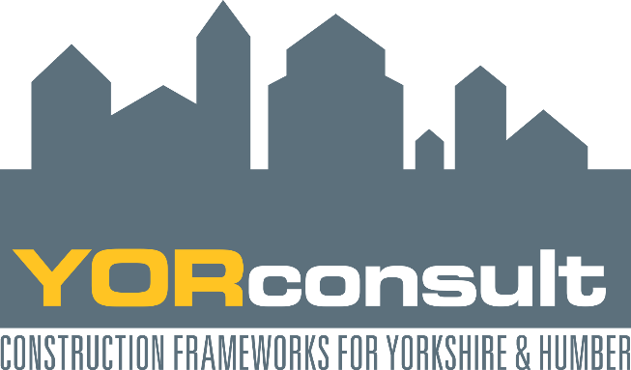

YORconsult2 Consultant Briefing & Consultation Event
Friday 27th January 2017, 14.00pm
Kings Manor, York University, Exhibition Square, YO1 7EP

YORconsult is one of the YORhub Construction Frameworks (www.YORhub.com) which were developed to provide an efficient and collaborative approach to the procurement of Construction related Consultancy Services. YORhub frameworks can be accessed by any Local Authority, Public Sector Body or Third Sector Organisation in the Yorkshire and Humber region providing them with access to high quality construction contractors/ consultants.
The current YORconsult framework expires at the end of April 2018, and will be replaced by YORconsult2.
Prospective suppliers are invited to attend this briefing event to:
- Discover the proposals for the new YORconsult2 framework
- Attend two shaping workshops in the areas of framework structure and social benefits
- Raise questions with YORconsult framework managers

Attendees will have the opportunity to take part in both workshops.

Event Programme
13.30 Refreshments on arrival
14.00 Welcome/ agenda/ background
14.10 YORconsult2 proposals
14.40 Breakout session 1
15.20 Refreshments
15:40 Breakout session 2
16:20 Closing remarks
16:30 Session end

The breakout sessions will include
Framework Structure
- Lotting structure
- Call off methods
- Form of contract
- Size of tender lists
- 1 framework vs 2 frameworks
- Procurement stage – PQQ (PAS91)/ pricing
- Call off Quality criteria

Added value & Framework Management Services
- Employment & Skills
- 4 Good fund
- BIM
- Framework Management Services

Who should attend
This workshop is aimed at supplier organisations in the Professional Consultancy Services sector who are interested in finding out about and shaping the replacement for YORconsult.

Places are limited so book early to avoid disappointment!

