USER GUIDE FOR RESPONDING TO NEGOTIATIONS (Tenders) VIA ORACLE

Registration/Log-In
- Log in to your supplier account using the “Oracle Log In” link below. If you are not yet registered on our supplier portal, please use the “Oracle Registration” link below to register.

Oracle Log In

Oracle Cloud Registration

- Log in using the log in box highlighted below. Your User ID is the email address you used when registering. When logging in for the first time please use “Forgotten Password” to create a password for your account.
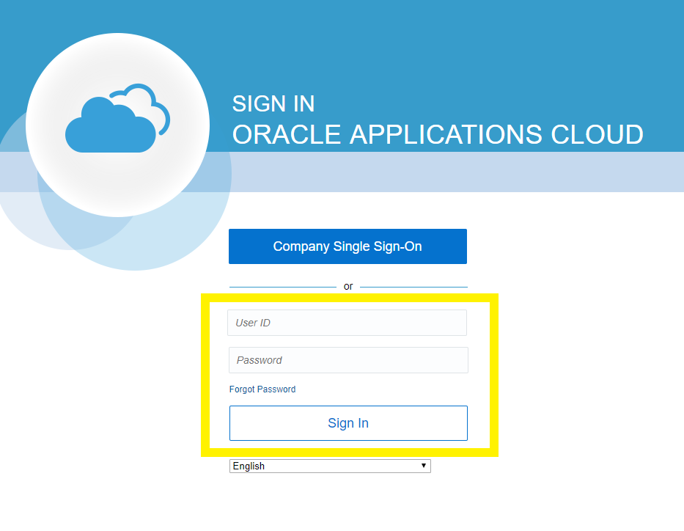

Finding Tendering Opportunities
- Once logged in select the “Supplier Portal” Icon as shown below.
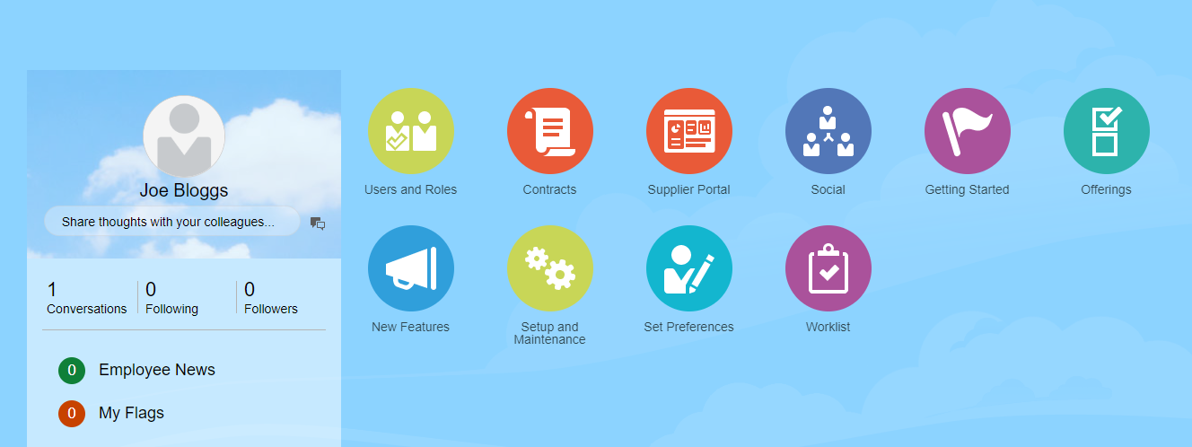

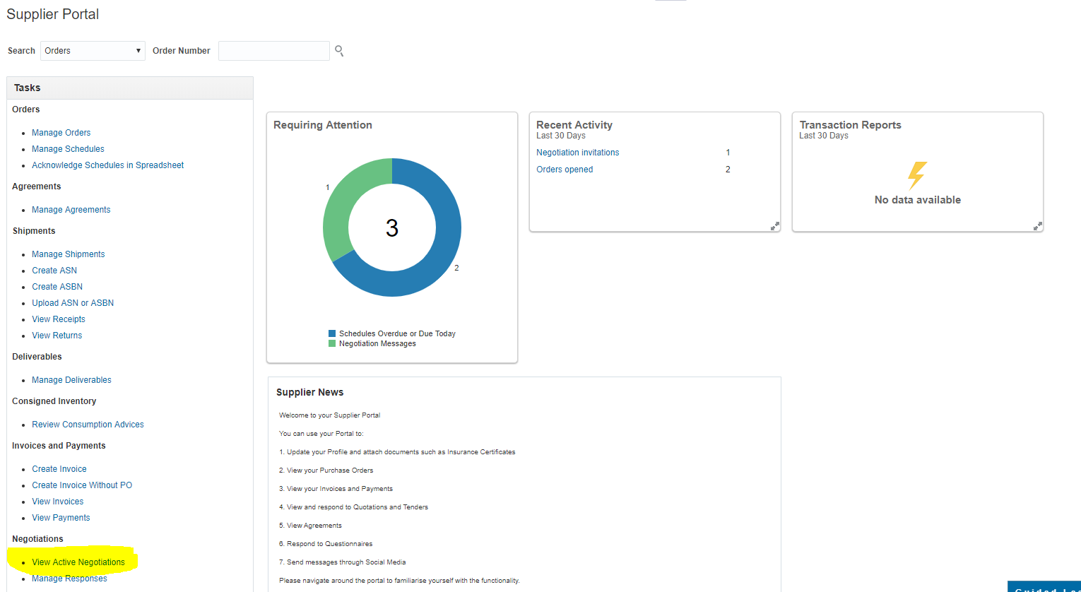
- Once you are into the supplier portal page, select “View Active Negotiations” as highlighted below. (Negotiation is the term used for tenders or Quotes.)

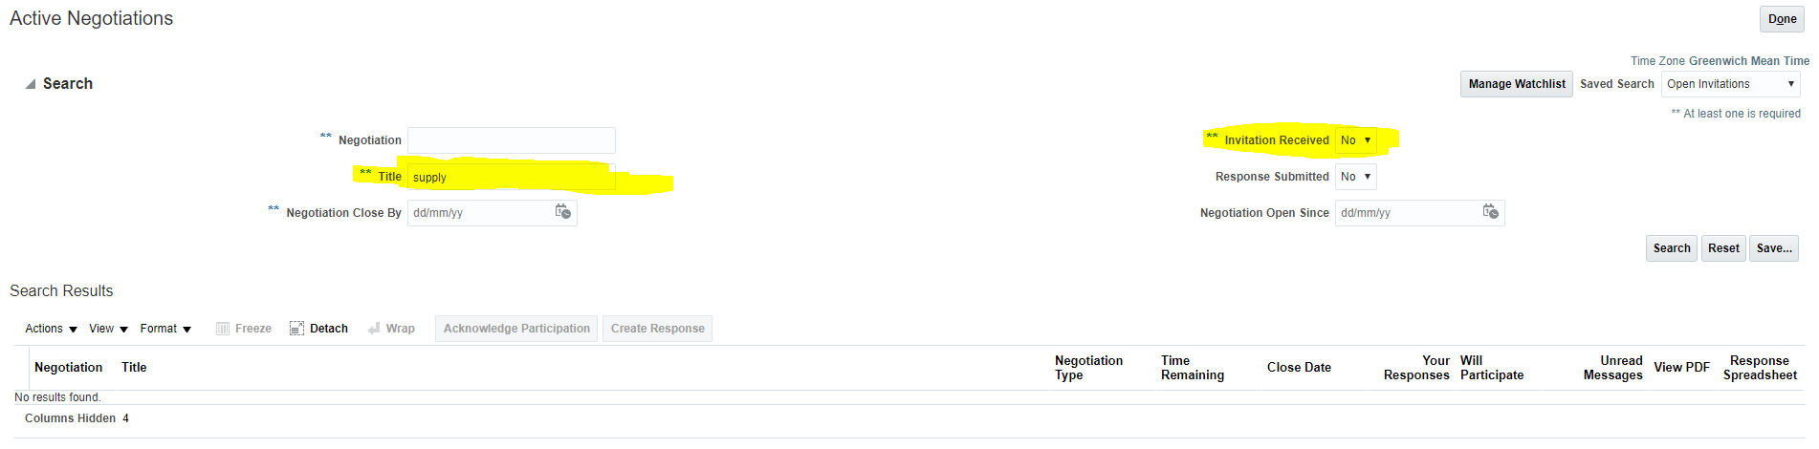
- Using the search fields, you can search for the negotiation you wish to submit a response to by entering the title of the negotiation field highlighted below. Please note that if you have been invited to the project via the system ensure that within the “Invitation Received” field “Yes” is selected. If you have not been invited to the project please ensure that “No” is selected. Invites to the project will be sent via email from the Oracle Cloud system to the registered contact on the system.
- To express an interest in the project please highlight the relevant project and then press the “Acknowledge Participation” button. This will alert the lead buyer that you will be intending to submit a response.

- Once you have found the negotiation and clicked into the project you will be able to see details of the project using the tabs highlighted below.
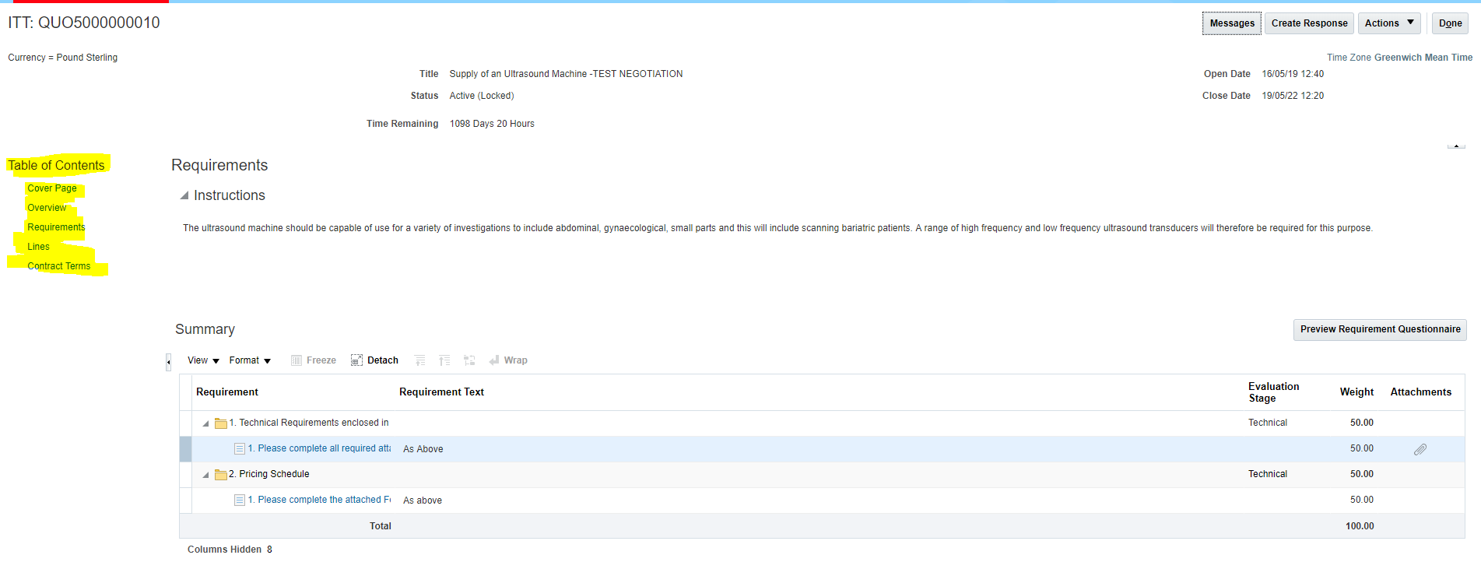

Creating Tender Responses
- If you wish to submit a bid for the opportunity you can do so by pressing the “Create Response” tab highlighted below and accept the Terms and Conditions of Use.
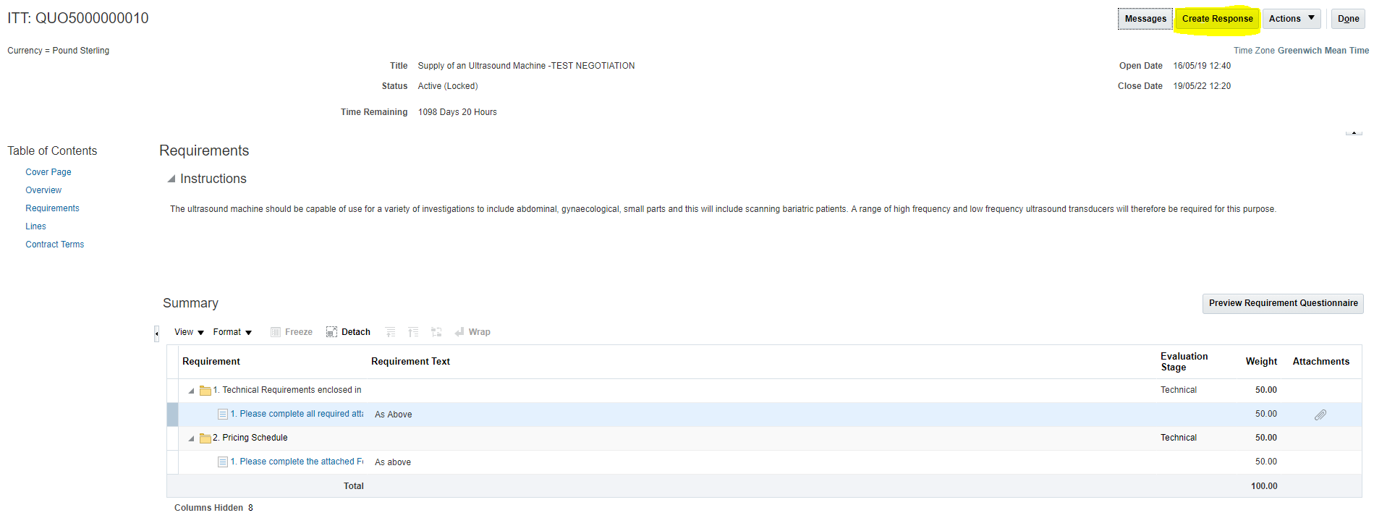

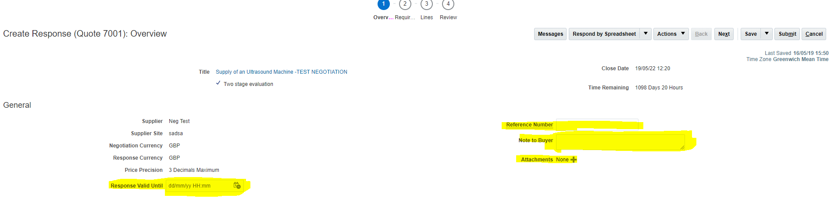
- On the first screen of your response you can add a “Response Valid Until” date as well as giving your response a reference number. If you wish you can also add any notes to the procurement lead which they will see when they open your response and furthermore you have the option to add any attachments that support your response such as your environmental policy. Once this screen is completed to your satisfaction you can select the next button to take you to the tender requirements.

- On the requirements tab you will be able to see each requirement for the tender. Please ensure that you respond to all requirements before moving onto the next stage by using the navigation tool highlighted below.
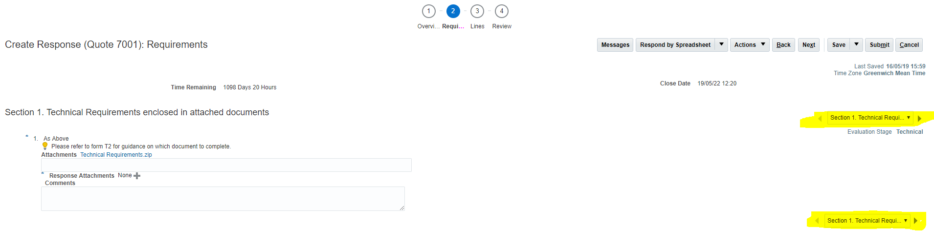

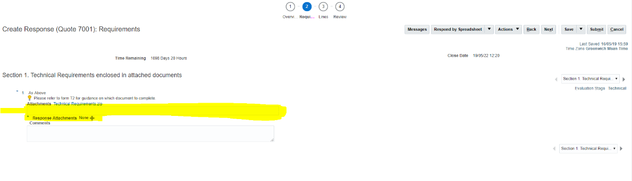
To respond to the requirement please use the response text field given to you and also ensure you upload any relevant documents that support your response. You may also wish to leave a comment regarding the requirement or any further information in the comments field provided however this is not a mandatory field.
Once you have completed the text fields and uploaded and supporting documents that you are required to submit you can select the “Next” button to take you to the next stage of the tender.
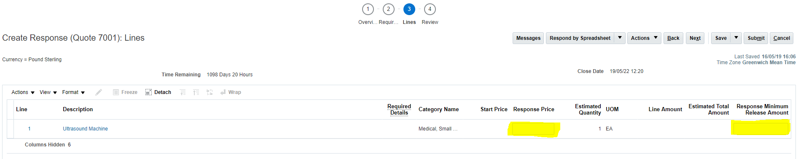
- At this stage you can summarise your commercial offering using the “Response Price” field, this is a mandatory field and you will not be able to submit your response until this field has been completed if you have any minimum order value you can also enter this under “Response Minimum Release Amount” field.
Once you have completed these fields to your satisfaction you can press the “Next” button to take you to the Review page.

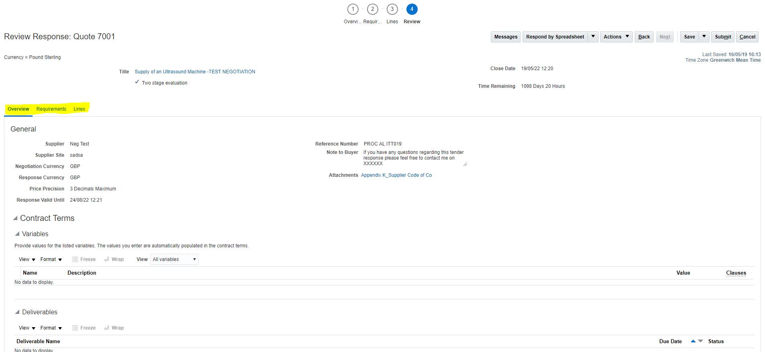
- Within the review page you can review your response before you submit, to navigate to each section of your response please use the fields highlighted in yellow below.

Clarification Questions
- If you have any clarification questions you wish the University to answer, you may submit these through the “Messages” icon, that is available to you at every stage of your response. This will allow you to message the procurement lead for more information.

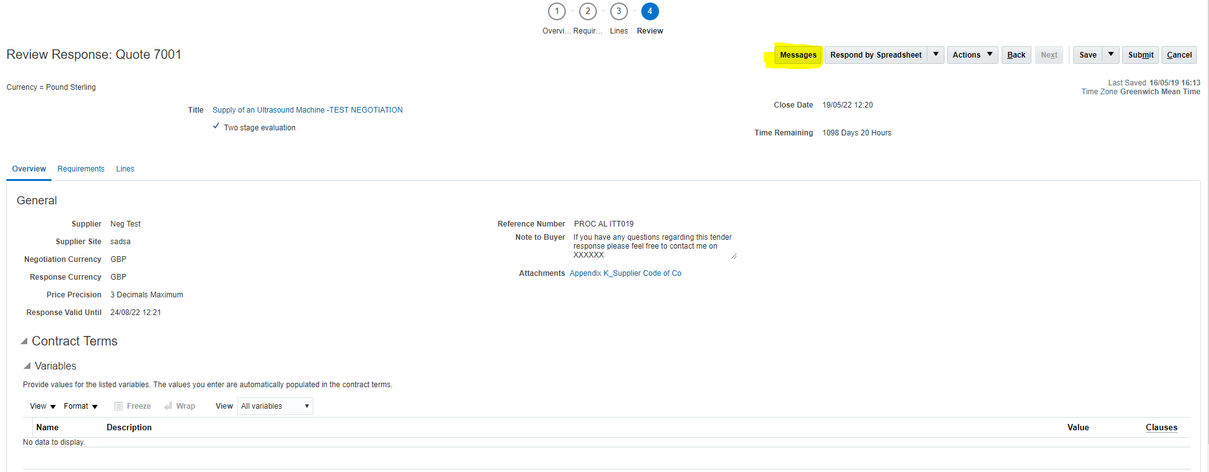

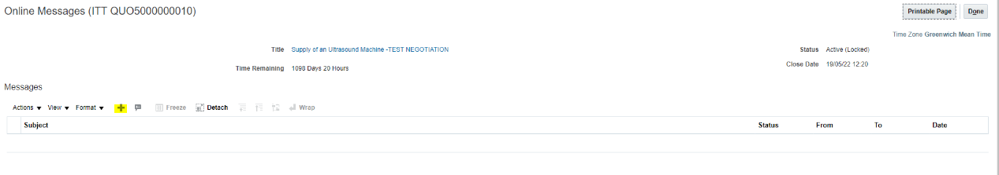
Within the messages tab you can create your message by pressing the “+” icon highlighted below.
This will bring up a text field that you can populate and also add any attachments as per the below.
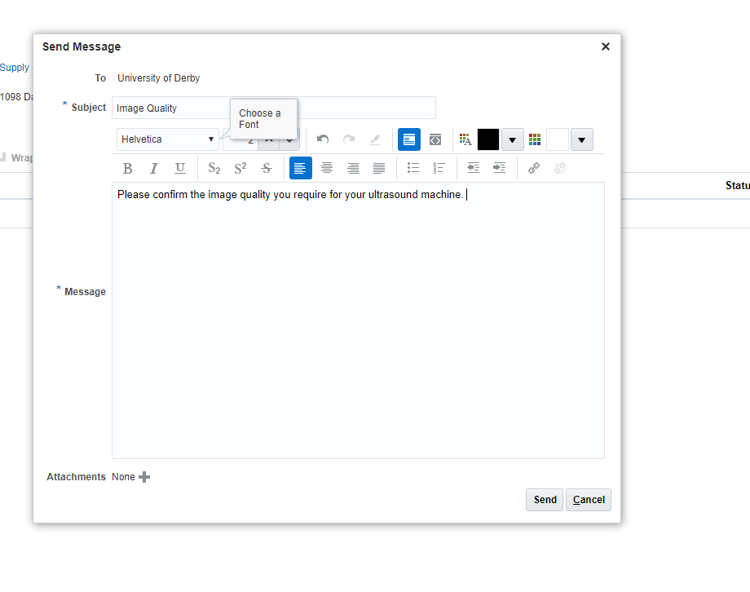

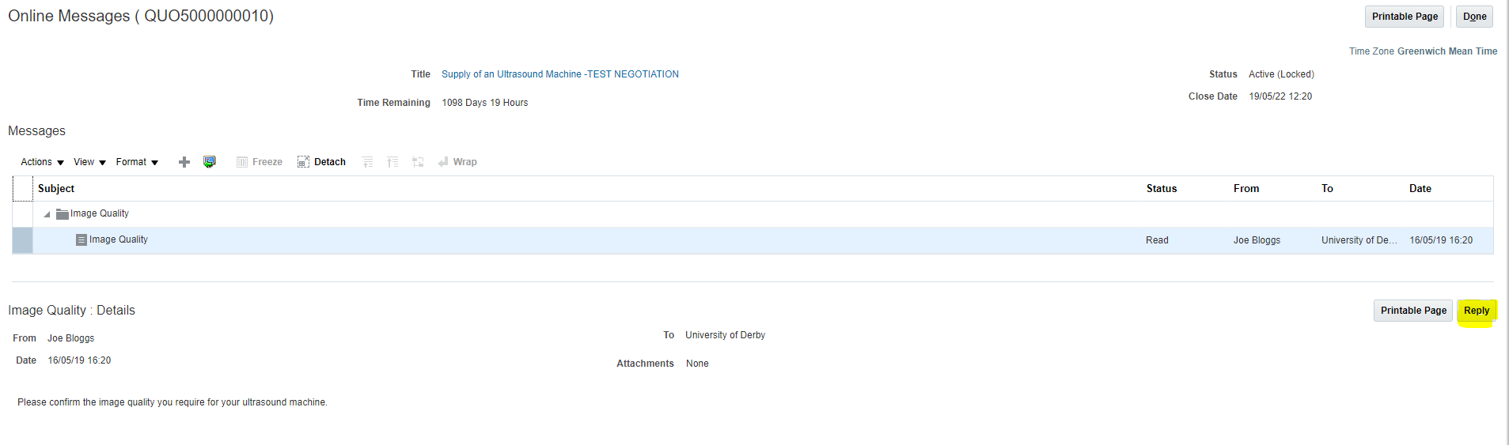
To reply to a message simply highlight the message you wish to respond to and press the Reply tab as highlighted below.
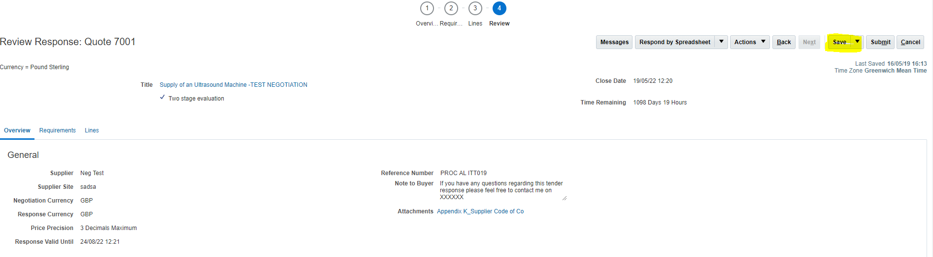
You can save your response progress if you wish to come back to it by pressing the “Save” button as per the below.
In order to get back to your response later simply follow steps 1 – 7.

Submitting Tender Responses
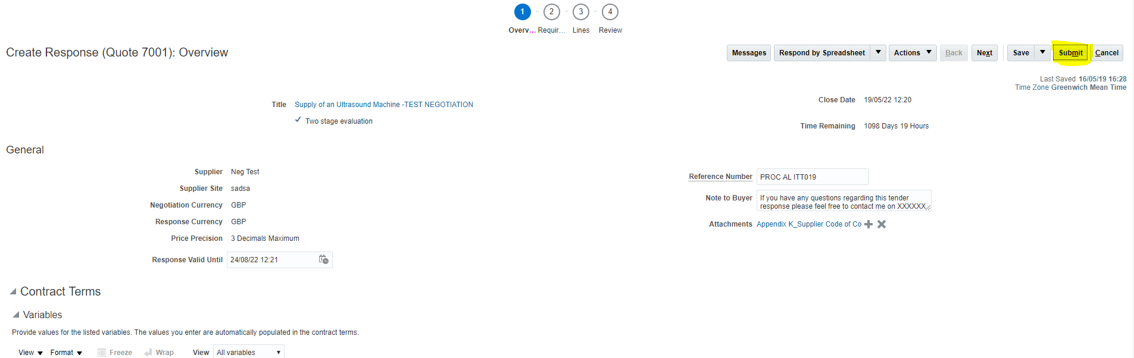
- When you response is complete press the “Submit” button which will submit your response ready for the buyer to view upon the closing of the opportunity.

PLEASE NOTE SOME OPPORTUNITIES MAY NOT ALLOW ANY TENDER RESPONSE AMMENDMENTS ONCE THEY ARE SUBMITTED. PLEASE ENSURE YOUR TENDER RESPONSE IS COMPLETE AND FULL TO YOUR SATISFACTION BEFORE SUBMITTING.
If you have any further questions regarding submitting a response please contact
Procurement@derby.ac.uk stating your name and contact number and a member of our procurement team will contact you to resolve your query.

Many thanks
Procurement Team

