

NHS England (London Region)

Intermediate (Level 2) Endodontic Draft
Service Specification

February 2018 (draft version 12)

Contents
1. NATIONAL / LOCAL CONTEXT AND EVIDENCE BASE 3
1.1. Background 3
2. SCOPE 4
2.1 General Objectives 4
2.2 Service Objectives 5
2.3 Service Requirements 6
2.4. Accessibility 6
2.5. Whole System Relationships 7
2.6. Service Duration 7
3. SERVICE DELIVERY 7
3.1 Service Model 7
3.2 Service Users 8
3.3 Service Quality 8
3.4 Restorative Provider Triage Requirements 9
3.5 Communication 10
3.6 Premises & Facilities / Equipment 10
3.7. Information Technology 12
3.8. Care Pathway(s) 12
4 REFERRALS, ACCESS AND ACCEPTANCE CRITERIA 13
4.1 Geographic coverage/boundaries 13
4.2 Location(s) of Service Delivery 13
4.3 Days/Hours of Operation 13
4.4 Disability Access 13
4.5 Referral Route 13
5 RESPONSE TIME AND PRIORITISATION 13
5.2 Discharge Criteria and Planning 13
6 PREVENTION, SELF-CARE, AND PATIENT/CARER INFORMATION 14
6.1 Clinical Care/After Care 14
7 PAYMENT MECHANISM 14
7.1. Funding will be a cost per case basis. 14
8 MONITORING ARRANGEMENTS 14
9 DEFINITIONS 15
10 GENERAL LEGISLATION AND GUIDANCE 17
11 PROMS & PREMS 18
11.1 Outcomes of Endodontic Care 18
APPENDICES 18
APPENDIX 1 Patient Advice Sheet 20
APPENDIX 2 Endodontic Referral Screening Form 23
APPENDIX 3 Complexity Levels 26
Appendix 4 Endodontic Need by Borough 28
Appendix 5 Current Acute Dental Restorative Providers 30
Appendix 6 Patient Endodontic Pathway……………………………………………………………………………………………………………31

NATIONAL / LOCAL CONTEXT AND EVIDENCE BASE

1.1. Background

The NHS assumed the responsibility for commissioning NHS General Dental Services (GDS) on 1 April 2006. Since 1 April 2013, NHS England has been commissioning these services following the dissolution of Primary Care Trusts (PCTs).

The NHS Five Year Forward View (FYFV) states that “Increasingly we need to manage systems – Networks of Care – not just organisations”. These services need to be integrated and delivered around the needs of patients not organisations or training programmes and it aligns to the purpose of this restorative dentistry commissioning guide. The FYFV aims to prevent ill health and promote health and wellbeing.

Restorative dentistry is a wide ranging dental speciality, encompassing a variety of clinical and diagnostic skills. The NHS England document “Securing Excellence in Commission NHS Dental Services” sets out the Levels of Complexity for the provision of dental care. In turn, it mandates the need for the NHS to continue to commission Advanced Mandatory Services (AMS). The technical definition of restorative dentistry is given as follows:

Restorative dentistry is the study, diagnosis and integrated management of diseases of the oral cavity, the teeth and supporting structures. It includes the restoration and replacement of teeth, care of the supporting structures (gums and bone) so that functional, psychological and aesthetic needs of an individual patient can be met

The General Dental Council (GDC) recognises that within the overall scope of restorative dentistry there are three sub-specialties or “mono-specialties” that represent very distinct disciplines with their own skill sets. Restorative dentistry therefore encompasses the distinct disciplines of endodontics (management of diseases of the dental pulp and their sequelae, specifically root treatments), periodontal care (the management of diseases of the gums and deeper tissues that hold the teeth or implants in the jaws) and prosthodontics (the prosthetic rehabilitation of the mouth following extensive tooth damage or loss), each with a distinct technical skill set. Whilst these three disciplines can be considered in isolation, the foundation of restorative dentistry is based upon how these interact in patients that require multifaceted care.

Restorative dentistry therefore covers a variety of general dental services which includes, fillings, crowns, dentures, root treatments and gum treatments. The majority of what comes under the definition of “restorative dentistry” is actually primary dental care and can be, and is, provided in every general dental practice under the GDS contract. Restorative care can however be divided into three levels representing the increasing complexity of patient factors and/or technical procedures. These levels range from routine Level 1 care to the complex and specialist Level 3 care.

Where restorative dentistry is provided within an acute hospital trust the delivery of endodontics, periodontology and prosthodontics may not be high priority for that team when compared to managing cancer, maxillo-facial trauma and significant development abnormalities.

It is the contract holder (the provider) of the GDS contract who is responsible for ensuring that as a minimum Level 1 complexity of care is provided to a high standard under his or her contract. Performers working under this contract may be more skilled in some aspects of restorative care than others so not every performer will necessarily undertake all procedures. However, sometimes there are aspects of technical delivery related to anatomy, physiology or background health that are very challenging and that may take a patient’s needs beyond what will be provided routinely without additional experience, skills, training and competence.

Sometimes the technical difficulties are much less of an issue, but the planning, co-ordinating and sequencing of different elements of care can be complex. In some cases it is the task of changing patient behaviour or their general health that complicates care and requires additional skills or services. Often it is all of these. Trying to explain and find the best of a myriad of options for the patient, defining to them what constitutes success and failure in each and how inherent uncertainties affect outcome, is a particular challenge.

The quality of the outcome of restorative care can be measured in terms of trouble-free longevity; healing of infection, teeth survival rather than extracted, bridges or dentures that do their job well for many years, or as patient-centred outcomes of comfort, function and aesthetics. Restorative dental procedures are invasive and often irreversible and, if badly planned or delivered, can cause significant harm to a patient and affect quality of life. Rather than preserving teeth and function, poorly planned or delivered care will shorten the lives of the teeth and lead to further treatment/ re-treatment, at an additional and cost. Consequently, investing in a system that can provide rational planning and high quality care the first time treatment is provided delivery is sensible because the lifetime financial and biological costs of failure, of having to repeat treatment or manage the consequences, can be very considerable.

SCOPE

General Objectives

2.1.1 NHS England (London Region) intends to commission Level 2 restorative services (endodontics) by utilising GDC registered specialists and accredited performers such as Dentists with Special Interests (DwSI) and Dentists with Enhanced Skills (DES) who undertake endodontics at the competency Level 2.

2.1.2 NHS England national guidelines for the appointment and accreditation of performers who undertake work at the competency Level 2 in endodontics has been published in draft format.The purpose of the guidelines is to set out a framework for appointing, accrediting and the re-accreditation of clinicians who undertake work at the competency Level 2. In doing so, it brings together previous guidance from the Department of Health (DH), current draft guidance for commissioning restorative dentistry from NHS England and the principles underpinning Good Medical and Dental Practice.

2.1.3 The draft NHS England commissioning guide for restorative dentistry sets out a framework for restorative services within a Managed Clinical Network (MCN), ensuring that the complexity of the patient or procedure matches the skills and setting of the individual providing the treatment. The MCN will be established to oversee the implementation and the functioning of the specialist pathway, including quality improvement, mentorship, education, training of others, audit and leadership. The MCN chair will be accountable to commissioners and will be responsible to the London Region Local Dental Network (LDN). It will be consultant-led where possible, and all Level 2 and 3 restorative dentistry providers will play an active role and will have a formal link to the MCN.

Service Objectives

    - The service will provide Level 2 endodontics for patients being referred by London Region General Dental Practitioners (GDPs) for patients residing in London or with a GP in London.

    - The service will work to a time-limited national Personal Dental Services (PDS) agreement. The service will provide consistent, high quality care based on the quality assurance principles as set out in the PDS agreement.

    - The Level 2 service is defined as procedures/conditions to be performed or managed by a clinician with enhanced skills, competence and experience who may or may not be on a specialist list. This care may require specialist equipment or environment standards but can usually be provided in an intermediate care setting”.

    - Delivering the following principles - the service should:

- Improve access and reduce waiting times in secondary care for Level 2 endodontic services for London residents
- Give patients flexibility, choice and equity of access
- Respond to the needs of London residents in providing an appropriate range of restorative dental procedures within an intermediate setting
- Reduce the number of inappropriate referrals into secondary (acute) care (where not necessary for training and education of the workforce)
- Comply with the PDS agreement regulations
- Recognise that high quality healthcare is multidisciplinary and should be delivered through good working relationships with others
- Develop an appropriate skill mix within an MCN (to be established)
- Offer high quality healthcare with continually improving services and development for staff
- Establish a positive working relationship between NHS England (London Region), the LDN, referring GDPs and acute providers
- When required by NHSE England (London Region), LDN / MCN and HEE respond to training and up-skilling needs of the workforce – this might become apparent from patterns of declined referrals

    - The performer must be included on the primary care Dental Performers’ List and the GDC Specialist List for Restorative Dentistry, or be accredited to undertake restorative work at the competency Level 2

    - The triage element will be consultant-led, pending the development of the National E-Referral system which the provider would be required to fully utilise.

    - Triage (from one agreed referral proforma) will be undertaken in a secondary care setting, by acute providers who are currently commissioned by NHS England (London Region) to provide substantive restorative dental services. A mechanism must be agreed to allow time and facility for this to take place by a clinician with Level 3 competency of endodontics / restorative dentistry

2.3 Service Requirements

2.3.1 NHS England (London Region) requires the Level 2 service to be provided within a suitable primary, acute or community care setting.
2.3.2 This will be a service consisting of:

  - Patients referred by their GDP and referred to a secondary care provider delivering restorative dental services using the appropriate referral form (See Appendix 2 for example referral form).

  - Should an electronic Referral Management Service (RMS) be procured and implemented by the commissioner, patients should be referred by their GDP via the RMS.

  - The Level 2 service will include examination, diagnosis, investigation, management and treatment and after care as appropriate. Also clinical review where indicated following treatment.

2.3.3 NHS England (London Region) will work with the secondary care commissioners and providers to assess the impact of the service on acute (i.e. the ‘shift’ from secondary to intermediate care). This should be audited for complex cases.

2.3.4 The Provider shall accept appropriate referrals from acute triage made under protocol from GDPs for patients who are NHS England (London Region) registered with NHS England (London Region) General Medical Practitioners (GPs). Patients who are outside the London Region should be referred to services within the areas of residency.

2.3.5 Both the referring GDP and the provider shall undertake a patient assessment during which options for treatment will be discussed with the patient and/or each other when necessary. The use of the Patient Advice Sheet will be implemented (see Appendix 1).

2.3.6 The Provider shall gain informed written consent from the patient for all treatments.

2.3.7 Patients will be referred to the service in accordance with agreed criteria. They shall be treated, where appropriate, under local anaesthesia. Patients will not be treated under IV sedation.

2.3.8 Patients under a NHS course of treatment shall have a Band 2 course of treatment opened and charged as appropriate by the referring dentist. A copy of the FP17 referral notice shall be completed and included with the referral. No additional charges shall be levied to the patient by the service provider.

Accessibility

2.4.1 The availability of the Level 2 service will be agreed by the commissioner.

2.4.2 On receipt of correctly triaged referral, patients will be offered a choice of appointment by the restorative service practice.

2.4.3 The Provider shall obtain and maintain a valid NHS.net account. This should be used for sending and receiving Patient Identifiable Data (PID) with other providers, NHS England (London Region) and any future electronic RMS.

2.4.4 The Provider will deal with emergencies involving their restorative patients as required within their PDS agreement, and will provide out of hours cover for patients under their treatment for endodontic procedures.

2.4.5 In the event of an unexpected complication occurring with care provided by the Provider, a clear communication pathway shall be agreed with the Consultants in Restorative Dentistry in secondary care.

Whole System Relationships

    - The Provider shall work collaboratively with the Commissioner to further develop the endodontic services.

    - The Provider shall develop positive working partnerships with other providers and GDPs to facilitate integrated working.

    - The Provider shall ensure that all NHS patients have the following basic rights:

- Continuity and consistency of service
- A service that is equitable for all users
- To be addressed by their chosen title and/or name
- To have their personal dignity respected
- To have their confidentiality respected
- A right to complain without fear or recrimination
- No discrimination on the basis of gender, ethnicity, sexual orientation

Service Duration

    - The contract for the service shall be for three years in the first instance, with the option for the Commissioner to be able to extend for a further period of two years (3+2).

SERVICE DELIVERY

3.1 Service Model

3.1.1 The specification requires the Provider to deliver Level 2 restorative services to patients who are London residents or registered with NHS England (London Region) GP. Referrals must be made by GDPs or specialist dental practitioners, hospital specialists, and practitioners in the community and salaried services. Patients shall be treated under local anaesthesia. NHS England (London Region) is currently scoping the inclusion of a RMS with the intention of commissioning at some stage. Once in place, it will be adopted by the entire dental profession in accordance with the guidelines set by NHS England (London Region).

3.1.2 The range of procedures which can be performed under this Level 2 specification include as outlined in the draft Restorative Commissioning Guide and the enhanced practitioner validation guide

3.1.3 This should not preclude Level 3a procedures that the Provider can demonstrate to be within their clinical competency / scope and setting. The Provider shall be expected to exercise his/her clinical judgement as to the suitability of the patient to be treated within an intermediate care setting.

3.2 Service Users

3.2.1 The service users comprise of:

NHS patients aged 16 and over either residing in London or registered with a London GP, who has been clinically assessed and deemed suitable to have their treatment provided in an intermediate setting by accredited providers and/or specialists.

Service Quality

    - The Provider shall be required to have a quality assurance process that ensures the following:

- All dental care provided is appropriate and of a consistent quality
- Effective measures for infection control and decontamination which comply with the Health Technical Manual (HTM) 01-05
- All legal requirements relating to health and safety in the workplace are satisfied
- All legal requirements relating to the GDC in respect of the LifeLong Learning programme of Continuing Professional Development (CPD) of GDPs, DCPs and the wider dental team are satisfied
- All clinicians performing restorative dentistry within this contract to be appropriately registered professionally. This means inclusion on the GDC’s Restorative Dentistry specialist list or performers who undertake endodontic competency at Level 2 (accredited to DwSI/ DES).
  - DCPs should be appropriately qualified and registered or be enrolled in a recognised training programme
- The Provider/Performer must have appropriate and adequate indemnity cover in place throughout the duration of the contract
- All personal data processed in connection with the provision of the service are processed in accordance with the requirements of the Data Protection Act 1998 and, where necessary, the common law duty of confidentiality. Compliance at Level 2 (or with an improvement plan for compliance at that level) with the current Dental Practice version of the NHS Digital Information Governance (IG) Toolkit

The Provider shall be expected to demonstrate Level 2 competencies as follows:

- Examination and diagnosis
- Treatment planning and patient management
- Clinical practice – medical & dental emergencies
- Clinical practice – anaesthesia, pain and anxiety control / surgery (basic surgical principles) / surgery specific procedures (as relevant) / non-surgical management of hard and soft tissues
- Communication – patients and relatives/clinical teams, peers and other professionals
- Professionalism – ethics and legislation
- Able to train and teach others in endodontic practice to scope future training programmes

    - The Provider shall be required to:

- Demonstrate evidence of staff competence for all staff
- Ensure record keeping is legible and of an appropriate standard
- Ensure appropriate patient booking systems are in place
- Ensure systems are in place for dealing with emergencies
- Ensure systems are in place for accessing translation services, if required
- Ensure a complaints system is in place for patients and carers
- Ensure adequate data protection of sensitive patient identifiable information

    - The Provider shall be responsible for assuring quality through both case and patient audit.

    - The Provider shall, at any time on receipt of reasonable notice (three working days), allow representatives of NHS England (London Region) to visit the premises on a working day in order to undertake an inspection of the premises and to assess compliance with statutory and health and safety requirements.

Restorative Provider Triage Requirements

All triage will be delivered by London secondary care Consultants in Restorative Dentistry / Endodontics providers. Triage providers will need access to Specialists / Consultants in Restorative Dentistry and Endodontics that hold a valid Certificate of Completion of Specialist Training (CCST) as defined by the General Dental Council (GDC): https://www.gdc-uk.org/professionals/specialist-lists

For the avoidance of doubt all successful Level 2 and triage providers must have the IT infrastructure to send and receive electronic referrals including digital x-ray imaging.

    - Referrals into the Restorative service will only be accepted with a radiograph of ‘suitable diagnostic quality’. In rare circumstances where a radiograph cannot be supplied, a valid clinical explanation must be given.

    - Referrals should not be accepted if they are considered to be Level 1 competency. The definitions of Level 1 procedures defined by the draft national commissioning guide and London Region LDN Restorative sub-group are in (Appendix 2)

    - All Level 2 referrals that cannot be treated by a GDP should be triaged through the restorative service.

    - A list of London Region restorative triage services can be found in (Appendix 3)

    - A flow chart of the endodontic pathway can be found in (Appendix 3)

Endodontic treatment / retreatment: For a Tooth that is Restorable and in the Interest of the Patient to retain

- Root canal curvature >30º but <45º
- Locating and negotiating canals NOT considered negotiable in the coronal 1/3 but patent thereafter, based on radiographic evidence
- Difficulties with local analgesia that cannot be resolved by routine measures e.g. pulpal conditions
- Locating and negotiating where the referring GDP has attempted but experienced problems with location, instrumentation or obturation of the root canals
- Teeth > 25mm in length
- Incomplete root development
- Limitation of mouth opening (between 25mm and 35mm inter-incisal opening)
- Removal of fractured posts, less than 8mm in length?
- Well condensed root fillings short of ideal working length with evidence of likely patency beyond existing root filling where previous treatment did not involve complicating factors

    - Referrals should be forwarded on to secondary care if they are considered to be level 3 competency level. See definitions for levels of complexity.

3.4.7 Referrals received that are illegible or incomplete should be sent back to the original referring practice and an explanation for the rejection provided so that the GDP can rectify accordingly.

Communication

    - Some patients requiring restorative dental services will have special communication needs. Signage and accessible information such as ‘Easy Read’ that take into account the additional needs of these patients must be appropriate to the individual needs of each patient. Large print or easy read appointment cards should be available, if required.

    - Effective communication should be used with the patient to ensure that the patient understands what treatment is being proposed, any potential complications or why treatment is not recommended.

    - All forms of communication should be considered when communicating with the patient.

    - The patient’s treatment needs and any treatment plans advised or undertaken must be communicated to the referring clinician.

    - Any original radiographs and study models provided by the referring clinician should be returned on completion of the treatment. All patient identifiable communication should be sent by secure NHS.net to NHS.net or by signed for post. All radiographs should be of suitable diagnostic quality.

    - The Provider is expected to build good working relationships with all local GDPs, CDS, acute trusts and patient groups to ensure a smooth patient pathway.

Premises & Facilities / Equipment

    - The endodontic service must be provided in a location that is accessible by all members of the community and with good transport links.

    - The premises shall be accessible to emergency services vehicles.

    - All premises shall be CQC registered to provide clinical services throughout the duration of the contract

    - The following are statutory minimum requirements that must be met by the Provider:

a. Employers’ Liability Insurance
b. Electricity at Work Regulations (Portable Appliance Testing)
c. Pressure Vessel & Autoclave Regulations
d. Ionising Radiation Protection Regulations
e. Hazardous Substances Risk Assessment and COSHH Assessment
f. RIDDOR
g. Compliance with Water Bye-Laws
h. Compliance with Resuscitation Council and British National Formulary Guidelines for
Medical Emergencies in Dental Practice with reference to:
- Emergency drugs including portable oxygen supply
- Portable self-powered suction
- Airway adjuncts
- Monitoring equipment (as appropriate)
- Arrangements for storage and disposal of clinical waste and sharps
- Current cross-infection control guidelines
- Defibrillator

    - Additionally, the Provider shall ensure that all those involved in the provision of the service have adequate Professional Indemnity cover.

    - Premises shall be subject to inspection by an NHS England (London Region) Commissioner, Dental Practice Adviser (DPA) and Infection Control Nurse to ensure the premises meet all statutory requirements for the Level 2 restorative service.

3.6.7. The Provider shall be responsible for set-up costs. The following would be required as a minimum by any Provider wishing to provide restorative services from their premises:

Endodontic Instruments
- Rubber Dam (latex and latex-free) and appropriate frame and a broad range of clamps needed for single tooth and other isolation methods of teeth within the dentition in combination with relevant caulking agent of the dentition
- Endodontic operating Microscope
- Single use protocol for all endodontic files
- Rotary system and appropriate motor hand piece with matched GP obturation System
- Hand files (sizes #06 - #140) with matched 02 tapered GP points to allow traditional ‘cold’ obturation of a variety of sized root canals / to include lateral accessory cones and appropriate sized finger spreaders
- Piezon ultrasonic system / Unit with a variety of tips relevant for micrcoscopic endodontic work
- Endodontic access burs / Gates Glidden / Goose neck round burs
- Selection of burs to allow section and removal of cast metals, ceramics and Zirconium
- Endodontic explorers/probes
- Safe End Endodontic irrigating syringes with appropriate sizes
- Collimated radiography machine and Endo Ray film holders
- Third generation Apex Locator
- Thermal obturation system , eg System B and and warm GP backfil machine e.g. Hot Shot / Obtura MTA / Biodentine
- EDTA paste e.g. Glyde
- Electric pulp tester
- Endo Ice or equivalent
- Sodium hypochlorite irrigant
- Eucalyptus oil/GP solvent
- EDTA irrigant solution
- Intra canal dressing (non-setting Ca(OH)2 non-setting calcium hydroxide)
- Post retrieval system

General Practice Standards
- Reception and waiting room
- Adequate staffing levels
- Care park and/or pick-up facilities
- Pre and post-operative instructions, consent and medical history forms
- Wheel chair access
- Emergency equipment and drugs

3.6.8. The premises shall be either owned or leased for the full duration of the PDS agreement.

3.7. Information Technology

The Provider shall be expected to follow all mandated NHS Information Governance (IG) requirements and be linked to an approved clinical system that allows:
- Effective storing of electronic patient records
- Sending and retrieving electronic communications including radiographs
- The use of NHS.net
- Internet access
- Transmit activity data electronically to NHS England (London Region)
- Electronic transmission of data to the NHSBSA Dental Services

The operation and purchase of any IT equipment will be the sole responsibility of the Provider.

3.8. Care Pathway(s)

3.8.1. The proposed pathway will take account of the following:

- NHS England (London Region) LDN Restorative sub-group Levels of Complexity
- Ensure that all Level 2 procedures/referrals which do not fall under the exclusion criteria of service are appropriately triaged
- Ensure that all referrals subject to suitability are referred to an accredited Provider of Restorative dentistry, who will then undertake the necessary surgical procedures
- Upon completion of the procedure, the Provider will ensure that a copy of all associated patient notes and the discharge documentation is forwarded to the referring clinician
- If required, a follow-up appointment or telephone call will be arranged

REFERRALS, ACCESS AND ACCEPTANCE CRITERIA

4.1 Geographic coverage/boundaries
The Provider shall provide the services to all eligible service users within the NHS England (London Region) recognised boundaries and catchment areas (i.e. all 32 London Boroughs).

Location(s) of Service Delivery
The service shall be located within the boundaries of the NHS England (London Region).

Days/Hours of Operation
The service will be delivered over a minimum of five days per week including weekends and evening sessions. One session per week will be reserved exclusively for emergency patients however can be utilised for general appointments if there are no emergencies.

Disability Access
The following needs to be accessible by wheelchair service users: reception, pan-oral radiograph treatment room and toilet. The waiting area must include appropriate seating and communication aids as well as adequate space for service users who use wheelchairs or mobility scooters.

Referral Route
It is expected that referrals to this service will be mainly from primary care GDPs and sent to the appropriate restorative secondary care provider for triage.

RESPONSE TIME AND PRIORITISATION

    - Referrals will be triaged by the secondary care provider within three working days. Providers will need to ensure adequate coverage at all times.

5.1.2 Assessment appointments (if necessary) will take place in the intermediate setting within three weeks on receipt of a complete and valid triaged referral.

5.1.3 All courses of treatments to have been started by the Provider within four weeks.

5.1.4 Urgent/emergency cases requiring immediate attention shall be triaged as above and treated by the Provider within one week. A discussion must take place with the referring GDP for all emergency cases.

5.2 Discharge Criteria and Planning

    - The Provider shall discharge patients back to the GDP once they have treated the patient. This shall include full discharge documentation sent to both the referring GDP and a copy provided for the patient/carer.

    - The Provider shall discharge the patient with a care plan and emergency care instructions.

6 PREVENTION, SELF-CARE, AND PATIENT/CARER INFORMATION

6.1 Clinical Care/After Care

6.1.1 The Provider shall ensure that a clear pathway of referral is established with the local restorative consultants for referral into hospital in the event of complications arising which cannot be managed in the intermediate care setting.

6.1.2. Clinical outcomes shall be measured using the restorative patient audit tool (still in development). PROMs and PREMs for each case treated from both the clinical and patient perspective.

Patient Reported Measures: Patient Reported Experience Measures (PREMs) is a rolling programme of experience gathering, which reports regularly to demonstrate patient experience trends and can be used to inform service development and improvement. This is usually completed through questionnaires.
Patient Reported Outcome Measures (PROMs) are a quality of life measure. By measuring the quality of life before and after a treatment or intervention, and again after a fixed amount of time, gives insight into the impact of a treatment or intervention to a patient’s life.

6.1.3. Detailed patient records shall be maintained by the Provider. All cases shall be recorded on the FP17 forms and transmitted to the NHSBSA Dental Services within the two-month submission deadline.

As a minimum, records should be retained according to the period of time set out under the Department of Health Code of Practice on Retention/Disposal of Records under the NHS for Community Care. This is 11 years for adults and up to the age of 25 years for children. However, in accordance with advice provided by clinical indemnity providers, records that relate to complex treatment or particularly difficult patients should be kept for longer (up to 30 years).

7 PAYMENT MECHANISM

7.1. Funding will be a cost per case basis.

7.2. Tariff per course of treatment (CoT) is £360.00.

8 MONITORING ARRANGEMENTS

8.1. In addition to routine monitoring information available through the NHSBSA Dental Services and the information collected on the referral form, the Provider will supply information to the NHS England (London Region) on a monthly basis. This is to include a minimum data set which will also form the basis for service evolution and contract management. This would include but not be limited to:

- Total number of Courses of Treatment per month
- Waiting time for assess per month
- Waiting time for procedure per month
- Number of sedations per month (if applicable)
- Number of complaints per month
- Number of Failure to Attend (FTA) per month
- Number of rejected referrals
- GDP source of referral
- Hospital source of referral

8.2. NHS England (London Region) will undertake an annual audit of the restorative contract which will involve the production of patient records.

8.3. NHS England (London Region) will expect each Provider to complete their own self-audit of their restorative contract.

8.4. The service will be monitored on a monthly basis by NHS England (London Region).

8.5. In addition, NHS England (London Region) requires notification of any complaints, significant events and Serious Incidents/Never Events as and when they occur.

8.6. Information collected by the restorative Providers should be discussed at regular meetings to help assess the patient pathway waiting times.

8.7. The Provider will conduct a restorative patient satisfaction survey and share the results and actions/recommendations with NHS England (London Region). The survey will be conducted at the cost of the Provider, and will be above and beyond any existing level surveys and the national Friends and Family Test (FFT).

8.8. The Provider will supply any further information required by NHS England (London Region) for the purposes of monitoring the contract.

8.9. The provider will meet with NHS England (London Region) at appropriate intervals to be determined by the NHS England (London Region).

9 DEFINITIONS

The NHS England London Region definitions of complexity are taken from the NHS England Draft Restorative Commissioning Guide and the London Restorative LDN sub group.

Complexity and Procedure levels:

The Department of Health Advanced Care Pathway Working Group defined procedures and modifying patient factors that describe the complexity of a case. The levels of complexity do not describe contracts, or practitioners or settings. Levels 1, 2 and 3 care descriptors reflect the competence scope required of a clinician to deliver care of that level of complexity.

The level of complexity may change depending upon one or more of the following factors:
- Medical History
- Social
- Patient anxiety
- Other patient-associated modifiers.

Endodontic Care

Level 1 Complexity
Diagnosis and management of patients with uncomplicated endodontic treatment need including but not limited to:
- Root canals with a curvature <30º to root axis and considered negotiable, from radiographic evidence, through their entire length
- No root canal obstruction or damaged access, e.g. perforation
- Previously treated teeth with a poorly condensed root filling short of ideal working length where there is evidence of likely canal patency beyond the existing root filling
- Routine dismantling of plastic restorations, crowns and bridges to assess restorability
- Pulp extirpation as an emergency treatment
- Incision and drainage as an emergency treatment
- Straightforward retreatment
This also includes any endodontic treatment not covered in level 2 or 3 procedural complexity

Level 2 complexity
The management of patients with teeth requiring endodontic treatment or retreatment where:
- Root canal curvature >30º but <45º
- Locating and negotiating canals NOT considered negotiable in the coronal 1/3 but patent thereafter, based on radiographic evidence
- Difficulties with local analgesia that cannot be resolved by routine measures
- locating and negotiating where the referring GDP has attempted but experienced problems with location, instrumentation or obturation of the root canals
- Teeth > 25mm in length
- Incomplete root development
- Limitation of mouth opening (between 25mm and 35mm inter-incisal opening).
- Removal of fractured posts, less than 8mm in length?
- Well condensed root fillings short of ideal working length with evidence of likely patency beyond existing root filling where previous treatment did not involve complicating factors

Level 3 complexity
The management of patients with teeth requiring endodontic treatment or retreatment where:
- Root canals curvature >45º
- Recurved (S-shaped) root canals
- Canals are NOT considered negotiable through their entire length based on radiographic evidence
- Developmental tooth anomalies present, e.g. bifid apex, complex branching of root canal(s), dens in dente, gemination, and C-shaped canals).
- Assessment and planning the long term management of severely traumatised teeth where severity extends beyond enamel & dentine; usually involving multiple teeth
- The management of teeth with iatrogenic damage or pathological resorption.
- Severe limitation of mouth opening. (inter-incisal opening less than 25mm)
- Complicated retreatments are required (e.g. well-fitting posts longer than 8mm; posts thought to be associated with a perforation; carrier-based obturations; silver points; fractured instruments; well condensed root fillings to length; overfilled roots with apical lesions).
- Major iatrogenic errors e.g. large ledges, blocked canals, perforations where these can be rectified
- Periradicular surgery

Level 1 and 2 procedures are usually performed in primary care settings. However, some Level 1, 2 and 3 procedures may be performed in a secondary care setting if modifying patient factors or local circumstances require this e.g. requirement for skill mix and/or multidisciplinary team and/or general anaesthesia.

10 GENERAL LEGISLATION AND GUIDANCE

- NHS Constitution for England, updated 2015
Available at: https://www.gov.uk/government/publications/the-nhs-constitution-for-england
- NHS Five Year Forward View, 2014
Available at: http://www.england.nhs.uk/wp-content/uploads/2014/10/5yfv-web.pdf
- Securing Excellence in Commissioning NHS Dental Services, 2013
Available at: http://www.england.nhs.uk/wp-content/uploads/2013/02/commissioning-dental.pdf
- Equity and Excellence: Liberating the NHS, 2010
Available at: https://www.gov.uk/government/uploads/system/uploads/attachment_data/file/213823/dh_117794.pdf
- Implementing care closer to home, modified 2009
Available at:
http://webarchive.nationalarchives.gov.uk/+/http://www.dh.gov.uk/en/Healthcare/Primarycare/Practitionerswithspecialinterests/DH_074419
- High Quality Care for All – NHS Next Stage Review Final Report, 2008
Available at: https://www.gov.uk/government/uploads/system/uploads/attachment_data/file/228836/7432.pdf
- NHS England Specialty Training, Health Education England (formerly, Modernising Medical Careers)
Available at: http://specialtytraining.hee.nhs.uk
- NHS Personal Dental Services Agreement
Available at:
https://www.gov.uk/government/publications/standard-general-dental-services-contract-and-personal-dental-services-agreement
- Health Technical Memorandum 01-05: Decontamination in primary care dental
practices, 2013
Available at: https://www.gov.uk/government/uploads/system/uploads/attachment_data/file/170689/HTM_01-05_2013.pdf
- Ionising Radiation (Medical Exposure) Regulations 2000 (IRMER), 2012
Available at: https://www.gov.uk/government/publications/the-ionising-radiation-medical-exposure-regulations-2000
- HIV-infected health care workers: Guidance on management and patient notification, 2005
Available at: https://www.gov.uk/government/publications/hiv-infected-healthcare-workers-and-exposure-prone-procedures
- Equality Act, 2010
Available at: http://www.legislation.gov.uk/ukpga/2010/15/contents
- Human Rights Act 1998
Available at: http://www.legislation.gov.uk/ukpga/1998/42/contents.
- Dental Practitioners’ Formulary
Available at: https://bnf.nice.org.uk/dental-practitioners-formulary/
- GDC Scope of Practice guidance
Available at: https://www.gdc-uk.org/professionals/standards/st-scope-of-practice
- GDC Fitness to Practice advice
Available at: https://www.gdc-uk.org/professionals/ftp-prof
- GDC Standards for the Dental Team guidance
Available at: https://www.gdc-uk.org/professionals/standards/team
- Caldicott review: information governance in the health and care system, 2013
Available at: https://www.gov.uk/government/publications/the-information-governance-review
- NHS Digital Information Governance Toolkit
Available at: https://www.igt.hscic.gov.uk/

Legislation and Guidance Pertinent to Restorative Dentistry

- Conscious sedation in the provision of dental care: report of an Expert Group on Sedation for Dentistry, Standing Dental Advisory Committee, 2003

Available at: http://webarchive.nationalarchives.gov.uk/+/www.dh.gov.uk/en/Publicationsandstatistics/Publications/PublicationsPolicyAndGuidance/DH_4069257

11 PROMS & PREMS

11.1 Outcomes of Endodontic Care

Endodontic treatment should be followed up radiographically at one year. If healing is progressing then normally it will continue; where there is doubt as to whether the treatment has been successful then further follow up is advised at four years or before if there are symptoms.

Endodontic treatment enjoys a predicable outcome providing it is delivered to an appropriate technical standard. This is defined as a well condensed root canal filling to within 2mm of the radiographic apex and a satisfactory coronal seal. This is one outcome threshold that can be used to assess and monitor quality within a MCN audit.
Successful endodontic treatment also results in a pain free functional tooth which can act as a reasonable and simple patient-based outcome.

In teeth with vital pulp at the point of treatment a positive outcome can be expected 96% of the time; those that have non vital pulps and/or have a chronic infection at the point of treatment have an 86% positive outcome; the figure is the same for previously treated teeth provided there are no predisposing factors precluding the completion of treatment to the above standard. Tooth survival has been reported at 97% with the major cause of failure being a lack of protective coronal restoration. These figures provide a reasonable benchmark for the success of treatment for consideration by an MCN.
Most endodontic failures of satisfactorily treated teeth result from uncontrolled periodontal disease, root fracture, dental caries or inability to restore adequately to function which is why these factors are included in the exclusion criteria for treatment above.

APPENDICES

Appendix 1: Patient Advice Sheet

Appendix 2: Endodontic referral form

Appendix 3: Complexity levels

Appendix 4: Endodontic need by borough

Appendix 5: Current acute dental restorative providers

Appendix 6: Patient endodontic pathway

APPENDIX 1 – Patient Advice Sheet

GUIDANCE FOR GENERAL DENTAL PRACTITIONERS

Proposal for Patient Information Sheet for access to NHS Specialist/Secondary Care Endodontic Treatment

Background

Under the NHS constitution NHS treatment is available to all irrespective of gender, race, disability, age, sexual orientation, religion, belief, gender reassignment, pregnancy and maternity or marital or civil partnership status. The service is designed to improve, prevent, diagnose and treat both physical and mental health problems with equal regard. It has a duty to each and every individual that it serves and must respect their human rights. At the same time, it has a wider social duty to promote equality through the services it provides and to pay particular attention to groups or sections of society where improvements in health and life expectancy are not keeping pace with the rest of the population.

It is also committed to providing the most effective, fair and sustainable use of finite resources. Public funds for healthcare will be devoted solely to the benefit of the people that the NHS serves. Money spent on treatments that are ineffective or likely to produce no benefit is money wasted that could be allocated to other treatments.

It is vital that healthcare professional and patients discuss potential treatments and make decisions on what to recommend/accept based on clinical need and suitability.

In dentistry it is often complicated to discuss with patients why a treatment they want to be referred for may not be the clinically indicated treatment. There is the added complexity of providers offering private treatment as an alternative to the recommended NHS treatment.

Process

It is proposed that to ensure that the appropriate conversations take place with the patient prior to referral and to give the dentist a format for those discussions that the following patient sheet be completed when advising the patient. This sets out why NHS restorative treatment may not recommended or referral to NHS specialist or secondary care is not recommended and records the discussion of options for other NHS treatment or private treatment.

The attached draft patient sheet is based on the complexity levels and referral form developed by the LPN but will need discussion and clinical development. It is attached here as a discussion aid not in any way as a finished product.

The example sheet sets out reasons for acceptance, delay or refusal and is signed by dentist and patient. The patient receives a copy. A copy could also be sent to a central body for recording or held by the dental practice for audit.

It is based on the criteria set out in the LPN complexity paper that to be eligible for referral there should be:

- Stable oral environment should have been achieved and all caries managed.
- Patient is informed and understands that the treatment may involve multiple long appointments and that success cannot be guaranteed.
- Tooth / Teeth should be predictably restorable and made functional after removal of disease with supra-gingival sound coronal tooth tissue distributed circumferentially with a minimum height of 3mm and thickness of 2mm, together with intact axial pulp chamber walls.
- For many teeth this will only be possible after removal of existing restoration(s) and the placement of a sound and well-fitting provisional restoration prior to referral.
- Where the referred tooth has a de-cemented bridge retainer or caries is evident at the restoration margin, the restoration should be removed by the referring practitioner for caries removal and restorability assessment before referral. The tooth should only be referred with a sound well-fitting temporary restoration in place.
- Patient is informed and understands that the referring practitioner is responsible for the provision of all restorative phases after completion of endodontic treatment (and not to do so would risk both endodontic failure and tooth loss).
- Endodontic treatment is not precluded by either patient cooperation or medical history.
- Patient is motivated with satisfactory periodontal health. For BPE codes 2, 3 &, 4, there should be clarification that supra/sub gingival debridement has been performed using local anaesthetic and periodontal control achieved prior to referral.
- Referral must be accompanied by a periapical radiograph of diagnostic quality (please see notes on radiographs accompanying referral below)
- Referral request must fall into either level II or III complexity – as described in the acceptance criteria below.
The patient must be informed and understand that referral for treatment is preceded by a consultation and does not guarantee acceptance for treatment, if deemed unsuitable

Standardising these discussions on a standard form used across London should help to minimise the rejection of referrals and to reduce complaints from patients who are not referred or who are offered private treatment as it sets out the reasons clearly

EXAMPLE FORM

PATIENT ADVICE SHEET/ACCEPTABILITY FOR NHS RESTORATIVE DENTAL TREATMENT FORM

Dentist Name ............................................................................................

Practice name and address .............................................................................................................

Patient name .................................................................................................................................

Date of examination ......................................................................................................................

I have examined you today and given the following advice regarding endodontic treatment:

I am recommending

Referral to secondary care for endodontic treatment according to the guidelines ................
This referral falls into level II or III as set out in the guidelines ................
Patient understands that they will be assessed by the secondary care provider
and acceptance for treatment is not guaranteed .................

I am not recommending referral for Endodontic Treatment at this time as
the following dental work/oral healthcare needs to be completed before a referral can be made
Stabilising oral environment
Management of caries
Removal and replacement of existing restorations
Periodontal health improvement

Details………………………………………………………………………………………………………………………………….

I am not recommending referral for advanced NHS endodontic treatment because
Patient unable to commit to long treatment plan/appointments
Oral Health is not sufficient to sustain teeth
Medical History precludes endodontic treatment
Periodontal Health is not satisfactory
Success chance of endodontic treatment is low

Details …………………………………………………………………………………………………………………………….

We have discussed other options for NHS dental treatment .....................
The patient wishes to be considered/ referred for private endodontic treatment .....................
Signed ................................................................................ (dentist) .............................................................................. (patient)

APPENDIX 2

Endodontic Referral Screening Form Approved by Local Professional Network (Restorative Dentistry) – London - March 2016
Nature of Referral (referral cannot be accepted if both boxes ticked)
Opinion only | Yes | No tick
Request for Treatment | Yes | No tick

Details of the Referral:
Tooth / Teeth being referred  Reason for referral  (please circle one of following) | (e.g. UR6, UL1, LL5 etc.)  Advice only (including diagnostic or treatment planning challenges)  Root Canal Treatment  Root Canal Re-Treatment (including correction of iatrogenic errors? )  Periradicular Surgery  Other endodontic management (vital pulp therapy, complex sequelae of trauma, resorption, dental anomalies, systemic complications)
Nature and History of Presenting problem
(to include present and/or past symptoms)
Medical history
Medications
Please provide details of treatment provided in primary care for this tooth/teeth (including any difficulties encountered)
e.g. pulp extirpated, tooth opened to drain infection, incision & drainage, or restoration removed to assess restorability
Current BPE scores:
  L |  | R
Has all treatment of primary dental disease (caries and periodontal inflammation) been completed  Details of primary disease treatment completed | Yes  No  Please tick relevant box
All London level I, II and III NHS Endodontic referrals will be made by use of this pro-forma which is the agreed process of clinical triage for patients requiring Endodontic services in the London. The process is overseen by the Local Professional Network and referrals that do fulfil the stated requirements or fall out with level II (moderately difficult) or level III (complex) will be declined and returned to the referrer.
Risk screening & entry criteria:
- Stable oral environment should have been achieved and all caries managed.
- Patient is informed and understands that the treatment may involve multiple long appointments and that success cannot be guaranteed.
- Tooth / Teeth should be predictably restorable and made functional after removal of disease with supra-gingival sound coronal tooth tissue distributed circumferentially with a minimum height of 3mm and thickness of 2mm, together with intact axial pulp chamber walls.
- For many teeth this will only be possible after removal of existing restoration(s) and the placement of a sound and well-fitting provisional restoration prior to referral.
- Where the referred tooth has a de-cemented bridge retainer or caries is evident at the restoration margin, the restoration should be removed by the referring practitioner for caries removal and restorability assessment before referral. The tooth should only be referred with a sound well-fitting temporary restoration in place.
- Patient is informed and understands that the referring practitioner is responsible for the provision of all restorative phases after completion of endodontic treatment (and not to do so would risk both endodontic failure and tooth loss).
- Endodontic treatment is not precluded by either patient cooperation or medical history.
- Patient is motivated with satisfactory periodontal health. For BPE codes 2, 3 &, 4, there should be clarification that supra/sub gingival debridement has been performed using local anaesthetic and periodontal control achieved prior to referral.
- Referral must be accompanied by a periapical radiograph of diagnostic quality (please see notes on radiographs accompanying referral below)
- Referral request must fall into either level II or III complexity – as described in the acceptance criteria below.
- Patient must be informed and understand that referral for treatment is preceded by a consultation and does not guarantee acceptance for treatment, if deemed unsuitable.
Radiographs Accompanying Referral (important information):
- All referrals must be accompanied by a current, dated and diagnostically acceptable parallel-view periapical radiograph(s) of the tooth (teeth) referred.
- Radiographs (and thus the referral) will be rejected by the triager if the diagnostic quality is unsafe for decision-making (radiographs fall into either IR(ME)R2000 Grade 1 or 2).
- Where paper copies of conventional or digital radiographs accompany the referral the same quality standards will apply – e.g. the referral will not be accepted where the quality of the paper copy does not allow safe diagnostic assessment by the triager.
Patient Details:
Full Name
NHS number
Hospital number (if previously attended the Hospital)
Date of Birth:
Address (Including postcode):

Gender:
E-mail: | Mobile Phone number:
Referring GDP Details and Declarations:
Name of referring dentist

Practice Address

Date of referral

E-mail
Telephone number;
GDP referrer confirms that appropriate radiograph(s) have been submitted with referral? | Yes  tick  No
GDP referrer confirms that the tooth is restorable and is of strategic value This is the only place strategic teeth are mentioned  for patient’s oral health? | Yes  tick  No
GDP referrer confirms that they will undertake any suggested pre-treatment restorative dismantling suggested by the Specialist / Consultant after Consultation | Yes  tick  No
GDP referrer confirms that they will take on the responsibility of tooth restoration (core and cuspal-protection restoration) after endodontic therapy and that the patient understands the importance and risks of this not being done | Yes  tick  No
If the referral is of level 1 Complexity (Routine) Teaching and Education – does the referrer wish that the patient is considered for teaching and education | Yes (referrer must accept that if there is no capacity the referral will be declined)  tick  No
Please confirm that your referral fulfils the London LPN triage requirements for Level 2 or 3 complexities? | Yes  tick  No
If the answer to the above question is NO then please outline another valid reason why the patient should be assessed

APPENDIX 3 – COMPLEXITY LEVELS

Complexity Assessment:

Level 1 Complexity – Routine (Teaching and Training)
Level 1 complexity is the expected scope of all General Dental Practitioners. Referrals will NOT be accepted for referral triage unless such patients are required for training and teaching within London.
Diagnosis and management of patients with uncomplicated endodontic treatment need, including but not limited to:

- Root canals with a curvature <30º to root axis and considered negotiable (i.e., canal(s) not sclerosed or 25+mm long) from radiographic evidence, through their entire length
- No root canal obstruction or damaged access, e.g. (near)perforation
- Previously treated teeth with a poorly compacted root filling, short of the optimal working length, with evidence of likely canal patency beyond the root filling
- Pulp extirpation or incision and drainage as an emergency treatment
- Straightforward retreatment

Level 1 also includes any endodontic treatment complexity not covered in level 2 or 3

Level 2 Complexity – Moderately Difficult
The management of endodontic problems under the following circumstances:
- Root canal curvature >30º but <45º
- Locating and negotiating canals NOT radiographically evident in the coronal 1/3 but appears patent thereafter
- Difficulties with local analgesia that cannot be resolved by routine secondary measures, such as supplementary periodontal ligamental or intra-osseous injection
- Correction of moderately complex iatrogenic technical problems in location, negotiation, instrumentation, disinfection (persistent infection/symptoms) and obturation
- Teeth with anticipated working length > 25mm when accompanied by narrowness and curvature <30°
- Incomplete root development
- Molar tooth endodontic treatment is accompanied by limitation of mouth opening (between 25mm and 35mm inter-incisal opening)
- Removal of fractured short posts (less than ~ 8mm) in length not accompanied by other complications cited for level 3 complexity
- Well-compacted root fillings are short of optimal working length with evidence of likely canal patency and anatomy beyond the root-filling and not accompanied by other complicating factors
- Diagnosis/management of complex “cracked tooth syndrome” dilemmas

Level 2 also includes any endodontic treatment complexity not covered in level 3

Level 3 Complexity - Complex
The management of endodontic problems under the following circumstances:

- Root canal curvatures >45º , particularly when accompanied by narrowness and length greater than 21mm
- Root canals with multiple curves (in same or opposite directions e.g., S-shaped)
- Root canals NOT radiographically evident through their entire length based on a good quality, normally incident radiograph (horizontally angled views will obscure canal systems)
- Root canal systems with anatomical complexities other than curvatures; e.g., complex developmental tooth anomalies, additional roots, bifid apices, complex branching of root canal(s), invaginations such as dens in dente, gemination, C-shaped canals, etc.
- Assessment and planning the long-term management of severely traumatised teeth where severity extends beyond enamel & dentine; usually involving multiple teeth and alveolus
- The management of saveable and restorable teeth with structural damage of iatrogenic or pathological origin (resorption)
- Severe limitation of mouth opening (inter-incisal opening less than 25mm)
- Complex root canal retreatments involving removal of well-fitting posts longer than 8mm; associated perforations; carrier-based, resin or silver point root-fillings; fractured instruments; well-compacted root fillings to length; overfilled roots with apical lesions, persistent infections or pain not resolved by guideline-quality root canal treatment.
- Correction of complex iatrogenic technical problems in location, negotiation, instrumentation, disinfection (persistent infection/symptoms) and obturation, e.g. difficult but potentially rectifiable ledges, blocked canals, perforations, etc
- Periradicular surgery

Appendix 4

Endodontic Need by Borough

Boroughs | Population | Endodontic Need
Hillingdon | 219,259 | 4
Hounslow | 201,963 | 3
Ealing | 262,978 | 4
Brent | 244,716 | 4
Harrow | 187,629 | 3
Hammersmith & Fulham | 145,347 | 1
Kensington & Chelsea | 128,272 | 1
Westminster | 187,732 | 2
Waltham Forrest | 202,000 | 3
Redbridge | 215,220 | 4
Barking & Dagenham | 136,747 | 1
Havering | 189,960 | 2
City & Hackney | 205,220 | 2
Tower Hamlets | 212,378 | 4
Newham | 237,000 | 4
Barnet | 282,465 | 4
Enfield | 239,600 | 3
Haringey | 204,425 | 2
Camden | 187,334 | 2
Islington | 177,322 | 1
Bexley | 181,780 | 2
Bromley | 247,450 | 3
Greenwich | 200,318 | 2
Lambeth | 252,274 | 3
Lewisham | 220,491 | 2
Southwark | 237,369 | 3
Sutton | 151,229 | 1
Merton | 158,248 | 1
Croydon | 281,124 | 4
Richmond | 148,509 | 1
Kingston | 131,100 | 1
Wandsworth | 252,281 | 3

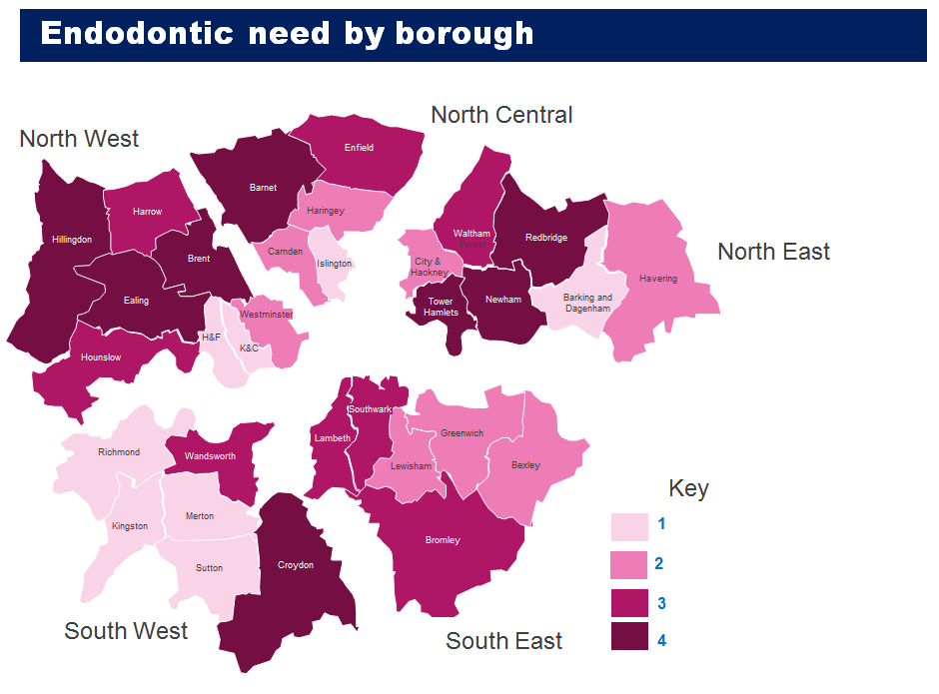

Appendix 5 CURRENT ACUTE DENTAL RESTORATIVE PROVIDERS
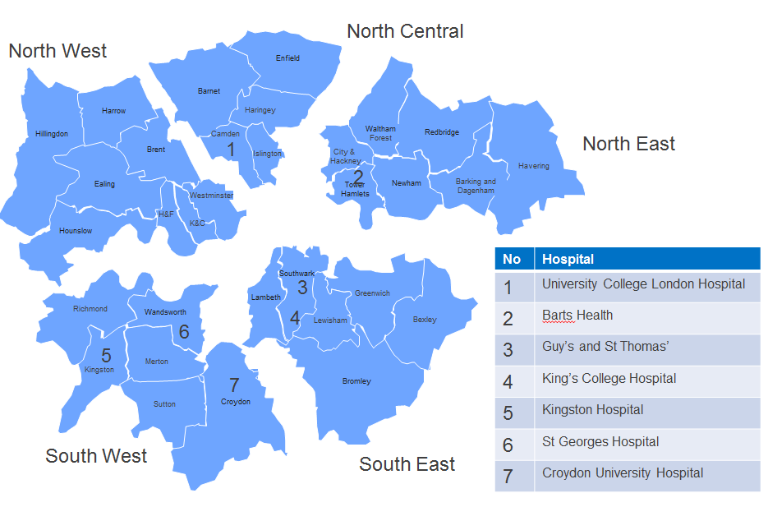
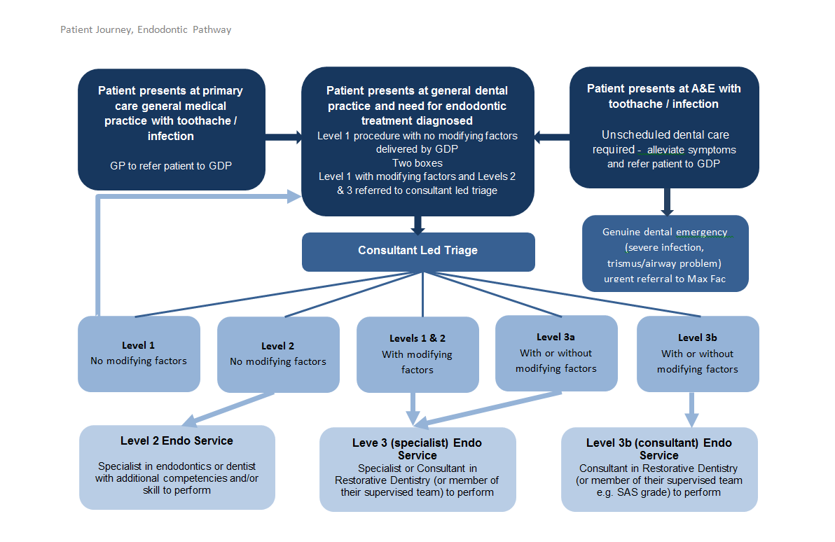

The accreditation process will either follow a National or London model
Premises shall be deemed as suitable upon inspection during mobilisation period
Standard forms for referral, treatment, aftercare as agreed by LDN

