

JAGGAER Commercial System
Supplier Registration Guidance

Contents
- Introduction 3
- How to register as a supplier 3
  - How to access to Supplier Registration page 3
  - Registration Data 4
- Logging into Jaggaer 7
  - Log into Jaggaer 7

Introduction

This document will take the user through the steps required to register as a supplier on Jaggaer. Further guidance and a video walkthrough can be found at: https://education.app.jaggaer.com/web/login.html.

How to register as a supplier

  - How to access the Supplier Registration page

1. Navigate to the Jaggaer log in page at https://education.app.jaggaer.com/web/login.html

Click the ‘Click here to register!’ button
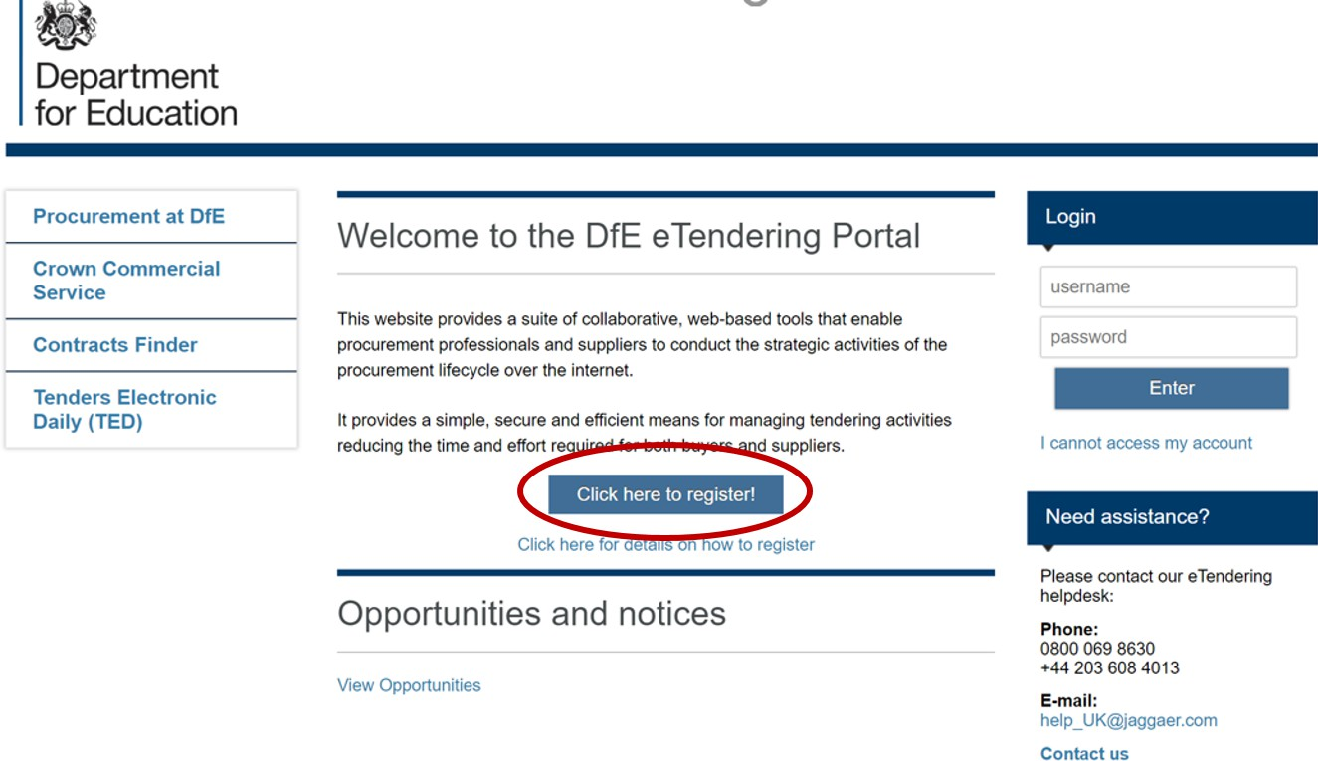

Registration Data

To register as a supplier on Jaggaer it is necessary to complete the information in the three tabs shown below:
‘Registration data’, ‘Basic Profile Forms’, ‘My Category Selection’

- Registration Data tab

The mandatory fields should be completed for ‘Organisational Details’ and ‘User Details’. Once satisfied with your answers click the ‘Save’ button.
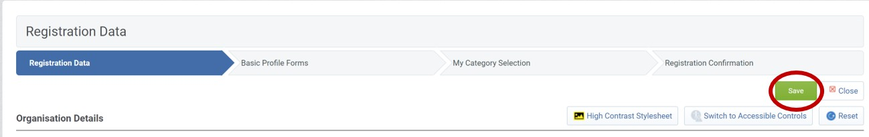
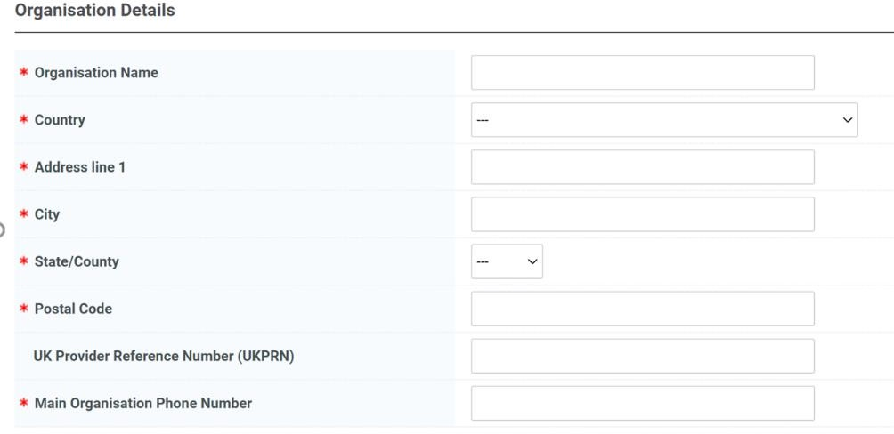
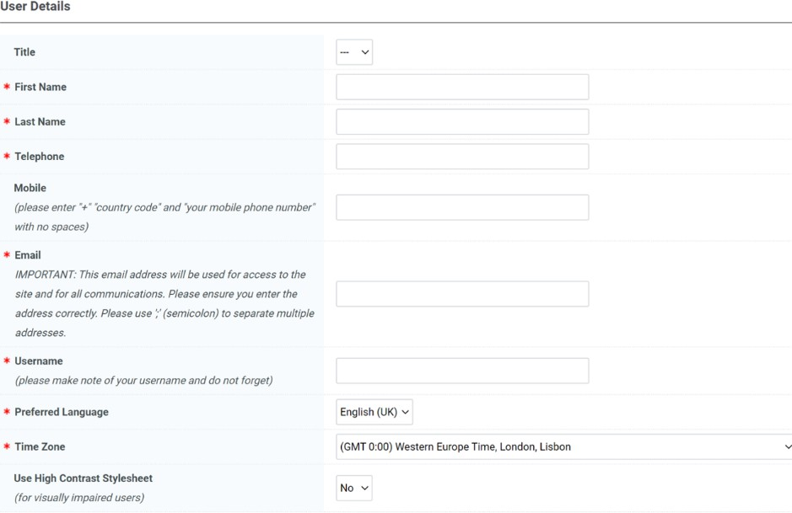

If any mandatory fields have been missed there will be a pop-up message stating the error. Revisit the answers and check for blank answers in the form, then click save when completed.
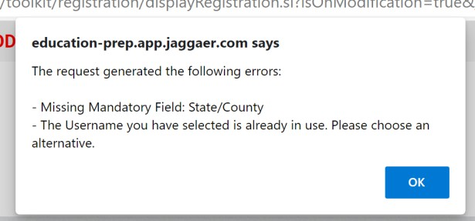

- Basic Profile Forms

There are 3 mandatory questions to answer in the ‘Basic Profile Forms’. Once complete click the ‘Save & Continue’ button.
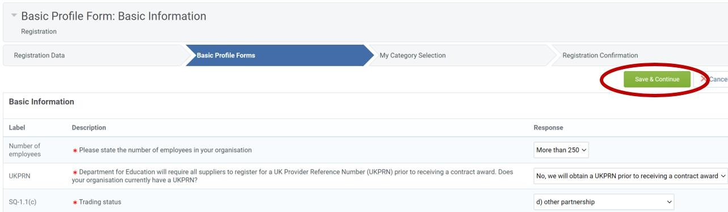

- My Category Selection

You will receive alerts to any open opportunities published by the DfE that align to categories you have selected. Please add categories to your profile that describe the services your organisation delivers.
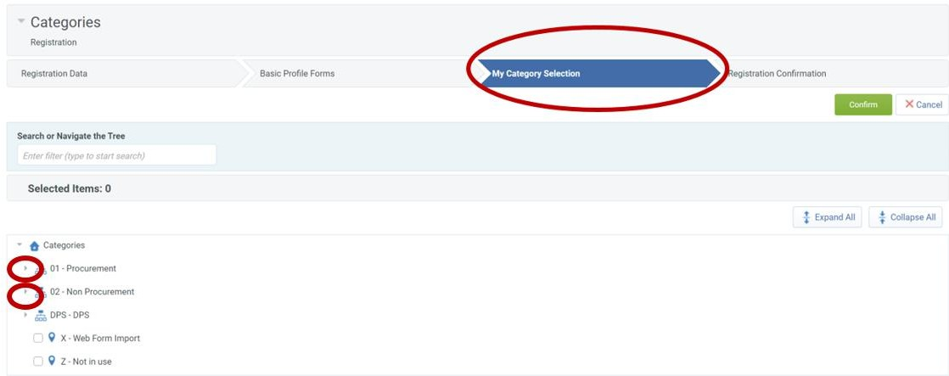

An example of the drop-down menu when opened is shown below:
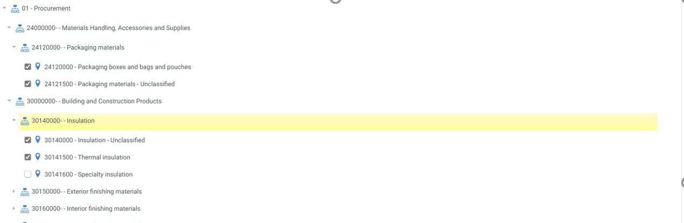

- Registration Complete

Once all the information is complete, the final tab is ‘Registration Confirmation’. You will receive an email with your username and password, which you can use to log into Jaggaer.
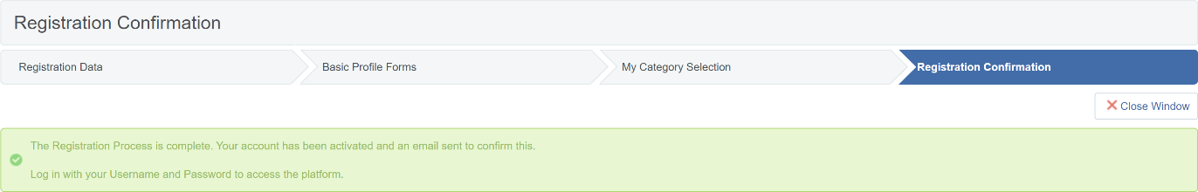

Logging into Jaggaer

Log into Jaggaer

- Navigate to the Jaggaer log in page.

Enter your login details which were provided in an automated email when you have registered
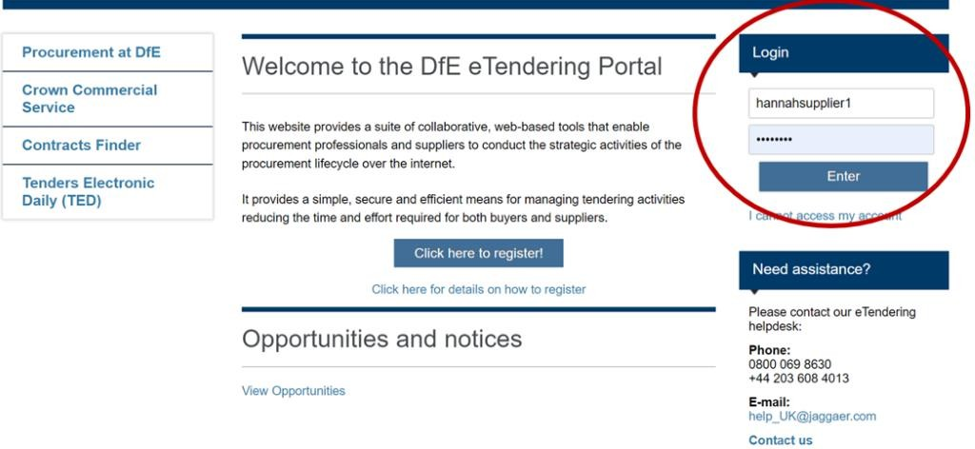

- Read and Accept the User Agreement

Click ‘I agree’ or ‘I do not agree’, then click ‘Next’
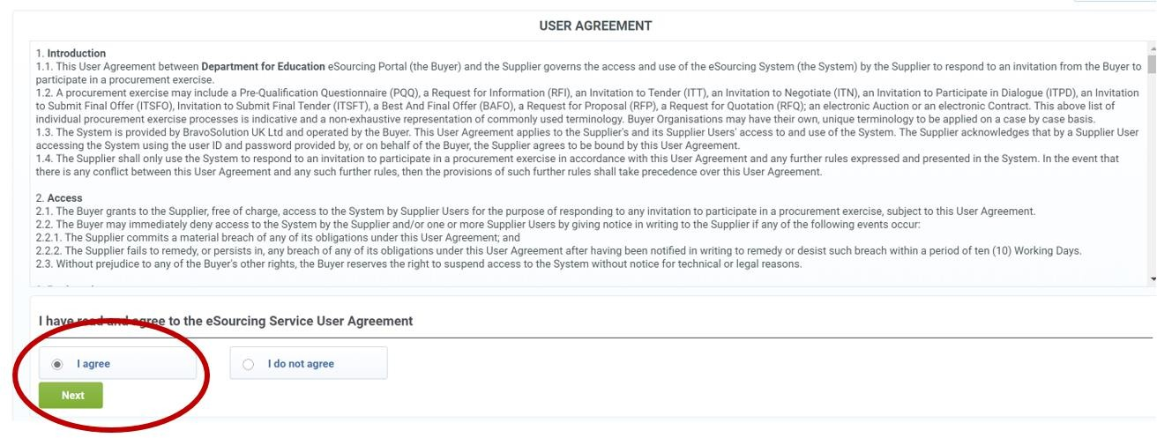

- You will be asked to create a new password for your account

Enter the password you wish to chose twice and click ‘Submit’
