**Bude-Stratton Town Council**

**Provision to design, re-build/re-locate Katy’s Corner Playpark**

**To be submitted no later than 31 May 2023**

**Employer Contract Administrator**

Bude-Stratton Town Council Steve Hayes (FM)

The Parkhouse Centre Bude-Stratton Town Council

Ergue Gaberic Way

Bude

EX23 8LY

1. **General Requirements**
   1. Overview of project

Bude-Stratton Town Council is seeking a suitably qualified company to design and build a new play area to replace the existing play equipment within Katy’s Corner. The current play area will also be re-located to the lower tier of the play park and will complement the newly refurbished play area already in place. The old location of Katy’s corner will be transformed into a family seating area. Estimated size is approx 20mx20m.

Preferred themes for the play park design are as follows, but you are welcome to submit a proposal based on another theme, if you prefer:

* Bude Harbour
* Eco Village
* Train Station/Farm

The location of the site is at Bencoolen Road, Bude, EX23 8PJ.

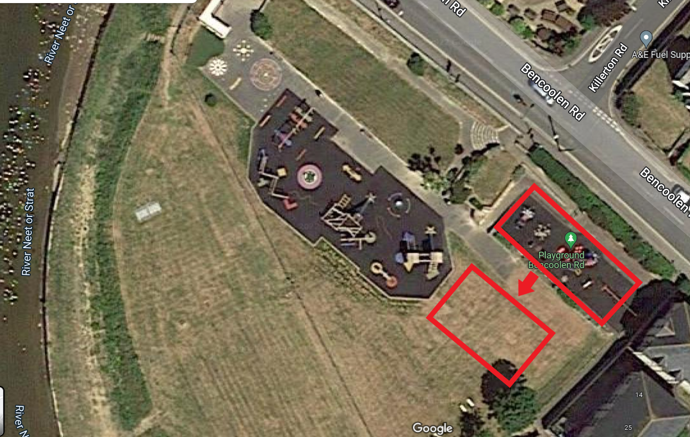

The main Bencoolen playground is a centrally located and well used due to a recent complete redevelopment of the main play area. Due to the age and condition of the equipment and surfacing within Katy’s Corner, BSTC has prioritised funding to completely re-develop Katy’s corner and re-locate the new play park onto the same level as the existing play park.

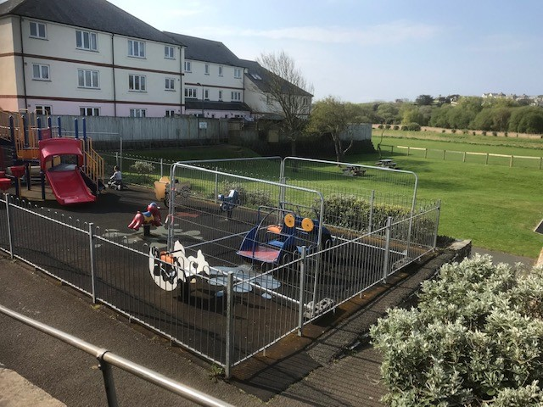

The playground is located next to a main road but has good pedestrian access at 3 main points and a large Cornwall Council owned car park located approximately 100yards away.

The budget allowed is a maximum of £85,000 (Ex VAT). The council may also wish to explore options within that scope and other potential opportunities there may be with joint applications for further grant funding or sponsorship in the area. Companies should provide designs and quotations based on the upper limit; however, the council reserve the right to reduce the allocated budget to a lower limit with a preferred contractor.

* 1. **Prices**

All pricing should be exclusive of VAT and valid for a minimum of 180 days from the due date of the response.

Prices will be fixed and firm for the duration of the contract.

**1.3 Non-Consideration of a Tender Response**

BSTC has the right to refuse any or all submissions without tenderers being able to claim any compensation. All costs associated with the tender process and response is the responsibility of the suppliers that have been invited to participate.

BSTC may refuse a tender response if there has been any attempt to vary or alter the details within the tender document or if the tenderer is not able to provide all the information required by BSTC to make a full evaluation.

Any offence or inappropriate actions by the provider/supplier, including an offence under the Prevention of Corruption Act 1906 (2), or the supplier directly canvasses any member of the council concerning the tender other than “appropriate” contact made to the individuals named within this document for the purposes of clarifying the requirements or raising any questions pertaining to the tender.

1. **Contract Conditions**

The successful contractor will enter into an agreement by way of a purchase order (PO), with BSTC. In addition, a binding contract with agreed terms and conditions will be created for both BSTC and successful contractor to jointly authorise. The agreement will not be final until both parties have signed the contract.

The work is for the design, re-location, supply and installation of playground equipment, surfacing and all associated works which must all comply to European Safety Standards primarily EN1176 and EN1177 (taking into account any revisions).

The successful contractor must provide evidence of Public Liability Insurance of no less the £5 Million and Employers Liability Insurance to BSTC within the tender process.

Confirmation of works hours, storage of materials, access/egress, location of skips (if any), and a final programme of works including RAMS will need to be finalised and provided to BSTC before work begins, most likely at the “pre-start” meeting, along with a detailed **Construction Phase Plan.**

1. **Overview Of Requirements**
   1. **Area**

Katy’s Corner will include:

* Removal and disposal of existing play equipment (unless it is possible to relocate to new site)
* New safety surfacing (supplier to provide a number of options) and groundworks required to make good and ensure regulations are met over the entire area
* Pre-Cast Concrete (PCC) edging or alternative options that the supplier may offer or recommend
* New play park equipment suitable for 0-6 years of age with a selection of themes to compliment the surface colours and markings
* Consideration of the play assessment table
* No seating or bins required
* No fencing is required
* A selection of disabled playpark equipment

The materials used will be scored largely on the quality of the material, along with the aesthetic look and feel that is suitable for the desired outcome, local area and play park already in situ. This will be calculated by using the matrix **(Appendix 1- Assessment).**

The council will consider all types of materials that can be used as the primary material of the structures and equipment although the most environmentally friendly material would be the council’s first choice.

* 1. **Surfacing**

The choice of surfacing for both new play park and family seating area will be recommended by the supplier, the use of coloured wet pour would be encouraged to create an inviting and unique experience, whilst still providing a good level of longevity in terms of location, maintenance and potential vandalism. The current play park has experienced vandalism in the past, mainly on the wet pour areas by means of cutting strips out near to the edges where it is most likely to shrink. Grass Crete may also be considered for the new family area.

* 1. **Removals**

All existing equipment and flooringare to be removed. However, if the supplier feels that any existing equipment from Katy’s corner could be utilised within the new play park and still meets the safety regulations, this could be set aside for future use. All seating and fencing are to remain at the old Katy’s corner site for use with the family seating area.

**3.4 Value Add**

The Council will be open to any additional value-added options within the proposal such as (but not limited to) which may be scored as part of the **discretionary 10%**

* Open day Event support and giveaways
* Aftercare service (outside of any standard warranty inclusions

**3.5 Post Installation Inspection**

Please allow for a RPII qualified inspection following completion of the project and any noted defects or medium to high-risk reports that need to be attended to and resolved before the open date noted on the table below.

1. **Additional Requirements**

The remaining area from Katy’s corner will require new flooring which is yet to be decided. The main use of this area will become a family seating area which may require shade and cover from the elements due to the openness of the play park.

**5. Consultation**

It is likely that the council will undertake a public consultation to show either submissions or the preferred design once selected.

The details of the format and date is to be finalised; however, this is primarily to receive public feedback on the design and any common trend in terms of conditions or revisions that need to be made before construction.

**6. Timetable for project**

|  |  |
| --- | --- |
| **Action** | **Expected Date** |
| Tender Release Date | **25 April 23** |
| Site meeting for interested contractors | **TBC** |
| Tender Response Due | **31 May 23** |
| Shortlisting and user group consultation | **1 Jun 23 – 19 Jul 23** |
| Selection of Preferred Supplier and any revisions to design | **21 Jul 23** |
| Order placed with supplier | **TBC** |
| Works commence date | **Oct 23** |
| Works completion date | **Dec 23** |
| Snagging, inspections and open to general public | **Jan 24** |

**Suppliers are to provide details of expected lead in times to start work from the time the purchase order is received and expected duration of the build.**

**7. General Quality and Method of Works**

**Levels of skill required:**

Appointed suppliers must ensure all workers are appropriately skilled and experienced for the type and quality of works.

The contractor shall inspect all components and materials carefully before using and reject and report any that are defective.

**Supervision**

In addition to the constant management and supervision of the works provided by the contractor in charge, all significant types of works must be under the close control of a competent person or supervisor to ensure the satisfactory quality and progress of the works alongside the external project manager (FM) who will meet with the contractor at the pre-start and weekly during construction.

**Repairs**

The contractor shall make good any damages as a consequence of carrying out works described within this tender.

In this respect any making good shall therefore be deemed to be included in each clause.

**Noise and Pollution**

The contractor shall take all necessary precautions to prevent nuisance from smoke, dust, rubbish and all other causes including excessive noise to the general public.

**Site Security and Safety**

The employer (BSTC) expects this site to be safe and requires appropriate safety wear to be worn as identified in the contractor’s risk assessments. The contractor shall comply in all respects with the requirements and intent of the Health & Safety at Work Act 1974 etc.

and the Construction Health, Safety and Welfare Regulations 1996 (CHSW 96) and associated current legislation, good practice as well as local rules (if they apply).

The contractor is to provide all Risk assessments, Method statements and/or RAMS before commencing any works to the Facilities Manager (BSTC). The contractor’s method of works must also comply to the CDM 2015 regulations.

The Facilities Manager acting on behalf of BSTC as Health and Safety Officer reserves the absolute right to suspend any works at site should any continuing breaches of Health and Safety be observed or take place. Such closure will be at no cost to BSTC and no extension of timings be entertained. This will include breaches and incidents noted by the FM or advised to by BSTC.

**Lighting and Power**

The contractor shall make their own arrangements for light and power as and when required.

**Small Plant and Equipment**

The contractor shall provide all tools, plant and equipment necessary for the safe and correct execution of works required.

**8. Scoring of Tender (scoring Table in conjunction with Appendix 1)**

|  |  |  |
| --- | --- | --- |
| **Criteria** | **Information** | **Percentage** |
| Play Assessment | Referring to the scoring matrix, scoring will be made according to the play values of the design. This is to be provided by the supplier; however, BSTC and the FM will examine the responses and verify the scoring | 30% |
| Play Design | Using the relevant section in **Appendix 1**, detail the rationale and design approach. Additionally, BSTC Councillors (in consultation with local user groups) and FM will score on the layout flow, practicality and how it may encourage children to use the space and equipment and also challenge themselves. | 30% |
| Materials | With reference to the details in **Appendix 1** under “Materials” this will be used as a guide to score on the materials used. This will be aesthetically, longevity and eco-friendly, based on the scoring provided as a percentage of materials used throughout the new play area. | 20% |
| Presentation and Information | Suppliers are encouraged to provide a 3D visual (not to include adults or children) and a CAD of the area. Any supporting information specifically to answer any requirements set out in the tender, or that is relevant to the scoring or experience of the contractor | 10% |
| Discretionary | This is to allow any additional consideration and for scoring aspects such as value-added inclusions, warranties, or information within a tender not requested but is a clear benefit to BSTC and community. This element will be subjective and dependant on the view of BSTC councillors and the FM | 10% |

**Scoring Guide**

|  |  |  |
| --- | --- | --- |
| 8-10 | Superior | Exceptional demonstration of the relevant ability, understanding, experience, skills, resources and quality measures required to meet the projects aims or requirements. Response highly relevant with comparable contract value |
| 6-8 | Good | A comprehensive response submitted in detail and relevance and clearly meets the most of the projected aims or requirement with no or little negative indications or inconsistencies |
| 4-6 | Adequate | Reasonable achievement of the requirements specified within the tender offer. Some errors, risks or weaknesses or omissions which can be corrected/overcome with minimum effort. |
| 2-4 | Below Expectations | Minimal achievement of the requirements specified in the tender offer and presentation for that criterion. Several  errors, risks, weaknesses or omissions which  are possible bur difficult to correct or overcome. |
| 0-2 | Poor to deficient | Limited response provided, or a response that is inadequate, irrelevant, inaccurate, misleading and does not achieve the basic requirements or specification of the tender |

**8. Site Meeting and Questions by Suppliers**

There will be a site meeting to give all suppliers the opportunity to meet with the Facilities Manager and Councillor(s) in 30-minute slots to clarify any questions.

However, this is not mandatory and suppliers are welcome to visit the site at their own convenience without penalty.

**9. Project Lead**

The Facilities Manager for Bude-Stratton Town Council has been appointed to co-ordinate with regards to both the tender process and project management of the new playground.

**Bude-Stratton Town Council (FM)**

Steve Hayes

07442337714

[shayes@bude-stratton.gov.uk](mailto:shayes@bude-stratton.gov.uk)

**10. Format and Response**

The tender response should be in a hard copy (including a copy of Appendix 1 and Appendix 2) as per below with design visuals being in A1 size or as close to A1 as possible. Quotations and supplementing information can be in A4 and if possible, a copy via USB delivered using the details below. An email copy should be sent to Steve Hayes using the email address above.

Tenders are to be returned in a plain white envelope marked only with:

Tender-Katy’s Corner Play Park and Ancillary Works

Bude-Stratton Town Council

The Parkhouse Centre

Ergue-Gaberic Way

Bude

EX23 8LG