Framework Schedule 6 (Order Form Template and Call-Off Schedules)

Order Form

CALL-OFF REFERENCE: HVE Zerto License, Support and Implementation Services

THE BUYER: Home Office, Hendon Data Centre,

BUYER ADDRESS 1 Peel Square, Aerodrome Road,
London NW9 5JE

THE SUPPLIER: MTI Technology Limited
SUPPLIER ADDRESS: Saltire Court, 20 Castle Terrace, Edinburgh, EH1 2EG
REGISTRATION NUMBER: SC112019
DUNS NUMBER: [Insert if known]
SID4GOV ID: [Insert if known]

APPLICABLE FRAMEWORK CONTRACT

This Order Form is for the provision of the Call-Off Deliverables and dated 19/02/2021.
It’s issued under the Framework Contract with the reference number RM6068 for the provision of Technology Products and Associated Services.

CALL-OFF LOT(S):

- Lot 3 Software & Associated Services

CALL-OFF INCORPORATED TERMS

The following documents are incorporated into this Call-Off Contract. Where numbers are missing we are not using those schedules. If the documents conflict, the following order of precedence applies:
- This Order Form including the Call-Off Special Terms and Call-Off Special Schedules.
- Joint Schedule 1(Definitions and Interpretation) RM6068
- The following Schedules in equal order of precedence:

- Joint Schedules for RM6068
  - Joint Schedule 2 (Variation Form)
  - Joint Schedule 3 (Insurance Requirements)
  - Joint Schedule 4 (Commercially Sensitive Information)
  - Joint Schedule 11 (Processing Data)

- Call-Off Schedules for HVE Zerto License, Support and Implementation Services
  - Call-Off Schedule 6 (ICT Services)
  - Call-Off Schedule 8 (Business Continuity & Disaster Recovery) Part B
  - Call-Off Schedule 11 (Installation Works)

- CCS Core Terms (version 3.0.6)
- Joint Schedule 5 (Corporate Social Responsibility) RM6068
- Annexes A to E Call-Off Schedule 6 (ICT Services)

No other Supplier terms are part of the Call-Off Contract. That includes any terms written on the back of, added to this Order Form, or presented at the time of delivery.

CALL-OFF SPECIAL TERMS
None

CALL-OFF START DATE: 10/03/2021

CALL-OFF EXPIRY DATE: 09/03/2024

CALL-OFF INITIAL PERIOD: Three Years (36 Months)

CALL-OFF OPTIONAL EXTENSION One Year (12 Months)
PERIOD

CALL-OFF DELIVERABLES

INTRODUCTION AND BACKGROUND TO THE AUTHORITY

Hendon Data Centre (HDC) Operations, part of the Home Office (HO), are inviting bids for the procurement of Zerto licenses, premium support and implementation and configuration support.

OVERVIEW of requirement

The Authority is seeking Zerto licenses for DR and journaling capability to protect production virtual machines on a multi-tenanted virtual environment.

Licenses should cover 100 production VMs in the first instance but the Authority may need to increase this number over time.

Premium support is required as well as implementation and configuration support.

SPECIFICATION
- The Authority requires the following option below – 100 VM license, 3 years support and the Zerto Quick Start Service

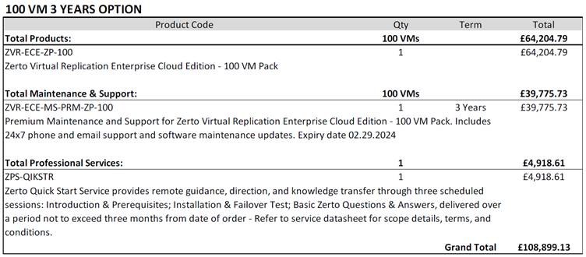

- Within the contract period we will want to be able to increase the number of VM licenses as described below:

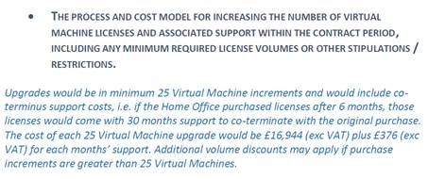
- At this point the Authority does not need the Zerto Expert Advisory Service but we would like the option to be able to call off this requirement at a later date if required. The Authority will use the Contract Variation process to do this, using Joint Schedule 2 – Variation Form, and based on receiving a quote acceptable to the Authority from MTI Technology Limited for this requirement at the appropriate time
- The Authority would also like to include the option to extend the Contract by one year (12 months).

LOCATION FOR DELIVERY
Hendon Data Centre
1 Peel Square
Aerodrome Road
London
NW9 5JE

DATES FOR DELIVERY OF THE DELIVERABLES
10/03/2021

TESTING OF DELIVERABLES
None

WARRANTY PERIOD
The warranty period for the purposes of Clause 3.1.2 of the Core Terms shall be 90 days

MAXIMUM LIABILITY
The limitation of liability for this Call-Off Contract is stated in Clause 11.2 of the Core Terms.

The Estimated Year 1 Charges used to calculate liability in the first Contract Year is £108,899.13 Excluding VAT

CALL-OFF CHARGES
£108,899.13 Excluding VAT to be invoiced upon signature of the Order Form

The Charges will not be impacted by any change to the Framework Prices. The Charges can only be changed by agreement in writing between the Buyer and the Supplier because of a Specific Change in Law or Benchmarking using Call-Off Schedule 16 (Benchmarking) where this is used.

REIMBURSABLE EXPENSES
None

PAYMENT METHOD
Method of payment: BACS

Before payment can be considered, each invoice MUST state a valid PO a number as issued by the Authority.

Invoice should include a detailed elemental breakdown of work completed and the associated costs.

Payment will be made 30 days following receipt of a correctly submitted invoice. The Authority will raise a purchase order on award of the contract.

BUYER’S INVOICE ADDRESS:
Home Office Shared Service Centre
HO Box 5015
Newport
Gwent NP20 9BB

BUYER’S AUTHORISED REPRESENTATIVE
Steve Butler
Commercial Manager
stephencharles.butler1@homeoffice.gov.uk
Home Office Commercial Directorate
Southern House
Wellesley Grove
Croydon CR0 1XG

SUPPLIER’S AUTHORISED REPRESENTATIVE

SUPPLIER’S CONTRACT MANAGER

KEY STAFF
Not applicable

KEY SUBCONTRACTOR(S)
Not applicable

COMMERCIALLY SENSITIVE INFORMATION
Not applicable

SERVICE CREDITS
Not applicable

ADDITIONAL INSURANCES
Not applicable

GUARANTEE
Not applicable

SOCIAL VALUE COMMITMENT
Not applicable
For and on behalf of the Supplier: |  | For and on behalf of the Buyer:
Signature: |  | Signature:
Name: |  | Name: | Steve Butler
Role: |  | Role: | Commercial Manager
Date: |  | Date: | 26/02/2021

Call-Off Schedule 20 (Call-Off Specification)
This Schedule sets out the characteristics of the Deliverables that the Supplier will be required to make to the Buyers under this Call-Off Contract

INTRODUCTION AND BACKGROUND TO THE AUTHORITY

Hendon Data Centre (HDC) Operations, part of the Home Office (HO), are inviting bids for the procurement of Zerto licenses, premium support and implementation and configuration support.

OVERVIEW of requirement

The Authority is seeking Zerto licenses for DR and journaling capability to protect production virtual machines on a multi-tenanted virtual environment.

Licenses should cover 100 production VMs in the first instance but the Authority may need to increase this number over time.

Premium support is required as well as implementation and configuration support.

SPECIFICATION
- The Authority requires the following option below – 100 VM license, 3 years support and the Zerto Quick Start Service

- Within the contract period we will want to be able to increase the number of VM licenses as described below:
- At this point the Authority does not need the Zerto Expert Advisory Service but we would like the option to be able to call off this requirement at a later date if required. The Authority will use the Contract Variation process to do this, using Joint Schedule 2 – Variation Form, and based on receiving a quote acceptable to the Authority from MTI Technology Limited for this requirement at the appropriate time
- The Authority would also like to include the option to extend the Contract by one year (12 months).

