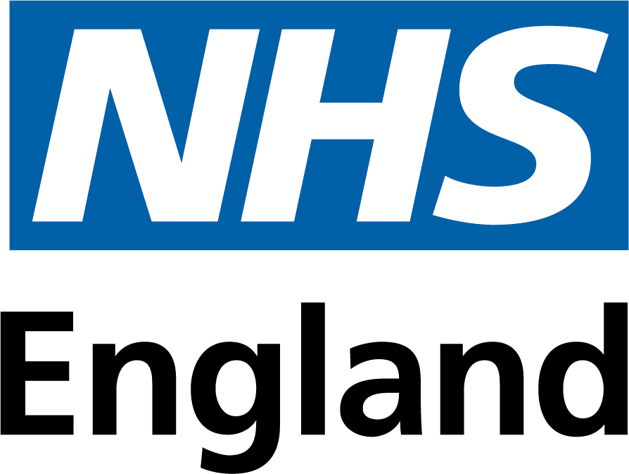
Parties appointed to the framework agreement

The parties selected to participate in the framework agreement are:
Abbvie Ltd
Accord-UK Ltd
Alissa Healthcare Research Limited
Aspen Pharmacare UK Limited
Aspire Pharma Limited
Astellas Pharma Ltd
Aventis Pharma Ltd t/a Sanofi
Baxter Healthcare Ltd
Bayer PLC
Besins Healthcare UK Ltd
BioCryst Ireland Limited
Celix Pharma Ltd
Chiesi Limited
Colonis Pharma Ltd
CSL Behring UK Ltd
CST Pharma Limited
Day Lewis Medical Ltd
Dexcel Pharma Ltd
Drugsrus Ltd
Eisai Ltd
Essential Pharma
Esteve Pharmaceuticals Ltd
Ferring Pharmaceuticals Ltd
Flynn Pharma Ltd
G.L-2. Pharma UK Limited
Galen Limited
Gedeon Richter UK Ltd
Glenmark Pharmaceuticals Europe Limited
Grunenthal Ltd
IBSA Pharma Ltd (Pharmasure)
Infectopharm Ltd
Ispen
Janssen-Cilag Ltd
Kyowa Kirin International UK New Co Ltd (Grunenthal Meds)
Lupin Healthcare (UK) Limited
Medac Pharma LLP
Merck Serono Limited
Mercury Pharmaceuticals Limited
Merz
Morningside Pharmaceuticals
Mylan (Vatris)
Napp Pharmaceuticals Ltd
Neon Healthcare Ltd
Neuraxpharm UK Ltd
Nordic Pharma
Norgine Pharmaceuticals Limited
Novartis Pharmaceuticals UK Ltd
Novo Nordisk
Organon Pharmaceuticals UK Ltd
Orifarm UK
Otsuka Pharmaceuticals UK Limited
Pfizer Ltd
Pharming Group
Provepharm UK Ltd
Qdem Pharmaceuticals Limited (Napp Pharmaceuticals Ltd)
Rayner Surgical Group Ltd
Recordati Rare Diseases UK Ltd
Ridge Pharma
Rovi Biotech Ltd
Sandoz Ltd
Selective Supplies Ltd
SERB SA
Strandhaven Ltd t/a Somex Pharma
Sun Pharma UK Ltd
Synchrony Pharma Ltd
Takeda UK Ltd
Teva UK Limited
Theramex HQ UK
Thornton and Ross Ltd
Tillomed Laboratories Ltd
Wockhardt UK Limited
Xiromed
Zentiva Pharma UK Ltd

