Slade Brook Reservoir
Seepage Repairs
Project: | Slade Brook Reservoir
Our reference: | 100381628QA | Your reference:
Prepared by: | A Kirby | Date: | 10th June 2022
Approved by: | A Kirby | Checked by: | J Pawson
Subject: | Scope of works

Scope of works
This note describes the scope of works for proposed remedial works to seal seepage at structures on the dam impounding Slade Brook Reservoir.

Background
Slade Brook reservoir is an impounding reservoir on the Slade Brook situated in the south-western outskirts of Kettering. It is located off a residential road, Thurston Drive and is bounded to the west by the A14. The National Grid Reference of the reservoir is SP 864 770. Its area is about 6ha and its volume about 110,000m³. It’s purpose is for flood attenuation and it is currently used for amenity.
Figure 1.1: General view from downstream
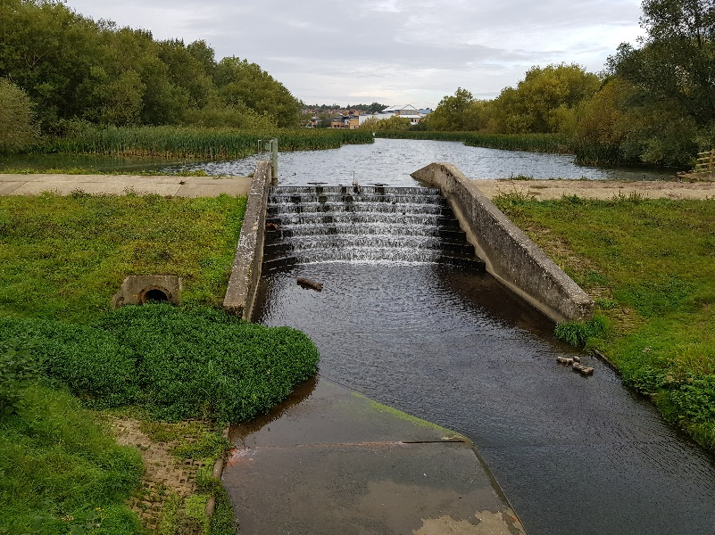
Source: 10/12/21
The dam is an earthen embankment about 2.5m in height. It has a central stepped concrete spillway to pass normal flows. In a flood, the water level in the reservoir rises to the crest of the dam and overtops the sections of the embankment on both sides of the central spillway. These sections are protected with concrete slabs on the crest and articulated concrete blocks on the downstream slope to prevent erosion.
A bottom outlet or scour is provided by a 600mm diameter concrete pipe culvert controlled by a penstock in the dam crest on the right hand side. There is a wet chamber upstream of the penstock.

Issues to be repaired
Seepage has been noted at three locations:
- At the downstream headwall of the bottom outlet culvert
Figure 1.2: Downstream headwall of bottom outlet culvert
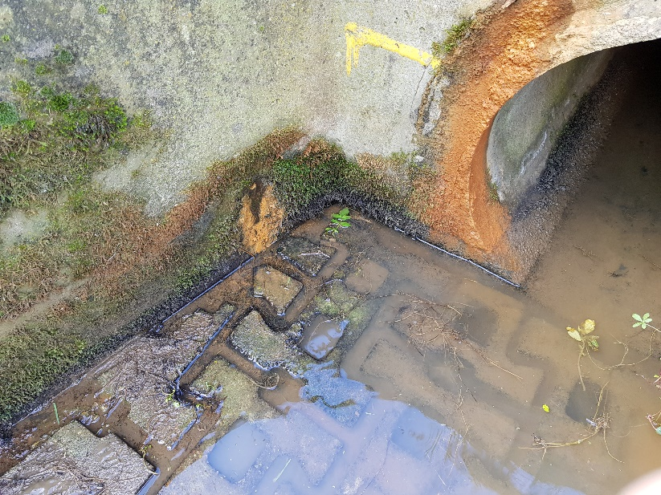
Source: 06/10/2020
Seepage is exiting from drainage holes in the side walls and from the pipe annulus. The most likely cause of the seepage is considered to be damage at the joint between the downstream pipe leg and the penstock chamber. However there is the possibility that more general seepage is occurring at the interface between the chamber/pipe and the surrounding earthfill.
Figure 1.3: Penstock chamber | Figure 1.4: Failed grout between penstock frame and pipe
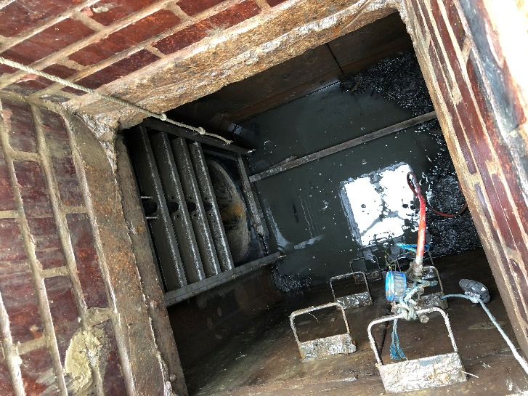 | 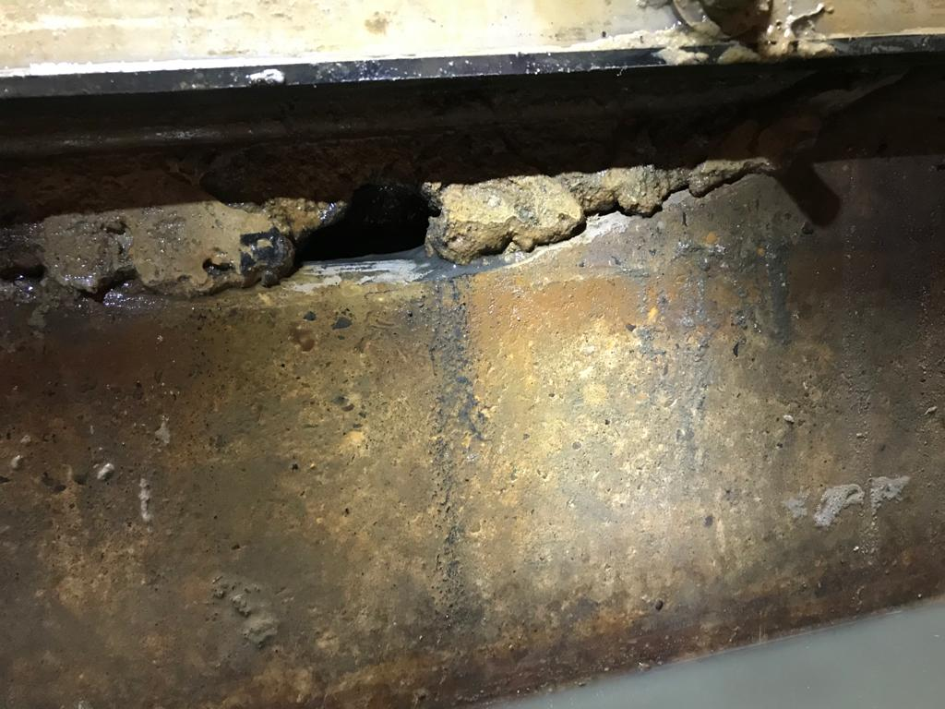
Source: NNC | Source: NNC
- And 3. Adjacent to both the spillway sidewalls
Seepage is noted exiting from the downstream face of the embankment at the interface between the embankment and the spillway sidewalls.
Figure 1.5: Seepage at toe of right hand spillway side wall | Figure 1.6: Seepage at toe of left hand spillway side wall
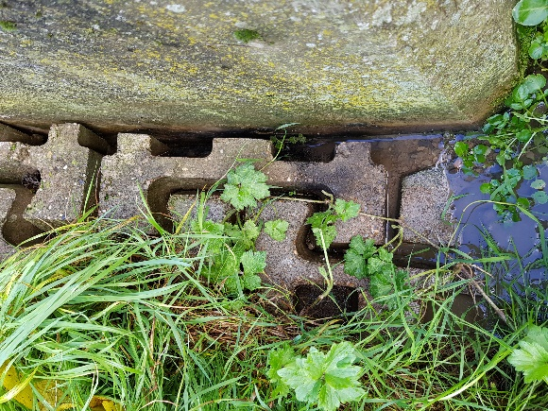 | 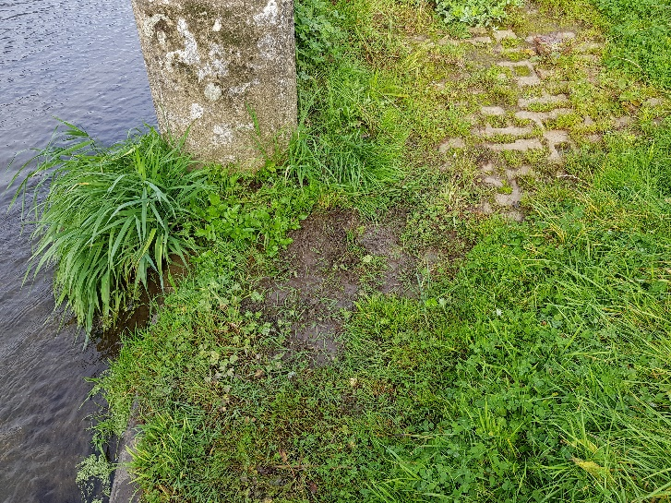
Source: 06/10/20 | Source: 12/10/21
It is likely that minor differential movement between the spillway and embankment has opened up small seepage paths. These appear to start at no deeper than 0.5-1.0m below crest level which suggests the seepage may be due to movement between the concrete crest slab and the spillway sidewalls. The Contractor should assume seepage does not occur deeper than 3.0m below crest level.
Penstock sealing
In addition to the seepage the penstock gate frame is letting water past into the downstream leg of the concrete pipe. This appears to be due to the damaged grout as shown in the figure above.
It is envisaged that the works to repair these issues will be a mix of specialist concrete repairs and polyurethane grouting.

Existing drawings
Existing drawings of the original dam construction are not available. Information gained during works to the crest in 2008 and replacement of the penstock in 2020 are shown in drawings:
Location Plan
Site Plan
231469/001 Slade Brook Reservoir Crest Repair Works
Gate Valve Technical Layout.

Control of water levels
Works shall be carried out without lowering water levels within the reservoir because flows need to be maintained in the downstream watercourse.
The Contractor should note that inflows into the reservoir will raise water level particularly after heavy rainfall and may in floods overtop the whole dam. Water levels can only be lowered below the spillway weir using the bottom outlet penstock, unless over-pumping is carried out.
The Contractor shall be responsible for managing water levels within the penstock chamber to suit his method of work. The Contractor shall make himself aware of weather forecasts and reservoir water levels during the progress of his works and to protect the works, his equipment and materials from damage due to floods.
The penstock chamber is a wet chamber with a pipe inlet in the reservoir. Based on historical information the pipe inlet is understood to be approximately 9.5m upstream of the crest and at a level of 1.6m below the level of the main weir. There is no fixed method of isolating the chamber from the reservoir. NNC have purchased a pipe bung which has been used to de-water the chamber in 2020 by installing the bung from the chamber into the upstream pipe leg. At the request of the Contractor, NNC will make the pipe bung available for use on a no-liability basis. The Contractor should satisfy himself of the suitability of the bung for dewatering the chamber or propose his own alternative. There is a stoplog frame on the upstream side of the chamber that may facilitate secondary isolation of the chamber but its condition and details of its dimensions are not known.

Figure 1.7: Inlet to penstock chamber showing stoplog frame
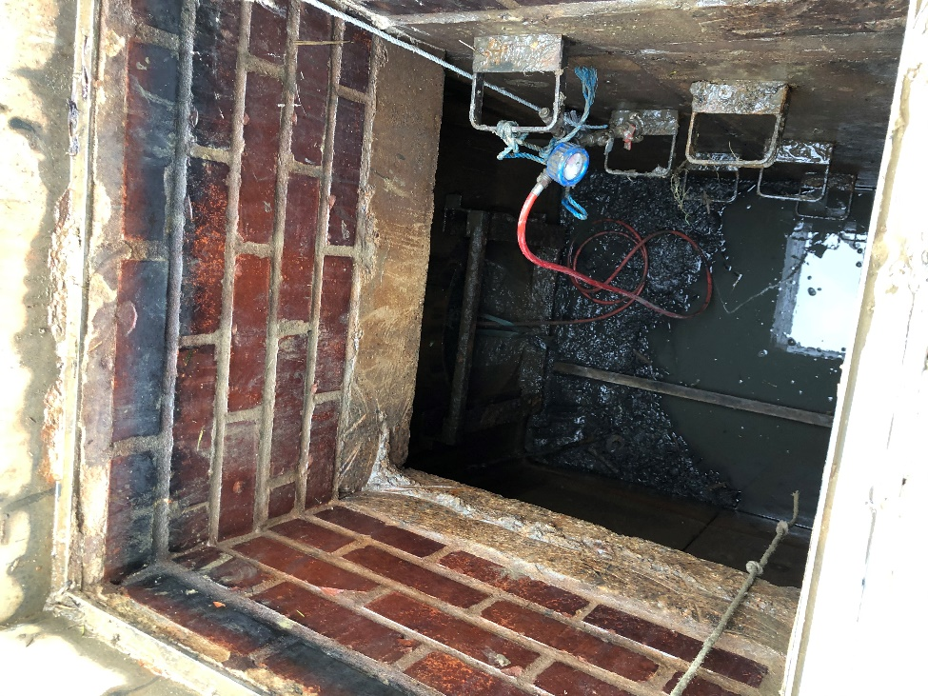
Source: NNC

Reservoirs Act
The reservoir is considered to be a large raised reservoir and as such falls under the ambit of the Reservoirs Act 1975. The safety of the impounding structure at all times is therefore critical.
Under the Reservoirs Act 1975 a Qualified Civil Engineer who is on the All Reservoirs Panel of Engineers is appointed to oversee any works that could affect the safety of the reservoir. These works will fall within that definition and NNC have appointed Mr Andrew Kirby as the QCE.
The Contractor’s proposed method of work, temporary works, plant and materials proposed shall be submitted to the QCE for his review and no objection at least 48 hours prior to each work activity. The QCE shall be invited to inspect all stages of works and prior to the covering up of any surfaces or works or re-flooding of the penstock chamber.

Activities to be carried out by the Contractor
It is envisaged that the following activities will be required to carry out the remedial works. The Contractor shall be responsible for his method of working and may propose alternatives to the activities outlined below to achieve successful completion of the remedial works.
Sealing seepage
Stage 1
- Isolate the penstock chamber from the reservoir and dewater it
- Take off the penstock gate and frame
- Break out the damaged grout
- Inspect the chamber pipe joint for signs of damage
- Seal joint with epoxy concrete repair and injection grouting
- Re-seat the gate and its frame to seal against the chamber wall
- Re-flood the chamber by over-pumping
- Monitor seepage for 7 calendar days from downstream headwall to check seepage sealed
Stage 2
- Injection grouting from the crest at each spillway side wall to seal the interface between wall and crest.
Stage 3 – provisional - if Stage 1 has not been successful in sealing the leak at the culvert, and following discussion with QCE:
- Re-isolate the penstock chamber from the reservoir and dewater it
- Injection grouting from the crest and/or within the penstock chamber to seal around the external perimeter of the chamber
It is envisaged that the injection grouting will be polyurethane grouting under low pressure. The layout, depth, spacing, orientation, materials and pressure of the injection grouting shall be designed by the Contractor to suit his equipment and the nature of the seepage (contact erosion along outer concrete faces. Grouting shall only be carried out by specialists in small-scale grouting of this nature. Details of the proposed grouting methods, equipment and materials shall be submitted to the QCE for no objection.
Concrete repairs
Localised concrete repairs are required at the following locations:
Location 1: Location 2:
Top of the right hand spillway crest Right hand spillway wall
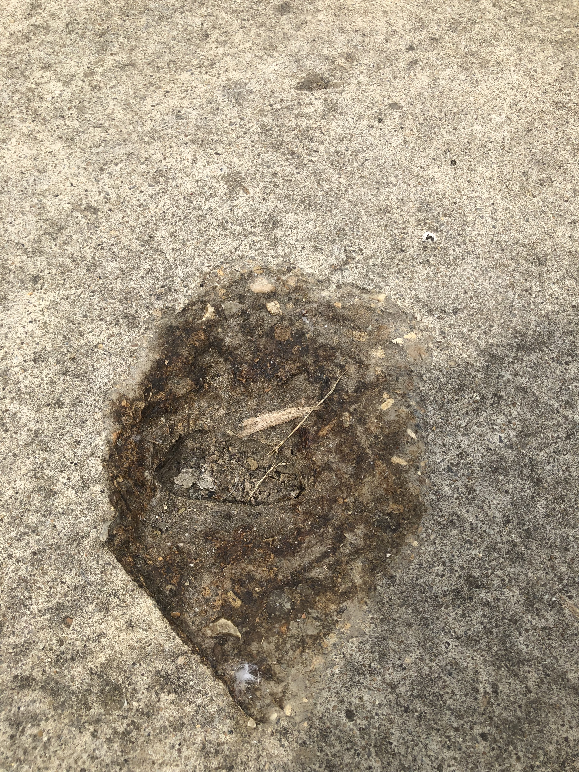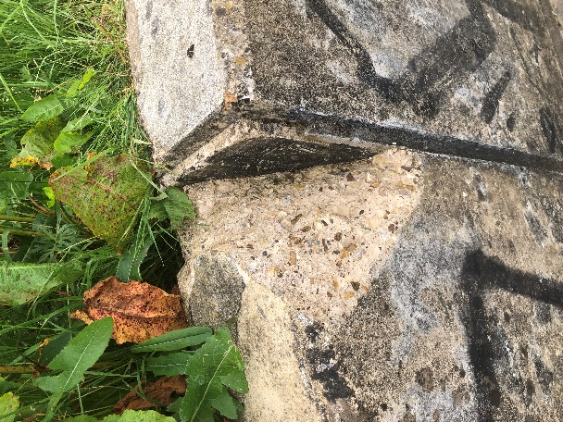

Activities to be carried out by the Contractor
The contractor will be allocated an area approximately 10x10m off Thurston Drive to be used as a site compound. This area shall be secured with HERAS fence panels at all times and made good upon completion of the works. The contractor is expected to make provision for their own welfare facilities and keep noise and disruption during the works to a minimum. Working hours shall be 08:00 – 16:30.
Contractor must ensure the public footpath and access to the Golf Club is not restricted during works.

