Crown Commercial Service

____________________________________________

Call-Off Order Form for RM6187 Management Consultancy Framework Three (MCF3)

_____________________________________________

CALL OFF ORDER FORM FOR MANAGEMENT
CONSULTANCY SERVICES
FOR
RCD3051 PROVISION OF CONSULTANCY SERVICES IN SUPPORT OF LONDON UNDERGROUND DRIVERLESS TRAINS BUSINESS CASE DEVELOPMENT
CONTRACT REFERENCE: CCCC21B14

CONTRACT FOR
DEPARTMENT FOR TRANSPORT

Framework Schedule 6 (Order Form and Call-Off Schedules)

Order Form

Call-off reference: CCCC21B14

The buyer: Department for Transport

Buyer address: Department for Transport, Great Minster House, 33 Horseferry Road, London, SW1P 4DP

The supplier: Turner & Townsend Project Management Limited,
Supplier address: One New Change, London, EC4M 9AF
Registration number:
DUNS number: REDACTED

Applicable framework contract

This Order Form is for the provision of the Call-Off Deliverables and dated:

29 December 2021

It is issued under the Framework Contract with the reference number RM6187 for the provision of management consultancy services.

Call-off lot: Lot 1 Business

Call-off incorporated terms
The following documents are incorporated into this Call-Off Contract.
Where schedules are missing, those schedules are not part of the agreement and cannot be used. If the documents conflict, the following order of precedence applies:

- This Order Form including the Call-Off Special Terms and Call-Off Special Schedules.
- Joint Schedule 1(Definitions and Interpretation) RM6187
- The following Schedules in equal order of precedence:

Joint Schedules for RM6187 Management Consultancy Framework Three
REDACTED

Call-Off Schedules
REDACTED

- CCS Core Terms (version 3.0.7)
- Joint Schedule 5 (Corporate Social Responsibility)
- Call-Off Schedule 4 (Call-Off Tender)

Supplier terms are not part of the Call-Off Contract. That includes any terms written on the back of, added to this Order Form, or presented at the time of delivery.

Call-off special terms

The following Special Terms are incorporated into this Call-Off Contract:

Call-off start date: 10January 2021

Call-off expiry date: 09 May 2023

Call-off deliverables:

Option B: See details in Call-Off Schedule 20 (Call-Off Specification)

Maximum liability

The limitation of liability for this Call-Off Contract is stated in Clause 11.2 of the Core Terms.

The Estimated Year 1 Charges used to calculate liability in the first contract year are:

£2.5m

Call-off charges

See details in Call-Off Schedule 5 (Pricing Details)

All changes to the Charges must use procedures that are equivalent to those in Paragraphs 4, 5 and 6 (if used) in Framework Schedule 3 (Framework Prices)

The Charges will not be impacted by any change to the Framework Prices. The Charges can only be changed by agreement in writing between the Buyer and the Supplier because of:

- Specific Change in Law
- Benchmarking using Call-Off Schedule 16 (Benchmarking)

Reimbursable expenses

Recoverable as stated in Framework Schedule 3 (Framework Prices) paragraph 4

Payment method

Before payment can be considered, each invoice must include a reference to a timesheet including detailed elemental breakdown of work completed and the associated costs.

Payment can only be made following satisfactory delivery of pre-agreed certified products and deliverables, or with the prior consent of DfT.

The Supplier will submit timesheets for approval as part of weekly Contract Management Review meetings. Once approved these will be converted into invoices payable monthly against the purchase order for the project.

Invoices must include the Purchase Order number provided by the Department.

Buyer’s invoice address
REDACTED

Buyer’s authorised representative

REDACTED

Buyer’s security policy

Information is a key asset and its proper use is fundamental to the delivery of public services. Therefore, there is a continuing need to ensure protection of personal and other sensitive information.

The Department takes data security extremely seriously and applies agreed Government security procedures to all Contracts involving the handling of data and ‘Official Sensitive’ and ‘Commercial Sensitive’ information.

The Supplier is required to take adequate steps to ensure suitable protection of, and keep confidential, all information received as part of their Work Package, including, as necessary, limits on access to IT systems and password protections.

Supplier’s authorised representative
REDACTED

Supplier’s contract manager
REDACTED

Progress report frequency

The Supplier will provide weekly progress reports or at such frequency as may reasonably be required by the DfT from time to time (subject to any alternative arrangements being reached). Such reports would be expected to cover the following areas:

progress on business case workstream activities;

look ahead and time frames / milestones for work stream activities;

forecast completion dates for work stream activities;

risks and issues impacting progress;
financial progress, including costs incurred to date, forecast costs to the end of any particular work stream and costs incurred by reference to any agreed budget.

The DfT expects that any such reports and associated meetings will complement, rather than replace, other meetings in the normal course of business at which feedback can be given and planning undertaken.

Progress meeting frequency

Frequency to be agreed at the inception phase of the project

Key staff

REDACTED

Key subcontractor(s)
REDACTED

Commercially sensitive information

To be confirmed

Service credits

Not applicable

Additional insurances

Not applicable

Guarantee

Not applicable

Buyer’s environmental and social value policy

REDACTED

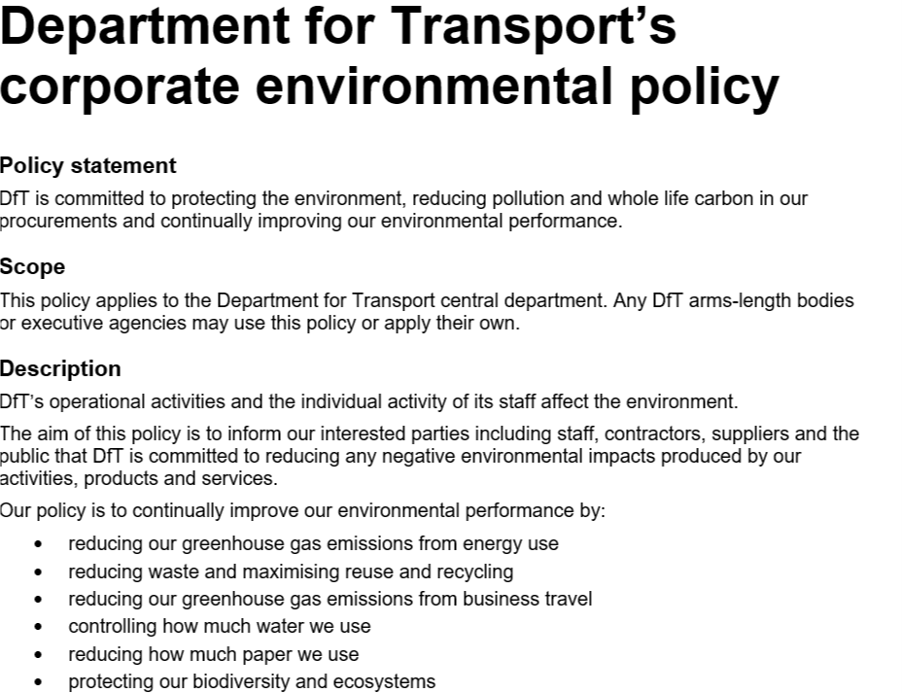
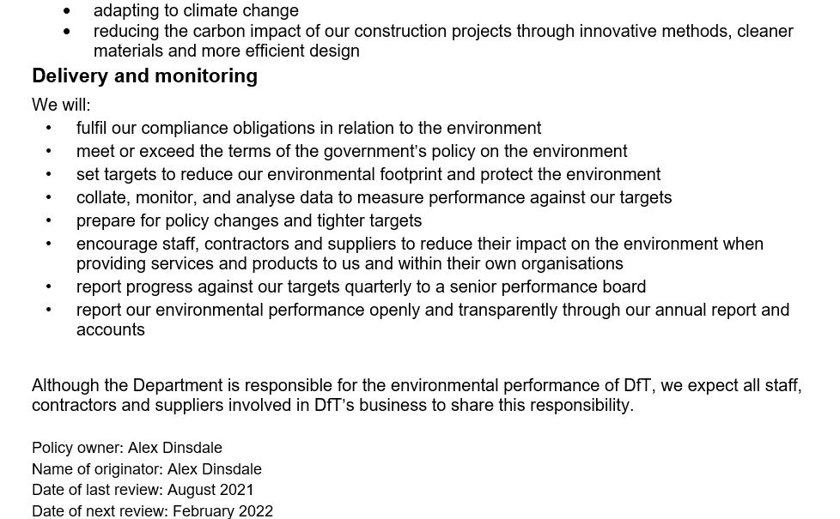

Social value commitment

The Supplier agrees, in providing the Deliverables and performing its obligations under the Call-Off Contract, that it will comply with the social value commitments in Call-Off Schedule 4 (Call-Off Tender)

Formation of call off contract
By signing and returning this Call-Off Order Form the Supplier agrees to enter a Call-Off Contract with the Buyer to provide the Services in accordance with the Call-Off Order Form and the Call-Off Terms.
The Parties hereby acknowledge and agree that they have read the Call-Off Order Form and the Call-Off Terms and by signing below agree to be bound by this Call-Off Contract.
For and on behalf of the Supplier:

REDACTED

For and on behalf of the Buyer:

REDACTED

