Website redesign and consolidation - scope of project

Contents

1. Project Sponsorship 2
2. Introduction 3
3. Project Purpose and Justification 4
4. Scope Description 5
4.b High Level Requirements 5
5. Author 6
6. Appendices 7

Project Sponsorship

Project Sponsor | Role
Denice Currie | Director of Communications
Amit Patel | Director of IT

Introduction

Stonewater is a leading social housing provider, with a mission to deliver good quality, affordable homes to people who need them most. We manage around 33,600 homes in England for over 75,000 customers, including affordable properties for general rent, shared ownership and sale, alongside specialist accommodation such as retirement and supported living schemes for older and vulnerable people, domestic abuse refuges, a dedicated LGBTQ+ Safe Space, and young people’s foyers.

We are driven by our vision of everyone having the opportunity to have a place that they can call home. We plough our surplus into building new homes, improving our existing housing stock and investing in customer services. We achieved a ‘One Star’ rating in the 2019 Best Companies survey and are ranked 78th in the Top 100 best not-for-profit organisations to work for and 25th in the best housing associations to work for in 2019.

Our talented 800+ employees embody our values – being ambitious, passionate, agile, commercial and ethical. For the second consecutive year we achieved a ‘One Star’ rating in the 2020 Best Companies Top 100 best not-for-profit organisations to work for and made the list for the top 25 best housing sector organisations to work for in the UK

With an annual turnover of around £191 million and £1.8 billion in assets, Stonewater is a strong, dynamic and well-managed social business, with a long-term rating of A+ by independent credit ratings agency, S&P Global Ratings and a top G1/V1 governance and viability ranking from the Regulator of Social Housing.

As a result of the coronavirus pandemic, our website and its supporting sites have become more important than ever as a key channel for Stonewater customers and stakeholders. Therefore, an excellent customer journey, overall customer experience and design are vital to ensure the website not only meets but exceeds the expectations of our customers and stakeholders. .

Stonewater are looking to appoint an external supplier to redesign and deliver a new customer-centric corporate website.

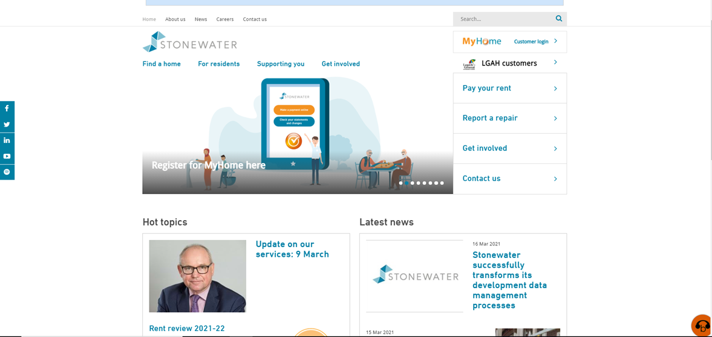

https://www.stonewater.org/

Project Purpose and Justification

The overall aim of the project is to develop a trusted, secure, future-focused website, which puts customers at the heart of what we do. The website will enable Stonewater to provide the best customer journey and user experience, and showcase our brand and values, in line with our customer promise.

A key objective is to encourage an increase in customer use of the corporate website, including self-service portals, and engagement with digital communication. The aim is for this to contribute to a reduction in dependency on traditional contact channels, such as calling the Customer Support Centre, the current first point of contact with Stonewater for many customers.

To achieve this, we are looking to improve the customer experience by providing an engaging and effective website that directs customers to the information and services they need, quickly and easily

At present, the current Stonewater websites are hosted on different platforms including Umbraco and WordPress content management systems (CMS). While we are flexible in our approach to selecting a suitable CMS, our aim is to migrate the website and its sub sites (where possible) onto one platform. Please see appendix A for more details.

Stonewater require a platform that is agile to current, emerging and future technologies and proposed future advancements. The platform will also need to accommodate the expansion of our planned digital offerings, such as Chatbots, interactive eligibility checkers etc.

This change in platform will also enable a redesign of the websites, showcasing our brand and values with a clean and engaging design.

Appendix A provides details of the websites that require redesign, such as Stonewater.org and its sub sites, as well those sites requiring migrating to a single platform.

Scope Description

While a key consideration for the project is to ensure that the look and feel of the website is consistent across all sites, migrating to a single platform

Links and travel between sub sites and the main site need to be as seamless as possible to give the feel of one site and point of information. As shown in Appendix A, there are also a number of 3rd party solutions and sites that will need to be retained and included within the final solution.

Our expectation is for the delivery of the project requirements to be complete by 31^{t} March 2022, therefore the project will need to operate within the limitations of the scope and desired solution.

The chosen supplier will be required to engage with a variety of stakeholders from all areas of the business and we encourage a collaborative approach.

4.b High Level Requirements

- New site must be created on a suitable CMS to allow internal colleagues to carry out content updates and to allow for future enhancements beyond the project
- Provide Stonewater with the ability to easily edit all content on the website avoiding the need for code, including forms
- Provide enhanced search engine optimisation (SEO)
- Enable images to be used in a much more effective way (i.e. size and placement)
- Have clearly defined areas for different user groups e.g. customers, media, other stakeholders
- Include a 'gateway' process for content to be approved before it goes live
- Be able to assign approvers for pages
- Provide audit trail of who has made changes to the website
- Include current sub sites as part of the main site e.g. MyHome, careers portal, Customer hubb
- Supports all media (photos, videos, 360 type tours etc.)
- Comply with or exceed all current accessibility regulations
- Compatible with Browesaloud (accessibility) software
- Must be responsive. Responsive Web Design (RWD)Develop the user journey and deliver an engaging design
- Site will also need to link into other 3rd party web solutions currently used by Stonewater

Author

Author | Julian Vassell
Title | Project Manager
Version | 0.05
Date | 19 March 2021

Appendices

Appendix A

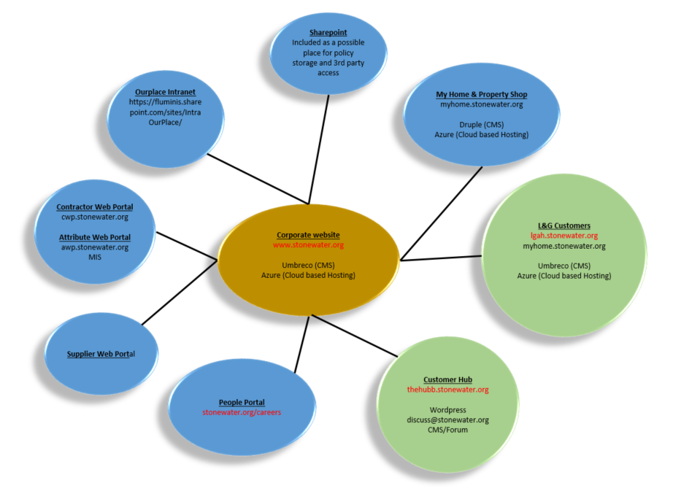

Group | Web Site | Site Type | Information
A | - www.stonewater.org | Main site | Main corporate site to be redesigned
B | - lgah.stonewater.org  - thehub.stonewater.org | Sub sites to be redesigned | Sites to be incorporated as part of redesign
C | - Myhome.stonewater.org  - Cwp.stonewater.org  - mypropertyshop.stonewater.org/ | Sub sites to be linked to only | Sites to be linked to from main corporate site
D | - Stonewater.org/careers | Sub site to be included and links to externally hosted content | Careers area to be included on main corporate site but links to third party sites for additional services. Eg careers portal software.

