4.5.3 SWITCHED LAMPS (CDM-T, CDO, SON/T, CPO, MCF/U, MBF/U)

  - BULK LAMP CLEAN AND CHANGE
The cyclic maintenance of road lighting units shall be carried out in accordance with TD 23/99 of the DMRB, and to the testing frequency stated in GM701-ADAMR.

maintenance requirements

- Bulk lamp clean and change to be carried out every 3 years (GM 701 – PG86)

- 1 - The following tasks shall be undertaken (M&RC-SPEC PG25/26-1300)

  - thorough cleaning of all photo electric control unit’s luminaire external surfaces internal surfaces and any other components affecting the optical performance of the luminaire. The cleaning methods and materials shall be in accordance with Clause 1371AR. The Contractor shall ensure that the internal surfaces and any other components affecting the optical performance of luminaires with an ingress protection rating of IP65 shall not normally be cleaned. Cleaning materials shall not cause harmful effects to the range of materials and surfaces to be cleaned

  - the degreasing lubrication and operation of all toggles wing nuts hinges door locks and any raising and lowering gear

  - correct alignment of the bracket luminaire and luminaire optical equipment with respect to the carriageway

  - tightening of all grub screws locking devices and the like in accordance with the manufacturer’s written instructions

  - a report of any damage or corrosion

  - a report of any electrical component showing signs of overheating fracture condensation ingress of moisture or tracking

  - the removal of the lamp(s) during the luminaire cleaning process. The lamp(s) to be refitted shall be the existing or new as appropriate

  - replacement of lamps either by bulk replacement or individually following burn to extinction. (Bulk replacement required on motorways and dual carriageways with a speed limit in excess of 40 mph.)

  - marking all new lamps indelibly with date of installation

  - identifying faults on any lighting unit which fails to operate or undertaking minor repairs or reporting such failure

  - spraying of all isolated electrical components with a demoisturising spray

  - checking of all electrical connections any Defects shall be recorded

  - checking of all earthing connections any Defects shall be recorded

  - removal of all debris from 1 metre radius of column base or foundation

  - cleaning of the column flange

  - repair of grouting

  - raising and lowering of columns including provision and operation of all necessary specialist equipment and

  - cleaning of all warning and numbering labels

- 2 The electricity supply shall be isolated at the cut-out before lamp removal and fitting and all maintenance Operations. (M&RC-SPEC PG25/26-1300)

- 3 Disposal of lamps shall be in accordance with Clause 1372. (M&RC-SPEC PG25/26-1300)

- 4 All labour employed on electrical or associated Site Operations shall comply with the requirements of Appendix 14/71. (M&RC-SPEC PG25/26-1300)

UNIT / MEASUREMENT / ITEMISATION

- Bulk clean, clean translucent surfaces, bulk clean and change 594 number. (MOM Schd. B Issue 7 PG19)

- The measurement of bulk clean, clean translucent surfaces, bulk lamp clean and change shall be the number of lamps within which the item is carried out. (MOM Schd. B Issue 7 PG19)

- Separate items shall be provided for cleaning and changing of lighting lamps, electrical testing of network cabling and electrical components including feeder pillars and structural testing of lighting columns (<20m in height) in accordance with Chapter II paragraphs 3 and 4 and the following:

Group Feature
I 1 Sub-Asset Type.
II 1 Item.
(MOM Schd. B Issue 7 PG20)

additional information
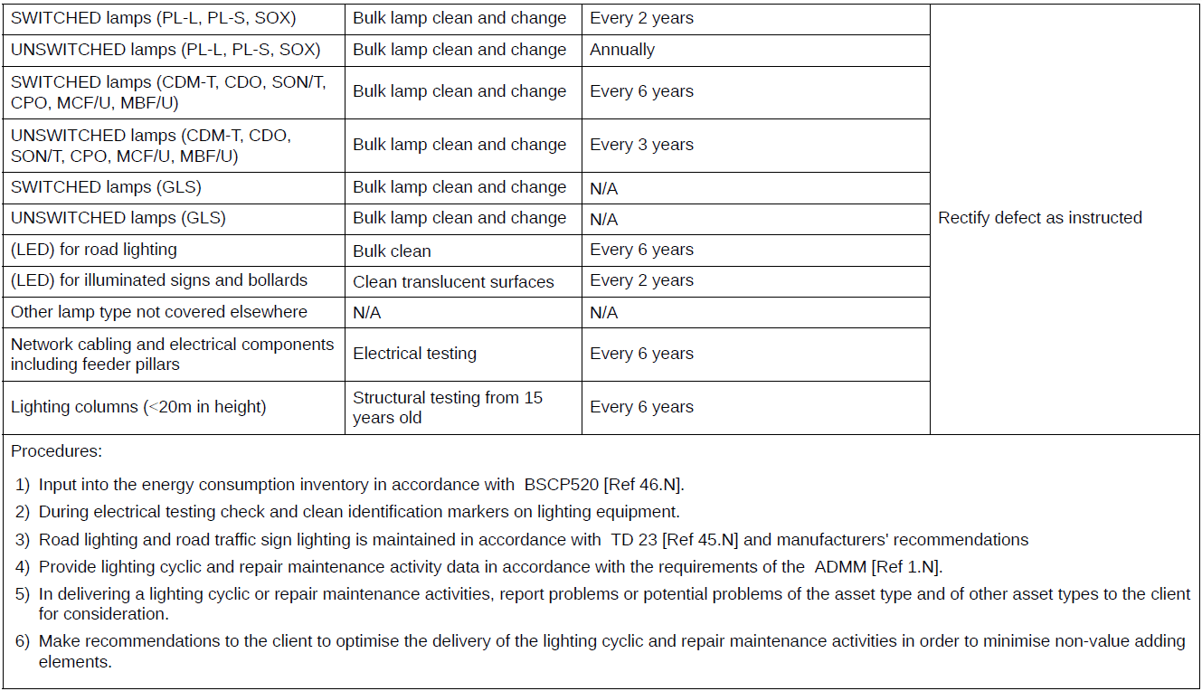
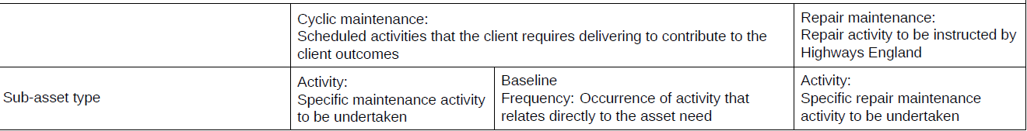
(GM 701 – PG86)

