21 October 2021

FAO: Procurement

**PROJECT TITLE: OCTAVIA HOUSE METAL RAIL FENCING AND INSTALL SLIDING GATE (Estate Improvement Budget)**

|  |  |
| --- | --- |
| Scope of Works | The contracted supplier will be required to: -  Supply Automatic Sliding Vehicular to include Sliding Gate Kit up to 5m rack, Heavy Duty Steel racking.  Battery Backup, cable -pull external manual release, photocells, anti- Vandal covers, flashing lamp, loop detector, induction cable, 7day Timer clock DTC, Master cloneable remote 433MHz Slave cloneable remote 433MHz, Latching key switch.  Drop key fireman switch, Safety end wireless Kit, Safety edge wireless transmitter - RF, 4 Channel Safety edge relay, LED Flashing lamp.  A black painted metal steel railing fence RAL 9005 with forged spiked finials in wrought iron style to new metal railings.  Demolish existing front **1 Brick** wall and rebuild new wall as per drawing and complete with brickwork footing and coping to match existing.  Run cable for the new Vehicular gate  Supply powder coated metal fence railing  Rebuild 6 brickwork 1 1/2 piers and match pier cap finials  Groundwork to concrete in sliding gate.  Apply primer to the railings patch prime as required and paint two undercoats and one gloss finishing coat on surfaces of mild steel fences and gate both existing and new. Jet wash existing footings and piers.  Install 6 LED pillar light to piers column  Supply Fobs for residents 12 Fob keys and 5 extra for lookahead residents & RBKC residents 69 + 8 extras **Total 94**  Safety Edge Protection to new gate  Install Visual aid to confirm Gate opening and closure  Allow for welfare provision  Contract Management to be provided  Site Management/Supervision to be provided  Unforeseen Works |
| Project Lead | Fola Adesakin |
| Department | Estate and Environmental Services |
| Project Team | Fola Adesakin, Patrick Sullivan, Dominic Davies, |
| Estimated Project Cost | £50,000 - £55,000 Excl. VAT, based on Benchmark Cost Exercise. |
| Funding Route | Estate Improvement Budget (EIB) |
| Consultation | Consultation has been undertaken with the Residents Association and the Estate in line with the Estate Improvement Budget (EIB) processes. Letters were issued to the whole estate, and residents were consulted on the proposed works.  Support has been given by local Councilors for the works. |
| S.20 Required | No as through EIB and no recharge |
| JCT Minor Works 2016 | Yes |
| CDM Requirements | Not expected to exceed 30 days with more than 20 workers at any time or have over 500 person days on site. |
| Proposed Project Start Date | TBC through tender process by procurement.  If agreed, site works would need to be commence on Monday 29 November 2021. |
| Proposed Project Works Period | Works to be agreed in set time frame. It is thought that works should not take more than 30 working days.  Monday 29 November 2021 – Friday 21 January 2022.  No works to be undertaken on Weekends  Works to be proposed between the hours of 9am – 5pm |
| Project Specification | Please see attached documentation |
| Tender Evaluation Criteria | 60: 40 (Quality: Cost) |
| Tender Questions | 1.0) Please submit a minimum of two examples of previous contracts that are similar to this Project. Submissions, which do not, in the opinion of the Council, adequately meet the requirements of this Project with regard to previous experience, will be excluded from the Technical and Price Criteria outlined below and will not be taken forward to any subsequent stages of the Tender evaluation.  2.0) Please identify the potential issues around working within a residential site where neighbours are residents, and how you would look to mitigate them. Please answer with emphasis on site specifics.  3.0) Please outline how you propose to manage site logistics i.e. welfare facilities, deliveries, parking, residents and other business access etc. with minimal disruption to neighbours on a small site. Please answer with emphasis on site specifics.  4.0) Please identify the potential Health and Safety issues specific to this particular project and how you propose to mitigate them. Please answer with emphasis on site specifics.  5.0) Please outline the environmental and sustainability principles that should be taken into consideration prior and during the works to avoid or minimise any negative impact on the environment. Please answer with emphasis on site specifics. |
|  |  |

**Picture of the existing site**

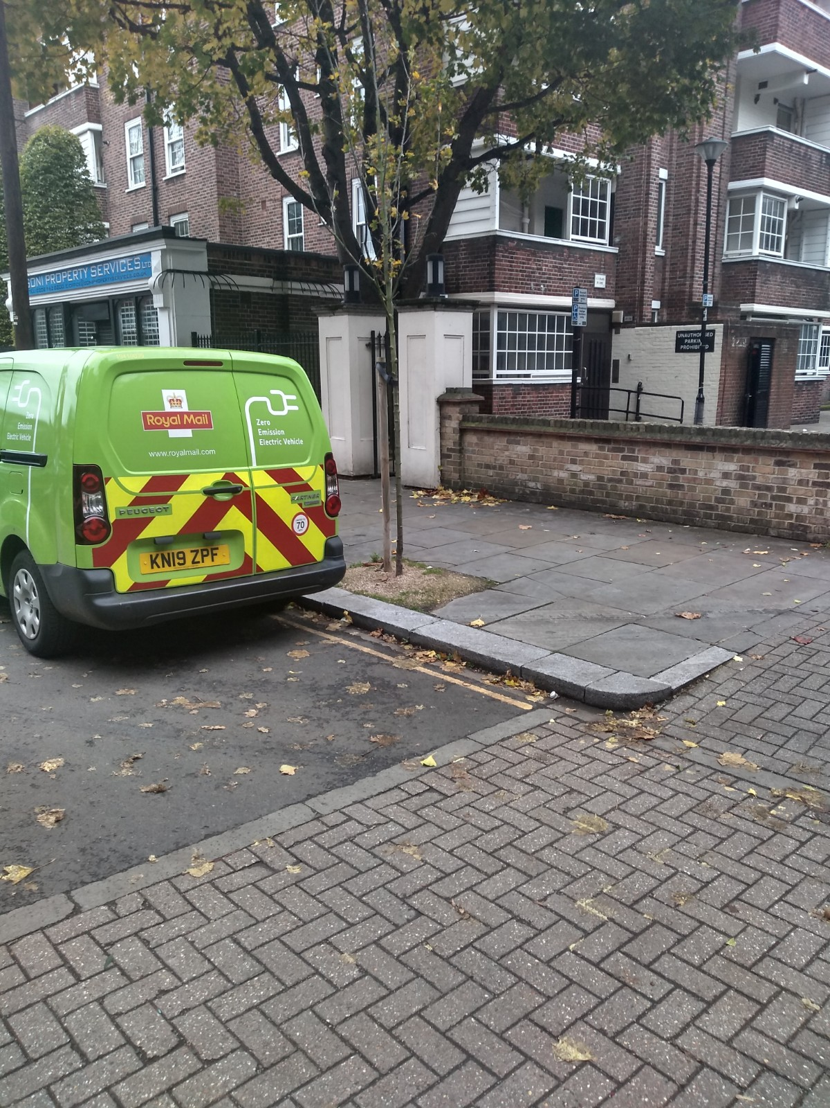

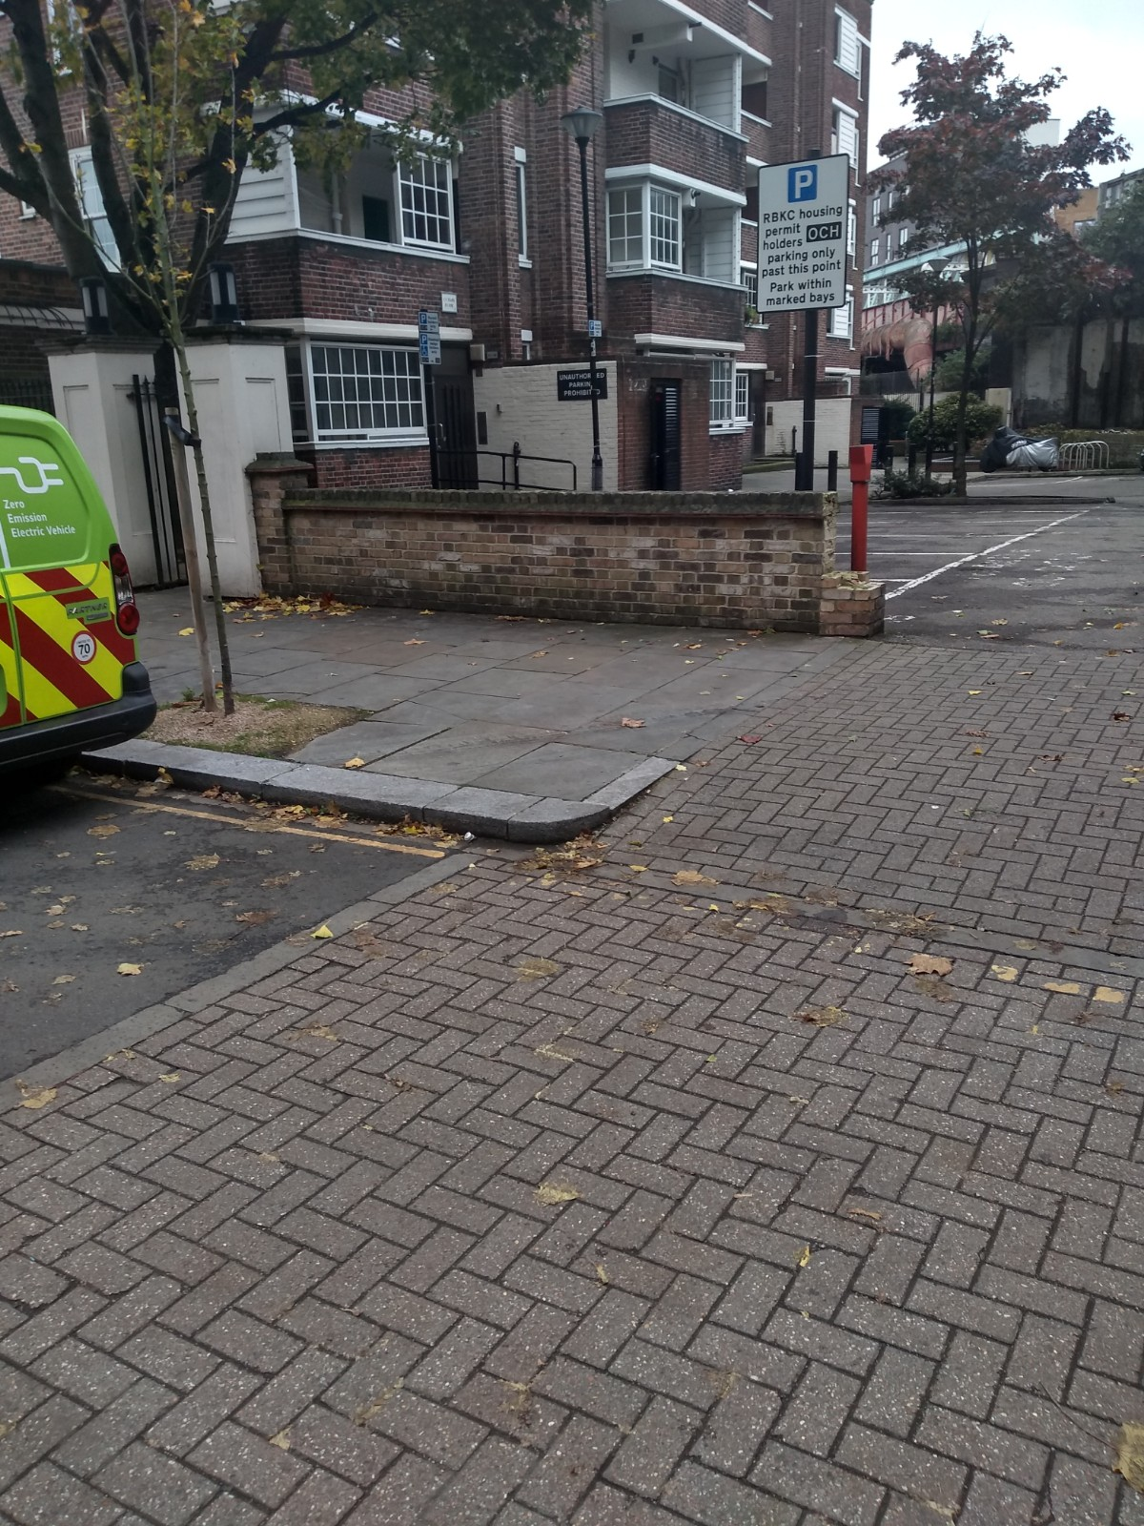

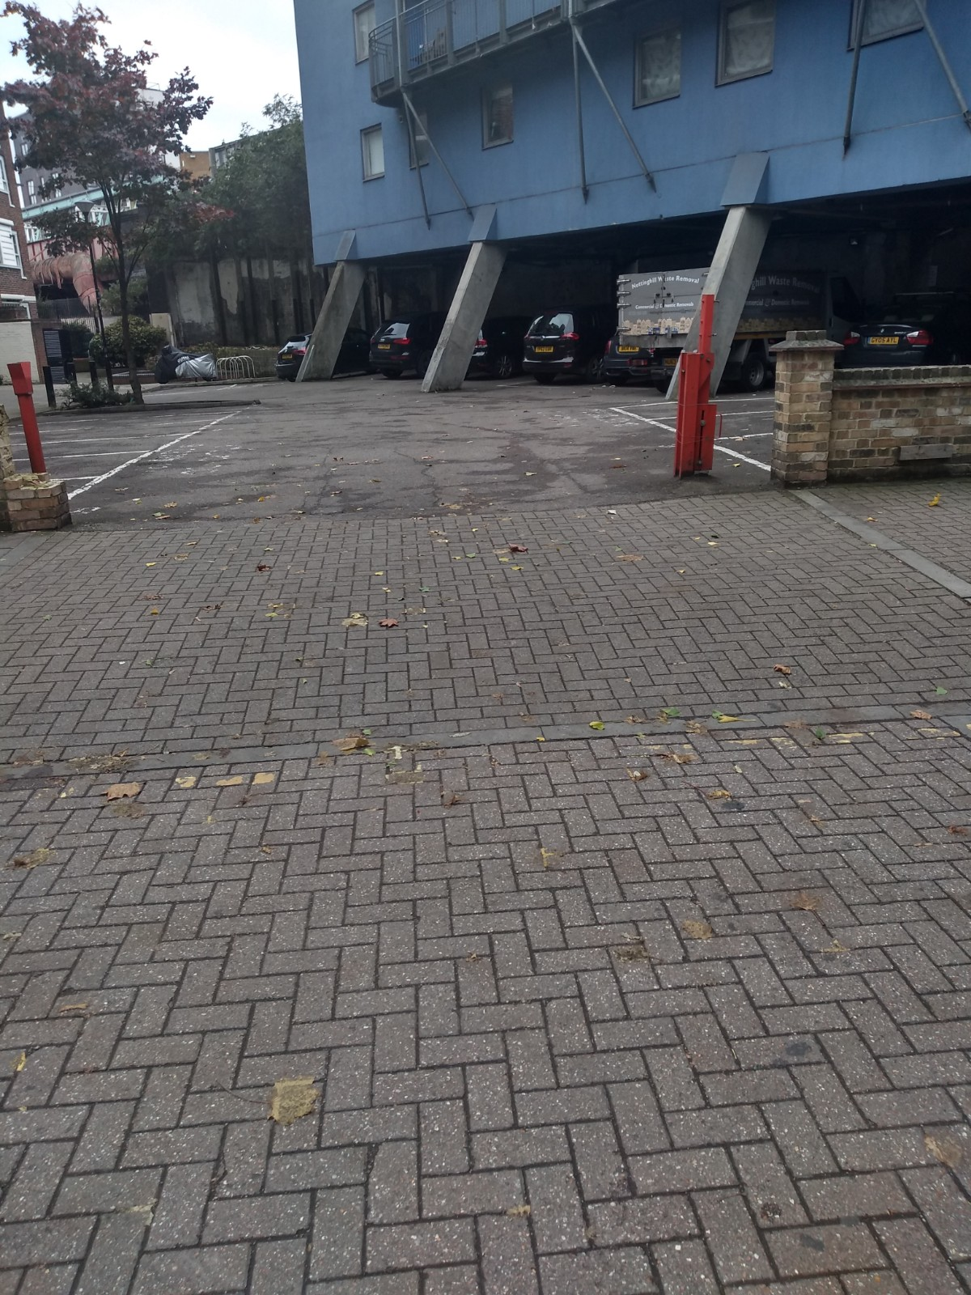

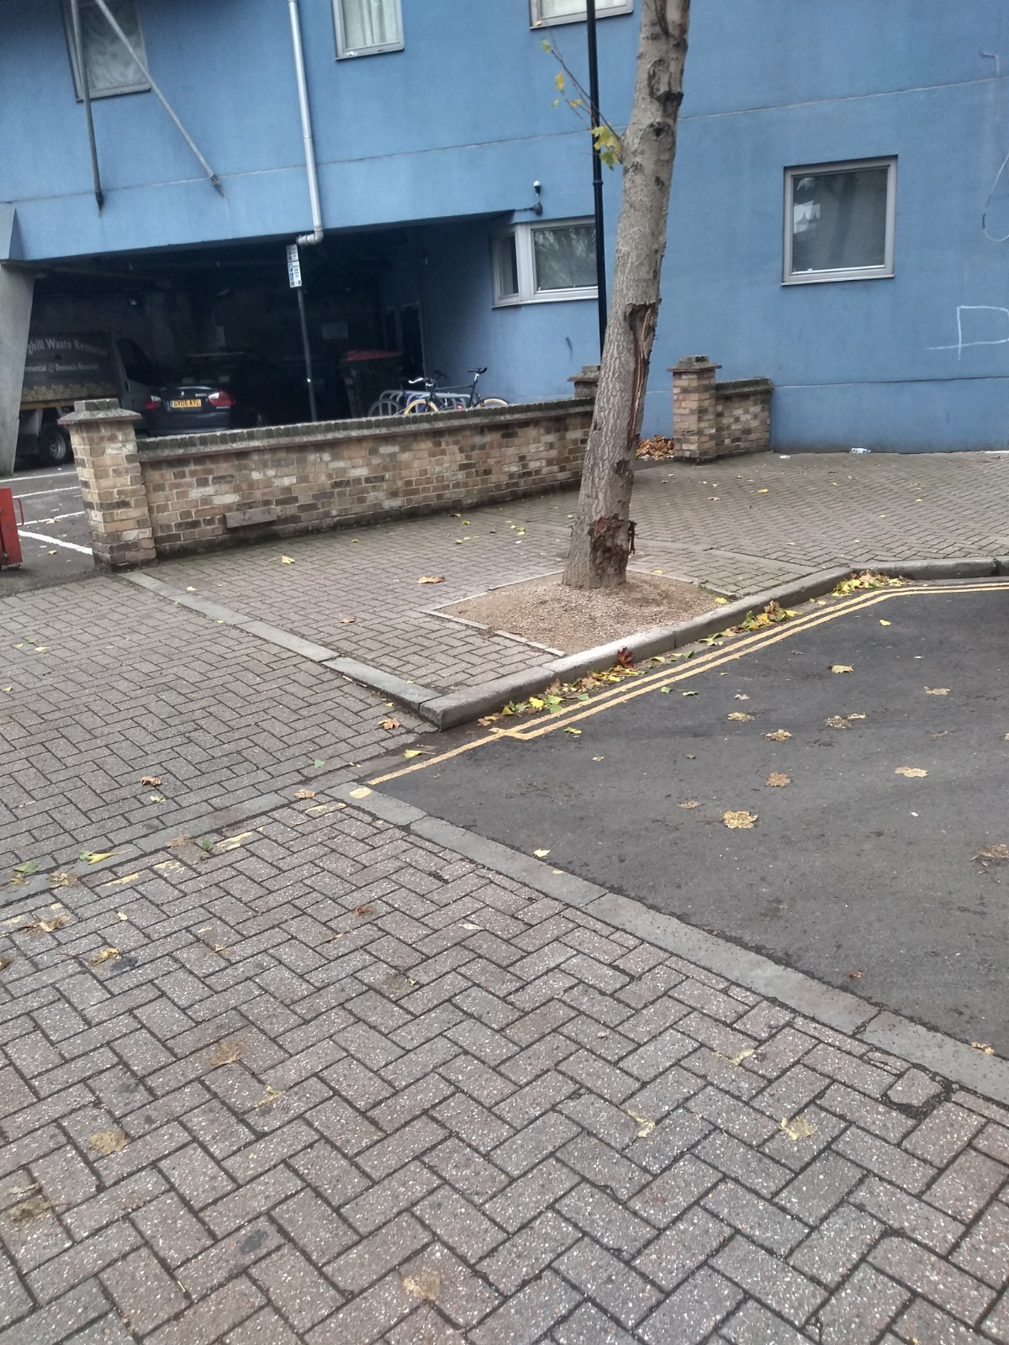

Yours faithfully

**Fola Adesakin**  
*Environmental Surveyor*

*Royal Borough of Kensington and Chelsea*

*Network Hub, 292 Kensal Road, London, W10 5BE*

**Our Values | Putting Communities First | Respect | Integrity | Working Together**

