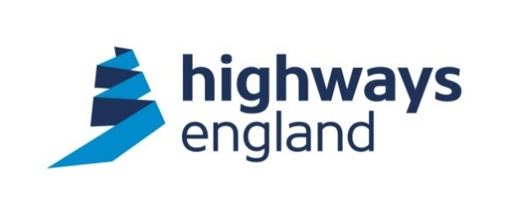

Highways England Contract for the Provision of Rapid Electric Vehicle Charging Points

Volume 1

Form of Contract

ISSUE 1_0

Highways England Contract for the

Provision of Rapid Electric Vehicle Charging Points

VOLUME 1 – Form of Contract

Document Control

Issue No. | 1_0
Status | ISSUE
Remarks | For Tender Approval
Date | 10 October 2018
Prepared by | N Pinnington
Checked by | A Boswell
Authorised by | A Boswell
Project number | 248492-91

Highways England Contract for the

Provision of Rapid Electric Vehicle Charging Points

Volume 1- Form of Contract

Form of Contract 1

Form of Contract
This agreement is made as a Deed on the ..…………..day of……………..….………20

BETWEEN

- Highways England Company Limited whose registered office is Bridge House, 1 Walnut Tree Close, Guildford, GU1 4LZ whose company number is 09346363 (the “Customer”); and

- [insert the supplier’s name] whose registered office is [insert the supplier’s registered office address] whose company number is [insert the supplier’s company number if a private limited company] (the “Supplier”).

WHEREAS the Customer wishes to have provided the following goods and services namely the provision of rapid electric vehicle charging points pursuant to the ESPO Framework Agreement (reference 636_17).

NOW IT IS AGREED THAT

- The Supplier will provide the goods and services in accordance with the terms of the call-off contract and the other Contract Documents.
- The Customer will pay the Supplier the amount due in accordance with the terms of the call off contract and the other Contract Documents.
- In the event of any inconsistency between the terms of the call-off contract and the other Contract Documents the terms of the call off contract shall take precedence.
- The following documents comprise the Contract Documents and shall be deemed to form and be read and construed as part of this agreement:
  - Form of Contract
  - Master Contract Schedule
  - Call-Off Terms
  - Service Information
  - Tender Queries and Responses
  - Supplier’s Quotation Submission
  - Tender Clarifications
  - Customer’s Letter of Contract Award

This document has been executed as a deed and is delivered and takes effect on the date stated at the beginning of it.

EXECUTED AS A DEED BY THE CUSTOMER

by affixing the common seal of

Highways England Company Limited

in the presence of:

……………………………..

Authorised Officer

……………………………..
Authorised Officer

EXECUTED AS A DEED BY THE SUPPLIER

[Supplier’s Name] acting by two of its Directors

or one Director and its Company Secretary

……………………………..

Director

……………………………..

Director or Secretary

