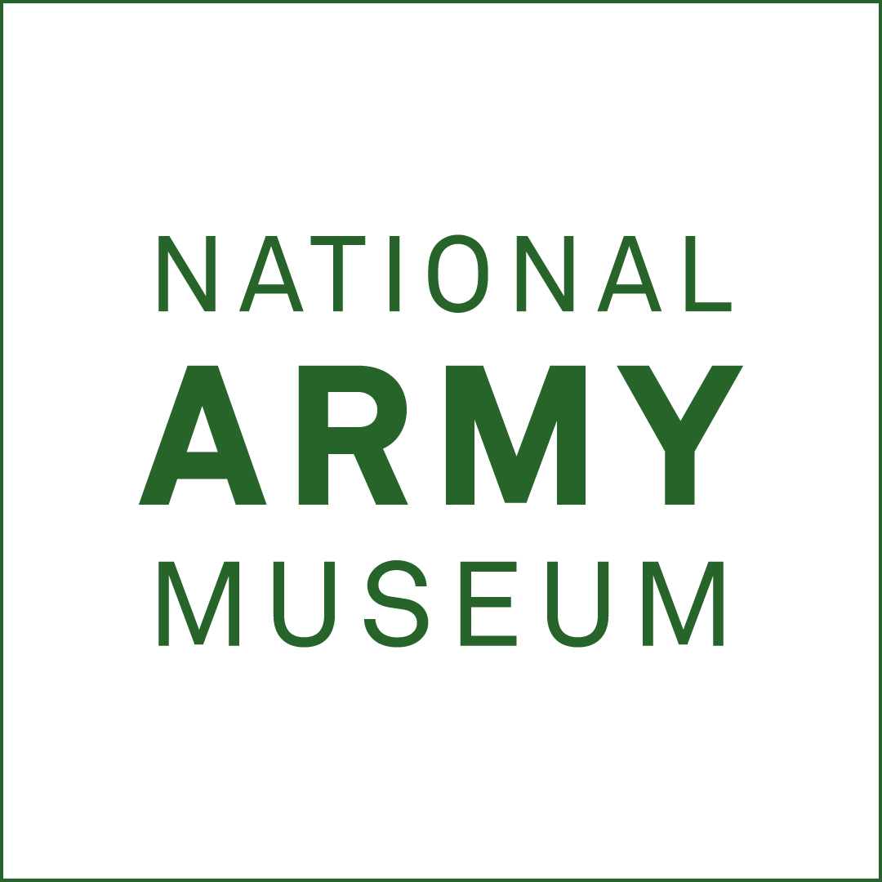
  - National Army Museum
SEPTEMBER 2025

PROVISION MECHANICAL MAINTENANCE SERVICES ACROSS THE NATIONAL ARMY MUSEUM ESTATE

OPERATIONS DIVISION

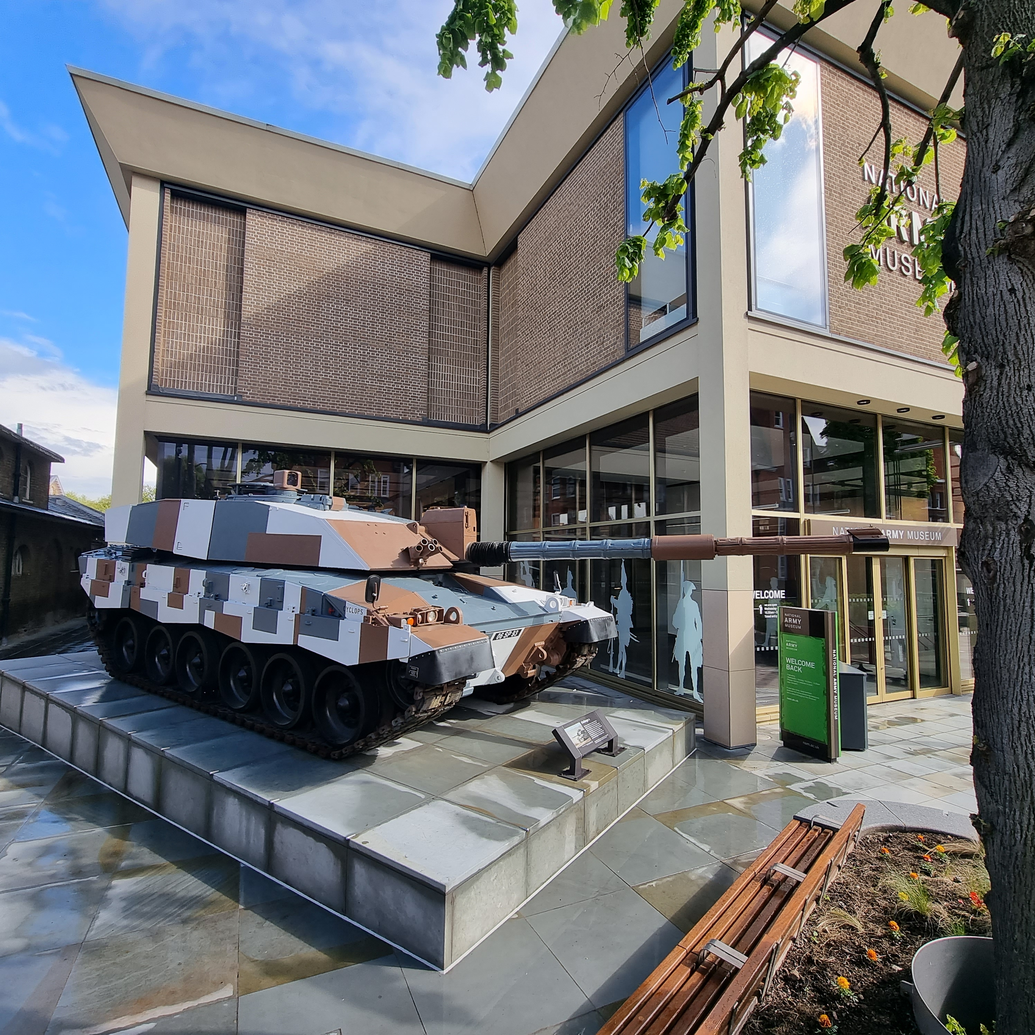

NATIONAL ARMY MUSEUM
ROYAL HOSPITAL ROAD
CHELSEA
LONDON SW3 4HT

MECHANICAL MAINTENANCE SERVICES ACROSS THE NATIONAL ARMY MUSEUM ESTATE

Brief, Tender and contractor’s information
CONTENTS | Page
The Client | 3
The National Army Museum (NAM) Project Board | 3
the NAM - Background | 3
Scope of Works | 3
In scope | 3
Out OF SCOPE | 4
nominated subcontractors | 4
site visits | 4
programme | 6
Information for Tenderers | 6
Financial SuBMISSION | 6
Contract Award Criteria | 8
Enquiries | 8
Tendering Costs | 8
Insurances | 8
Health and Safety | 8
Security | 8
GENERAL | 8
ANNExes
Annex A: FORM OF TENDER | 9
Annex B: CERTIFICATE OF BONA-FIDE TENDER | 10
Annex C: CONTRACTOR QUALIFICATION QUESTIONNAIRE | 11
Annex D: HEALTH AND SAFETY QUESTIONNAIRE | 18
ANNEX E: TEMPLATE FOR PRICING | 22
ANNEX F: Maintenance Tender Asset List - NAM Chelsea
ANNEX G: Maintenance Tender Asset List - NAM Stevenage | (Annexes F – J under separate cover)
ANNEX H: NAM Chelsea BMS Information

ANNEX J: NAM Chelsea AHU Technical Data Sheets
The Client

The Client is the Council and Director of the National Army Museum.

- The NATIONAL ARMY MUSEUM (NAM) Project Board

The NAM Project Board will include:

Mike O’Connor
Helen Kibblewhite
Cameron Crawley
Mark Durston
A representative from Finance

The Contractor will assume the roles where required of Principal Contractor as defined under the CDM 2015 Regulations, reporting to the Project Board for the complete.

- THE NAM - Background

The NAM, a Body incorporated by Royal Charter (1960), is the British Army's own Museum. It is the only museum in the United Kingdom to tell the Story of Our Army as a whole from the New Model Army to today's military operations in Iraq, Afghanistan and elsewhere. It commemorates the contribution of soldiers, male and female, who have served in our Army. By using examples from the past, the NAM inspires the present generation of soldiers to understand that they are the inheritors of a rich tradition of bravery, service and professionalism.

Across three locations – the main Museum in Chelsea and its Reserve Collections Store and Vehicle Store in Stevenage – the Museum employs ~85 permanent staff and in 2024/25 hosted over 180,000 visitors to the Museum in Chelsea.

- SCOPE OF WORKS

With this tender, the National Army Museum is looking to appoint a suitably competent and qualified contractor to service and maintain the mechanical services as detailed, contained within Annexes F and G at the Museum’s Chelsea and Stevenage sites for three years, with the possibility of a two-year extension. Service frequencies have been specified on these annexes and all assets are to be maintained to the SFG20 standards.

- IN SCOPE

- Undertake a condition survey of the existing installation within 45 days of the commencement of the Maintenance Agreement to confirm the operational status of the assets listed in Annexes F and G. To provide a comprehensive report on the findings, together with a costed list of any remedial works considered necessary.

- Share electronically and maintain on site a permanent record of maintenance work done via a logbook, including any repair or replacement of and to equipment.

- BMS service visits at NAM Chelsea, visits to co-inside with maintenance visits for AHU/AC assets. Annex H provides details of the NAM Chelsea BMS system.

- Two filter changes per annum for all AHUs at both NAM Chelsea and NAM Stevenage, with the annual contract cost to include the filters. Annex J provides information on AHU’s and filter sizes, however, it is for the contractor to check the accuracy of these.

- The cost of all consumable and replacement items for the works to include lubricating oil, gaskets, gland packings, electrical fuses and switches, drive belts, bearings and other similar items required for the repair and maintenance of the various systems involved.

- All necessary equipment, including access equipment required to maintain and reach assets listed in Annexes F and G. NAM owned scissor lifts are available for use at NAM Stevenage for suitably trained and certified personnel.

- Provide a 24/7 emergency call out service.

- Servicing of assets that are front of house at NAM Chelsea must be carried out on a Monday when the Museum is closed to the public or must be completed prior to 09:30am Tuesday to Friday.

- OUT OF SCOPE

The following elements are out of the scope of this contract:

- BMS service visits at NAM Stevenage

- NOMINATED SUB-CONTRACTORS

The Museum wishes to utilise the services of Humidity Solutions to service the humidifiers at both sites. The point of contact is Mr Drew Strong (Technical Manager) service@humiditysolutions.co.uk

- SITE VISITS

Site visits will be required prior to any tender submission. Site visits for max. two personnel will take place on the following dates:

Chelsea:

Allow 45 minutes for each visit.

30 September 2025 10am – 4pm
2 October 2025 1pm – 4pm

Stevenage

Allow 30 minutes for each visit.

1 October 2025 10am – 4pm

Attendance must be arranged by contacting:

Mark Durston – Facilities Officer via facilities@nam.ac.uk

Access to the both the Chelsea and Stevenage sites is by arrangement only, it is essential that note is taken of any arrangements for entry.

The names of personnel visiting (maximum 2) the site and the registration number of vehicles must be supplied. Parking is by arrangement and not to be assumed. Any changes in personnel must be agreed in advance.

- PROGRAMME

Tender Invitation issued | 19 September 2025
Tender submission to NAM | 1600hrs on 15 October 2025
Successful contractor appointed | 23 October 2025

- INFORMATION FOR TENDERERS

Tender Process

The process to be followed will be in accordance with the NAM Financial Procedures Memorandum in that it will be a sealed bid process.

The NAM will not necessarily award to the lowest price tenderer. NAM reserves the right to appoint the contractor who has interpreted the brief fully and provided value for money.

Tender Return

All electronic tender documents/electronic media are to be addressed to tenders@nam.ac.uk and annotated with “TENDER DOCUMENTS NOT TO BE OPENED BEFORE 1600hrs on 15 October in the body of the email. On no account are the tender documents to be passed to the requesting department before the tender board date. The Museum reserves the right to discount any tender received in contravention of this instruction.

Tenders are to remain open for acceptance for a period of 90 days.

Tender shall comprise of 1 x electronic (PDF format) to be sent to tenders@nam.ac.uk and address of the following:

  - Financial Tender;

  - The Completed Form of Tender (Annex A);

  - Certificate of Bona-Fide Tender (Annex B);

  - Contractor Qualification Questionnaire (Annex C);

  - Health and Safety Questionnaire (Annex D);

  - Completed Template for Pricing (Annex E)

  - Any other information that is required to clarify the tender.

- Financial SUBMISSION

Annual Cost

The fee is in the region of £65,000 per annum.

The fee is to include all expenses. This will include travel costs, accommodation, disbursements and all other expenses and costs required in the provision of the Services. The fee should exclude VAT.

Instalment Payments

NAM suggests a payment schedule of the annual contract sum paid in monthly instalments.

Information to accompany the Tender

Completed Contractor Qualification and Health and Safety and Template for Pricing questionnaires (Annexes C, D & E)

Relevant Experience

Provide details of relevant experience. For each project, include a description of the project, your role, client, budget and project dates

Tenderers Project Team

List the proposed Contract Manager for this contract and provide their CV.

Resource Plan & Availability of Personnel

Advise the resource plan for the proposed servicing.

Advise how quickly the contractor could begin work if appointed.

Practice Approach

Outline your approach to ensure the servicing of the assets listed in Annexes F and G.

References

Provide details of three recent contracts that are relevant to this project including the name and contact details of the clients’ representatives who could be approached for references.
- Contract Award Criteria

The Tender Board will comprise the Project Board and other nominated individuals.

Tenders will be assessed on the following criteria:

Fee | 50%
Qualifications and Experience | 20%
Approach | 20%
Project Team & Resourcing | 10%

- Enquiries

All enquiries arising from this Invitation to Tender must be submitted in writing via email to:

Mark Durston, Facilities Officer – facilities@nam.ac.uk

- Tendering costs

The Client will not be responsible for, or pay for any costs or expenses, that are incurred by any tendering contractor in preparing and submitting their tender.

- INSURANCES

The minimum amount insured in respect of public liability shall be £10M for any one occurrence or series of occurrences arising out of one event.

- HEALTH AND SAFETY

Contractor should provide all Method Statements, Risk Assessments, and COSHH Information Data Sheets prior to commencing the contract.

Contractor is to ensure that all works are made safe by the end of each working shift and the area is left in a clean and tidy condition to the satisfaction of the Client.

Contractor is to ensure that all items of the Museum are adequately protected from dust or damage during any works.

- SECURITY

The contractor is to ensure that all employees and sub-contractors to be employed on the Client will require the contractor to ensure that all employees and sub-contractors are Disclosure and Barring Service cleared. The Client reserves the right to prohibit entry of any employee as a result of the DBS enquiry.

- GENERAL

Contractors will be issued with the Museum’s Contractor’s Code of Conduct on appointment.
Allow for the removal of any hazardous material or controlled waste related to works undertaken from site and include for provision of copies of any disposal certificates to the Client.

All contractors’ personnel must book in and out of the Museum on each shift.

You should be aware the NAM is subject to the Freedom of Information Act 2000 and is required to comply with any requests submitted.

- ANNEXES

Attached to this specification are copies of annexes that must be completed and enclosed with the tender.

- Annex A – Form of Tender
- Annex B – Certificate of Bona-Fide Tender
- Annex C – Contractor Qualification Questionnaire
- Annex D – Health and Safety Questionnaire
- Annex E – Template for Pricing
- Annex F – Maintenance Tender Asset List - NAM Chelsea
- Annex G – Maintenance Tender Asset List - NAM Stevenage
- Annex H – NAM Chelsea BMS Information
- Annex J – NAM Chelsea AHU Technical Data Sheets

Annex A – Form of Tender

Tender for: Mechanical maintenance services across the National Army Museum estate

To: The Council and Director of the National Army Museum

Sirs,

I/We the undersigned, having examined the enclosed tender documents and Appendices, do hereby offer to execute and complete in accordance with the said documents the works described therein:

For the sum as listed in the attached document:

Tenderer Reference: Mechanical maintenance services across the National Army Museum estate. K-7-16-2-1-1-4

I/We hereby affirm our agreement to enter into a contract with the Council of the National Army Museum for the due performance of the Works in the form described by the above said documents.

I/We have completed the Certificate of Bona-Fide Tender included in this document

I/We understand that the Trustees are not bound to accept the lowest or any tender which may be received nor or responsible for any cost incurred in the preparation of any tender

I/We declare that this offer is to remain open for acceptance for a period of thirty days from the date fixed for the receipt of tenders

Signed: ____________________________________________________

In the capacity of

Duly authorised to sign the tender on behalf of:

Date:
Annex B – CERTIFICATE OF BONA-FIDE TENDER

Tender for: Mechanical maintenance services across the National Army Museum estate

I/We certify that this is a bona-fide tender and that I/we have not fixed or adjusted the amount thereof by or under in accordance with any agreement or arrangement with any other person.

I/We also certify that I/We have not done and I/We undertake that I/we will not do at any time any of the following acts:

  - Communicate to a person other than the person calling for these tenders the amount or approximate amount of the proposed tender except where the disclosure, in confidence, of such amount(s) was necessary to obtain insurance premium quotations required for the preparation of the tender.

  - Enter into any agreement or arrangement with any other person that he shall refrain from tendering or as to the amount of any tender to be submitted;

  - Offer or pay or give or agree to pay or give any sum of money or valuable consideration directly or indirectly to any person for doing or having done or causing or have caused to be done in relation to any other tender or proposed tender for the said work any act or thing of the sort described above.

In this certificate the word “person” includes any person and any body, association, corporate or un-incorporated; and “any agreement” includes such transaction, formal or informal, and whether legally binding or not.

Signed: ____________________________________________________

In the capacity of

Duly authorised to sign the tender on behalf of:

Date:
Annex C: - CONTRACTOR QUALIFICATION QUESTIONNAIRE

Tender for: Mechanical maintenance services across the National Army Museum estate

    - Please answer all questions and sign the declaration at end of the questionnaire.

    - If there is insufficient space for your response, please attach and sign any additional pages.

    - Please answer the questions specifically for your business NOT for the group if you are part of a group of companies.

    - Please note the term business refers to: Sole proprietor, partnership, limited liability partnership, incorporated company, co-operative, or voluntary organisation as appropriate.

This document is confidential, and all information provided will be for the purpose of supplier management only and kept solely within the National Army Museum. The information supplied by the contractor / supplier will be used to assess the contractor’s fitness for any work being tendered.

Supply of this document to an applicant does not imply or guarantee that the recipient will be awarded works on a project.

A ADMINISTRATIVE INFORMATION

A1 Trading Name of Business

A2 Registered Name of Business (if different from A1)

A3 How long has the business been trading?

A4 Main address for correspondence

A5 Registered Office address (if different from above)

A6 Name of person applying on behalf of the business.

A7 Position or title in the business of the person named in A6

A8 Telephone Number of the person named in A6

A9 Facsimile Number of the person named in A6

A10 E-Mail address of the person named in A6

A11 Is the business a sole trader, partnership, private limited company, public limited company, limited liability partnership, co-operative, voluntary organisation or other? (Please specify)

A12 Please provide the business’ VAT Registration Number

A13 If applicable, please state the number and date, and provide a copy of the Certificate of Incorporation or Registration (and Change of Name) under the Companies Acts or Industrial and Provident Societies Acts in the UK or the professional or trade register of the EU member state in which the company is established.

Applicable/Not applicable:

Certificate Number:

Date:

A14 Is the business part of a group?

Yes/No:

A15 If part of a group, please describe the group structure, (please provide an organisation chart if appropriate) and give names of the other Divisions or Subsidiary Companies in the Group.

Attached/Not Attached:

B BUSINESS PROBITY

B1 a) Being a company, no resolution has been passed or Order of the Court made for the company’s winding up otherwise than for the purposes of bona fide reconstruction or amalgamation, or receiver, or manager, or administrator on behalf of a creditor appointed in respect of the company’s business or any part thereof, or is not the subject or proceedings for any of the above procedures, or is not the subject of similar procedures under the law of any other state.

Not applicable / confirmed / not confirmed:

Details:

b) Being an individual, you are not bankrupt, you have not had a receiving order or administration order made against you, or made a composition or arrangement or trust deed with or for the benefit of your creditors, or made any conveyance or assignment for sequestration of your estate or appear to be unable to pay or to have no reasonable prospect of being able to pay a debt within the meaning of the Insolvency Act or any similar procedure under the law of any EU member state.

Not applicable / confirmed / not confirmed:

Details:

B2 Please confirm that no Directors, Partners, Associates or the Company Secretary have been involved in any company, which has been liquidated or gone into receivership.

Confirmed / not confirmed:

Details:

B3 Please confirm that none of the Directors, Partners, Associates or the Company Secretary has been convicted of a criminal offence relating to the conduct of their business or profession.

Confirmed / not confirmed:

Details:

B4 Please confirm that neither the company nor any of the Directors, Partners, Associates or Company Secretary has committed an act of grave misconduct in the course of their business or profession.

Confirmed / not confirmed:

Details:

B5 List the full names of every Director, Partner, Associate and the Company Secretary and indicate their title.

Attached / Not Attached:

B6 Please confirm that all obligations relating to the payment of taxes under the law of any part of the United Kingdom or the EU member state in which the company is established have been fulfilled.

Confirmed / not confirmed:

Details:

B7 Please confirm that all obligations relating to the payment of social security contributions under the law of any part of the United Kingdom or EU member state in which the company is established have been fulfilled.

Confirmed / not confirmed:

Details:

B8 Please confirm that you understand that serious misrepresentation in the provision of information will be grounds for disqualification from the tender process.

Confirmed / not confirmed:

C ECONOMIC AND FINANCIAL STANDING

C1 If the business is a member of a group of companies, please give the name and address of the ultimate holding company.

C2 Would the ultimate holding company be prepared to guarantee your contract performance as its subsidiary?

Yes / No:

C3 Please state the name and title of the person in the business responsible for financial matters:

C4 Please confirm that we may obtain references from your bankers and provide their name and address:

Confirmed / not confirmed:

Details:

C5 Have you been trading for three years or more? If yes, please attach copies of your audited Accounts for the past two years, to include:

- Balance sheet
- Profit and Loss Account
- Full notes to the Accounts
- Director’s Report
- Auditor’s Report
- Statement of Turnover in respect of the services to be provided under this contract.
NB: Where no accounts are audited, signed copies of the Partnerships accountant should be submitted.

Details attached – Yes / No:

C6 If the Accounts you are submitting are for a year ended more than 10 months, ago, Please confirm that the business is still trading and provide a statement of turnover since the last set of published accounts:

Not applicable / applicable:

Details attached – Yes / No:

C7 Has your business ever had a contract terminated for breach under the terms of the contract? (If yes, please provide details)

Not applicable / applicable:

Details attached – Yes / No:

C10 Has your business ever had a contract not renewed for failure to perform to the terms of the contract? (If yes, please provide details)

Not applicable / applicable:

Details attached – Yes / No:

C11 Please give the Name of the Insurer, Policy Number, extent of cover, Expiry date and provide a copy of your Employer’s Liability Insurance Policy or other evidence that you have such insurance.

C12 Please give the Name of the Insurer, Policy Number, extent of cover, Expiry date and provide a copy of your Public / Product Liability (Third Party) Insurance Policy or other evidence that you have such insurance.

C13 Please give the Name of the Insurer, Policy Number, extent of cover, Expiry date and provide a copy of your Professional Indemnity Insurance Policy or other evidence that you have such insurance

D COMPLIANCE WITH EQUAL OPPORTUNITIES LEGISLATION

D1 Is it your policy as an employer to comply with your statutory obligations under the Race Relations Act 1976, the Sex Discrimination Acts 1975 and, 1986, and the Disability Discrimination Act 1995 (or similar legislation of the EU member state in which applicant is established) and, accordingly, your practice not to treat one group of people less favourably than others because of their sex, colour, race, nationality or ethnic origins or disability in relation to decisions to recruit, train or promote employees?

Yes/No:

D2 In the last three years has any finding of unlawful racial, sexual or, disabilities discrimination been made against your organisation by any court or Employment tribunal?

Yes/No:

D3 In the last three years, has your organisation been the subject of formal investigation by the Commission for Racial Equality, Equal Opportunities Commission, Disability Rights Commission or other equalities body (or similar organisation in an EU member state) on grounds of alleged unlawful discrimination?

Yes/No:

D4 If yes, what steps did you take in consequence of that finding?

D5 Is your policy on equal opportunities set out:

a) in instructions to those concerned with recruitment, training and promotion?

Yes/No:

b) in documents available to employees, recognised trade unions or other representative groups of employees?

Yes/No:

c) in recruitment advertisement or other literature?

Yes/No:

d) in service delivery guidance notes/procedures or your quality manual?

Yes/No:

E MODERN SLAVERY ACT COMPLIANCE

E1 In performing its obligations under the agreement, the Supplier shall and shall ensure that each of its subcontractors shall:

- Comply with all applicable laws, statutes, regulations in force from time to time including but not limited to the Modern Slavery Act 2015; and
- Take reasonable steps to ensure that there is no modern slavery or human trafficking in the Suppliers or subcontractors supply chains or in any part of their business.
- The Supplier represents and warrants that neither the Supplier nor any of its officers, employees or other persons associated with it has been convicted of any offence involving slavery and human trafficking; and having made reasonable enquiries, to the best of its knowledge, has been or is the subject of any investigation, inquiry or enforcement proceedings by any governmental, administrative or regulatory body regarding any offence or alleged offence of or in connection with slavery and human trafficking.
- The Supplier shall implement due diligence procedures for its own suppliers, subcontractors and other participants to ensure that there is no slavery or human trafficking in its supply chains.
- If the Museum agrees that the Supplier may subcontract its obligations, the Supplier shall implement an appropriate system of due diligence designed to ensure the subcontractor complies with the principles of the Modern Slavery Act 2015 and that the subcontractor shall take reasonable steps to ensure that there is no modern slavery or human trafficking in the subcontractors supply chains or in any part of its business
- The Supplier shall notify the Museum as soon as it becomes aware of any actual or suspected slavery or human trafficking in a supply chain which has a connection with this Agreement.
E SUPPLIER STATEMENT

We certify that the information supplied is accurate to the best of our knowledge and that we accept the conditions and undertakings requested in the assessment. We understand that false information could result in our exclusion from the Tender process or the Approved Suppliers List at any time, even after initial inclusion. We also understand that it is a criminal offence to give or offer any gift or consideration whatsoever as an inducement or reward to any servant of a public body and that any such action will empower such body to cancel any contract currently in force and will result in exclusion from the Tender and / or the Approved Suppliers List.

Signed by: _____________________________________________________

Name: (in BLOCK LETTERS) ______________________________________

Title: _________________________________________________________

Date: _________________________________________________________

for and on behalf of: _____________________________________________

This form should be signed by a Director, Partner or other authorised signatory of the organization and returned as part of the Tender Response
Annex D: - HEALTH AND SAFETY QUESTIONNAIRE

Build Elements of the Exhibition ‘Beyond Burma: Forgotten Armies’ at The National Army Museum

1. COMPANY DETAILS

Registered Office:

Main contact office (if different):

Contact Telephone numbers:

Contact email address:

Total number of employees:

Does your Company have a health and safety policy statement?
If yes, please attach a copy to this questionnaire.

2. ORGANISATION FOR HEALTH AND SAFETY

Does your Company have a Director/Senior Manager who is responsible for health and safety? If yes, please give their details.
Name:

Contact telephone number/s:

Contact email:

Does your Company have a Health and Safety Manager/ Advisor? If yes, please give their details.

Name:

Contact telephone number/s:

Contact email:

If your Company’s Health and Safety Manager/Advisor is a Consultant then please provide their company’s full details.

Company name:

Business address:

Main Switchboard number:

Does your Company maintain written health and safety procedures? If yes, please provide information concerning your procedures for the following:

• Training

• Providing health and safety information to employees

• Health and safety committees

• Testing of equipment

• Risk assessment

• Supervision

How does your organisation keep up to date with changes in health and safety?

3. INCIDENTS/ ENFORCEMENT ACTION

Please provide information showing the number and nature of RIDDOR reported incidents over the last 3 years.

How are accidents/ incidents reported and investigated within your Company?

How are near misses reported and investigated?

Has any Enforcement Authority (HSE or Local Authority) served an improvement or prohibition notice on your Company within the last 3 years?
If so, please provide details.

Has your Company been prosecuted for health and safety offences within the last 3 years? If so, please provide details.

4. RISK ASSESSMENT

Has your Company completed risk assessments for this type of work? If so, please provide examples of assessments.

Who is responsible for carrying out risk assessments on your work activities?

Please provide examples of method statements for this type of work.

5. WORK ON SITE

When working for the National Army Museum, will you use any sub-contractors? If so, how do you ensure that sub-contractors will be suitable?

Who will be responsible for supervision on the site?

How do you intend to monitor the work of your employees, including sub-contractors, while they are working on our site?

If you intend to use any hazardous substances, have risk assessments been carried out? If so, please provide details:

How do you ensure that equipment brought onto site will be safe?

How will you ensure that any waste is suitably controlled and disposed?

6 OTHER INFORMATION

Please provide the names, addressees and contact telephone numbers for 3 references for organisations where you have carried out similar work

Reference 1:
Name:

Address:

Telephone Number/s:

Reference 2:
Name:

Address:

Telephone Number/s:

Reference 3:
Name:

Address:

Telephone Number/s:

Annex E: - TEMPLATE FOR PRICING

Tender for: Mechanical maintenance services across the National Army Museum estate

CHELSEA

Description | Annual Cost (£)
BMS and HVAC Controls
Heating and Cooling
Ventilation
Space Heating
TOTAL

STEVENAGE

Description | Annual Cost (£)
Heating and Cooling
Ventilation
TOTAL

EMERGENCY CALL OUT RATES

The contractor shall indicate below the hourly charge rates for operatives attending the
site on emergency call out. The rates indicted shall be payable only for the period that the operative is engaged on site and shall include all costs of labour, insurance, travelling time, expenses, overheads, profits etc.

Description | Hourly Charge Rate (£)
Mechanical Engineer
BMS / Controls Engineer

ROUTINE CALL OUT RATES FOR ADDITIONAL WORKS

The contractor shall indicate below the hourly charge rates for operatives attending the
site on for routine additional works. The rates indicted shall be payable only for the period that the operative is engaged on site and shall include all costs of labour, insurance, travelling time, expenses, overheads, profits etc.

Description | Hourly Charge Rate (£)
Mechanical Engineer
BMS / Controls Engineer

