Pre-construction Information
The aim of pre-construction information is to provide details to any contractor tendering/quoting for construction work where RSPB is the client in order that they may plan the work, develop their risk assessments and, if required, produce a construction phase plan.

Key Project Information
Site address and location | RSPB Pagham Harbour
Project Description and intended use of final structure/building | Completion of groundworks including creating and reprofiling of rills and scrapes. Installation of one stoplog sluice. Installation of a predator exclusion fence.
Planned start date of construction phase | 01/08/2026
Planned finish date of construction phase | 31/10/2026
Reason for planned finish date of construction phase | Site will be too wet to carry out works after this period. Cannot start earlier due to bird breeding season and consent restrictions.
Other important project dates

Client Project Management Arrangements
Client Brief | Invitation to Tender attached.
Arrangements for communication of all parties through the project | All communication via the RSPB Project Manager
Arrangements for co-ordination of on-going design work and handling design changes | As soon as it becomes known that a design element is to be modified the design change shall be developed based on risk assessment regarding execution, maintenance and repair.  The Principal Contractor shall be required to update, amend and modify as necessary the detailed construction phase Health and Safety Plan to address any health and safety risks associated with individual design elements, modified during the works.  Any changes should be reported to the RSPB Project Manager.

Key Dutyholders
Client name and address | RSPB Pagham Harbour
Designer | RSPB Project Manager (with support of RSPB Hydrologist, RSPB Ecologist, RSPB Site Staff)
Principal Contractor (if already appointed) | Not yet appointed.
Contractor(s) | Not yet appointed.

Site Location Map
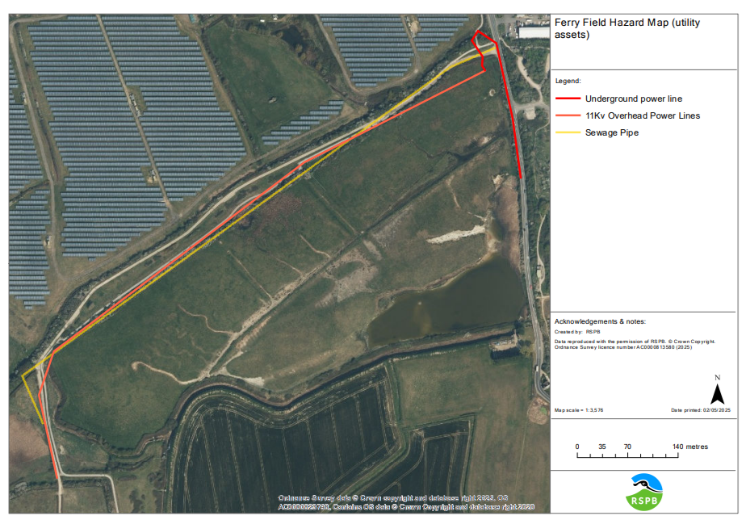
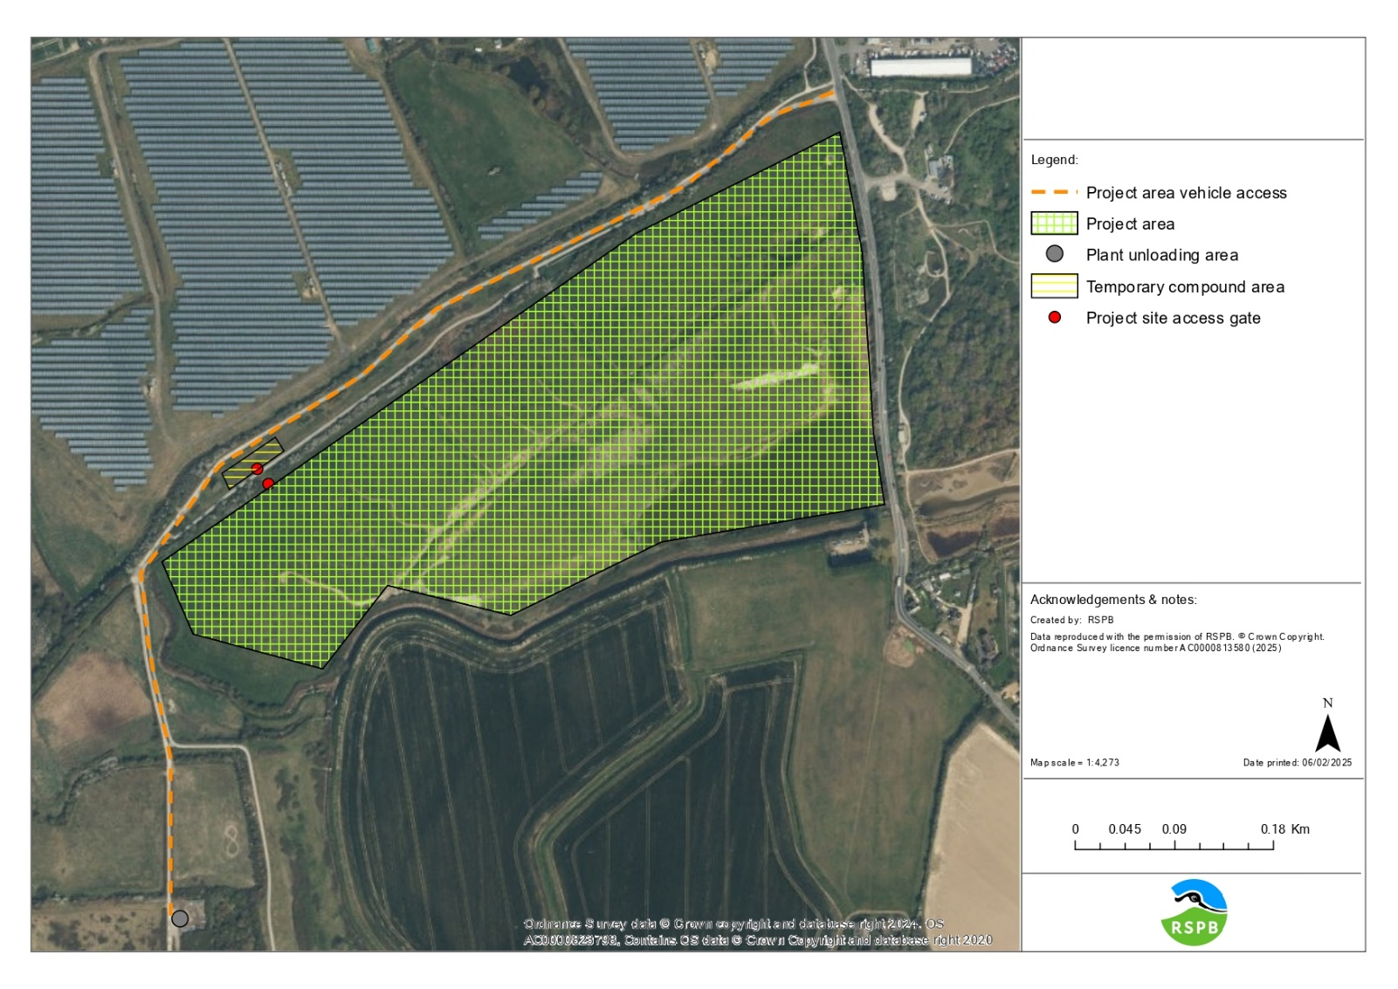

Emergency Procedures
Relevant emergency contact details (e.g. Keyholders, Building’s alarm company, Network Rail, Police, Environment Agency, site graziers) | RSPB Project Manager – Ruth Gillies – 07751 400077 – ruth.gillies@rspb.org.uk  RSPB Site Manager – Ant Smith – 077107 60408 - Anthony.Smith@rspb.org.uk
Details of nearest hospital or medical facilities | St. Richards Hospital  Spitalfield Lane  Chichester  West Sussex  PO19 6SE
Type of emergency services access e.g. 4WD, air or routine | 4WD
Fire Evacuation Plan | Fire Risk Assessment attached.
Procedure if Asbestos Containing materials Disturbed | N/A
Discovery of UXO | Follow advice attached below. Call 01993 886682.  Site Survey carried out and attached.  Talk will be provided to contractors prior to works commencing.
Environmental emergency plans | Emergency Plan attached.
Habitat emergency Plans

The following is information on the project held by the client to be considered in designing out health and safety risk during construction and for future use and maintenance of the building/structure

General Site Information
Details of site security required and where compound areas are to be provided: | Storage of plant and materials in area marked on Access Map.  Track access gate is locked overnight between 5pm – 9am
Details of site transport requirements, parking restrictions, and any vehicle movement restrictions | Speed limit of 5 mph on site.

Details of any unauthorised areas or other authorisation requirements
Details of any dates/times where access not permitted or restricted? | Site access 24/7.  Visitor centre opening times: 10am – 4pm
Parking/turning arrangements for plant and vehicles | Plant can be kept in the locations marked on the access map.  Turning area for plant marked on the access map
Restrictions on deliveries/waste collection/storage | All deliveries should be communicated to the RSPB Project Manager, to ensure little impact to the RSPB’s daily work. Storage of plant and materials in the locations marked on the access map.
Areas of public/visitor access close to works | Public footpaths are marked on the above hazard map.  Some access routes are on public footpaths.
Welfare provision | RSPB visitor centre toilets are available to use between 9am – 5pm (locked overnight)
Smoking arrangements | No smoking permitted anywhere on site.
Details of any previous land use or adjacent land uses that may impact on/be impacted by the work | Cattle and graziers will be on site. All gates must be left as found. Graziers should not be prevented from carrying out their required work.  The access track is in constant use by Southern Water staff vehicles, including HGV’s, and must be kept clear at all times.

Any permit to work requirements
Fires & Hot Work | Fires are not permitted as part of this contract

Site Specific Hazards
Existing services including known buried services, overhead cables and masts | Known hazards are marked on the above map.
Existing ground conditions, underground structures or water courses: | The main access track is hardstanding. There is no hardstanding within the work area.  Main watercourses are shown on the hazard map.  There are no underground structures we are aware of.
Previous structural modifications: | N/A
Information about existing structures: | N/A
Ground conditions and contaminated land – include details of any soil surveys | Ground should be relatively dry during the work period, depending on weather.
Risk of engulfment in swampland/earthfall etc. | Area of swamp and damp areas are marked on the works map in the Invitation to Tender document.
Requirement to work at height | N/A

Difficulties relating to plant and equipment:

Details of asbestos management plan. Where intrusive work will be undertaken outline requirement for refurbishment and demolition survey | There is no known asbestos in the locations of this work.  If asbestos is found, contact the RSPB Project Manager immediately.
Existing storage of hazardous materials | RSPB’s Hazardous Materials are stored in a COSHH cabinet at our workshop. There is no space here to store contractor materials.
Any risks to the contractor arising from the clients’ activities (visitors/animals /events etc) | There may be cattle on site in some neighbouring fields. Please keep a safe distance and leave all gates as found. If there are any issues, contact the RSPB Site Manager immediately. Cattle will be removed from project area for duration of works  The main entrance track is a bridleway. Care should be taken, including use of banksmen, sound warnings and cones, when using this track.
Details of any hazardous materials likely to be involved in the work | Fuels (Petrol, Diesel).
Details of any fragile roofs | No rooves involved.
Any regime for legionella flushing that will be required for the duration of the works | No Legionella flushes required.
Identify any health hazards – e.g. noise/vibration/biological agents/zoonoses/ticks/leptospirosis | Ticks – Lyme Disease  Leptospirosis  Vibration and noise from machinery

Habitat & Environmental Site Information
Waste | Any waste must be disposed of by a licenced waste contractor.
Water | Water on site is unsafe and polluted. Flooding is unlikely but not impossible. All contractors must sign up to the EA flood alert system for this area.
Record any restrictions necessary to avoid danger or damage to property, including effluent treatment plants and associated structures such as soakaways. Identify measures to protect water supplies, catchment areas and archaeological, nature conservation and environmental interests. | Biosecurity measures should be in place to prevent spread of invasive species.  Wheels, tracks and buckets of machinery should be cleaned before coming onto site and before leaving site.
Arrangements for protected species | Mitigation statements outlined in the planning permission must be followed.  30m buffer zone must be kept around the Badger sett.  Marked section of the bund must be untouched to mitigate for Water Voles.

Existing Plans, Drawing and Documents

Relevant plans, drawings and documents included with this pre-construction information
Planning Permission and Conditions | Fire Risk Assessment
UXO Information | Site Emergency Plan
UXO Survey Results | Water Vole Mitigation Statement
Badger Mitigation Statement

Completed By: Ruth Gillies
Date: 26/02/2026

