Clarifications to Bidder’s Questions:

Digital aerial low tide survey and validation study of digital aerial survey methods at Morecambe Bay and Duddon Estuary Special Protection Area (SPA) in winter 2023/24

**Q) Would it be possible to get Google KMZ files of the areas of interest?**

A) We can provide KMZ files upon request, showing the Morecambe Bay and Duddon Estuary SPA boundary and the survey sectors for the validation study.

**Q) Please could you clarify the purpose or aim of the survey? Should the emphasis be for a quota requiring an accurate snapshot in time or is it for monitoring change requiring repeatability?**

A) Ideally the digital aerial survey will provide a snapshot in time which can be compared with the findings of the visual aerial survey of Morecambe Bay conducted in 2005/6 but also provide a baseline against which the results of future repeat surveys, using the same methodology and the same or similar survey design, can be compared in order to understand changes in abundance and particularly distribution of birds over time.

**Q) Prior to the survey, would it be possible to conduct a site visit, preferably in the company of an ornithologist who could elaborate on appearance, habitat, and behaviour in order to structure the survey appropriately?**

A) It would be expected that the successful bidder will have sufficient ornithological expertise within their company or engage sub-contractors with the necessary knowledge/expertise, such that arranging a site visit with Natural England would not be necessary.

**Q) In the RFQ document there is a 2018 study listed in the references, but it is not public. Would it be possible to obtain a copy of this report and some of the sample imagery?**

A) I’ll look into this.

**Q) It is not clear whether the identification is required at the family, genus or species level. We will need to establish the visual discriminatory characteristics that would enable spectral signatures to be determined. Please advise what the expectation is?**

A) Identification of each individual bird should be made to the lowest taxonomic level possible, ideally with an accompanying categorisation of the degree of confidence in that identification being correct. Thus ideally, a bird will be identified to a species level with a high degree of confidence. In some cases though it may be that a bird can only be identified to a higher group level – e.g. large gull with a high degree of confidence but not identified at all to species level with any confidence. In other cases a bird might be identified to a higher group level – e.g. large gull with a high degree of confidence and to species level e.g. lesser black backed gull with a lower degree of confidence in that species level identification. Thus, two tier identification is often adopted as a standard approach with an ID to a higher taxonomic level and a lower taxonomic level (where possible) each with an associated confidence score.

**Q) Do you have previous population estimates on Morecambe Bay from previous surveys or reports etc to enable us to form the basis of a power analysis?**

A) The WeBS high tide core counts for Morecambe bay are probably the best estimate to use as a reference.  They will give the peak abundance estimate in each recent winter for each species. You will then have to assume that those numbers of individuals are randomly distributed across the whole SPA to do a power analysis. We appreciate that this is not ideal, but the best solution in this situation.

WeBS counts can be accessed on BTO’s website here: [BTO WeBS Reports](https://app.bto.org/webs-reporting/numbers.jsp)

Type Morecambe bay into the drop-down list (circled in red below) and you can access count data.

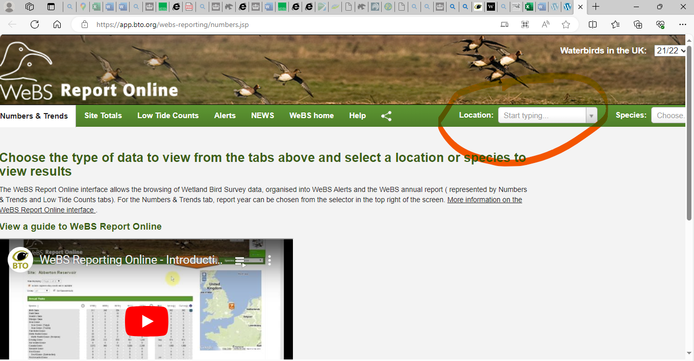

**Q) Do you have the shapefiles for the Vantage point survey areas (Fig2 & Fig3) on page 16 of the RfQ document, for 100% flight coverage (or at least the size of the area for costing)**

A) My colleague will send these across to you.

**Q) Could you clarify regarding 2 or more vantage point surveys? – one in each location or 2 of each?**

A) There are two separate aerial survey components:

1. conduct **one** high precision digital aerial survey of the **entire Morecambe Bay and Duddon Estuary SPA** in December 2023/January 2024 centred around the time of low tide. Ideally the survey should occur on or as close as possible to the date/time when one of the monthly, standard ground-based low tide counts of the estuarine parts of this coastline (Rivers Kent, Leven, Lune & Wyre and Morecambe Bay West (including South Walney & Piel Channel Flats)) will be conducted under a separate contract let by Natural England.
2. conduct **two or more** high precision digital aerial validation surveys of **selected areas of the SPA**.These surveys **must be** coordinated with bespoke low tide ground-based surveys of selected validation sites/low tide count sectors within the SPA that will be conducted under a separate contract let by Natural England specifically for the purpose of this validation exercise.

The reference to “two or more” surveys occurs only in the context of objective b) of the RfQ. The objective is to ensure that, for the purpose of validation of the digital aerial survey findings, each of the sectors mapped in Figures 2 and 3 of the RfQ are flown over **more than once** – **preferably repeatedly** **(twice or more) on a given day** (at the same time as the ground-based surveyors (under another contract) are repeatedly counting birds on the ground). Objective b) in the RfQ contains the following additional clarification text i.e. “*These aerial validation surveys should be undertaken within one day at different stages of tide and delivered either through careful planning of the survey to fulfil objective a) (e.g. surveys might be undertaken on the falling tide, at low tide as part of the whole estuary survey, and on the rising tide) or, if necessary, through a separate digital aerial survey/flight*.”  The scenario mapped out in the RfQ is that the sectors illustrated in Figures 2 and 3 might be flown over initially on a falling tide, and that this would be repeated later the same day at low tide – perhaps as part of the survey of the whole SPA – and repeated a third time on the same day on a rising tide. However, this scenario is aspirational, and it may not be practical to implement given the time required to do three surveys of each of these areas at 100% coverage – hence the phrase “two or more”. **The key point of this objective is that more than a single overflight of all the sectors which are the focus of this validation task must be made on the day on which the validation data are collected**. Bidders are invited to submit survey proposals which they consider are deliverable given the practicalities and cost limitations.

**Q) Should the aerial vantage survey areas be conducted on the same day?**

A) The survey of the entire SPA (Task 1) should be completed in a single day. Similarly,the aerial validation surveys (Task 3) should be undertaken within one day at different stages of tide and delivered either through careful planning of the SPA wide survey (Task 1) (e.g. surveys might be undertaken on the falling tide, at low tide as part of the whole SPA survey, and on the rising tide) or, if necessary, through separate digital aerial surveys/flights. Thus, if it is practical to do so, the survey flights to collect validation data from the areas depicted in Figures 2 and 3 of the RfQ (Task 3) would ideally be collected on the same day as the SPA wide survey (Task 1). However, NE acknowledge that this may not be practical. If bidders consider the flights needed to deliver the validation survey data (task 3) can only take place on a different day to that on which the SPA wide survey is flown (Task 1) this should be made clear in their tender. Similarly if bidders consider that it is impractical to deliver repeated overflights of each of the areas depicted in Figures 2 and 3 on the same day and that this could only be done on different days, they should make this clear in their tender. As noted in the RfQ “*Bidders should explain their approach to delivery of both Tasks 1) and 3).*”

**Q) Should the report include ground vantage point survey results as well?**

A) No. This survey is covered by the other contract: PBDM_WP4_Task4.1_MB&DE_SPA_ground_RFQ