Company Name | AB Print Group
Company Address | 1 Grange Valley Road  Batley  WF17 6GH
Company Contact | Alan Williamson  Alan.Williamson@abprintgroup.com
Description of Company Activity | AB Print Group specialise in Litho, Digital and Screen printing.
Objective of the proposed project (Please explain what is required in the project) (max 250 words) | AB Print Group wishes to select and appoint a suitable Contractor for the design, supply and installation of the 90kWA Solar Panel PV system and invites suppliers to submit a tender to meet our requirements:  - Required PV Solar System Size: 90 kW  - The project value: £60,000  - Roof material = Steel Cladding  - Roof Dimensions = 32m x 34m (1088m2)  - Height to Eaves = 8m  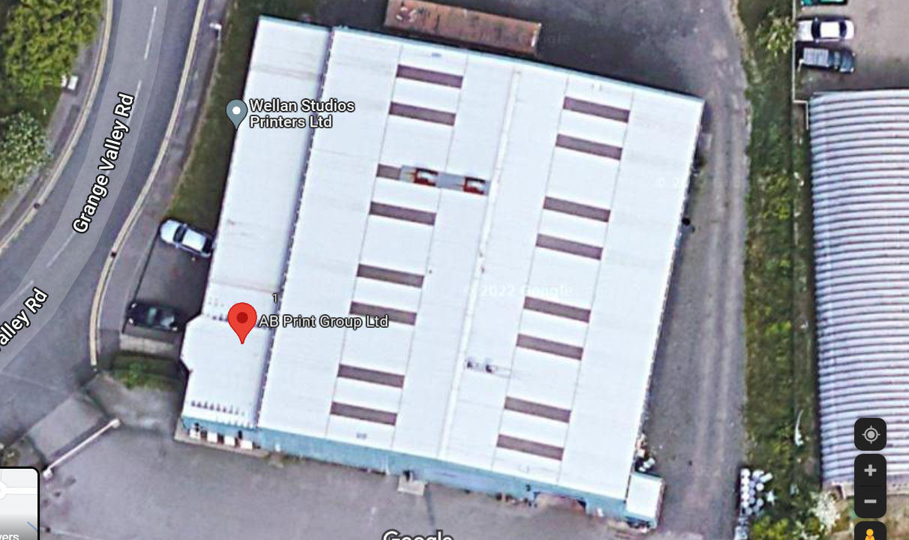
Tenders are Invited from suppliers who can provide the necessary skills and expertise to deliver the specification  Suppliers will be bidding for a project that is part funded by the European Regional Development Fund as part of the European Structural and Investment Growth Programme 2014-2020. | Please submit prices into four sections as per the following  assumptions:  • Solar Panels, framework and inverters.  • Electrical infrastructure work.  • Scaffolding, access, skips, etc.  • Installation and commissioning.  The initial award will be awarded to the highest-scoring provider.  Tenders will be scored using the following scoring scheme.  1. The most competitive Price  2. Warranty  3. Evidence of expertise in fitting  4. Evidence of being able to fit the panel in the time required.  5. The ability to leave natural light rooflights unobscured.  The project is part-funded by the England European Regional Development Fund as part of the European Structural and Investment Funds Growth Programme 2014-2020.  With this invitation to tender, we would like to call on interested parties to assist AB Print Group with this assignment.
Required project timescales (start and duration of project? ) | Project start date: 01/06/2022  Duration: 12 weeks
Total Anticipated Project Value  (Please note that the procurement will only go ahead to contract once the funding has been agreed) | £60,000
Required response date (this must be at least 10 working days from posting of advert) | 25/04/2022 (Assumes it can be put on Contracts Finder by Monday 15/04/2022)
How to apply? Contact SME. | Alan.williamson@abprintgroup.com  Responders will be free to arrange a visit to the premises to survey the property.
Criteria for decision making  (Examples of Assessment Criteria could include:  Price  Expertise fit  Timing Fit  Suitability of proposed methodology)  Weighting of the criteria to be determined by SME
  Criteria | %
  Price | 70
  Warranty | 10
  Expertise fit - Description of previous experience | 5
  Expertise fit – Not covering up rooflights. | 5
  Timing fit – able to complete the work within the required timescales. | 10
  Total | 100
Scoring | Price  The lowest priced tender will score full marks and other tender scores will be calculated on the basis of their deviation from the lowest. For every 1% a price is higher than the lowest, 1% of the score will be deducted from that tenderer’s score. The minimum score will be 0. For example:  Warranty  The highest warranty will score full marks and other tender scores will be calculated on the basis of their deviation from the highest. For every 1% a warranty is lower than the highest, 1% of the score will be deducted from that tenderer’s score. The minimum score will be 0. For example:  Expertise Fit – Description of previous experience / Not covering up rooflights  Quality related criteria will be evidenced through sharing of case-studies / project review documents relating to similar projects completed on other businesses. The ability to not cover up rooflights can be shown using roof plans of where they will be placing the panels. These criteria will be scored on the basis of the following scale:  Timing Fit  Under the terms of the funding, the project needs to be completed within 12 weeks of the Funding Agreement. The anticipated start date will be 09/05/2022. This criteria will be scored on the following scale:
  Lowest gets full marks - all others 1% off the score for every 1% higher than lowest
  Tenderer | Price | Score | % difference
  Tender A | £50,000 | 30 | -
  Tender B | £58,000 | 25 | 16
  Tender C | £75,000 | 15 | 50
  Tender D | £82,000 | 11 | 64
  Tender E | £100,000 | 0 | 100
  Highest gets full marks
  Tenderer | Warranty | Score
  Tender A | Greater than 10 years | 10
  Tender B | Between 5 and 10 years | 8
  Tender C | Less than 5 years | 5
  Tender D | Between 1 and 5 years | 3
  Tender E | No warranty | 0
  100% | In respect of each element of the Services identified in the question, the proposals fully explain how the relevant element will be delivered to the standards required, throughout the term.  The proposals are clear, precise and robust.  The explanation is sufficient to give a high degree of confidence that all of the relevant aspects of the specification will be delivered.
  80% | In respect of each element of the Services identified in the question, the proposals explain how the relevant element will be delivered to the standards required, throughout the term.  The proposals are clear, precise and robust.  The explanation is sufficient to give a high degree of confidence that the relevant aspects of the specification will, for the most part, be delivered. To the extent that the explanation is not sufficient to give that high degree of confidence, the explanation does not raise concerns.
  60% | In respect of each element of the Services identified in the question, the proposals explain, to some extent, how the relevant element will be delivered to the standards required, throughout the term.  The proposals are clear, but there are some concerns around precision and / or robustness.  The explanation is sufficient to give confidence that the relevant aspects of the specification will, for the most part, be delivered. To the extent that the explanation is not sufficient to give that confidence, the explanation raises one or more concerns but no material concerns.
  40% | In respect of each element of the Services identified in the question, the proposals explain, to some extent, how the relevant element will be delivered to the standards required, throughout the term, but for certain elements the explanation is very limited.  There are concerns around the clarity, and around the precision and / or robustness, of the proposals.  The explanation is sufficient to give confidence that the relevant aspects of the specification will be delivered to some extent. To the extent that the explanation is not sufficient to give that confidence, the explanation raises one or more concerns, one of which is a material concern.
  20% | In respect of one or more elements of the Services identified in the question, the proposals fail to explain to any extent how the relevant element will be delivered to the standards required, throughout the term; and / or the proposals are mainly or wholly unclear; and / or the explanation is insufficient to give confidence that the relevant aspects of the specification will be delivered and / or the explanation for any one or more of the elements raises multiple material concerns.
  0% | No response or response is irrelevant to the question asked.
  Highest gets full marks
  Tenderer | Ability to complete work | Score
  Tender A | Within 12 week period | 10
  Tender B | One month over 12 week period | 6
  Tender C | Two months over 12 week period | 3
  Tender D | Over two months over 12 week period | 0
Date for Contract Decision (i.e. how long before the SME will inform the successful respondent) | 29/04/2022

