Request for Quotation

Holton Heath NNR: Royal Naval Cordite Factory Buildings - Access Restriction
Ref: NNR19/0372

07/02/2025

Request for Quotation
Holton Heath NNR: Royal Naval Cordite Factory Buildings - Access Restriction
Ref: NNR19/0372
You are invited to submit a quotation for the requirement described in the specification, Section 2.
Please confirm by email, receipt of these documents and whether you intend to submit a quote or not.
Your response should be returned to the following email address by:
Email: helen.woolley@naturalengland.org.uk
Date: 28/02/2025
Time: 23:59 GMT
Ensure you include the name of the quotation and ‘Final Submission’ in the subject field to make it clear that it is your response.
Contact Details and Timetable
Helen Woolley will be your contact for any questions linked to the content of the quote or the process. Please submit any clarification questions via email and note that, unless commercially sensitive, both the question and the response will be circulated to all tenderers.
Action | Date
Date of issue of RFQ | 07/02/2025 at 15:00 GMT
Deadline for clarifications questions | 21/02/2025 at 17:00 GMT
Deadline for receipt of Quotation | 28/02/2025 at 17:00 GMT
Intended date of Contract Award | 07/03/2025
Intended Contract Start Date | 10/03/2025
Intended Delivery Date | 31/03/2025

Section 1: General Information
Glossary
Unless the context otherwise requires, the following words and expressions used within this Request for Quotation shall have the following meanings (to be interpreted in the singular or plural as the context requires):
“Authority” | means Natural England who is the Contracting Authority.
“Contract” | means the contract to be entered into by the Authority and the successful supplier.
“Response” | means the information submitted by a supplier in response to the RFQ.
“RFQ” | means this Request for Quotation and all related documents published by the Authority and made available to suppliers.

Conditions applying to the RFQ
You should examine your Response and related documents ensuring it is complete and in accordance with the stated instructions prior to submission.
Your Response must contain sufficient information to enable the Authority to evaluate it fairly and effectively. You should ensure that you have prepared your Response fully and accurately and that prices quoted are arithmetically correct for the units stated.
By submitting a Response, you, the supplier, are deemed to accept the terms and conditions provided in the RFQ. Confirmation of this is required in Annex 2.
Failure to comply with the instructions set out in the RFQ may result in the supplier’s exclusion from this quotation process.
Acceptance of Quotations
By issuing this RFQ the Authority does not bind itself to accept any quotation and reserves the right not to award a contract to any supplier who submits a quotation.
Costs
The Authority will not reimburse you for any costs and expenses which you incur preparing and submitting your quotation, even if the Authority amends or terminates the procurement process.
Self-Declaration and Mandatory Requirements
The RFQ includes a self-declaration response (Annex 1) which covers basic information about the supplier, as well as any grounds for exclusion. If you do not comply with them, your quotation will not be evaluated.
Any mandatory requirements will be set out in Section 2, Specification of Requirements and, if you do not comply with them, your quotation will not be evaluated.
Clarifications
Any request for clarification regarding the RFQ and supporting documentation must be submitted via email no later than the deadline for clarifications set out in the Timetable. The Authority shall be under no obligation to respond to queries raised after the clarification deadline.
The Authority will respond to all reasonable clarifications as soon as possible but cannot guarantee a minimum response time. The Authority will publish all clarifications and its responses to all suppliers via email unless deemed commercially sensitive.
If a supplier believes that a request for clarification is commercially sensitive, it should clearly state this when submitting the clarification request. However, if the Authority considers either that:
the clarification and response are not commercially sensitive; and
all suppliers may benefit from its disclosure,

then the Authority will notify the supplier (via email), and the supplier will have an opportunity to withdraw the request for clarification by sending a further message requesting the withdrawal of the clarification request. If not withdrawn by the supplier within 2 working days of the Authority’s notification, the Authority may publish the clarification request and its response to all suppliers and the Authority shall not be liable to the supplier for any consequences of such publication.
The Authority reserves the right to seek clarification of any aspect of a quotation and/or provide additional information during the evaluation phase to carry out a fair evaluation. Where the Authority seeks clarification on any aspect of the quotation, the supplier must respond within the timeframe requested by the Authority.
Amendments
The Authority may amend the RFQ at any time prior to the deadline for receipt. If it amends the RFQ the Authority will notify you via email.
Suppliers may modify their quotation prior to the deadline for Responses. No Responses may be modified after the deadline for Responses.
Suppliers may withdraw their quotations at any time by submitting a notice via the email to the named contact.
Conditions of Contract
The Authority’s Standard Good and Services Terms & Conditions (used for purchases under £50k) can be located on the Natural England Website Procurement at Natural England - Natural England - GOV.UK (www.gov.uk) and will be applicable to any contract awarded as a result of this quotation process. The Authority will not accept any changes to these terms and conditions proposed by a supplier.
Suppliers should note that the quotation provided by the successful bidder will form part of the Contract.
Prices
Prices must be submitted in £ sterling, exclusive of VAT.
Disclosure
All Central Government Departments, their Executive Agencies and Non Departmental Public Bodies are subject to control and reporting within Government. In particular, they report to the Cabinet Office and HM Treasury for all expenditure. Further the Cabinet Office has a cross-Government role delivering overall Government policy on public procurement, including ensuring value for money and related aspects of good procurement practice. For these purposes, the Authority may disclose within Government any details contained in your quotation. The information will not be disclosed outside Government during the procurement.
In addition, the Authority is subject to the Freedom of Information Act 2000 and the Environmental Information Regulations 2004, which provide a public right of access to information held by public bodies. In accordance with these two statutes, the Authority may be required to disclose information contained in your quotation to any person who submits a request for information pursuant to those statutes.
Further to the Government’s transparency agenda, all UK Government organisations must advertise on Contract Finder in accordance with the following publication thresholds:
Central Contracting Authority’s: £12,000
Sub Central Contracting Authority’s and NHS Trusts: £30,000
For the purpose of this RFQ the Authority is classified as a Central Contracting Authority with a publication threshold £12,000 inclusive of VAT.
If this opportunity is advertised via Contracts Finder, we are obliged to publish details of the awarded contract including who has won the contract, the contract value, and indicate whether the winning supplier is a small and medium-sized enterprise (“SMEs”) or voluntary organisation or charity. A copy of the contract must also be published with confidential information redacted.
By submitting a Response, you consent to these terms as part of the procurement.
Disclaimers
Whilst the information in this RFQ and any supporting information referred to herein or provided to you by the Authority have been prepared in good faith the Authority does not warrant that this information is comprehensive or that it has been independently verified.
The Authority does not:
- make any representation or warranty (express or implied) as to the accuracy, reasonableness or completeness of the RFQ;
- accept any liability for the information contained in the RFQ or for the fairness, accuracy or completeness of that information; or
- accept any liability for any loss or damage (other than in respect of fraudulent misrepresentation or any other liability which cannot lawfully be excluded) arising as a result of reliance on such information or any subsequent communication.
Any supplier considering entering into contractual relationships with the Authority following receipt of the RFQ should make its own investigations and independent assessment of the Authority and its requirements for the goods and/or services and should seek its own professional financial and legal advice.

Information Security requirements
The Government Security Classification Policy (GSCP) sets out the administrative system used by HM Government (HMG) to protect information and data assets appropriately against prevalent threats through the use of ‘classification tiers’. HMG uses three classification tiers; OFFICIAL, SECRET and TOP SECRET. Each tier provides a set of recommended baseline behaviours and a set of protective controls, which are proportionate to the threat profile for that tier AND the potential impact of a compromise, accidental loss or incorrect disclosure of information held within that tier.
Tenderers and suppliers must ensure that appropriate protective security controls are in place to comply with the GSCP and manage the information shared and received as part of this tender exercise.
A full suite of guidance documents is available on GOV.UK, with specific guidance for tenderers and suppliers set out in Guidance 1.6 - Contractors and Contracting Authorities.docx (publishing.service.gov.uk).
Use of Artificial Intelligence
The Authority expects suppliers to declare where they have used AI software in the creation of Tender responses or intend to use AI software in the performance of the contract. How any AI software was, or will be, used should be to be declared within the technical submission part of the tender. We may require you to answer specific question/s on this topic, particularly where the Authority expects that usage is highly likely or clearly relates to the contract requirements.
Suppliers must follow any guidelines or regulations related to AI use and declarations as indicated in the PPN 2/24 Improving Transparency of AI use in Procurement.
Any information, instructions, or data provided by the Authority to suppliers as part of this tender, the requirements, or contract should not be directly inserted into Generative AI software (such as Gemini, ChatGPT, or CoPilot) without prior permission, unless this information is clearly published in the public domain.
Use of any Authority confidential tender information for training AI software is prohibited. it is advised that Defra’s data or instructions, or anything marked as confidential should not be directly inserted into AIs. For example, putting Authority’s instruction email into Gemini, ChatGPT, or CoPilot is not recommended.
If you intend to use AI to provide goods or services to the Authority, then you are required to complete a declaration which is simply answering the question stated within the 'Information to be returned’. The answer to this question will not be used in scoring your quote.
Protection of Personal Data
In order to comply with the General Data Protection Regulations 2018 the supplier must agree to the following:
- You must only process any personal data in strict accordance with instructions from the Authority.
- You must ensure that all the personal data that we disclose to you or you collect on our behalf under this agreement are kept confidential.
- You must take reasonable steps to ensure the reliability of employees who have access to personal data.
- Only employees who may be required to assist in meeting the obligations under this agreement may have access to the personal data.
- Any disclosure of personal data must be made in confidence and extend only so far as that which is specifically necessary for the purposes of this agreement.
- You must ensure that there are appropriate security measures in place to safeguard against any unauthorised access or unlawful processing or accidental loss, destruction or damage or disclosure of the personal data.
- On termination of this agreement, for whatever reason, the personal data must be returned to us promptly and safely, together with all copies in your possession or control.
General Data Protection Regulations 2018
For the purposes of the Regulations the Authority is the data processor.
The personal information that we have asked you provide on individuals (data subjects) that will be working for you on this contract will be used in compiling the tender list and in assessing your offer. If you are unsuccessful the information will be held and destroyed within two years of the award of contracts. If you are awarded a contract it will be retained for the duration of the contract and destroyed within seven years of the contract’s expiry.
We may monitor the performance of the individuals during the execution of the contract, and the results of our monitoring, together with the information that you have provided, will be used in determining what work is allocated under the contract, and in any renewal of the contract or in the award of future contracts of a similar nature. The information will not be disclosed to anyone outside the Authority without the consent of the data subject, unless the Authority is required by law to make such disclosures.
Equality, Diversity & Inclusion (EDI)
The Client is striving to create a diverse and inclusive working environment where every individual has equality of opportunity to progress and to apply their unique insights to making the UK a great place for living. The Service Provider is expected to respect this commitment in all dealings with Natural England staff and service users.
Suppliers are expected to;
- support Defra group to achieve its Public Sector Equality Duty as defined by the Equality Act 2010, and to support delivery of Defra group’s Equality & Diversity Strategy.
- meet the standards set out in the Government’s Supplier Code of Conduct
- work with Defra group to ensure equality, diversity and inclusion impacts are addressed (positive and negative) in the goods, services and works we procure, barriers are removed and opportunities realised.
Sustainable Procurement
Addressing global sustainability impacts and realising additional community benefits within commercial activity is core to Defra group’s approach, working with its supply chain is key to achieving sustainable outcomes. In addition to supporting Defra group to meet its outcomes we look to understand and reduce negative sustainability impacts associated with our commercial activity and realise benefits.
The Client encourages its suppliers to share these values, work to address negative impacts and realise opportunities, measure performance and success.
Suppliers are expected to have an understanding of the Sustainable Development Goals, the interconnections between them and the relevance to the Goods, Services and works procured on the Client’s behalf
Conflicts of Interest
The concept of a conflict of interest includes but is not limited to any situation where an Involved Person or Relevant Body has directly or indirectly, a financial, economic or other personal interest which might be perceived to compromise their impartiality and independence in the context of the procurement procedure and/or affect the integrity of the contract award.
We expect suppliers to mitigate appropriately against any real or perceived conflict of interest through their work with government. A supplier with a position of influence gained through a contract should not use that position to unfairly disadvantage any other supplier or reduce the potential for future competition
Where the supplier is aware of any circumstances giving rise to a conflict of interest or has any indication that a conflict of interest exists or may arise you should inform the Authority of this as soon as possible (whether before or after they have submitted a quotation). Tenderers should remain alert to the possibility of conflicts of interest arising at all stages of the procurement and should update the Authority if any new circumstances or information arises, or there are any changes to information already provided to the Authority. Failure to do so, and/or to properly manage any conflicts of interest may result in a quotation being rejected.
Provided that it has been carried out in an open, fair and transparent manner, routine pre-market engagement carried out by the Authority should not represent a conflict of interest for the supplier.

Section 2: The Invitation
Specification of Requirements
- Background to Natural England

Natural England is the government’s advisor on the natural environment. We provide practical advice, grounded in science, on how best to safeguard England’s natural wealth for the benefit of everyone. Our remit is to ensure sustainable stewardship of the land and sea so that people and nature can thrive. It is our responsibility to see that England’s rich natural environment can adapt and survive intact for future generations to enjoy.

- Background to the specific work area relevant to this purchase

Holton Heath National Nature Reserve

Holton Heath National Nature Reserve (NNR) is in East Dorset approximately 2km northeast of Wareham, . The NNR consists of three sites grouped closely together on the edge of Poole Harbour, on part of the former Royal Naval Cordite Factory which produced high-grade propellants for naval shells during the First and Second World Wars. These are known as Holton North, Holton South and Sandford Heath, where the 2 former sites have no public access due to the past industrial heritage and contaminated land issues.

The NNR comprises a variety of lowland heathland habitats (wet, dry and humid heath), coniferous and deciduous woodland, reedbed, and intertidal foreshore. Holton Heath NNR is designated as a Site of Special Scientific Interest (SSSIs) and also forms part of the Dorset Heathlands Special Protection Area (SPA), Dorset Heaths Special Area of Conservation (SAC) and Ramsar site.

Royal Naval Cordite Factory (RNCF) Holton Heath

The former cordite factory is also designated as a Scheduled Monument by Historic England (HE) and includes the earthworks, buried remains, foundations, ruins and standing buildings of the former Royal Naval Cordite Factory (RNCF) Holton Heath within three separate areas of protection. This purpose-built complex was principally in operation between 1916 and 1945 and is situated on lowland heathland and was an extensive complex covering approximately 200ha. It was equipped to be largely self-sufficient, with the various ingredients necessary for cordite production being manufactured on-site and transported by a railway network. The site was physically organised according to process and risk and was essentially divided into different factory departments through which the manufacturing process flowed. Many of the structures on site were built of timber or brick, and many have been demolished. There are, however, extant structures of concrete and/or brick, footings and extensive earthwork remains.

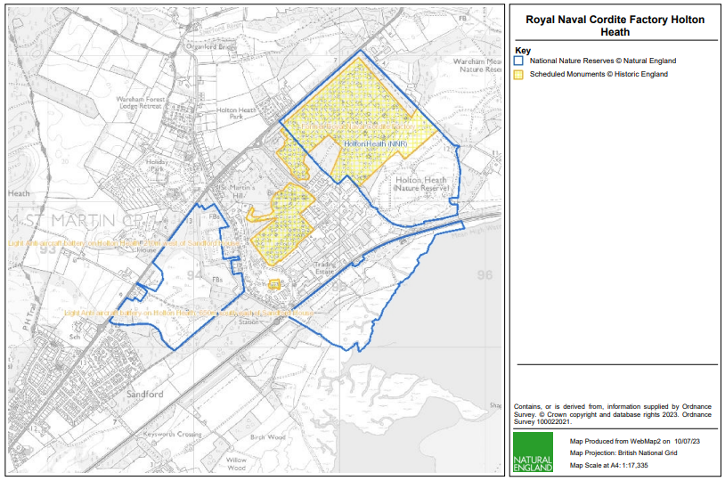
Figure 1: Holton Heath National Nature Reserve (NNR) and Royal Naval Cordite Factory (RNCF) Holton Heath Scheduled Monument.

Holton Heath NNR and the Scheduled Monument

The largest of the three areas of the scheduled monument lies in the Holton North section of the NNR, and comprises an extensive area of standing buildings, footings, and earthworks. Due to issues of residual contamination, particularly asbestos, there has been little active management of the heathland or preservation of the buildings over the years, resulting in the buildings declining in condition and becoming overgrown with vegetation. Due to the concerns around residual land contamination, there is no public access to Holton North and the site is fenced off to prevent unauthorised public access.

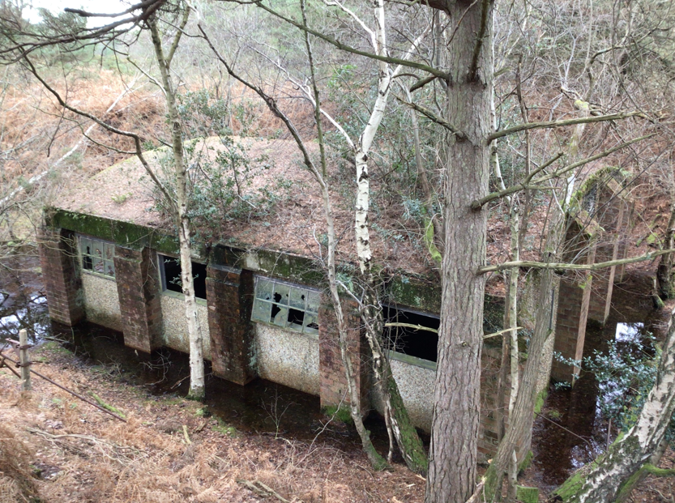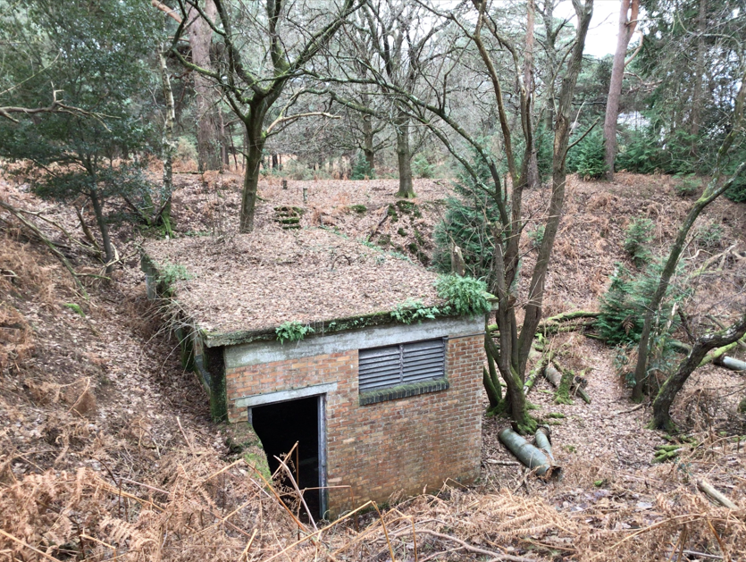
Figure 2: Standing buildings of the former RNCF Holton Heath (Photos: ©Natural England/ Steve Hall).

This decline in condition of the scheduled monument has led Historic England to place the site on the Heritage at Risk Register. Discussions between Natural England and Historic England have led to an agreed course of action to eventually remove it from the At-Risk Register. The buildings will be allowed to continue to decline over time in a managed process, with building recording and suitable interpretation providing a record of the factory complex to enable removal from the Heritage at Risk Register.

- Requirement

Context of Requirement

Although the Holton North site is fenced off with security fencing to prevent unauthorised public access, there are occasional breaches of this fence, with people then accessing the buildings which often no longer retain doors or windows. There are concerns for the safety of any people who access the buildings, particularly as they are allowed to decline in condition.
Over the years, the site was contaminated with a range of heavy metals, explosives residues, other chemicals and asbestos. Exposure to any of the site contaminants is hazardous to health. Asbestos was used extensively on the site and in many forms and is the main and most hazardous contaminant. Inhalation of asbestos fibres can cause serious long term health conditions some of which can be fatal. Much of the asbestos was associated with the buildings on site, and much of the asbestos was used to lag steam pipes around the site (often contained in brick lined trenches). The site has been surveyed and risk assessed, and over a number of years much of the asbestos has been removed. Today most of the remaining asbestos is in the form of discarded or dumped debris, but some also remains in buildings and some of the brick lined trenches.
All personnel attending the site will undertake the Holton Heath site induction and the Asbestos and Chemical Contamination Induction. High earth bunds and easily accessible heights with excessive and potentially fatal drops are particularly prevalent on Holton North; avoid these areas wherever possible.
Natural England wish to have metal shuttering/ bars, as appropriate, designed, fabricated and installed across the open doorways of buildings at the former Royal Naval Cordite Factory, Holton Heath NNR, to prevent unauthorised access. This is intended to be undertaken as a Design and Build contract.

The requirement is to provide a design pack and scope to enable the tender and construction.

All installation to be external to building and to still permit access through one entrance (the primary entrance) once installed. Metal hatch/roller shutter as appropriate for the primary access to each building- these to have means to be locked/ secured to allow NE access. The rest bar grills (with bar spacings designed to accommodate wildlife access).

Openings detailed in “NNR19-0372 Holton Heath NNR- RNCF Building Openings”- these are not intended to be final measurements and are an indication of scale and scope to inform tenders. Contractor to take measurements of their own for design.
Design of structures to be undertaken in consultation with Natural England, with Natural England to review and approve designs.
All site visits must be arranged with the East Dorset NNR Team and accompanied by NNR staff as the site is closed to the public. All site visitors will need to complete a Site Induction and comply with the measures lain out within. Site visits to be arranged with:

James Hitchen
Reserve Manager
East Dorset NNRs
Mobile: 07795634990

Summary of Requirement

Natural England wish to have metal shuttering/ bars, as appropriate, designed, fabricated and installed across the open doorways of buildings at the former Royal Naval Cordite Factory, Holton Heath NNR, to prevent unauthorised access. This is intended to be undertaken as a Design and Build contract.

The requirement is to provide a design pack and scope to enable the tender and construction.
Output

The design pack and scope to enable the tender and construction.
The following previously commissioned reports will be made available to the successful contractor to aid in the preparation of the contractor’s method statement and risk assessment:

Holton Heath NNR Site-Based Risk Assessment
Holton and Sandford Heaths Hazard Map
Holton and Sandford Heaths Fire Plan
Structural Report on the Condition of the Buildings Holton Heath NNR
Asbestos Survey- Buildings Holton Heath NNR
Asbestos Management Plan Holton Heath NNR
Asbestos Management Plan Figures Holton Heath NNR
Building surveys – Summary Report Holton Heath NNR
The reports should in the first instance be presented as an electronic version (MS Word or PDF). A hard copy may also be presented if this is standard for the contractor/ consultant, but Natural England’s corporate document storage system requires an electronic version.

Any hard copy should be sent to:

F.A.O. Steve Hall
Natural England Mail Hub
Natural England
Foss House
Kings Pool
1-2 Peasholme Green
YORK
YO1 7PX

- Materials and equipment

All labour, materials and equipment to be provided by the contractor.

- Health and Safety

All work is to be carried out with full regard to the safety of the workforce, any visitors to the work site and the general public. A risk assessment specific to this work is to be completed and approved by Natural England before work begins. The quotation must indicate whether any working at height may be involved (including low-level ladder inspection). Natural England will provide information about individual site hazards to inform contractor’s risk assessments.

Payment
The Authority will raise purchase orders to cover the cost of the services and will issue to the awarded supplier following contract award.
The Authority’s preference is for all invoices to be sent electronically, quoting a valid Purchase Order number. The contractor may invoice for the works once the final report is submitted to Natural England.
It is anticipated that this contract will be awarded to end no later than 31/03/2025. Prices will remain fixed for the duration of the contract award period. We may at our sole discretion extend this contract to include related or further work. Any extension shall be agreed in writing in advance of any work commencing and may be subject to further competition.
Evaluation Methodology
We will award this contract in line with the most economically advantageous tender (MEAT) as set out in the following award criteria:
Technical – 60%
Commercial – 40%
Evaluation criteria
Evaluation weightings are 60% technical and 40% commercial, the winning tenderer will be the highest scoring combined score.
Award Criteria | Weighting (%) | Evaluation Topic & Weighting | Sub-Criteria | Weighted Question
Technical | 60% | Service Proposal | Methodology | 1 Question  Q1 (40% of technical score available)
Technical | 60% | Service Proposal | Skills, knowledge and experience | 2 Questions  Q2.1 (50% of technical score available)  Q2.2 (10% of technical score available)
Commercial | 40% | Whole life cost of the proposed Contract | Commercial Model | 1 Question  Q4 (100% of commercial score available)

Technical (60%)
Technical evaluations will be based on responses to specific questions covering key criteria which are outlined below. Scores for questions will be based on the following:
Description | Score | Definition
Very good | 100 | Addresses all the Authority’s requirements with all the relevant supporting information set out in the RFQ. There are no weaknesses and therefore the tender response gives the Authority complete confidence that all the requirements will be met to a high standard.
Good | 70 | Addresses all the Authority’s requirements with all the relevant supporting information set out in the RFQ. The response contains minor weaknesses and therefore the tender response gives the Authority confidence that all the requirements will be met to a good standard.
Moderate | 50 | Addresses most of the requirements with most of the relevant supporting information set out in the RFQ. The response contains moderate weaknesses and therefore the tender response gives the Authority confidence that most of the requirements will be met to a suitable standard.
Weak | 20 | Substantially addresses the requirements but not all and provides supporting information that is of limited or no relevance or a methodology containing significant weaknesses and therefore raises concerns for the Authority that the requirements may not all be met.
Unacceptable | 0 | No response or provides a response that gives the Authority no confidence that the requirement will be met.

Technical evaluation is assessed using the evaluation topics and sub-criteria stated in the Evaluation Criteria section above.
Separate submissions for each technical question should be provided and will be evaluated in isolation. Tenderers should provide answers that meet the criteria of each technical question.

Methodology | Detailed Evaluation Criteria
Q1 Demonstrate an understanding of the requirement and provide detail of how the requirement will be met. | Outline how the requirement will be achieved, demonstrating a clear understanding of the nature of the requirements. Provide information in sufficient detail to allow a full appraisal of the suitability of the approach to deliver for the project.

Skills, knowledge, and experience | Detailed Evaluation Criteria
Q2.1 Demonstrate that you have the skills, knowledge, and experience to undertake this contract. | 1) Evidence of recent and relevant experience of structural survey and evaluation of building condition and design of structures/fittings relating to historic buildings or structures, particularly former industrial or military buildings. Evidence of working in protected sites and landscapes.  2) Evidence of expertise/ competence of staff including evidence of Surveyor/ Structural Engineer/ Architect/ or Conservation Architect industry recognised memberships, organisational registration or individual accreditation eg:  • Institute of Structural Engineers (ISE)  • Institute of Chartered Engineers (ICE)  - • Royal Institute of Chartered Surveyors (RICS)
Q2.2. Provide evidence of organisational Health and Safety management and certification. | All construction contractors engaged by Natural England should hold a valid Safety Schemes In Procurement (SSIP) certification or ISO 45001 accreditation in the correct trade and scope. All other contractors should be able to demonstrate a H&S system to the equivalent of SSIP certification and must complete a Natural England Contractor Competence Questionnaire.  Provide evidence of suitable certification/ accreditation and/ or organisation H&S policy.

Commercial (40%)
The Contract is to be awarded as a fixed price which will be paid according to the completion of the deliverables stated in the Specification of Requirements.
Suppliers are required to submit a total cost to provide the deliverables stated in the Specification of Requirements. In addition to this the Commercial Response template must be completed to provide a breakdown of the whole life costs against each deliverable used in the delivery of this requirement
Calculation Method
The method for calculating the weighted scores is as follows:
Commercial
Score = (Lowest Quotation Price / Supplier’s Quotation Price ) x 40% (Maximum available marks)
Technical
Score = (Bidder’s Total Technical Score / Highest Technical Score) x 60% (Maximum available marks)
The total score (weighted) (TWS) is then calculated by adding the total weighted commercial score (WC) to the total weighted technical score (WT): WC + WT = TWS.
Information to be returned
Please note, the following information requested must be provided. Incomplete tender submissions may be discounted.
Please complete and return the following information:
- completed Commercial Response template
- separate response submission for each technical question (in accordance with the response instructions)
- complete AI question [ ''Do you use Artificial Intelligence (AI) or machine learning tools, including large language models within your quote submission or service delivery processes.?''] response which will not be scored, is to be returned within technical response
- completed Mandatory Requirements (Annex 1)
- completed Acceptance of Terms and Conditions (Annex 2)
Award
Once the evaluation of the Response(s) is complete all suppliers will be notified of the outcome via email.
The successful supplier will be issued the contract, incorporating their Response, for signature. The Authority will then counter sign.

Annex 1 Mandatory Requirements
Part 1 Potential Supplier Information
Please answer the following self-declaration questions in full and include this Annex in your quotation response.
Part 1.1 Potential Supplier Information:
Question no. | Question | Response
1.1(a) | Full name of the potential supplier submitting the information
1.1(b) | Registered office address (if applicable)
1.1(c) | Company registration number (if applicable)
1.1(d) | Charity registration number (if applicable)
1.1(e) | Head office DUNS number (if applicable)
1.1(f) | Registered VAT number
1.1(g) | Are you a Small, Medium or Micro Enterprise (SME)? | (Yes / No)
Note: See EU definition of SME https://ec.europa.eu/growth/smes/business-friendly-environment/sme-definition_en
Part 1.2 Contact details and declaration
By submitting a quotation to this RFQ I declare that to the best of my knowledge the answers submitted and information contained in this document are correct and accurate.
I declare that, upon request and without delay you will provide the certificates or documentary evidence referred to in this document.
I understand that the information will be used in the selection process to assess my organisation’s suitability to be invited to participate further in this procurement.
I understand that the authority may reject this submission in its entirety if there is a failure to answer all the relevant questions fully, or if false/misleading information or content is provided in any section.
I am aware of the consequences of serious misrepresentation.

Question no. | Question | Response
1.2(a) | Contact name
1.2(b) | Name of organisation
1.2(c) | Role in organisation
1.2(d) | Phone number
1.2(e) | E-mail address
1.2(f) | Postal address
1.2(g) | Signature (electronic is acceptable)
1.2(h) | Date

Part 2 Exclusion Grounds
Part 2.1 Grounds for mandatory exclusion
Question no. | Question | Response
2.1(a) | Please indicate if, within the past five years you, your organisation or any other person who has powers of representation, decision or control in the organisation been convicted anywhere in the world of any of the offences within the summary below.
 | Participation in a criminal organisation. | (Yes / No)  If yes please provide details at 2.1 (b)
 | Corruption. | ((Yes / No)  If yes please provide details at 2.1 (b)
 | Fraud. | (Yes / No)  If yes please provide details at 2.1 (b)
 | Terrorist offences or offences linked to terrorist activities | (Yes / No)  If yes please provide details at 2.1 (b)
 | Money laundering or terrorist financing | (Yes / No)  If yes please provide details at 2.1 (b)
 | Child labour and other forms of trafficking in human beings | (Yes / No)  If yes please provide details at 2.1 (b)
2.1(b) | If you have answered yes to question 2.1(a), please provide further details.  Date of conviction, specify which of the grounds listed the conviction was for, and the reasons for conviction.  Identity of who has been convicted  If the relevant documentation is available electronically please provide the web address, issuing authority, precise reference of the documents.
2.1 (c) | If you have answered Yes to any of the points above have measures been taken to demonstrate the reliability of the organisation despite the existence of a relevant ground for exclusion? (i.e. Self-Cleaning) | (Yes / No)
2.1(d) | Has it been established, for your organisation by a judicial or administrative decision having final and binding effect in accordance with the legal provisions of any part of the United Kingdom or the legal provisions of the country in which the organisation is established (if outside the UK), that the organisation is in breach of obligations related to the payment of tax or social security contributions? | (Yes / No)
2.1(e) | If you have answered yes to question 2.3(a), please provide further details. Please also confirm you have paid or have entered into a binding arrangement with a view to paying, the outstanding sum including where applicable any accrued interest and/or fines.

Part 2.2 Grounds for discretionary exclusion
Question no. | Question | Response
2.2(a) | The detailed grounds for discretionary exclusion of an organisation are set out on this webpage, which should be referred to before completing these questions.  Please indicate if, within the past three years, anywhere in the world any of the following situations have applied to you, your organisation or any other person who has powers of representation, decision or control in the organisation
2.2(b) | Breach of environmental obligations? | (Yes / No)  If yes please provide details at 2.2 (f)
2.2(c) | Breach of social obligations? | (Yes / No)  If yes please provide details at 2.2 (f)
2.2(d) | Breach of labour law obligations? | (Yes / No)  If yes please provide details at 2.2 (f)
2.2(e) | Shown significant or persistent deficiencies in the performance of a substantive requirement under a prior public contract, a prior contract with a contracting entity, or a prior concession contract, which led to early termination of that prior contract, damages or other comparable sanctions? | (Yes / No)  If yes please provide details at 2.2 (f)
2.2 (f) | If you have answered Yes to any of the above, explain what measures been taken to demonstrate the reliability of the organisation despite the existence of a relevant ground for exclusion? (Self Cleaning)

Annex 2 Acceptance of Terms and Conditions
I/We accept in full the terms and conditions appended to this Request for Quote document.
Company ____________________________________________________
Signature ____________________________________________________
Print Name ____________________________________________________
Position ____________________________________________________
Date ____________________________________________________

