

REQUEST FOR INFORMATION

Table of Contents
1. Introduction 3
Disclaimer and conditions 3
Freedom of Information and transparency 3
2. Company Introduction 4
3. Our current service 5
4. What are we looking for 5
5. Why we are undertaking a soft market exercise 6
6. Instructions for Correspondents 7
RFI Timetable 8
Procurement Timetable 8
Clarification Questions & Submissions 8
Points of Contact 9
Format of Responses 9
7. KEY QUESTIONS 9

CUSTOMER: The Insolvency Service
START DATE: 10/07/2017
DATE RESPONSE REQUIRED: 28/07/2017

Introduction

This Request for Information (RFI) seeks information relating to The Insolvency Service requiring a continuity of service for Desktop Services, Hosting of Applications, Identity Management and Service Management at the end of the existing contract in May 2019.

This RFI document outlines a number of broad requirements and the Authority would like feedback from the market in meeting them.

Disclaimer and conditions
No information contained in this RFI, or in any communication made between the Authority and any Responder in connection with this RFI, shall be relied upon as constituting a contract, agreement or representation that any contract will necessarily be offered.

The Authority reserves the right, subject to compliance with the Regulations, to change without notice the basis of, or the procedures for, the competitive tendering process or to terminate the process at any time.

Under no circumstances shall the Authority incur any liability in respect of this RFI or any supporting documentation and the Authority will not reimburse any costs incurred by Responders or potential Responders in connection with preparation and/or submission of their responses to this RFI.

Freedom of Information and transparency
The Authority is committed to open government and to meeting its legal responsibilities under the Freedom of Information Act (FOIA) 2000. Accordingly, all information submitted to a public authority may need to be disclosed by the public authority in response to a request under the Act. The Authority may also decide to include certain information in the publication scheme, which it maintains under the Act.

If a responder considers that any of the information included in its response is commercially sensitive, please identify the information and explain what harm may result from disclosure if a request is received, and the time period applicable to that sensitivity. Responders should be aware that, even where they have indicated that information is commercially sensitive, the authority might be required to disclose it under the Act if a request is received.

Organisation Introduction

The Insolvency Service is an executive agency of the Department for Business, Energy and Industrial Strategy (BEIS) and supports the delivery of the BEIS vision of strong, sustainable and balanced growth. It is also the regulator for the insolvency sector in England and Wales.

The Insolvency Service is the Government agency that provides an internationally respected insolvency regime that helps rescue struggling businesses and allows those in debt to make a fresh start. Our core purpose is to deliver confidence in the market place through supporting those in financial distress, tackling misconduct and maximising returns to creditors. We provide the framework to deliver public services that deal with personal and corporate insolvency and misconduct that can accompany or lead to it. Through this work we collaborate with range of partners from the corporate sector and a number of Whitehall Departments. At the core of our functions are the following responsibilities:

- Administer and investigate the affairs of bankrupts and companies in compulsory liquidation
- Establish the reasons for the insolvency
- Deal with the disqualification of unfit directors in all corporate failures and the extended restrictions of bankrupts for misconduct
- Tackle wider corporate abuse which can lead to market distortion

The agency employs c. 1,500 employees spread across 22 sites with a budget of ~£105million delivered from a mix of fee income, BEIS funding and other funding sources.

As an executive agency we have a number of business areas, outlined below.

Business Area | Function
Official Receiver Services (ORS) | Undertakes the administration of bankruptcies and compulsory liquidations; acts as Trustee in bankruptcy and Liquidator of insolvent company estates, realising assets for the benefit of creditors; and enforces the insolvency regime through targeted sanctions and appropriate enforcement action.
Investigation & Enforcement Services (IES) | Delivers a range of investigation and enforcement activities to support fair and open markets.
Redundancy Payments Service (RPS) | Makes payment of statutory redundancy, along with certain contractual debts, from the National Insurance Fund (NIF) owed to ex-employees of, mainly, insolvent employers.
Estate Accounting Services | Provides a number of different administration, banking and scanning functions for the Insolvency Service, Insolvency Practitioners and the general public.
Debt Relief Order (DRO) Team | Responsible for the administration and management of debt relief orders.
Adjudicator Team | The Adjudicator Team will determine applications for debtor petition bankruptcy, removing that function from the Courts. Once the bankruptcy order has been made, the case will be referred to ORS to deal with the administration and any investigation and enforcement.
Insolvency Practitioner Regulation Services | Overall responsibility for monitoring the activities of the bodies that authorise insolvency practitioners and improving standards within the insolvency profession.
Long Term Asset and Distribution Team (LTADT) | Deals with the realisation of long term assets in ORS cases including properties, income payments agreements, pensions, PPI compensation and shares. Distributes any funds realised to creditors.
Insolvency Policy | Responsibility for ensuring the insolvency system remains fair, open and effective, thus ensuring that confidence in the regime is maintained

Information on insolvency statistics and our Annual Plan can be found under the “About Us” section on the Insolvency Service section of the GOV.UK website.

https://www.gov.uk/government/organisations/insolvency-service

Our current service
The majority of our IT Services are provided by a single supplier.
The bulk of the agency’s IT applications and systems are hosted within a secure data centre of the service provider. This includes identity access management, security, service management and help desk. This contract is due to expire in May 2019.

The desktop solution is also provided by the above service provider. These desktop services include desktop equipment, productivity tools (currently Microsoft Office and Outlook), printers and scanners.
The desktop and hosting project is looking to identify and source replacement for all these services

What are we looking for
The Insolvency Service requires a stable and viable desktop solution to support the agency strategy and enable:
- Location independent working
- Home working
- Field based working
- Provide a hosting solution that meets agency needs and aligns with the agency’s future strategies

The primary objectives are to deliver improvements that reflect user requirements, improve flexibility and efficiency that will support future strategies. We are also aiming to provide a service that enables more mobile, location independent working.

The new services should give us the ability to respond quicker to change, plan for and utilise new technologies as they become available while maintaining the appropriate level of security. The transition to the new service and any future improvements are expected to be delivered in a flexible and incremental manner.

Why we are undertaking a soft market exercise

The Insolvency Service is undergoing a significant period of change to transform itself into a more efficient and effective organisation to ensure greater financial stability in the long term. The agency is defining a Target Operating Model (TOM), to be adopted over a four-year period, modernising current operations and processes to achieve an efficient and consistent service to the agency’s clients. A key element of that transformation to the new operating model will be delivery of a desktop and hosting solution.

As part of the work to build a sustainable organisation, we are seeking stability for critical core services, particularly desktop and hosting which is essential for the agency to operate. With the ability to be flexible, react in a timely and cost effective way to meet organisational changes required to implement the TOM.

The aim of this Request for Information is to:
- Determine and understand the market interest to deliver these services.
- How these services could be grouped
- Understand how the service/s could be potentially delivered and managed in order to support efficiency improvements and delivery of benefits to users / staff.
- Understand the different costing models available.
- Options in delivering the services including full hosting provision as an alternative to Infrastructure as a service, Platform as a service and Software as a service. Annex A contains details of current number of servers etc.

The required capabilities are summarised in the diagram below and in more detail in the table
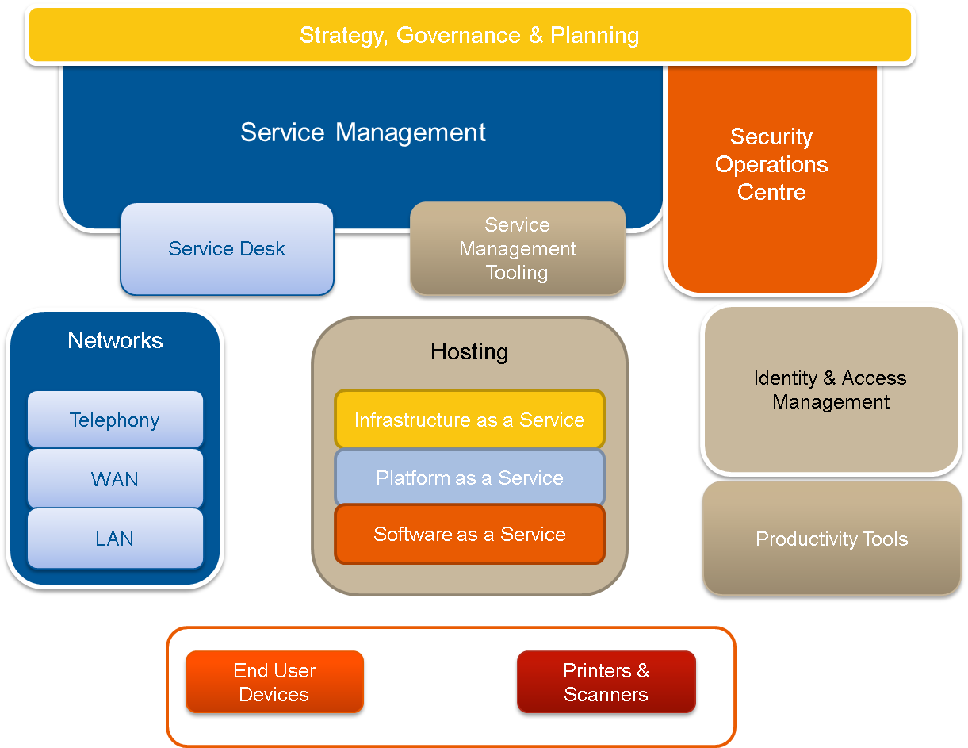
N.B – the Networks (Telephony, WAN and LAN) are not included in this RFI.
Capability | Description | Sourcing considerations
Strategy, Governance & Planning | This capability provides the alignment of IT strategy with the agency’s strategic goals, governance of all I&T services, architecture and related planning. The I&T Directorate is accountable for these capabilities. | This will be retained within the organisation as the accountability related to these services cannot be out-sourced.
Service Management | The service management capability provides the ability to manage all I&T services across the estate and consolidates services across all service providers, both internal and external. The service management function is supported by Service Desk and Service Management Tool (SMT). In view of disaggregation of applications to various cloud platforms (see Hosting below), the service management capability needs to be able to co-ordinate and integrate different service components to provide a unified, end-to-end service to the users, both within and external to INSS. | The service management capability can either be in-house or outsourced. If out-sourced, an internal INSS service management team will be retained to govern the service provided by the outsourced service provider. If it is in-house, the required tooling and support services, like the Service Desk and the Service management tool, may still be outsourced.
Service Desk (SD) | The service desk enables service management to receive calls and help users resolve minor issues. This capability is manned with individuals. The number of individuals required is generally measured as a ratio of total number of users they need to support, i.e., number of users in INSS. | The pricing can be on the basis of manned stations, as above, or based on the calls handled.  The service desk capability can be separate to the service management.
Service Management Tool (SMT) | The service management tool enables the end to end service management capability. It is for use by all the functions within SM, and users within INSS. | As the service management needs to consolidate and integrate various service components each potentially provided by different service providers, a single SMT owned and used at the top level service management helps create an end-to-end, integrated service.  The procurement of the SMT is partly dependent on how SM and SD capabilities are provided / procured.
Security Operations Centre (SoC) | The security operations centre accesses all alerts and messages from across the systems to identify potential security events and correlate them to potential incidents. They also provide security incident response in conjunction with SM | The SOC is a specialist capability but needs to work closely with SM. Similar to SM, it should have the ability to monitor alerts and identify events from diverse service providers and platforms.
Networks | The networks capability includes all connectivity including Telephony, WAN & LAN. | This is currently being procured and is not included in the current procurement. However, the SM will need to manage these services as well.
Hosting | Hosting capability refers to the hosting of the application services. The intention is to procure all of the service through various Cloud (as a service) services. This will disaggregate the applications to multiple service providers with varying service levels, interface standards and charging methods. | Due to disaggregation, it is expected that there will be multiple service providers.
Hosting – Software as a Service (SaaS) | This is the first preference for each of the application. With the Software as a Service, INSS will only need to manage the application configuration with all the support services to users. The service provider will be responsible for managing all the enabler services. | Feasibility for hosting applications in SaaS is underway.
Hosting – Platform as a Service (PaaS) | This is the second preference and is to be considered only if a SaaS service is not available for the application. This provides all the required software services such as databases, application servers etc. required by an application. | Feasibility for hosting applications in PaaS is underway.
Hosting – Infrastructure as a Service (IaaS) | This is the last option and is to be considered if neither SaaS nor PaaS services are available for an application. | We already have some services with a IaaS provider which will remain with the provider.
Identity and Access Management (IAM) | The Identity and Access management capability provides the identity directories, authentication and authorisation capabilities consumed or used by other applications and services across INSS.
Productivity Tools (PT) | The productivity tools are the common set of software tools used for creating, read and editing documents, basic analysis of data etc. that users require to perform as part of their business activities. The File Storage capability enables these files to be stored. It also includes communication tools such as Email & Messaging | The productivity tools can be a cloud service, accessed through a browser or an application on the device or combinations that enable both offline & online access and editing of documents.
End User Devices (EUDs) | This capability provides the physical devices to end users using which they can access the applications and tools. This includes the devices and related accessories such as Displays, keyboards & mice.
Multi-Function Devices (MFDs) | This capability provides printing, scanning, copying and fax capabilities through multifunction devices as part of general office requirements. It does not include specialist scanning or printing capabilities.

This is an indication of the current hosting infrastructure for desktop support, business applications and other support services:
Environment | Quantity | Physical / Virtual
Dev | 5 | Virtual
Development (non-ASC) | 16 | Virtual
Production | 7 | Large Physical Blade
Production | 6 | Medium Physical Blade
Production | 1 | Physical
Production | 141 | Virtual
Production | 9 | Other
Proving/Testing | 4 | Physical
Proving/Testing | 92 | Virtual
Proving/Testing / IAZ | 1 | Virtual
Other | 10 | Virtual

The information gathered as part of this soft market test will be used to inform the outline business case for the future service.

Instructions for Suppliers
The RFI is issued solely for the purpose of conducting market engagement and does not constitute any commitment by the Authority to undertake any procurement exercise in the future. This exercise includes no element of supplier evaluation. No parties will be prejudiced by any response of failure to respond to this questionnaire, there is no commitment of any kind involved on either side.
This RFI does not constitute a call for competition to procure any services and the Authority is not bound by any proposal offered. The authority is also not liable for any costs, fees or expenses incurred by any party in its response to this soft market testing questionnaire.

RFI Timetable

Response required by | 28/07/17

Clarification Questions & Submissions
Clarification questions relating to the Request for information or the submission of proposals should be submitted in writing, quoting the RFI title to the Authority’s central email address ‘procurement@insolvency.gsi.gov.uk’.

The Authority will collate all questions relating to the Request for information and respond to all parties as per the timetable.

There is an option to have a conference call or visit to the Insolvency or suppliers premises. This will need to take place before the response due date.

Points of Contact
All enquires and document submissions should be made via the Authority’s email address and communications must be headed as Desktop and Hosting Project and sent to procurement@insolvency.gsi.gov.uk

Format of Responses
Responses can be provided in your own preferred format, with a 1,000-word limit for each of the questions set out below.
Response should be completed in English and in pounds sterling.
Responses must be received by 5:00pm 28 July 2017 and sent to procurement@insolvency.gsi.gov.uk

KEY QUESTIONS
The agency would like you to answer the following questions:

Organisation Details

    - Organisation name and address:
1.1.2 Registered company name and address (if applicable):
1.1.3 Name of relevant division or department and address:
1.1.4 Contacts:
Please provide relevant contact names, telephone and fax numbers, and email addresses.
Name | Appointment/ responsibilities | Telephone number | Fax number | Email address
1.1.5 Company registration number

Service provision questions
Interest
The Insolvency Service is considering seeking a commercial partner to provide a continuity of service for Desktop services and hosting of agency systems at the conclusion of the existing contract in May 2019.
1 | What is/are your delivery model/s for the service/s listed above? Do you deliver all yourself or deliver with a partner?
2 | Please provide evidence that the timeline can be achieved and examples of where deliverables and capabilities have been delivered.

Innovation in delivery
The Insolvency Service has developed a Target Operating Model that will enable us to modernise our services and deliver a financially sustainable organisation. It is expected to take a number of years to complete the modernisation; therefore we need to ensure services we procure are flexible and adaptable.
3 | Please provide examples covering key factors and considerations of how you have helped other organisation’s transition
4 | Please provide examples of how you have delivered innovative ways of working that have delivered, and continue to deliver, efficiencies for your customers.

Commercial Aspects
The Insolvency Service will be seeking a contract that provides the appropriate level of certainty for the organisation as we deliver our Target Operating Model.
5 | Please provide an overview of your pricing model/s, factoring in our need for flexibility.
6 | Based on the information provided, for an organisation of this size and based on your experience, can you provide indicative costs for a) implementation and b) annual running costs?

Transition
7 | Please provide an indicative example of a transition and implementation plan.
8 | Please describe what your view will be of the key risks, issues and potential mitigations based on your experience and the information that we have provided.
9 | What level of input would you typically require from a) The Insolvency Service and b) the incumbent service provider to facilitate the process? This includes key data you would require in order to respond to a tender.
10 | We are keen to understand the resilience of your business model – please set out a typical availability and disaster recovery plan.
11 | Based on the information provided do you consider any of our requirements not feasible? If so, why?

[END OF DOCUMENT]

