DPS SUPPLIER GUIDANCE – DPS SQ RESPONSE

CONTENTS

A) ACCESSING APPLICATION DOCUMENTS AND RESPONDING 2
B) EDITING A SUBMITTED RESPONSE 13
C) RETURNING TO A PARTIALLY COMPLETED RESPONSE 16
D) LOTS 21

Please that the print screens are not all from one 'project' and therefore there might be differences in the detail between the different print screens. This does not affect the individual guidance steps.

ACCESSING APPLICATION DOCUMENTS AND RESPONDING

- Log on EastMids Tender Portal at https://www.eastmidstenders.org/ or click on link in notification email.

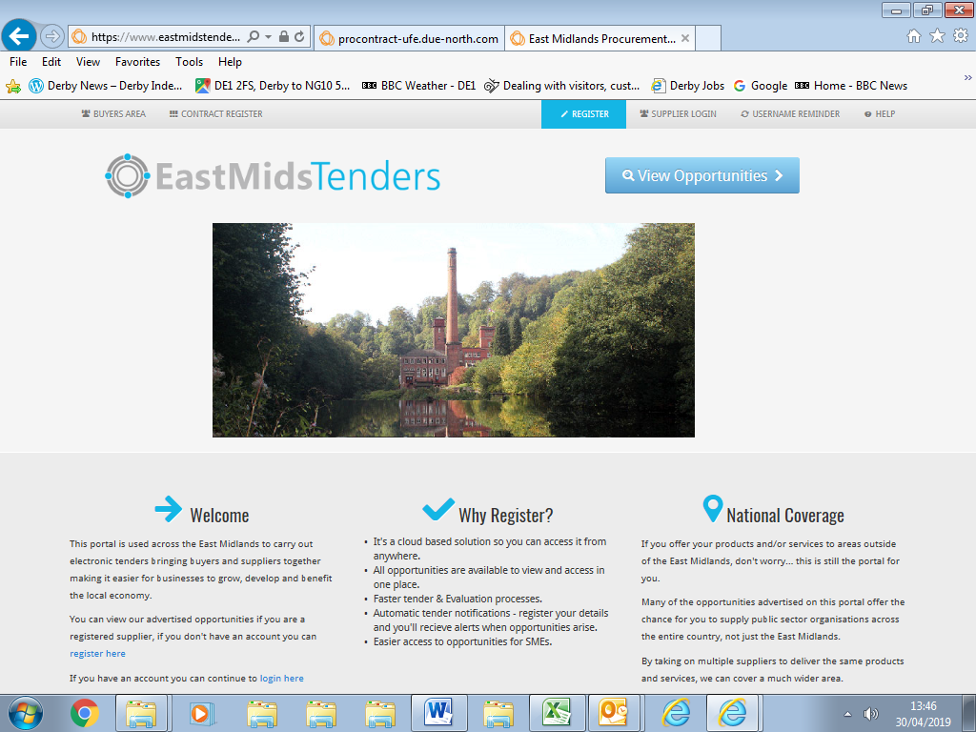

- Click on 'Find Opportunities'

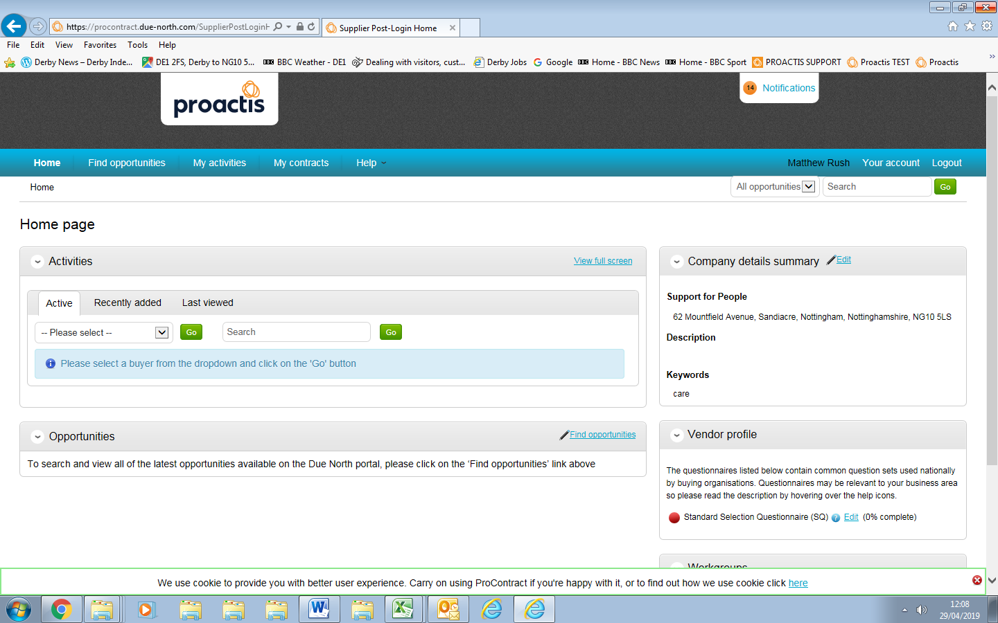
- Click on arrow on right hand side of 'Organisation' box and select Derby City Council and click on update button at the bottom left hand side of the screen.

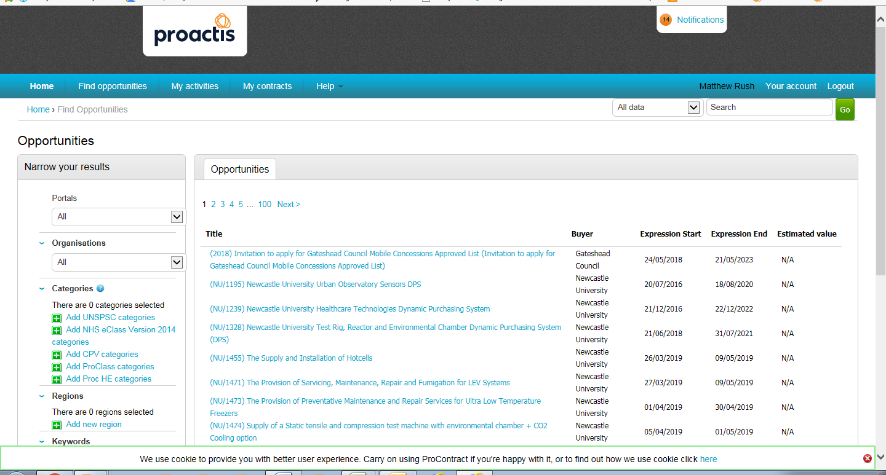

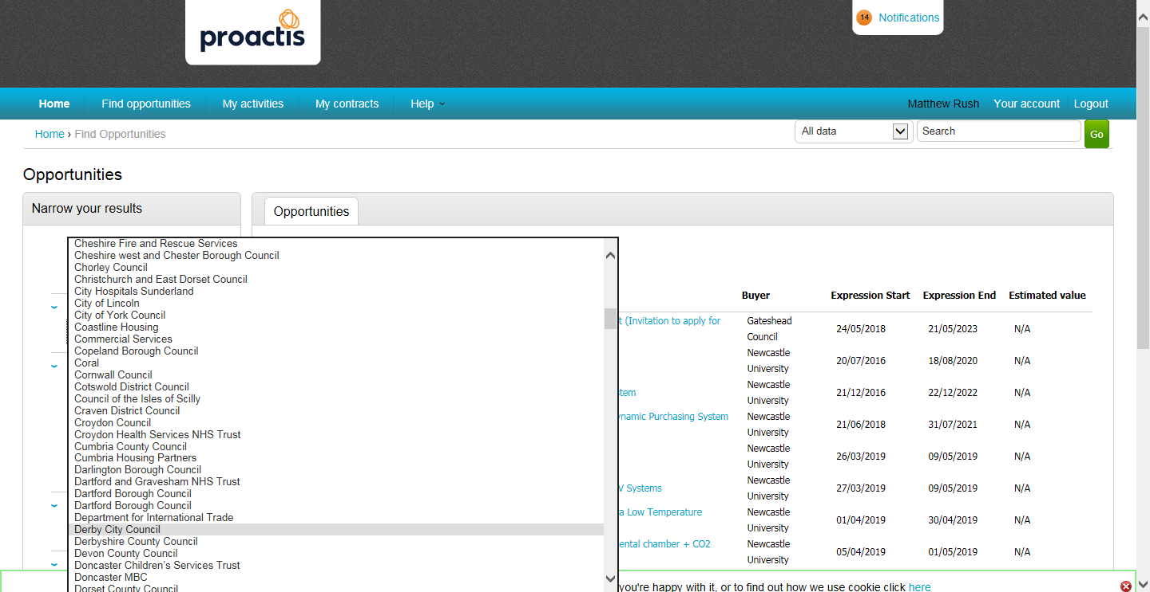

- This will show a list of live projects/contract opportunities relating to Derby City Council.

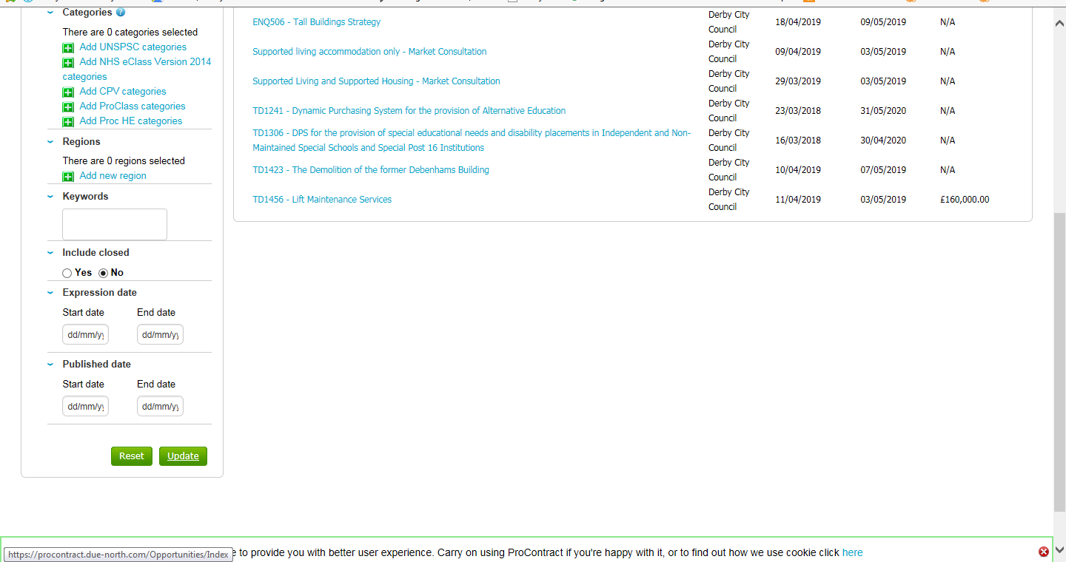

- Select appropriate opportunity by clicking on 'blue text'.

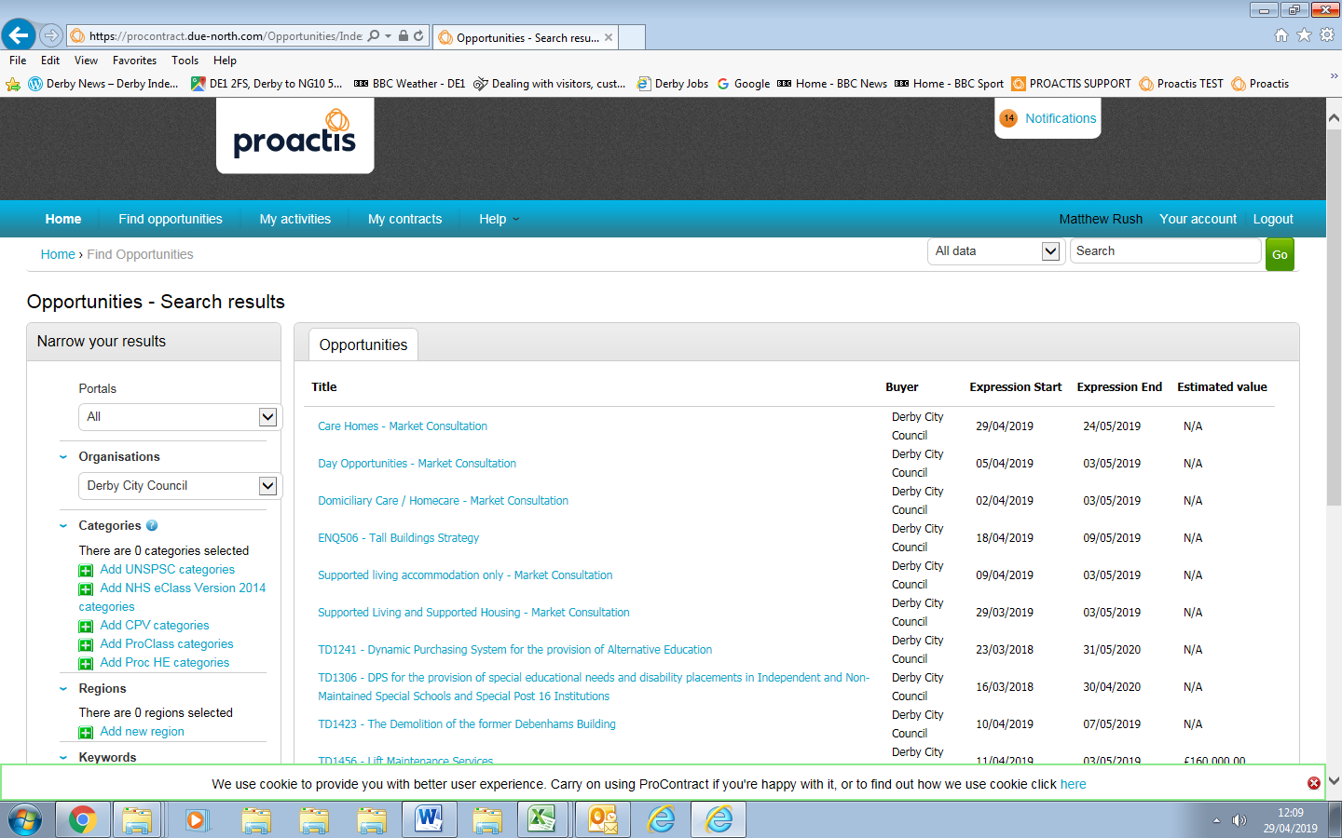

- This is the project overview. Click on 'Register interest in this opportunity'

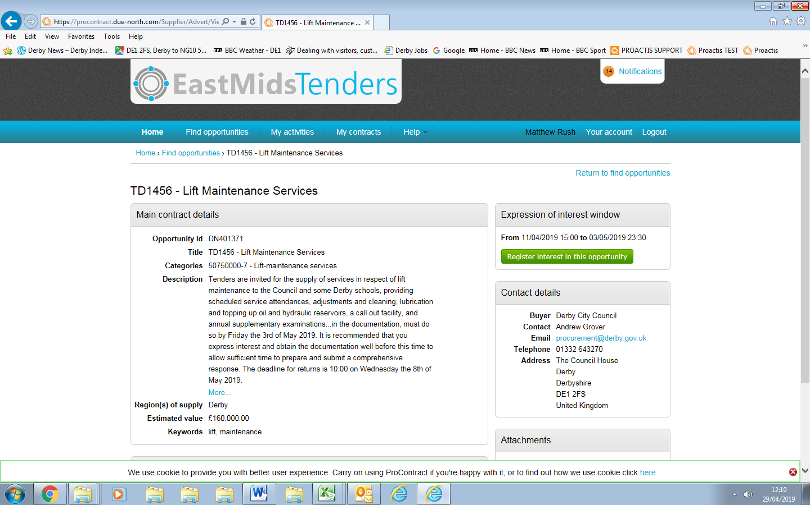

- A window appears confirming 'expression of interest has been successful'. To view ITT event (opportunity) click on 'here' (in blue text).

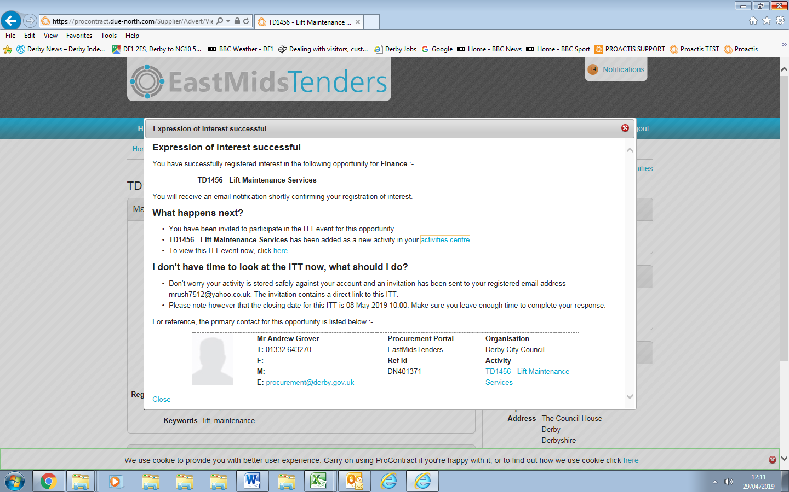

- This will take you to a different page, showing further details, related attachments and an on-line questionnaire that will need completing.

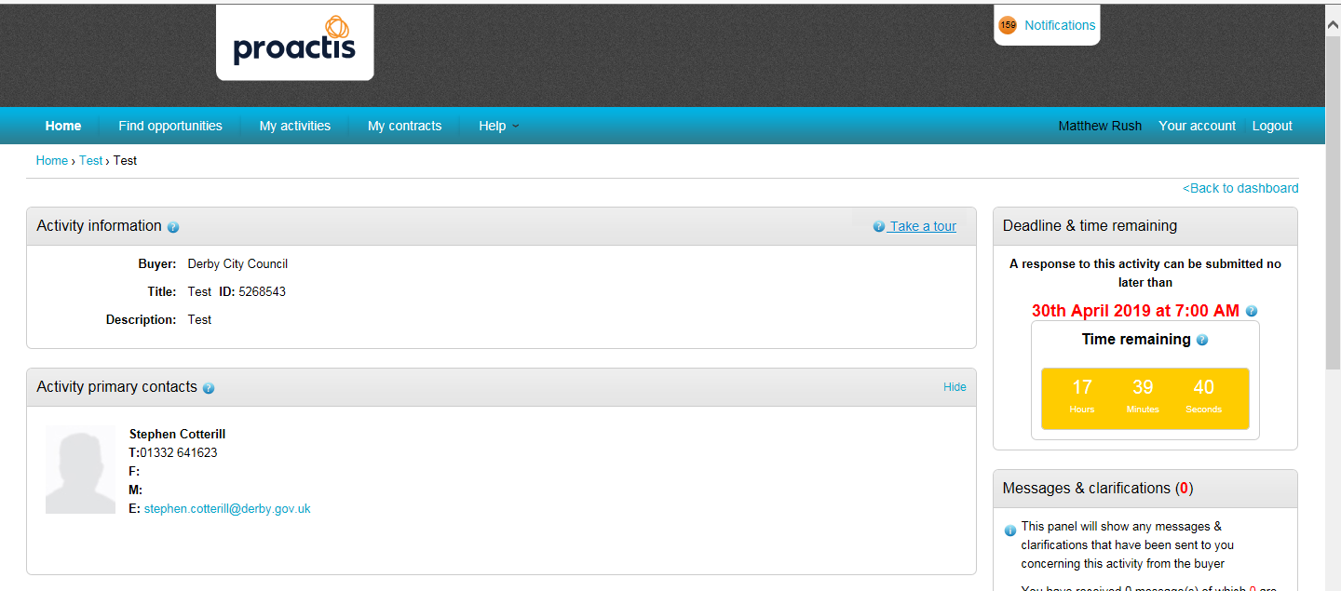
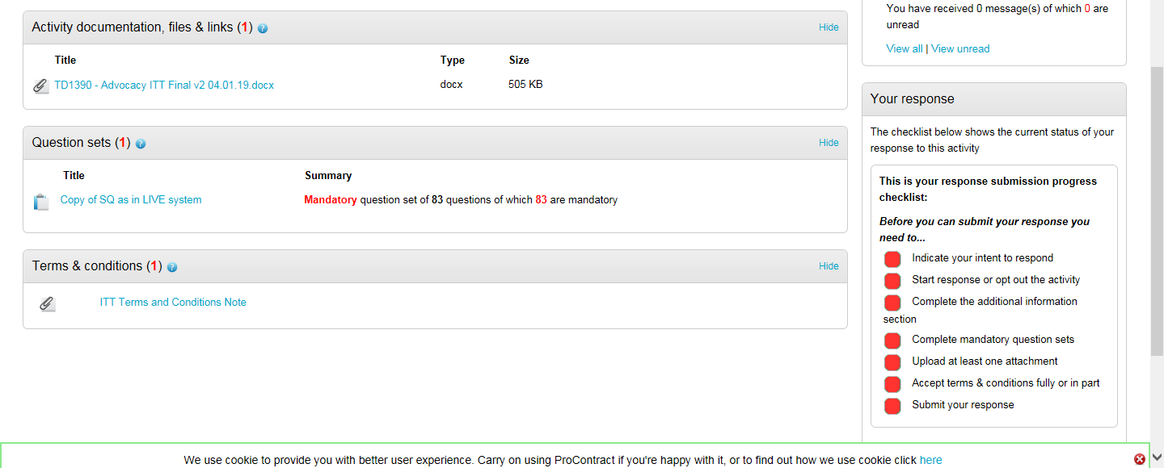

- View and download documents as appropriate. Click on 'start my response' which will take you to the response wizard.

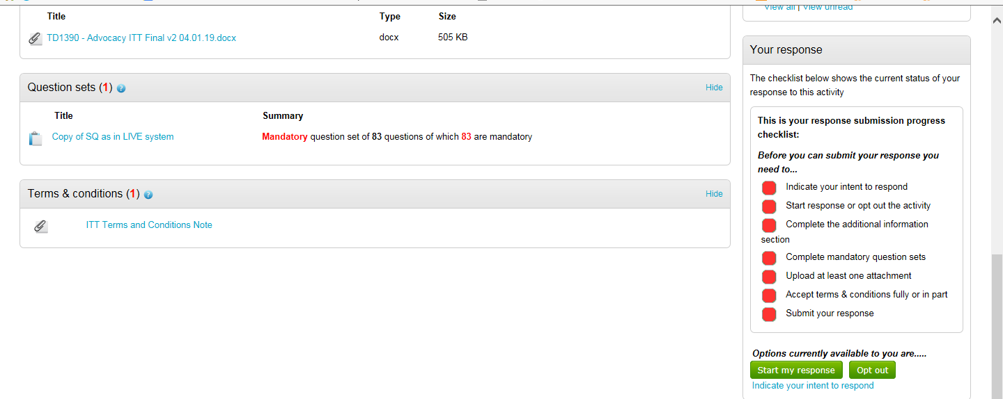

- To start your response to the on-line questionnaire click on 'Edit' in the 'Question Sets' section. (If there are Lots follow points 46 to 58 instead of points 10 to 15)

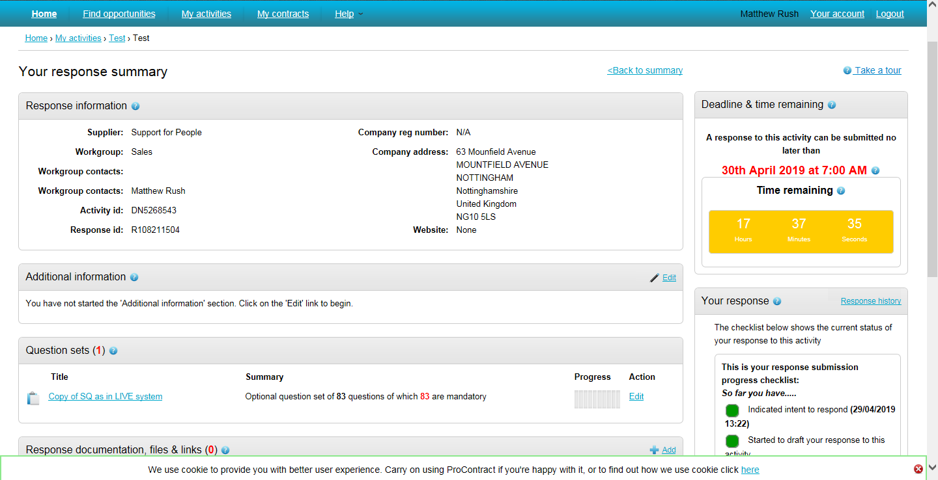

- Complete the relevant on-line questions. Responses can be saved and changed. Not all questions need to be completed in one go. (It will save after each question is answered). You can log out and log back into complete your response – see Section C

- The question status colour changes from red to green when you have completed the question. If you fail to attach a required document the question status will remain red until you add in the attachment.

- Click on the blue ‘Answer question’ text to open the question. Click on 'show more information' to show further explanation relating to the question.

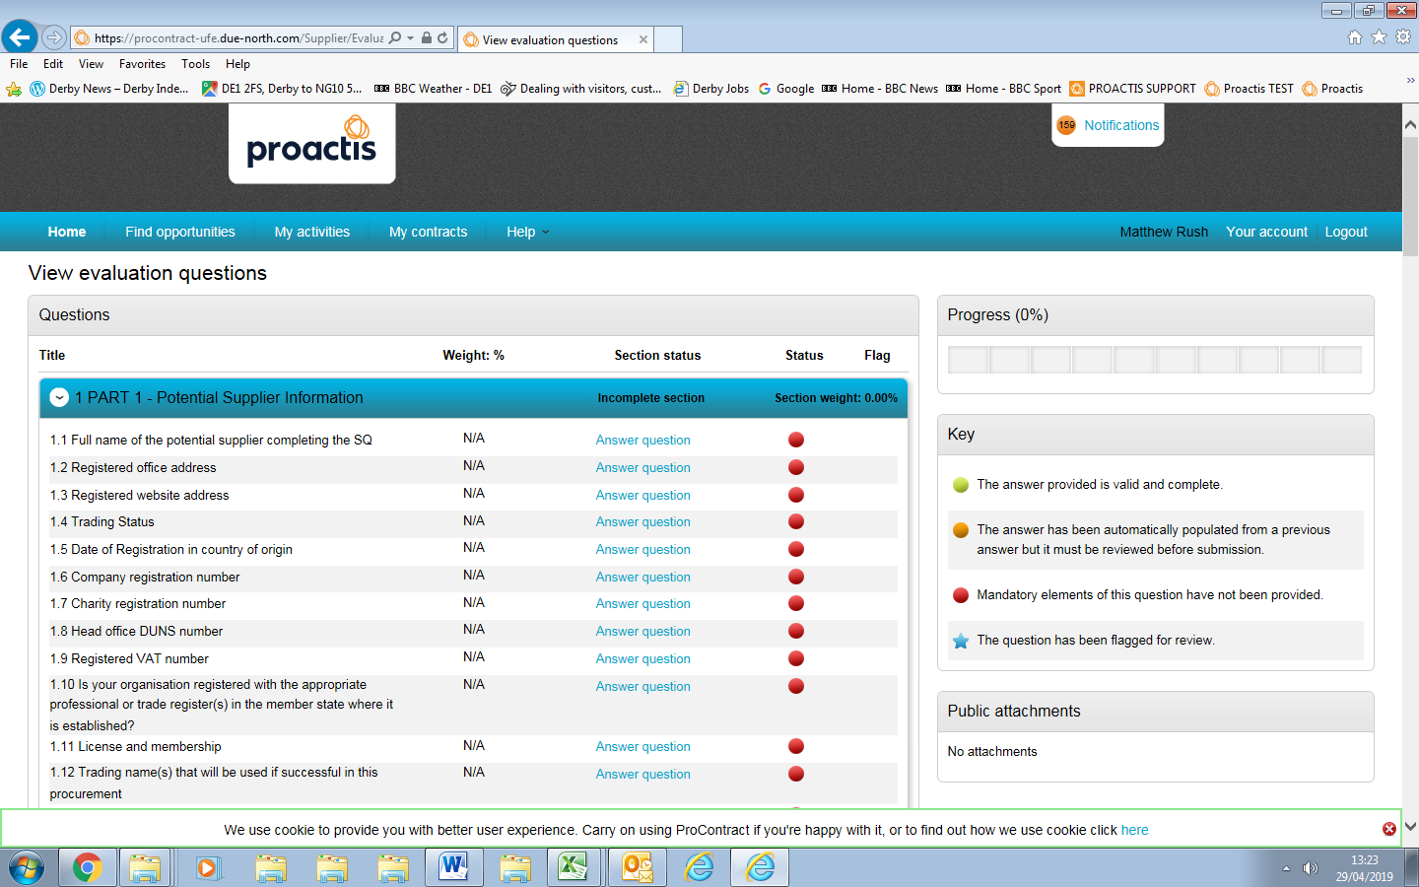

- Complete each question as required. Some will be a 'Yes/No' response, some will require an attachment, some will require text, some will be a mixture.

- When you have completed your answer click on ‘Save and next’ you will be automatically taken to the next question to answer. Clicking on 'Save and close' closes the question and takes you back to the full set of questions.

- Once all are completed click on 'Back'.

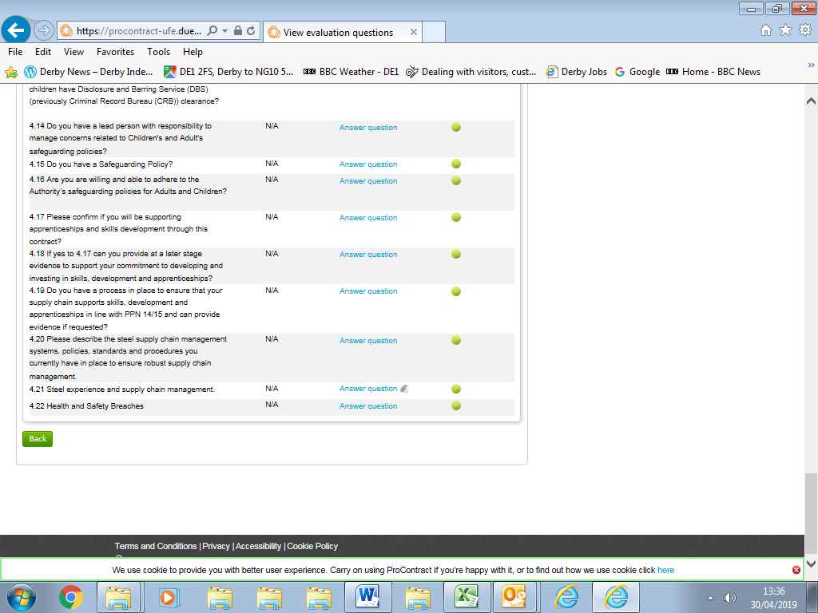

Please note: Where you have answered the same question in an on-line response to Derby City Council in a different procurement process it should remember the response and will be marked as 'green'. However you should recview your response to ensure it is still correct and up to date.

- Click on 'Edit' in 'Additional Information' section.

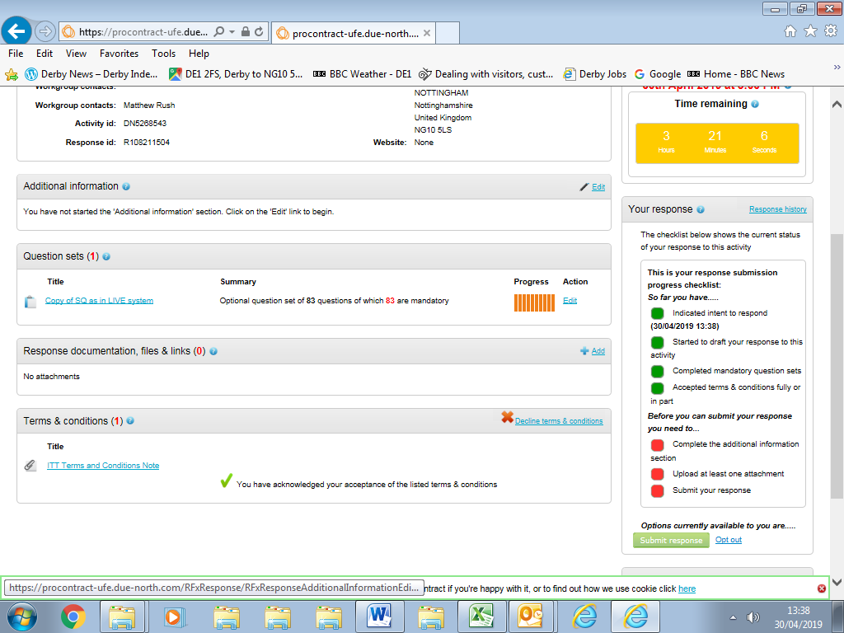

- Complete further infirmation boxes or tick to confirm you are not providing further information (you are not required to do so).

- Click on 'Save'.

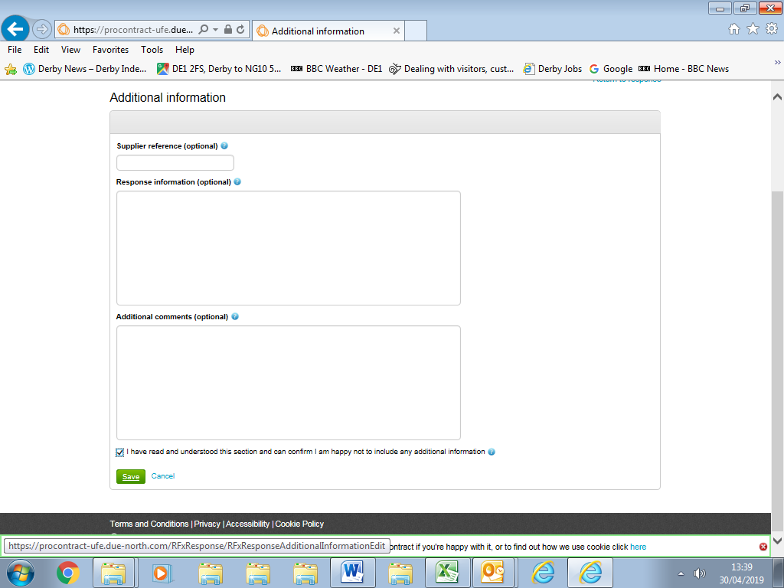

- This will take you back to the response wizard main page.

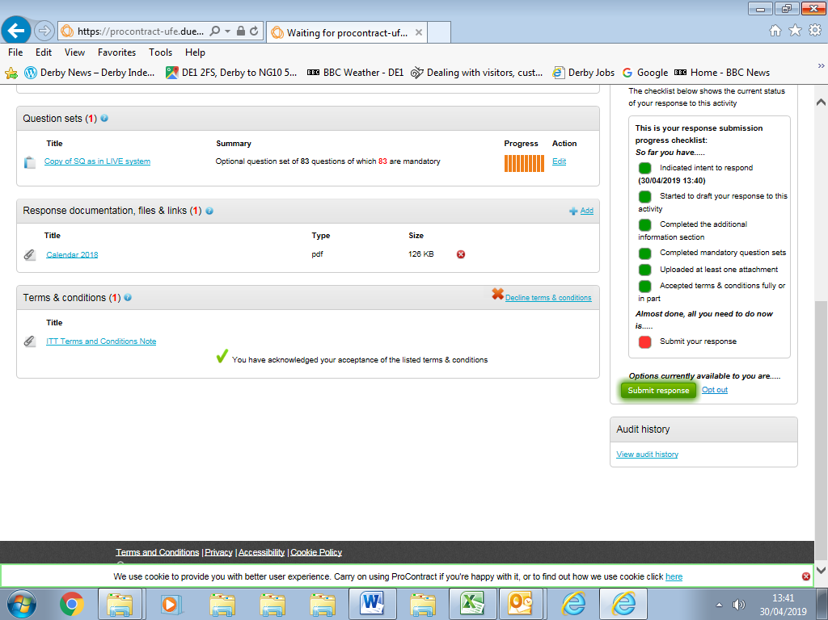

- Complete the remaining requirements as indicated by any red blocks on the 'response submission progress checklist' , for example:
- Accept terms and conditions

- Once all required actions are completed click on 'Submit Response'

- Click on Submit Response in the confirmation pop up window.

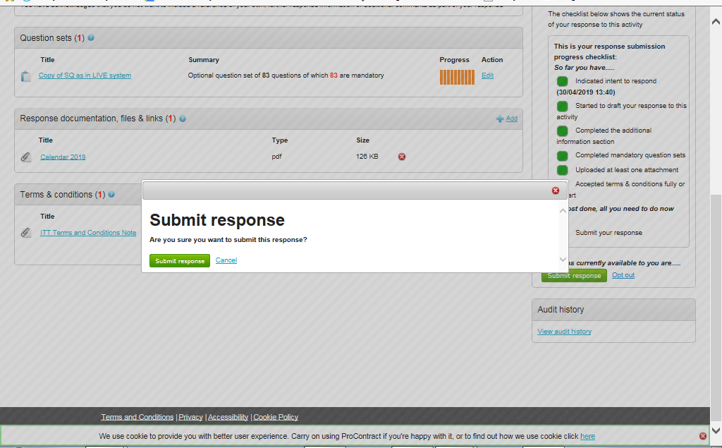

- Your response has been submitted.

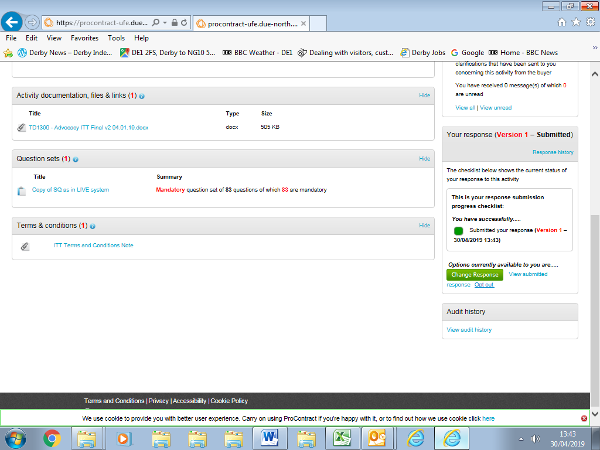

EDITING A SUBMITTED RESPONSE

- You may edit your response at any time before the response deadline.

- The Council will only see your 'final' submitted response.

- Log on EastMids Tender Portal at https://www.eastmidstenders.org/

- Click on 'My Activities'.

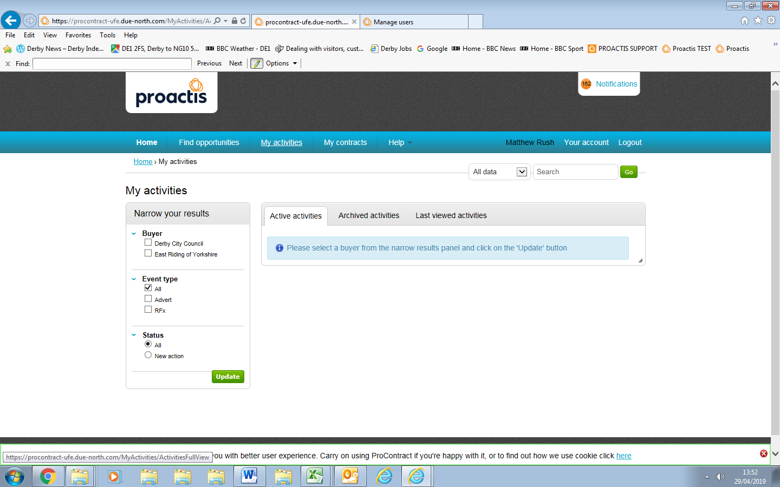

- Select 'Derby City Council' from 'Narrow Your Results' section.

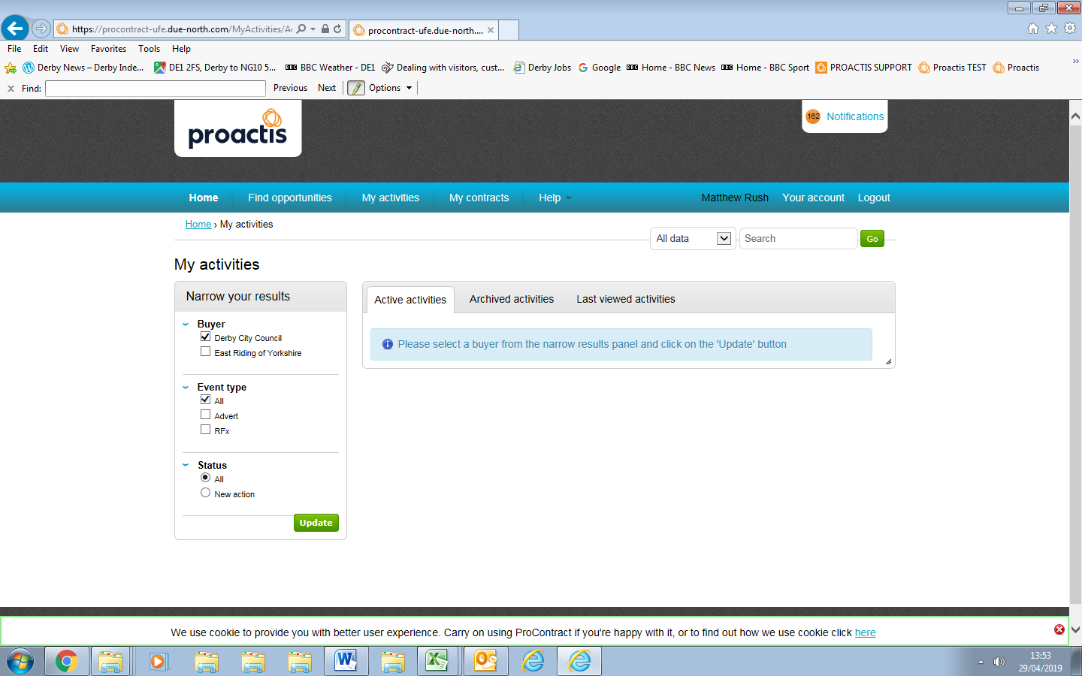

- Click on 'Update'

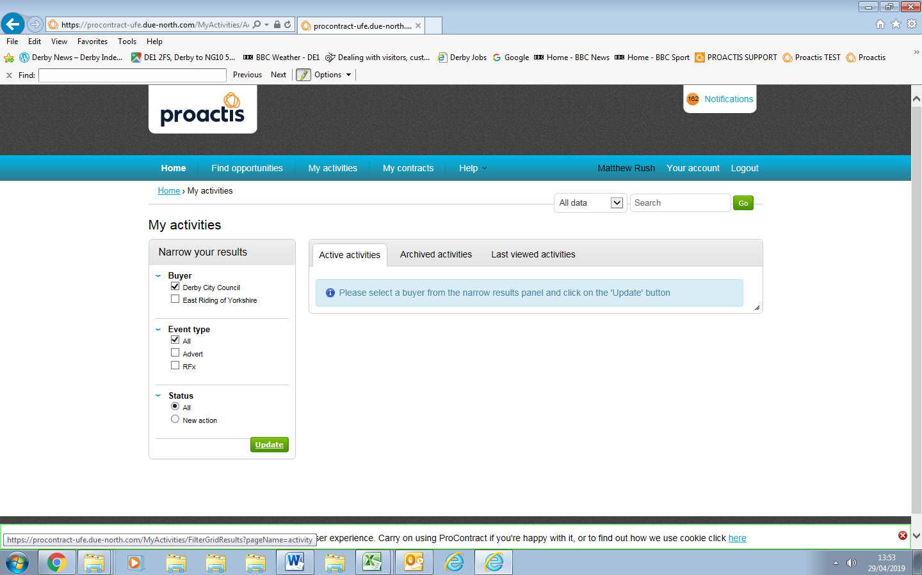

- Click on relevant contract opportunity in blue text.

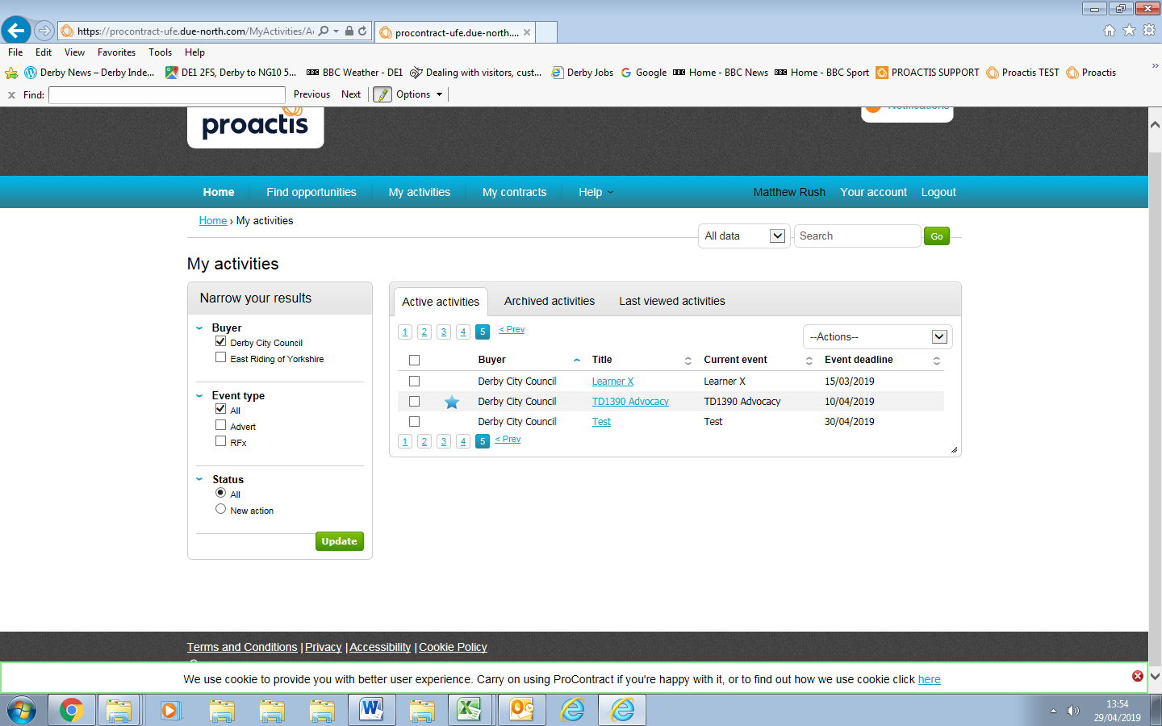
- Click on 'Open' on your submitted response.

- Click on 'Change Response' and amending any previously submitted information and then resubmitting your response in the same way as previously described in Section A

RETURNING TO A PARTIALLY COMPLETED RESPONSE

- You may return to a partially completed response.

- Log on EastMids Tender Portal at https://www.eastmidstenders.org/

- Click on 'My Activities'.

- Select 'Derby City Council' from 'Narrow Your Results' section.

- Click on 'Update'

- Click on relevant contract opportunity in blue text.

- Click 'open' on draft response.

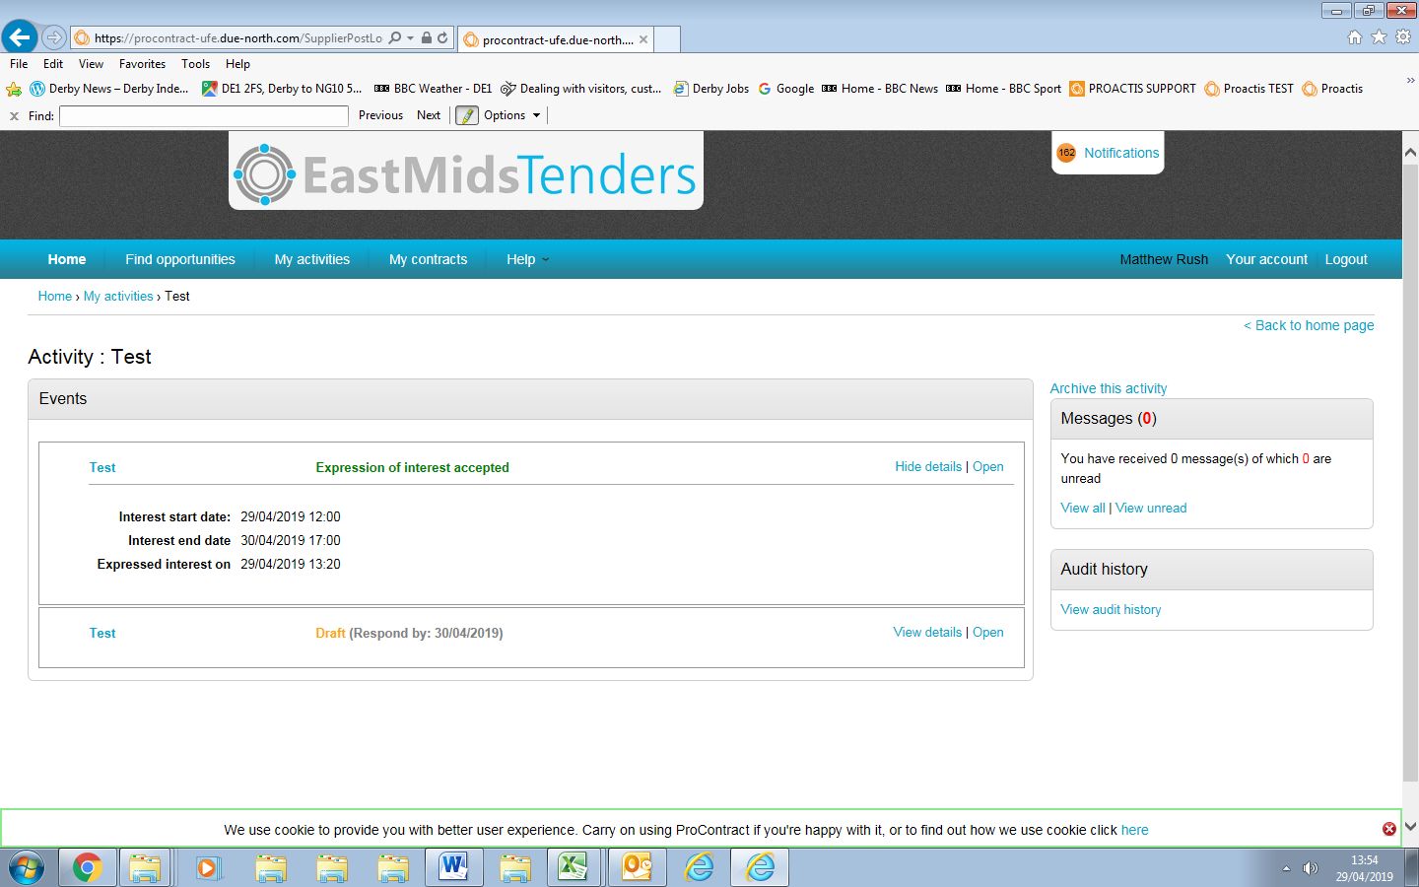

- This opens up the response wizard.

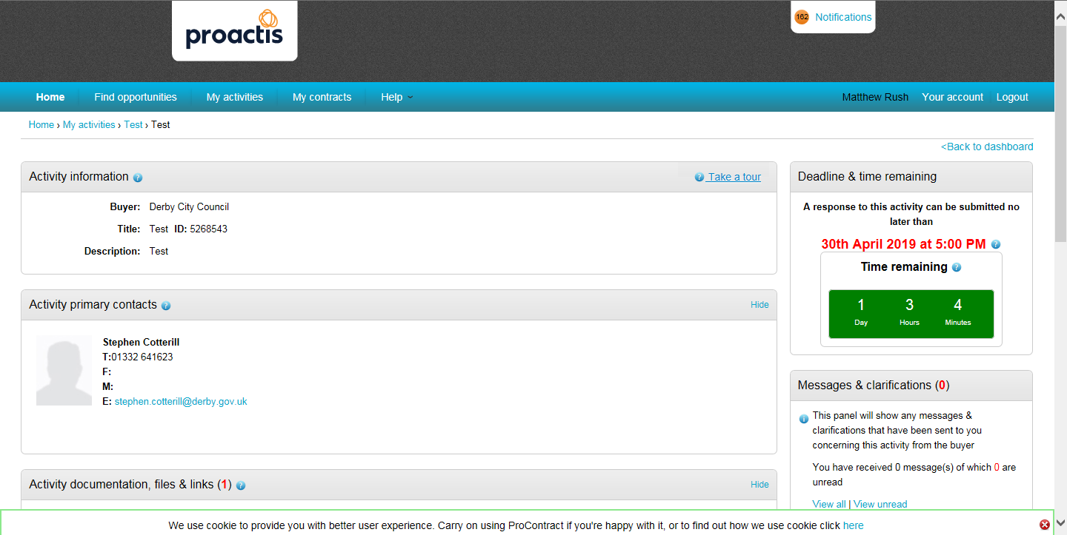

- Scroll to the bottom left of the page and click on 'View Draft Response'.

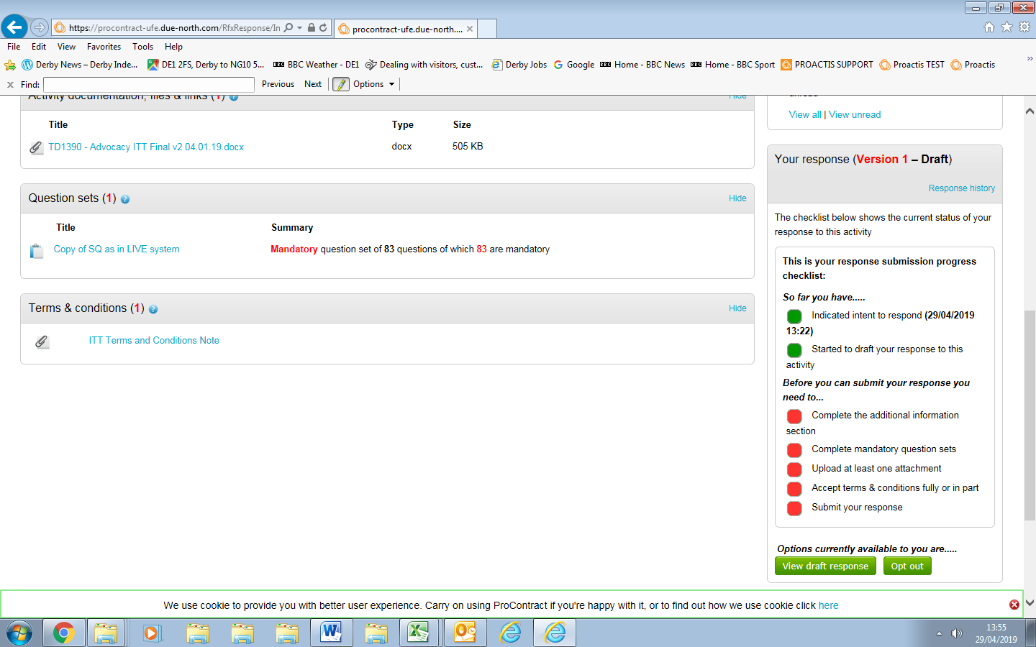

- Click on 'Edit' in Question Sets section.

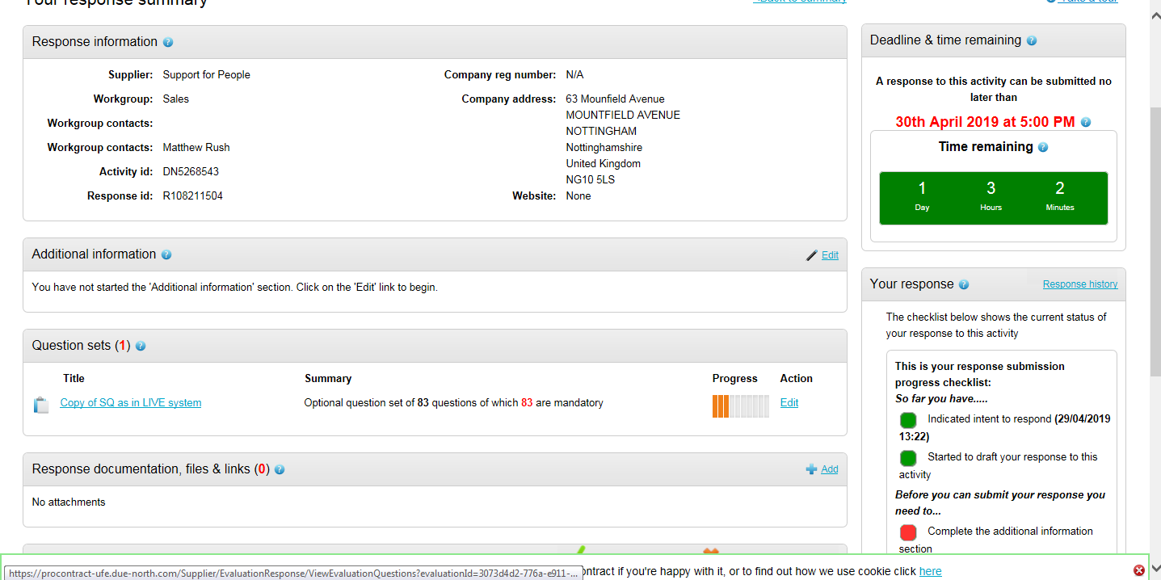

- Continue completing response.

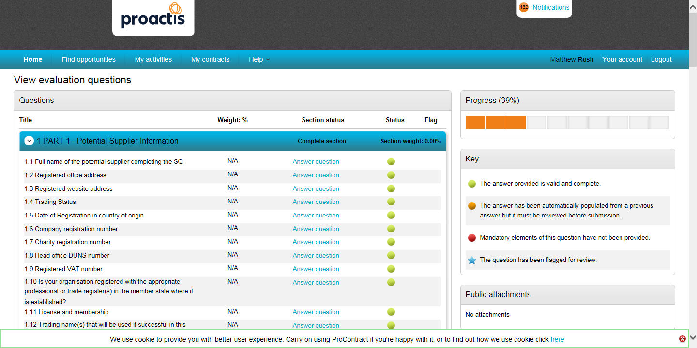

- Once completed submit response as described in points 16 to 24.

LOTS

- If the process is split into Lots, the Lot questionnaires are to be completed for the Lots you are bidding on.

- Mandatory ones must be completed. Optional ones must be completed or opted out of.

- There will be an on-line questionnaire that needs completing. Click on start my response.

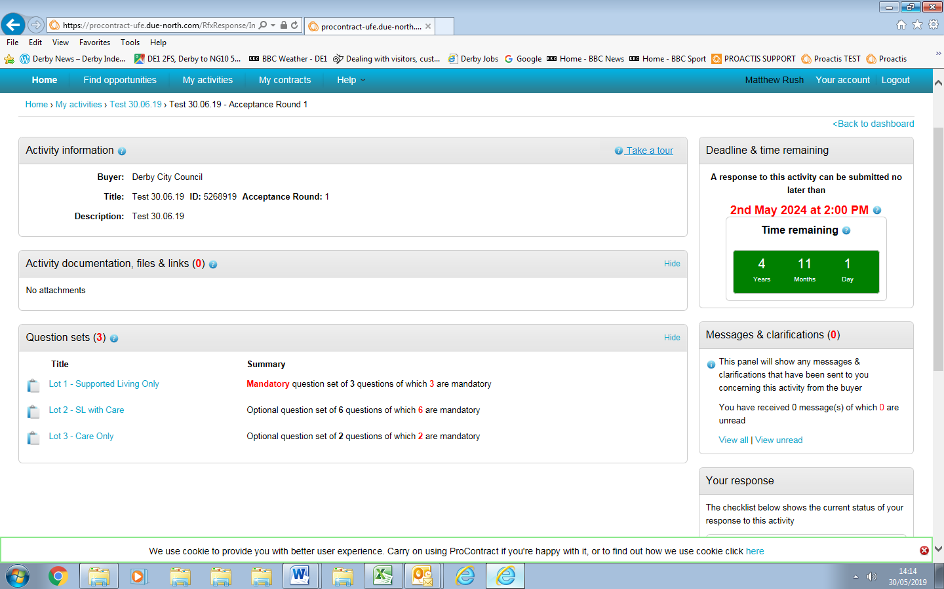
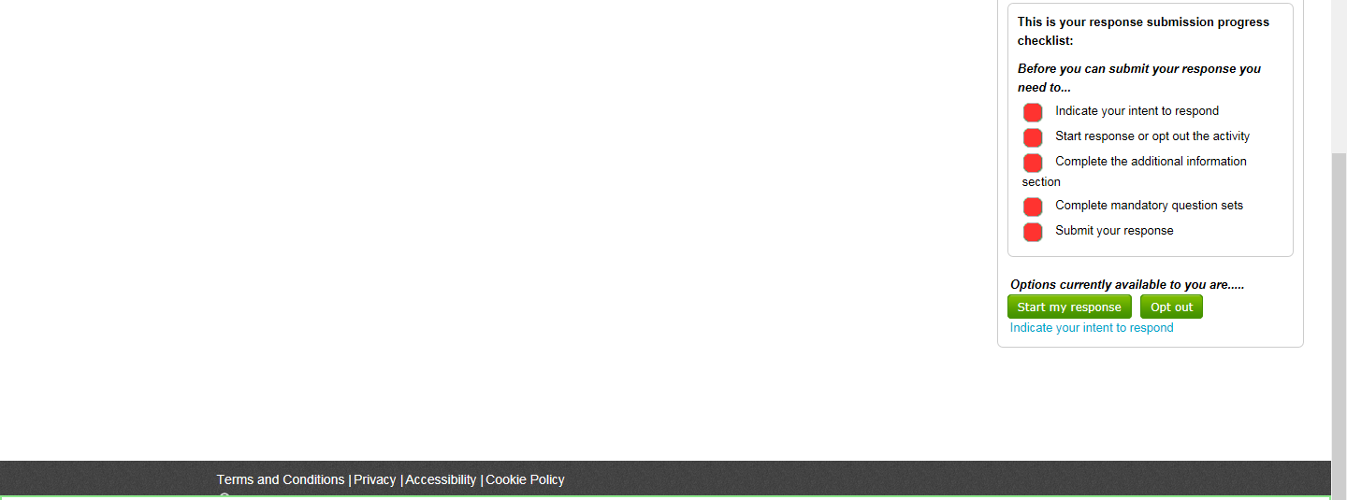

- To start your response to each on-line questionnaire click on 'Edit' in the 'Question Sets' section. ('Opt out' of Lots you do not wish to submit a response to a Lot).

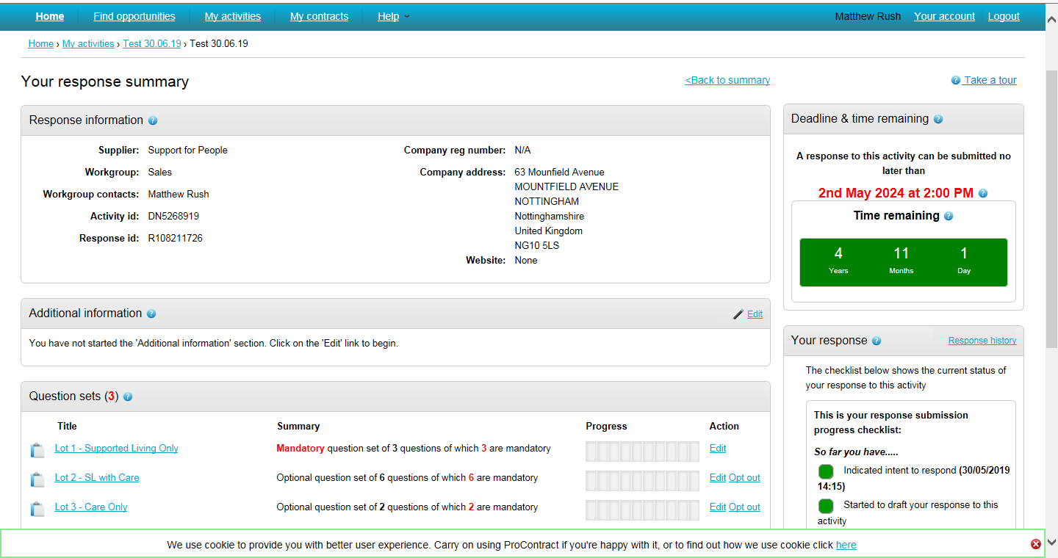

- NOTE: Often the Manadtory questionnaire relates to all Lots and therefore just submitting the Mandatory question will not mean you have submitted a response for the Lot. You also need to submit a response for the Lots you are interested in.

- Complete the relevant on-line questions. Responses can be saved and changed. Not all questions need to be completed in one go. (It will save after each question is answered). You can log out and log back into complete – see Section C.

- The question status colour changes from red to green when you have completed the question. If you fail to attach a required document the question status will remain red until you add in the attachment.

- Click on the blue ‘Answer question’ text to open the question. Click on 'show more information' to show further explanation relating to the question.

- Complete each question as required. Some will be a 'Yes/No' response, some will require an attachment, some will require text, some will be a mixture.

- When you have completed your answer click on ‘Save and next’ you will be automatically taken to the next question to answer. Clicking on 'Save and close' closes the question and takes you back to the full set of questions.

- Once all are completed click on 'Back'.

- Once you have opted out and completed the response for the Lots you wish to bid on the response wizard will look like the below.

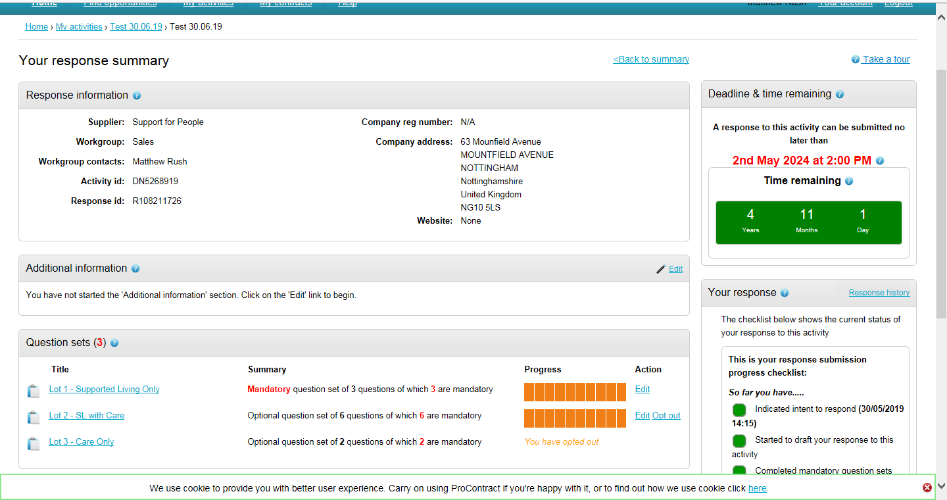

- Go to point 17 to continue your response.

