Conversion of MAN 15T HX77
Support Vehicles to EPLS Mk3 Variant
OSVP/0032

Initial Spares List

Annex F
V1

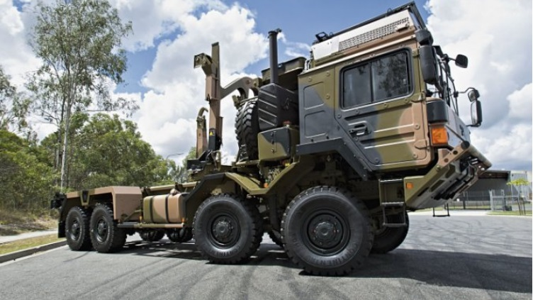

Version History

Issue: V1

Author:

Date: 29 September 2017.
Authorised by:

Signature:

Date: 29 September 2017
Checked for The Authority by:

Signature:

Date:

 | Version | Amendment |  |  | Date
 | V1 | First Submission Document for ITN |  |  | 29/09/17

Contents

1. Introduction 4
2. Objective 4
3. Provisional Spare Parts List 5

Table 1: Table of Abbreviations

Abbreviation | Interpretation for this Document
ILHS | Integrated Load Handling System
EPLS | Enhanced Palletised Loading System
MTB UK | MAN Truck and Bus UK Limited
RMMV | Rheinmetall MAN Military Vehicles
LORA | Level Of Repair Analysis

- Introduction
This document outlines the spare parts that may be required during the first 2 years of operation of the ILHS fitted to EPLS Mk3.
It should be noted that this list is only provisional and that some parts may not be required within the first 2 years dependant on the type of service that each vehicle is subjected to. A complete and concise list can only be defined after the LORA has taken place. As this requires some in-service data, this may be some time after the first batch of vehicles enter service.
- Objective
The overall objective of designing the Mk3 ILHS is to enhance the operation, reliability and longevity of the equipment. The Mk3 ILHS is a development of the Mk1 and Mk2, and as such incorporates many design changes and improvements that have been identified during the service life of Mk1 and Mk2. In some cases, these improvements are only minor modifications, but others are signiificant. The main development change is the incorporation of the previous separate intermediate subframe into the new integrated baseframe.
Even though large volumes of ILHS have been supplied to other Government agencies around the globe, there is limited feedback from in-service units to enable an accurate analysis of which components of the equipment may be subject to additional maintenance over and above that recommended by the manufacturer.
Consequently, the list shown below is that recommended by Hiab, the manufacturer of the equipment, for the L121 contract.
MTB UK are of the opinion that this list exceeds the needs of the requirement and therefore could be adjusted to suit the projected schedule for the EPLS Mk3.
On this basis, MTB UK will refine the list going forward to make it more representative of actual needs.

A proportion of the main list of spares shown below should already be held on stock by the Authority to service existing Mk1 & Mk2 EPLS. At this stage, these common parts have not been identified so the Authority should use the Hiab proposal until such time as this can be completed in combination with the LORA.

- Provisional Spare Parts List
REDACTED

