Stowmarket Community Centre toilet block refurbishment project

Lobby 4.85m x 2.45m approximately
Disabled WC 2.1m x 189m approximately
Male WC 5.25m x 1.74m approximately
Female WC 5.25m x 2.97m (minus disabled WC) approximately

Female WC
Strip back area
All fixtures and fittings to be replaced, so clearance of everything to start.
Dispose of cubicles. Toilets, basins, flooring, plaster etc
Cut security bar away from window.

Rectify damp issue to brickwork
There is an issue of damp far exterior corner. Investigate cause of damp, take action to stop damp coming back and provide guarantee of this.

Plumbing first fix
The general layout of the area will be kept the same. Renew if needed. Move surface plumbing to hide above suspended ceiling if possible.

Electrics first fix
Supply for hand dryer, new lighting and extraction fan. All surface mounted electrics chased in.

Plastering
Re-plastering of area

Suspended ceiling supply and install
The existing ceiling is the underside of the concrete slab roof, this is to be covered with a suspended ceiling with LED light panels. 600mm x 600mm wipeable white tiles
Lighting to be on PIR’s.
Possible insulation in ceiling void. Price as add on.

Plumbing second fix
Three new push button toilets
Two new basins with push operated taps.
New radiator
Possible sensor taps. Price as add on.

Electrics second fix
Lighting, LED panels for suspended ceiling 600mm x 600mm
Hand dryer, spec to be confirmed.
Extraction fan.

Cubicle install
Install of modern style cubicles made from MFC

Carpentry
Replace toilet area door with new internal flush door with automatic closer
Install Client supplied blind.
Box in exposed pipework where possible, if cannot be chased into walls.

Wall Finishes
Altro Whiterock as splashback detail to basins.
Altro Whiterock panel beneath hand-drier position.
All walls and timber surfaces to be redecorated.

Flooring
Install of flooring, coved up all walls. Flooring to be a vinyl safety flooring appropriate to commercial washrooms.

Male WC
Strip back area
All fixtures and fittings to be replaced, so clearance of everything to start.
Dispose of cubicles. Toilets, basins, flooring, plaster etc
Removal of existing stainless steel urinal trough and associated cistern.
Removal of privacy divider screen at end of urinal stall.

Rectify damp issue to brickwork
There is an issue of damp far exterior corner of female WC. Investigate cause of damp, take action to stop damp coming back and provide guarantee of this.

Plumbing first fix
The general layout of the area will be kept the same. Renew if needed. Move surface plumbing to hide above suspended ceiling if possible.

Electrics first fix
Supply for hand dryer, new lighting and extraction fan. All surface mounted electrics chased in.

Plastering
Re-plastering of area

Suspended ceiling supply and install
The existing ceiling is the underside of the concrete slab roof, this is to be covered with a suspended ceiling with LED light panels. 600mm x 600mm wipeable white tiles
Lighting to be on PIR’s.
Possible insulation to suspended ceiling. Price as add on.

Plumbing second fix
two new push button toilets
two new basins
two new urinals
New radiator
Possible sensor taps. Price as add on.

Electrics second fix
Lighting, LED panels for suspended ceiling 600mm x 600mm
Hand dryer, spec to be confirmed.
Extraction fan

Cubicle install
Install of modern style cubicles made from MFC
Supply and install new privacy screen, to match new cubicles.

Carpentry
Replace toilet area door with new internal flush door with automatic closer
Install Client supplied blind.
Box in exposed pipework where possible, if cannot be chased into walls.

Wall Finishes
Altro Whiterock as splashback detail to basins.
Altro Whiterock panel beneath hand-drier position.
All walls and timber surfaces to be redecorated.

Flooring
Install of flooring, coved up all walls.

Disabled WC
Strip back area
All fixtures and fittings to be replaced, so clearance of everything to start. Dispose of cubicles. Toilets, basins, flooring, plaster etc
Baby Change unit is new, so just remove, set aside & re-install.

Rectify damp issue to brickwork
There is an issue of damp far exterior corner of the female WC. Investigate cause of damp, take action to stop damp coming back and provide guarantee of this.

Plumbing first fix
The general layout of the area will be kept the same. Renew if needed. Move surface plumbing to hide above suspended ceiling if possible.

Electrics first fix
Supply for hand dryer and new lighting. All surface mounted electrics chased in.

Plastering
Re-plastering of area

Suspended ceiling supply and install
The existing ceiling is the underside of the concrete slab roof, this is to be covered with a suspended ceiling with LED light panels. 600mm x 600mm wipeable white tiles
Lighting to be on PIR’s.
Possible insulation in ceiling. Price as add on.

Plumbing second fix
New toilet, basin and radiator. Part M compliant.
Larger basin as part of new Doc M pack.
Possible sensor tap. Price as add on.

Fittings
Supply and install all rails etc to comply with part M

Electrics second fix
Disabled toilet alarm
Lighting
Hand dryer

Carpentry
Replace toilet area door with new internal flush door with automatic closer
Remove glazed panel above door and stud partition infill.
Install Client supplied blind.
Box in exposed pipework where possible, if cannot be chased into walls.

Wall Finishes
Altro Whiterock as splashback detail to basin
All walls and timber surfaces to be redecorated.

Flooring
Install of flooring, coved up all walls. Flooring to be a vinyl safety flooring appropriate to commercial washrooms.

Instant water heater
Remove existing heater due to size and reinstall smaller unit, with the possibility of moving to a more suitable location.
Lobby Area
Strip back area
All fixtures and fittings to be replaced, so clearance of everything to start. Dispose of waste.

Plumbing first fix
Move pipework so that it will be concealed above new suspended ceiling.

Electrics first fix
Supply for new lighting. Move existing electrics so that it will be concealed above new suspended ceiling. All surface mounted electrics chased in.

Plastering
Re-plastering of area

Suspended ceiling supply and install
The existing ceiling is the underside of the concrete slab roof, this is to be covered with a suspended ceiling with LED light panels. 600mm x 600mm wipeable white tiles
Lighting to be on PIR’s.
Where suspended ceiling meets the external exit doors, a sloping bulkhead detail needs to be created within the suspended ceiling as the height of the ceiling will be lower than the head of the door frame.
Possible insulation in suspended ceiling. Price as add on.

Electrics second fix
Disabled toilet alarm
Lighting

Plumbing Second Fix
Supply and install new radiator

Carpentry
Replace twin internal doors to match newer internal corridor doors. One larger than the other for wheelchair access.
Remove glazing above corridor doors and infill with stud partition detail.
Box in exposed pipework where possible, if cannot be chased into walls.

Wall Finishes
All walls and timber surfaces to be redecorated.

Flooring
Install of flooring, coved up all walls. Flooring to be a vinyl safety flooring appropriate to commercial washrooms.

Externally
Carry out investigations and repairs to possible corner of roof, hopper overflow position, hopper, downpipe and cracked brick/mortar pointing, where water penetration may be occurring.

Female WC

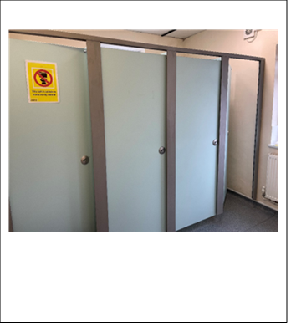
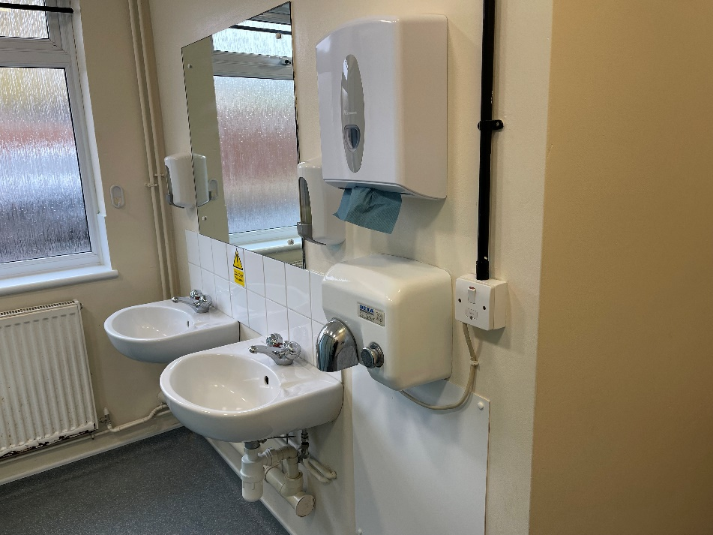
Male toilet

Lobby Area

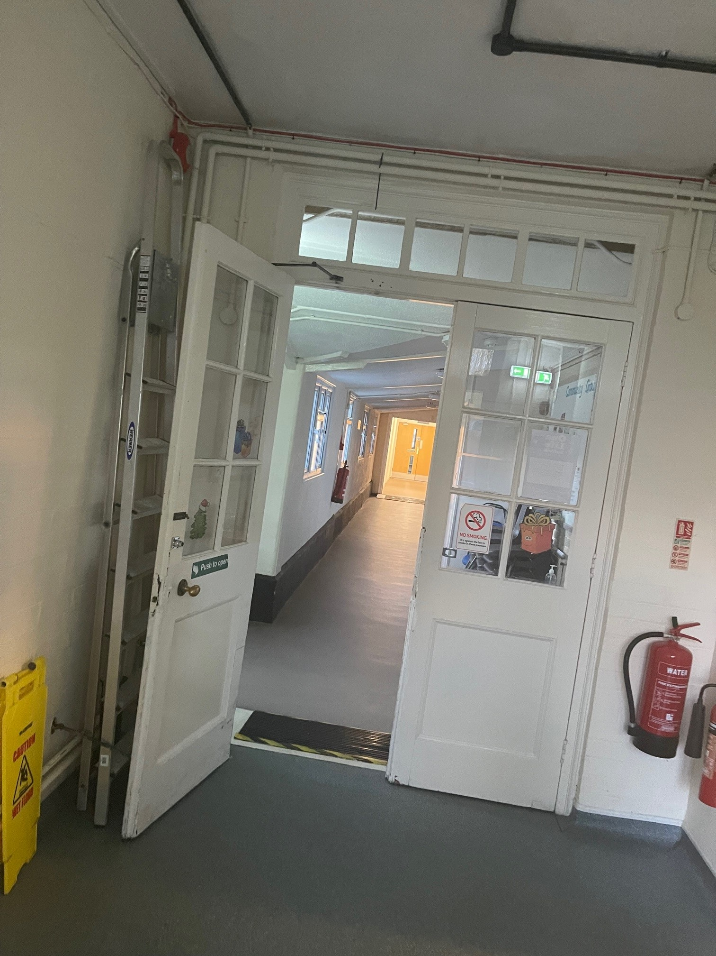
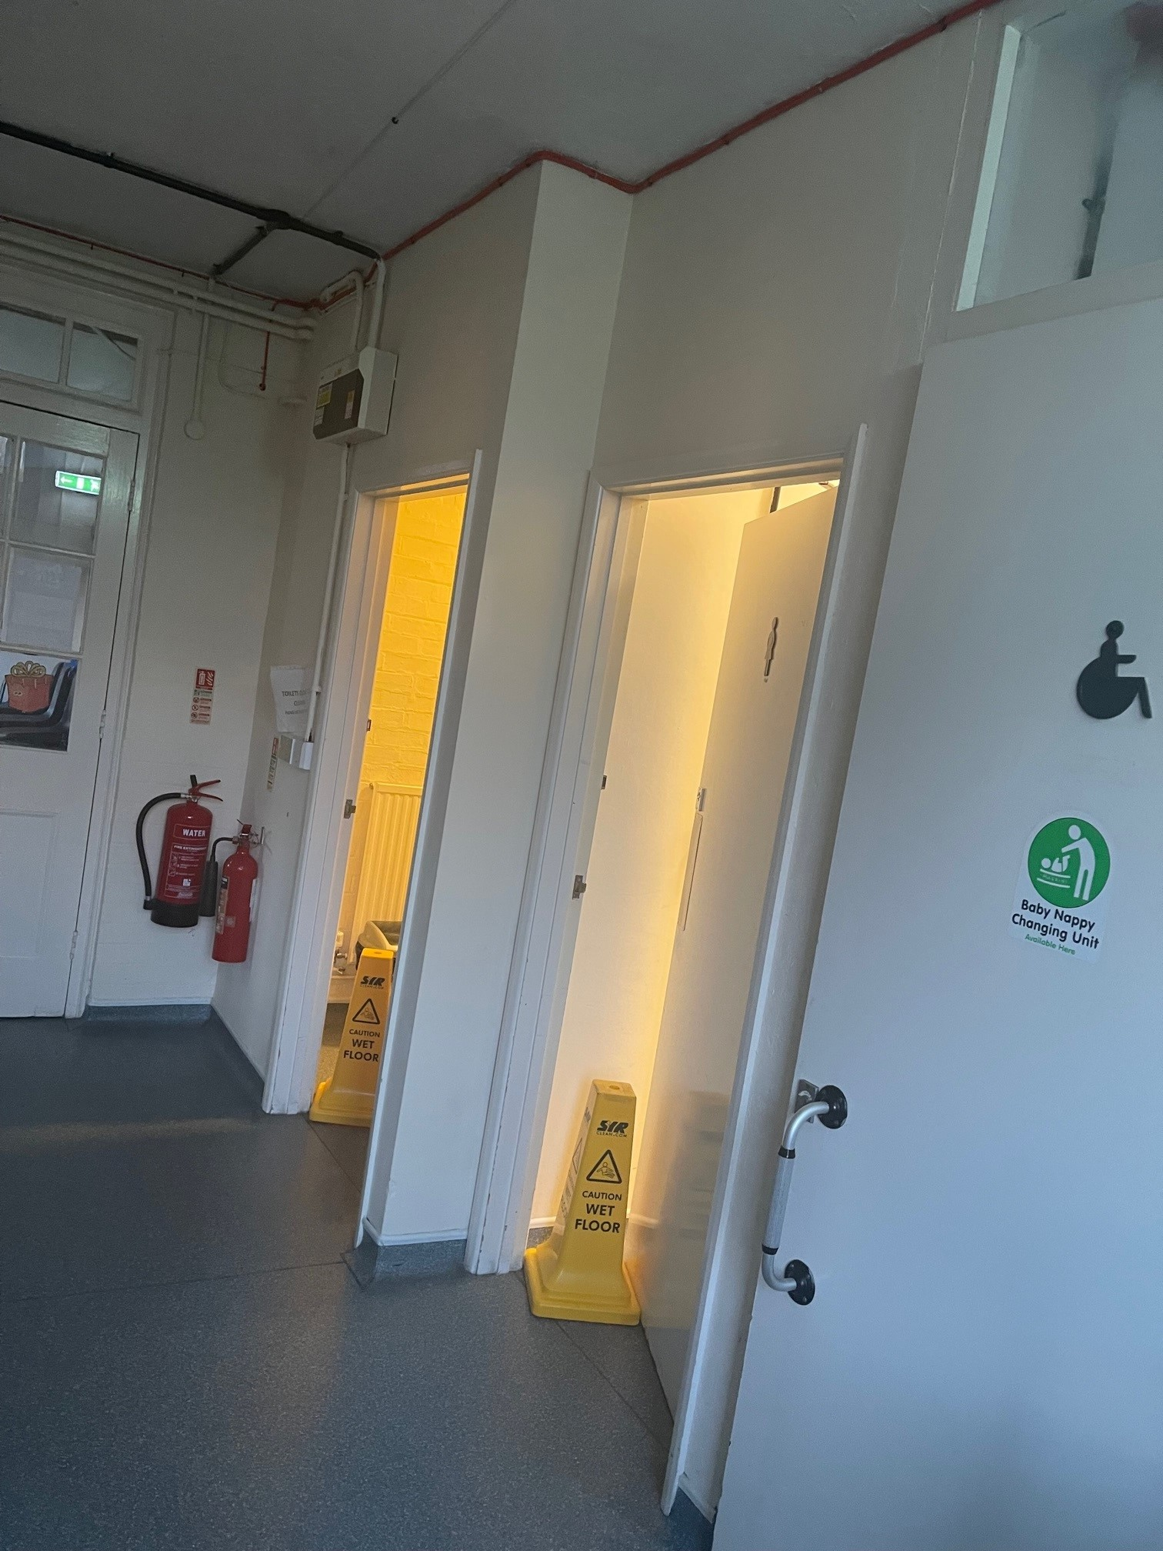

New doors to match above image

