

Our Ref: CPU/HMC/N0095

15/02/2019

Requirement for AC systems – Tendered through Contracts Finder

Dear Sir or Madam

Background
The College is based mainly on one large campus situated at Framwellgate Moor, Durham. The campus was completely rebuilt in 2004. Since then it has benefitted from continual development including a recent £5 million redevelopment which incorporates a Higher Education Centre, Advanced Manufacturing Centre and a Creative and Digital Centre. The College is currently working towards delivering a new £8.2 million STEM facility in 2019.
New College Durham is a mixed economy college offering vocational programmes, A Levels, Higher Education, Apprenticeships and Adult Learning. The College has extremely strong links with employers across the regional area, who work with us on apprenticeships, work and industry placements and curriculum design and delivery. The College prides itself as being a sector leader in the UK and is currently:

- Beacon Status

- Academic Achievement that place it in the top 10% of similar colleges in England

- Awarded TEF silver for Higher Education Programmes

- Financial Health measured as ‘Outstanding’ by Framework of Excellence criteria

- Degree awarding status for Foundation Degrees

- ISO 14001:2015 Environmental Management System

- www.newcollegedurham.ac.uk

- Leaders in Diversity

Foreword

The college is going out to tender for the provision of the service detailed in the following pages with the objective of achieving value for money and achieving a reduction in our current costs. We wish to identify a Supplier to meet these requirements and therefore any company wishing to bid should provide complete information to enable competitive evaluation. Regular checks of the Colleges website is recommended as this is the route that clarification Q&A’s will be provided.

Procurement Schedule

1. | Tender documents to be issued | 15th February 2019
2. | Receipt of Tenders | Midnight 15th March 2019
3. | Site Visit – please e-mail richard.newton@newdur.ac.uk | 9am 25th February 2019
4. | Clarification Deadline will be effective 48 hours prior to the receipt of the submissions. Clarifications will be updated regularly and interested parties should check our website regularly for updates. Please contact helen.collin@newdur.ac.uk for details
5. | Notification of Preferred Supplier along with requests for PPQ, RAMS, Insurance Certification, Enhanced DBS | w/c 18th March 2019
6. | Fully Operational/Installation/Commissioning Lot 1 | w/c 22nd June 2019
7. | Fully Operational/Installation/Commissioning Lot 2 | w/c 8th April 2019

While the college will endeavour to adhere to this timetable, it should be noted that changes might become inevitable as procurement proceeds. Any changes will be notified to Suppliers as necessary.

Specification of Requirements:

New replacement of air conditioning systems to Green 2nd Floor and Main Comms Room

Introduction

The detail below will provide a focus for the design, a scope of works and list the specific outcomes required from the installation of new replacement air conditioning systems at New College Durham. Each specific area system of current comfort cooling will be replaced at such time as approved by the directorship, via capital asset renewal, and will be carried out system by system over the coming years. It will be the successful contractor’s duty to ensure the systems installed achieve value for money alongside the necessary considerations of energy efficiency and environmental sustainability.
The hardware must include the most capable technologies at the time of installation and upon completion in the entirety must provide reasonable consistency across the site. This will allow the brief to be achieved including a degree of future proofing.

The successful contractor will become familiar with the existing system to allow seamless integration with the current controls strategy and will make every effort to work with the building engineering management contractor, in place at the time, during the design and installation to ensure all necessary aspects of control are achievable

Design Criteria Lot 1 – Green 2nd Floor

The internal design conditions within the building are; - all areas 22°C +/- 2°C at times of occupancy. Internal temperatures are assumed dry resultant @ 1.5m above floor level. Internal noise levels in all areas not regularly exceeding 35db. The hardware will be from a tier 1 category and of high quality so as to ensure, for a reasonable timeframe; - ease of future maintenance, addition or alteration without undue delays created by obsolescence, lack of supply chain parts and/or technical assistance from the supply company itself eg. Toshiba or equivalent make.

Design Criteria Lot 2 – Main Comms Server Room

The system requirement for Lot 2 are system cooling only for the main comms server room.

The hardware will be required to be from a tier 1 category and of high quality so as to ensure, for a reasonable timeframe; - ease of future maintenance, addition or alteration without undue delays created by obsolescence, lack of supply chain parts and/or technical assistance from the supply company itself eg. Toshiba or equivalent manufacturer.

General Information

The successful contractor holds an, in date, F Gas company certificate and shall be responsible for the design, supply, delivery, offloading, installation, waste, co-ordination and commissioning of the installation in its entirety. Early site visits and a focussed design shall eliminate the potential for variation of works during the installation phase. All structural steel currently supporting existing external units will be reused following appropriate integrity checks. Where this is not possible, by alteration or addition, it shall be the contractor’s duty to inform as necessary and reasonably prior to any works commencing.

Site Visit

It is anticipated that prior to submission of the tender for works, it will be deemed that the contractor has visited site and is familiar with all requirements and outcomes expected from the new installation. Issues arising from a failure to do so will be at their risk and cost.

Warranty Guarantees

For the first year or any period of cover provided by installation and manufacturers guarantee, whichever is longer, the successful contractor must be available to attend site in a timely manner in order to provide assistance in terms of business critical system requirements.

Fundamental Requirements

Side feedback from building users has been that the function and perception of the manner in which the current comfort cooling system operates: - The installed system of comfort cooling runs alongside the wet heating system to achieve a room set point at an agreed level over a timed period of occupancy. In function, the ac system creates levels of “wind chill” which many building users find to be intolerable. This relates to the position and fan speeds of the units in place and leads to complaints and a request to shut down the ac system prematurely i.e. before the set point temperature has been achieved! This allows, in turn, the building temperature to increase during the day causing an overshoot created by both early heating to set point but also the inclusion of occupancy derived additional heat input. Any new system installation must consider these issues.

Scope of works

- Visit site to make all quantity and quality checks necessary to appropriately price as required by the individual contract.
- Existing power supplies to be utilised at all times for new installation.
- All related works planned and undertaken by the successful contractor.
- Confirm and decommission, appropriately and responsibly, the existing Hitachi system specific to the contract.
- Remove all existing, system specific, infrastructure and deal with all waste as appropriate.
- Install all new system infrastructure, making good any fire stopping as required in a timely manner.
- All contract lifts and works on the roof must consider the roof covering. Any landing areas or routes that will take any abnormal and or repeated load forces must be protected and any load spread out as much as possible to insure roof membrane integrity is upheld. Any damage to the roof resulting from failure to appropriately protect it will be repaired in a timely manner at the contractors cost.
- All indoor units must be connected via the Harc system to the bms or via an appropriate means that has been confirmed suitable by the, in place, building engineering management maintenance contractor.
- All indoor units must be installed in a location as to provide best access for regular planned maintenance (cleaning filters etc).
- Test, prove and commission the installation inclusive of updated system asset lists and certification as required by industry standards.
- Insulate all pipe work as necessary using materials capable of maintaining the necessary constant vapour barrier

The following information will show the location and specifics of the currently agreed systems approved for renewal

LOT 1
Replacement of System 2 Green 2nd floor
Current comfort cooling installation
Asset / Location | Model | Serial Ref No. | Ceiling (C) Wall (W) | Asset (bar code id) | Room No. | Installation Date | Make | Type of Gas | Room  Function
A/C outdoor unit sys 2 roof | RAS-24 FSN | U43F5837 |  | 2329 | Roof | SEP 2007 | HITACHI | R410A | Computer  17
A/C indoor unit 2nd floor green | RPK-1.5 FSNM | U42Y3857 | W | 2268 | 236 | SEP 2007 | HITACHI | R410A | Computer  17
A/C indoor unit 2nd floor green | RPK-1.5 FSNM | U42Y6506 | W | 2257 | 220 | SEP 2007 | HITACHI | R410A | Class room
A/C indoor unit 2nd floor green | RPK-2 FSNM | U42Y4234 | W | 2266 | 237 | SEP 2007 | HITACHI | R410A | Class room
A/C indoor unit 2nd floor green | RPK-2 FSNM | U42Y4229 | W | 2256 | 219 | SEP 2007 | HITACHI | R410A | Class room
A/C indoor unit 2nd floor green | RPK-2 FSNM | U42Y4197 | W | 2255 | 218 | SEP 2007 | HITACHI | R410A | Class room
A/C indoor unit 2nd floor green | RPK-2 FSNM | U42Y4193 | W | 2265 | 238 | SEP 2007 | HITACHI | R410A | Class room
A/C indoor unit 2nd floor green | RPK-2 FSNM | U42Y4174 | W | 2267 | 239 | SEP 2007 | HITACHI | R410A | Class room
A/C indoor unit 2nd floor green | RPK-2 FSNM | U42Y4175 | W | 2254 | 214 | SEP 2007 | HITACHI | R410A | Class room
A/C indoor unit 2nd floor green | RCI-2.5 FSN1E | 4FE44818 | C | 2264 | 240 | SEP 2007 | HITACHI | R410A | Class room
A/C indoor unit 2nd floor green | RCI-2.5 FSN1E | 4FE44828 | C | 2253 | 213 | SEP 2007 | HITACHI | R410A | Class room
A/C indoor unit 2nd floor green | RPK-1.0 SRN2M | U43F0897 | W | 2251 | 208 | SEP 2007 | HITACHI | R410A | Office

A/C indoor unit 2nd floor green |  | RPK-1.0 SRN2M | U43F0895 | W | 2252 | 209 | SEP 2007 | HITACHI | R410A | Office
A/C indoor unit 2nd floor green |  | RCI-2.5 FSN1E | 4FE18962 | C | 2250 | 205 | SEP 2007 | HITACHI | R410A | Staff room 8 computer
A/C indoor unit 2nd floor green |  | RCI-2.5 FSN1E | 4FE59729 | C | 2261 | 243 | SEP 2007 | HITACHI | R410A | Class room
A/C indoor unit 2nd floor green |  | RPK-1.0 SRN2M | U43F0932 | W | 2262 | 242 | SEP 2007 | HITACHI | R410A | Office  Occ health
A/C indoor unit 2nd floor green |  | RPK-1.0 SRN2M | U43F0899 | W | 2263 | 241 | SEP 2007 | HITACHI | R410A | Office  Occ health
Quantity
23Kg plus 13.58Kg
TOTAL Sys 2
36.58KG

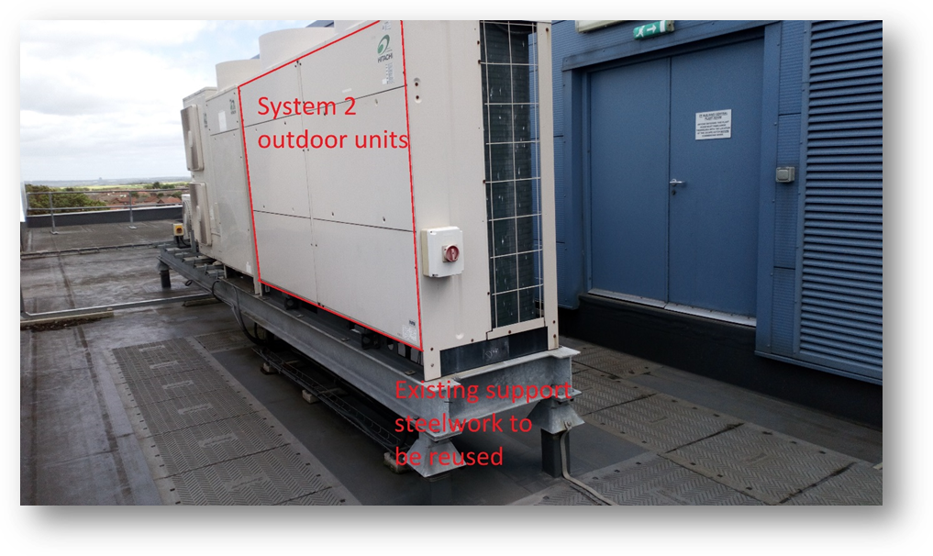
It is reasonably understood that the only timeframe for this installation would be during the summer break of 2019,- term completes June 21st and it is expected the contract will commence as soon as possible thereafter.

LOT 2
Replacement of Main Comms room cooling level 1
Current comms room cooling installation
Asset/Location | Model | Serial Ref No | Unit type | Asset (bar code id) | Room no | Installation date | Make | Type of gas | Quantity
A/C indoor unit comms room | RPC-5.0FSN2E | 4HE55254 | underslung | 2567 | comms room | Aug-10 | HITACHI | R410A
A/C indoor unit comms room | RPC-5.0FSN2E | 4HE55253 | underslung | 2568 | comms room | Aug-10 | HITACHI | R410A
A/C indoor unit comms room | RPC-5.0FSN2E | 4HE52988 | underslung | 2569 | comms room | Aug-10 | HITACHI | R410A
A/C indoor unit comms room | RPC-5.0FSN2E | 4HE55255 | underslung | 2570 | comms room | Aug-10 | HITACHI | R410A
A/C outdoor unit | RAS-10HRNSE | 4HE48534 |  | 2565/2652 |  | Aug-10 | HITACHI | R410A | 6.2 Kg
A/C outdoor unit | RAS-10HRNSE | 4HE48531 |  | 2566/2653 |  | Aug-10 | HITACHI | R410A | 6.2 Kg

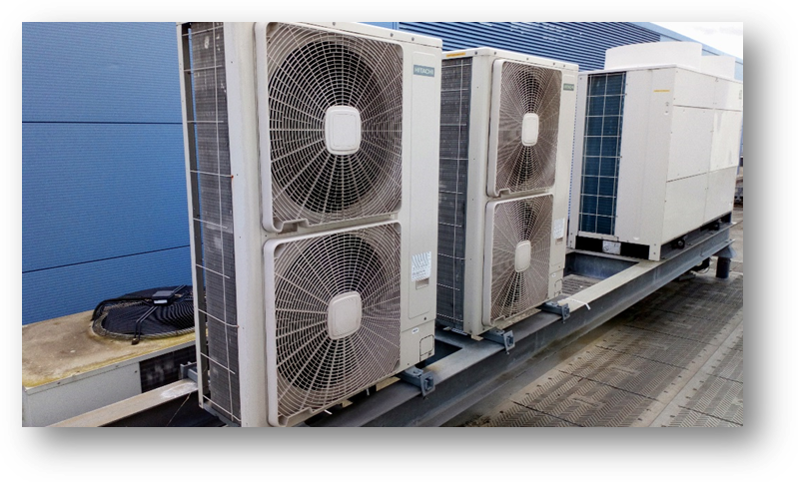
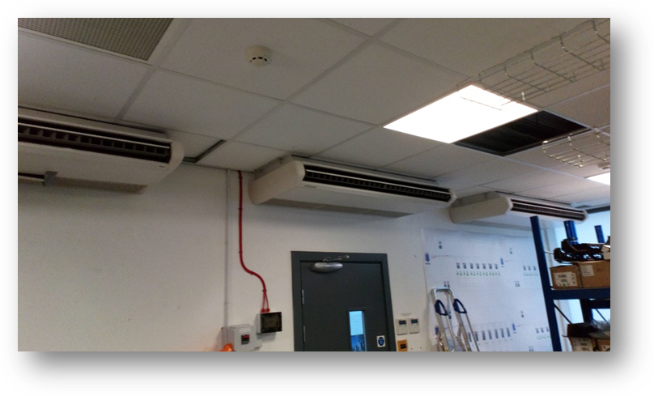

Asset/Location | Model | Serial Ref No | Unit type | Asset (bar code id) | Room no | Installation date | Make | Type of gas
A/C outdoor unit | CUSSHIEM/01 | U73867-02-002 |  | 2096 | Roof | Sep 2004 | AIREDALE | R407C
A/C outdoor unit | CUSSHIEM/01 | U73867-02-001 |  | 2097 | Roof | Sep 2004 | AIREDALE | R407C
A/C indoor unit |  |  | floor | 2237 | comms | Sep 2004 | AIREDALE | R407C
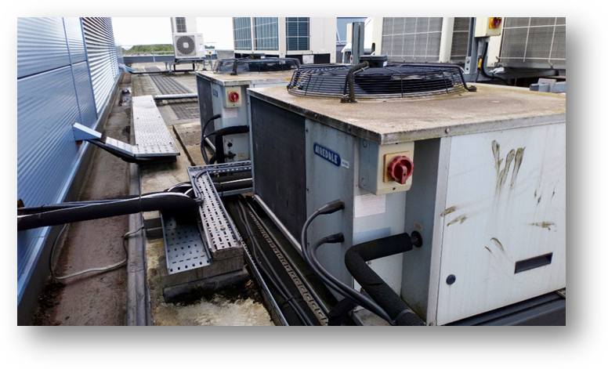

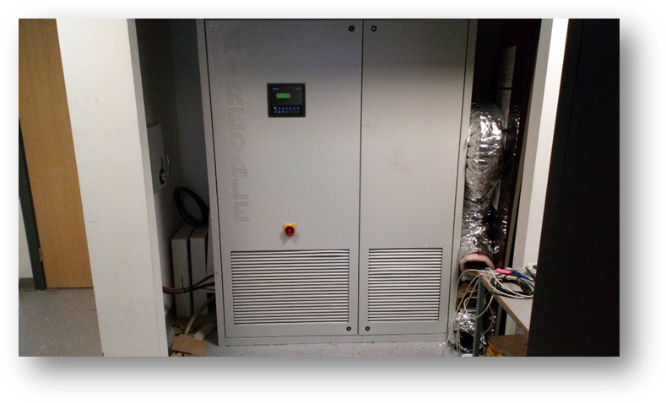
The problem free operation of the comms room is of paramount importance. There are four underslung ceiling units (pic 2) and one floor mounted Airedale unit (pic 4). The primary cooling falls to the ceiling mounted units with the Airedale now in standby for unexpected primary system redundancy. The new system will exceed cooling capacities of the collective systems in place and provide a more streamlined approach to cooling and failure provision. - Single point of failure is not an option.
The installation of the Comms room, lot 2, would be expected to be completed during the Easter break of 2019 (2 weeks) w/c 8th April 2019.

Award Criteria and Evaluation Methodology

This Installation will be awarded to the most economically advantageous tenders applying the award criteria and evaluation methodology detailed below.

Non-Pricing

Other than in the case of scores for pricing, scores under each award criterion will be awarded on the following basis:

Assessment of Response | Score
Excellent: Meets all expectations / Demonstrates complete understanding of all the requirements of this particular specification / No reservations. | 4
Good: Meets most expectations / Demonstrates good understanding of most of the requirements of this particular specification / No reservations. | 3
Marginal: Meets some expectations / Response is standardised with no apparent understanding of the requirements of this particular specification / Minor reservations. | 2
Poor: Does not meet expectations / Response is weak & does not adequately address the specification / Significant reservations. | 1
Unacceptable: Response is missing / Response is very weak and does not address the specification / Major reservations. | 0

Pricing

The lowest average rates submitted, in accordance with the Schedule of Prices Appendix A, will be awarded the highest score and all other Tenderers will be awarded pro rata scores on the relative competitiveness of their price compared to the lowest average e.g. (Lowest Price – Lowest Price / Lowest Price * 100) = X%. This percentage will be deducted from the total score available for Contract Price

Evaluation Criteria /Weighting

Criteria | Percentage
Cost | 40%
Customer Requirement/Specification | 50%
Ability to complete within specified time frame | 5%
Added Value please provide specific details | 5%

This Tender has been broken down as follows:

Lot 1 – AC Installation Green Corridor
Lot 2 – AC Installation Server Room Comms

Further information required from Supplier

For the purpose of evaluation the Supplier must provide all the information requested in the preceding sections and in addition must provide:

- detailed costings of all aspects provision;
- details of any additional facilities provided over and above those requested;
- accounts
- a Company Profile;
- a copy of the Company’s last three years audited accounts;
- the name, address, phone, fax and email address of primary and secondary contact persons;
- Statements of the Supplier’s policies on or approach to Equality and Diversity, Data Protection, Sustainability and ‘The Modern Slavery Act 2015’.

The Supplier may provide any other literature or suggest any innovation it feels appropriate in supporting its tender application.

Terms and Conditions of Purchase (Goods/Service)

- Definitions

  - In these conditions ‘the Purchaser’ means New College Durham. The ‘Supplier’ means the supplier named on the contract and ‘the Goods/Service’ means any such goods/service as are to be supplied to the Purchaser by the Supplier (or by any of the Supplier’s sub-contractors) pursuant to or in connection with this ‘the Order’.
  - In relation to clause 9 the following definitions will apply

“Agreement Personal Data” | the data described by the documented instructions provided by the Purchaser in documentation which is held with this contract.
“Authorised Sub-Processor” | any third party appointed by the Supplier in accordance with this agreement, with the prior written consent of the Purchaser, to Process Agreement Personal Data
“Data Protection Laws” | all applicable laws (including decisions) and guidance by relevant supervisory authorities relating to data protection, the processing of personal data and privacy, including:  - the Data Protection Act 1998;  - (with effect from 25 May 2018) the General Data Protection Regulation (EU) 2016/679;  - the Privacy and Electronic Communications (EC Directive) Regulations 2003 (as may be amended by the proposed Regulation on Privacy and Electronic Communications); and  - any legislation that, in respect of the United Kingdom, replaces or converts into domestic law the General Data Protection Regulation (EU) 2016/679, the proposed Regulation on Privacy and Electronic Communications or any other law relating to data protection, the processing of personal data and privacy as a consequence of the United Kingdom leaving the European Union;  and references to “Data Subjects”, “Personal Data”, “Process”, “Processed”, “Processing”, and “Data Processor” have the meanings set out in, and will be interpreted in accordance with:  - in respect of processing undertaken on or before 24 May 2018, the Data Protection Act 1998;  - in respect of processing undertaken on or after 25 May 2018, the General Data Protection Regulation (EU) 2016/679; and  - in respect of processing undertaken on or after the date on which legislation comes into force that, in respect of the United Kingdom, replaces or converts into domestic law the General Data Protection Regulation (EU) 2016/679, that legislation
“Data Security Incident” | the accidental or unlawful destruction, loss, alteration, unauthorised disclosure of, or access to, Agreement Personal Data transmitted, stored or otherwise Processed
- The Goods/Service

  - The Goods/Service shall be to the reasonable satisfaction of the Purchaser and shall conform in all respects with any particulars specified in this Order and in any variations thereto.

  - The Goods/Service shall conform in this respect with the requirements of any statutes, orders, regulations or by-laws from time to time in force.

  - The Goods/Service shall be fit and sufficient for the purchase for which such goods/service are ordinarily used, and for any particular purpose made known to the Supplier by the Purchaser, and the Purchaser relies on the skill and judgement of the Supplier supply of the Goods/Service in the execution of the Order.

- The Price

  - Unless otherwise agreed in writing by the Purchaser, the Supplier shall render a separate invoice in respect of each consignment delivered under this Order. Payment shall be due 30 days after receipt of the Goods/Service or the correct invoice therefore, whichever is the later.

  - Value Added Tax, where applicable, shall be shown separately on all invoices as a strictly net extra charge.

- Delivery

  - Where any access to the premises is necessary in connection with delivery or installation the Supplier and his sub-contractor shall at all times comply with the reasonable requirements of the Director of Corporate Services

  - The time of delivery shall be of the essence and failure to deliver within the time promised or specified shall enable the Purchaser (at his option) to release himself from any obligation to accept, and pay for, the Goods/Service and/or to cancel all or part of the order thereof, in either case without prejudice to his other rights and remedies.

- Guarantee

  - The guarantee period applicable to the Goods/Service shall be 12 months from putting into service or 18 months from delivery, whichever shall be the shorter (subject to any alternative guarantee arrangements agreed in writing between the Purchaser and the supplier). If the Purchaser shall within such guarantee period or within 30 days thereafter give notice in writing to the Supplier of any defect in any of the Goods/Service as may have arisen during such guarantee period under proper and normal use the Supplier shall (without prejudice to any other rights and remedies which the Purchaser may have) as quickly as possible remedy such defects whether by repair or replacement (as the Purchaser shall elect) without cost to the Purchaser

- Payment

  - Invoices relating to the purchase of equipment/services specified above should be in the name of New College Durham, quoting official order number and send to:
Expenditure
Finance Department New College Durham
Framwellgate Moor Centre Durham
DH1 5ES

- Health and Safety

  - The Supplier represents and warrants to the Purchaser that the Supplier has satisfied himself that all necessary tests and examinations have been made or will be made prior to delivery of the Goods to ensure that the Goods are designed and constructed so as to be safe and without risk to the health or safety of persons using the same, and that he has made available to the Purchaser adequate information about the use for which the Goods/Service have been designed and have been tested and about any conditions necessary to ensure that when put to use the Goods will be safe and without risk to health. The Supplier shall indemnify the Purchaser against all actions, suits, claims, demands, losses, charges, costs and expenses which the Purchaser may suffer or incur as a result of or in connection with any breach of this Condition

- Freedom of Information

  - The Purchaser will make information available to third parties as required by the Freedom of Information Act 2000 (FOIA) and the Environmental Information Regulations 2004 (EIR). The Supplier must acknowledge that the College may be obliged under the FOIA or the EIR to disclose information without informing the Supplier regardless of whether the Supplier considers the information confidential.
- Data Protection

  - The Purchaser, where designated as a Data Processor in relation to services provided to the Supplier, shall comply with this clause 9.
  - Compliance with Laws
    - In performing the Services and its other obligations under this Agreement the Supplier will comply with the Data Protection Laws.
    - The Supplier will not cause the Purchaser to breach any obligation under the Data Protection Laws.
    - The Supplier will notify the Purchaser without undue delay if, in the performance of the Services, it identifies any areas of actual or potential non-compliance with the Data Protection Laws or this clause 9.
  - Authority
The Purchaser authorises the Supplier to Process the Agreement Personal Data during the term of this Agreement as a Data Processor solely for the purpose of providing the Services.
  - Sub-processing
    - The Supplier will not engage or use any third party for the Processing of Agreement Personal Data or permit any third party to Process Agreement Personal Data without the prior written consent of the Purchaser.
    - If the Supplier appoints an Authorised Sub-Processor pursuant to clause 9.4.1, the Supplier will ensure that there is in place a written contract between the Supplier and the Authorised Sub-Processor that specifies the Authorised Sub-Processor’s processing activities and imposes on the Authorised Sub-Processor the same terms as those imposed on the Supplier in this clause 9.
    - The Supplier will remain responsible for all acts and omissions of Authorised Sub-Processors as if they were its own.
  - Supplier obligations
    - The Supplier will, and will procure that any Authorised Sub-Processor will:
      - Process the Agreement Personal Data only on documented instructions (including this Agreement) from the Purchaser;
      - without prejudice to clause 9.5.1.1, ensure that Agreement Personal Data will only be used for the purpose of providing and to the extent required to provide the Services;
      - without prejudice to clause 9.5.1.2, not without the express prior written consent of the Purchaser:
- convert any Agreement Personal Data into anonymised, pseudonymised, depersonalised, aggregated or statistical data;
- use any Agreement Personal Data for “big data” analysis or purposes; or
- match or compare any Agreement Personal Data with or against any other Personal Data (whether the Supplier’s or any third party’s);

      - not permit any Processing of Agreement Personal Data outside the United Kingdom and/or the European Economic Area (as it is made up from time to time) without the Purchaser’s prior written consent (unless the Supplier or the relevant Authorised Sub-Processor is required to transfer the Agreement Personal Data to comply with United Kingdom, European Union (as it is made up from time to time) or European Union Member State Applicable Laws, in which case the Supplier will notify the Purchaser of such legal requirement prior to such transfer unless such Applicable Laws prohibit notice to the Purchaser on public interest grounds);
      - ensure that any individual authorised to Process Agreement Personal Data accesses such Agreement Personal Data strictly on a need to know basis as necessary to perform their role in the provision of the Services, and:
        - is subject to appropriate contractual confidentiality obligations or is under an appropriate statutory obligation of confidentiality;
        - will comply with this clause 9; and
        - and is appropriately reliable, qualified and trained in relation to their Processing of Agreement Personal Data;
      - implement (and assist the Purchaser to implement) technical and organisational measures to ensure a level of security appropriate to the risk presented by Processing the Agreement Personal Data, in particular from a Data Security Incident;
      - notify the Purchaser immediately after becoming aware of a reasonably suspected, “near miss” or actual Data Security Incident, including the nature of the Data Security Incident, the categories and approximate number of Data Subjects and Agreement Personal Data records concerned and any measure proposed to be taken to address the Data Security Incident and to mitigate its possible adverse effects. Where, and in so far as, it is not possible to provide all the relevant information at the same time, the information may be provided in phases without undue further delay, but the Supplier (and Authorised Sub-Processors) may not delay notification under this clause 9.5.1.7 on the basis that an investigation is incomplete or ongoing. The Supplier will not, and will procure that Authorised Sub-Processors will not, make or permit any announcement in respect of the Data Security Incident to any person without the Purchaser’s prior written consent;
      - assist the Purchaser in:
        - responding to requests for exercising Data Subjects’ rights under the Data Protection Laws, including by appropriate technical and organisational measures, insofar as this is possible;
        - documenting any Data Security Incidents and reporting any Data Security Incidents to any supervisory authority and/or Data Subjects;
        - taking measures to address Data Security Incidents, including, where appropriate, measures to mitigate their possible adverse effects; and
        - conducting privacy impact assessments of any Processing operations and consulting with supervisory authorities, Data Subjects and their representatives accordingly; and
      - at the option of the Purchaser, securely delete or return to the Purchaser or, at the Purchaser’s option, transfer to any Replacement Supplier all Agreement Personal Data promptly after the end of the provision of Services relating to Processing, and securely delete any remaining copies and promptly certify (via a director) when this exercise has been completed.
  - Information provision
    - The Supplier will, and will procure that Authorised Sub-Processors will:
      - make available to the Purchaser all information necessary to demonstrate compliance with the obligations set out in this clause 9; and
      - allow for and contribute to audits, including inspections, conducted by the Purchaser or another auditor mandated by the Purchaser.
  - The Supplier will prepare and securely maintain a record of all categories of Processing activities carried out on behalf of the Purchaser in relation to the Agreement Personal Data, including as a minimum: (i) its name and contact details and details of its Data Protection Officer; (ii) the categories of Processing it carries out on behalf of the Purchaser; (iii) any transfers of Agreement Personal Data outside the United Kingdom and/or the European Economic Area (as it is made up from time to time); (iv) a general description of the technical and organisational security measures referred to in clause 9.5.1.6; and (v) the same information in relation to any Authorised Sub-Processor, together with its name and contact details (together the “Data Record”). The Supplier will promptly upon request securely supply a copy of the Data Record to the Purchaser.
- Indemnity and Insurance

  - Without prejudice to any rights or remedies of the Purchaser the Supplier shall indemnify the Purchaser against all actions, suits, claims, demands, losses charges, costs and expenses which the Purchaser may suffer or incur as a result of or in connection with any damage to property or in respect of any injury (whether fatal or otherwise) to any person which may result directly or indirectly from any defect in the Goods/Service or the negligent or wrongful act or omission of the Supplier.

  - The Supplier shall effect with a reputable insurance company a policy or policies of insurance covering all the matters which are the subject of indemnities under these Conditions and shall at the request of the Purchaser produce the relevant policy or policies together with receipts or other evidence of payment of the latest premium due thereunder.

  - The Supplier will indemnify the Purchaser against all actions, suits, claims, demands, losses charges, costs and expenses, in each case arising out of or in connection with any breach by the Supplier of any of its obligations under clause 9 (including any failure or delay in performing, or negligent performance or non-performance of, any of those obligations).

- Termination or Supplier’s Insolvency

  - Without prejudice to any other rights or remedies of the Purchaser under this Order the Purchaser shall have the right forthwith to terminate this Order by written notice to the Supplier or his trustee in bankruptcy or receiver or (if a company) liquidator or administrator if the Supplier shall have a receiver appointed over all or a substantial part of his or its assets or (if an individual) be declared bankrupt or (if a company) shall go into liquidation or have an administrator appointed to manage its affairs.

- Assignment and Sub-contracting

  - The Supplier shall not without the written consent of the Purchaser assign the benefit or burden of this Order or any part thereof.

  - No sub-contracting by the supplier shall in any way relieve the Supplier of any of his responsibilities under this order.

- Governing Law

  - These conditions shall be governed by and construed in accordance with English Law and the Supplier hereby irrevocably submits to the jurisdiction of the English Law courts. The submission to such jurisdiction shall not (and shall not be construed so as to) limit the right of the Purchaser to take proceedings against the Supplier in any other court of competent jurisdiction, nor shall the taking of proceedings in any one or more jurisdiction preclude the taking of proceedings in any other jurisdiction, whether concurrently or not.

- Contacts and References

  - In order to help evaluation your offer please provide reference sites with named contacts where you have carried our similar installations.

The Supplier’s offer should be e-mailed to:

tenders@newdur.ac.uk

Alternatively the Supplier’s offer may be addressed to:

Susan Dring
Corporation Secretary
New College Durham
Framwellgate Moor Campus
Durham
DH1 5ES

Please note that tender replies that are sent to the College in the post must be sent in an A4 envelope which does not in any way identify your Company.

The College reserves the right if it so wishes to:

- reject all tenders, or
- reject the lowest tender where it considers another offers best value or
- award Lots independently

The College expects that any Tender supplied would be held open for a period of three months from the closing date for receipt of tenders.

Further reasonable information relating to this tender may be obtained by e- mail from the following.

Helen Collin
Procurement and Contracts Manager
helen.collin@newdur.ac.uk

Yours faithfully,

Helen

Helen Collin
Procurement and Contracts Manager

Central Purchasing Unit
Direct Line: 0191 375 4517
Fax: 0191 375 4371
helen.collin@newdur.ac.uk

