***Specification for consultancy services to assess the potential for raising finance for the West London Orbital from new development***

The West London Alliance[1] and Transport for London are seeking to appoint consultants to advise on the scope for securing contributions from new development toward the costs of development and delivery of the West London Orbital (WLO) overground railway project, taking forward high-level work on funding and financing issues completed by Grant Thornton/Mott Macdonald.

***The West London Orbital***

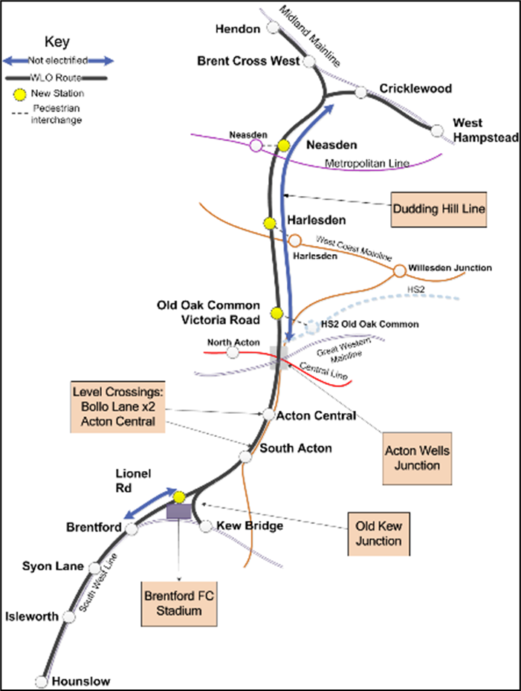The WLO is a proposed overground heavy rail link that would form part of the London Overground network to connect West Hampstead and Hendon at the northern/eastern end with Hounslow and Kew Bridge at the western end, with stations including Brent Cross West, Neasden, Harlesden, Acton and Brentford along the way. It will link strategic development opportunities at Brent Cross/Cricklewood, Staples Corner, Neasden, Old Oak/Park Royal and the Great West Corridor and provide interconnectivity between Thameslink; the Jubilee and Bakerloo London Underground lines; Euston-Watford Junction and North London TfL Overground Rail lines; and HS2 and Elizabeth lines:

The WLO will use existing infrastructure – using the Midland main line freight lines, bringing the Dudding Hill line between Cricklewood and Old Oak Common back into passenger use and then following the North London Overground line, the freight only line to Kew and Hounslow Loop route to Hounslow.

It will directly link four opportunity areas designated in the London Plan, which together can provide at least 56,500 homes and 118,500 jobs:

* Brent Cross/Cricklewood, with capacity for 9,500 homes and 26,000 jobs
* Wembley, with capacity for 14,000 homes and 13,500 jobs
* Old Oak/Park Royal, with capacity for 25,500 homes and 65,000 jobs
* Great West Corridor, with capacity for 7,500 homes and 14,000 jobs

The WLO will also improve accessibility by providing interchange to five more opportunity areas, which could provide an additional 38,000 homes and 18,000 jobs:

* Colindale/Burnt Oak, with capacity for 7,000 homes and 2,000 jobs
* Harrow and Wealdstone, with capacity for 5,000 homes and 1,000 jobs
* Hayes, with capacity for 4,000 homes and 1,000 jobs
* Heathrow, with capacity for 13,000 homes and 11,000 jobs
* Southall, with capacity for 9,000 homes and 3,000 jobs)

For the purposes of this study, the cost of the WLO is taken to be £435m – £605m (2017 prices) or £524m – £728m (outturn costs)[2]. Construction is projected to commence in 2026 and complete around 2029. Development of the scheme is at an early GRIP2 (feasibility) stage.

***Funding the WLO***

Development of the project is proceeding on the basis that TfL’s financial situation means they will not have the funds available for the project until the 2030s at the earliest. Consequently WLA/TfL have been exploring other options for raising the required funding. In 2019 Grant Thornton and Mott Macdonald were commissioned to assess the different funding options available, model the potential contribution they could provide and set out the key actions that TfL/WLA need to take to implement them. The West London Orbital Funding Study has now been completed.

This study considered a long list of funding options and identified the following short list of options which were assessed in more detail:

1. Community Infrastructure Levy (CIL);
2. Section 106;
3. Business Rates Retention;
4. Redevelopment of Public Sector Land;
5. Workplace Parking Levy; and
6. National Homebuilding Fund / Other Government grants.

This current commission relates to options 1 and 2 and is intended to supplement the Study by quantifying the contribution that can realistically be sought from development, in particular having regard to viability issues.

The Funding Study drew on information about past development trends (using data from the London Development Database) and about future plans from borough local plan site allocations compiled as part of a parallel economic benefits study carried out by Steer/Arcadis.

On CIL, the study considered two options:

* A broad CIL rate for all development in boroughs benefitting from the WLO (£20psm in the boroughs the WLO runs through – Barnet, Brent, Ealing and Hounslow - and £10psm in the other West London boroughs who can be shown to benefit from it - Hammersmith and Fulham, Harrow, Hillingdon). Modelling suggests that over 25 years this could raise between £214m (based on past trends) and £285m (based on future plans).
* An additional “above plan” £20 psm supplementary levy charged for development within 1 km of WLO stations that can be shown to be directly dependent on the project. Modelling suggests this could raise £13.3m from residential development and £7m from commercial development.

On s106, modelling was undertaken to show how much could be raised using planning obligations to secure part of the additional land value the WLO would support if the project was prioritised over other calls on it (affordable housing and other infrastructure) for development within 1 km of a WLO station. This showed that the total value that could be tapped based on hypothetical affordable housing targets was:

|  |  |  |  |
| --- | --- | --- | --- |
| Affordable Housing Target | WLO-dependent RLV uplift, £m | Difference | % above baseline |
| 50% | 797.9 | Baseline | Baseline |
| 35% | 896.4 | 98.5 | 12.3% |
| 0% | 1,126.4 | 328.5 | 41.2% |

The Study dealt with the CIL and section 106 options separately and did not consider development viability.

The report and supporting technical report are attached as annexes to this specification.

***Accelerating housing delivery***

The Economic Narrative produced by Steer/Arcadis referred to earlier sought to estimate the potential impact the WLO might have in terms of accelerating housing delivery. It did this by estimating the effect of reduced financing costs for a development due to a developer shortening their development cashflow. An accelerated programme would be expected to result in a larger quantum of receipts being received and the ability to pay off borrowing more quickly, resulting a reduced interest charge for the developer. The approach taken is described in more detail in paragraphs 6.14-6.16 of the Economic Narrative report.

Discussions with Homes England and others and the monitoring of build-out of sites along the route by TfL/WLA have reinforced the importance of this aspect of the business case for the WLO.

***Purpose and scope of the commission***

TfL/WLA now want to procure consultants to build on the analysis in the West London Orbital Funding Study and provide senior decision-makers at the Greater London Authority, Transport for London, West London boroughs and the West London Alliance with sufficient information to take decisions about further work relating to development contributions to help refine a WLO funding strategy.

Given the increased salience of the potential for the project to support acceleration of housing delivery as well as an increase in overall numbers of units, TfL/WLA also want to have a more detailed review of this aspect to inform development of the business case for the WLO.

It therefore falls in three parts:

*Part 1:*

Provision of information about:

* The amounts that could realistically be sought from development in West London through CIL and/or s106 to contribute towards the costs of developing/implementing the WLO, building on the modelling in the WLO Funding Study. This should consider options for “broad” options and ones more focussed on areas nearer WLO stations and so potentially more able to bear higher rates.
* Potential impacts on development viability and steps that could be taken to mitigate them (such as differential CIL rates by use/location/scale of development).
* Potential impacts on other policy requirements made of development – such as affordable housing and other infrastructure.

This needs to be in a format allowing the testing of different options (such as CIL rates and levels of s106 contributions and different levels of affordable housing). It should also include sensitivity testing to take account of potential changes in the West London development market.

It must be informed by knowledge of development viability essentials across West London local planning authorities.

*Part 2:*

Advice on steps that could be taken now to start seeking s106 contributions to fund development of the WLO project, including support for setting a benchmark contribution level per square metre for different types of development in the vicinity of proposed WLO stations, drawing on the analysis carried out for Part 1.

It is not currently envisaged that either aspect of this commission will involve large-scale engagement with individual local planning authorities; the WLA will ensure that any information required from them is sought and passed on.

*Part 3*

Building on the Steer/Arcadis Economic Narrative referred to earlier and informed by the overview of the West London development market underpinning parts 1 and 2 of this commission, articulate and, as far as possible, quantify the scope for the WLO to accelerate housing delivery in West London as well as supporting an increase in overall numbers.

This should draw on available literature about the effects of transport investment on accelerating development and experience of other relevant projects. It should be of sufficient robustness to be drawn on in developing the business case for the project.

***Analysis required***

The analysis should:

1. Identify the scale of contributions that could be sought from new development in West London without having impacts on development viability that would put delivery of London Plan and local development plan policies at risk.

Viability should be considered on a broad, area-based basis in accordance with relevant national planning guidance on viability testing of local plan policies. The analysis should be based on an agreed number of residential and commercial typologies typical of sites that are likely to come forward for development over the plan period, where necessary differentiating between viability issues specific to the designated opportunity areas in West London boroughs (see annex) and in other parts of the boroughs concerned.

1. Using the output from this assessment, identify:
   1. the contributions per square metre that could be sought from different types of development in different parts of West London without rendering them unviable and
   2. the potential overall contribution that could be sought from development in West London.

Options should include the broad and more focussed approaches considered in the WLO Funding Study (see above).

1. Identify any potential impacts on delivery of National/Mayoral/borough policy requirements from seeking WLO contributions – including in particular affordable housing requirements.
2. Advise how the most effective use could be made of CIL and/or s106 (or combination of the two) to secure contributions towards the cost of the WLO having regard to the evidence about viability and relevant legislation and guidance, identifying the opportunities and risks associated with each option and the scope for using different tools to obtain contributions for the same project.
3. Consider the effects of introduction of a national Infrastructure levy linked to development values as proposed in the “Planning for the Future” white paper.
4. Provide advice on the potential for seeking early contributions from development towards the cost of WLO project development (e.g. engineering and design, environmental and other assessments, and preparation of the case for powers) – in particular to help support the agreement of a benchmark £/sq m rate to inform discussions between local planning authorities and developers.
5. Draw on the evidence about viability essentials in West London (including in particular the agreed development typologies), technical literature and experience of similar transport projects to articulate and, as far as possible, quantify the potential for implementation of the WLO to contribute to acceleration in housing delivery.

This analysis is likely to be drawn on by local planning authorities in preparing local plan policies, in setting CIL rates and policy documents dealing with use of planning obligations and in taking planning decisions, and must therefore be sufficiently robust for these purposes.

***Required outputs:***

* A concise report backed by detailed annexes setting out the results of typology viability testing giving:
  + An overview of relevant viability essentials across West London, for each West London borough and, where distinctive, in designated opportunity areas.
  + An assessment of the quantum of contribution that could be sought from development in different parts of West London, including zones 1, 1.5 and 2km around proposed WLO stations, without an undue impact on viability or other regional/local policy requirements and existing agreed transport infrastructure upgrades. This should include analysis on a “per unit” basis using the typologies used for study element 2 above so the local impacts of different contribution levels can be readily identified.
  + Informed by this analysis, advice on the optimum use of CIL and/or s106 by Local Planning Authorities, having regard to the opportunities/risks presented by each.
  + An assessment of potential issues that might be presented by changes to national legislation along the lines of the “Planning for the Future” white paper.
  + Benchmarks that could be used in the short/medium-term to inform negotiations between local planning authorities.
  + An account of the linkages between implementation of the West London Orbital and the West London development market that might accelerate the delivery of housing units and, drawing on the evidence of viability essentials in West London developed for the other elements of this commission, seek to quantify these impacts
* A slide deck presentation of key findings

The successful consultant may also be asked to attend a meeting of the joint TfL/GLA/WLA Project Oversight Group and a wider workshop of senior borough officers on WLO funding issues to present the findings.

***Work stages and deliverables***

Stage 1: *Familiarisation:*

Gaining familiarity with the West London Orbital project and the case development work to date including in particular:

* The West London Orbital Funding Study (attached)
* The West London Orbital Economic Narrative

Gaining familiarity with relevant planning policies – the London Plan and West London local planning authorities’ local plans (both adopted and those in progress) and relevant CIL charging schedules, planning obligations and supplementary planning documents.

An inception meeting to confirm arrangements and assumptions for the project, any additional data required and, to agree the approach to be taken to stakeholder engagement and to ensure the client officers’ requirements are understood.

Stage 2: *Initial results:*

Present initial findings regarding potential quantum of contributions that could be sought and viability impacts.

Hold a progress meeting with TfL/WLA and provide weekly email updates.

Deadline for initial results: 29th October 2021

Stage 3: *Final reporting:*

Attend meeting with TfL/WLA to present draft reports and emerging recommendations, and to collect any feedback.

Make adjustments necessary to accommodate this feedback.

Produce a final report which contains full detail.

Deadline for final report: 30th November 2021

It is envisaged that payment will be made on the basis of 3% on commencement, 33% at the end of phase 2 and 33% on completion.

***Submission requirements***

Written submissions are invited from interested consultants setting out understanding of, and proposed approach to, the brief and setting out:

* Experience and technical knowledge of the issues involved in seeking contributions for strategic infrastructure projects through the planning system including, in particular, development viability and the relevant requirements of national planning policy and guidance
* Understanding of relevant national, London-wide and local planning policy requirements
* Experience of preparing evidence base documents for use in planning policy-making and decision-taking
* Potential to add value
* CVs for staff that will work on the project stating the individual contribution each will make. The proposed project manager should be identified
* The fee proposal, identifying Details of the number of days to be spent on the key areas of the brief and the proposed breakdown of costs/time for each broken down into days and rates, including costs/time breakdown (including hourly billing rates) of all staff that will work on the project. Day rates should be given for any subsequent additional work.
* .Any additional considerations consultants consider necessary in meeting the aims of the project.
* Three examples of similar projects undertaken elsewhere in the last five years, with project budget, client name, email address and contact number for references.
* Details of internal quality assurance systems that will be used for the project.
* Details of levels of professional indemnity insurance and public liability insurance held.
* Details of relevant equal opportunities policies.
* If the Consultant is unable to provide all the works themselves, they must specify and give details of any sub-contractors.

**Submissions will be assessed on the basis of a 70% quality/30% price weighting.**

ANNEX

RELEVANT WEST LONDON OPPORTUNITY AREAS

|  |  |  |  |
| --- | --- | --- | --- |
| OA | Indicative Housing units | Indicative Jobs | Borough(s) |
| Colindale / Burnt Oak | 7,000 | 2,000 | Barnet |
| Brent Cross / Cricklewood | 9,500 | 26,000 | Barnet |
| Wembley | 14,000 | 13,500 | Brent |
| OOC / Park Royal | 25,500 | 65,000 | Brent, Ealing and H+F (OPDC is local planning authority) |
| Southall | 9,000 | 3,000 | Ealing |
| White City | 7,000 | 2,000 | H+F |
| Harrow & Wealdstone | 5,000 | 1,000 | Harrow |
| Hayes | 4,000 | 1,000 | Hillingdon |
| Heathrow | 13,000 | 11,000 | Hounslow and Hillingdon |
| Great West Corridor | 7,500 | 14,000 | Hounslow |
| TOTAL | 108,000 | 143,500 |  |

1. The West London Alliance is a sub-regional partnership comprising the boroughs of Barnet, Brent, Ealing, Hammersmith and Fulham, Harrow, Hillingdon and Hounslow
2. NB these figures have been updated since the Funding and Finance Study