Station code | Representative sample 1 | Representative sample 2 | Representative sample 3 | Preliminary BSH
SDOR_CEND1315_SDOR62_STN_008_A1 | 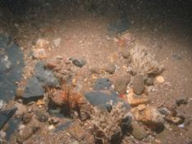 | 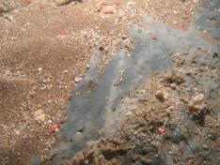 | 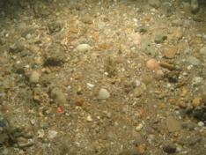 | High energy circalittoral rock
SDOR_CEND1315_SDOR14_STN_009_A1 | 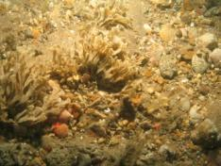 | 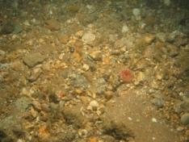 | 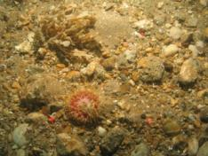 | Subtidal coarse sediment
SDOR_CEND1315_SDOR67_STN_010_A1 | 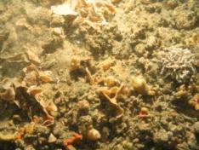 | 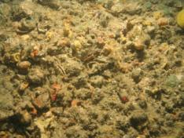 | 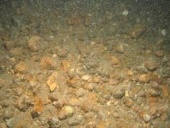 | Subtidal coarse sediment
SDOR_CEND1315_SDOR13_STN_011_A1 | 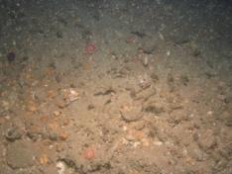 | 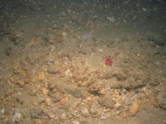 | 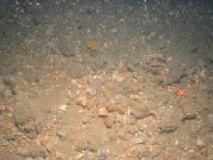 | Subtidal coarse sediment
SDOR_CEND1315_SDOR69_STN_012_A1 | 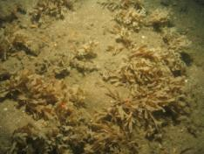 | 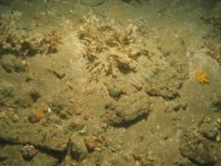 | 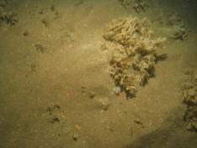 | High energy circalittoral rock, subtidal coarse and subtidal sand.
SDOR_CEND1315_SDOR70_STN_013_A1 | 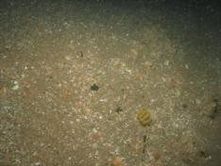 | 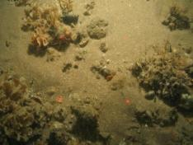 | 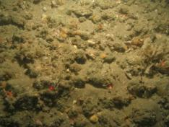 | Moderate energy circalittoral rock, subtidal coarse and subtidal sand.
SDOR_CEND1315_SDOR72_STN_014_A1 | 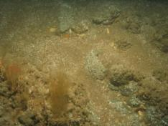 | 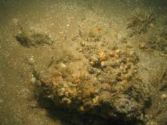 | 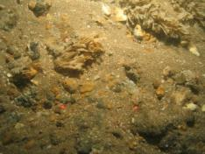 | High energy circalittoral rock. Subtidal coarse sediment.
SDOR_CEND1315_SDOR48_STN_015_A1 | 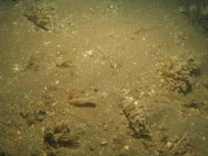 | 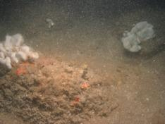 | 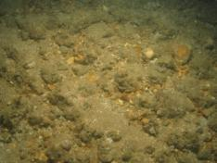 | High energy circalittoral rock.
SDOR_CEND1315_SDOR73_STN_016_A2 | 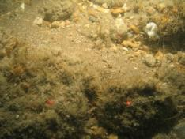 | 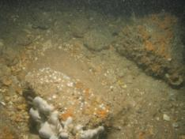 | 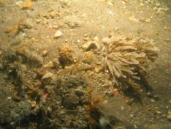 | High energy circalittoral rock.  Subtidal coarse sediment
SDOR_CEND1315_SDOR09_STN_017_A1 | 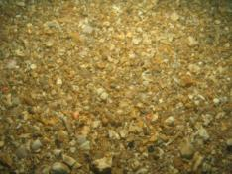 | 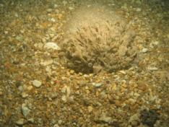 | 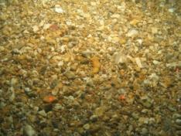 | Subtidal coarse sediment
SDOR_CEND1315_SDOR09_STN_019_A1 | 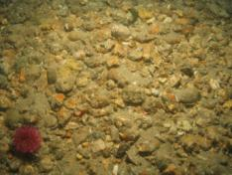 | 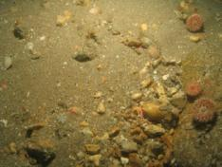 | 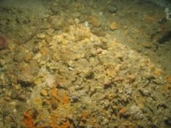 | Moderate energy circalittoral rock. Subtidal coarse sediment
SDOR_CEND1315_SDOR78_STN_020_A1 | 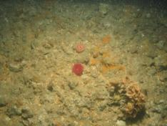 | 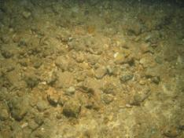 | 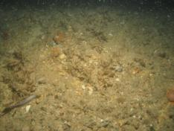 | Moderate energy  Subtidal Coarse
SDOR_CEND1315_SDOR76_STN_022_A1 | 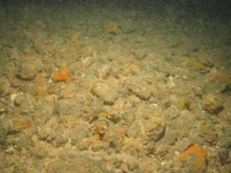 | 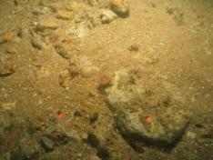 | 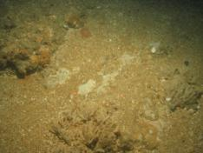 | Moderate energy  Subtidal Coarse
SDOR_CEND1315_SDOR79_STN_023_A1 | 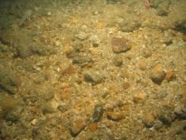 | 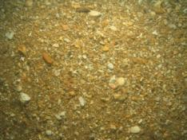 | 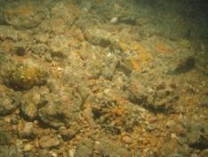 | Moderate energy  Subtidal Coarse
SDOR_CEND1315_SDOR51_STN_025_A1 | 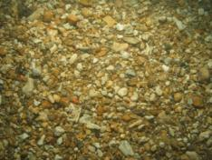 | 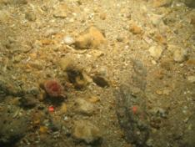 | 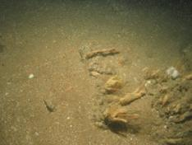 | Moderate energy  Subtidal Coarse
SDOR_CEND1315_SDOR83_STN_026_A1 | 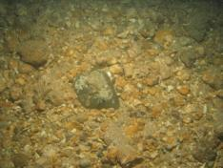 | 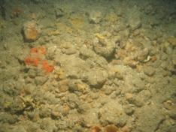 | 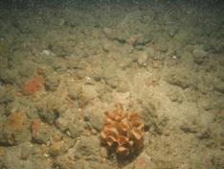 | Moderate energy circalittoral rock. Subtidal coarse sediment
SDOR_CEND1315_SDOR77_STN_028_A1 | 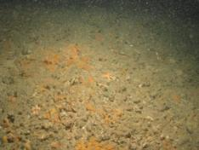 | 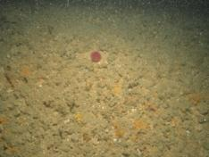 | 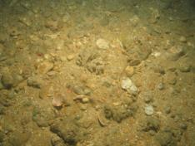 | Moderate energy circalittoral rock. Subtidal coarse sediment
SDOR_CEND1315_SDOR55_STN_029_A1 | 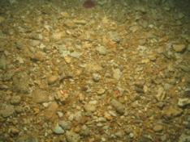 | 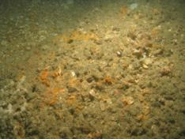 | 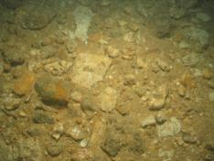 | Moderate energy circalittoral rock. Subtidal coarse sediment
SDOR_CEND1315_SDOR56_STN_032_A1 | 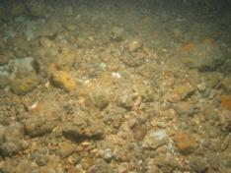 | 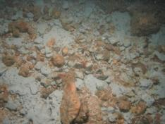 | 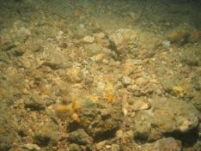 | Moderate energy circalittoral rock. Subtidal coarse sediment
SDOR_CEND1315_SDOR52_STN_035_A1 | 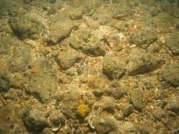 | 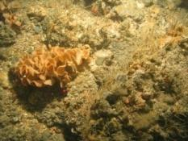 | 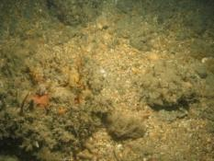 | Moderate energy circalittoral rock. Subtidal coarse sediment
SDOR_CEND1315_SDOR54_STN_036_A1 | 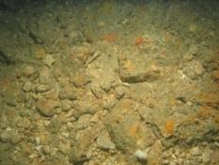 | 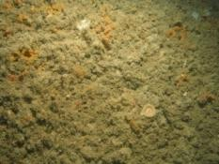 | 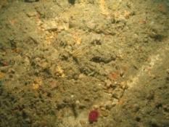 | Moderate energy circalittoral rock.
SDOR_CEND1315_SDOR53_STN_037_A1 | 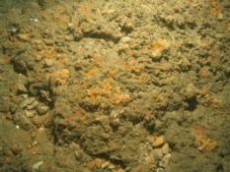 | 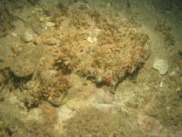 | 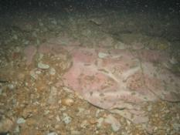 | Moderate energy circalittoral rock.
SDOR_CEND1315_SDOR80_STN_038_A1 | 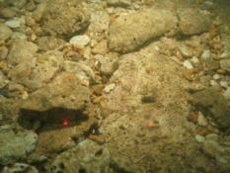 | 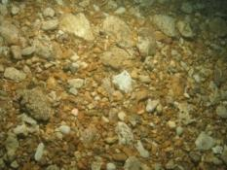 | 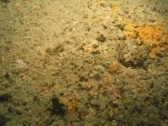 | Moderate energy circalittoral rock.
SDOR_CEND1315_SDOR81_STN_039_A1 | 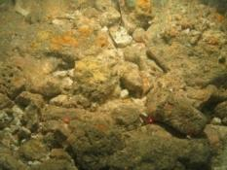 | 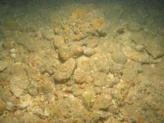 | 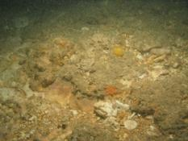 | High energy circalittoral rock.
SDOR_CEND1315_SDOR37_STN_044_A1 | 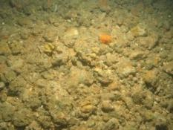 | 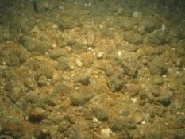 | 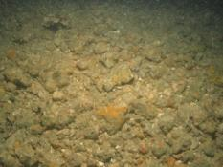 | Moderate energy circalittoral rock.
SDOR_CEND1315_SDOR26_STN_049_A1 | 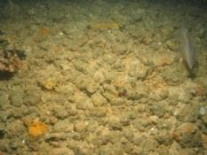 | 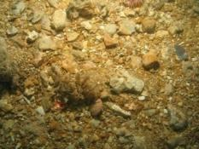 | 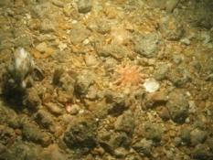 | Moderate energy circalittoral rock. Subtidal coarse sediment
SDOR_CEND1315_SDOR23_STN_053_A1 | 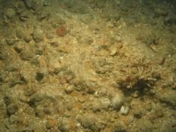 | 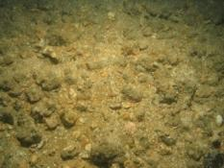 | 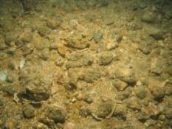 | Moderate energy circalittoral rock. Subtidal coarse sediment
SDOR_CEND1315_SDOR47_STN_057_A1 | 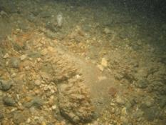 | 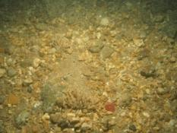 | 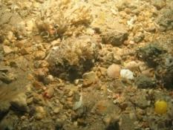 | Moderate energy circalittoral rock. Subtidal coarse sediment
SDOR_CEND1315_SDOR57_STN_058_A1 | 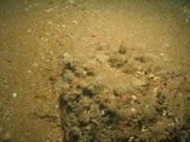 | 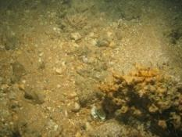 | 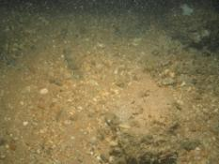 | Moderate energy circalittoral rock. Subtidal coarse sediment
SDOR_CEND1315_SDOR58_STN_060_A1 | 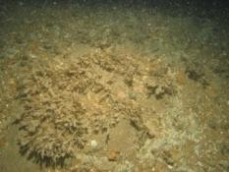 | 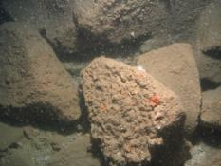 | 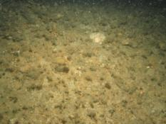 | Moderate energy circalittoral rock. Subtidal coarse sediment
SDOR_CEND1315_SDOR61_STN_061_A1 | 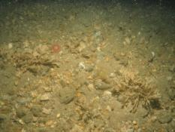 | 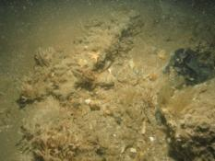 | 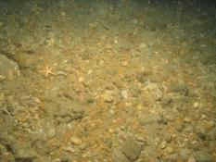 | Moderate energy circalittoral rock. Subtidal coarse sediment
SDOR_CEND1315_SDOR63_STN_062_A1 | 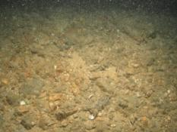 | 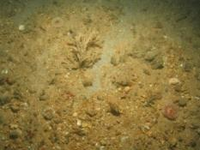 | 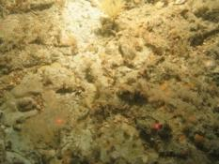 | Moderate energy circalittoral rock. Subtidal coarse sediment
SDOR_CEND1315_SDOR19_STN_063_A1 | 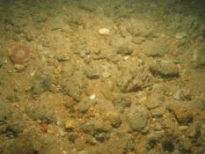 | 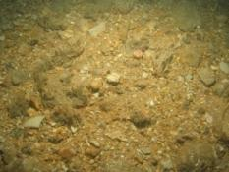 | 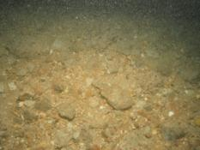 | Moderate energy circalittoral rock. Subtidal coarse sediment
SDOR_CEND1315_SDOR65_STN_064_A1 | 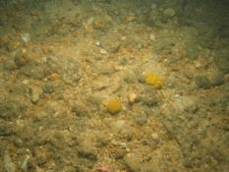 | 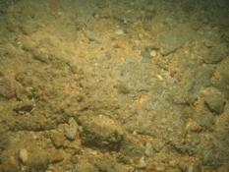 | 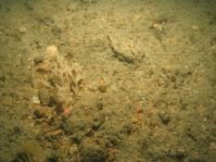 | Moderate energy circalittoral rock. Subtidal coarse sediment
SDOR_CEND1315_SDOR64_STN_066_A1 | 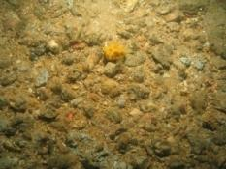 | 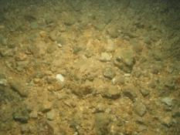 | 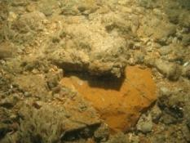 | Moderate energy circalittoral rock. Subtidal coarse sediment.
SDOR_CEND1315_SDOR87_STN_069_A1 | 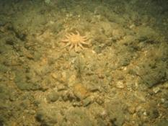 | 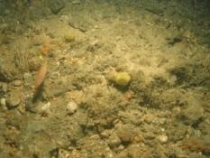 | 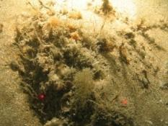 | Moderate energy circalittoral rock. Subtidal coarse sediment.
SDOR_CEND1315_SDOR86_STN_070_A1 | 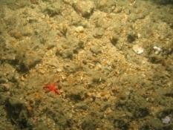 | 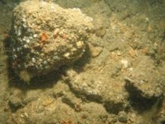 | 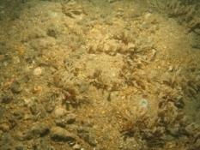 | Moderate energy circalittoral rock. Subtidal coarse sediment.
SDOR_CEND1315_SDOR44_STN_071_A1 | 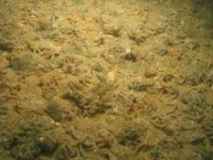 | 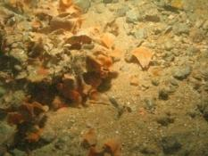 | 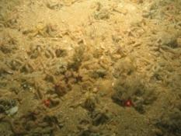 | Moderate energy circalittoral rock. Subtidal coarse sediment.
SDOR_CEND1315_SDOR43_STN_072_A2 | 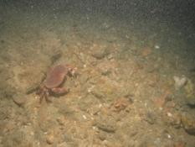 | 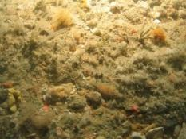 | 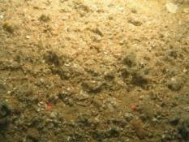 | Moderate energy circalittoral rock.
SDOR_CEND1315_SDOR21_STN_073_A1 | 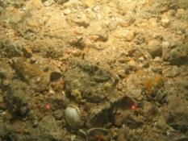 | 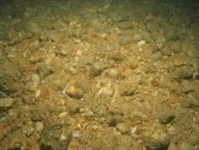 | 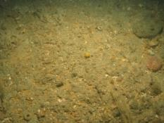 | Moderate energy circalittoral rock. Subtidal coarse sediment.
SDOR_CEND1315_SDOR45_STN_074_A1 | 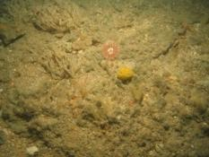 | 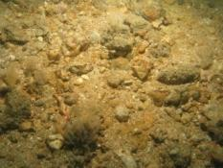 | 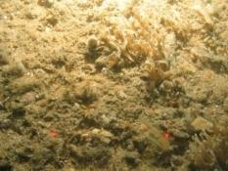 | Moderate energy circalittoral rock. Subtidal coarse sediment.
SDOR_CEND1315_SDOR46_STN_075_A1 | 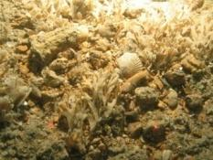 | 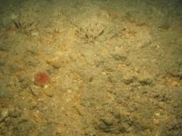 | 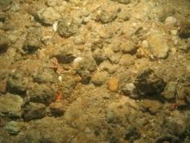 | Moderate energy circalittoral rock. Subtidal coarse sediment.
SDOR_CEND1315_SDOR30_STN_083_A1 | 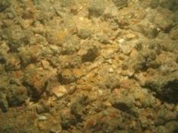 | 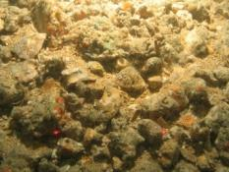 | 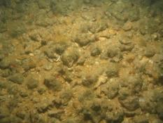 | Subtidal coarse sediment and cobble field.
SDOR_CEND1315_SDOR30_STN_085_A1 | 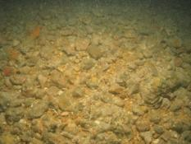 | 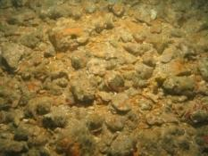 | 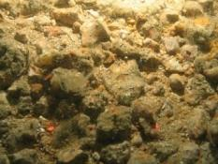 | Subtidal coarse sediment and cobble field.
SDOR_CEND1315_SDOR41_STN_086_A1 | 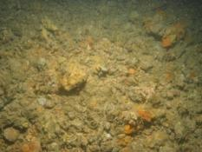 | 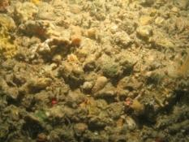 | 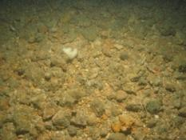 | Subtidal coarse sediment and cobble field with gravel.
SDOR_CEND1315_SDOR40_STN_091_A1 | 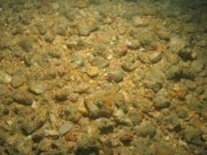 | 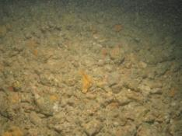 | 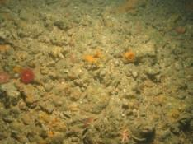 | Moderate energy circalittoral rock. Subtidal coarse sediment.
SDOR_CEND1315_SDOR34_STN_092_A1 | 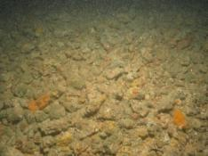 | 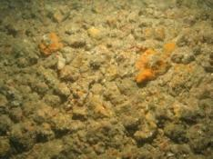 | 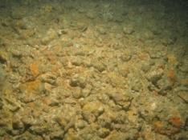 | Moderate energy circalittoral rock. Subtidal coarse sediment.
SDOR_CEND1315_SDOR32_STN_093_A1 | 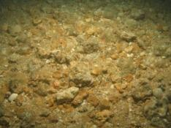 | 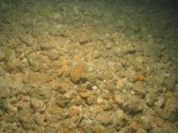 | 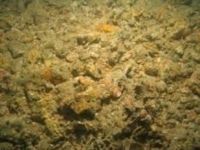 | Moderate energy circalittoral rock. Subtidal coarse sediment.
SDOR_CEND1315_SDOR29_STN_094_A1 | 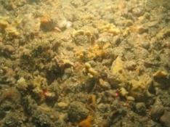 | 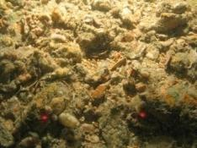 | 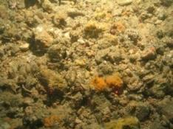 | Moderate energy circalittoral rock. Subtidal coarse sediment.
SDOR_CEND1315_SDOR23_STN_095_A1 | 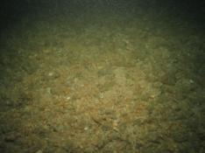 | 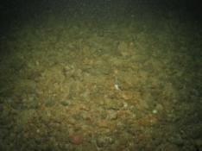 | 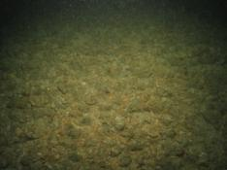 | Moderate energy circalittoral rock. Subtidal coarse sediment.
SDOR_CEND1315_SDOR26_STN_096_A1 | 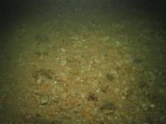 | 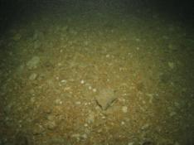 | 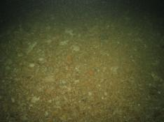 | Moderate energy circalittoral rock. Subtidal coarse sediment.
SDOR_CEND1315_SDOR30_STN_097_A1 | 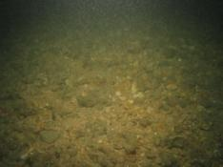 | 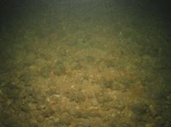 | 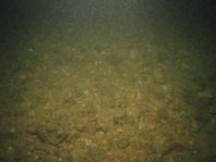 | Moderate energy circalittoral rock. Subtidal coarse sediment.
SDOR_CEND1315_SDOR35_STN_098_A1 | 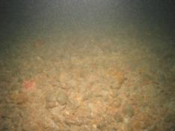 | 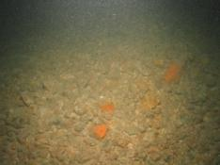 | 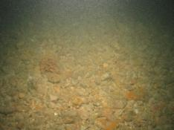 | Moderate energy circalittoral rock. Subtidal coarse sediment.
SDOR_CEND1315_SDOR37_STN_099_A1 | 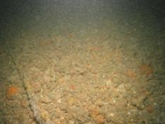 | 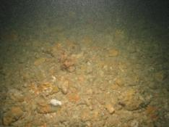 | 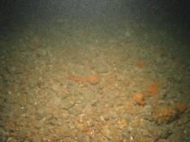 | Moderate energy circalittoral rock. Subtidal coarse sediment.
SDOR_CEND1315_SDOR41_STN_100_A1 | 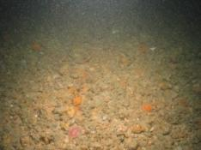 | 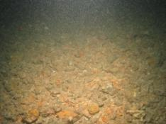 | 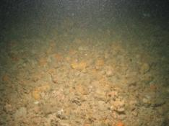 | Subtidal coarse sediment.
SDOR_CEND1315_SDOR53_STN_103_A1 | 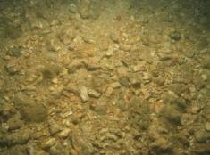 | 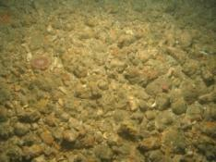 | 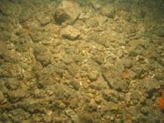 | Subtidal coarse sediment.
SDOR_CEND1315_SDOR51_STN_104_A1 | 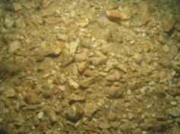 | 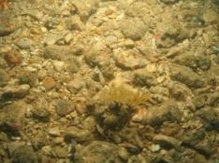 | 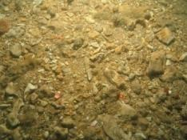 | Subtidal coarse sediment
SDOR_CEND1315_C52_STN_105_A1  HG | 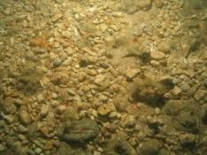 | 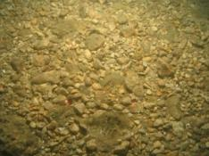 | 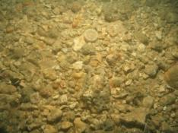 | Subtidal coarse sediment
SDOR_CEND1315_C50_STN_107_A1 | 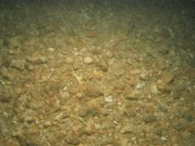 | 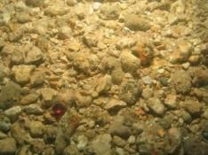 | 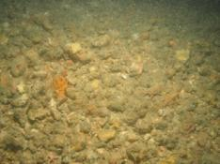 | Subtidal coarse sediment
SDOR_CEND1315_C54_STN_108_A1 | 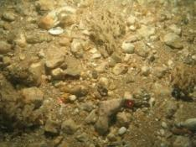 | 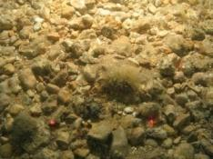 | 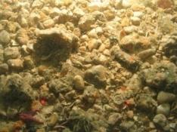 | Subtidal coarse sediment
SDOR_CEND1315_C49_STN_109_A1  HG NS | 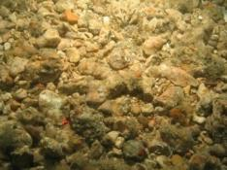 | 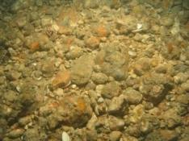 | 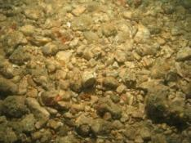 | Subtidal coarse sediment
SDOR_CEND1315_C48_STN_111_A1 | 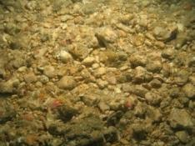 | 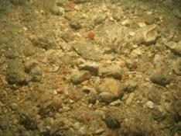 | 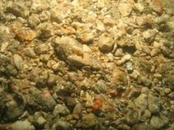 | Subtidal coarse sediment
SDOR_CEND1315_C43_STN_112_A1 | 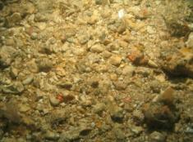 | 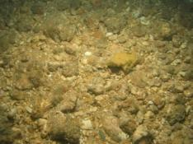 | 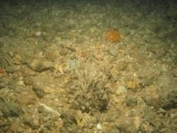 | Moderate energy circalittoral rock. Subtidal coarse sediment.
SDOR_CEND1315_C42_STN_113_A1 | 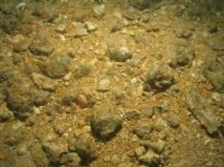 | 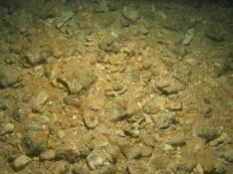 | 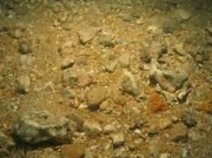 | Moderate energy circalittoral rock. Subtidal coarse sediment.
SDOR_CEND1315_C41_STN_114_A1  HG | 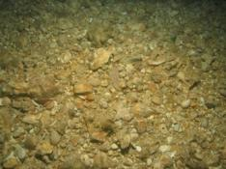 | 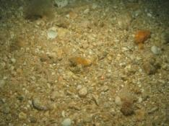 | 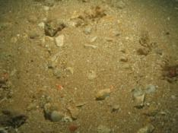 | Moderate energy circalittoral rock. Subtidal coarse sediment.
SDOR_CEND1315_C39_STN_116_A1 | 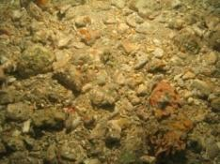 | 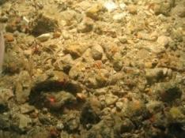 | 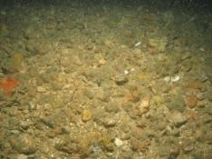 | Moderate energy circalittoral rock. Subtidal coarse sediment.
SDOR_CEND1315_C38_STN_117_A1 | 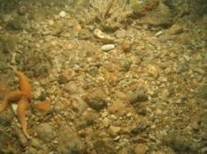 | 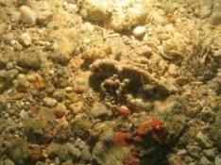 | 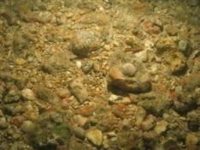 | Moderate energy circalittoral rock. Subtidal coarse sediment.
SDOR_CEND1315_C37_STN_119_A1 | 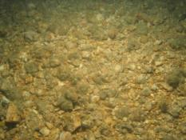 | 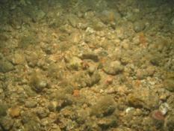 | 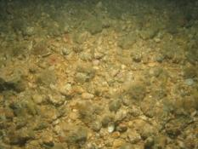 | Moderate energy circalittoral rock. Subtidal coarse sediment.
SDOR_CEND1315_C40_STN_120_A1 | 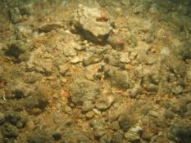 | 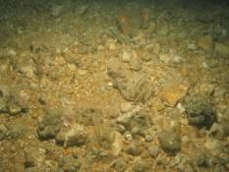 | 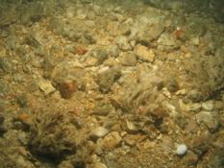 | Moderate energy circalittoral rock. Subtidal coarse sediment.
SDOR_CEND1315_C36_STN_121_A1 | 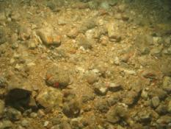 | 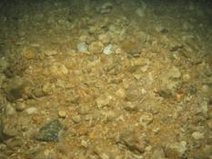 | 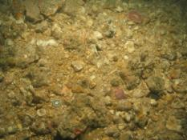 | Moderate energy circalittoral rock. Subtidal coarse sediment.
SDOR_CEND1315_C30_STN_123_A1 | 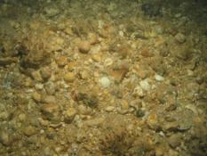 | 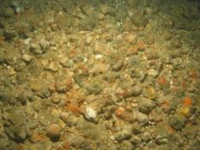 | 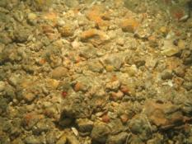 | Moderate energy circalittoral rock. Subtidal coarse sediment.
SDOR_CEND1315_C32_STN_124_A1 | 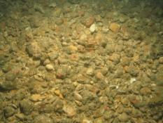 | 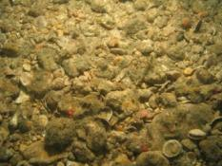 | 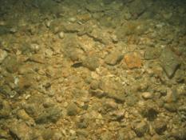 | Moderate energy circalittoral rock. Subtidal coarse sediment.
SDOR_CEND1315_C33_STN_125_A1 | 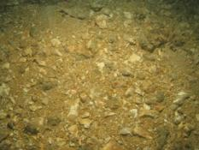 | 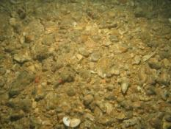 | 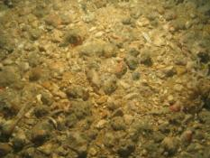 | Moderate energy circalittoral rock. Subtidal coarse sediment.
SDOR_CEND1315_C31_STN_127_A1 | 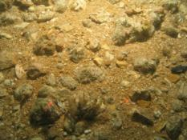 | 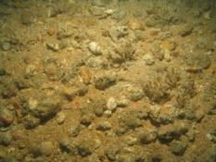 | 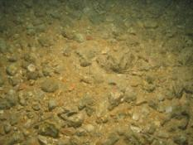 | Moderate energy circalittoral rock. Subtidal coarse sediment.
SDOR_CEND1315_C28_STN_128_A1 | 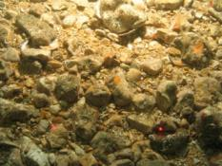 | 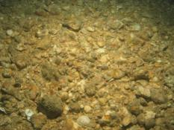 | 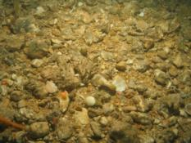 | Moderate energy circalittoral rock. Subtidal coarse sediment.
SDOR_CEND1315_C27_STN_129_A1 | 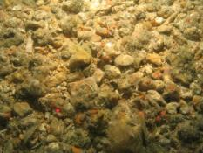 | 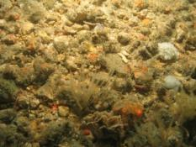 | 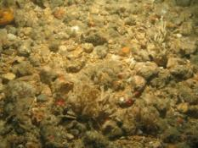 | Moderate energy circalittoral rock. Subtidal coarse sediment.
SDOR_CEND1315_C26_STN_130_A1 | 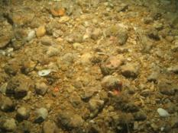 | 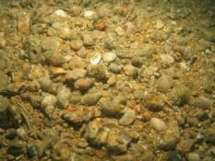 | 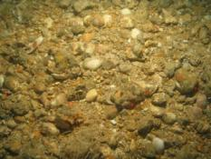 | Moderate energy circalittoral rock. Subtidal coarse sediment.
SDOR_CEND1315_C29_STN_132_A1 | 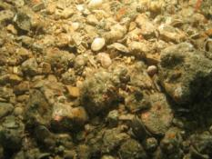 | 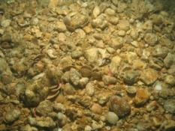 | 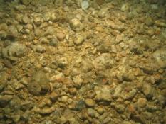 | Moderate energy circalittoral rock. Subtidal coarse sediment.
SDOR_CEND1315_C20_STN_133_A1 | 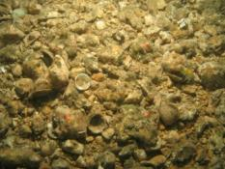 | 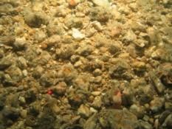 | 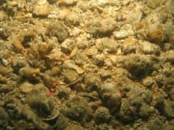 | Moderate energy circalittoral rock. Subtidal coarse sediment.
SDOR_CEND1315_C24_STN_134_A1 | 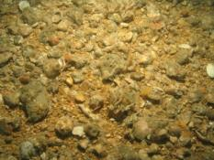 | 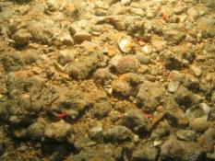 | 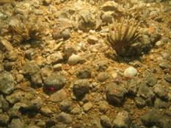 | Moderate energy circalittoral rock. Subtidal coarse sediment.
SDOR_CEND1315_C68_STN_135_A1 | 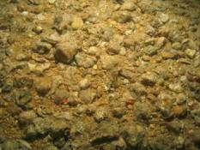 | 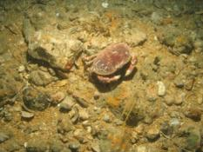 | 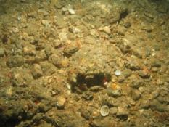 | Moderate energy circalittoral rock. Subtidal coarse sediment.
SDOR_CEND1315_C70_STN_137_A1 | 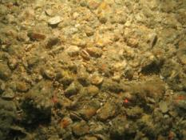 | 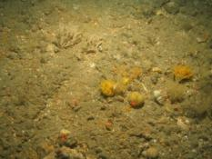 | 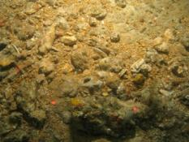 | Moderate energy circalittoral rock. Subtidal coarse sediment.
SDOR_CEND1315_C21_STN_138_A1 | 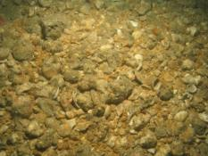 | 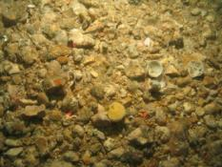 | 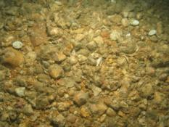 | Moderate energy circalittoral rock. Subtidal coarse sediment.
SDOR_CEND1315_C61_STN_139_A1 | 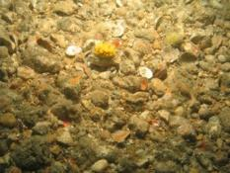 | 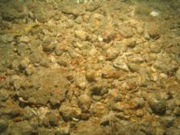 | 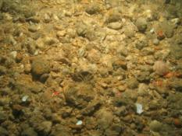 | Moderate energy circalittoral rock. Subtidal coarse sediment.
SDOR_CEND1315_C19_STN_140_A1 | 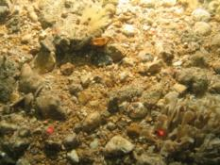 | 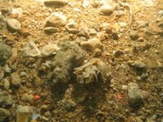 | 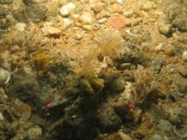 | Moderate energy circalittoral rock. Subtidal coarse sediment.
SDOR_CEND1315_C69_STN_141_A1 | 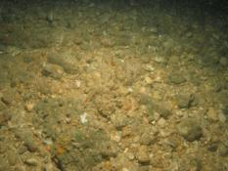 | 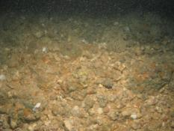 | 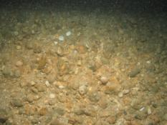 | Moderate energy circalittoral rock. Subtidal coarse sediment.
SDOR_CEND1315_C16_STN_142_A1 | 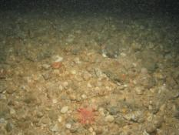 | 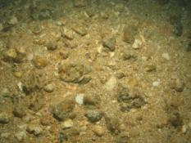 | 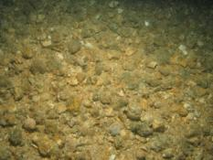 | Moderate energy circalittoral rock. Subtidal coarse sediment.
SDOR_CEND1315_C67_STN_143_A1 | 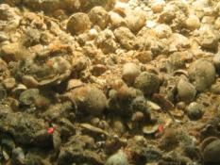 | 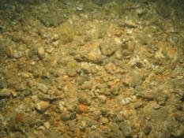 | 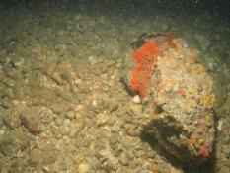 | Moderate energy circalittoral rock.
SDOR_CEND1315_C18_STN_144_A1 | 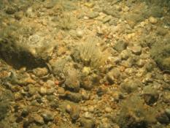 | 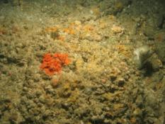 | 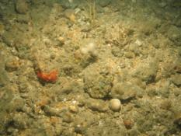 | Moderate energy circalittoral rock.
SDOR_CEND1315_C55_STN_145_A1 | 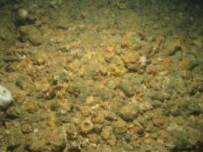 | 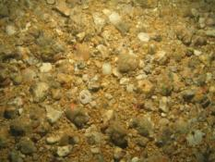 | 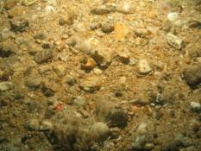 | Moderate energy circalittoral rock. Subtidal coarse sediment.
SDOR_CEND1315_C17_STN_146_A1 | 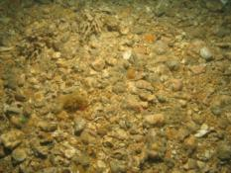 | 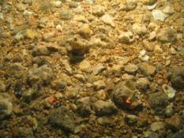 | 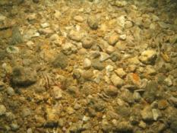 | Moderate energy circalittoral rock.
SDOR_CEND1315_C64_STN_147_A1 | 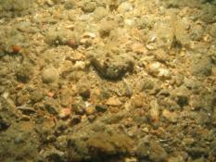 | 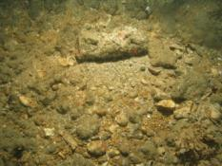 | 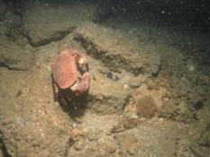 | Moderate energy circalittoral rock.
SDOR_CEND1315_C13_STN_148_A1 | 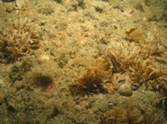 | 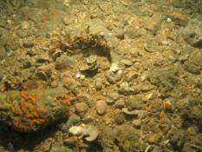 | 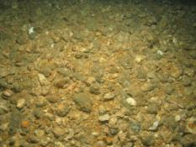 | Moderate energy circalittoral rock.
SDOR_CEND1315_C15_STN_149_A1 | 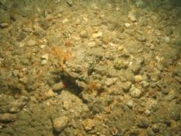 | 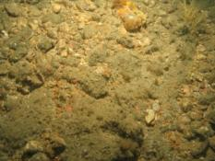 | 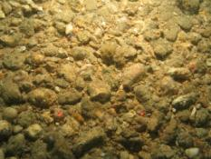 | Moderate energy circalittoral rock. Subtidal coarse sediment.
SDOR_CEND1315_C65_STN_151_A1 | 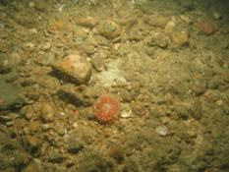 | 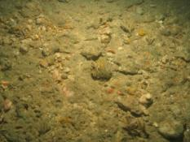 | 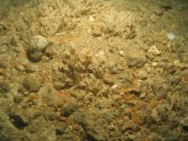 | Moderate energy circalittoral rock.
SDOR_CEND1315_C12_STN_152_A1 | 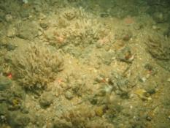 | 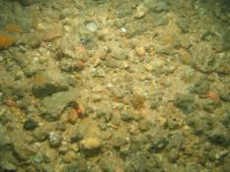 | 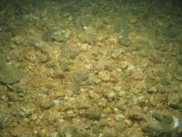 | Moderate energy circalittoral rock.
SDOR_CEND1315_C14_STN_153_A1 | 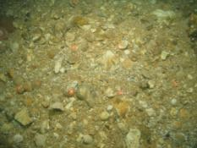 | 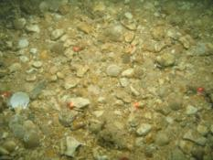 | 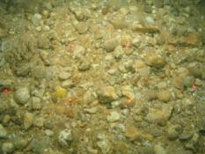 | Moderate energy circalittoral rock. Subtidal coarse sediment.
SDOR_CEND1315_C56_STN_155_A1 | 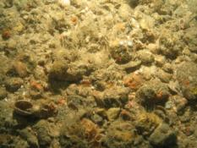 | 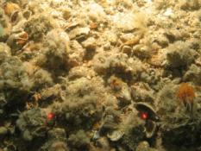 | 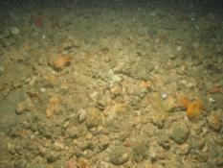 | Moderate energy circalittoral rock. Subtidal coarse sediment.
SDOR_CEND1315_C09_STN_156_A1 | 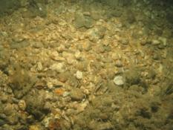 | 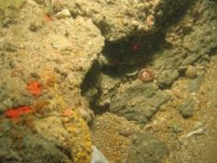 | 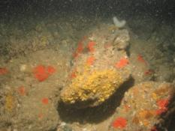 | Moderate energy circalittoral rock. Subtidal coarse sediment.
SDOR_CEND1315_C57_STN_158_A1 | 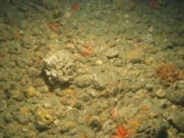 | 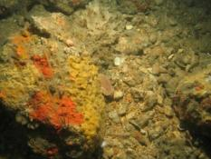 | 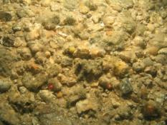 | Moderate energy circalittoral rock. Subtidal coarse sediment.
SDOR_CEND1315_C11_STN_159_A1  WRECKAGE / LITTER | 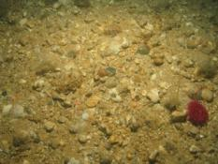 | 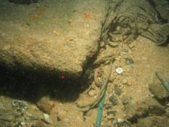 | 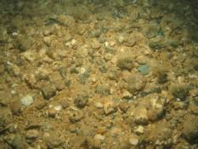 | Moderate energy circalittoral rock. Subtidal coarse sediment.
SDOR_CEND1315_C66_STN_160_A1 | 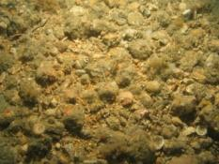 | 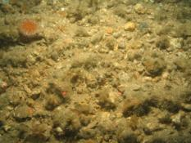 | 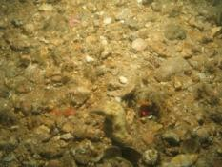 | Moderate energy circalittoral rock. Subtidal coarse sediment.
SDOR_CEND1315_C01_STN_161_A1 | 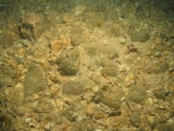 | 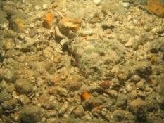 | 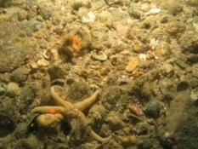 | Moderate energy circalittoral rock. Subtidal coarse sediment.
SDOR_CEND1315_C10_STN_162_A1 | 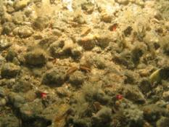 | 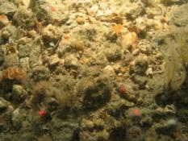 | 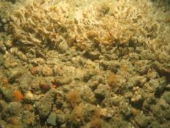 | Moderate energy circalittoral rock. Subtidal coarse sediment.
SDOR_CEND1315_C62_STN_163_A1 | 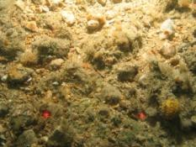 | 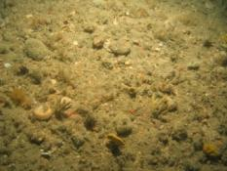 | 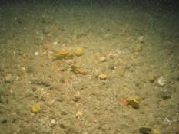 | Moderate energy circalittoral rock. Subtidal coarse sediment.
SDOR_CEND1315_C07_STN_164_A1 | 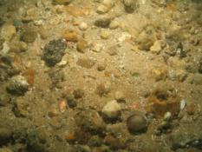 | 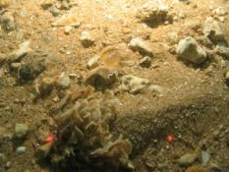 | 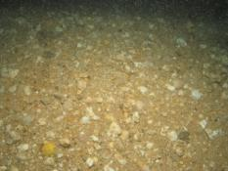 | Moderate energy circalittoral rock. Subtidal coarse sediment.
SDOR_CEND1315_C05_STN_166_A1 | 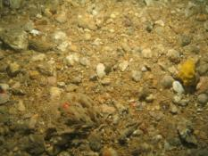 | 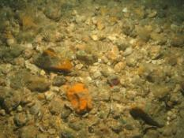 | 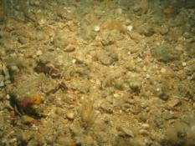 | Moderate energy circalittoral rock. Subtidal coarse sediment.
SDOR_CEND1315_C03_STN_167_A1 | 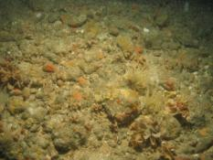 | 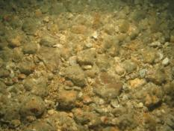 | 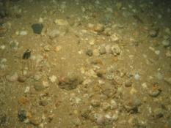 | Moderate energy circalittoral rock. Subtidal coarse sediment.
SDOR_CEND1315_C08_STN_168_A1 | 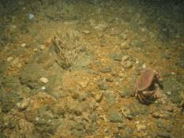 | 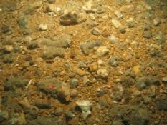 | 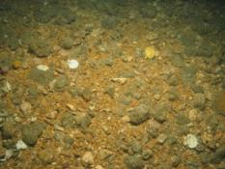 | Moderate energy circalittoral rock. Subtidal coarse sediment.
SDOR_CEND1315_C02_STN_169_A1 | 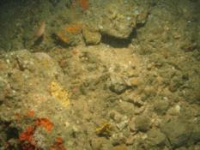 | 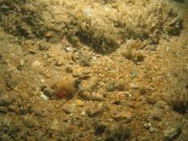 | 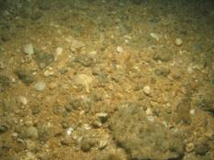 | Moderate energy circalittoral rock. Subtidal coarse sediment.
SDOR_CEND1315_C06_STN_170_A1 | 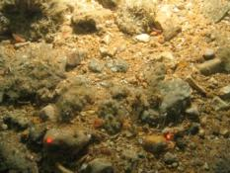 | 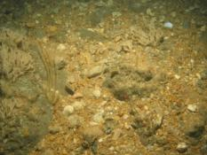 | 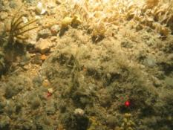 | Moderate energy circalittoral rock.
SDOR_CEND1315_C63_STN_171_A1 | 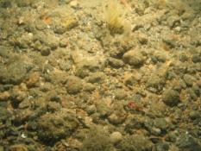 | 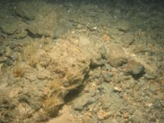 | 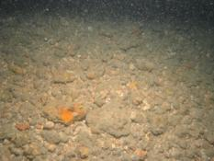 | Moderate energy circalittoral rock.
SDOR_CEND1315_C60_STN_172_A1 | 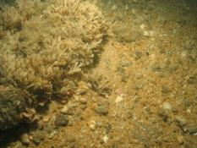 | 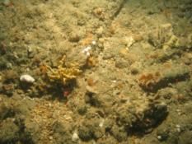 | 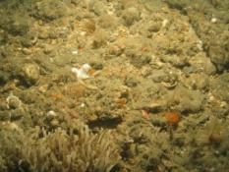 | Moderate energy circalittoral rock.
SDOR_CEND1315_C04_STN_173_A1 | 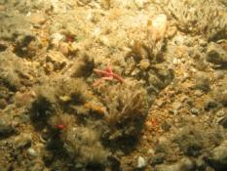 | 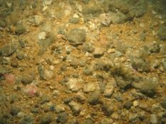 | 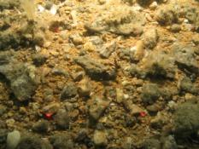 | Moderate energy circalittoral rock.
SDOR_CEND1315_C59_STN_174_A1 | 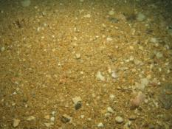 | 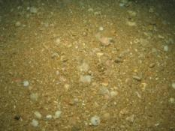 | 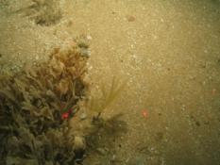 | Subtidal coarse sediment, Subtidal sand
SDOR_CEND1315_C58_STN_176_A1 | 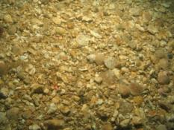 | 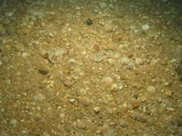 | 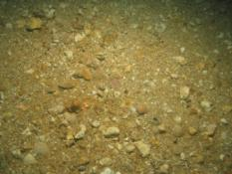 | Subtidal coarse sediment
SDOR_CEND1315_C20_STN_177_A1 | 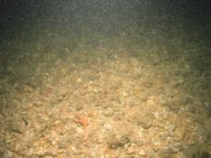 | 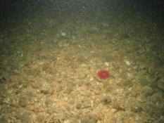 | 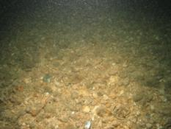 | Subtidal coarse sediment
SDOR_CEND1315_C27_STN_178_A1 | 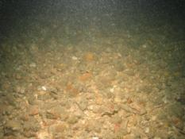 | 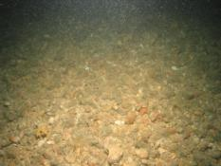 | 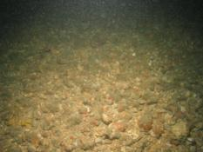 | Subtidal coarse sediment
SDOR_CEND1315_C32_STN_179_A1 | 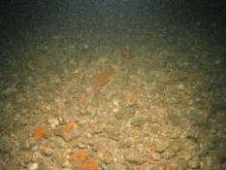 | 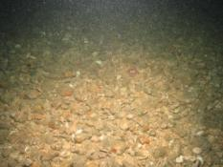 | 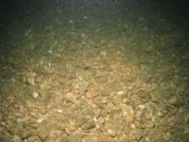 | Subtidal coarse sediment
SDOR_CEND1315_C36_STN_180_A1 | 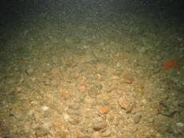 | 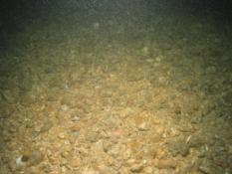 | 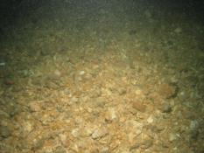 | Subtidal coarse sediment
SDOR_CEND1315_C40_STN_181_A1 | 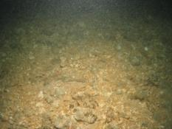 | 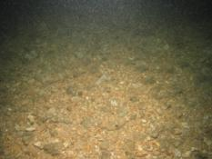 | 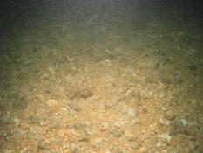 | Subtidal coarse sediment
SDOR_CEND1315_C42_STN_182_A1 | 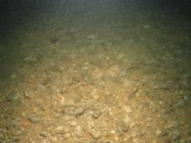 | 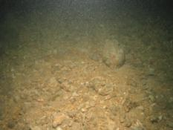 | 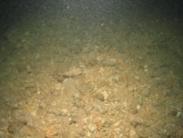 | Subtidal coarse sediment

