Annex 1: Methodology guidance
This annex outlines elements of the CCRA4 Independent Assessment (CCRA4-IA) methodology relevant to the production of the Technical Report. This document is intended to be read alongside the CCRA4-IA Technical Report Invitation to Tender (ITT).
The document includes the following sections:
- Risk assessment methodology
- Urgency Scoring

Risk assessment methodology
This section details elements of the desired methodology for assessing climate change risks and opportunities to the UK in the CCRA4-IA Technical Report.

Outcome areas

In CCRA4 – risks and opportunities are to be organised under the following set of outcomes areas:
- ECONOMY: The functioning of our economy including goods and services which we expect and rely on
- HEALTH & WELLBEING: Our physical and mental health and wellbeing
- BUILT ENVIRONMENT: The comfort, security and safety of our homes and places of work
- INFRASTRUCTURE : The functioning of energy, transport, communication and water infrastructure, on which we depend
- LAND, NATURE AND FOOD: The state of the natural world, which supports our food production and other vital services
Each outcome area is associated with a particular cross-cutting area of societal outcomes or goals that are at risk from climate change. These five outcome areas will be used to group the named risks and opportunities assessed in the Technical Report. It is expected that these outcome areas will serve as chapters in the CCRA4-IA Technical report. The outcome area themes are similar to the chapters in the CCRA3-IA Technical report.
In CCRA3-IA Technical Report there was a chapter named ‘International dimensions’, focused on climate risks arising from changes outside of the UK. This will not be maintained as a separate area of CCRA4-IA, but instead risks arising from international climate change will be integrated throughout the outcome areas as relevant. For example, the infrastructure systems area will consider risks to continued functioning of UK infrastructure from both changes in the UK’s weather and climate AND changes in weather and climate abroad.

Time periods

Risks and opportunity should be assessed (using the urgency scoring methodology outlined below) for four different time periods, as the evidence allows.

- Present: Risk and opportunities should be evaluated using the climate conditions of now/the recent past, against which future period assessments will be compared. We propose that this assessment should be conducted from the climate and weather conditions realised (or those that could have been realised) over the average of the 2001 – 2020 period, consistent with the most up-to-date UK climatology used by the UK Met Office, and close in time to the date of the most recent UK census data.
- 2030s: A near-term reference period centred on 2035, to represent the climate for which the next round of national adaptation programmes will need to fully prepare for. This period was not evaluated in the previous Technical Report but should be included, where the evidence allows, in the CCRA4-IA Technical Report assessment.
- 2050s: A mid-century reference period, centred on 2055, consistent with the end of the period of ‘inevitable’ climate change, regardless of the trajectory of global GHG emissions over the next few decades.
- 2080s: A late-century reference period, centred on 2085 used to consider the implications of further climate change beyond the middle of the century, particularly for long-lived assets.
Credible trajectories of future climate change (as outlined in section b) should be formally considered for each of these time periods for the risk assessment.

Future climate scenarios

Consistent with The Intergovernmental Panel on Climate Change (IPCC) Sixth Assessment Report, a global warming level framing should be used, to span the range of climate risks the UK may experience.

For each time-period outlined in section a, two different GWLs are proposed to be used to assess risks and opportunities from climate change (Table 1). These two futures are consistent with both a ‘central’ and ‘high-end’ warming outcome under a global emissions trajectory consistent with only current-policy global emissions reduction (disregarding Nationally Determined Contributions (NDCs) as well as net-zero and other long-term targets). Variation in the UK climate hazards at each global warming level should also be considered in the analysis of risks and opportunities, as well as potential changes in UK exposure and vulnerability to climate risk.

Table 1: Proposed Global Warming Levels to be considered at each time period for the CCRA4-IA assessment
 | Central future | High-impact future
2030s | 1.5⁰C | 2⁰C
2050s | 2⁰C | 2.5⁰C
2080s | 2.5⁰C | 3⁰C/3.5⁰C

Cross-cutting themes

A set of cross-cutting themes will run across CCRA4-IA. These include:
- Cascading risks
- The interaction of climate risk/adaptation with other societal goals (including Net Zero and environmental improvement)
- Distributional impacts
- Economic impacts
- Spatial risk hotspots
The CCC will be developing cross-CCRA analytical frameworks for these, which will be finalised in consultation with the Technical Report authors in early 2024 and should then be applied in the evaluation of risks and opportunities relevant to each outcome area.
For the cascading risks theme, a qualitative framework needs to be applied to each societal outcome area, in consultation with stakeholders, to consider cascading risk. The framework will include: i) identification of a small number of priority cascades connected to the outcome area, ii) mapping of critical components of the cascade and iii) consideration of actions to reduce the cascade. Toolkits and support will be provided to contractors to support their application of the framework. Details of the CCC's wider cascading impacts framework will be provided to the successful bidder and its application agreed at the project kick-off meeting. The framework will also be used to standardise evidence on cascading risk as part of the open Call for Evidence.

CCRA Urgency Scoring Methodology
The CCRA Technical Report aims to identify where further adaptation is needed over the next five years. To do this it uses a defined methodology (see Chapter 2.3 of the CCRA3 Technical Report) to produce an ‘urgency’ score for the risks facing the UK. This methodology is applied across the risks identified in the CCRA and is informed by the evidence base and expert judgements of the report authors.
There are three steps to this methodology:
- What is the current and future level of risk/opportunity in the absence of further adaptation? This step assesses risks and opportunities to the UK under the current and future climates for different time periods (e.g. present day, 2030s, 2050s and 2080s). This assessment rates the magnitude of each potential risk as ‘high’, ‘medium’, ‘low’ or ‘unknown’, as well as the confidence (‘high’, ‘medium’, ‘low’) in the available evidence base. No further adaptation measures are assumed to be deployed except those in place today for this step.
- To what extent is the risk/ opportunity going to be managed under current and expected plans? This step assesses the extent to which future risks or opportunities would be reduced or realised by existing Government commitments for new adaptation measures (and adaptation that might reasonably be expected to happen unprompted).
- Are there benefits to further action over the next five years? This involves identifying if there are benefits (e.g. avoided costs, avoiding lock-in, substantial co-benefits) for additional action over the next five years in areas where current plans are expected to lead to adaptation shortfalls.
The three steps of this methodology allow each risk to be put into one of a set of urgency categories (Figure 1):
- More action needed: New, stronger or different government policies or implementation activities– over and above those already planned – are needed in the next five years to reduce vulnerability to climate change.
- Further investigation/Research priority: Research is needed in the next five years to fill significant evidence gaps or reduce the uncertainty in the current level of understanding in order to assess the need for additional action.
- Sustain current action: Current or planned levels of activity are appropriate, but continued implementation of these policies or plans is needed to ensure that the risk continues to be managed in the future. This includes any existing plans to increase or change the current level of activity.
- Watching brief: The evidence in these areas should be kept under review, with long-term monitoring of risk levels and adaptation activity so that further action can be taken if necessary. Risks with more urgency (‘More action needed’ or ‘Further Investigation’) are those that are highlighted to be addressed by Government policy over the next five years
Figure 1 Urgency scoring methodology used in CCRA3

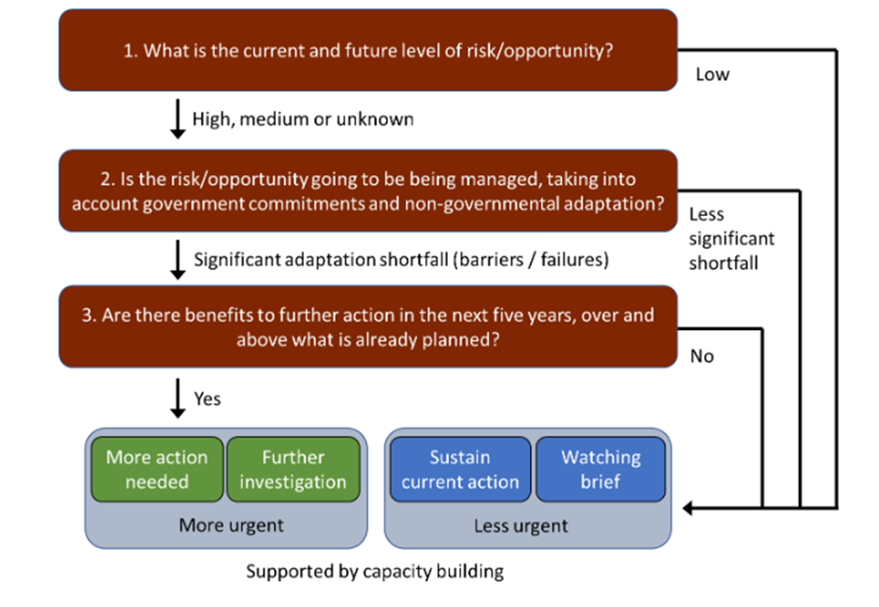
Source: Watkiss, P. and Betts, R.A. (2021) Method. In: The Third UK Climate Change Risk Assessment Technical Report.

The full CCRA3-IA Technical Report methodology can be found in Chapter 2 of the report and includes the full urgency scoring methodology. This scoring methodology should account for a range of risk-related elements including, but not limited to, lock-in of risk, interdependencies and cascading risk, distributional effects, and Net Zero. For CCRA4-IA Technical Report the full urgency scoring methodology will need to be applied in Task 6 to the subset of risks identified in Task 5 (including additional or emergent risk identified in task 3) and subject to any method refinements in Task 3. Full details of these tasks are provided in the CCRA4-IA Technical Report ITT.

https://www.un.org/en/climatechange/all-about-ndcs
Joeri Rogelj et al., Credibility gap in net-zero climate targets leaves world at high risk. Science380, 1014-1016(2023). DOI:10.1126/science.adg6248

