Armstrong Hall Trust- Fundraising Advisor Brief

Project Overview
Thornbury Town Council is seeking suitably qualified and experienced consultancy support to provide advice and assistance on the implementation of their fundraising strategy for the redevelopment of the Armstrong Hall.

Project background
Thornbury is a market town in South Gloucestershire, just north of Bristol, with a population of 13,000 which is rapidly growing due to new housing developments. Thornbury has a strong, thriving and very active voluntary and community sector which use a range of community venues in the town including The Armstrong Hall.
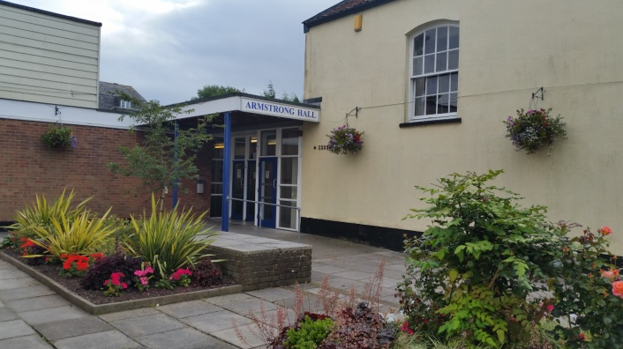
The present Armstrong Hall Trust (of which the Town Council is currently the Sole Trustee) owns the freehold to the Armstrong Hall site and has a longstanding desire to upgrade and modernise its facilities, which are in urgent need of refurbishment. The Armstrong Hall Complex provides a large meeting hall (350 capacity), with stage and changing rooms, the smaller Cossham Hall (130 capacity), a bar, kitchen and two smaller meeting rooms.
The Armstrong Hall complex caters for a wide range of users and uses including drama groups, dance and exercise classes, music, arts, flower arranging, luncheon clubs, meetings and lectures as well as private hire functions.
It is home to a community-based cinema and popular events including Pantomime, productions by local Community Groups, the two weeklong Arts Festival, the Horticulture Show, regular dances and musical performances.
The Armstrong Hall is located between the Museum and the High St, fronting onto Chapel St. and has good access to other services, facilities and car parking.

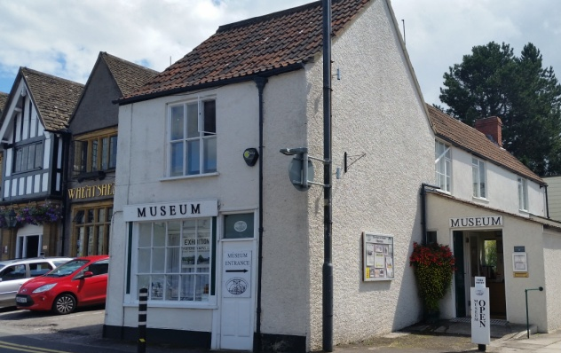
The town’s museum is also located in a former detached cottage on the Armstrong Hall site. The Museum is accredited and run by the Thornbury & District Heritage Trust (TDHT) and they have a desire for more space for exhibitions and archives and to improve access to the building.

The Armstrong Hall complex is located within the conservation area. The Cossham Hall and Museum, whilst not listed buildings, are locally an important part of Thornbury’s heritage.
The Armstrong Hall Trust have ambitious plans to redevelop and refurbish the site to meet the increasing demand as the town’s population grows and to enable this will embark on a £5 million capital appeal to create an arts and cultural hub for the community of Thornbury and surrounding area.

Progress so far:
The Trust has completed two consultations to determine the future of the Hall and where the Community would like to see the Hall sited. The last consultation completed in March 2018 showed overwhelming community support to see a new build Hall complex on the existing site. Architects have developed some initial concept designs which have been largely supported by the community and these have also had favourable response from the Planning Authority at the pre-planning application stage.
In 2019 a fundraising consultant was appointed to work with the Trust and community to develop a strategy for a capital appeal for funding. This strategy determined that the appeal should be set at £5 million to be a realistic and achievable figure. This strategy has been approved and the Trust are now seeking a suitably experienced fundraising advisor with experience in arts and culture to take the fundraising forward over the next few years.

Scope of works
To work with the project team providing advice and overseeing Capital Appeal Activities based on a monthly retainer. It is anticipated that activities would include:
- Recruitment of appeals officer.
- Analysis of existing consultation and additional consultation, if required, to establish need and demand for the project
- Preparation and implementation of detailed communications plan throughout the fundraising period
- Preparation of Case for Support
- Establishing an Appeals Committee
- Approaching and engaging with Key Lead Funders, High Net Worth individuals and Grant Funders
- Preparation and Implementation of Public Phase of fundraising
- Develop a legacy for the campaign
- Any additional work that may be identified as the project evolves, this would be quoted and paid for separately.

Project timeline
The Trust anticipate appointing successful candidate April 2020.

Required experience
- Substantial experience in fundraising with demonstrable experience of raising income through the development and delivery of a Fundraising Strategy.
- Experience in a variety of fundraising and marketing activities, including statutory, individual giving, digital giving, trusts and foundations, donations, bequests, legacies and capital funding.
- Experience of working with a Charity and Trustees
- Experience of working with Community groups
- Experience of working with and raising funds for a similar type of project such as a Community Hall/ Theatre and/ or Museum

Tender process
Quotations should be received no later than 10am on Monday 20 April 2020 and sent to the address listed below in a sealed envelope or via email to clerk@thornburytowncouncil.gov.uk. Quotations and supporting information will then be considered at a Trust meeting. Further information and or clarification maybe sought from you prior to an appointment.
Quotations should be based on a fixed, all-inclusive daily rate/anticipated monthly rate to undertake the full scope of the works identified above and to detail the means of delivery involved including itemised elements, VAT and any other areas of expenditure.
In addition to the quotation, information should be provided about how you propose to manage the project, to include the following areas:
- A brief history of your organisation
- a summary of your overall services & experience
- a summary of similar client organisations to whom you have provided similar services
- a statement of what you consider are the specific services the AHT may require to meet our overall objective
- a methodology of how you would provide the services
- the proposed output from your services
- an introduction to the staff you propose to deploy to carry out the service and the location from where you will provide the services.
- timetable of events for the services
- a statement of the resources and involvement required from AHT
- a brief statement on why we should engage your services
- your proposed professional fees, any other disbursements and when payment would be due
- Your hourly rates for additional work on this and other works (see below)
- Your terms and conditions of any appointment.

Contact for further information
If you will be providing a response and quotation for these works or require further information, please contact:
Mr Stephen Nugent, Armstrong Hall Project Manager
Phone: 01454 568218 or 01454 412060
Email: s.nugent@armstronghallthornbury.org
Any response to queries raised during the tender period will be shared with other tenderers

Appendix A – Strategy Summary

Appendix A – Strategy Summary

In October 2019, a consultant was commissioned to provide a fundraising strategy for the redevelopment of the Armstrong Hall Complex. This strategy is the culmination of their work and also considers feasibility and preparation work required.
• The proposed Armstrong Hall Complex will involve the rebuilding of the Armstrong Hall and incorporation of Thornbury Museum and the historic Cossham Hall. The current facility is well used, and supported by the community, but is no longer fit for purpose. The proposed project will create an Arts and Cultural Hub for Thornbury providing space for meeting, events, performances, exhibitions and the museum. It is an ambitious project with current costings indicating a total cost of between £5 million and £8 million. It has recently been agreed to consider scaling this back to between £3million and £5million. Consequently, this strategy will focus on a £5 million target. There was an attempt to fund a performance venue in 2011 on the site, which failed due to the high operational costs that were unsustainable. There is currently a team of volunteers undertaking on-going fundraising activities that have raised over £100,000.
• The strategy was prepared following site visits, meetings with stakeholders and funders, a strategy day, desktop research and the application of accepted capital appeal theory, combined with extensive experience and expertise in the field of capital appeals.
• The strategy outlines the fundraising approach required to reflect the vision of the Hall Redevelopment Working Group for the Armstrong Hall Complex.
• The identification of constituencies of support and analysis of the external and internal environment undertaken at the strategy day have been taken into consideration when developing the strategy.
• Immediate Challenges and Opportunities include:
o Clarification of final building design, costs and usage
o Preparation of comprehensive business plan demonstrating sustainability of building when complete and operational o Clarifying evidence of need and demand linking to agreed usage
o Leadership

Appeal Fundraising Goals Overview
Year | Focus | Target Income | Cost
Year 1 | Preparation, Private Phase |  | TBC
Years 2 & 3 | Active, Private Phase  - Lead Funders (£ 2,000,000)  - High Net Worth Individuals (£750k)  - Corporate Support (£250k)  - Trust, Foundations, Grants (£1,000,000) | £4,000,000 | TBC
Year 4 | Active Public Phase | £1,000,000 | TBC
 |  | £5,000,000

Year 1 - Preparation, Private Phase involves:
o A number of critically important, non-fundraising actions necessary within the preparation phase. o Secure Funding for Appeal Costs (est. £68,000 per annum)
o Recruitment of Fundraising Consultant
o Recruitment of Appeal Officer
o Establish Appeal Committee
o Evidence
o Communications Plan
o Case for Support
Years 2 & 3 - Active, Private Phase involves:
o Secure Lead Funders – Public Works Loan, Arts Council, National Lottery Heritage Fund
o Secure Donations from High Net Worth Individuals
o Secure Large Corporate and Organisational Donations
o Secure Funding from Trusts Foundations and Grant Funders
Year 4 - Active Public Phase
o Launch Public Appeal
o Follow Communications Plan
o Stewardship

